Ocean Voyager – Run 04 Demo
Behind the Scenes
Random pool exploration • collision handling • RGB + thermal sensing • opportunistic sensor fusion • reconstructed trajectory

1. What this demo shows
This demo is a real pool run of the Ocean Voyager autonomous surface vehicle using the v45 controller. The run combines stochastic navigation with safety recovery and multi-sensor object detection. The animation is a post-processed replay: it uses the run’s timestamped motor and sensor logs, archived RGB imagery, thermal imagery, and fusion events to show what the vehicle was doing and what its sensors were seeing.

2. Operating landscape and coordinate convention
The renderer represents the test area as a 5 ft × 7 ft rectangular operating region. For this Run 04 replay, the boat is anchored initially at (x, y) = (2.5, 0): the midpoint of the 5-ft near edge, facing into the pool along +Y. X therefore spans 0–5 ft and Y spans 0–7 ft.
The plotted route is explicitly a reconstructed/estimated trajectory, not an external ground-truth track. That distinction matters: the boat has no overhead motion-capture system or absolute indoor position sensor in this demo.
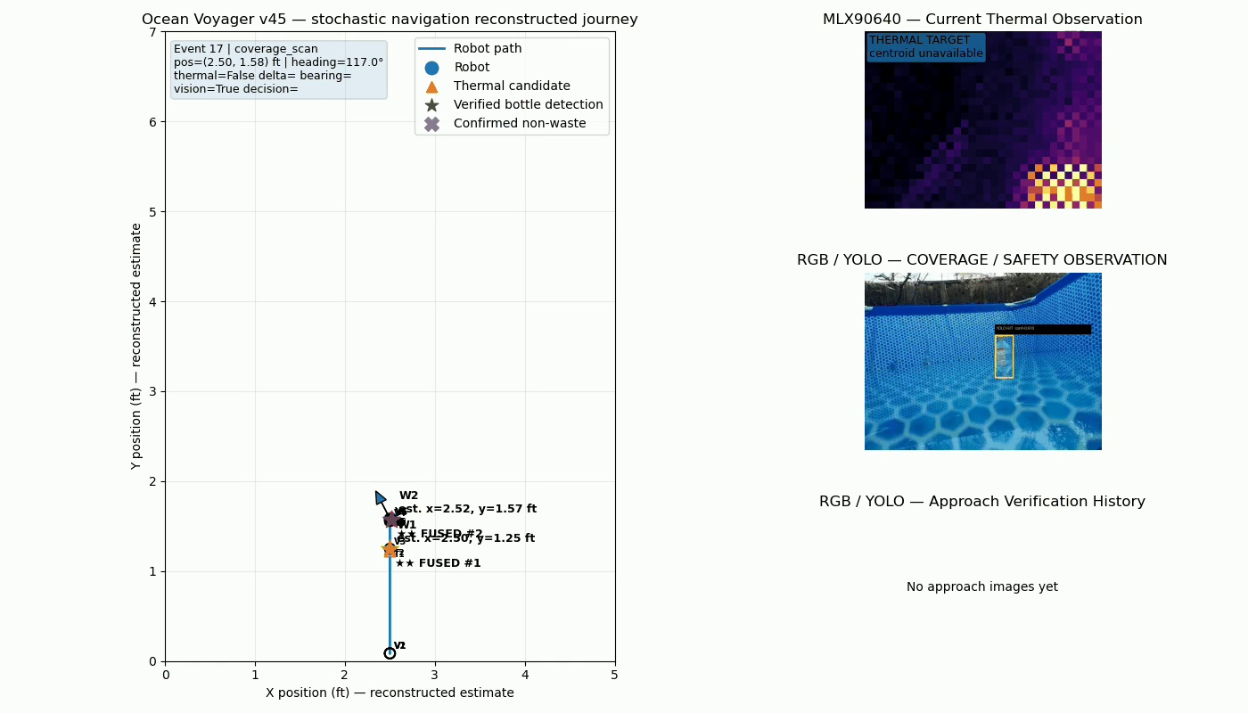
Representative frame from the actual Run 04 renderer: map, RGB view and thermal view are presented together.

3. Navigation: intentionally stochastic exploration
Unlike the earlier deterministic/lawnmower-style navigation experiments, v45 deliberately uses randomized action selection. The controller chooses among FORWARD, TURN_LEFT, TURN_RIGHT and PAUSE/OFF. Each action has a configurable probability and a configurable duration range. The purpose is practical exploration: keep the boat moving through different parts of the pool without depending on fragile absolute localization.
Run 04 used the navigation settings that had behaved well in the preceding physical test:
Action bank | Action | Probability | Duration range
Normal | Forward | 0.70 | 2–12 s
Normal | Left | 0.07 | 1–6 s
Normal | Right | 0.17 | 1–6 s
Normal | Pause | 0.06 | 0.2–4 s
Collision | Left | 0.15 | 0.5–6 s
Collision | Right | 0.45 | 1–6 s
Collision | Pause | 0.40 | 0.5–3 s
The asymmetry is intentional and empirical. The physical boat had a directional bias, so the probabilities were adjusted during pool testing rather than forcing a mathematically symmetric random walk.

4. Collision behavior
The main navigation intelligence is concentrated around wall encounters. The camera-derived safety logic identifies a likely wall/collision condition; the controller then leaves the normal action bank and selects from a separate collision-recovery bank. Recovery can include a substantial left or right turn or a pause. Once the situation clears, the vehicle returns to normal random exploration.
This design deliberately accepts that occasional wall contact may occur. The goal of this test is robust continued exploration and recovery, not perfect collision-free path planning.

5. RGB object detection
The RGB camera runs the trained YOLO bottle detector. When a detection is present, the run records confidence, bounding box, image-relative bearing and object area. Run 04 was especially useful because the corrected vision setup produced repeated real RGB detections rather than the mostly empty RGB results seen in the preceding run.

6. Thermal sensing
The MLX90640 thermal camera operates independently of RGB. It searches for a temperature-contrast blob and records thermal contrast (Δ°C) and estimated bearing. For this test the bottle contained warmer water, intentionally providing a clear thermal signature so the end-to-end fusion and pursuit logic could be exercised.
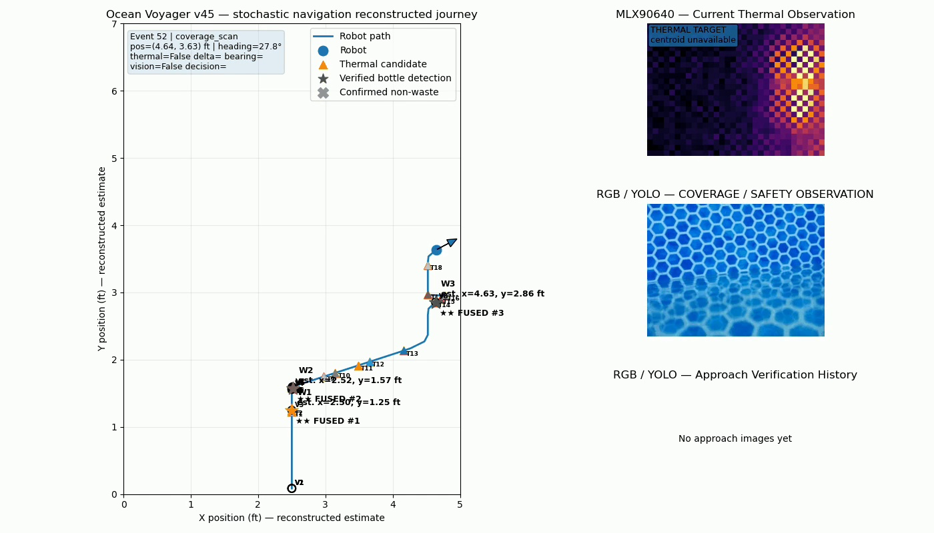
The replay keeps the physical trajectory, RGB observation and thermal observation on one synchronized display.

7. RGB + thermal fusion
The important demonstration feature is that RGB and thermal are not merely displayed side by side. The controller checks whether detections are temporally compatible and whether their estimated bearings agree sufficiently. A corroborated pair becomes a fused candidate.
The Run 04 renderer parsed 14 RGB detections, 40 thermal detections and 5 fused detections from the run. One particularly clean event had RGB and thermal bearings of approximately +17.6° and +18.9° respectively—about 1.3° apart—before the controller entered pursuit.

8. Opportunistic target pursuit
A fused object can temporarily interrupt random exploration. The vehicle steers toward the candidate and attempts a short approach, but target pursuit is deliberately bounded. In this run configuration a pursuit could last at most 5 seconds. The object behavior is therefore opportunistic: detect, investigate briefly, then return to exploration rather than allowing object tracking to dominate the mission.
A 30-second target cooldown follows an approach. This is an important robustness feature: even if the same bottle remains visible, or a detection bug repeatedly fires, the vehicle is guaranteed a period of ordinary random navigation before another target takeover. Run 04 showed this mechanism working, including a valid fused observation that was suppressed while the cooldown was active.
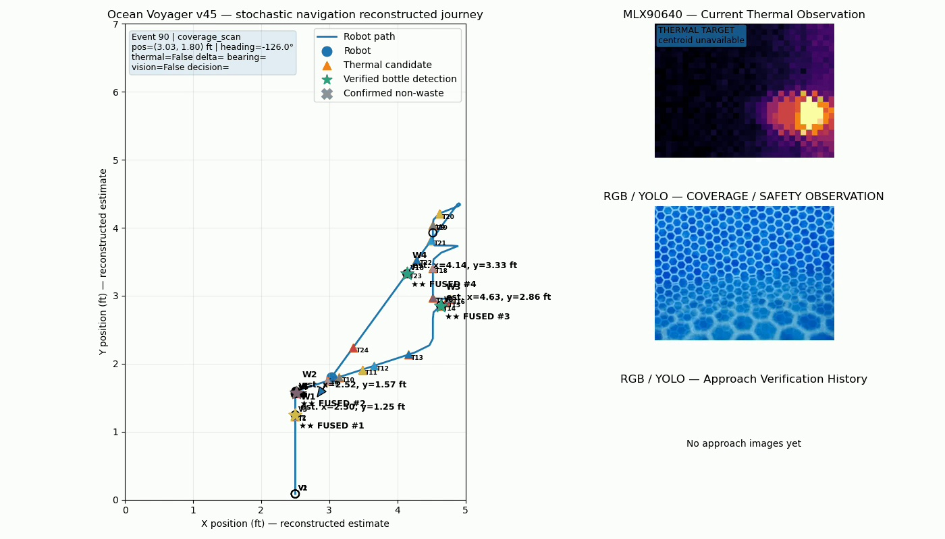
Representative later frame: the irregular route is consistent with the intentionally stochastic exploration policy.

9. How the trajectory in the animation is reconstructed
The map is produced after the run. The renderer starts from the known initial pose and replays the timestamped motor-state history. FORWARD translates the estimated pose along its current heading; TURN_LEFT and TURN_RIGHT change heading using display calibration rates; OFF/PAUSE produces no commanded translation. The v45 controller’s display calibration is approximately 0.175 ft/s forward, 30°/s left and 45°/s right.
The renderer then keeps the estimate within the physical pool domain and uses available wall/collision information as constraints. This produces a continuous, plausible reconstruction suitable for explaining the run, but it should not be interpreted as centimeter-accurate localization. Real effects such as water drift, pump asymmetry, momentum and wall contact are only approximated by the replay model.

10. What worked in the demo
- Continuous real-pool exploration using configurable stochastic navigation.
- Physical steering with deliberately asymmetric left/right behavior tuned from pool testing.
- Wall/collision detection and recovery followed by a return to exploration.
- RGB bottle detections from the corrected vision setup.
- Independent MLX90640 thermal detections with strong temperature contrast.
- Multiple RGB + thermal fused observations rather than sensor streams operating only in isolation.
- Short target takeovers and steering toward fused candidates.
- Cooldown suppression preventing repeated immediate pursuit of the same object.
- Automatic return from object-handling behavior to random exploration.
- Archival of motor, RGB, thermal and fusion information sufficient to create a synchronized post-run animation.

11. What the demo does not claim
The animation should not be presented as ground-truth localization or as proof of complete pool coverage. The plotted path is an estimated reconstruction. Likewise, this run demonstrates working opportunistic detection/fusion/pursuit behavior, but it is not a quantitative evaluation of detection precision, recall, coverage percentage or localization error. Those require separately designed experiments and ground truth.

12. The behind-the-scenes story in one paragraph
Ocean Voyager is not following a pre-drawn path in this demo. It continuously chooses bounded random movement actions, uses vision-based safety cues to recognize wall encounters and recover, and independently watches the scene with RGB and thermal sensors. When both sensors see compatible evidence of a bottle, the controller can temporarily leave exploration mode, steer toward the object, and then deliberately relinquish the target and resume exploration. A cooldown prevents repeated target chasing. After the physical run, the timestamped motor and sensor history is replayed from a known starting pose to produce the estimated trajectory and the synchronized RGB/thermal/fusion animation shown in the demo.

13. Suggested presentation language
A concise way to narrate the video is: “The left panel is a reconstructed trajectory from the boat’s logged motor actions and wall interactions, starting from a known initial pose. The RGB and thermal panels show the actual sensor observations from the run. Navigation is intentionally stochastic so the vehicle continues exploring without relying on absolute localization. When RGB and thermal detections agree, the boat can opportunistically divert toward the object. Pursuit is time-bounded and followed by a cooldown, so object detection cannot trap the vehicle in repeated tracking and normal exploration always resumes.”

