Ocean Voyager
Hardware Build & Assembly Guide
Reconstruction guide for the September 2026 powered-pool prototype

Purpose and build version
This guide is intended to let a new builder reproduce the current powered-pool Ocean Voyager: Raspberry Pi 4 Model B, independent Pi power bank, Raspberry Pi AI Camera/RGB camera, MLX90640 thermal sensor, DRV8833 dual H-bridge, two 3–5 V mini submersible pumps, separate 3×AA (~4.5 V nominal) motor supply, tubing/nozzles, and the low single-deck plastic plate/lid hull developed during pool testing.
Version warning. Earlier Ocean Voyager concepts mention Blue Robotics T200 thrusters, ESCs, LiPo/UBEC power, multiple cameras and a servo thermal scanner. Those are not the hardware recipe for this September 2026 pool-tested build.

1. Bill of materials
Part | Qty | Role | Buying/reference note
Raspberry Pi 4 Model B | 1 | Main computer | Search “Raspberry Pi 4 Model B”; existing project board is suitable.
5 V USB-C power bank | 1 | Dedicated Pi supply | Use a reliable Pi-capable USB-C power source; motor power remains separate.
Raspberry Pi AI Camera / IMX500 | 1 | Forward RGB camera | Official AI Camera. Amazon reference from development: ASIN B0DJ8VFWKM; search “Raspberry Pi SC1174 AI Camera IMX500”. Working replacement was marked MU2351.
Pi camera ribbon cable | 1 | CSI connection | Standard cable compatible with Pi 4 and camera.
MLX90640 thermal breakout, ~55° class | 1 | Forward thermal sensor | Search “MLX90640 55 degree thermal camera Raspberry Pi”; verify breakout voltage/pinout.
DRV8833 dual H-bridge breakout | 1 | Two-pump motor driver | Search “DRV8833 dual motor driver breakout”.
3–5 V mini submersible DC pumps | 2 installed; buy 4 | Left/right water jets | Development target: 3/4.5 V, ~0.18 A, ~80–120 L/h, ~40–110 cm lift. Amazon reference: SIPYTOPF ASIN B0CJFQ5KDT; verify listing before purchase.
3×AA switched battery holder | 1 | ~4.5 V nominal motor supply | Search “3 AA battery holder with switch leads”.
AA cells | 3 + spares | Pump power | Matched fresh cells; different chemistry/voltage requires recalibration.
Clear flexible tubing | 2 equal runs + spare | Pump discharge/nozzles | Buy to actual pump outlet/barb diameter; avoid kinks.
Low clear waterproof plastic enclosure | 1 | Electronics enclosure | Successful enclosure footprint was about 7×10×2 in; exact brand not essential.
Broad plastic lids/plates | 2+ | Under-plate + transverse flotation/support | Stiff, light plastic; preserve broad stable footprint.
Small side/pump mounts | 2 | Hold pumps and tubing geometry | Light plastic fixtures/boxes are sufficient if rigid.
Marine silicone / Marine Goop | 1 | Seams and penetrations | Search “marine silicone sealant clear” / “Marine Goop”.
Cable glands | as needed | Wire pass-throughs | Search PG7/PG9-style waterproof glands; size to cable.
Hookup/jumper wire, zip ties, Velcro, fasteners | assorted | Electrical + strain relief | Secure final wiring mechanically.

2. Mechanical architecture
The final prototype is intentionally low and wide. The clear electronics enclosure sits centrally and as low as practical. A broad plastic plate/lid beneath the body increases the flotation/support footprint. A second plate/lid runs across the boat to widen lateral support and resist roll. Left and right pumps are mounted laterally apart with their discharge directions fixed approximately parallel and aft.
Keep the Pi power bank, AA pack and electronics near the centerline and low. Do not recreate the earlier tall/double-decker stack: pool testing showed that a high center of mass, trapped water and shifting load made pump immersion and steering less repeatable.

3. Mechanical assembly — step by step
- Prepare the under-plate. Mark the longitudinal centerline on a broad, rigid plastic lid/plate.
- Attach the transverse plate. Add a second plate/lid across the craft with roughly symmetric left/right overhang.
- Dry-fit the enclosure. Center the low electronics box; load the Pi, power bank and battery holder before final attachment so balance can be checked.
- Mount the pumps. Place one pump on each side at similar depth. Keep inlets unobstructed and submerged at the intended waterline.
- Route tubing/nozzles. Use smooth, preferably similar-length runs. Aim outlets aft and parallel; secure them so thrust cannot rotate the nozzle.
- Mount RGB camera. Place at the forward face with a clear view. The current software rotates frames 180° because of the existing physical orientation.
- Mount MLX90640. Place forward-facing and close enough to the RGB optical axis for useful bearing comparison. Do not cover the thermal sensing window with ordinary plastic.
- Secure all mass. Fix Pi, power bank, AA holder, driver and wiring so nothing shifts during turns/wall contact.
- Seal penetrations. Prefer cable glands; add marine sealant and strain relief.
- Static float test. Before motors: check freeboard, roll, pump immersion, sensor clearance and trapped-water pockets.

4. Electrical architecture and exact GPIO mapping
Use two power domains: the Pi from its own USB-C power bank; pumps from the separate 3×AA pack through the DRV8833. Share ground as the logic reference. Never feed the pump battery into the Pi 5 V rail.
From | To
Pi GPIO17 | DRV8833 AIN1 / left input 1
Pi GPIO27 | DRV8833 AIN2 / left input 2
DRV8833 AOUT1/AOUT2 | Left pump
Pi GPIO22 | DRV8833 BIN1 / right input 1
Pi GPIO23 | DRV8833 BIN2 / right input 2
DRV8833 BOUT1/BOUT2 | Right pump
3×AA + | DRV8833 VM / motor supply
3×AA − | DRV8833 GND
Pi GND | Same DRV8833 GND — common reference
Pi CSI | AI Camera via ribbon
Pi GPIO2 / SDA1, physical pin 3 | MLX90640 SDA
Pi GPIO3 / SCL1, physical pin 5 | MLX90640 SCL
Pi 3.3 V + GND | MLX90640 power/GND if the chosen breakout is 3.3-V compatible
Driver-board caution. DRV8833 breakout labels vary. Some expose nSLEEP/SLP and some provide an onboard pull-up. Check the exact breakout documentation rather than guessing an unlabeled pin.

5. Pump polarity and steering semantics
Each pump must push water aft. If one runs backward, disconnect power and reverse that pump's two motor leads. The current software semantics are:
Command | Actuation | Result
FORWARD | Both sides contribute forward thrust; software can time them asymmetrically | Forward with calibration-dependent curvature
TURN LEFT | Right pump only | Yaw left
TURN RIGHT | Left pump only | Yaw right
OFF/PAUSE | Both pumps off | No commanded thrust; hull still coasts/drifts

6. Sensor installation and verification

6.1 RGB / AI Camera
Power the Pi off before inserting/removing the CSI ribbon. Lock both connector latches and verify the camera with Raspberry Pi rpicam tools before running Voyager. The current capture path uses rpicam-vid/MJPEG. The working unit also produced 4056×3040 stills during bench testing. If the rebuilt camera is mounted upright, remove the software's 180° rotation rather than accepting an inverted coordinate frame.

6.2 MLX90640
Enable I²C, connect SDA to GPIO2 and SCL to GPIO3, and verify the bus before autonomy. `i2cdetect -y 1` was used as a quick diagnostic during development. A reading near −273.15 °C is invalid sensor data, not a physical temperature. For a controlled end-to-end fusion test, a bottle with moderately warm water can create a clear thermal target; this is a test technique, not a claim that marine plastic is inherently warm.

7. Waterproofing / pre-water checklist
- Enclosure lid fully seated; no cable pinched through sealing surface.
- All penetrations sealed and strain-relieved.
- Power bank and AA pack cannot slide.
- DRV8833 and exposed electronics remain above splash/waterline.
- Pump tubing cannot kink; both inlets are submerged/primed.
- Both nozzles point aft and stay fixed under thrust.
- RGB and thermal views are unobstructed.
- Boat floats approximately level with motors OFF.
- No plate/lid pocket traps enough water to shift balance.
- Operator can immediately retrieve the boat and disconnect motor power.

8. Bring-up sequence — do not jump directly to autonomy
- Power-off inspection. Check wiring and confirm no connection between motor + and Pi 5 V.
- Pi-only boot. Motor battery disconnected; verify SSH and normal Pi operation.
- RGB-only test. Verify enumeration, capture and orientation.
- Thermal-only test. Verify I²C and plausible 24×32 temperature data.
- Driver logic test. Pumps disconnected; confirm GPIO initialization does not create unexpected output.
- Single-pump water test. One submerged pump at a time; use a very short pulse.
- Two-pump manual test. Confirm left/right semantics before longer movement.
- Straight calibration. Measure rebuilt craft; do not blindly reuse historical timing.
- Turn calibration. Determine meaningful left/right pulse durations.
- Static full-sensor HIL. RGB+thermal active with motors disabled/log-only.
- Short navigation-only pool run. Verify propulsion and collision handling before target takeover.
- Full fused run. Only then enable active RGB+thermal fusion and target pursuit.

9. Calibration notes from the successful development build
The 3 V / 2×AA setup was marginal; moving to ~4.5 V nominal with 3×AA produced much more dependable continuous motion. One early 4.5 V straight-line calibration used roughly 1.6 s left versus 1.0 s right. Later controllers used different timing and still showed directional bias. These are historical starting points only: battery state, pump variation, tubing, nozzle angle, loading and water conditions all affect calibration.
The known software mapping is left GPIO17/27 and right GPIO22/23. In the safe manual test, LEFT means right pump only and RIGHT means left pump only. Very short ~0.2–0.25 s turn pulses were often physically ineffective; OFF means coasting, not an immediate stop.

10. Software prerequisites for hardware checkout
The project uses Raspberry Pi OS, Python, gpiozero, OpenCV, NumPy, Adafruit Blinka/MLX90640 libraries, Ultralytics YOLO and Raspberry Pi rpicam utilities. Enable I²C. The working project tree has used `~/robot/ocean_voyager_sim_hil_build_0_5_10` and the powered controller `~/robot/voyager_pool_v45.py`. Keep the model file `best.pt` with the project if reproducing the current RGB verifier.
For the official AI Camera/IMX500, current Raspberry Pi documentation uses up-to-date system software and the IMX500 firmware package (`sudo apt install imx500-all`). Ocean Voyager's v45 path can still perform host-side Ultralytics inference on captured RGB frames; on-camera inference is not required for the mechanical build.

11. Troubleshooting by symptom
Symptom | First checks
Pump audible, little/no flow | Fully submerge/prime; inspect tubing/air/kinks; verify battery voltage; reseat connectors/common ground.
Only one pump works | Swap/test one variable at a time: pump, driver output, GPIO/control wiring.
Boat bends consistently | Check nozzle alignment, tubing restriction, pump depth and battery state before software retuning.
Boat cannot turn while against wall | Hull may be pinned; create clearance rather than assuming longer rotation alone will work.
Pi resets when pumps start | Confirm pumps are on the separate motor supply; inspect power and grounding.
No thermal I²C device | Check SDA/SCL, power, ground, I²C enablement and connector seating.
Thermal reports −273.15 °C | Invalid read; troubleshoot sensor/bus.
No camera found | Power down, reseat ribbon, verify orientation, test rpicam tools.
Image upside down | Match current 180° software rotation or change mounting/software consistently.
Behavior changes between runs | Inspect trapped water, shifted mass, pump immersion, battery state and nozzle geometry.

12. Builder quick-reference wiring
PI POWER BANK --USB-C--> RASPBERRY PI 4
GPIO17 --> DRV AIN1
GPIO27 --> DRV AIN2 --> AOUT1/AOUT2 --> LEFT PUMP
GPIO22 --> DRV BIN1
GPIO23 --> DRV BIN2 --> BOUT1/BOUT2 --> RIGHT PUMP
3xAA (+) --> DRV VM
3xAA (-) --> DRV GND <-- PI GND [COMMON REFERENCE]
PI CSI -----------> RASPBERRY PI AI CAMERA
PI GPIO2 / SDA1 --> MLX90640 SDA
PI GPIO3 / SCL1 --> MLX90640 SCL
PI 3.3V + GND ---> MLX90640 [compatible breakout]

13. Acceptance checklist
- Pi boots reliably from independent power bank.
- RGB camera captures correctly oriented, unobstructed images.
- MLX90640 returns plausible data and responds to a controlled warm/cool object.
- Both pumps produce repeatable aft-directed flow at ~4.5 V nominal motor supply.
- Manual LEFT and RIGHT yaw in the expected directions.
- Boat floats level enough for stable pump immersion.
- Straight/turn timing has been recalibrated on this rebuilt craft.
- No water enters the electronics enclosure during static and short-motion tests.
- Ctrl-C/program shutdown leaves both pumps OFF.
- Only after all above: navigation, sensor monitoring, then active fusion/pursuit.

Appendix A. Final prototype photographs
These photographs document the mechanical configuration the guide is intended to reproduce. Exact container/lid brands are less important than the low center of mass, broad support footprint, lateral pump separation, fixed nozzle geometry and protected sensor view.
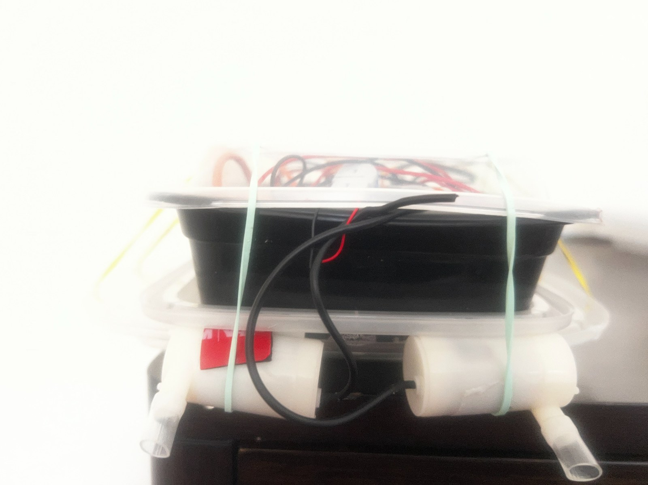
Figure A1. Front view of the final low, wide pool-test structure.
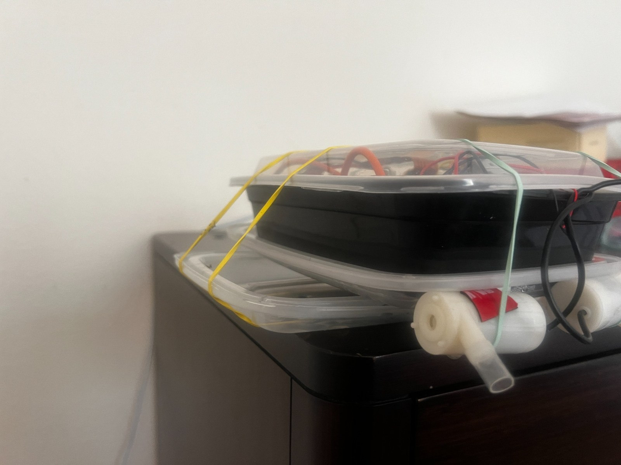
Figure A2. Oblique view showing the enclosure, transverse support and pump/tubing arrangement.
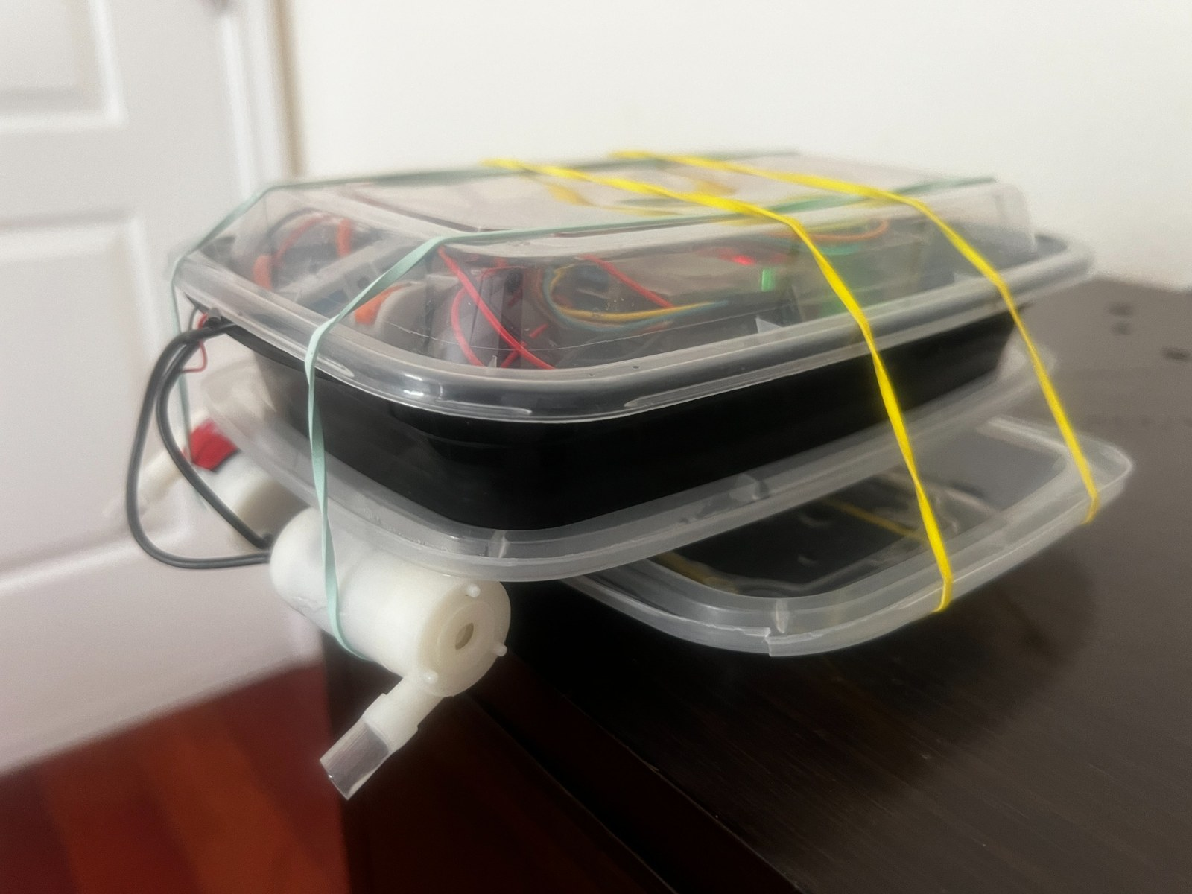
Figure A3. Layered under-plate/lid structure and laterally separated propulsion.
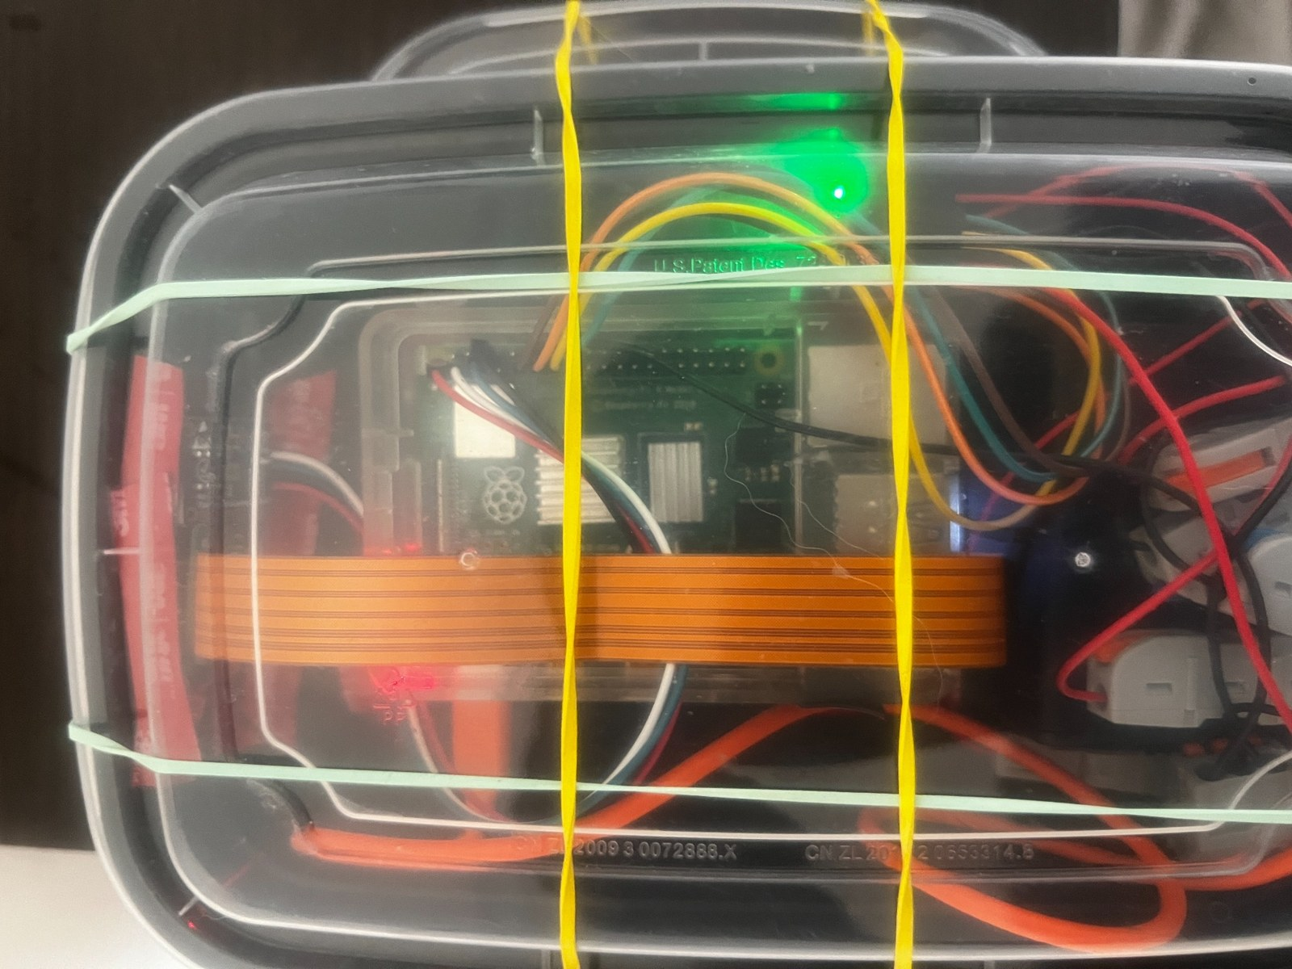
Figure A4. Top view of the clear electronics enclosure and secured components.
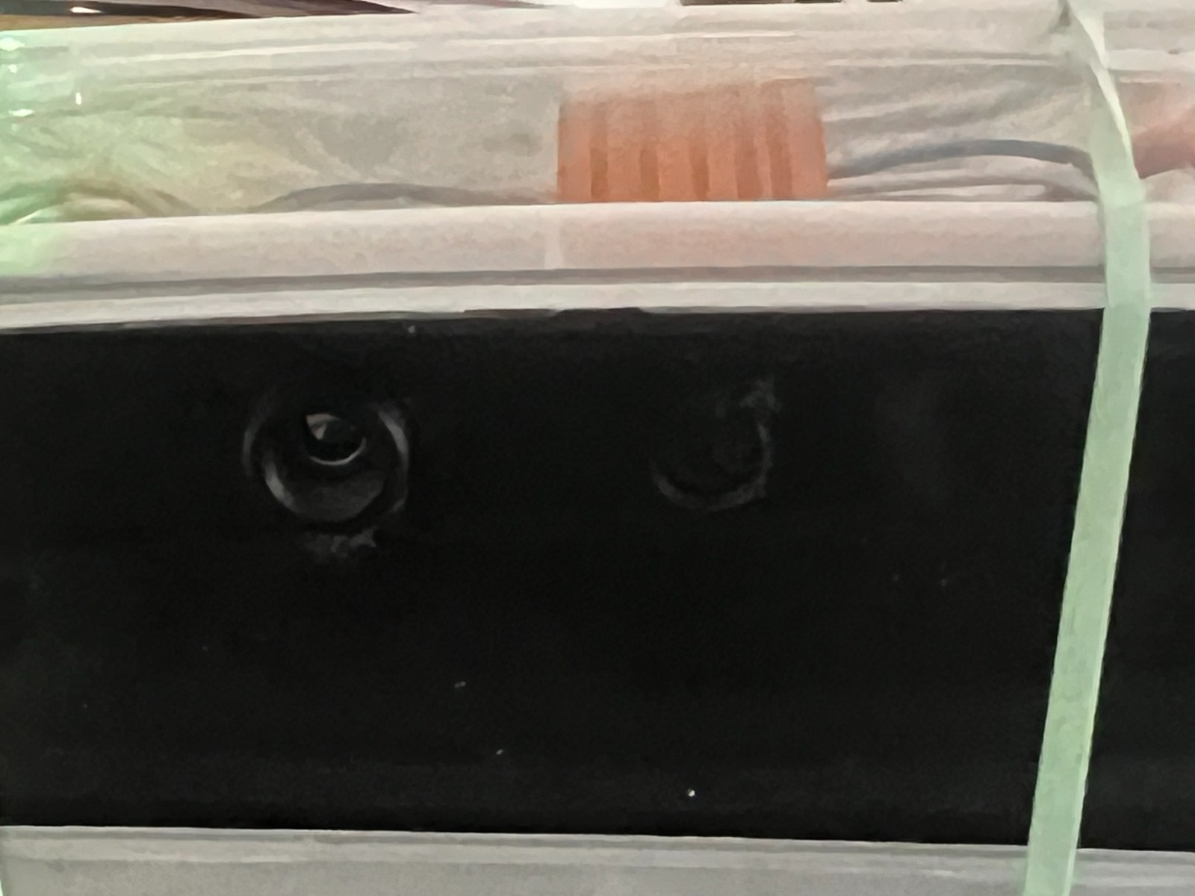
Figure A5. Forward sensor openings; preserve unobstructed RGB and thermal views.

Appendix B. Procurement reference strings
Amazon references retained from development (verify the live listing before buying):
• Pumps: SIPYTOPF mini submersible pump, ASIN B0CJFQ5KDT; target class 3–5 V / ~0.18 A / ~80–120 L/h / ~40–110 cm lift.
• RGB: Raspberry Pi AI Camera / SC1174 / IMX500, ASIN B0DJ8VFWKM; working replacement marked MU2351.
• Thermal: search “MLX90640 55 degree thermal camera breakout Raspberry Pi”.
• Driver: search “DRV8833 dual motor driver breakout”.
• Motor pack: search “3 AA battery holder with switch leads”.
• Waterproofing: “marine silicone sealant clear”, “Marine Goop”, and correctly sized cable glands.
• Tubing: purchase against the actual pump outlet/barb diameter.
Marketplace references are procurement leads, not authoritative specifications. Match the electrical and mechanical requirements above.

