Ocean Voyager
Physical Pool Experiments & Engineering Learnings
From propulsion bring-up and deterministic navigation to stochastic exploration, collision recovery, RGB–thermal fusion, and trajectory replay • September 2026

Executive summary
Ocean Voyager’s pool work was not a single autonomy test; it was a sequence of controlled experiments that progressively exposed the difference between a controller that works in simulation and a small surface vehicle moving in real water. The central lesson was that physical dynamics dominated early navigation: the two pumps were asymmetric, OFF meant coasting rather than stopping, short steering pulses often had too little authority, wall contact changed the geometry of a turn, and camera observations had to remain live while motors were executing meaningful-duration maneuvers. Mechanical iteration was equally important: the hull evolved from a taller stacked arrangement to a lower, wider structure with supporting plates/lids beneath and across the boat, improving stability and making propulsion behavior more repeatable.
The navigation strategy therefore evolved substantially. Early deterministic and lawnmower-style ideas assumed localization and repeatable motion that the platform did not yet possess. Vision-based CLOSE/OPEN and pre-collision controllers improved perception but often over-corrected, oscillated, or became trapped in collision-recovery loops. The eventual v45 strategy deliberately simplified the mission: strongly favor forward/random exploration, accept that occasional wall contact can occur, use a separate recovery action bank after collision, and make object investigation a short opportunistic diversion rather than the dominant behavior.
By Run 04, the real pool system demonstrated continuous stochastic exploration, wall-triggered recovery, independent RGB and MLX90640 thermal detections, multiple RGB+thermal fused observations, bounded target pursuit, a mandatory cooldown before another pursuit, return to exploration, and a synchronized post-run replay. The trajectory shown in the replay is an estimate reconstructed from logged actions and constraints—not external ground truth.

1. Test platform and why pool testing mattered
The powered pool platform used a Raspberry Pi-based controller, two small 3–5 V submersible pumps through a DRV8833 dual H-bridge, an RGB camera for YOLO bottle detection, and an MLX90640 thermal camera. Earlier software/SIL and manual-motion HIL had already validated the mission logic and sensor sequence, but propulsion was still disabled. Real-water testing introduced effects that the earlier stages could not reproduce faithfully: unequal thrust, momentum, drift, pump start behavior, wall friction, camera motion, changing illumination, and the absence of reliable absolute position.
An important methodological choice was to isolate subsystems whenever possible. Propulsion faults were tested separately from I²C/thermal issues; steering authority was tested separately from full autonomy; and later RGB/thermal fusion was evaluated independently from trajectory accuracy. This prevented one physical fault from being misdiagnosed as a software or perception failure.

2. Hull, buoyancy and structural evolution
The pool campaign also drove a substantial mechanical redesign. Early versions used a taller, stacked or "double-decker" arrangement to carry the electronics above the flotation structure. Although convenient for packaging, the taller stack raised the center of mass and made the boat more sensitive to roll, uneven loading, trapped water and shifts in the electronics enclosure. Those effects mattered directly to navigation because a changing hull attitude also changes how the two pump jets sit in the water and therefore changes steering.
The later design moved toward a lower single-deck electronics arrangement and added broad plastic plate/lid surfaces beneath and across the boat. The lower plate increased the effective flotation footprint and helped spread the load over a wider area; the transverse plate/lid tied the two sides together and provided additional support against roll. The objective was not simply to make the boat float higher, but to make its waterline and attitude more repeatable from run to run.
Configuration / issue | Change | Pool-testing learning
Tall stacked / double-decker layout | Electronics and structural layers were stacked vertically. | Packaging was simple, but the higher center of mass made stability and trapped-water imbalance more consequential.
Lower single-deck arrangement | Reduced vertical stacking and kept the electronics mass lower. | A lower mass distribution produced a more stable platform for sensing and propulsion.
Plate/lid underneath | Added a broad support/flotation surface below the main body. | A wider flotation footprint improved buoyancy margin and reduced sensitivity to local loading.
Plate/lid across the boat | Added a transverse structural/flotation member spanning the hull. | The wider lateral support improved roll resistance and helped keep the pump geometry more consistent.
Final pool-tested structure | Low electronics enclosure, broad plates/lids, secured components and twin pump outlets. | Once mechanically stable, remaining motion errors were much easier to attribute to propulsion/control rather than hull instability.
Photographic documentation: Figures A1–A4 in Appendix A show the final pool-tested mechanical configuration from the front, oblique, top, and forward-sensor views. These images document the lower electronics deck, broad under-plate/lid support, transverse support arrangement, pump/nozzle placement, and protected forward sensor openings described above.
Mechanical lesson: navigation could not be debugged independently of hull mechanics. A boat that lists, traps water, changes its waterline, or shifts its pump depth effectively changes its steering calibration during the experiment. Stabilizing the physical structure was therefore a prerequisite for interpreting later left/right bias, collision behavior, visual drift and random-navigation performance.

3. Propulsion bring-up: from intermittent pumps to usable motion

2.1 Early intermittent propulsion
Initial pool/kitchen/bathtub checks found that a pump could sometimes be audible while producing little or no water flow. A loose common-ground connection at a three-point connector was found and reseating it restored both pumps, proving that connector integrity was one real contributor. Intermittent no-flow behavior later recurred, so the team also considered low voltage margin and pump priming/air pockets.

2.2 Moving from ~3 V to ~4.5 V
The original 2×AA supply placed the 3–5 V pumps near the low end of their range. A controlled change to 3×AA (~4.5 V nominal) produced much more dependable continuous motion. This became the practical basis for later pool navigation tests.

2.3 Propulsion asymmetry was a system property, not noise
Straight motion required unequal actuation. In an early 4.5 V burst calibration, approximately 1.6 s on the left versus 1.0 s on the right produced roughly straight travel. A later controller configuration around 0.5 s left versus 0.7 s right was also much closer to straight, although residual clockwise curvature remained. The exact timing depended on the control scheme, but the persistent lesson was the same: left and right propulsion could not be assumed symmetric.

4. Fundamental physical lessons from the water
Observation | What it meant | Control implication
OFF is not STOP | The hull keeps momentum and drifts/coasts after motor power is removed. | Perception and recovery must account for motion during OFF/scan intervals.
Short turns can be physically meaningless | ~0.2–0.25 s steering pulses often did not rotate the boat enough, especially near a wall. | Vision may update at ~10 fps, but motor maneuvers need not be only ~0.1–0.25 s long.
Wall contact changes steering geometry | A hull pressed against a wall may not rotate even with sustained turning thrust. | Collision recovery sometimes needs clearance before attempting another turn.
Forward travel is curved | Unequal pumps and water dynamics create a repeatable directional bias. | Use empirical trim/probability bias rather than assuming equal motors.
Real motion is continuous | The boat moves while images are acquired and processed. | Camera and motor execution should be concurrent, not stop-turn-look-stop loops.

5. Early deterministic coverage and localization assumptions
The initial ambition was structured pool coverage—square-boundary or lawnmower patterns with known coordinates and turns. This was attractive because it gave a clean coverage story, but it depended on assumptions that were weak on the real platform: repeatable distance per motor command, repeatable heading change, and sufficiently accurate pose estimates. Earlier manual-HIL work had already exposed lane displacement, accumulated pose error, duplicate encounters, and boundary overrun; powered pool motion amplified those problems.
This led to an important reframing: navigation did not have to know a perfect (x,y) continuously in order to produce useful exploration. Absolute-looking trajectory visualization could be reconstructed after the run, while the real-time controller could focus on local actions, fresh visual evidence, collision handling, and sensor opportunities.

6. Vision-based wall experiments: what was tried

5.1 CLOSE/OPEN classification
Early visual navigation attempted to classify the forward view as CLOSE or OPEN. Calibration runs at farther, ~1 ft, ~0.5 ft, and hard-contact distances showed that the scene could not be represented reliably by one scalar. Far/open scenes were sometimes classified as CLOSE, causing unnecessary avoidance and destroying forward runway.

5.2 Edge-density and scale metrics
Two center-view metrics became useful diagnostics: edge density E_C and a scale/distance-transform metric S_C. Representative far/open E_C values were roughly 0.014–0.049 with S_C around 114–142; closer views could overlap these ranges. Very close views could have E_C around 0.001–0.008. A repeated hard-contact/saturated signature was approximately E_C≈0 and S_C≈65534.6.
The key learning was not a magic threshold. E_C and S_C were viewpoint- and texture-dependent, so temporal change over multiple fresh frames was more informative. The hard-contact signature was valuable for recognizing that collision had already happened, but it was too late to be the primary avoidance signal.

7. Navigation-controller evolution: v9 through v23
Version / phase | Experiment and learning
v9–v10 | Moved toward continuous visual navigation; forward motion and camera processing occurred together and turn direction was latched instead of rapidly alternating. Exposed weaknesses in binary CLOSE/OPEN classification.
Calibration phase | Collected far/medium/~1 ft/~0.5 ft examples and established that E_C/S_C overlap too much for a simple one-frame classifier.
Pre-v17 | Repeated forward/left cycles and avoidance-heavy behavior showed that excessive correction can prevent meaningful pool coverage even when open runway exists.
v17/v18 | Introduced latest-frame asynchronous vision at roughly 10 fps, stale-frame rejection, persistent confirmation and temporal approach logic. This separated camera rate from motor-command duration.
v19 | Added predictive approach behavior and patient same-direction recovery. Pre-collision detection occurred in at least some trials, but weak actuation still allowed contact.
v20 | Replaced tiny turn pulses plus long coast periods with continuous turning while vision remained live. Turning authority improved, but 'turn until OPEN' could become an endless circle.
v21 | Added minimum and maximum continuous-turn durations. This bounded circles, but the controller could briefly return FORWARD and immediately re-trigger from the same saturated collision view.
v22 | Introduced a STUCK concept: remember a failed direction, create clearance, scan, and avoid immediately commanding forward from an unusable collision image. First run exposed a software interface bug.
v23 | Packaged corrected STUCK logic using cached analyzed metrics. The session ended before conclusive physical recovery validation because the Pi battery died.

8. Why several seemingly reasonable approaches failed
- Rapid LEFT/RIGHT alternation: Ignored inertia and produced oscillatory behavior.
- 0.25 s turn + ~1 s OFF/scan: Too little steering authority and too much coasting toward/along the wall.
- Many patient tiny pulses: Reduced rapid flipping but could spend many seconds making almost no useful geometric change.
- Unlimited continuous turn: Solved weak actuation but could circle indefinitely if OPEN was never recognized.
- Bounded turn → immediate FORWARD: The same saturated wall image could instantly retrigger recovery; the vehicle had not truly escaped.
- Choose LEFT/RIGHT from a saturated 0/65534 view: The image no longer contained enough directional structure to make a meaningful choice.
- Perfect lawnmower as the immediate goal: Required localization and motion repeatability that were not yet physically available.

9. Concurrency and logging became part of the control solution
One of the strongest architecture results was that camera latency was not the main blocker. The later multithreaded pipeline produced roughly 9.8–10.3 fps with frame ages commonly around 0–1 ms and no meaningful stale-frame backlog. A latest-frame/single-slot model allowed old images to be overwritten rather than queued. This meant a turn could remain active for 0.5–1+ seconds while vision continued updating every ~0.1 seconds.
This distinction—fast perception, slower physically meaningful actuation—was essential. Stopping the motors merely to take another picture was both inefficient and misleading because the hull continued moving anyway.

10. From deterministic steering to visual-drift experiments
Later controllers exposed visual-drift monitoring and adaptive correction. The intent was to compare consecutive RGB frames and infer whether the boat was veering left or right while moving forward, then compensate using the opposite pump. v45 retained configurable drift controls (monitor/adaptive mode, ~0.7 s window, feature-count and pixel-shift thresholds, confirmation count, and bounded adaptation).
The experiment clarified an important separation of concerns: drift estimation could help trim forward motion, but it should not become a prerequisite for exploration. The pool vehicle could still make progress with imperfect heading knowledge if the mission policy tolerated stochastic movement and robustly handled walls.

11. Strategic pivot: stochastic exploration
The major simplification was to stop demanding a geometrically perfect route from an imperfectly localized boat. Instead, the controller would genuinely randomize among FORWARD, TURN_LEFT, TURN_RIGHT and PAUSE/OFF, with configurable probabilities and duration ranges. The only strong intelligence required for basic navigation was recognizing wall/collision situations and switching to a separate recovery action bank.
This also matched the physical reality of the platform: the boat already drifted and curved, so a stochastic policy could turn those imperfections into exploration rather than treating every deviation as an error. Fixed random seeds remained available when repeatability was needed for debugging.

12. v45 configuration that produced useful pool exploration
Bank | Action | Probability | Duration
Normal | FORWARD | 0.70 | 2–12 s
Normal | LEFT | 0.07 | 1–6 s
Normal | RIGHT | 0.17 | 1–6 s
Normal | PAUSE/OFF | 0.06 | 0.2–4 s
Collision | LEFT | 0.15 | 0.5–6 s
Collision | RIGHT | 0.45 | 1–6 s
Collision | PAUSE/OFF | 0.40 | 0.5–3 s
The asymmetry was deliberate. Earlier physical runs showed a tendency to bend clockwise/right, and the eventual probability mix was tuned empirically from observed behavior rather than made symmetric for aesthetic reasons. Wider duration ranges—up to 12 s forward and 6 s turning—also made the motion look and behave like exploration rather than a collection of tiny static circles.

13. Collision philosophy changed: handle reliably, do not require perfection
Earlier work aimed to avoid every wall contact. The later pool strategy accepted that occasional contact was tolerable for this prototype and prioritized recovery and continuation. When a collision signature was confirmed, the controller switched from the normal stochastic bank to a separately configurable collision bank. Once the view cleared, normal exploration resumed.
This was an engineering tradeoff, not a claim that collision avoidance was solved. It allowed the rest of the mission—coverage-like exploration, sensing, fusion and object approach—to be exercised without making perfect wall avoidance a blocking dependency.

14. Object detection was made opportunistic
Object handling had two goals: avoid physically driving into an object when possible, and approach a plausible target enough to investigate it. Neither behavior was allowed to monopolize navigation. RGB and thermal sensing ran independently, and only corroborated evidence could trigger the strongest target behavior.
A target pursuit was deliberately time-bounded, and after any approach the controller imposed a cooldown before another takeover. This protected the mission from repeatedly chasing the same bottle or from a detection bug that fired continuously. The design guaranteed a return to stochastic exploration.

15. Thermal experiments and the warm-water bottle
Thermal sensing itself was shown to be healthy, but ordinary bottle/pool temperature contrast could be marginal for an end-to-end fusion demonstration. A controlled test therefore filled the bottle with moderately warmer water. This was not intended to claim that every real debris item is warm; it was an instrumentation experiment designed to create an unambiguous thermal candidate while testing the fusion and pursuit pipeline.
In the warm-bottle run, thermal contrast became very strong—well above the active threshold at several points—while RGB initially produced few matching detections. That isolated the bottleneck to the RGB/vision side rather than the MLX90640. After the vision setup was corrected, the next run produced repeated RGB hits and genuine RGB+thermal fusion.

16. Pool run progression near the successful demo
Run | Purpose | Main learning
Run 01 | Random navigation baseline | Navigation worked sufficiently to continue testing; RGB hits occurred but there were no fused/target events. Collision episodes provided useful recovery evidence.
Run 02 | Navigation tuning | The stochastic policy was adjusted to the later 0.70/0.07/0.17/0.06 normal mix and asymmetric collision bank. Physical exploration looked substantially better, so these settings were frozen as a baseline.
Run 03 | Warm-bottle thermal test | Navigation was reasonably good and thermal response became very strong. RGB/YOLO was mostly reporting NONE despite large thermal deltas, identifying vision as the limiting side of fusion.
Run 04 | Vision corrected; full demo run | Repeated RGB and thermal detections, multiple fused candidates, pursuit/steering, cooldown suppression, collision recovery, and return to exploration. This became the renderer/demo baseline.

17. Run 04: what the pool system actually demonstrated
The Run 04 replay parsed 14 RGB detections, 40 thermal detections and 5 fused detections. One particularly clean fused observation had RGB bearing about +17.6° and thermal bearing about +18.9°, only ~1.3° apart. Fused evidence could trigger a short pursuit, including target steering. The pursuit cap was 5 s and the cooldown was 30 s; a later valid fused observation was correctly suppressed while cooldown remained active.
Together, this demonstrated the complete behavioral chain in real pool operation: stochastic search → wall/collision handling when needed → continued search → independent RGB and thermal observations → corroborated fusion → short target diversion → cooldown → guaranteed return to search.

18. Trajectory reconstruction and what it means
Because the boat did not have an external ground-truth localization system, the animation trajectory was reconstructed after the run. For the final Run 04 renderer, the pool was represented as 5 ft × 7 ft, with the known initial pose at (2.5, 0), centered on the near 5-ft edge and facing +Y.
The replay integrates timestamped motor states using display calibration of approximately 0.175 ft/s forward, 30°/s left turn and 45°/s right turn, then uses physical pool/wall constraints to keep the estimate plausible. Archived RGB, thermal frames, detections and fusion events are synchronized to that reconstructed path.
The result is useful for explaining the run, but it is explicitly an estimated trajectory—not centimeter-accurate ground truth. Drift, momentum, pump asymmetry and wall interactions are only approximated. A future reconstruction can use consecutive RGB frames and known motor actions to refine heading and displacement continuously.

19. The biggest engineering learnings
- Real-water dynamics forced the controller architecture to change; simulation-perfect motion assumptions were not adequate.
- Propulsion asymmetry should be measured and embraced in calibration rather than hidden behind symmetric commands.
- OFF means coasting. A controller for a surface vehicle must reason about inertia during sensing and decision periods.
- Perception frequency and motor-command duration are different design variables. Fast vision does not imply tiny motor pulses.
- Hard collision detection and pre-collision avoidance are different problems; a saturated wall image is useful for declaring contact but poor for choosing a direction.
- Temporal visual evidence is more useful than a single CLOSE/OPEN threshold.
- Perfect localization is not required for useful exploration if the mission policy is tolerant of uncertainty.
- Stochastic navigation was a productive simplification: it converted imperfect motion into exploration and reduced dependence on brittle pose estimates.
- Collision recovery can be separated from normal exploration through a different action bank.
- Object investigation should be bounded and opportunistic; cooldown is an important guard against repeated target capture.
- RGB and thermal should remain independently auditable. A strong thermal signal helped diagnose an RGB-side problem rather than masking it.
- Post-run replay is not just presentation. Synchronizing actions, RGB, thermal and fusion events exposed controller behavior and made debugging substantially easier.

20. What was deliberately not claimed
The pool experiments do not establish centimeter-level localization, guaranteed complete pool coverage, collision-free navigation, or general real-world thermal detectability of arbitrary plastic debris. Run 04 is a systems-integration demonstration: the physical platform can continue exploring, recognize/recover from wall situations, acquire independent RGB and thermal evidence, fuse compatible observations, briefly pursue a target, and return to exploration. Quantitative coverage, localization error, detection precision/recall in water, and collision-avoidance success rate require separately controlled ground-truth experiments.

21. Engineering narrative: how the pool attempts changed the design
The pool work progressively removed assumptions. First, equal pumps were removed as an assumption. Then instantaneous stopping was removed. Then tiny steering pulses, binary wall classification, perfect collision avoidance, deterministic coverage, and reliable real-time coordinates were each challenged by physical evidence. The final successful direction did not try to force the small prototype to behave like an ideal robot. Instead, v45 was designed around what the boat could reliably do: move for meaningful intervals, turn with asymmetric authority, keep looking while moving, recognize hard wall situations, recover probabilistically, exploit sensor opportunities, and always return to exploration. That shift—from imposing a perfect path to building a controller tolerant of physical uncertainty—was the central learning of the pool campaign. The same process occurred mechanically: the early tall stacked structure was replaced by a lower, wider flotation/support geometry so that software experiments were no longer being confounded by avoidable roll and buoyancy variation.

Appendix A. Mechanical Design Photographs
These photographs are referenced from Section 2 and document the final pool-tested structural configuration after the mechanical iterations described in the main text. The images are evidence of the implemented layout; the engineering interpretations and learnings are discussed in Section 2.
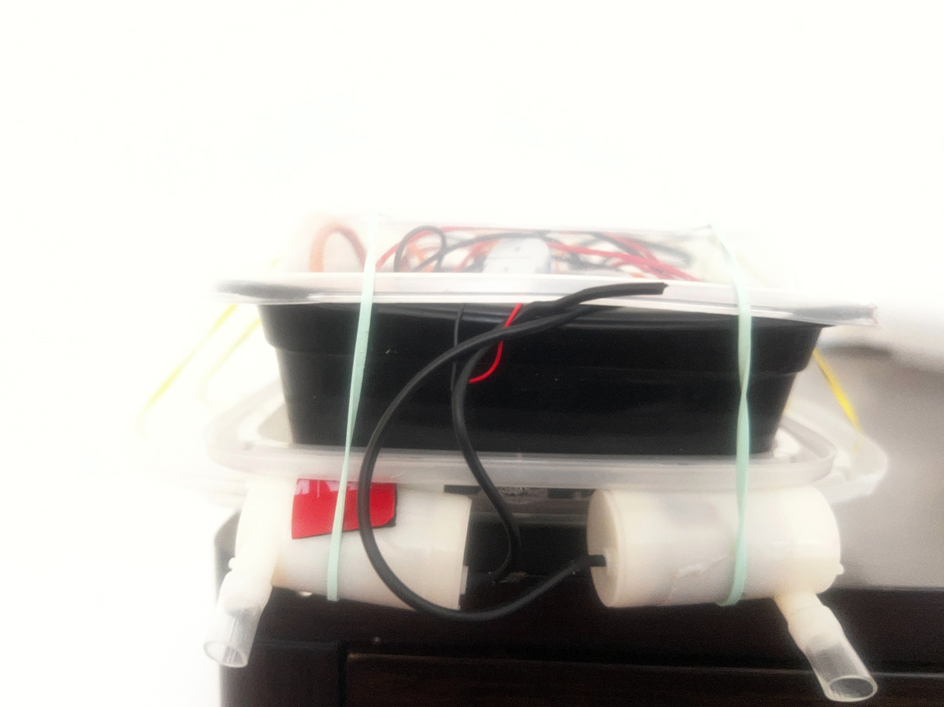
Figure A1. Front view of the later pool-test structure. The electronics enclosure is kept low, while the broad plate/lid structure and laterally separated pump assemblies create a wider support footprint.
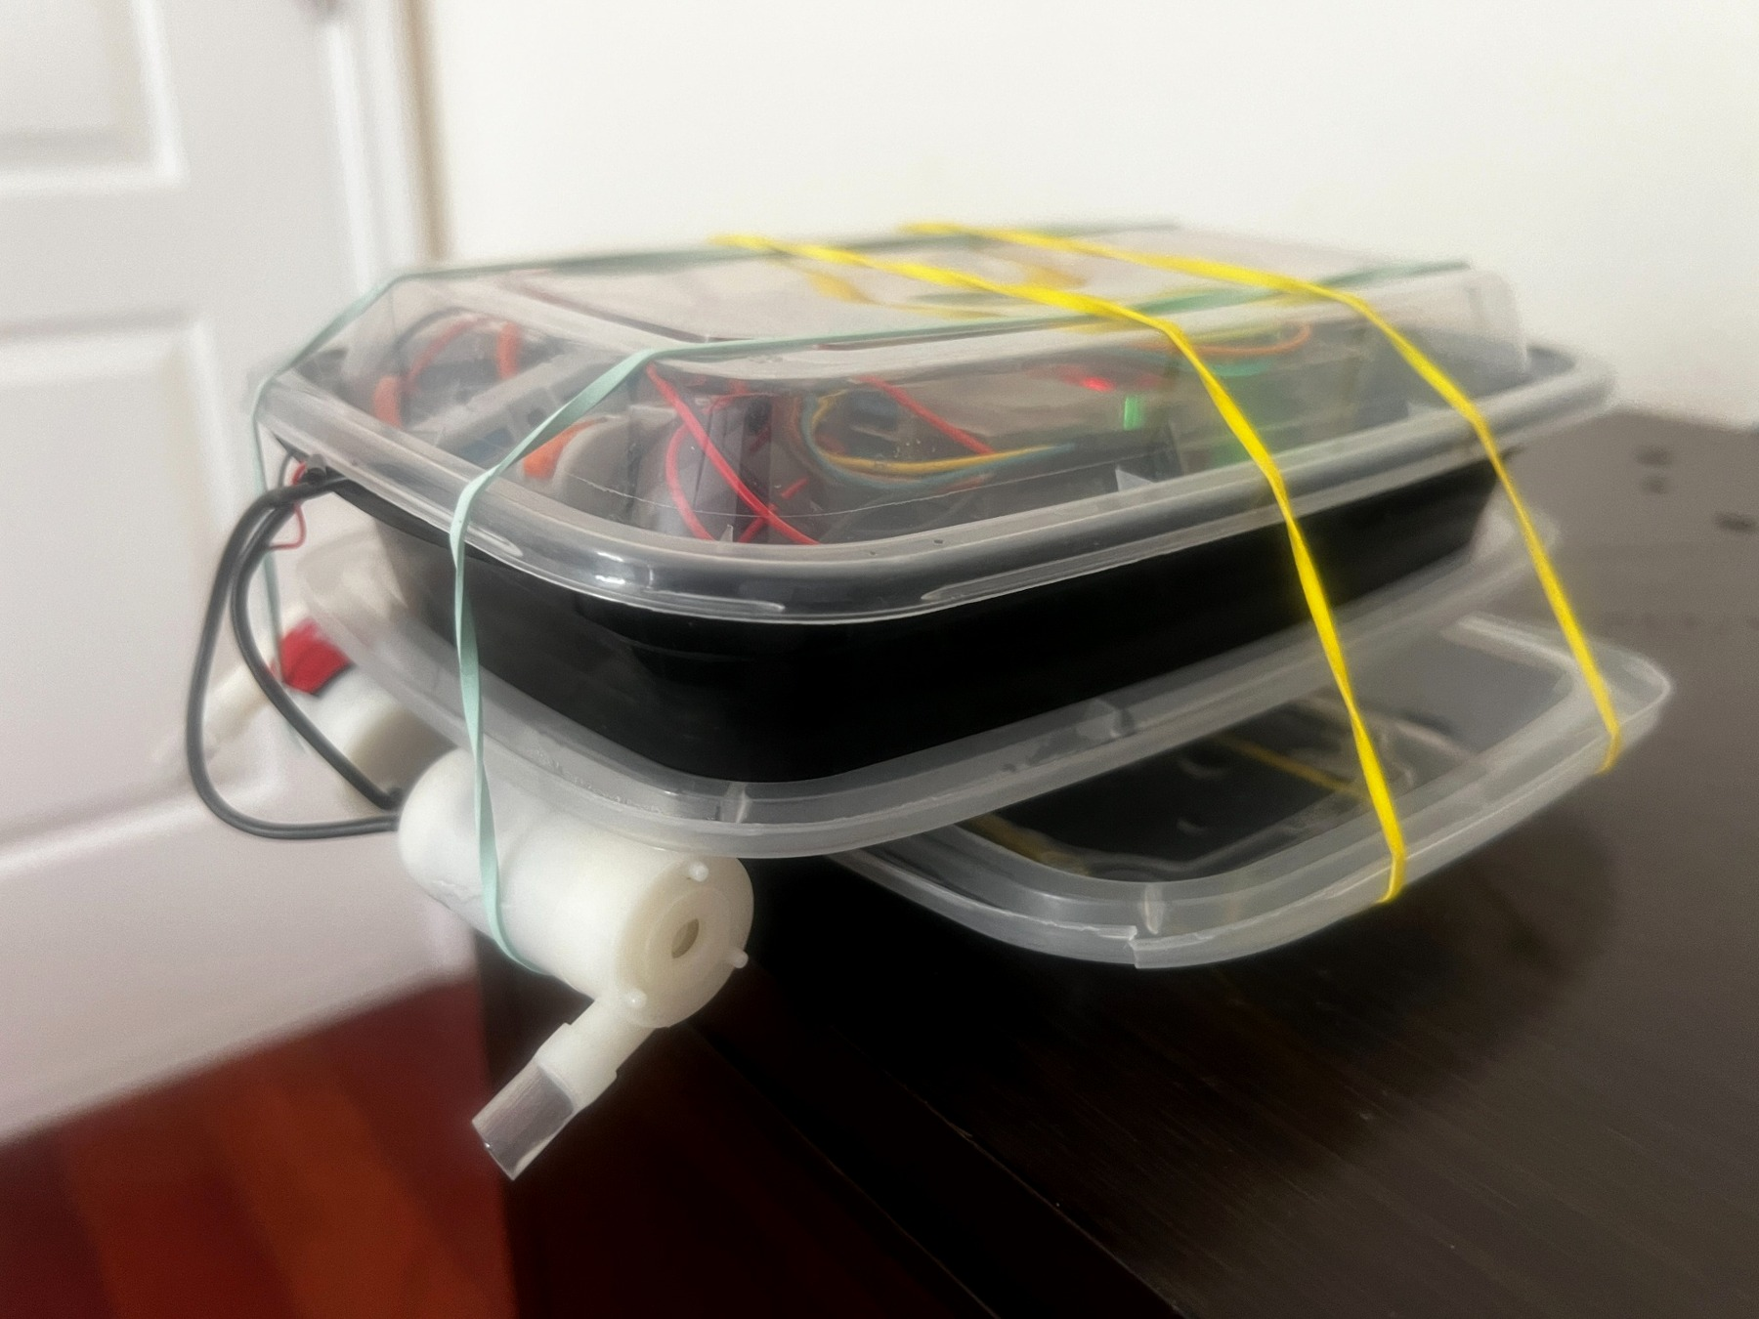
Figure A2. Oblique view showing the layered plate/lid arrangement beneath the electronics enclosure and the pump/nozzle placement. The wider base was part of the effort to improve buoyancy and roll stability.
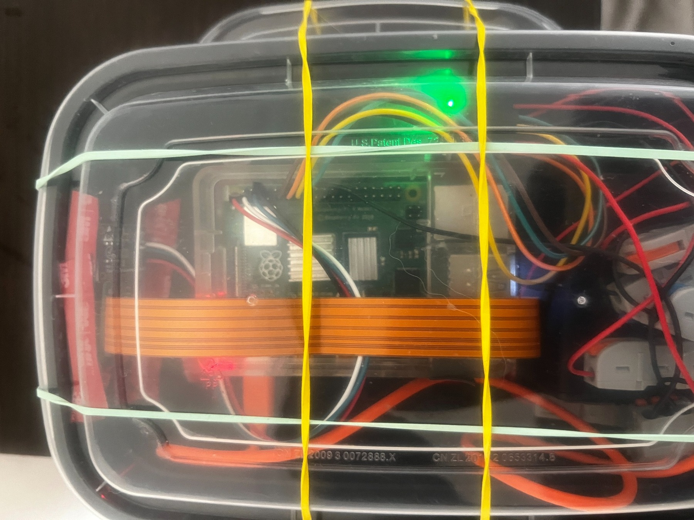
Figure A3. Top view of the electronics deck. The Raspberry Pi, power and wiring are contained in a low, clear enclosure and mechanically secured for pool runs.
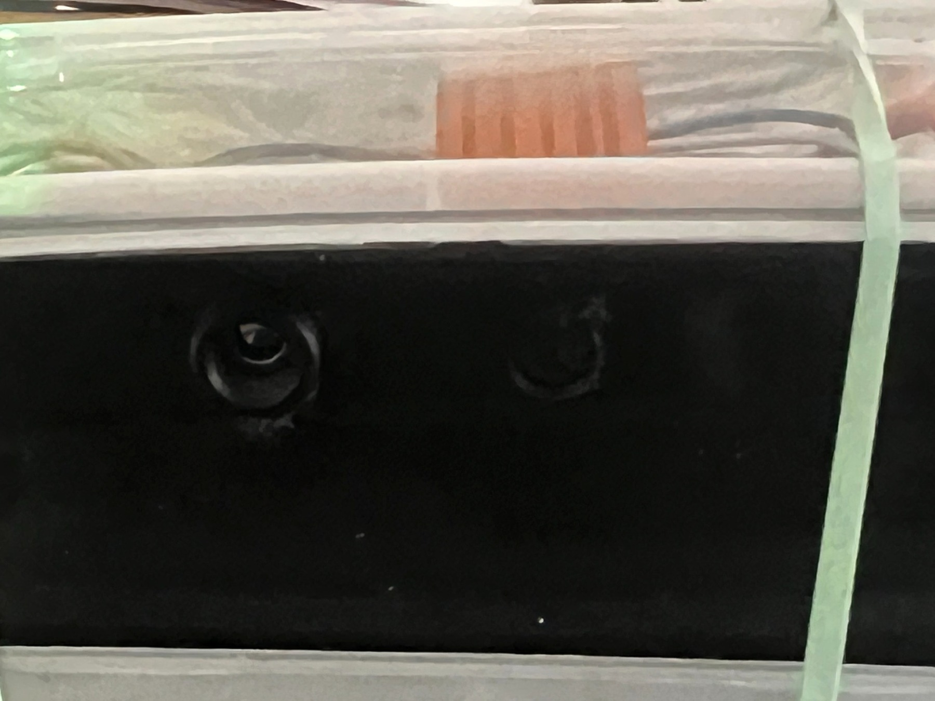
Figure A4. Forward sensor openings in the black enclosure. The final mechanical design had to preserve a usable field of view while also protecting and stabilizing the sensor package.

