**Program-3: Write a JavaScript code that displays text “TEXT- GROWING” with increasing font size in the interval of 100ms in RED COLOR, when the font size reaches 50pt it displays“TEXTSHRINKING” in BLUE color. Then the font size decreases to 5pt.**

**HTML CODE:**

**<!DOCTYPE html>**

**<html lang="en" dir="ltr">**

**<head>**

**<meta charset="utf-8">**

**<title>challenge 3</title>**

**<style>**

**\* {**

**box-sizing: border-box;**

**margin: 0;**

**padding: 0;**

**}**

**body {**

**font-size: 20px;**

**}**

**header {**

**margin: 0;**

**}**

**.main {**

**position: relative;**

**margin-left: 1%;**

**}**

**.main img {**

**margin-left: 5%;**

**height: 300px;**

**width: 200px;**

**}**

**#demo {**

**position: absolute;**

**margin-left:60%;**

**padding-bottom:250px;**

**transform: translate(-50%, -50%);**

**}**

**footer {**

**background: transparent;**

**}**

**footer p {**

**padding: 10px;**

**}**

**</style>**

**</head>**

**<body>**

**<header>**

**<a href="#home">Home</a>|**

**<a href="#places">Places</a>|**

**<a href="#gallery">Gallery</a>|**

**<a href="#aboutus">AboutUs</a>|**

**<a href="#search">Search</a>**

**</header>**

**<br>**

**<section class="main">**

**<h1>**

**AVENGERS: ENDGAME**

**</h1>**

**<br><br>**

**<img src="https://m.media-amazon.com/images/M/MV5BMTc5MDE2ODcwNV5BMl5BanBnXkFtZTgwMzI2NzQ2NzM@._V1_UY1200_CR90,0,630,1200_AL_.jpg" alt="AVENGERS ENDGAME">**

**<p id="demo"></p>**

**<br>**

**<p>by <a href="#">Advaith V_1JT18IS004</a> </p>**

**<br>**

**<p>**

**Avengers: Endgame is a 2019 American superhero film based on the Marvel Comics superhero team the Avengers. Produced by Marvel Studios and distributed by Walt Disney Studios Motion Pictures.In the film, the surviving members of the Avengers and their allies attempt to reverse the damage caused by Thanos in Infinity War. The official title was revealed in December 2018. With an estimated budget of $356–400 million, the film is one of the most expensive films ever made.The film grossed $2.798 billion worldwide, surpassing Infinity War's entire theatrical run in just eleven days and breaking numerous box office records, including becoming the highest-grossing film of all time, which it held from July 2019 until March 2021.**

**<br>**

**<p><i>Year</i> : 2021</p>**

**<p><i>Date</i> : 21st May </p>**

**<br>**

**<br>**

**<h2>Reviews</h2>**

**<br>**

**<p style="font-weight:bold; font-size:20px">Love Marvel movies! </p>**

**<table>**

**<tr>**

**<td> Alice</td>**

**<td> ⭐⭐⭐⭐ </td>**

**</tr>**

**</table><br>**

**<p>Always been one of the best part of my life #marvelforever</p>**

**<br>**

**<hr>**

**<br>**

**<p style="font-weight:bold; font-size:20px">Biggest fan of Marvel </p>**

**<table>**

**<tr>**

**<td> Bob</td>**

**<td> ⭐⭐⭐⭐⭐ </td>**

**</tr>**

**</table><br>**

**<p>I have watched every movie MCU has ever made! and i am a huge fan of MCU</p>**

**<br>**

**<hr><br>**

**<p style="font-weight:bold; font-size:20px">IRON MAN FOREVERR!</p>**

**<table>**

**<tr>**

**<td> Levi</td>**

**<td> ⭐⭐⭐⭐⭐ </td>**

**</tr>**

**</table><br>**

**<p>Biggest fan of IRON MAN:). Love his suit, looks so cool! HE IS THE best!! </p>**

**</section>**

**<br>**

**<section class="ending">**

**<a href="#home">Home</a>**

**<a href="#places">Places</a>**

**<a href="#gallery">Gallery</a>**

**<a href="#aboutus">AboutUs</a>**

**<a href="#search">Search</a>**

**</section>**

**<footer>**

**<p><i>Copyright &#169 2021 MARVEL Forever!</i></p>**

**</footer>**

**<script>**

**var var1 = setInterval(inTimer, 250);**

**var fs = 5; //font size**

**var ids = document.getElementById("demo");**

**function inTimer()**

**{**

**ids.innerHTML = 'Marvel';**

**ids.setAttribute('style', "font-size: " + fs + "px; color: red");**

**fs += 5;**

**if (fs >= 50)**

**{**

**clearInterval(var1); //paused**

**var2 = setInterval(deTimer, 250);**

**}**

**}**

**function deTimer() //fs = 50px**

**{**

**fs -= 5;**

**ids.innerHTML = 'AVENGERS ENDGAME';**

**ids.setAttribute('style', "font-size: " + fs + "px; color: purple");**

**if (fs == 5)**

**{**

**clearInterval(var2); //paused**

**var1 = setInterval(inTimer, 250);**

**}**

**}**

**</script>**

**</body>**

**</html>**

**SNAPSHOTS:**

1. **TEXT GROWING-**

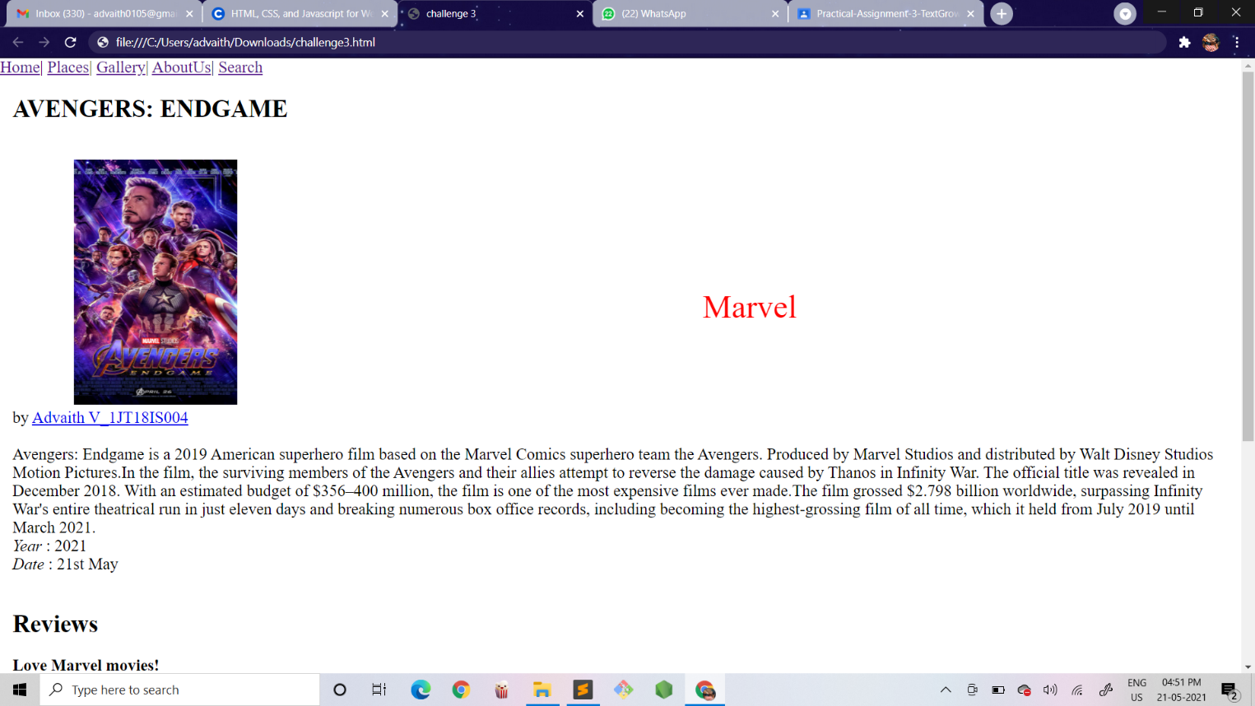

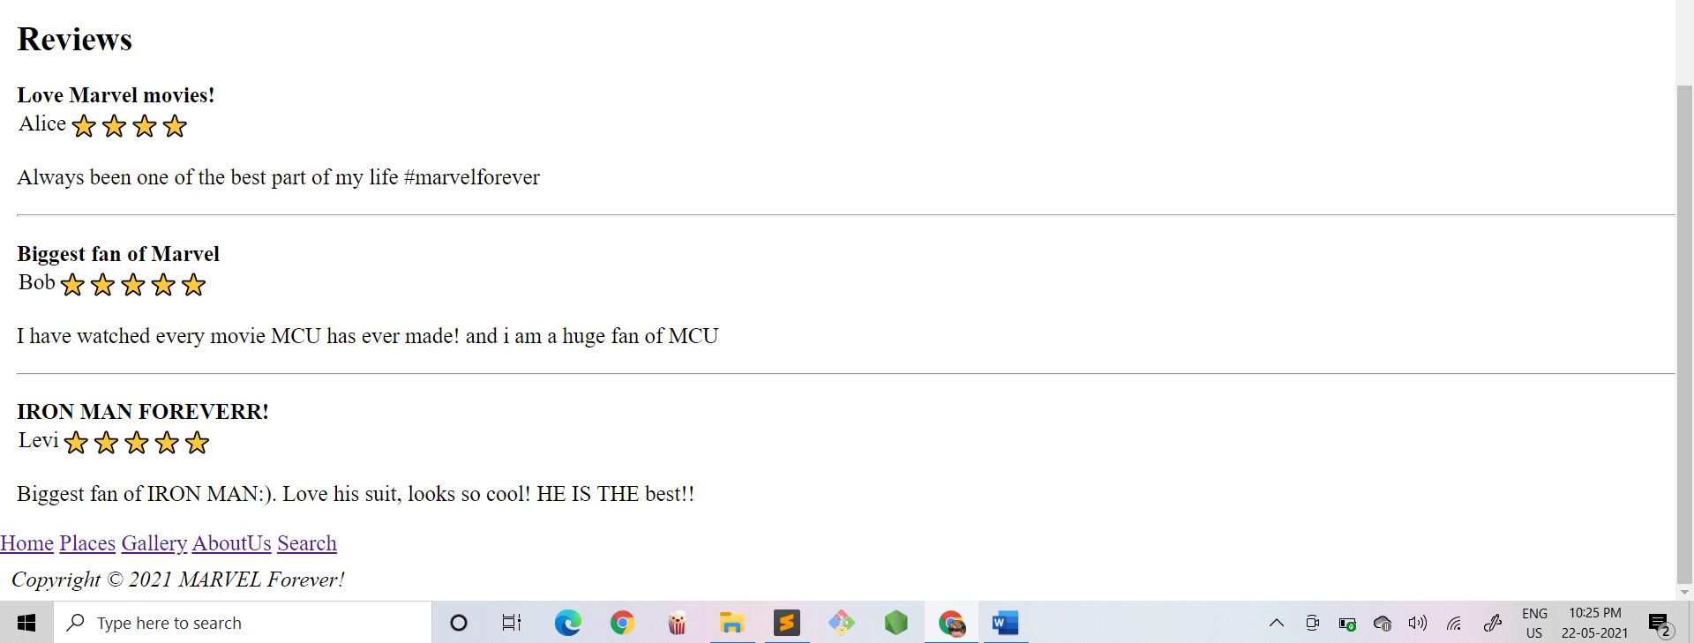

1. **TEXT SHRINKING-**



