

Bachelor Thesis Project (BTP) Report
P. Advaith Alenkrith
Roll Number: 170010024
Month of Submission: May 2021

Supervisor: Dr. Sharad Sinha, Computer Science and Engineering

This report is submitted towards partial fulfillment of the requirements for the award of the Bachelor of Technology (B.Tech) degree in Computer Science and Engineering at the Indian Institute of Technology Goa.

Identification of Covid19 by RESNET 50 And Detecting the Severity Of the Disease
P. Advaith Alenkrith
What is the project about?
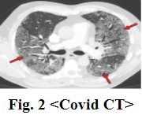
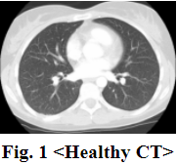
We all know how Covid 19 affected the whole world starting at the end of 2019. It was first discovered in Dec 2019 in Wuhan City, China. Because of Covid 19, many people died, and even more people are suffering from it. As of today, more than 150 million cases and 3 million deaths have been registered. As the disease spread recently, doctors and scientists are searching for ways to identify and cure the disease. With the recent advent of Image Recognition techniques, it is imperative that we as programmers and developers need to help them in identifying the disease. This is the main idea behind developing this model. Although Covid is generally tested by RT PCR, many scientists and radiologists identified notable changes in the victims’ lungs. There are many new white color formations and changes in the structure of various parts of the organ due to Covid. So, many radiologists, hospitals started to work with Computer vision scientists on the CT(Computed tomography) Scans and X-ray Images of the infected people to develop a model that can classify a given image as Covid or Non-Covid because RT PCR testing takes a lot of time. In this endeavor, many people have achieved excellent results and some of them are being implemented in hospitals. There are models which achieved up to 85 - 90 percent accuracy. About the other contributions on this topic, there is a light CNN for detecting Covid19 with 85 percent accuracy. There is a project named Automatic COVID-19 lung infected region segmentation and measurement using CT-scans images. I found this project very helpful and want to implement this idea into my project. Another interesting project is Deep neural network to detect COVID-19: one architecture for both CT Scans and Chest X-rays. The peculiarity of my project is we are more concerned about the alveoli region than the whole scan. The CT Scans of the Lungs give a greater understanding of the disease than X-rays as the CT scans give a clear picture of alveoli. Alveoli are tiny air sacs that are present in the lungs. In the Covid infected patients, the structure of these is changed. So, this project is based on running a Convolution Neural Network scanning lung CTs of healthy people, people who are suffering from other diseases, and Covid CTs. On top of that, it is also important to classify the severity of the disease as severe cases need to be treated first because of the low availability of the equipment in the hospitals. Therefore this project helps to identify the covid disease and classify the severity. I will try to develop the accuracy of the model so that it will be helpful for people. The current severity method only considers the last layer output, which can be developed to consider various layers. The Architecture developed for Image Classification is RESNET 50. RESNET stands for Residual Networks and helps in overcoming the vanishing gradient problem. We will discuss in great detail all these in the following sections. There are some disadvantages to the CT scan method. People are being advised to take X-rays first and then CT scan if required. However due to lack of testing equipments many hospitals are depending on CT Scans.

What are the principal contributions of the project?
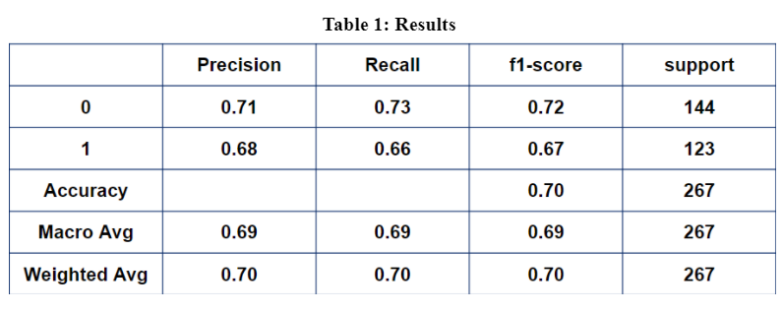
The principal idea, as discussed, is to detect Covid 19 by scanning the CT Scans of the patients. I worked on a project on non-pharmaceutical intervention, but this time, I want to work on the ways to identify the disease. The steps involved in this project are: the required dataset is collected (666 images), labeling is done followed by extracting the Region Of Interest (ROI), pre-processing steps such as data augmentation, Normalization, Standardization are applied. After this, the dataset is divided into test data (20 percent = 267 images) and train data (80 percent = 1065 images). The RESNET 50 model is developed and trained using train data. Next, the test data is applied to the model, and results are noted. Many experiments are done on CT Scan,s, but this project focuses more on the lungs’ alveoli. This is the main reason behind extracting the ROI, which I didn’t find in other models. Both Normalization and Standardization are applied as this yielded high training and testing accuracies. The epochs (10) are selected to prevent Underfitting and Overfitting problem. The batch size is chosen as 64 to run on any machine. The model achieved nearly 70 percent accuracy with an F1 score of 70 percent recall of 70 percent. As we see the percentages, we get a clear idea of how worthwhile the project can be developed further. The model classified 123 images into different severity levels (Low - 53, Medium - 8, High - 62). This classification still needs to be developed. With many new cases, it will be possible to get a considerable dataset, and the model can be further developed to achieve many things.
What are the methods/tools/techniques used in the paper?
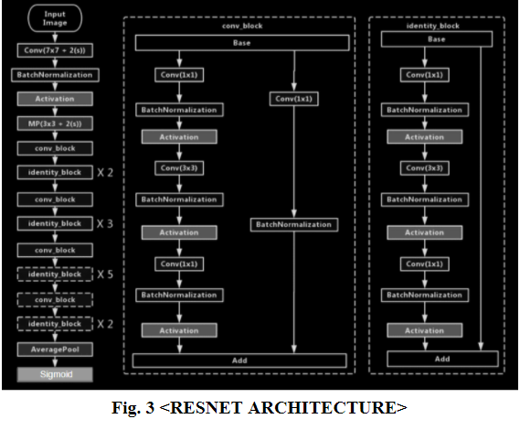
The first thing I did after deciding to work on the project is to search for the datasets. As this is a new disease, there is a limited number of datasets available. I collected those datasets that are applicable to my case. After that, I have downloaded important libraries that will be useful for my work, such as PIL, glob, NumPy, Keras, cv2, statistics, sklearn, skimage, matplot, pandas, scipy, and backend from Keras. These packages are important as they simplify our task and make sure we get the correct results. I noticed that all the images obtained from different sources have different file sizes and formats. It is very much needed that we maintain uniformity before passing on the data to our CNN. So all these images are converted to PNG format. This is done by taking each image of the dataset and assigning the .png extension at the end using the PIL library. Not only that, we also require the images to hold information such as labels. The label helps us to identify the image as Covid or Non-Covid just by seeing the image name. This also helps in further processing as the images are shuffled, and it will be useful to know the label. The names are given in such a format that all covid images end with 1.png and all non-covid images with 0.png. All these images with the correct extension and label are stored in a drive to prevent wastage of time every time we process the code. Once the files are stored, it will be easy to get them with the glob package whenever required. In the next step, we open each image, convert them to RGB format, and resize it to get the images of the required dimensions. The standard size for RESNET is 244*244*3, which is the format used in this project. 224*224 represents the width and height, while 3 represents the color channels. We have discussed that we aim to detect Covid 19 by scanning the alveoli region of the lung. In the given images, the whole CT is present. So, we need to extract the only important part of the image. For this, I have tried to do various calculations and obtain the correct part but could not. Then I got to know about the concept of Dark spots and light spots. Light spots in an image mean all the pixel values that have high pixel values, for example, pixel values greater than 250. Dark spots mean the pixel values are close to 0. So in our project, which is based on CT of the Lung, it is imperative to understand that alveoli are present inside the white material So, it is easy for us to get the region of interest if we get the boundaries by implementing the light spots technique. I identified all the light spots in the image by looping over all pixels of an image and saved those pixels whose Red, Blue, and green channels are greater than 250. After obtaining these pixels, we need to calculate the left highest pixel, right lowest pixel, top highest pixel, and bottom lowest pixel. These pixels are required to calculate the optimal rectangle to crop the image. Here, the left-highest pixel means the light spot pixel with the highest x value and x value < 30. This helps us to get the minimum x value to cut the image. All the other pixels are defined accordingly to get the correct cut. A relaxation of 5 pixels is given, and all these images are saved into a file for the same reason specified above. As we have very little data (666 images), we need to augment it to obtain the best results as CNN training requires a huge dataset. Data augmentation technique includes rotation, scaling, contrasting the image, shearing, flipping the image. We applied features such as contrasting the image, flipping, rotating the image, shearing, and adding noise on Region Of Interest Images. All of this is achieved using Imgaug Library. All of this is stored in the Augment Dataset folder for further processing. Now we have a considerable dataset size which has 1332 images. We need to apply pre-processing techniques such as normalization, Centering, and Standardization to the data. The data of the image is stored as an array of pixel values. As we all know, the pixel range is 0-255. Complete black means (0,0,0) while white mean (255,255,255). The problem with these values is our CNN doesn’t understand all these values properly. So it is recommended to change these values into a range of (0,1). So what we do is first change the image into ndarray of pixel values. Then using the OpenCV, we divide the pixel values by 255.0 to get the range into (0,1). This process is called Normalization. After Normalization, the array is passed for centering. The centering method begins by finding the mean of the image values. After that, this mean is subtracted from all other values in the array. By doing this, the mean of values of each image becomes zero. The data is then passed on to perform standardization. In this process, we first find the standard deviation of each image and divide each value of the image with the standard deviation. Generally, centering and dividing by the standard deviation is combinedly called standardization. All of this pre-processing is done using OpenCV. This ensures that the data is uniform and can be applied to the CNN. The next step is to divide the data into training and testing. Before that, we need to shuffle our data as our data consists of all images with the same label in one place. The data is divided into training and testing by using the split() function. We can give the percentage of testing and training. The training, testing, and the labels of both are converted as ndarrays as CNN accepts this format. These values are also stored as text files so that they will help us in further analysis. There are many pre-trained Convolutional Neural networks available which we can use to predict our data. I have used a pre-trained RESNET 50 CNN with imagenet weights to see the results. Most of the results predicted our test image datasets as nematodes. Nematodes are small snail-like structures. These predictions are not shocking, considering many such structures inside the lungs. Now we need to develop our own RESNET 50 model to perform the binary classification. As discussed in the previous sections, the main reason to choose the RESNET model is to overcome the vanishing gradient problem. In Neural Networks, the weights are constantly updated by the gradients that the layers receive. In many cases, the gradients become so small that there will be no effective change in weights. To overcome this problem, RESNET uses a technique to add the input to the result before calculating the final output. Let x be the input and F(x) output from the layer or block. In RESNET, the F(x) is added with the input x to make F(x)+x. This is then passed on for activation. RESNET 50 is named after the 50 layers it possesses. The initial layers of any CNN are to get the basic features, and the last layers are for complex features. We can guess, RESNET 50, because of its high number of layers, can be used to extract complex features. We need to understand the Identity block and convolution block for better understanding the RESNET 50 architecture. Identity block consists of Convolution layer, Batch Normalization, and RELU activation. In identity block, each of these except RELU activations is executed thrice one after the other i.e Conv ->BN -> RELU -> Conv -> BN -> RELU -> Conv -> BN. As we have seen, RELU considers the input along with F(x) before the final block activation. So the result F(x) is added and sent to the final RELU activation. Identity block is used when the input and output of the function have the same dimensions. Moving on to the Convolution block, the basic architecture is almost the same, but the input is not directly added to the F(x). Instead, a Convolution and BN are implemented on input and then added to the function. Then this is passed on to the activation layer. It is easy to understand when we use convolution blocks. We use them when input and output dimensions are different. The RESNET 50 consists of these blocks along with max pooling and average pooling layers. The total number of parameters in the model is 23,606,145. Out of which, 23,553,025 are trainable, and 53,120 are non-trainable parameters. Normally pooling is used to reduce the dimensions, but in the RESNET internal layers, mostly stride is used to achieve this. We can find many layers with stride two and reduce the dimensionality. The normal RESNET 50 uses the softmax function for dense layers at the end. But I used the Sigmoid function as I am working on binary classification, and the sigmoid activation function works best for this case. The RESNET 50 model takes the ndarray of the image and returns a value between 0 and 1. The value can be later converted to 0 or 1 based on if the value is greater than 0.5 or not. The optimizer used is adam, and the loss function is binary_crossentropy. Various activation functions, optimizers, and loss functions are tested, and the best ones are taken. This is called the tuning parameter stage. After that, training of the data is done. The epoch size is tested and fixed to 10 with a batch size of 64. There is a gradual decrease in the loss function as expected. After training the model, it is time we test its accuracy. The model was efficient, as discussed in the second section. Now we need to detect the severity of all covid positive images. For this, we need to classify the range of severity. I classified the range 0 - 0.45 as low, 045 - 0.50 as a medium, and greater than 0.5 as high. We need to extract the results of each covid image and classify them. For this, we need to create a list of all the layers of information that we want to extract and call the model. predict.
What did you learn by doing this project?
I am delighted that I have taken this project amongst all the options that I have because of the supportive professor and the many new things that I learned from this project. Even though I have worked previously on Image recognition projects, all of them were group projects. So, I did only a part of the work and was not involved in all the steps. The main motive was to work more and more on AI and ML projects as I plan to pursue my career in AI. Initially, when I started the project, I was confused about what methods and techniques to choose. There were many concepts that I was previously unaware of. The materials available online helped me greatly to solve my doubts. Eventhough most of the image recognition projects have a structured plan, some of the ideas, such as extracting ROI, Assigning labels directly to the name, Normalization along with standardization, were completely new and have increased the accuracy of the model significantly. I understood that such critical thinking is helpful and needed to get the desired results. By doing this project, I got an understanding of concepts like parameter tuning, RESNET architecture, different types of activation functions, pre-processing techniques, and data augmentation. This is the first project that I worked on, which can be helpful to society, and I want to make it more accurate. There were many difficulties I encountered while working on this project. Unifying different formats of objects is a complex problem as we are dealing with images. PIL library and OpenCV are mainly used for this project. When we open images with the PIL library, we cannot apply OpenCV techniques directly and vice versa. As some functions are specific to that library, I need to change the formats or save and retrieve them to perform those functions. I also encountered the problem of getting the same result irrespective of input. When I initially developed the model, the result was always 0 or 1. I got to know that this may be because of fewer data available. So, I did data augmentation and parameter tuning, and the problem got solved. Google Colab was very helpful as I need not install all the packages, and as the data and RAM of the cloud are used, it is easy to understand if the code can be run on any machine. This project taught me a plethora of techniques, methods, made me face difficulties and taught me how to overcome them.

Google Colab Link: https://colab.research.google.com/drive/11F41lcCU7WkrJut6D134xH_Z3jr5XDpg?usp=sharing
Dataset : https://github.com/UCSD-AI4H/COVID-CT

Reference:
https://en.wikipedia.org/wiki/Coronavirus
https://www.medicaldevice-network.com/news/coronavirus-ct-scans/
https://flothesof.github.io/removing-background-scikit-image.html
https://towardsdatascience.com/hitchhikers-guide-to-residual-networks-resnet-in-keras-385ec01ec8ff
https://github.com/AarohiSingla/ResNet50/blob/master/3-resnet50_rooms_dataset.ipynb
https://towardsdatascience.com/convolutional-neural-network-feature-map-and-filter-visualization-f75012a5a49c
https://www.mygreatlearning.com/blog/resnet/
https://pubs.rsna.org/doi/pdf/10.1148/ryct.2020200047
https://github.com/UCSD-AI4H/COVID-CT
https://www.geeksforgeeks.org/how-to-normalize-center-and-standardize-image-pixels-in-keras/
https://machinelearningmastery.com/how-to-normalize-center-and-standardize-images-with-the-imagedatagenerator-in-keras/
https://towardsdatascience.com/wtf-is-image-classification-8e78a8235acb#:~:text=Image%20classification!,the%20scenes%20in%20image%20classification.
https://github.com/Machine-Learning-Tokyo/DL-workshop-series/blob/master/Part%20I%20-%20Convolution%20Operations/ConvNets.ipynb
https://iopscience.iop.org/article/10.1088/1742-6596/1651/1/012143/pdf#:~:text=Therefore%2C%20DenseNet%20can%20alleviate%20the,task%20in%20computer%20vision%20processing.
https://towardsdatascience.com/extracting-regions-of-interest-from-images-dacfd05a41ba
https://towardsdatascience.com/review-densenet-image-classification-b6631a8ef803
https://www.hindawi.com/journals/jhe/2020/8843664/#data-availability
https://pubs.rsna.org/cms/10.1148/rg.2020200159/asset/images/medium/rg.2020200159.fig13b.gif
https://prod-images-static.radiopaedia.org/images/157288/4c1383482027c97c445f418c9b74b3_big_gallery.jpg
https://www.researchgate.net/publication/331364877/figure/fig3/AS:741856270901252@1553883726825/Left-ResNet50-architecture-Blocks-with-dotted-line-represents-modules-that-might-be.png

******

