RallyScope
INTERACTIVE BADMINTON PERFORMANCE & RIVALRY ANALYTICS
WEEK 5 • MINI-PROJECT 2 ADVAIT JISHNANI NET ID: AJ4700

01 Project overview
Goal. Build an interactive badminton dashboard that connects comeback performance, singles-versus-doubles competitiveness, and close head-to-head rivalries. Users will explore all three questions through coordinated views.
Why badminton. As a professional badminton player, this topic really spoke to me. I have experienced how quickly momentum can shift and how intense rivalries can become. I wanted to explore those patterns through data while combining my interest in sports and analytics.
Technology choice. After working with Tableau, I wanted to learn a new tool. Plotly Dash is a good opportunity to build interactive views using Python and learn it from scratch.
Selected layout. Balanced Overview: two comparison charts across the top, one wide rivalry chart below, and shared filters above all three.

02 Public dataset
FIELD | DETAIL
Dataset | BWF Match Data (public CSV files; one row per completed match)
Source | github.com/SahilMotyar/bwf-match-data
Coverage | 105,147 matches, 608 elite tournaments, Jan 2007–Jul 2026
Disciplines | Men's/Women's Singles, Men's/Women's Doubles, Mixed Doubles
Main fields | date, discipline, tournament, tier, round, team1, team2, winner, score
Derived fields | opening-game loser; comeback outcome; deciding-game flag; game-point margin; head-to-head meetings and win balance
Data types: nominal (player/pair and discipline), ordinal (round and within-era tournament tier), temporal (year), and quantitative (rates, counts, and score margins). Tour tier names changed in 2018, so tier ordering will only be compared within a consistent era.

03 Research questions & measures
RQ1 Greatest comeback players
Which players or pairs most consistently win after losing the opening game, and how does this vary by discipline and tournament level?
Metric: Comeback success rate = matches won after dropping Game 1 / matches in which Game 1 was lost. Require at least 10 opportunities per player or pair.
RQ2 Singles vs doubles competitiveness
Do singles and doubles matches differ in how often they reach a deciding third game and in their game-score margins?
Metric: Deciding-game rate = three-game matches / completed best-of-three matches; compare MS, WS, MD, WD, XD. Average per-game winning margin provides a second measure.
RQ3 Closest rivalries
Which players or pairs have the most evenly divided head-to-head records, among opponents who have met at least six times?
Metric: Rivalry parity = 100% − 2 × |Side A win share − 50%|. A perfect split scores 100%; bubble size shows number of deciding games in the rivalry.

04 Coordinated dashboard interaction
View A · Comeback leaders. Ranked horizontal bars; clicking a competitor filters matches involving that player or pair.
View B · Competitiveness. Deciding-game rates for all five disciplines, with average game-score margin in tooltips; clicking a discipline filters the other views.
View C · Rivalries. Bubble chart of meeting count vs. parity; selecting a rivalry filters the other charts to those two sides.
Shared behavior. Year, discipline, and tournament level filters apply across the dashboard. Every chart also supports hover details and clearing selections.

Data cleaning and scope
I will parse the ordered game scores, exclude incomplete or ambiguous score strings from rate calculations, and standardize player/pair identifiers. Only completed, score-valid best-of-three matches will enter deciding-game and comeback metrics. Tournament rounds will be mapped to an explicit order (R32 → R16 → QF → SF → Final).
All wireframe values on the next pages are illustrative placeholders; they are not findings from the dataset.

05 Dashboard sketches · selected layout
Selected: Balanced Overview. The top row makes comeback leaders and competitiveness easy to compare; the bottom panel gives rivalries more horizontal space for exploration.
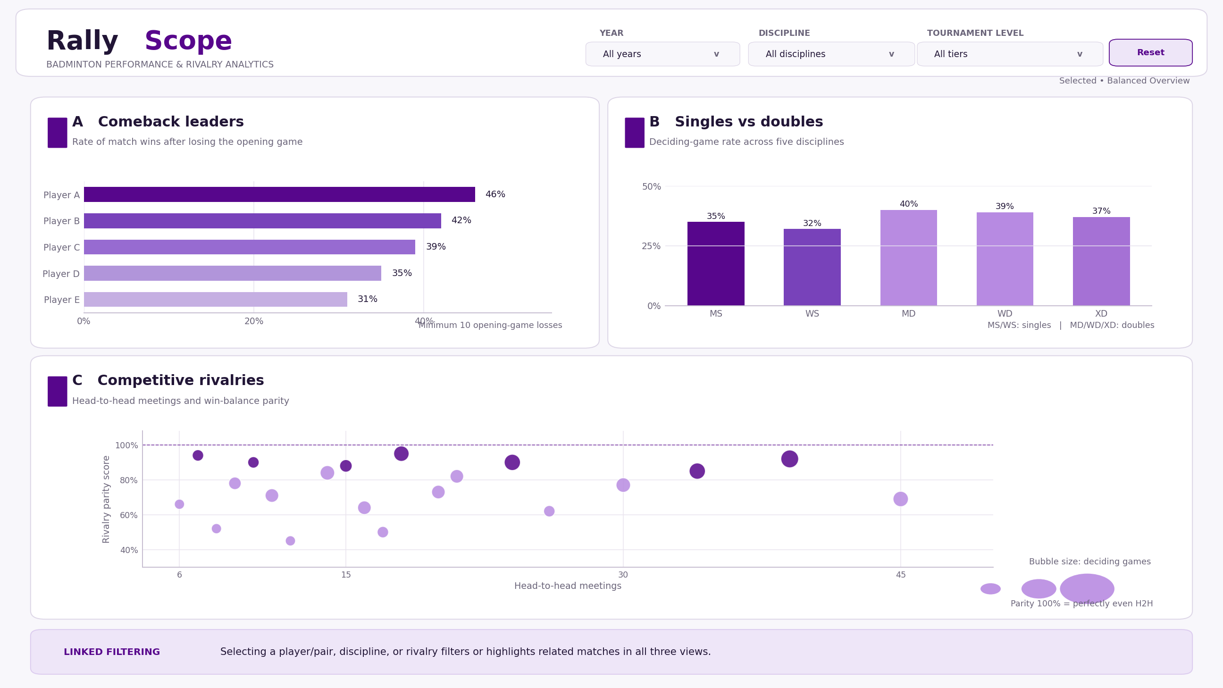
Figure 1. Balanced Overview (selected). All names and percentages shown are illustrative, not observed results.

Why this layout?
Gestalt proximity and enclosure. Each research question has a distinct card. Related charts share a grid, while the filter strip is visually separated above them.
Visual hierarchy. The rivalry panel receives the full lower row because it needs space for two quantitative axes, bubble sizes, and detailed tooltips.
Cross-filtering. Selections in any chart will highlight or filter related matches in the other two charts; a single Reset control clears selections.

06 Alternative layouts considered
I compared two other arrangements before choosing the Balanced Overview. Both retain the same three linked research views, but shift which question receives the most space.

Alternative A · Rivalry-focused
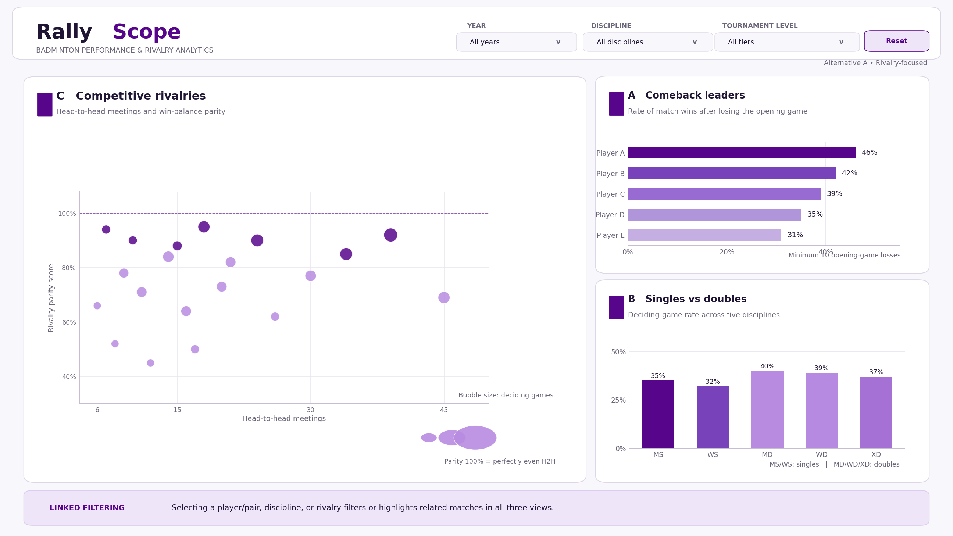
Figure 2. Makes the rivalry plot dominant, with two smaller supporting comparisons.

Alternative B · Trend-focused
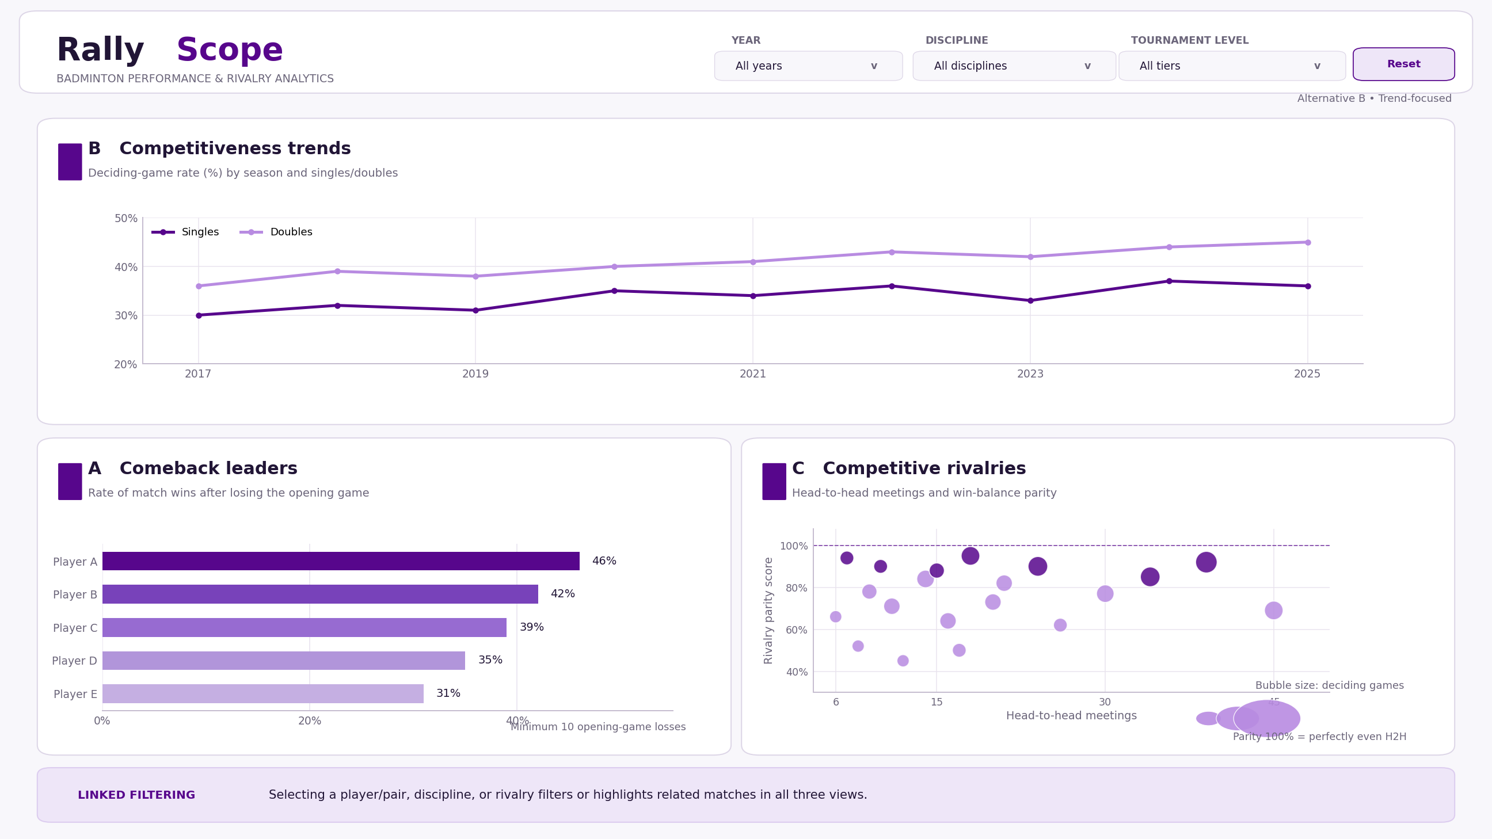
Figure 3. Emphasizes season trends, with comeback and rivalry charts beneath.
Reason for not selecting these: A is less balanced across the three questions; B emphasizes year-by-year trends more than the main singles-versus-doubles comparison. The chosen layout communicates all three questions more evenly.

07 Channel justification
The table describes the marks and channels in the selected Balanced Overview wireframe. Quantitative variables use aligned position and length; color and labeling identify categories; bubble area carries supplementary match-volume context.
Variable | Type | Mark | Channel | Principle | Justification
Player / pair | Nominal | Bar | Y label | Expressiveness | Identifies a competitor in the ranked list.
Comeback success rate | Quantitative | Bar | Length (X) | Effectiveness | Aligned bar lengths compare percentages.
Discipline | Nominal | Bar | X category + hue | Expressiveness | MS, WS, MD, WD, XD are labeled; hue helps group singles and doubles.
Deciding-game rate | Quantitative | Bar | Height (Y) | Effectiveness | Position represents the fraction requiring three games.
H2H meetings | Quantitative | Point | X position | Effectiveness | Position exposes rivalry sample size.
Rivalry parity | Quantitative | Point | Y position | Effectiveness | Higher values mean more even head-to-head splits.
H2H deciding games | Quantitative | Bubble | Area / size | Effectiveness | Area adds the number of deciding-game meetings.
Tournament tier | Ordinal | Filter | Ordered menu | Convention | Tour levels are ordered within each competition era.
Year | Temporal | Filter | Year range | Convention | Chronological range applies to all charts.

References and responsible use of AI
Dataset: Sahil Motyar, BWF Match Data (2007–2026), GitHub. https://github.com/SahilMotyar/bwf-match-data (accessed October 2026).
AI assistance: I used ChatGPT to brainstorm and refine research questions, develop illustrative wireframes, and help edit this proposal. Gemini assisted with formatting an earlier draft. I reviewed and selected the project direction, layout, and encoding choices myself.
No AI-generated chart values are presented as actual match statistics. Dataset-derived results and usability testing will be completed in later milestones.

