**Question 1**(4 points)

Question 1 Saved

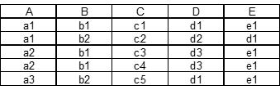

In the relation shown, assuming it will never change, which of the following functional dependencies are valid.

Question 1 options:

|  |  |
| --- | --- |
|  | C -> {B, D, E} |
|  | A -> E |
|  | E -> A |
|  | A -> D |
|  | {A, B} -> C |

Save

**Question 2**(4 points)

Question 2 Saved

Which of the following are properties of relations?

Question 2 options:

|  |  |
| --- | --- |
|  | There are no multivalued attributes in a relation. |
|  | Each attribute has a unique name. |
|  | No two rows in a relation are identical. |
|  | All of the above. |

Save

**Question 3**(4 points)

Question 3 Saved

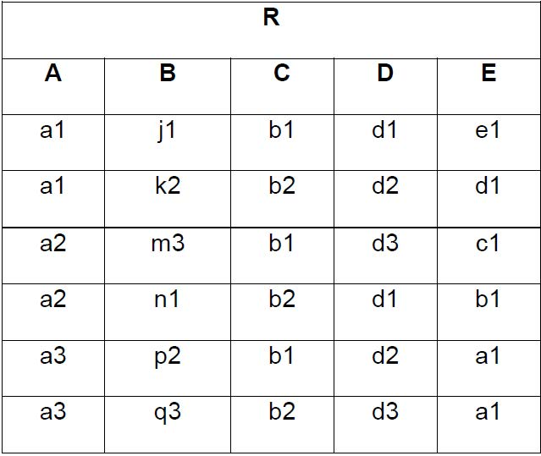

The cardinality of the instance of Relation R is:__________.

Question 3 options:

|  |  |
| --- | --- |
|  | 6 |
|  | 7 |
|  | 5 |
|  | None of the other answers are correct. |
|  | 8 |

Save

**Question 4**(4 points)

Question 4 Saved

In the normalization process, it is not necessary to:

Question 4 options:

|  |  |
| --- | --- |
|  | determine if every determinant is a candidate key. |
|  | identify all the candidate keys of a relation. |
|  | identify all the foreign keys of a relation. |
|  | identify all the functional dependencies of a relation. |
|  | identify all the determinants of a relation. |

Save

**Question 5**(4 points)

Question 5 Saved

Given the generic relation:

**GENERIC (PKey1, PKey2, Attribute1, Attribute2, Attribute3)**,

 and the functional dependencies:

**(PKey1, PKey2)** →**Attribute1** and **PKey2 → (Attribute2, Attribute3)**,

 which of the following is true?

Question 5 options:

|  |  |
| --- | --- |
|  | PKey2 is a candidate key. |
|  | All of the other answers are correct. |
|  | GENERIC is not fully normalized beyond 1NF. |
|  | PKey1 is a determinant. |
|  | GENERIC is in DK/NF. |

Save

**Question 6**(4 points)

Question 6 Saved



The degree of Relation R is:__________.

Question 6 options:

|  |  |
| --- | --- |
|  | 5 |
|  | 4 |
|  | None of the other answers are correct. |
|  | 6 |
|  | 7 |

Save

**Question 7**(4 points)

Question 7 Saved

The number of entity types that participate in a Unary relationship is:

Question 7 options:

|  |  |
| --- | --- |
|  | zero. |
|  | three. |
|  | two. |
|  | one. |

Save

**Question 8**(4 points)

Question 8 Saved



In Relation R, assuming it will never change, which of the following functional dependencies are valid.

Question 8 options:

|  |  |
| --- | --- |
|  | C -> E |
|  | {A, E} -> D |
|  | B -> {D, E} |
|  | A -> C |
|  | E -> D |

Save

**Question 9**(4 points)

Question 9 Saved

A relationship between the instances of a single entity type is called a ________ relationship.

Question 9 options:

|  |  |
| --- | --- |
|  | binary |
|  | ternary |
|  | primary |
|  | unary |

Save

**Question 10**(4 points)

Question 10 Unsaved



The degree of Relation R is a characteristic of the ______________.

Question 10 options:

|  |  |
| --- | --- |
|  | Intension |
|  | Entity Integrity |
|  | Referential Integrity |
|  | None of the other answers are correct. |
|  | Extension |

Save

**Question 11**(4 points)

Question 11 Saved

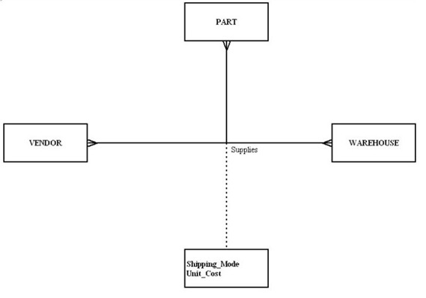

In the diagram, what type of relationship is depicted?

Question 11 options:

|  |  |
| --- | --- |
|  | Unary |
|  | Binary |
|  | Quad |
|  | Ternary |

Save

**Question 12**(4 points)

Question 12 Saved



In the diagram, which answer is true?

Question 12 options:

|  |  |  |  |
| --- | --- | --- | --- |
|  | |  |  | | --- | --- | | A) | Each patient has one or more patient histories | |
|  | |  |  | | --- | --- | | B) | Each patient has one and only one visit. | |
|  | |  |  | | --- | --- | | C) | Each patient history belongs to one and only one patient. | |
|  | |  |  | | --- | --- | | D) | Both A and C | |

Save

**Question 13**(4 points)

Question 13 Saved

What relationship pattern is illustrated in the following schema?

             EMPLOYEE (EmployeeID, OfficePhone, Manager)

             Manager in EMPLOYEE must exist in EmployeeID in EMPLOYEE

Question 13 options:

|  |  |
| --- | --- |
|  | Recursive relationship |
|  | Supertype/subtype relationship |
|  | Strong entity relationship |
|  | Association relationship |
|  | Intersection relationship |

Save

**Question 14**(4 points)

Question 14 Saved

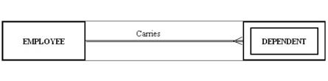

The figure shows an example of:

Question 14 options:

|  |  |
| --- | --- |
|  | a many-to-many relationship. |
|  | a strong entity and its associated weak entity. |
|  | a co-dependent relationship. |
|  | a double-walled relationship. |

Save

**Question 15**(4 points)

Question 15 Unsaved



The attribute names in Relation R represent part of the ______________.

Question 15 options:

|  |  |
| --- | --- |
|  | Extension |
|  | Referential Integrity |
|  | Entity Integrity |
|  | Intension |
|  | None of the other answers are correct. |

Save

**Question 16**(4 points)

Question 16 Saved



In Relation R, assuming it will never change, which of the following could serve as the primary key.

Question 16 options:

|  |  |
| --- | --- |
|  | A |
|  | C |
|  | {A, E} |
|  | D |
|  | B |

Save

**Question 17**(4 points)

Question 17 Saved

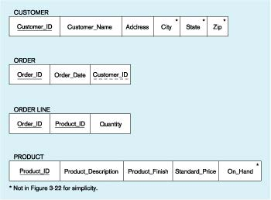

In Figure tb5–1, which of the following is a foreign key?

Question 17 options:

|  |  |
| --- | --- |
|  | Customer_ID |
|  | Order_ID |
|  | Product_ID |
|  | All of the above |
|  | None of the above. |

Save

**Question 18**(4 points)

Question 18 Saved

Which of the following is true about null values?

Question 18 options:

|  |  |
| --- | --- |
|  | A null value can mean that the value is unknown. |
|  | All of the other answers are correct. |
|  | A null value can mean that the value is known to be blank. |
|  | A null value can mean that no value for the field is appropriate. |
|  | A null value is ambiguous. |

Save

**Question 19**(4 points)

Question 19 Saved

A relationship where the minimum and maximum cardinality are both one is a(n) ________ relationship.

Question 19 options:

|  |  |
| --- | --- |
|  | mandatory one |
|  | unidirectional |
|  | optional |
|  | mandatory link |

Save

**Question 20**(4 points)

Question 20 Saved

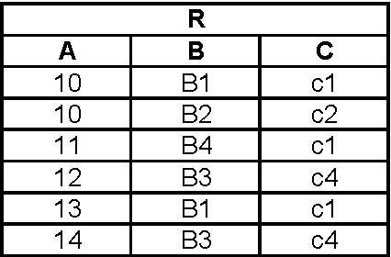

In Relation R, assuming it will never change, which of the following functional dependencies are valid.

Question 20 options:

|  |  |
| --- | --- |
|  | C -> B |
|  | C -> A |
|  | B -> A |
|  | B -> C |
|  | A -> B |

Save

**Question 21**(4 points)

Question 21 Saved

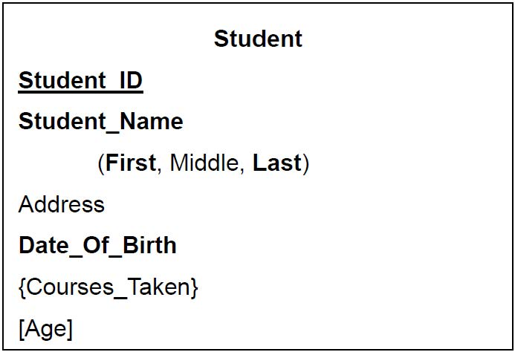

In Figure tb3–3, which attribute is multivalued?

Question 21 options:

|  |  |
| --- | --- |
|  | Student_Name |
|  | Address |
|  | Courses_Taken |
|  | Age |
|  | Date_Of_Birth |

Save

**Question 22**(4 points)

Question 22 Saved

Which of the following pairs of words/phrases are synonyms or represent similar concepts?

Question 22 options:

|  |  |
| --- | --- |
|  | three-schema architecture | three-tier architecture |
|  | internal level | nonprocedural DML |
|  | database state | extension |
|  | data abstraction | controlled redunda |
|  | schema construct | concurrency control |

Save

**Question 23**(4 points)

Question 23 Saved

A functional dependency between two or more nonkey attributes is called a:

Question 23 options:

|  |  |
| --- | --- |
|  | partial transitive dependency. |
|  | partial functional dependency. |
|  | partial nonkey dependency. |
|  | transitive dependency. |

Save

**Question 24**(4 points)

Question 24 Saved



In Figure tb3–3, which attribute is derived?

Question 24 options:

|  |  |
| --- | --- |
|  | Age |
|  | Address |
|  | Courses_Taken |
|  | Date_Of_Birth |
|  | Student_Name |

Save

**Question 25**(4 points)

Question 25 Unsaved



The cardinality of Relation R is a characteristic of the ______________.

Question 25 options:

|  |  |
| --- | --- |
|  | Extension |
|  | None of the other answers are correct. |
|  | Entity Integrity |
|  | Intension |
|  | Referential Integrity |