## **Quiz**

Top of Form

|  |
| --- |
| **Note:** It is recommended that you save your response as you complete each question. |

#### ****Question 1**** (4 points)

Question 1 Saved

A person's name, birthday, and social security number are all examples of:

Question 1 options:

|  |  |
| --- | --- |
|  | relationships. |
|  | entities. |
|  | attributes. |
|  | descriptors. |

Save

#### ****Question 2**** (4 points)

Question 2 Saved

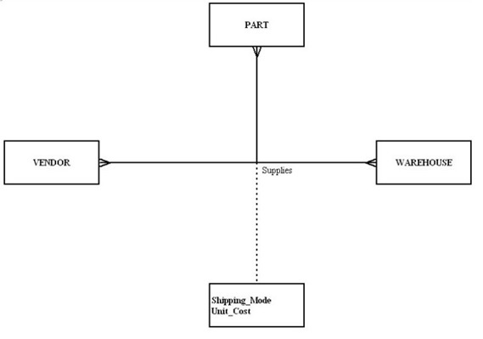

In the diagram, what type of relationship is depicted?

Question 2 options:

|  |  |
| --- | --- |
|  | Binary |
|  | Quad |
|  | Ternary |
|  | Unary |

Save

#### ****Question 3**** (4 points)

Question 3 Saved

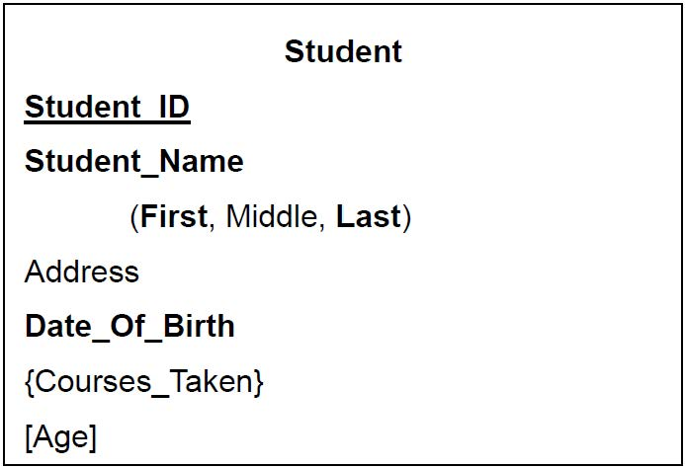

In Figure tb3–3, which attribute is derived?

Question 3 options:

|  |  |
| --- | --- |
|  | Address |
|  | Date_Of_Birth |
|  | Student_Name |
|  | Courses_Taken |
|  | Age |

Save

#### ****Question 4**** (4 points)

Question 4 Saved

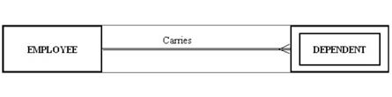

The figure shows an example of:

Question 4 options:

|  |  |
| --- | --- |
|  | a co-dependent relationship. |
|  | a strong entity and its associated weak entity. |
|  | a double-walled relationship. |
|  | a many-to-many relationship. |

Save

#### ****Question 5**** (4 points)

Question 5 Saved

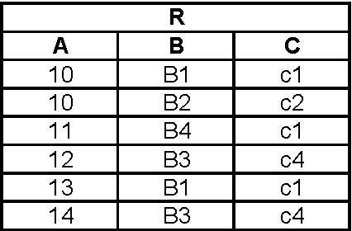

In Relation R, assuming it will never change, which of the following functional dependencies are valid.

Question 5 options:

|  |  |
| --- | --- |
|  | B -> C |
|  | B -> A |
|  | C -> A |
|  | A -> B |
|  | C -> B |

Save

#### ****Question 6**** (4 points)

Question 6 Saved

Which of the following is true about null values?

Question 6 options:

|  |  |
| --- | --- |
|  | A null value can mean that no value for the field is appropriate. |
|  | A null value can mean that the value is known to be blank. |
|  | All of the other answers are correct. |
|  | A null value can mean that the value is unknown. |
|  | A null value is ambiguous. |

Save

#### ****Question 7**** (4 points)

Question 7 Saved

Which of the following pairs of words/phrases are synonyms or represent similar concepts?

Question 7 options:

|  |  |
| --- | --- |
|  | schema construct | concurrency control |
|  | database state | extension |
|  | data abstraction | controlled redunda |
|  | three-schema architecture | three-tier architecture |
|  | internal level | nonprocedural DML |

Save

#### ****Question 8**** (4 points)

Question 8 Saved

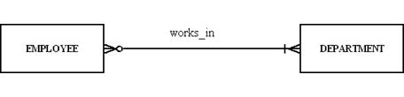

For the relationship represented in the figure, which of the following is true?

Question 8 options:

|  |  |
| --- | --- |
|  | A department can have more than one employee. |
|  | An employee can work in more than one department but does not have to work for any department. |
|  | A department must have at least one employee. |
|  | An employee has to work for more than one department. |

Save

#### ****Question 9**** (4 points)

Question 9 Saved

A ________ specifies the number of instances of one entity that can be associated with each instance of another entity.

Question 9 options:

|  |  |
| --- | --- |
|  | counter constraint |
|  | limit |
|  | cardinality constraint |
|  | degree |

Save

#### ****Question 10**** (4 points)

Question 10 Saved

Given the functional dependency (A, B) -> C, then _______.

Question 10 options:

|  |  |
| --- | --- |
|  | B -> A |
|  | A -> C |
|  | B -> C |
|  | A -> B |
|  | None of the other answers are correct. |

Save

#### ****Question 11**** (4 points)

Question 11 Saved

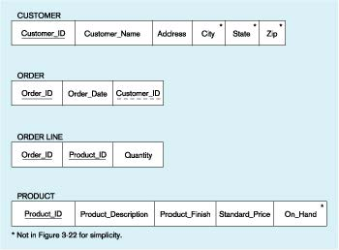

In Figure tb5–1, which of the following is a foreign key?

Question 11 options:

|  |  |
| --- | --- |
|  | Customer_ID |
|  | Order_ID |
|  | Product_ID |
|  | All of the above |
|  | None of the above. |

Save

#### ****Question 12**** (4 points)

Question 12 Saved

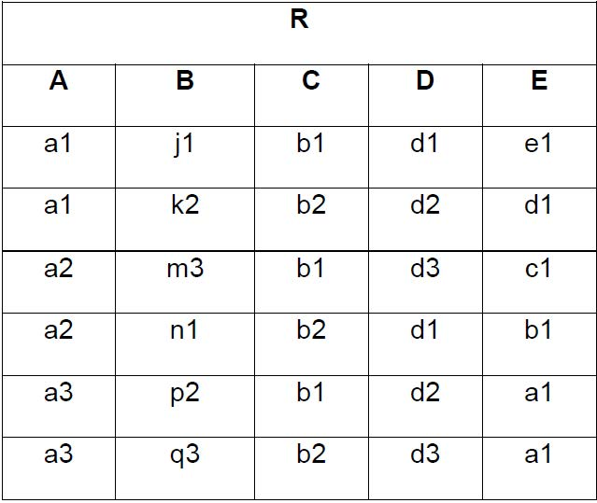

The attribute names in Relation R represent part of the ______________.

Question 12 options:

|  |  |
| --- | --- |
|  | Referential Integrity |
|  | Extension |
|  | Intension |
|  | Entity Integrity |
|  | None of the other answers are correct. |

Save

#### ****Question 13**** (4 points)

Question 13 Saved

A candidate key must satisfy all of the following conditions **EXCEPT:**

Question 13 options:

|  |  |
| --- | --- |
|  | each nonkey attribute is functionally dependent upon it. |
|  | the key must indicate the row's position in the table. |
|  | the key must uniquely identify the row. |
|  | the key must be nonredundant |

Save

#### ****Question 14**** (4 points)

Question 14 Saved

A relationship where the minimum and maximum cardinality are both one is a(n) ________ relationship.

Question 14 options:

|  |  |
| --- | --- |
|  | mandatory link |
|  | unidirectional |
|  | optional |
|  | mandatory one |

Save

#### ****Question 15**** (4 points)

Question 15 Saved

What relationship pattern is illustrated in the following schema?

             EMPLOYEE (EmployeeID, OfficePhone, Manager)

             Manager in EMPLOYEE must exist in EmployeeID in EMPLOYEE

Question 15 options:

|  |  |
| --- | --- |
|  | Intersection relationship |
|  | Recursive relationship |
|  | Strong entity relationship |
|  | Supertype/subtype relationship |
|  | Association relationship |

Save

#### ****Question 16**** (4 points)

Question 16 Saved

Which of the following are properties of relations?

Question 16 options:

|  |  |
| --- | --- |
|  | All of the above. |
|  | Each attribute has a unique name. |
|  | No two rows in a relation are identical. |
|  | There are no multivalued attributes in a relation. |

Save

#### ****Question 17**** (4 points)

Question 17 Saved



In Relation R, assuming it will never change, which of the following functional dependencies are valid.

Question 17 options:

|  |  |
| --- | --- |
|  | A -> C |
|  | E -> D |
|  | C -> E |
|  | B -> {D, E} |
|  | {A, E} -> D |

Save

#### ****Question 18**** (4 points)

Question 18 Saved

A relation that contains no multivalued attributes, and has nonkey attributes solely dependent on the primary key, but contains transitive dependencies is in which normal form?

Question 18 options:

|  |  |
| --- | --- |
|  | Third |
|  | Second |
|  | Fourth |
|  | First |

Save

#### ****Question 19**** (4 points)

Question 19 Saved

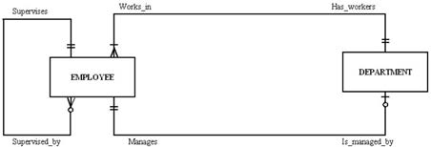

In the diagram, which answer is true?

Question 19 options:

|  |  |
| --- | --- |
|  | Each employee works in more than one department. |
|  | All of the other answers are correct. |
|  | Each employee can manage many departments. |
|  | Each employee can supervise one employee, no employees or many employees. |

Save

#### ****Question 20**** (4 points)

Question 20 Saved

Which of the following functional dependency diagrams accurately represents the following situation:

* A campus has many buildings.
* Each building has a unique name.
* Each building has many rooms.
* All rooms in any given building are numbered sequentially starting at "101."
* Each room has a certain capacity, although many rooms in the same building or different buildings may have the same capacity.
* Each room is assigned to a single department.
* A department may have many rooms in one or more buildings, each with the same or different capacities.

Question 20 options:

|  |  |
| --- | --- |
|  | (BuildingName, Capacity) → (Department, RoomNumber) |
|  | BuildingName → (RoomNumber, Capacity, Department) |
|  | RoomNumber → (BuildingName, Department, Capacity |
|  | (BuildingName, RoomNumber) → (Capacity, Department) |
|  | (Department, Capacity) → (BuildingName, RoomNumber) |

Save

#### ****Question 21**** (4 points)

Question 21 Saved

A relationship between the instances of a single entity type is called a ________ relationship.

Question 21 options:

|  |  |
| --- | --- |
|  | primary |
|  | unary |
|  | ternary |
|  | binary |

Save

#### ****Question 22**** (4 points)

Question 22 Saved

A functional dependency between two or more nonkey attributes is called a:

Question 22 options:

|  |  |
| --- | --- |
|  | partial transitive dependency. |
|  | partial functional dependency. |
|  | partial nonkey dependency. |
|  | transitive dependency. |

Save

#### ****Question 23**** (4 points)

Question 23 Saved



In Relation R, assuming it will never change, which of the following could serve as the primary key.

Question 23 options:

|  |  |
| --- | --- |
|  | B |
|  | {A, B} |
|  | {B, C} |
|  | C |
|  | A |

Save

#### ****Question 24**** (4 points)

Question 24 Saved

In a relational database design, all relationships are expressed by ____________________.

Question 24 options:

|  |  |
| --- | --- |
|  | creating a line between entities |
|  | creating a primary key |
|  | creating a foreign key |
|  | creating a subtype |
|  | creating a supertype |

Save

#### ****Question 25**** (4 points)

Question 25 Saved

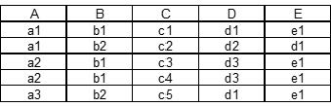

In the relation shown, assuming it will never change, which of the following functional dependencies are valid.

Question 25 options:

|  |  |
| --- | --- |
|  | A -> D |
|  | {A, B} -> C |
|  | C -> {B, D, E} |
|  | E -> A |
|  | A -> E |

Save

Save All Responses

Bottom of Form