Part A

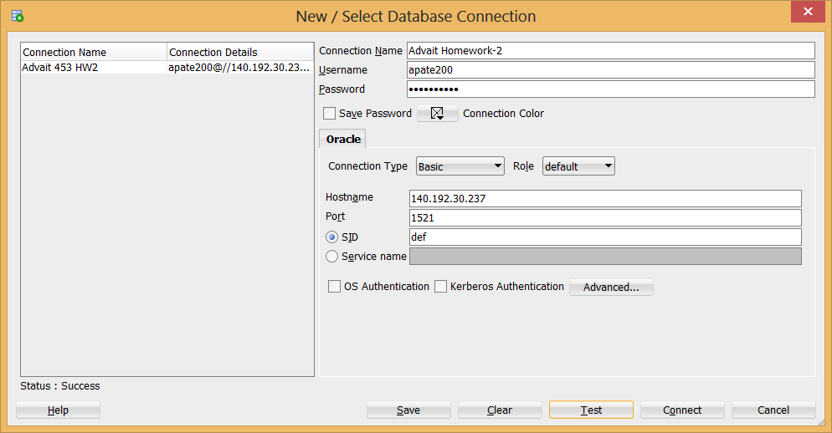

Part B

1. Screen Shot -1

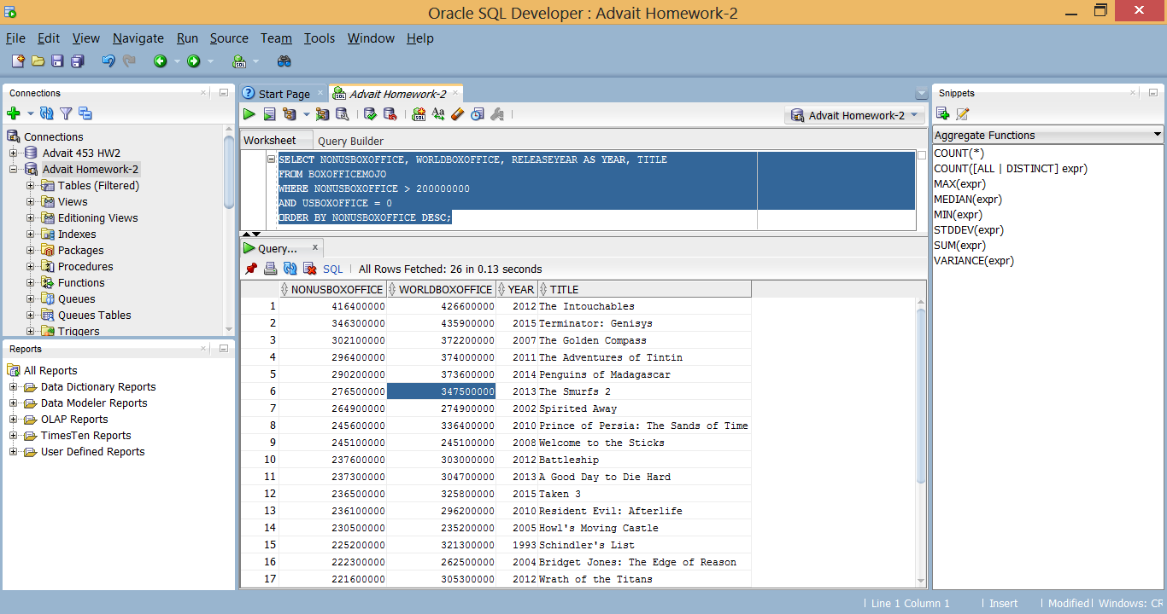

My Query:-

***SELECT NONUSBOXOFFICE, WORLDBOXOFFICE, RELEASEYEAR AS YEAR, TITLE***

***FROM BOXOFFICEMOJO***

***WHERE NONUSBOXOFFICE > 200000000***

***AND USBOXOFFICE = 0***

***ORDER BY NONUSBOXOFFICE DESC;***

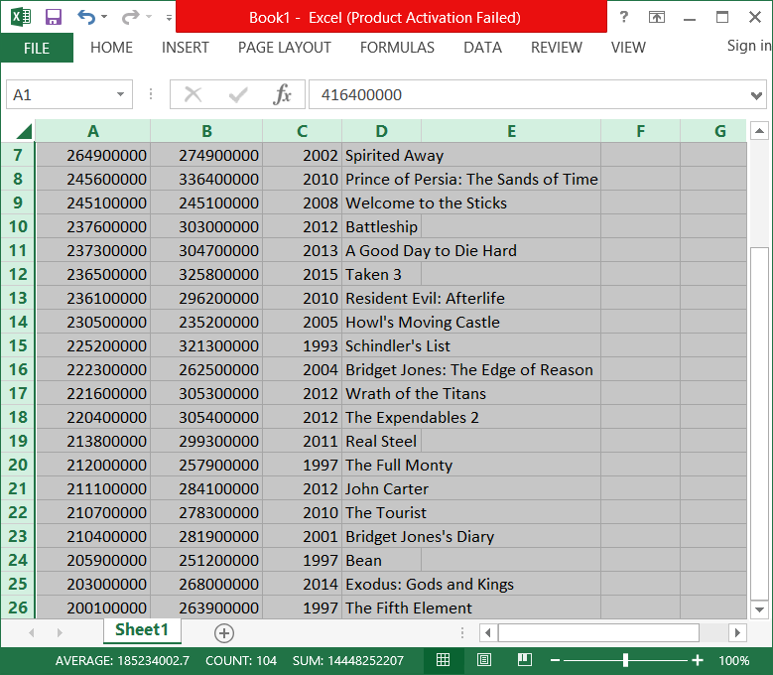

***Part C***

***Attached image for Part-c.***