Mimer

1. What is Mimer?

Mimer is a not a single webserver, or a file. The final purpose for this mimer assignment is to learn how to let web server handle Personal MIME type (or new custom MIME type), for example, file with ‘.xyz’ extension). Meanwhile, let the web browser on client side to know how to deal with such file, which downloaded from the web server with unknown extension.

1. How it works?

There are two main steps to make the whole process work. First, we need to let the web server return ‘Application/xyz’ MIME type. Second, create a handler to deal with the new file type on client machine.

1. Development Environment

I will do this assignment in my personal window laptop. Web Server and client web browser are on the same machine, which installed with Windows 7 (64-bit).

1. Preparation
   1. Web Server

I will reuse the MyWebServer which is for the last assignment. Of course, there will be some enhancements to adapt new requiremnts, see the details in the following chapters.

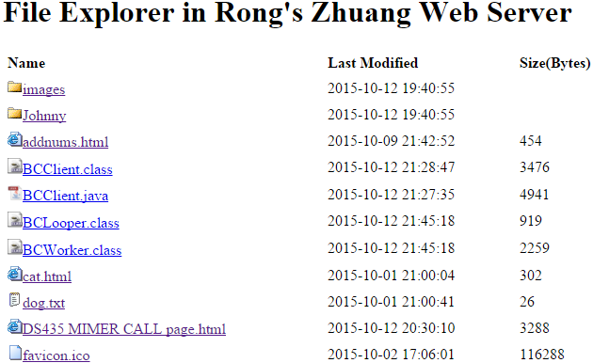

* 1. Client Side

I will configure some settings to my Windows machine, and create a handler written in java to process the .xyz file. Also, see the details below. By the way, I use Firefox as the default web browser. It seems there is an issue when opening customized file with chrome, because of some default security settings. You have to download the file to local disk, and you cannot open it directly in chrome.

1. Development Steps

The following content records all of the steps for this assignment. The chapter number(5.1, 5.2, …) are the main steps for my operations. To have a mapping relationship with the steps mentioned in your handout, I add a step number (within parenthesis) at the front of each title.

* 1. (Step1) Enhance MyWebServer.java
     1. Update method getContentType, return new MIME type ‘application/xyz’ for files with extension ‘.xyz’.

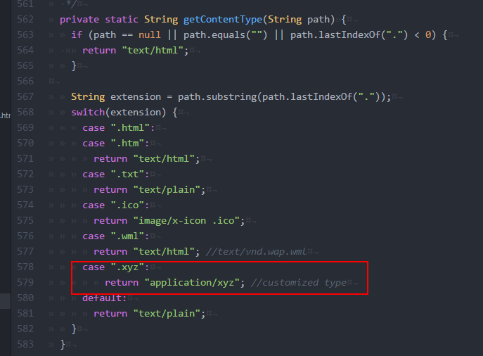

* + 1. Add ‘mimer-data.xyz’ to root folder of the web server, open it in web browser to check whether the Content-Type is returned correctly.

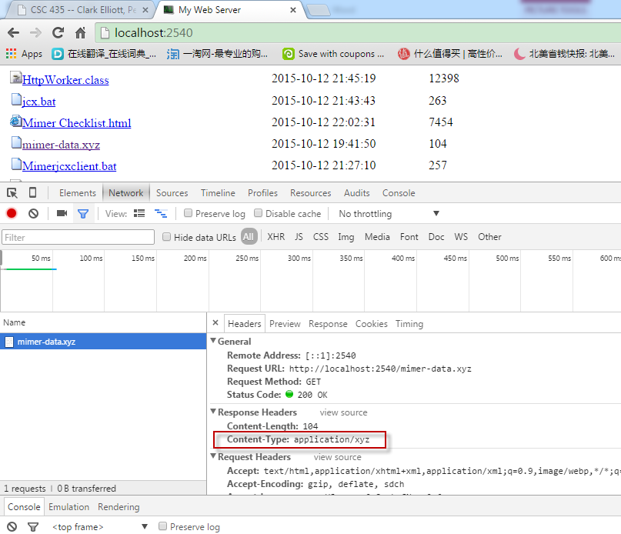

* 1. (Step1) Define new customized MIME type
     1. Win ->Run->‘regedit’
     2. Navigate to HKEY_CLASSES_ROOT\MIME\Database\Content Type, create new key ‘application/xyz’.

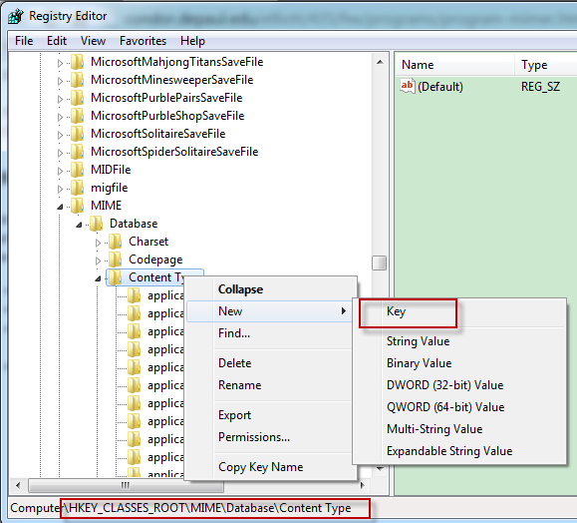

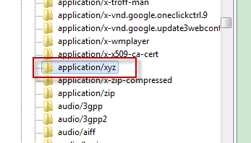

* + 1. Create new String, Name: ‘Extension’, Value ‘.xyz’

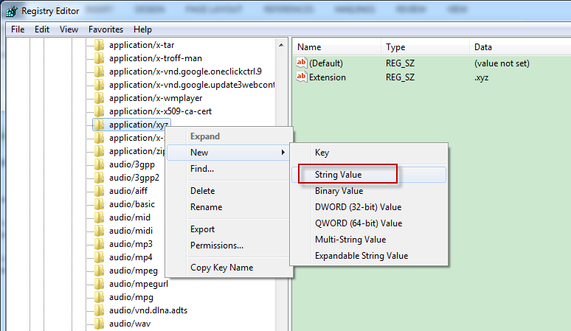

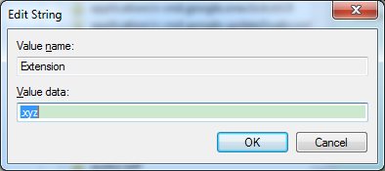

* 1. (Step1) Associating customized MIME type(.xyz) with a handler(shim.bat)
     1. Download and save shim.bat to working folder, mine is ‘D:\WorkSpace\GitHub\Course\CSC435\Mimer’.

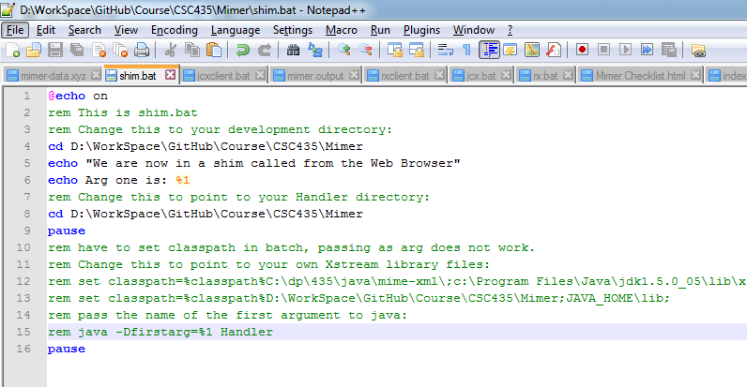

* + 1. Select file mimer-data.xyz, right click ->Open with -> Choose default program…

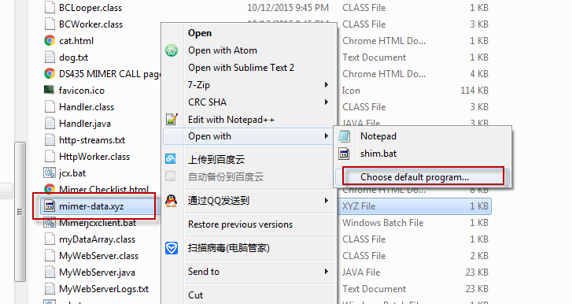

* + 1. Click ‘Browse…’ button.

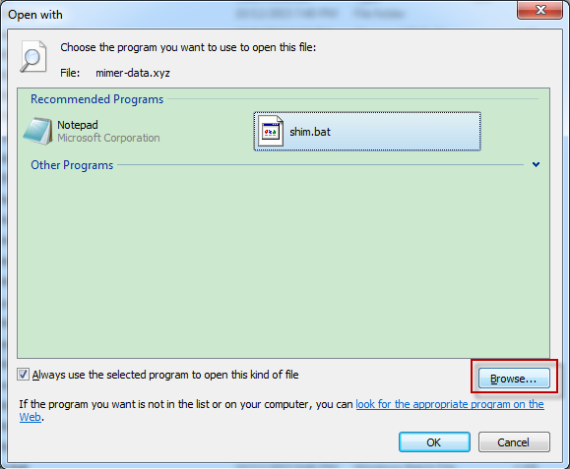

* + 1. Navigate to the folder where contains ‘shim.bat’, click ‘Open’ button.

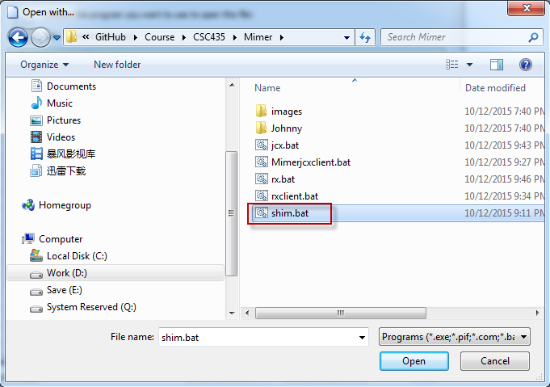

* 1. (Step1) Open a ‘.xyz’ file in browser to see whether the association works.
     1. Launch MyWebServer.
     2. Open Firefox to access server, click file ‘mimer-data.xyz’, or directly open url ‘localhost:2540/mimer-data.xyz’.

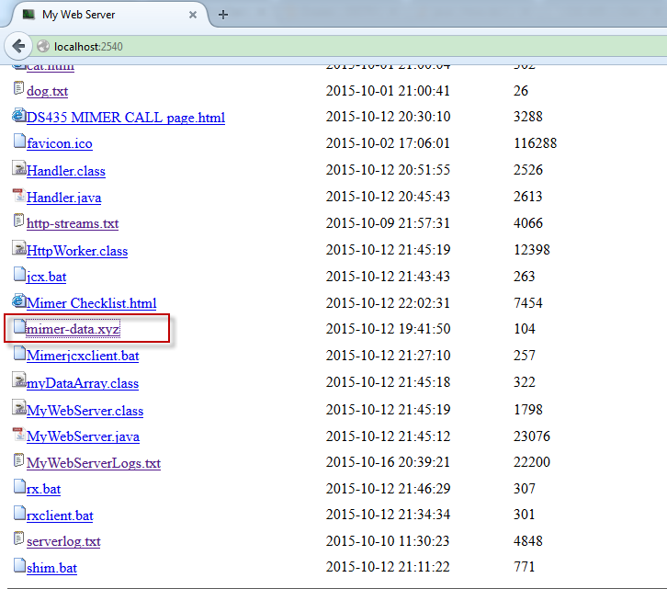

* + 1. Click ‘OK’ button to continue.

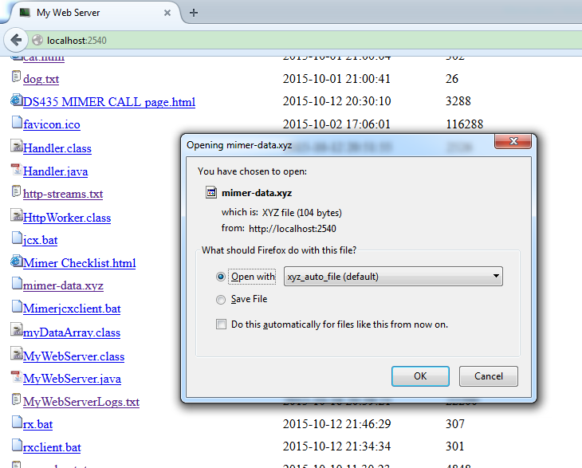

* + 1. ‘shim.bat’ is invoked, and ‘mimer-date.xyz’ is saved to temp folder by the browser automatically.

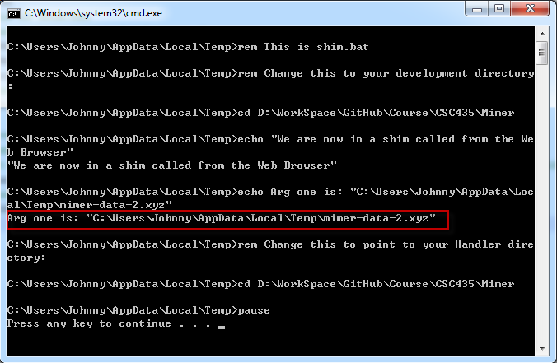

* 1. (Step2) Write a Java program that reads environment variables, and call it from server, through shim.bat
     1. Download Handler.java and compile to Handler.class
     2. Uncomment(remove the "rem" remark statement from), let handler execute.

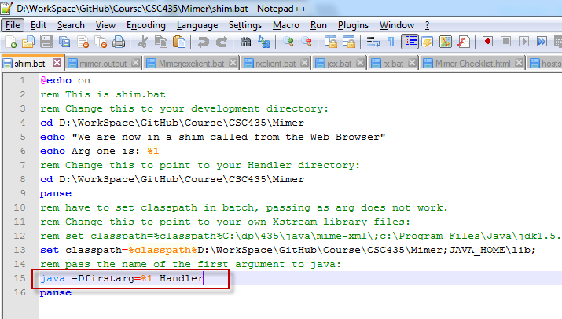

* + 1. Win -> Run -> ‘cmd’, navigate to work folder, run ‘shim mimer-data.xyz’

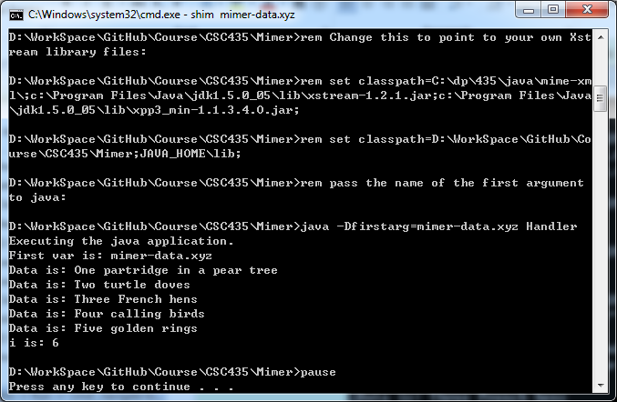

* + 1. Open file ‘C:\Temp\mimer.output’. The file is created by Handler.

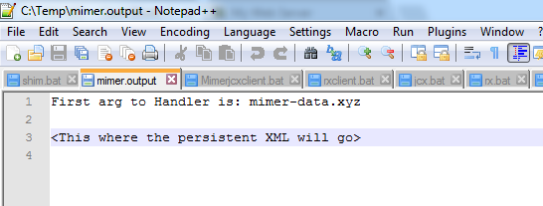

* + 1. Uncomment the line of ‘set classpath’, this ensure java to find the handler in the working folder.

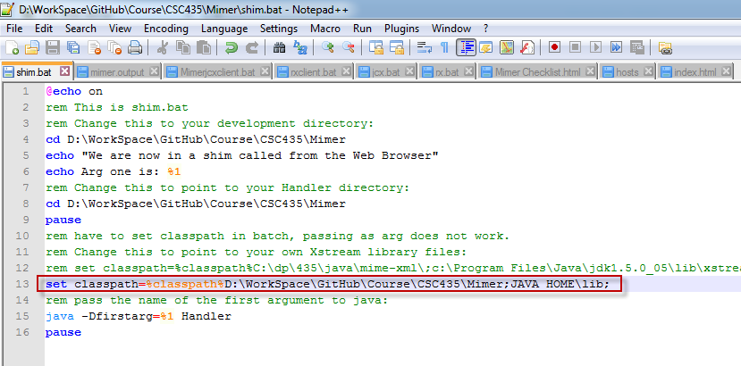

* + 1. Access url ‘localhost:2540/mimer-data.xyz’ in Firefox, shim.bat will be invoked, and Handler will be called.

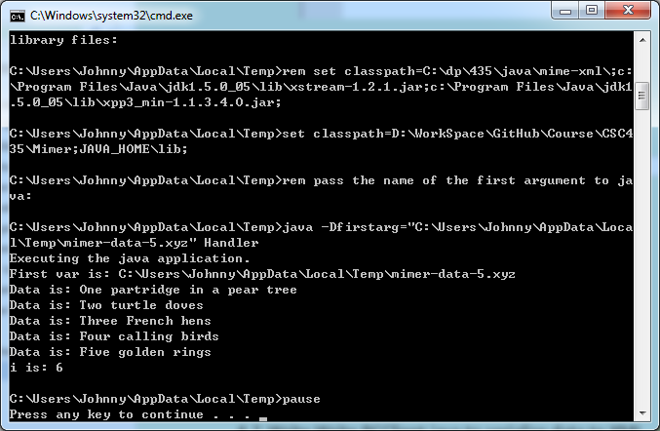

* + 1. Check output, the file location is different, which is coming from the browser, the latest access file.

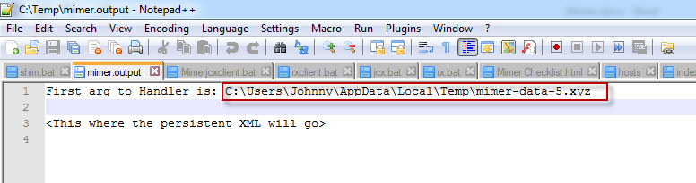

* 1. (Step3) Write BCClient.java to serialize data to XML
     1. Downloand xstream-1.2.1.jar and mimer/xpp3_min-1.1.3.4.O.jar, put them to JAVA_HOME, where is the location for JDK.

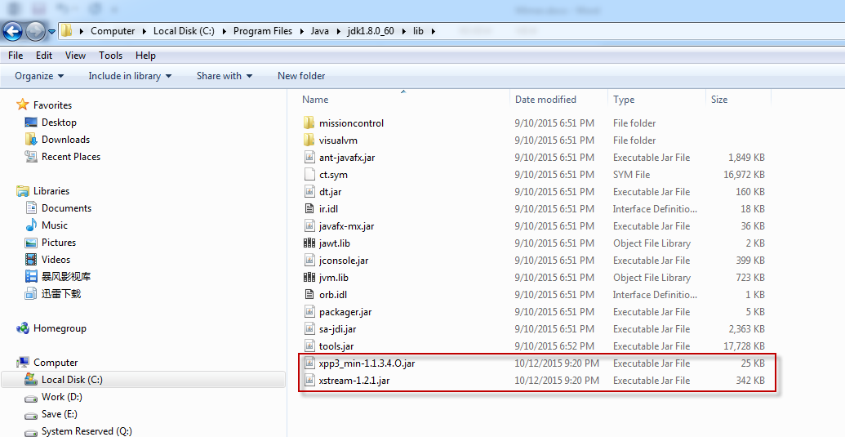

* + 1. Edit jcxclient.bat, set correct path for the above two jar file for compile BCClient.java.

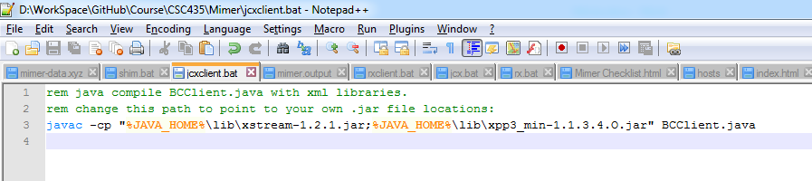

Configure JAVA_HOME environment variable if it doesn’t exist yet.

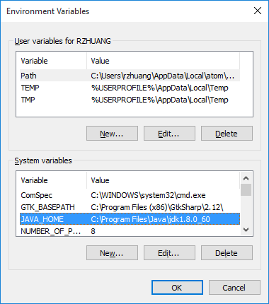

* + 1. Edit rxclient.bat, set correct path running BCClient.class.

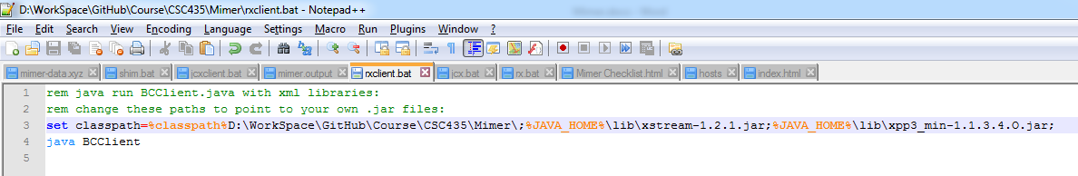

* + 1. Run jcxclient.bat, then run rxclient.bat to launch BCClient.
  1. (Setp4) Create the Back Channel communication between your handler and server
     1. Enhance MyWebServer.java, add classes of the MyDataArray, BCWorker, BCListener. And add code snippet into main function of MyWebServer.

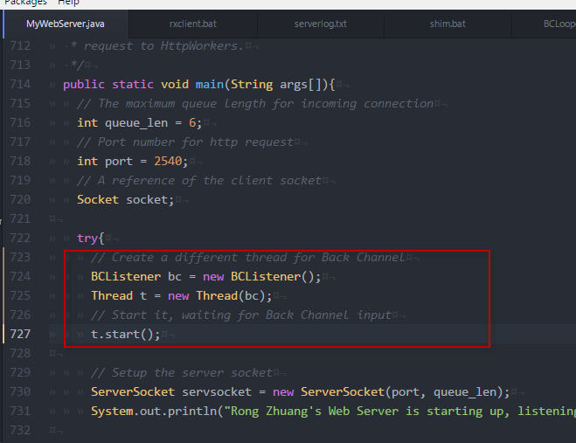

* + 1. Edit jcx.bat, set correct path for compiling MyWebServer.java.

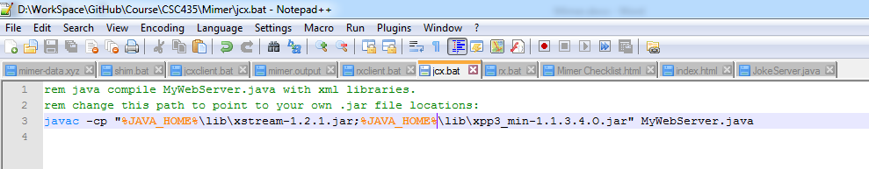

* + 1. Edit rx.bat, set correct path for running MyWebServer.class

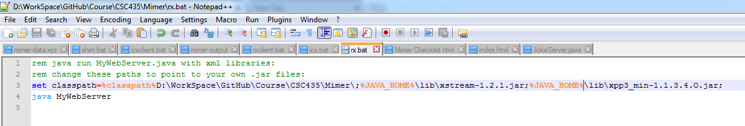

* + 1. Run jcx.bat, then run rx.bat to launch MyWebServer
    2. In BCClient, input any string, eg. ‘bcclientTest By Johnny’. BCClient will first print the content in xml format, and then print content in plain text.

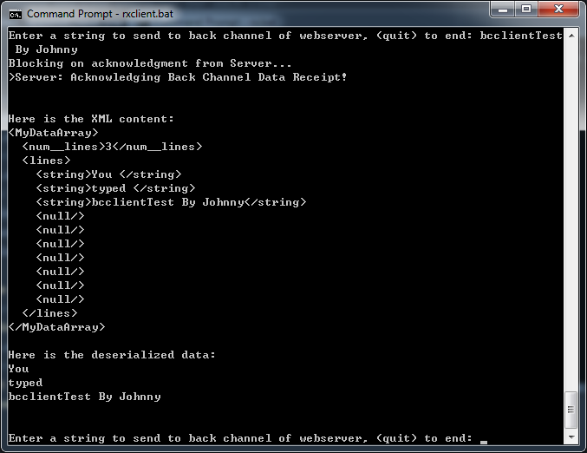

From the above screenshot, we can also see server has acknowledged that it has received data from BCClient.

* + 1. Check whether file C:\temp\mimer.output is created, and the content is correct.

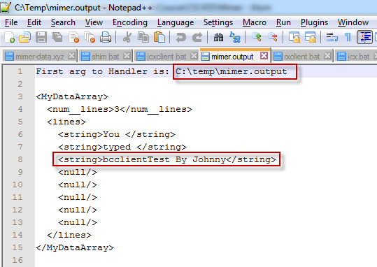

* + 1. In server side, we can see that it received the data from BCClient, and print the xml correctly. Besides, it desterilized the xml to DataArray object and printed the plain content.

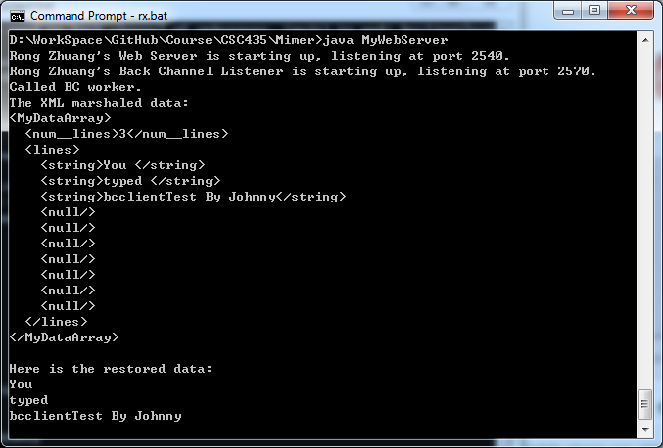

* 1. Combine your two Java programs
     1. Create BCHandler.java, let it read the environment variable to get the file path, open the file, fetch the content, serialize them to xml, save copy to local disk, send to MyWebServer at port 2570.
     2. Create jbch.bat, set path to compile BCHandler.java

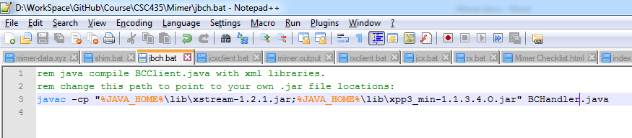

* + 1. Run jbch.bat to compile BCHandler and generate BCHandler.class.
    2. Edit shim.bat, use BCHandler to handle the xyz file. And add path for xstream.

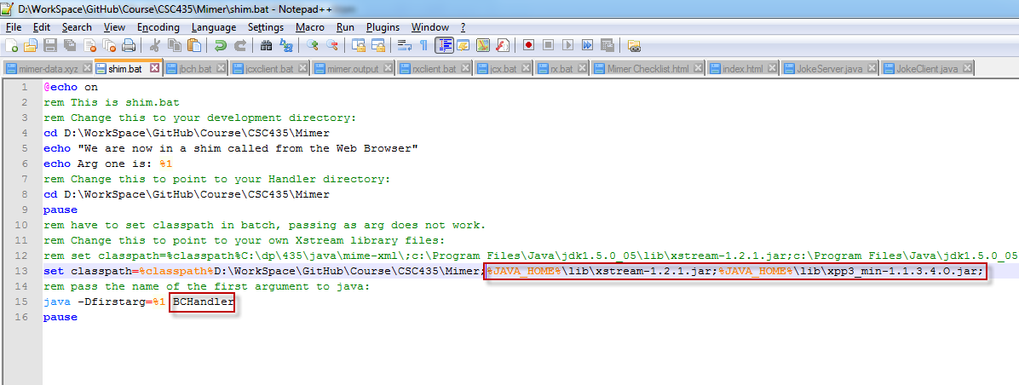

* + 1. Win->Run->cmd, navigate to working fold, run > ‘shim.bat mimer-data.xyz’. BCHandler will handle the file correctly, see the screenshot below.

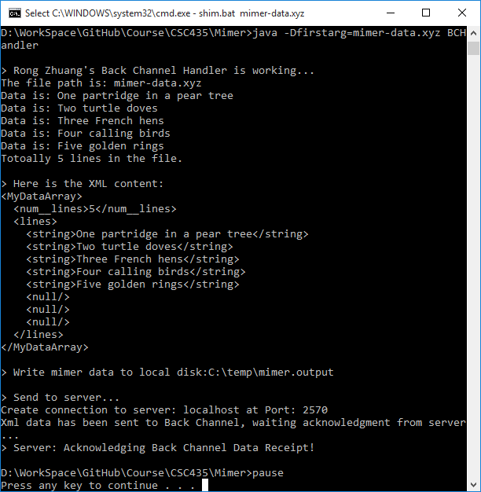

* + 1. In the server side(MyWebServer), the BCWorker is invoked and it processed the data correctly.

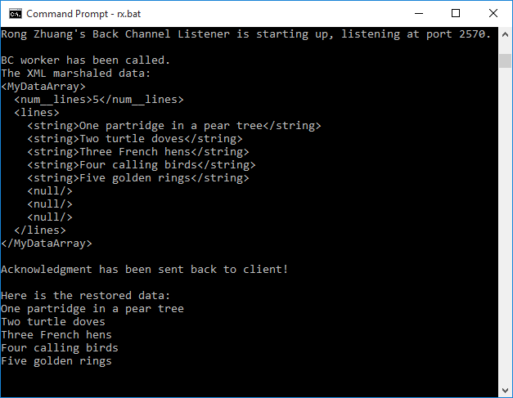

* + 1. In FireFox, access url <http://localhost:2540/mimer-data.xyz>
    2. The file is saved to temp file in local disk. BCHandler is invoked automatically.

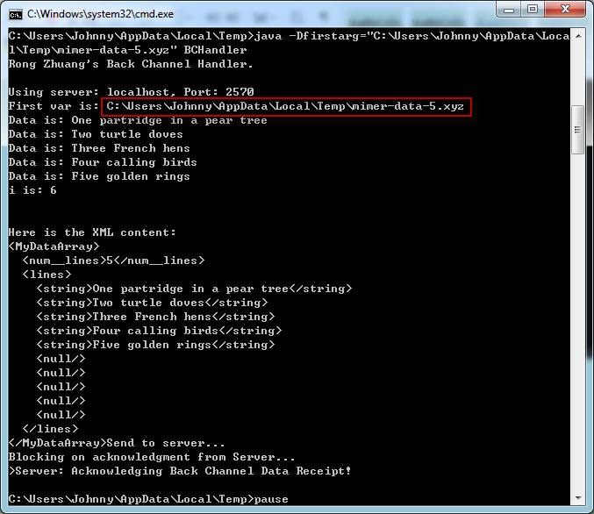

* + 1. In MyWebServer, it get the http get request first. This request is from the web browser. Then it received a back channel request and the BC worker is invoked to handle it.

