Report for Final Project

1. Project Name

Restaurant Recommendation

1. Team Member

* Rong Zhuang(Johnny)
* Marlon Garcia

1. Brief Ideas

This app is used to search restaurants. After login, you can share your experience with others about the restaurant you have been. You can submit ratings and reviews. All of the data are dynamic, which means this app connects backend server to retrieve data.

1. Development Tools

* Android Studio (IDE)
* Genymotion (Emulator)

1. Main screens/functions

|  |  |
| --- | --- |
|  | App Name: Restaurant Recommendation  Features:   * Regsiter/Login * Search Restaurant * Restaurant list and details * Submit Rating * Submit Review * Phone and Tablet Support |

* 1. Restaurant List

This is the entry of the app. All of the items of list are fetched from backend server. Restaurants are grouped to 5 categories: Restaurant, Dessert, CoffeeTea, Bakeries, IceCream.

|  |  |
| --- | --- |
|  | Features:   * Restaurants are displayed in list * Each item contains name, rating, review count, address. * Each item has a specific icon according to its category   Actions:   * When click on any item, it navigates to the detail screen * Search * Login |

* + 1. Search
    2. Login

Click the menu bar, select ‘Sign In’.

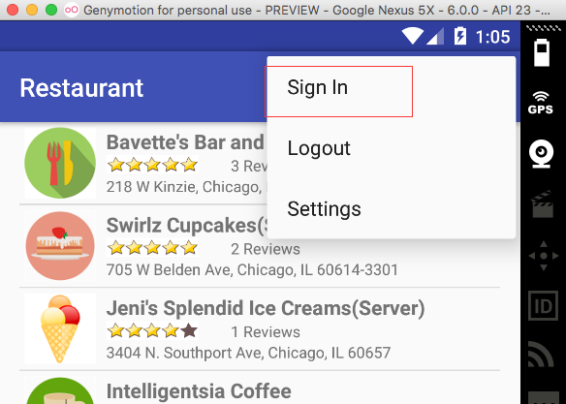

|  |  |
| --- | --- |
|  | Features:   * Input Name and Password to login   Actions:   * If you have no account yet, click Register button to sign up first. |

* + 1. Register

|  |  |
| --- | --- |
|  | Features:   * Provide Email address, user name and password for registration.   Actions:   * Go back to Login |

* 1. Restaurant Details

|  |  |
| --- | --- |
|  | Features:   * Details are displayed in this screen, some of them you’ve already seen in the list view. * Three images about this restaurant are shown. They are downloaded from internet dynamically. * Comments/Reviews from customers are shown.   Actions:   * Change rating * Write comment |

* + 1. Change Rating

When your touch on the rating bar, you may change the value of it. The new result will be submitted to server directly.

* + 1. Write Comment

You have to login first, otherwise, you will get an error message.

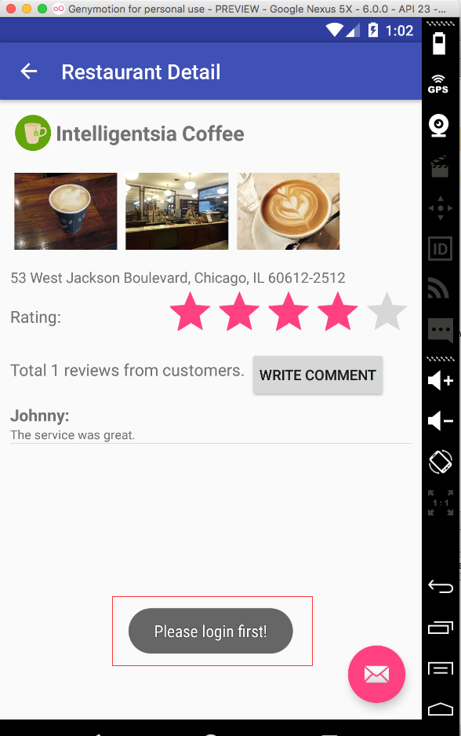

|  |  |
| --- | --- |
|  | Features:   * User name is displayed here. * Comment will be submitted to server after clicking submit button.   Actions:   * Cancel, return back to login screen. |

* 1. Search

Click the Search button in the menu bar.

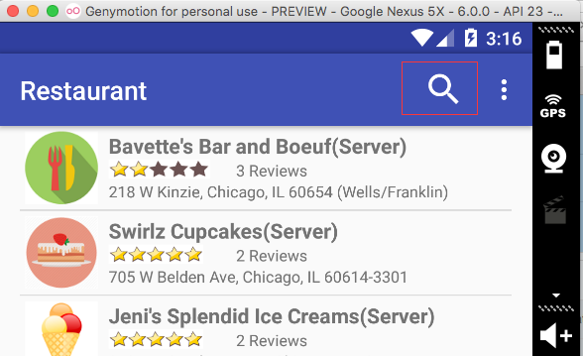

|  |  |
| --- | --- |
|  | Features:   * Input the keyword you want to search, press enter. The list will be refresh with new result.   Functions:   * Exit Search |

* 1. Email Button

Contact the owner of the app.

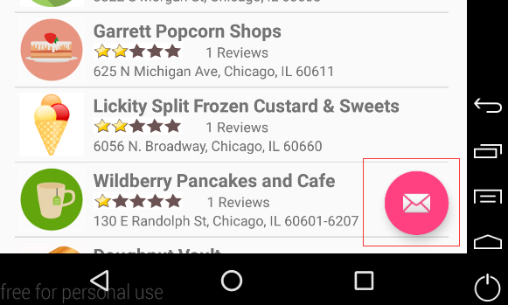

* 1. Rotation

In landscape mode, the layout still looks pretty.

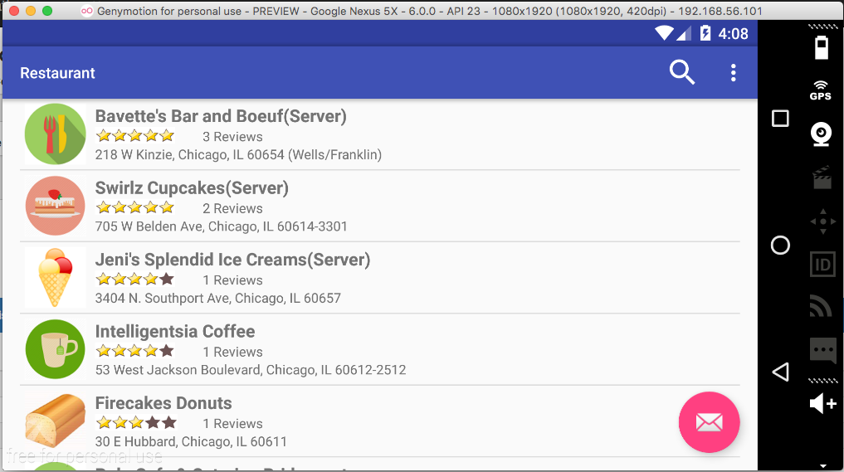

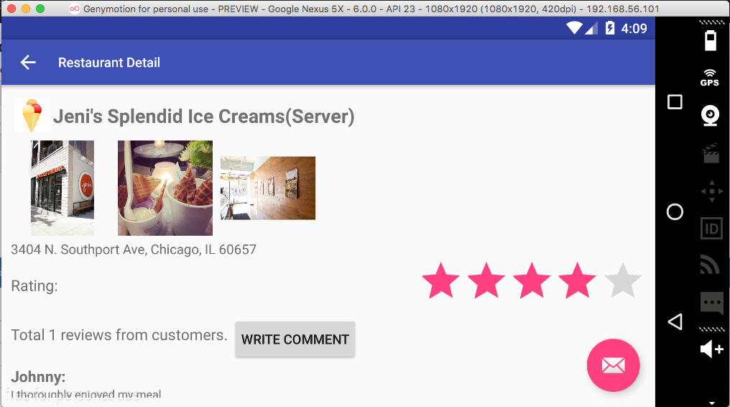

* 1. Tablet Support

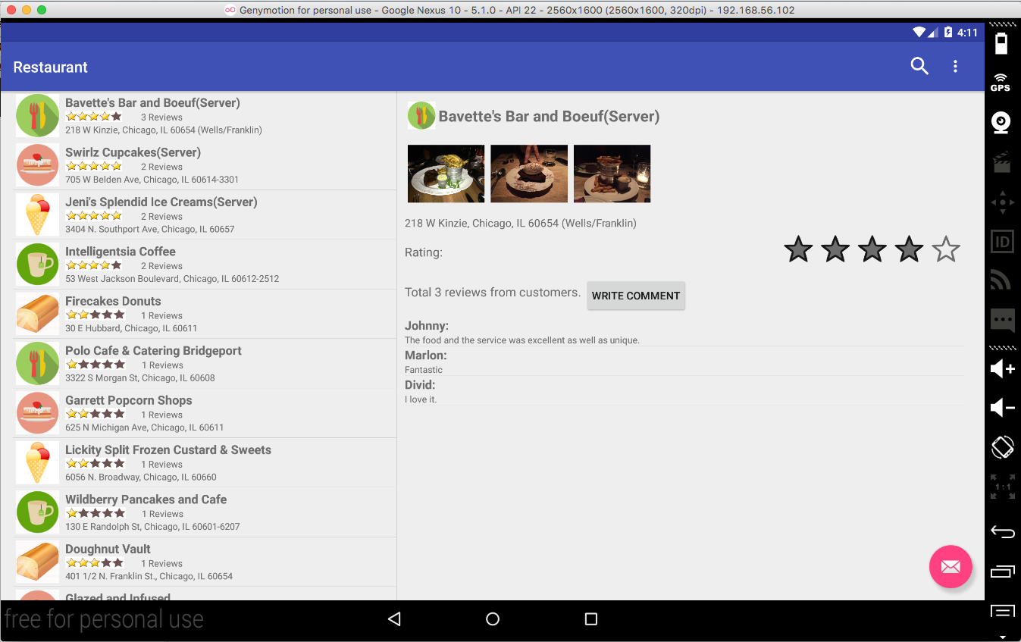

1. Server APIs
   1. Backend Server

The server is built with ASP.NET MVC 5.0. There is a home page where you can get the ideas how to use the APIs. For example, you can try the register and login functions in this page. They are using the same APIs which are also used in our Android app. These are RESTful APIs which return response in JSON or XML format. The data format depends on the requester. Both formats are supported by this API server.

* 1. Server Address

<http://140.192.34.69/restaurant/>

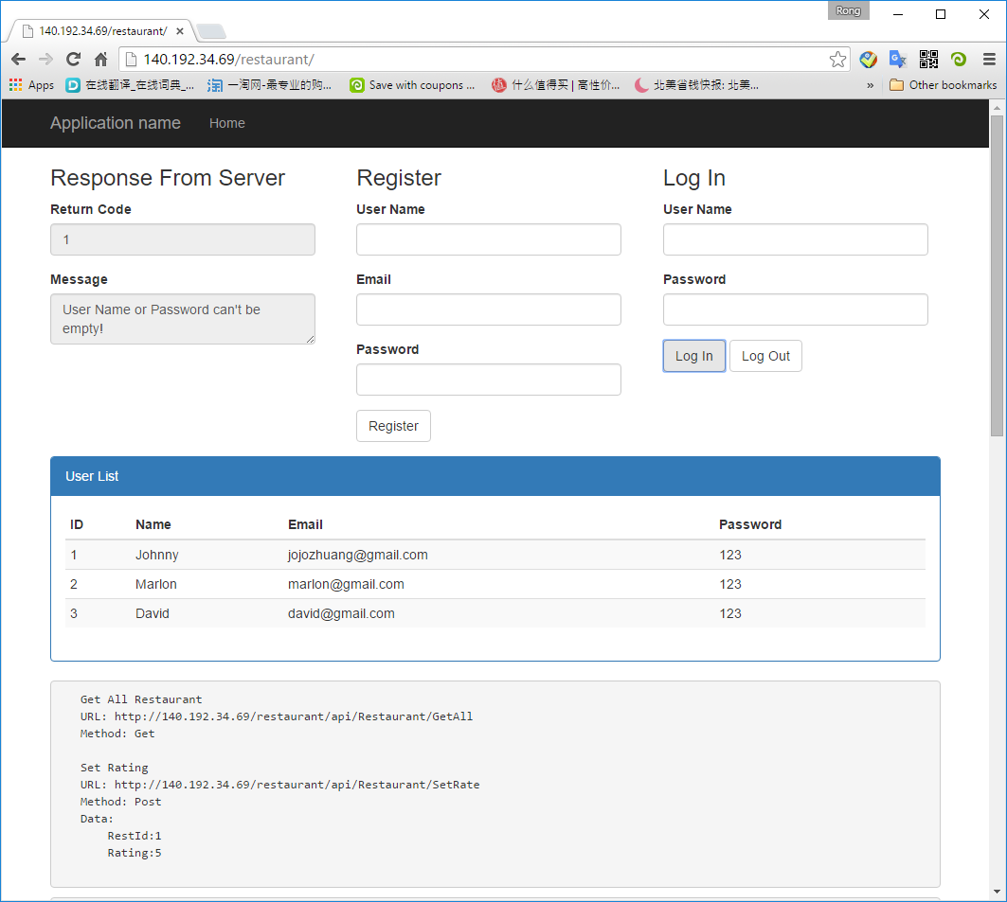

* 1. Server APIs

|  |  |  |  |
| --- | --- | --- | --- |
| **URL** | **Method** | **Parameters** | **Description** |
| /api/User/Register | POST | UserId:0 UserName:johnny Email:jojo@gmail.com  Password:aaa | Register |
| /api/User/Login | POST | UserName:johnny  Password:aaa | Login |
| /api/User/Logout | POST | UserName:johnny | Logout |
| /api/User/GetAll | GET |  | Get All User |
| /api/Restaurant/GetAll | GET |  | Get All Restaurant |
| /api/Restaurant/SetRate | POST | RestId:1  Rating:5 | Set Rating |
| /api/comment/GetAll | GET |  | Get All Comments |
| /api/comment/GetListByRestaurant?restid=1 | GET |  | Get Comments By Restaurant |
| /api/comment/GetListByUser?id=1 | GET |  | Get Comments By User |
| /api/comment/create | POST | RestId: 1  UserName: Johnny Content: Very good | Submit Comment |

* 1. Response from server
     1. Response for GET method

Server returns list data in xml or json format.

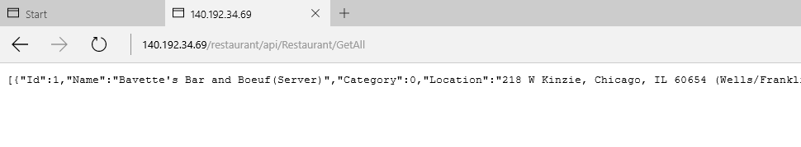

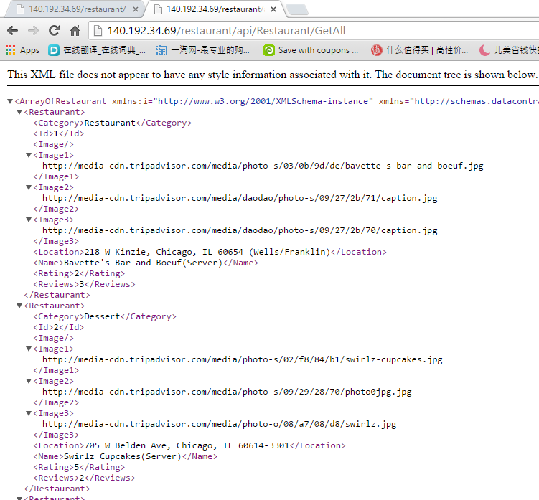

* + 1. Response for POST method

Server returns the operation result, which contains two attributes: Code and Message. Code=0 means, no error, operation succeeded. For example:

* {"RetCode":0,"Message":"Registration succeed!"}
* {"RetCode":1,"Message":"User Name, Email or Password can't be empty!"}

1. Used APIs

* Supporting multiple screen sizes (tablets and handsets) using Fragments
* Dynamic Data from Server
* Implicit intent, Float button for email.

1. Final Project Discussion
   1. Biggest Challenges
      1. Tablet Support

This app supports both phone and tablet use. During the development, we overcome lots of the difficulties to achieve this purpose. Fragment is not easy to handle.

* + 1. Dynamic Data

Most of the data for this Android app comes from backend API server. It cost us much time to build the server and APIs. It increases the complexity of this app. And more effort are spent on merging it with our app.

* 1. Limitation of the app
  2. Limitation of the Android SDK
  3. Overall experience

Learning how to develop Android app is a fantastic experience, especially when seeing our own app running properly as we expected. Though the functions are simple, there is a long way to go before publishing it to app store, we are still happy and proud of our achievement. Especially, we implement the dynamic data for this app. I like to use Java for developing Android apps. The handouts and samples provided by the instructor are really useful. It enables us to learn java and Android development quickly and efficiently.

Regarding the project, we have tried our best to add as many features as possible. We did encounter some obstacles/issues during the development. But at last, we overcome them and get the result we want. And it is really an indelible experience working together.

As a whole, we enjoyed this course and the Android development.

1. Group Member Contribution
   1. Rong Zhuang

* Setup the framework of the Android APP with fragment, menu bar.
* Search Function, Comment Submission
* Downloading pictures from remote server.
* Setup the framework of the API Sever with asp.net MVC.
* Build the APIs for restaurant, comment.
* Prepare the draft version of final document.
  1. Marlon Garcia
* Implement the login/register function in Android
* Implement the email float button
* Implement the rating
* Build the APIs for login, logout, registration and rating.
* Record the demo video