**CSC472-Project Proposal**

**Project Title:** Restaurant Recommendation System

**Team Project:** Yes. Rong Zhuang & Marlon Garcia

**Project Description:** This app can let user search the restaurant and submit their reviews/comments to the restaurant they are interested in. This system is made up with two parts, the frontend Android app and a backend web server which is built by .NET MVC.

**Functionalities:**

1. User register/login

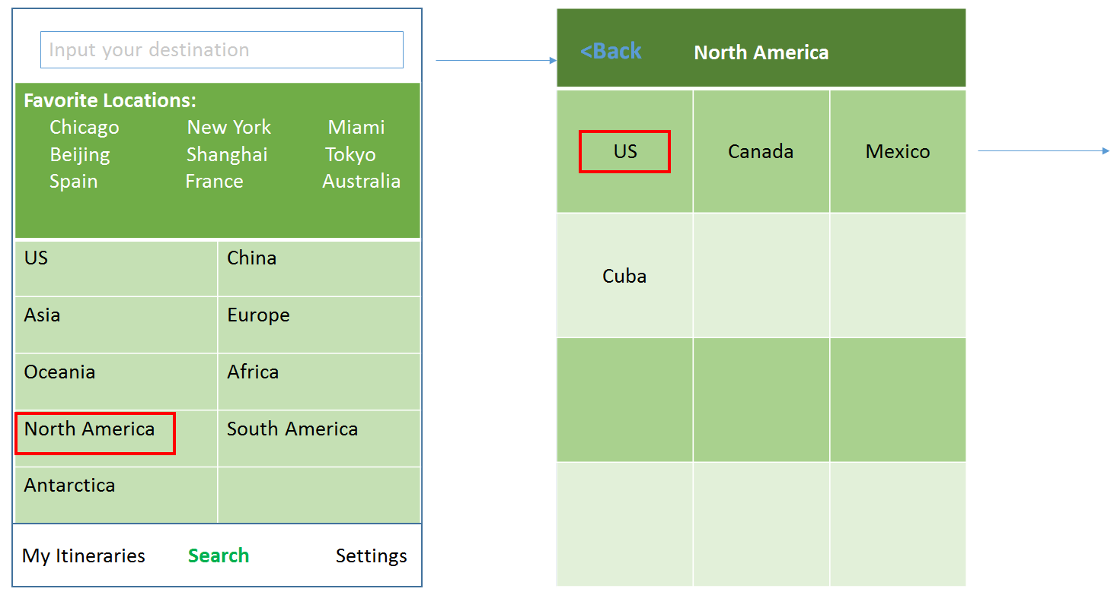

*Note: If the any of the favorite location is selected, it will navigate to the corresponding screen.*

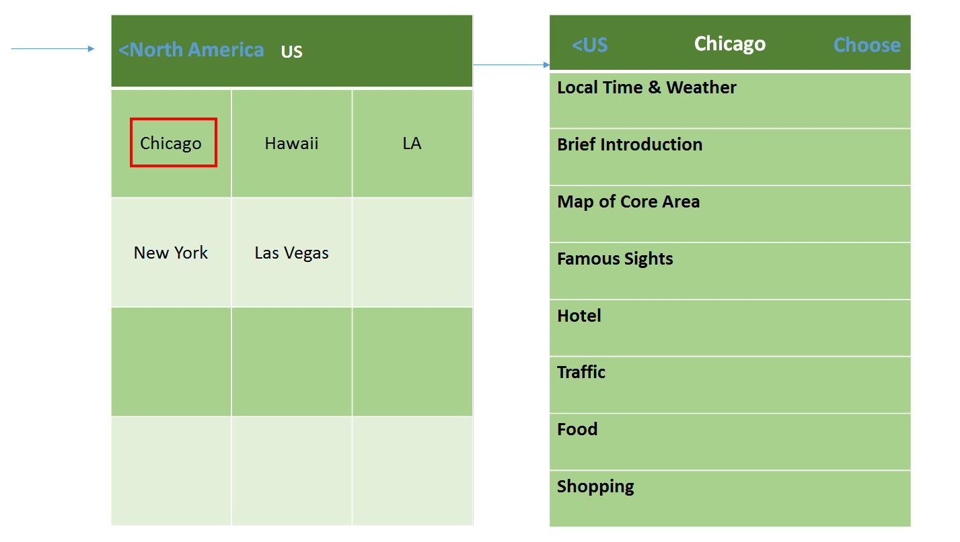

1. Search: Restaurant list.

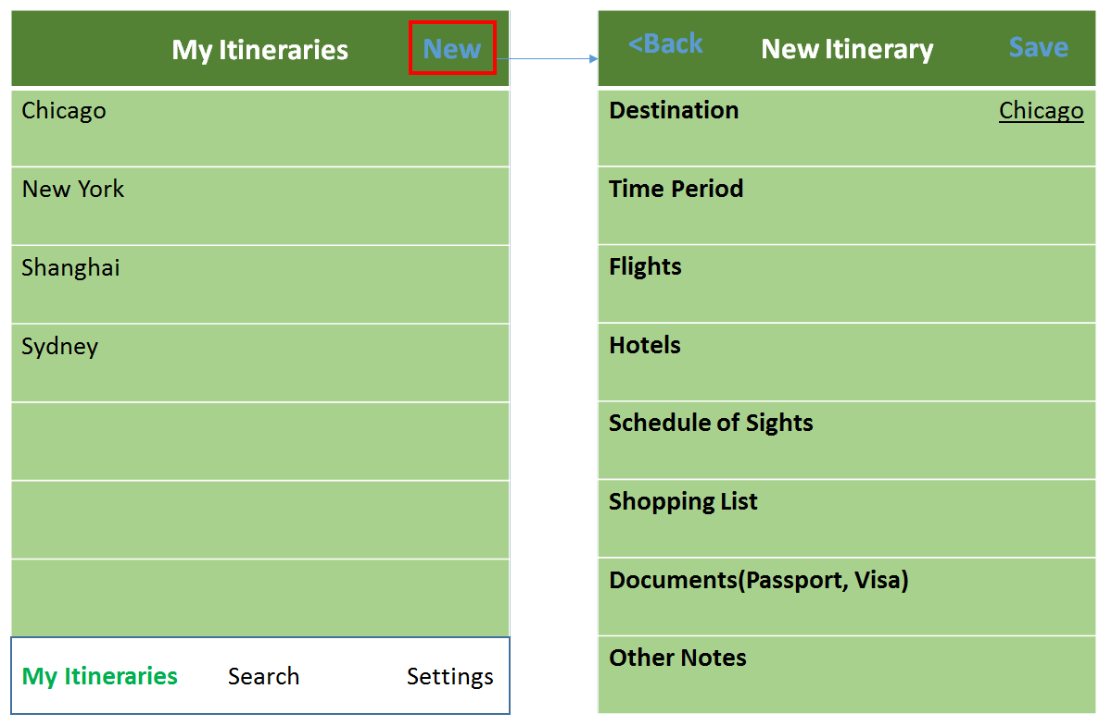

You can directly input destination in the itinerary details screen. Sub items within the itinerary includes: Destination, Time Period, Flights, Hotels, Schedule of Sight, Shopping List, Documents, Other Notes, etc.

1. Settings: Itinerary Settings, App settings.
2. Details: submit review/comment

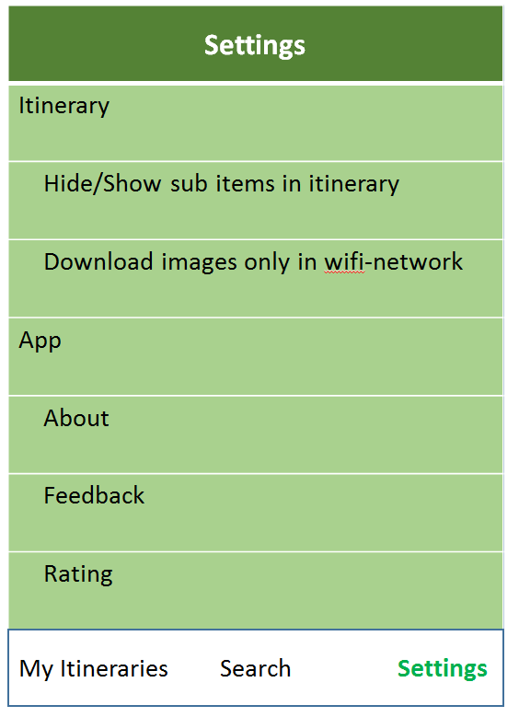

**API features:**

* Camera(Take picture for user profile)
* Location awareness(Locate the current position to find restaurants nearby)
* Google Map(Display restaurants in the map)
* Network(Wifi/Cellular, avoid downloading pictures when in cellular connection.)
* Multiple screen sizes support