Deploy web app which connects Azure SQL Database.

1. Create
2. Create App Service -> new Web App
3. Create Data + Storage -> new SQL Database
4. Create new database server(user, password, …)
5. Find the connection string of the created database

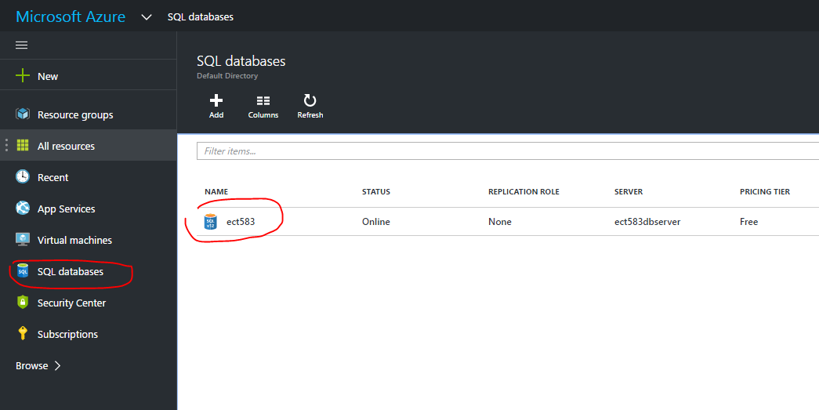

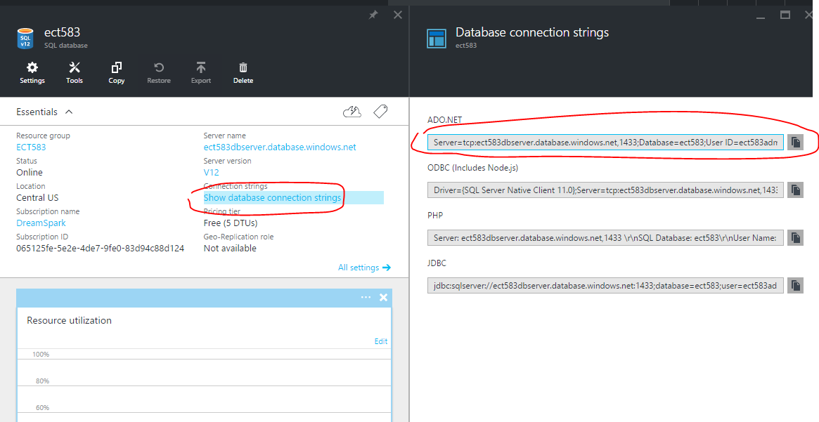

Server=tcp:ect583dbserver.database.windows.net,1433;Database=ect583;User ID=ect583admin@ect583dbserver;Password={your_password_here};Encrypt=True;TrustServerCertificate=False;Connection Timeout=30;

Replace with real password.

1. Access Azure database from local visual studio.
2. Find the new created SQL server(not SQL database)

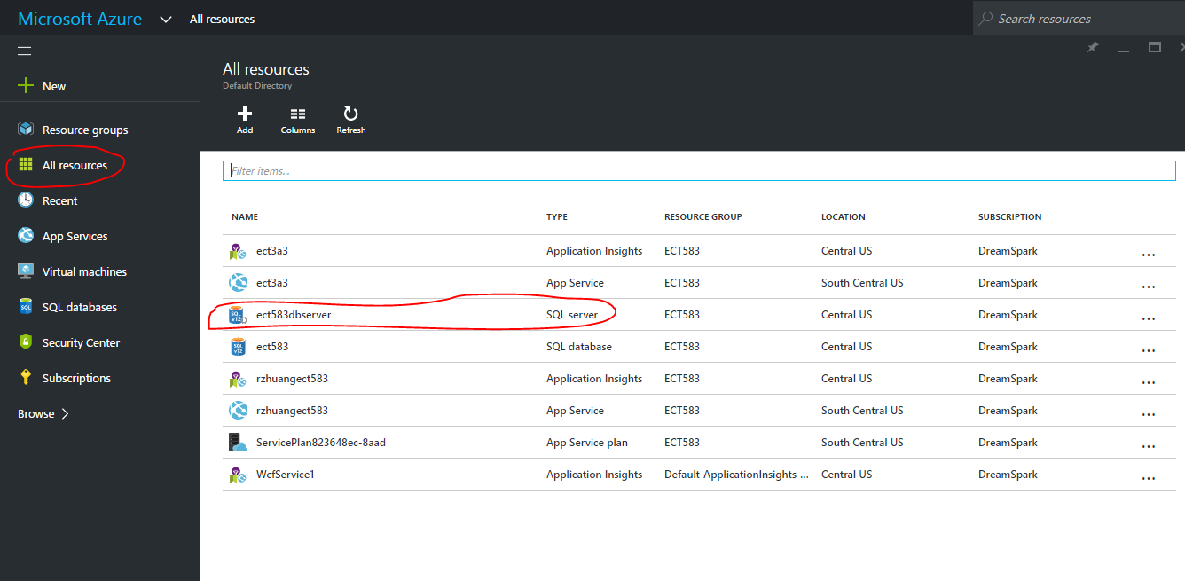

1. Add client IP address(140.192.34.30, my machine) to firewall list of Azure SQL server

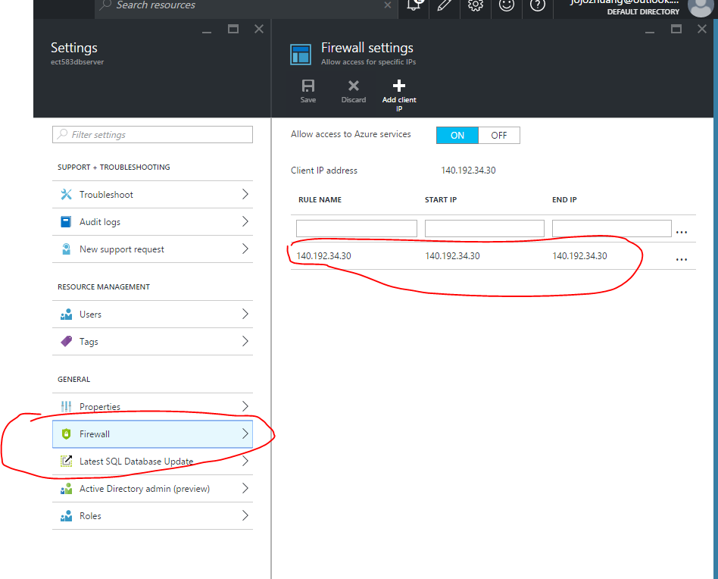

1. Replace the connection string in the web.config.

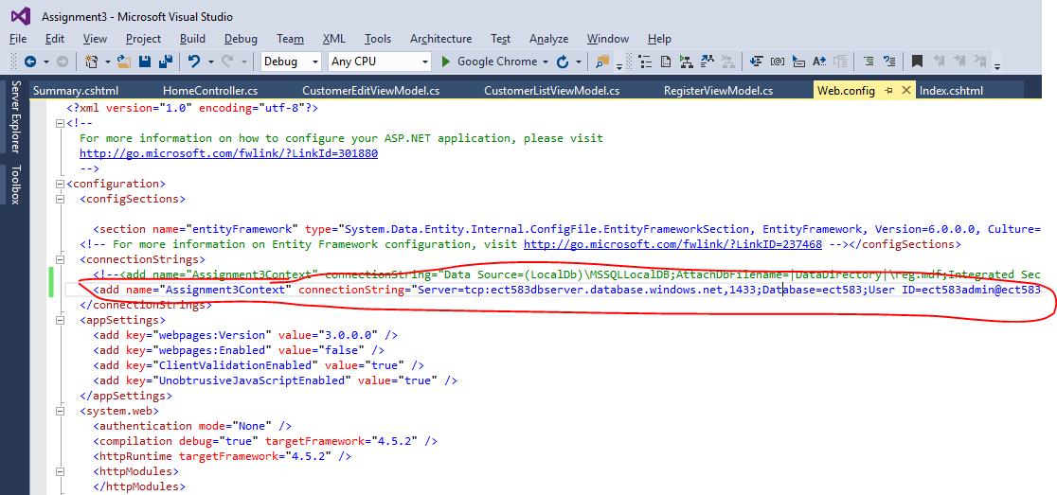

1. Launch application from visual studio, it should work.
2. Deploy web application to Azure and make it use Azure database.
3. Publish web application to Azure, same steps, only pay attention to the connection string.

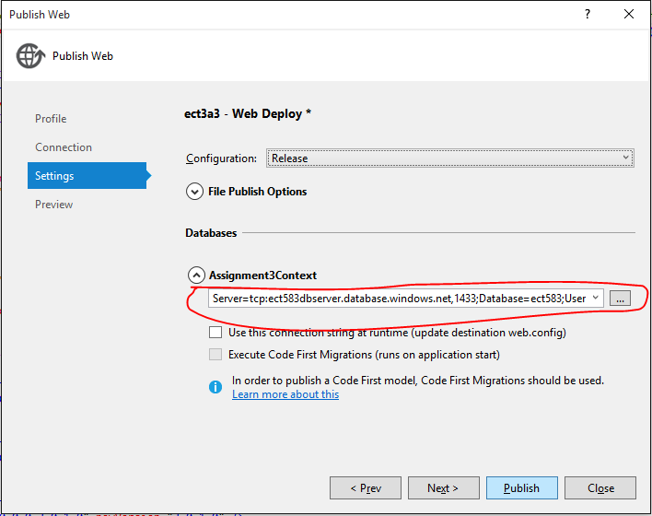

1. Find the new created web app.

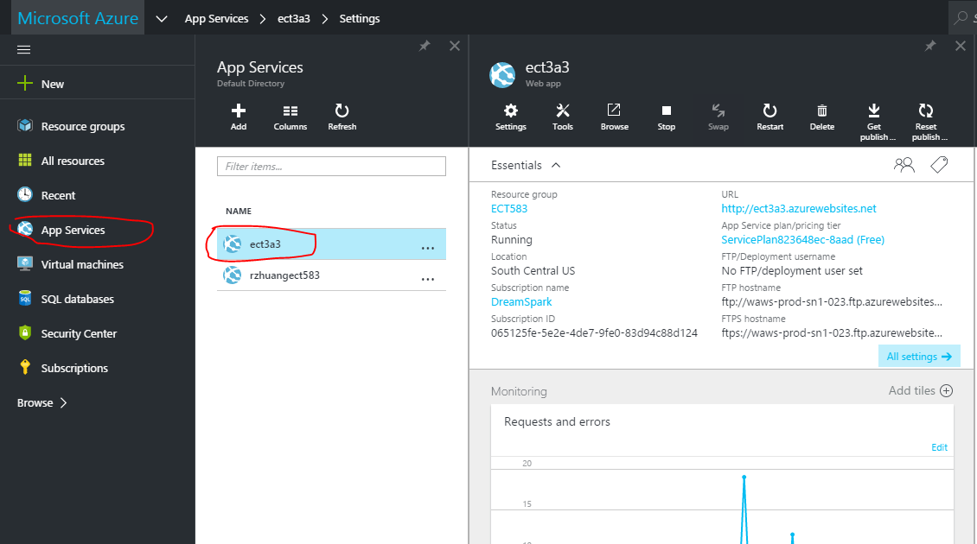

1. Application settings-> Connection strings.

Add new connection string with name and full connection string.

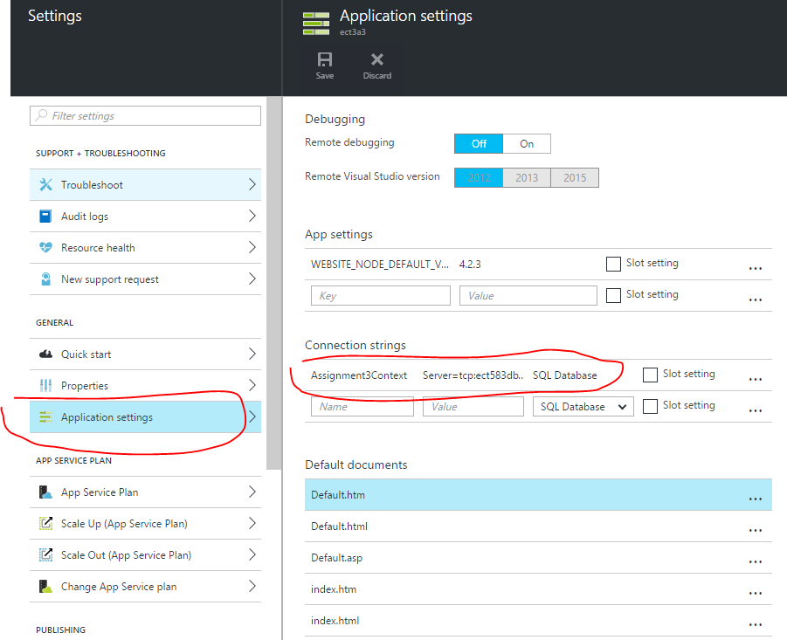

1. Your Azure website should work now.

