Assignment 4

Rong Zhuang

# Search Auto-Completion

You can search any product, including Console, Accessory, Game and Tablet.

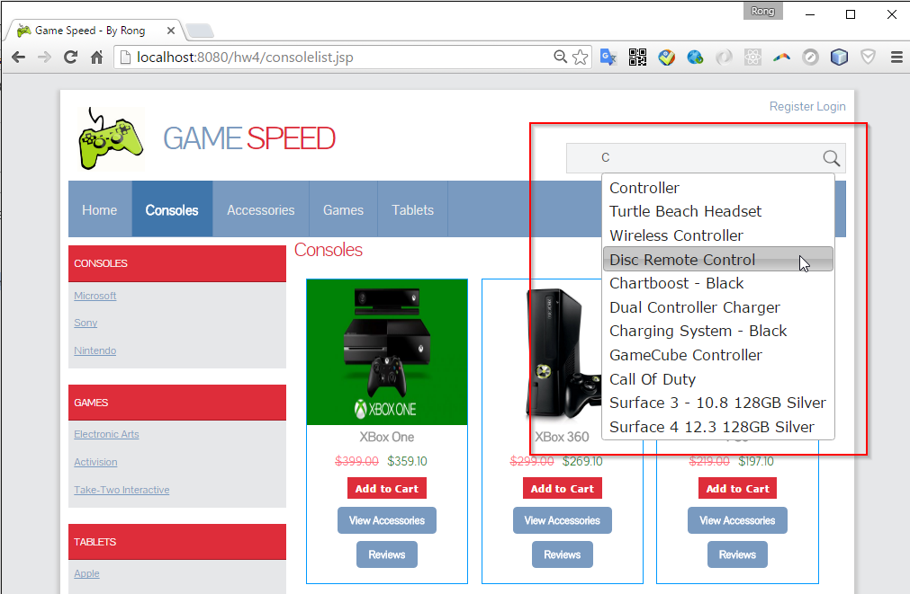

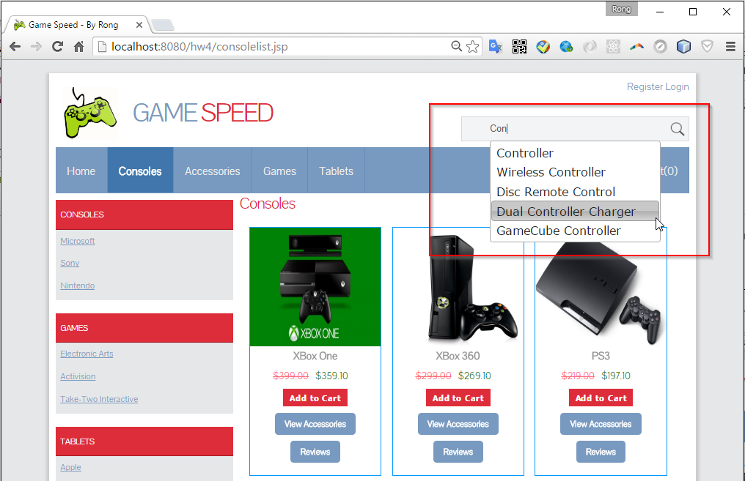

Search Result.

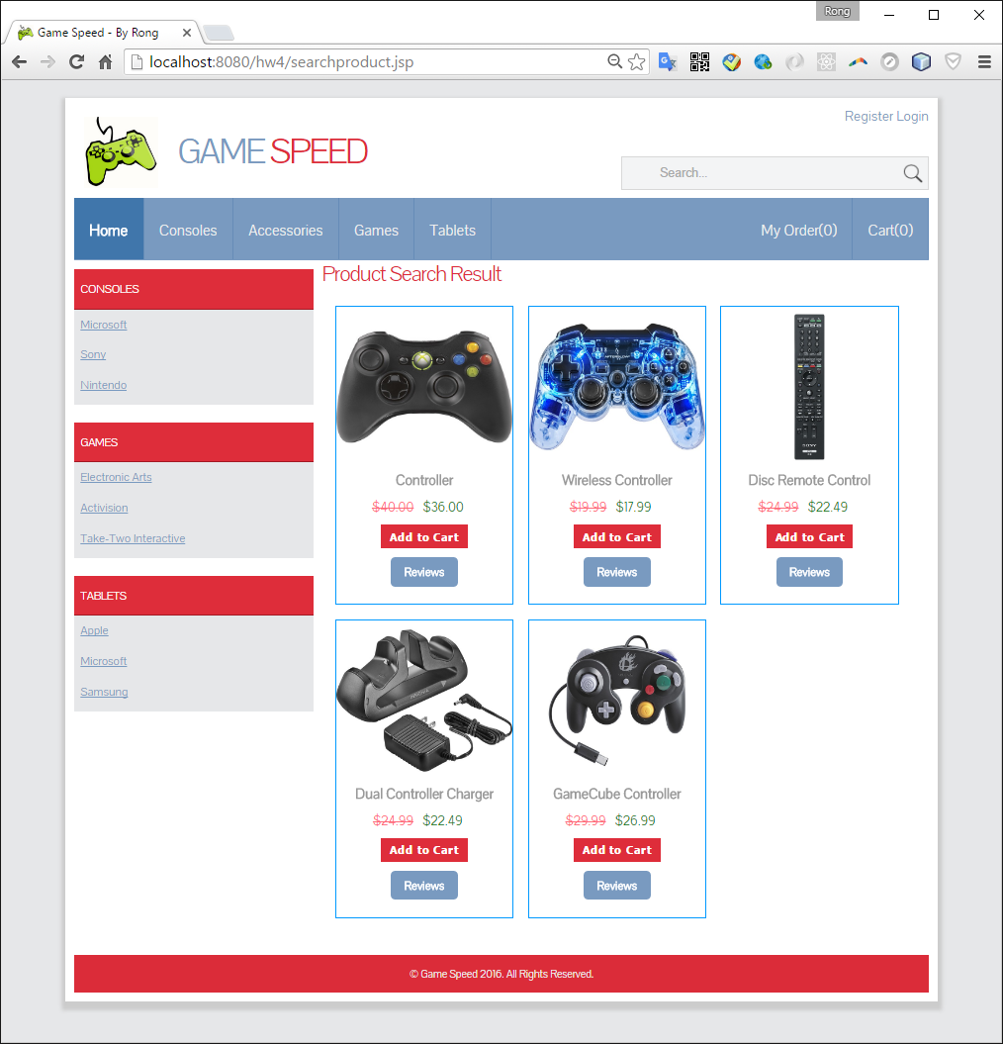

# Use MySql to persist Orders

* 1. Tables

SalesOrder and OrderItem

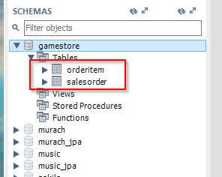

* 1. Create Order
     1. Check the current status

Currently, there are 6 orders already exist.

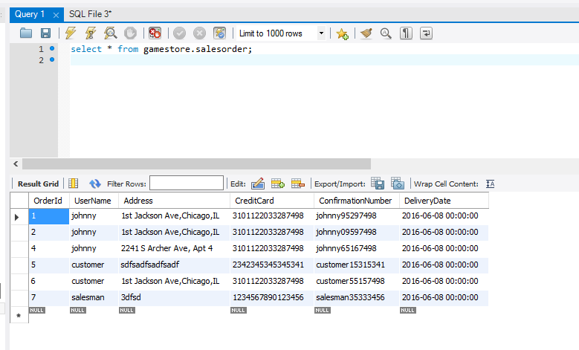

* + 1. Place Order

Add three items to cart.

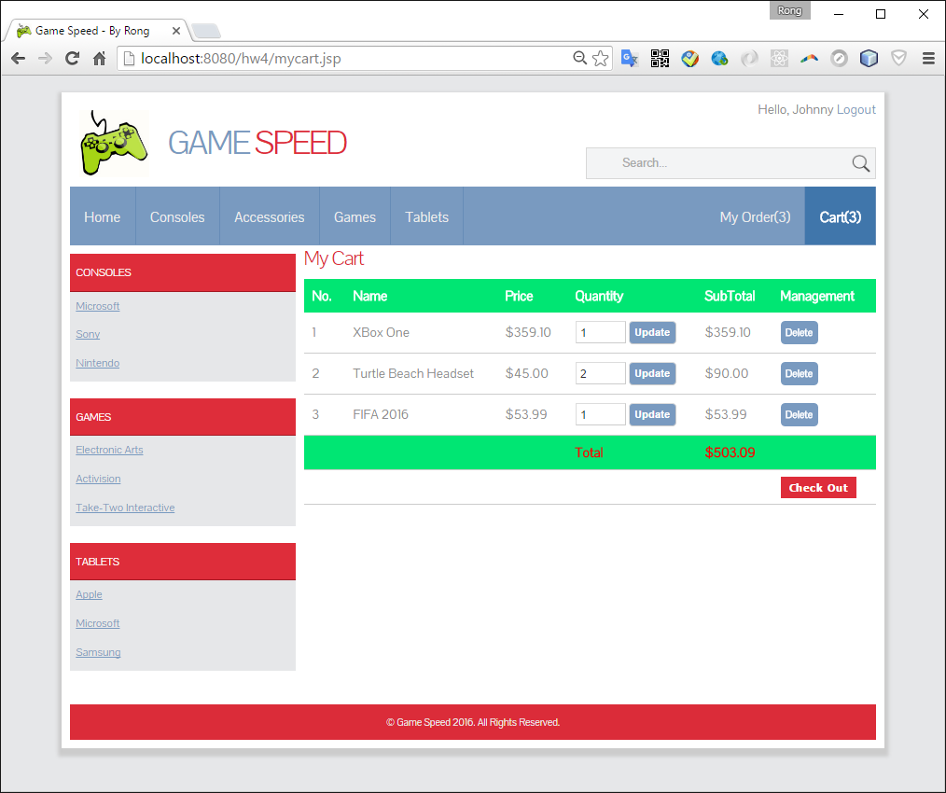

Checkout

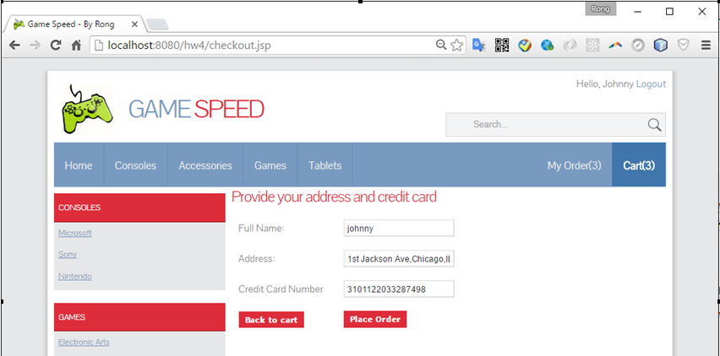

New order created.

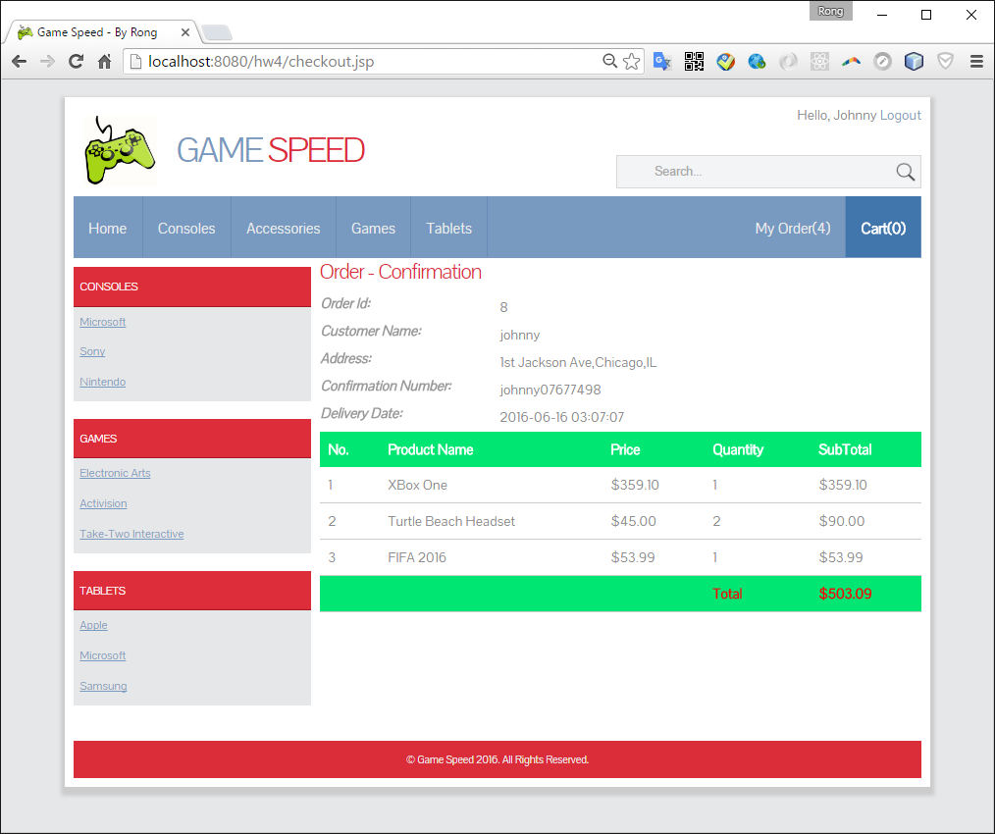

* + 1. Check in MySql Database

One more entry is inserted into SalesOrder table.

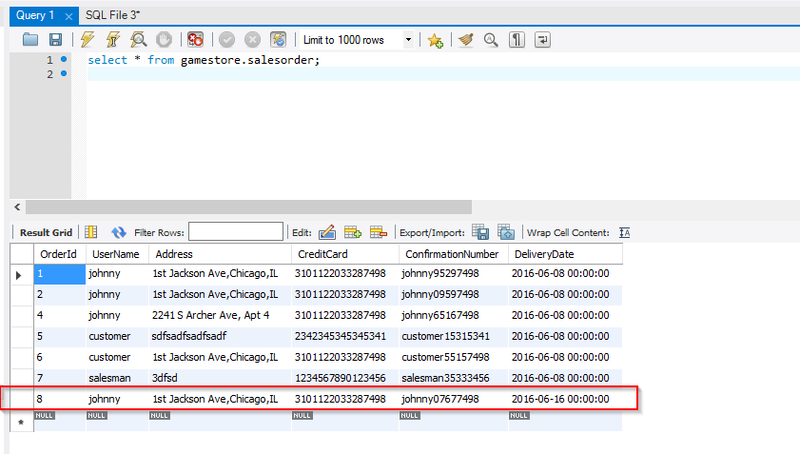

Check the orderitem table.

There are three new entries with the appropriate quantity are created.

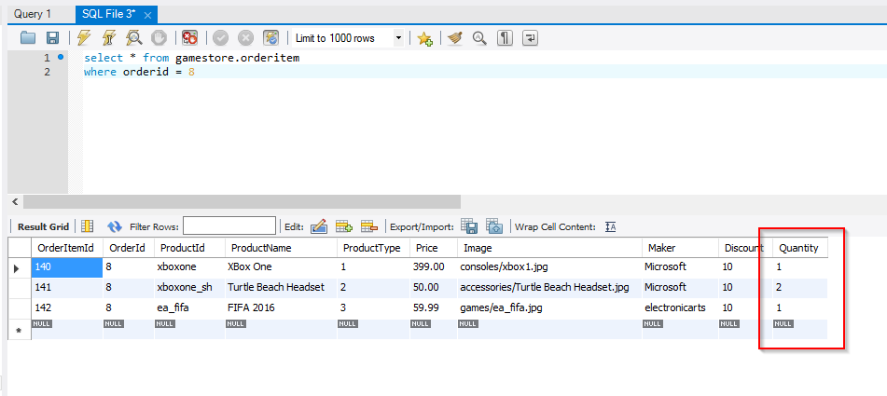

* 1. Update Order
     1. Check the current status

We will update the order just created which has the order id = 8.

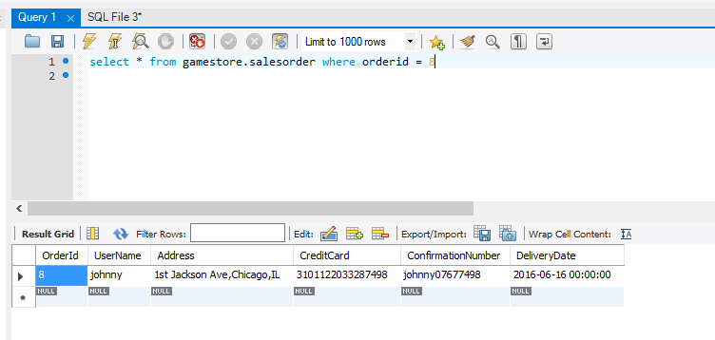

* + 1. Update Order

Login as ‘Salesman’, find the order in “All Orders”, click ‘Edit’ button.

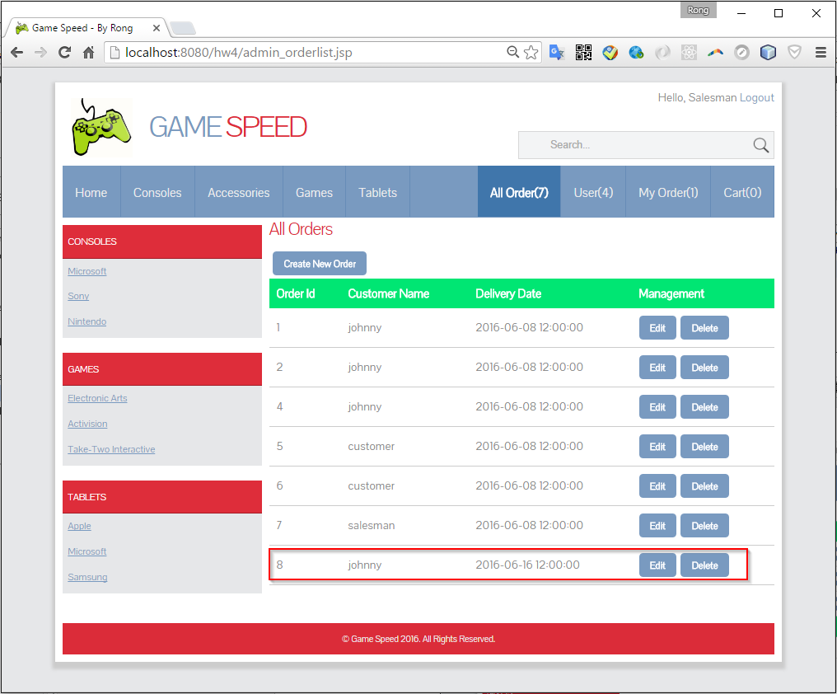

Update address to ‘243 s wabash chicago,il’ and change the quantity of ‘FIFA 2016’ to 6, click save.

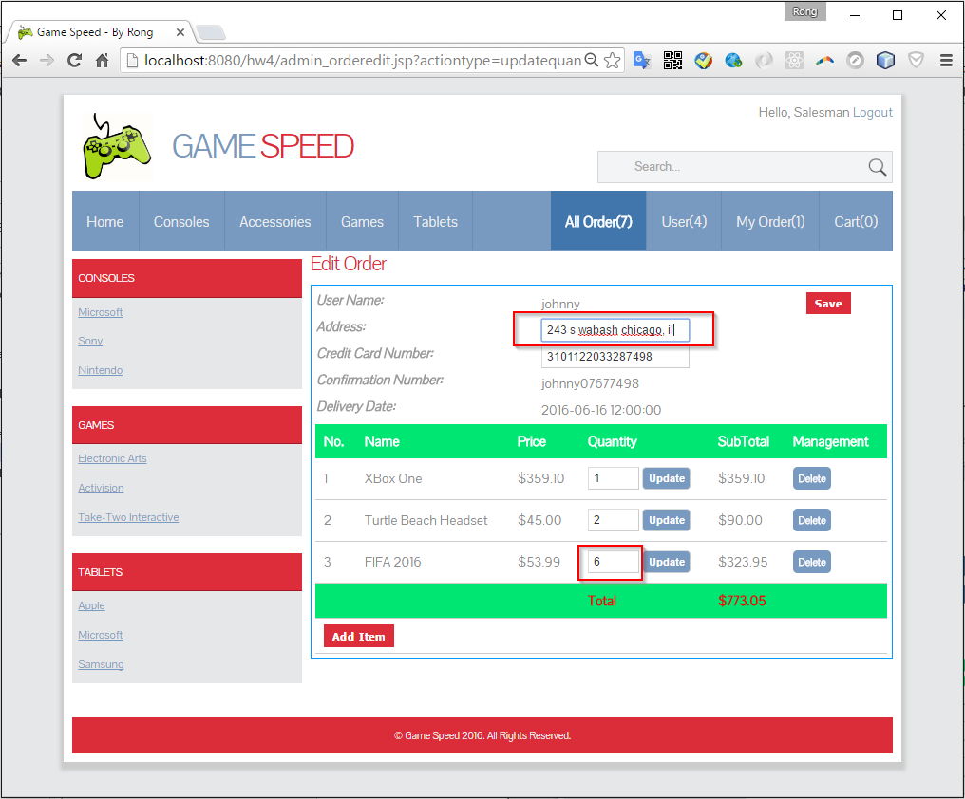

* + 1. Check in MySql Database

The address is updated accordingly.

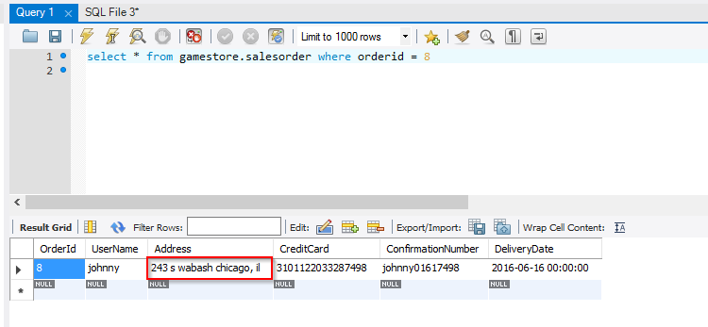

Check the orderitem table.

The quantity for item ‘FIFA 2016’ is updated to 6 correctly.

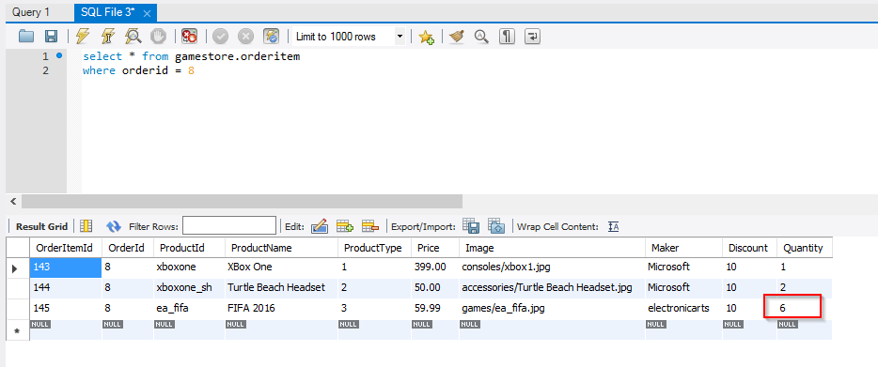

* 1. Delete Order
     1. Delete Order

Login as ‘Salesman’, find the order in “All Orders”, click ‘Delete’ button.

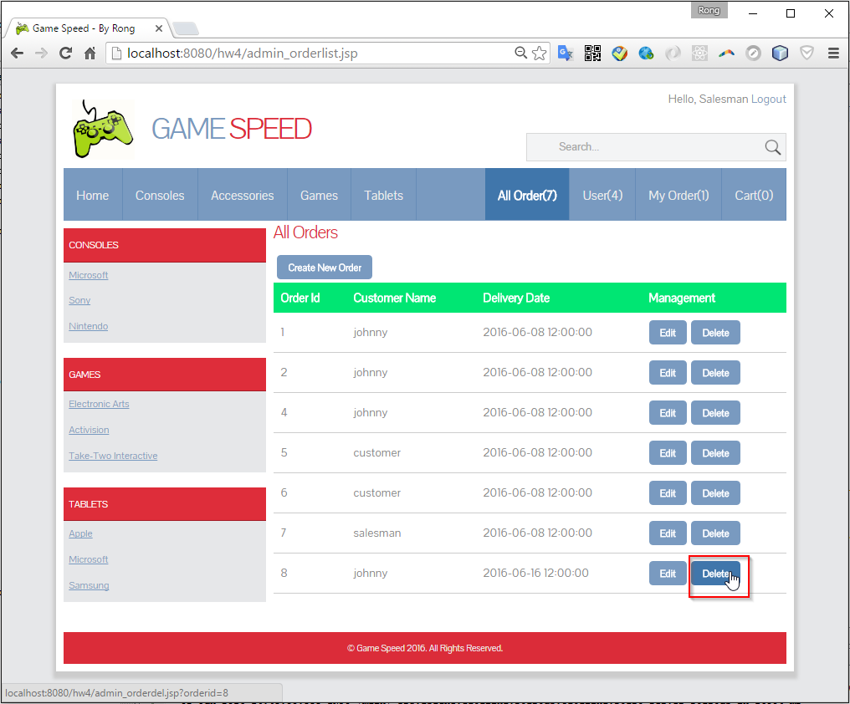

The order is removed from the list.

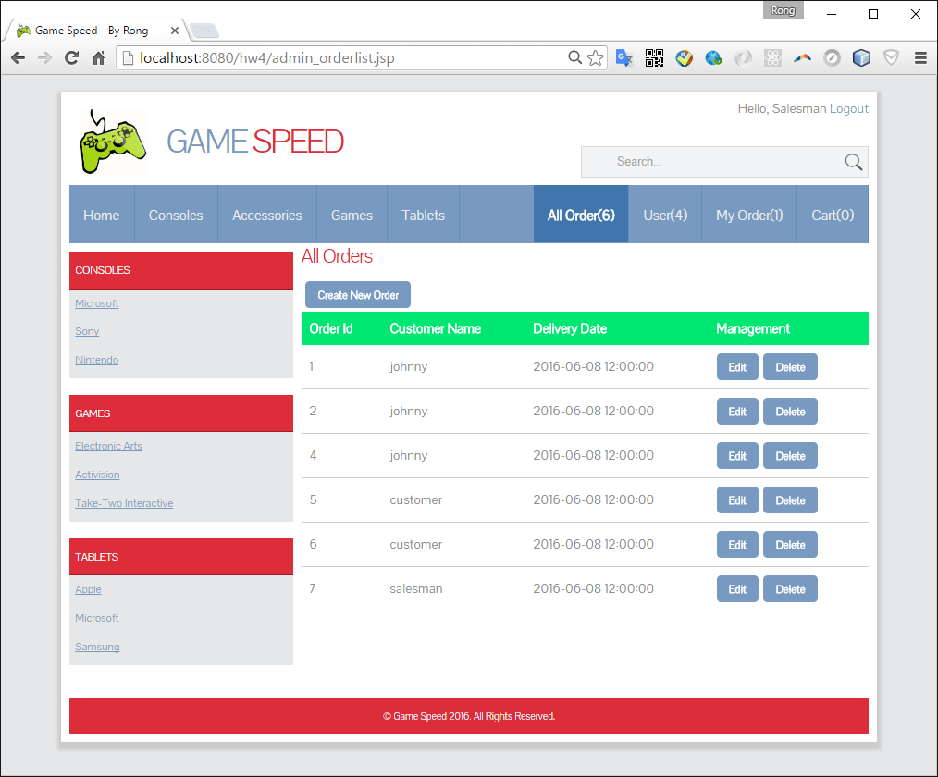

* + 1. Check in MySql Database

No entry found for order id = 8.

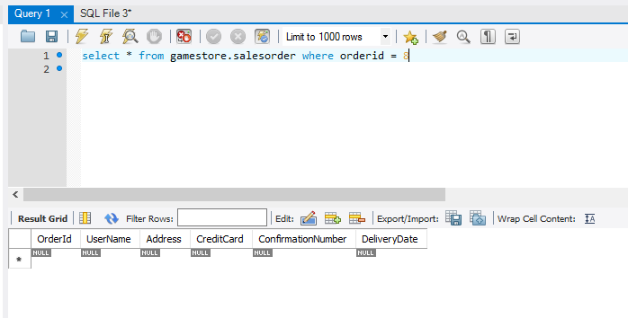

Check the orderitem table.

And no entry found for order id = 8, either.

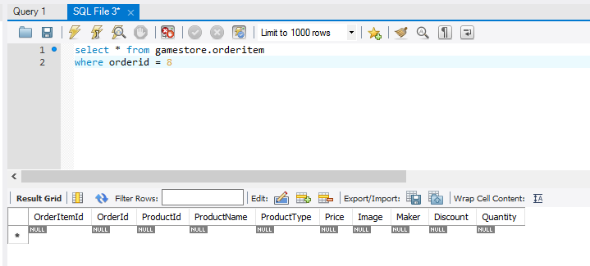

# Dependency

* 1. gson-2.3.1.jar

This library is used to convert json format data. It is used when implementing the auto complete function for search.

1. Put it into ‘lib’ folder of apache server. For example, ” C:\apache-tomcat-8.5.0\lib”.
2. Add “C:\apache-tomcat-8.5.0\lib\gson-2.3.1.jar” to environment variable ‘CLASSPATH’.
   1. SQL scripts for create

|  |
| --- |
| /***********************************************************  * Create the database named gamestore, its tables  ************************************************************/  DROP DATABASE IF EXISTS gamestore;  CREATE DATABASE gamestore;  USE gamestore;  CREATE TABLE SalesOrder (  OrderId INT NOT NULL AUTO_INCREMENT,  UserName VARCHAR(50),  Address VARCHAR(50),  CreditCard VARCHAR(50),  ConfirmationNumber VARCHAR(50),  DeliveryDate DATETIME,    PRIMARY KEY(OrderID)  );  CREATE TABLE OrderItem (  OrderItemId INT NOT NULL AUTO_INCREMENT,  OrderId INT,  ProductId VARCHAR(50),  ProductName VARCHAR(50),  ProductType INT,  Price Double(10,2),  Image VARCHAR(50),  Maker VARCHAR(50),  Discount INT,  Quantity INT,    PRIMARY KEY(OrderItemID)  ); |