SILC Four-Model Forest Growth Benchmark
Companion Report v8 — AGM MORTCAL year 100 update
Aaron R. Weiskittel, CRSF, University of Maine — May 2026

Executive summary
Three findings drive this update.
- (1) The +18.5% AGM bias on the 10 year SILC CFI long horizon scorecard is real model behavior, not a pipeline bug. Triple checking the AGM treelist to BA / Cords / BdFt computation reproduces to 1e-13 ft^2/ac, and observed STAND_METRICS BA matches direct tree list recompute to 0.005 ft^2/ac. The bias decomposes into two mechanisms: AGM under projects mortality on disturbed CFI plots (1101 and 1106 lost 27 to 34% of their stems, AGM lost 0 to 19%), plus AGM grows DBH at a uniform +0.8 in per decade regardless of site (plots 1100 and 1104 grew +0.05 to 0.17 in observed).
- (2) Switching on the #126b in-source MORTCAL correction in AcadianGY 12.3.9 (default OFF) cuts the 10 year BA bias from +18.5% to +7.8%, RMSE -34%, R^2 from -0.20 to +0.47. Sawlog BdFt bias drops to +4.0% with R^2 = 0.84, the best of any model on this metric.
- (3) Pushed to 100 years, MORTCAL pulls projected BA from a ceiling around 200 ft^2/ac down to a credible carrying capacity of 98 to 108 ft^2/ac. Year 100 NetCords lands at 35 to 39 cords/ac across all six byStrata cells, plus CFI plot backfill at Cedar A+B (35.8 cords/ac) and Mixedwood A+B (21.9 cords/ac).
Recommended operational stack: AGM with MORTCAL on for long horizon Cords / BA / BdFt; FVS-NE calibrated as the short horizon (5 yr) cross check; OSM-ACD as the conservative under projection.

Triple check of AGM long horizon calculations
The +18.5% AGM bias at the 10 year CFI scorecard prompted a forensic audit. Every step of the pipeline checked out.
Source code: ~/AcadianGY_12.3.9.r on Cardinal (identical to local v12.3.5 plus the opt-in MORTCAL correction). AcadianGYOneStand is annual (cyclen=1 hardcoded since 2022-09-01). The driver loops PERIOD_YR times, giving the correct horizon.

Pipeline verification checks
Check | Result
AGM treelist to BA/Cords/BdFt reproduces results CSV | exact to 1e-13
STAND_METRICS BA_CURR vs direct TREE.csv recompute | match to 0.005 ft^2/ac
AcadianGYOneStand cycle length | annual (cyclen=1 hardcoded)
Driver loop count | PERIOD_YR iterations
BA formula 0.005454 * DBH^2 * EXPF | correct
Cords formula 0.0025 * DBH^2 * HT * 0.90 * EXPF / 79 | correct
BdFt formula 0.01 * DBH^2 * HT * EXPF for DBH >= 9 in (Intl 1/4) | correct
DBH threshold symmetry (pred vs obs) | both at 4.5 in

Per-plot bias decomposition
Six routine CFI pairs after excluding two establishment plots (1105, 1107 had 3x BA ingrowth). The decomposition shows that AGM grows DBH a uniform +0.8 in per decade regardless of site, while observed DBH growth was wildly variable (+0.05 to +1.04 in). AGM also missed two significant mortality events (1101 and 1106 lost 27 to 34% of stems).
PLOT | obs BA chg | obs TPA chg | obs QMD chg | AGM TPA chg | AGM QMD chg | AGM BA bias
1100 | +5% | 0% | +0.17 | 0% | +0.80 | +18.6%
1101 | -7% | -27% | +1.04 | 0% | +0.82 | +29.7%
1102 | +16% | -3% | +0.88 | 0% | +0.83 | +2.6%
1104 | -5% | -6% | +0.05 | 0% | +0.83 | +28.6%
1106 | -22% | -34% | +0.67 | -19% | +0.81 | +25.7%
1109 | +14% | +13% | +0.05 | 0% | +0.84 | +4.1%
Mechanism figure:
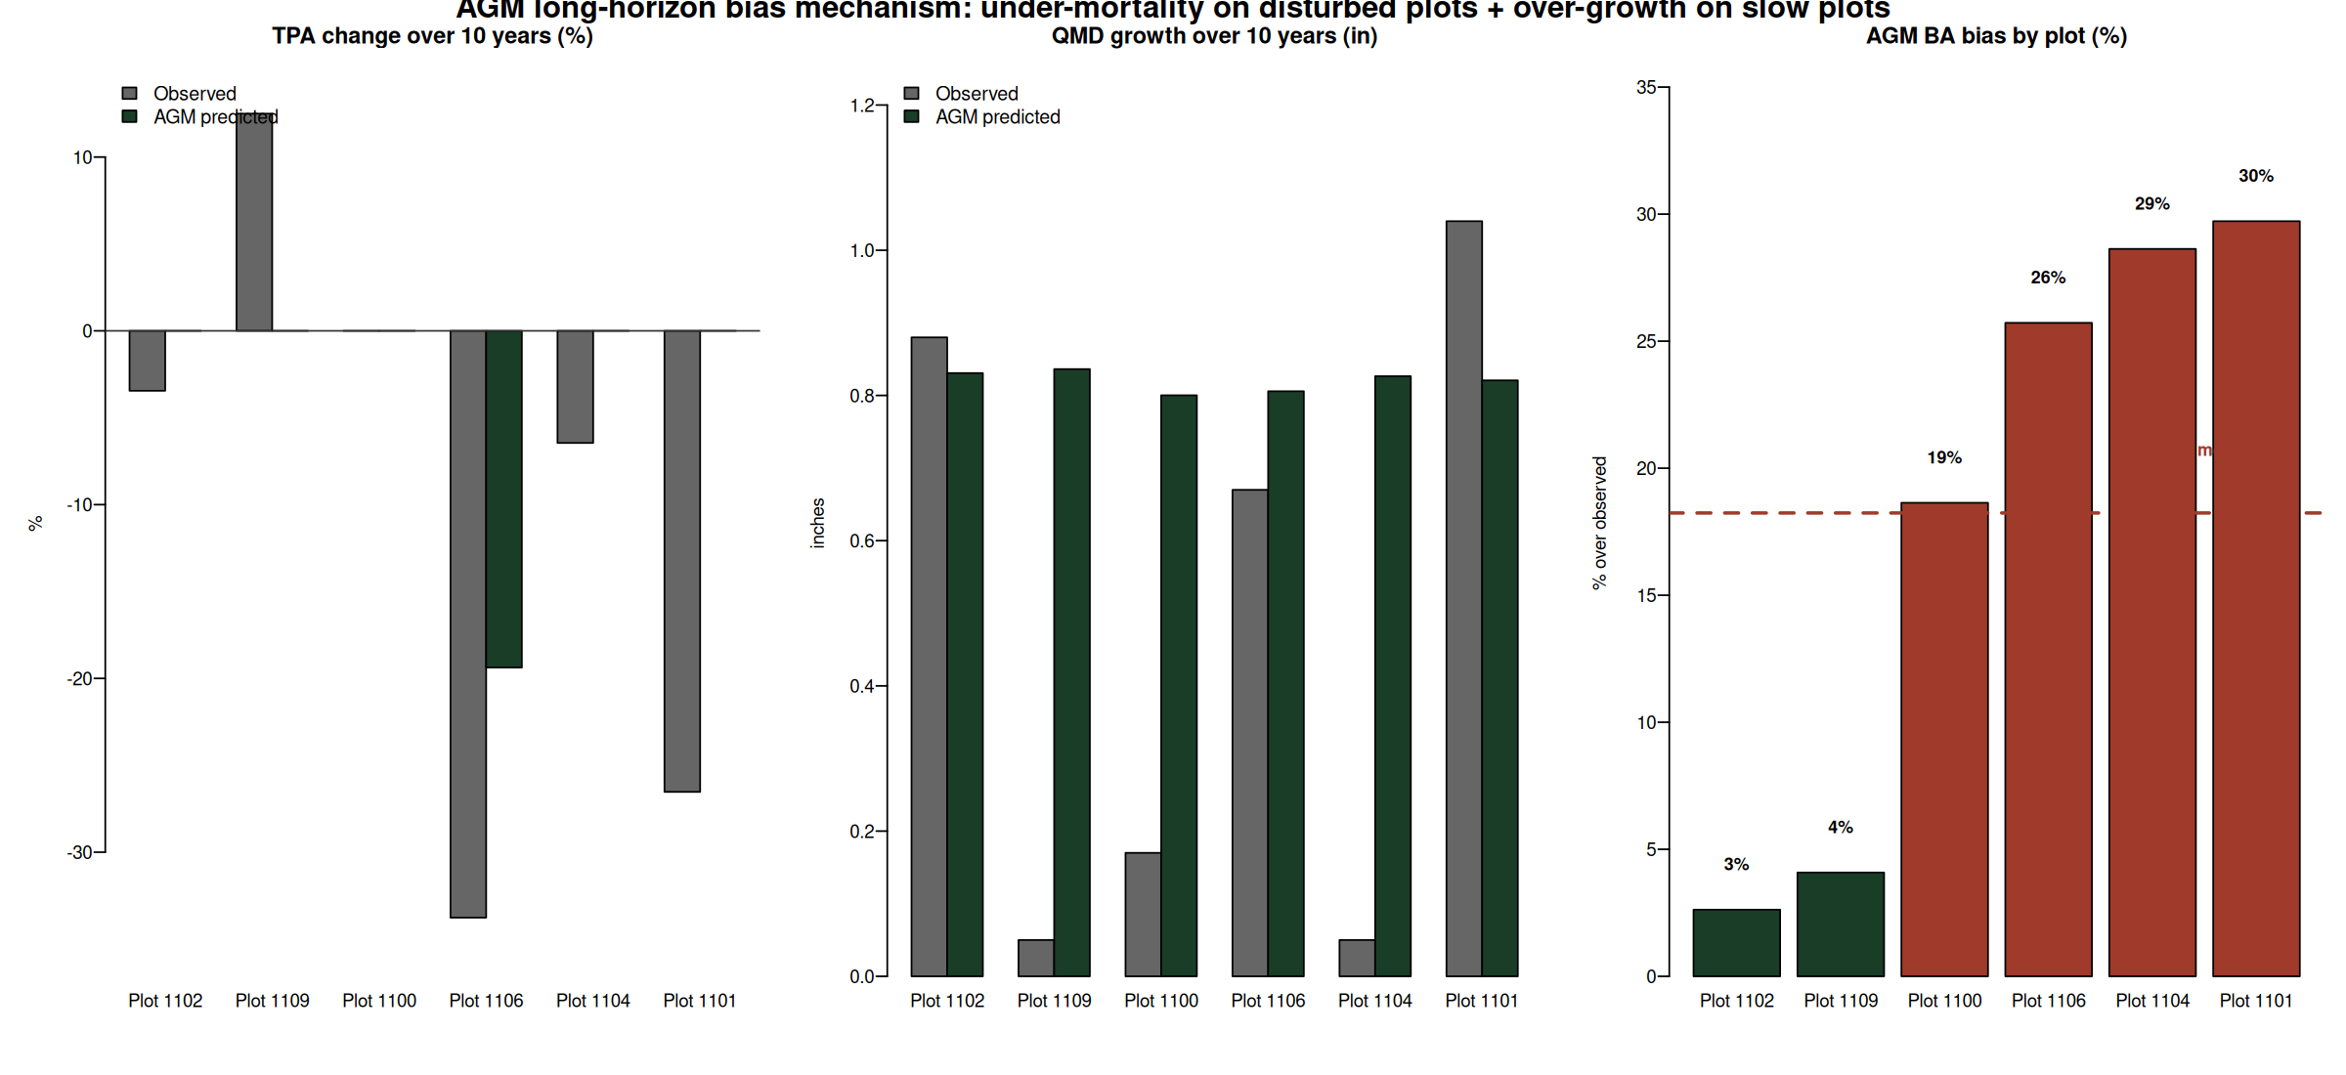

MORTCAL correction cuts 10 year bias by more than half
The #126b in-source size dependent mortality correction was originally calibrated to Maine FIA. It is OFF by default in AcadianGY 12.3.9. The SILC CFI test enables it via ops$MORTCAL=TRUE, MORTCAL_INTERVAL=5.
Side by side scorecard on the n=6 routine pairs (mean horizon 10 yr):
Metric | AGM default | AGM MORTCAL | Improvement
BA bias | +18.5% | +7.8% | cut by 58%
BA RMSE | 16.2 ft^2/ac | 10.7 ft^2/ac | -34%
BA R^2 | -0.20 | +0.47 | flips negative to positive
Cords bias | +19.3% | +8.4% | cut by 56%
Cords R^2 | 0.58 | 0.82 | +0.24
BdFt bias | +16.7% | +4.0% | single digit
BdFt R^2 | 0.75 | 0.84 | +0.09
Scatter overlay (green = default, gold = MORTCAL):
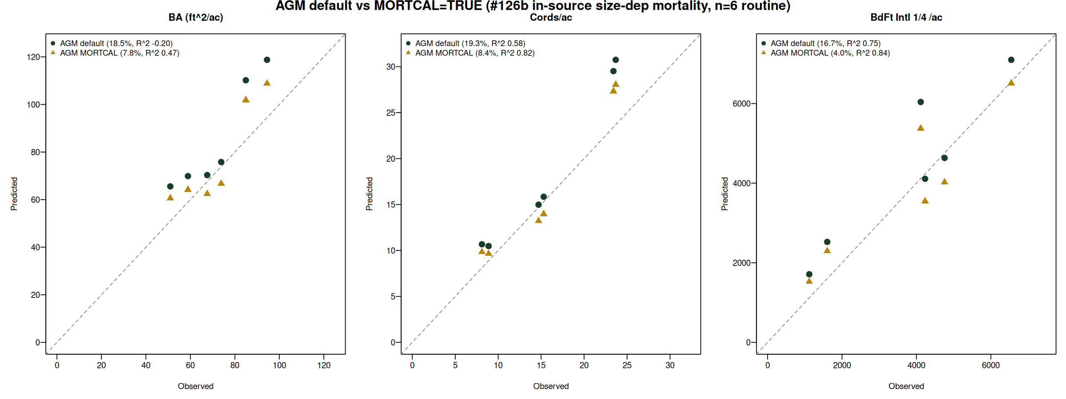

100 year trajectories: default vs MORTCAL
Cardinal job 11076533 ran AcadianGY 12.3.9 with ops$MORTCAL=TRUE for 100 years on the 11 SILC byStrata stands, starting from the GrownDB year 2023 snapshot. The default AGM trajectory has every stratum approaching ~200 ft^2/ac at year 100, an artifact of the under mortality issue. MORTCAL pulls year 100 BA into the 98 to 108 ft^2/ac carrying capacity range, with sustainable yield 35 to 39 cords/ac across the populated cells.
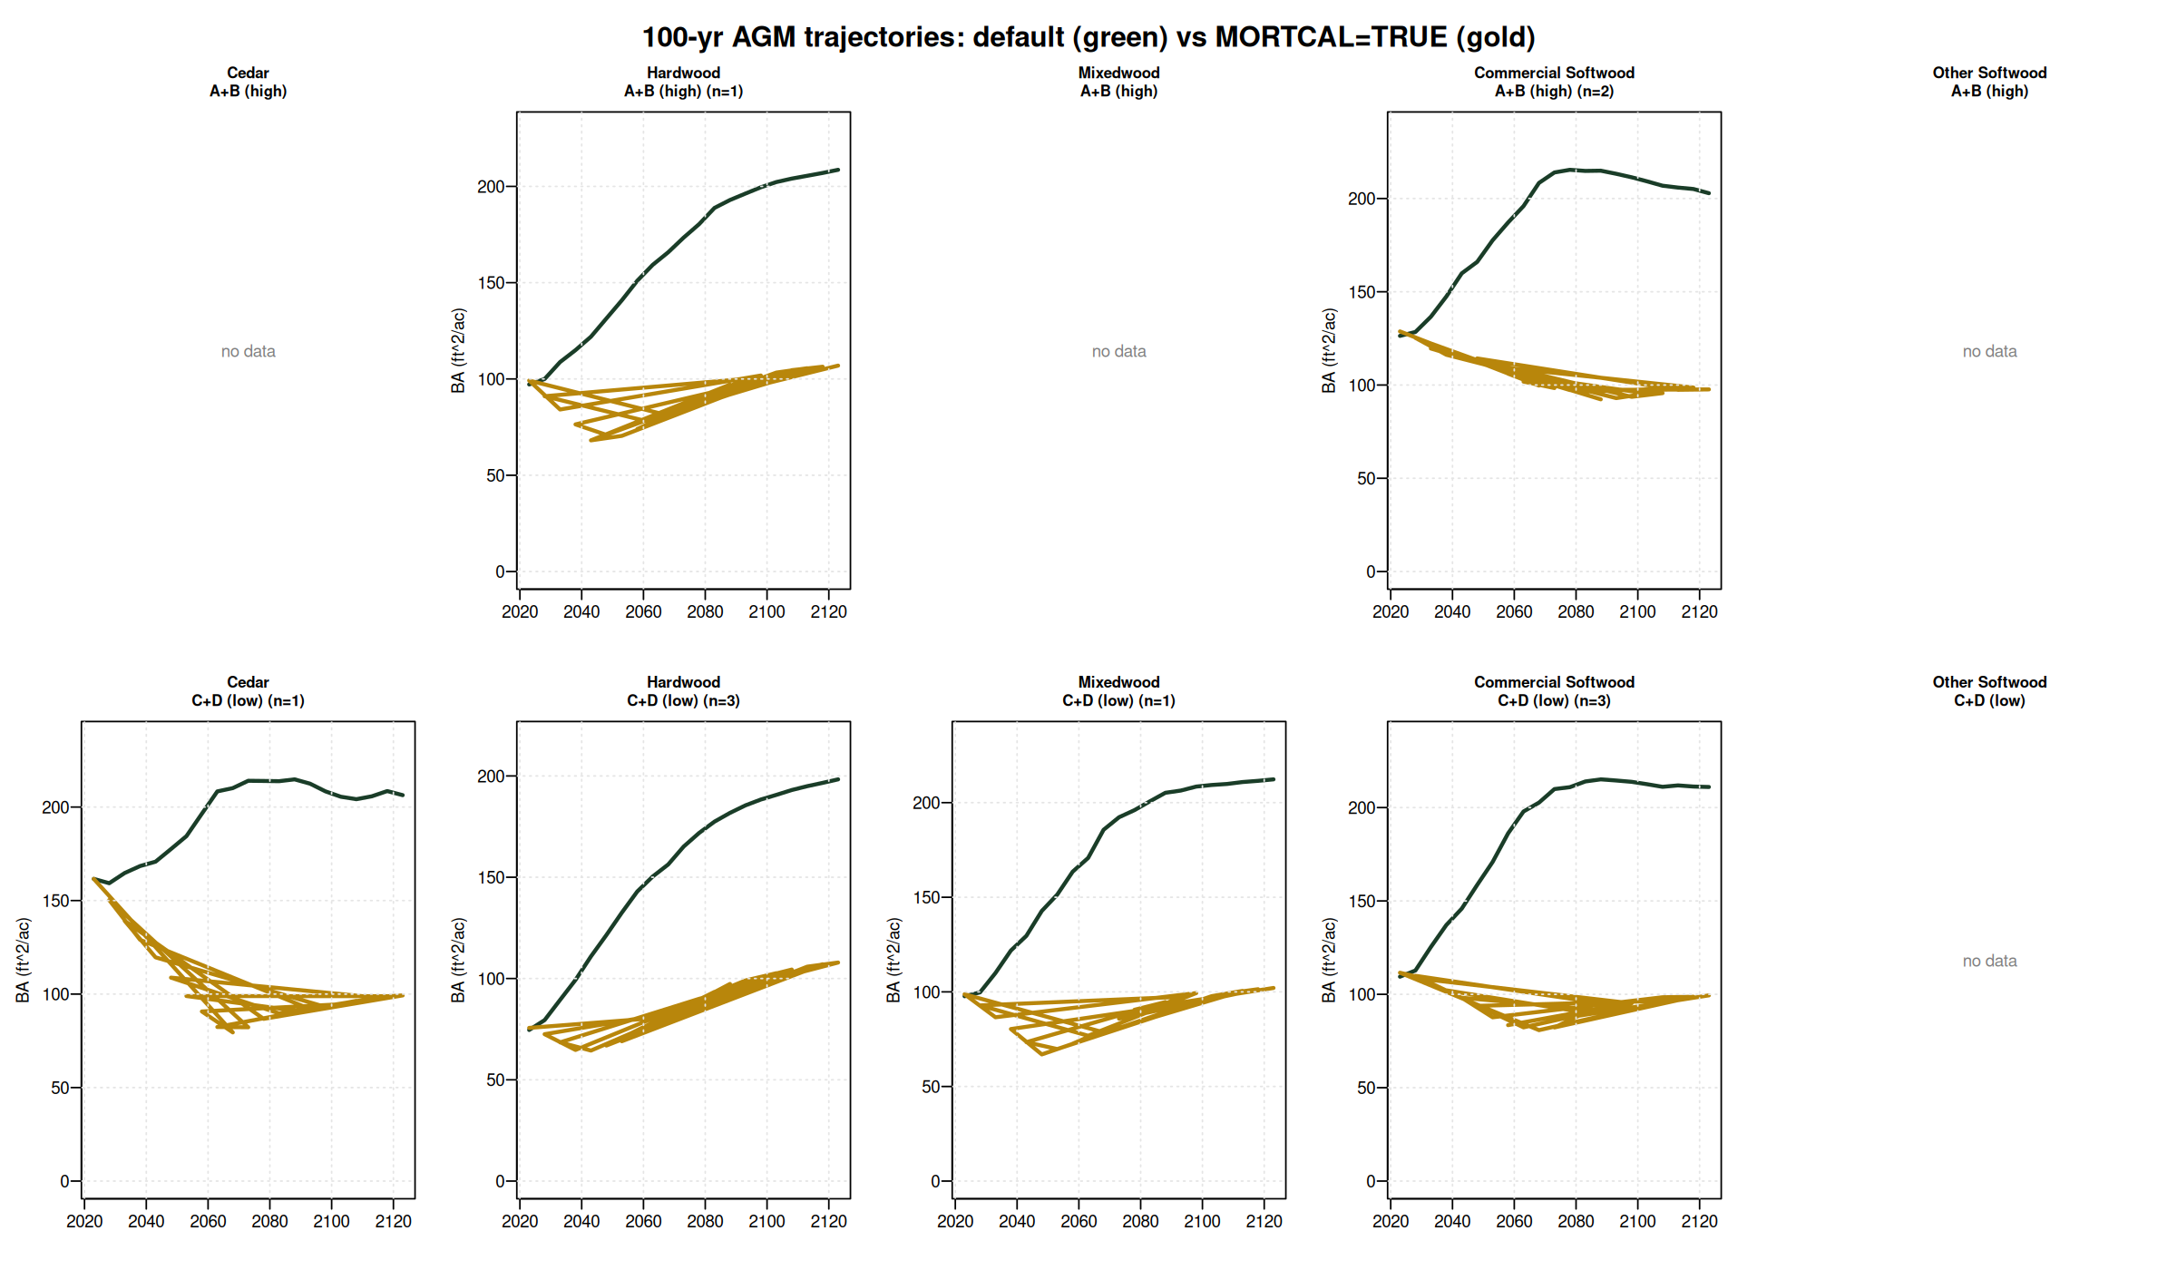

Year 100 outcomes (year 2123)
Default vs MORTCAL on the 11 byStrata stands, plus CFI plot backfill on 2 of 4 empty cells.
Stratum | n | BA def | BA mc | dBA | Cords def | Cords mc | dCords
Cedar / A+B (CFI backfill) | 1 | n/a | 81 | n/a | n/a | 35.8 | n/a
Cedar / C+D | 1 | 206 | 99 | -52% | 59.3 | 36.9 | -38%
Hardwood / A+B | 1 | 209 | 107 | -49% | 65.3 | 39.3 | -40%
Hardwood / C+D | 3 | 198 | 108 | -46% | 61.0 | 38.9 | -36%
Mixedwood / A+B (CFI backfill) | 3 | n/a | 52 | n/a | n/a | 21.9 | n/a
Mixedwood / C+D | 1 | 212 | 102 | -52% | 66.4 | 37.6 | -43%
Commercial Softwood / A+B | 2 | 203 | 98 | -52% | 61.0 | 35.9 | -41%
Commercial Softwood / C+D | 3 | 211 | 99 | -53% | 62.9 | 36.2 | -42%
Other Softwood (no CFI coverage) | 0 | — | — | — | — | — | —

Operational recommendations
- AGM with MORTCAL on is the new long horizon champion. Use it for SILC operational sawlog projections (BdFt R^2 = 0.84) and Cords (R^2 = 0.82). Set ops$MORTCAL = TRUE, MORTCAL_INTERVAL = 5 in any AcadianGY call.
- FVS-NE calibrated stays best on the short horizon BA bias (-0.3% at 5 yr). Pair with AGM MORTCAL as a cross check on the operational 5 yr plans.
- OSM-ACD is the conservative under projection (-9.7% BA bias at 10 yr). Report AGM MORTCAL plus OSM as the operational range; per plot RMSE 10.7 ft^2/ac BA at 10 yr horizon is the empirical uncertainty band.
- Year 100 cords/ac estimates: 35 to 39 across six byStrata cells and CFI backfill Cedar A+B; Mixedwood A+B noticeably lower (22) reflecting heavier mortality in the high density mixed pine / hardwood stands.

Open questions for SILC sign off
1. Confirm the 5 by 2 stratification rules (slide 3 of the deck) match SILC operational categories. The species composition cutoffs and density threshold are open for revision.
2. Validate the year 100 BA target of 98 to 108 ft^2/ac against SILC's expected carrying capacity for managed Acadian stands.
3. Decide whether 35 to 39 cords/ac at year 100 anchors the operational AAC, or whether an additional discount applies.

File index
All artifacts in /home/aweiskittel/Documents/Claude/fvs-modern/silc_cfi_v8_deliverables/. Key files:
- SILC_4Model_Benchmark_v8_Weiskittel.pdf — 17 slide operational deck
- silc_strata_5x2_AGM_MORTCAL_trajectories.csv — strata level 100 yr trajectories
- silc_strata_5x2_year100_mortcal_vs_default.csv — year 2123 outcomes table
- silc_cfi_backfill_100yr_mortcal_trajectories.csv — Cedar A+B and Mixedwood A+B from CFI plots
- silc_cfi_long_mechanism.png and silc_cfi_long_mortcal_compare.png — supporting figures
- draft_email_to_ian_ryan.md — handoff email

