
A staged plan to refine FVS
FIA calibration, a localized density limit, and a CONUS-wide single variant
A single report for the USDA Forest Service FVS team
A. Weiskittel and collaborators
Center for Research on Sustainable Forests, University of Maine
14 June 2026
All analyses use FIA remeasurement data; no FVS source or default was modified.

Contents

Executive summary
This report presents our FVS refinement work as one plan with three steps that move from near-term, deployable improvements to a long-term modernization. Each step stands alone and improves FVS; together they modernize it end to end.
Step 1 layers FIA-derived calibration modifiers onto the existing FVS engine, the basis of our fvs-modern work, and already beats the regional Northeast and Acadian variants on basal area. Step 2 replaces the species-weighted maximum SDI with a localized, FIA-derived one, jointly calibrated with mortality, to improve long-term density and self-thinning, and we have validated this across all 20 CONUS variants. Step 3 refits the component equations as a single trait-aware CONUS variant covering all species, retiring the 20 separately maintained regional variants; the components are built and engine integration is the next task.
Step | What | Status
1 | FIA calibration modifiers on the existing engine | working, benchmarked
2 | Localized maximum SDI for long-term predictions | validated, 20 variants
3 | Refit to one CONUS-wide variant | components built; integration next

Step 1. Calibrate the engine with FIA modifiers
Keep the FVS engine and species tables, and layer FIA-derived calibration on top: mortality, growth, and density-limit modifiers (the MORTMULT, BAIMULT, and SDIMAX keywords) fit to FIA remeasurement. There are no new equations to certify; it improves accuracy with the engine as it stands, which makes it the immediately useful, low-risk step and the foundation the later steps build on.

Benchmark evidence
On a clean Northeast benchmark (FIA remeasurement, with year-0 reproducing the observed stand state exactly), the calibrated engine is nearly unbiased on basal area where the native variants are not:
Configuration | Basal area bias | Density
Calibrated (FIA modifiers) | -0.6% | the one weakness, traced to maximum SDI
Native NE and ACD variants | +12 to +13% | -
The basal area result is the headline: on the integral that matters most, the calibrated engine already beats the regional variants in the Northeast. The single remaining weakness, density, traces entirely to the maximum-SDI setting, which is the subject of Step 2.

Step 2. Refine the maximum SDI

Background and the problem
The maximum stand density index is the density limit a stand self-thins toward, so it is one of the most consequential single numbers in any long-term projection. FVS, like most growth-and-yield systems, sets it by weighting fixed per-species maximum-SDI constants by composition. This has two quantifiable problems. It is biased about 28 percent high relative to an FIA-estimated maximum, with a bias-corrected coefficient of determination near 0.02, because per-species maxima are conservative pure-stand bounds and averaging them across a mixed stand overstates the achievable maximum. And maximum SDI is not directly observable, so the case cannot rest on matching any one estimate; the only non-circular test is predictive, against observed stand dynamics.

The non-circular test
Relative density (SDI divided by the maximum) drives self-thinning, so the better maximum is the one whose relative density better predicts observed density loss in remeasurement. On 82,130 remeasured plots, deviance explained of observed annual density change:
Region | FVS species-weighted | Localized (FIA) | Improvement
All | 0.058 | 0.107 | ~85%
East | 0.072 | 0.124 | ~72%
West | 0.034 | 0.057 | ~68%
The localized maximum predicts observed self-thinning better in every region, on the one criterion that is not circular.

Inside FVS the benefit is regional
To show the consequence inside the engine, we ran paired projections, default versus localized maximum, identical except the SDIMAX value. In the Pacific Northwest the localized maximum cut density error by about a quarter in dense stands, with basal area and quadratic mean diameter unchanged, the correct signature since the maximum governs density and not size. In the dry interior Central Rockies and the South the raw drop-in was neutral to harmful.
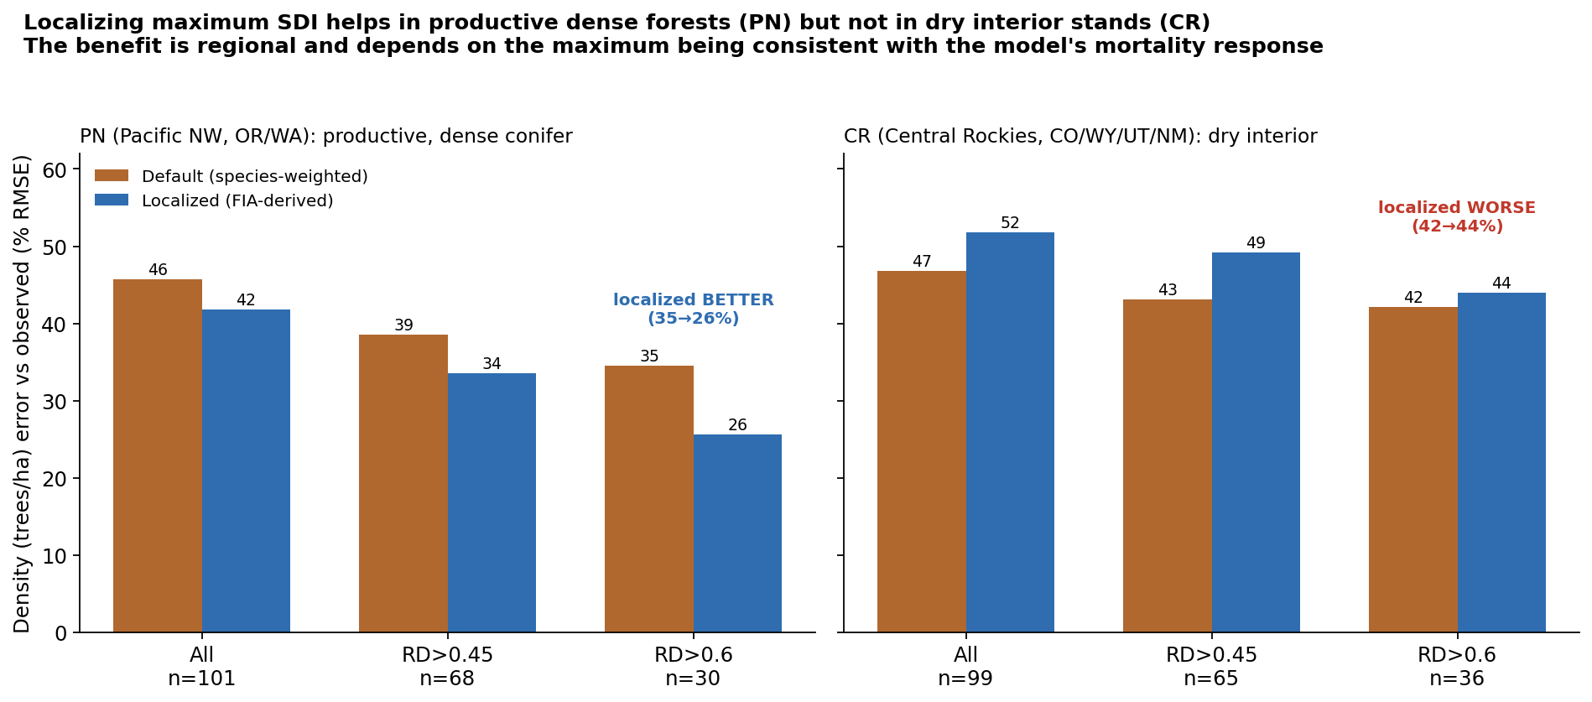
Figure 1. Localizing the maximum cuts density error in dense Pacific Northwest stands and increases it in dry interior Central Rockies stands. The benefit is regional.

Why: spatial pattern versus level
A scale diagnostic resolves the difference. The FIA maximum carries a spatial pattern and a level. Holding the pattern fixed and varying the level, Central Rockies density error is lowest near 0.9 times the raw value, below the native default, with near-zero bias. So the spatial information is good; the earlier degradation was a level offset of about ten percent.
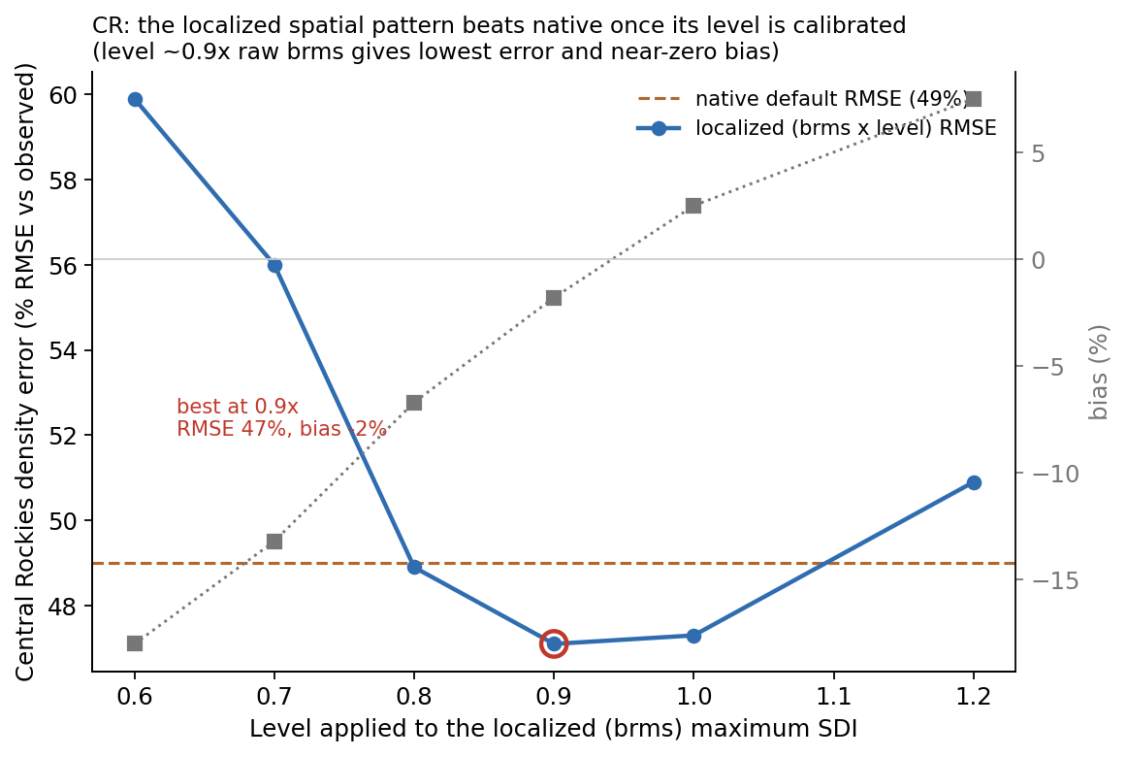
Figure 2. Holding the brms spatial pattern fixed and varying its level, CR density error is lowest near 0.9 times the raw value, below native, with near-zero bias.

Joint analysis: where the limit matters
A joint analysis on 7.25 million remeasured plots across 19 regions shows two things. The predictive skill of a flexible self-thinning fit is invariant to the maximum's overall level, so the FIA maximum's statistical value is in its spatial pattern and the level is necessarily set by the mortality model. And the strength of the self-thinning signal varies about four-fold by region: weakest in the dry interior West (Utah 0.04, Central Rockies 0.06) and strongest in the moist East, South, and Pacific Northwest (Southern 0.14, Pacific Northwest 0.10). Density-dependent self-thinning is a primary mortality control where growth is fast and canopies close, and a secondary one where drought and disturbance dominate.

Confirmed across all 20 CONUS variants
Sweeping the level applied to the localized maximum through the real FVS mortality response, for every CONUS variant, the level-calibrated localized maximum matches or beats the native species-weighted maximum in 19 of the 20 variants (the lone exception is Utah), with the largest gains where the native level was most off. The optimal level is strongly variant-specific, spanning 0.6 to 2.0 with a median near 1.2: most variants need the brms maximum scaled up to match their native mortality, a few need it scaled down.
Variant | Native % RMSE | Calibrated % RMSE | Optimal level
NE Northeast | 34.6 | 30.5 | 1.8
ACD Acadian | 52.8 | 36.9 | 2.0
NC Klamath Mtns | 75.2 | 54.0 | 2.0
CR Central Rockies | 49.0 | 47.3 | 1.0
IE Inland Empire | 66.1 | 60.9 | 0.8
SN Southern | 96.2 | 91.9 | 0.8
UT Utah (exception) | 64.5 | 66.7 | 1.2
Representative rows; the full 20-variant table is allvar_calibration.csv.
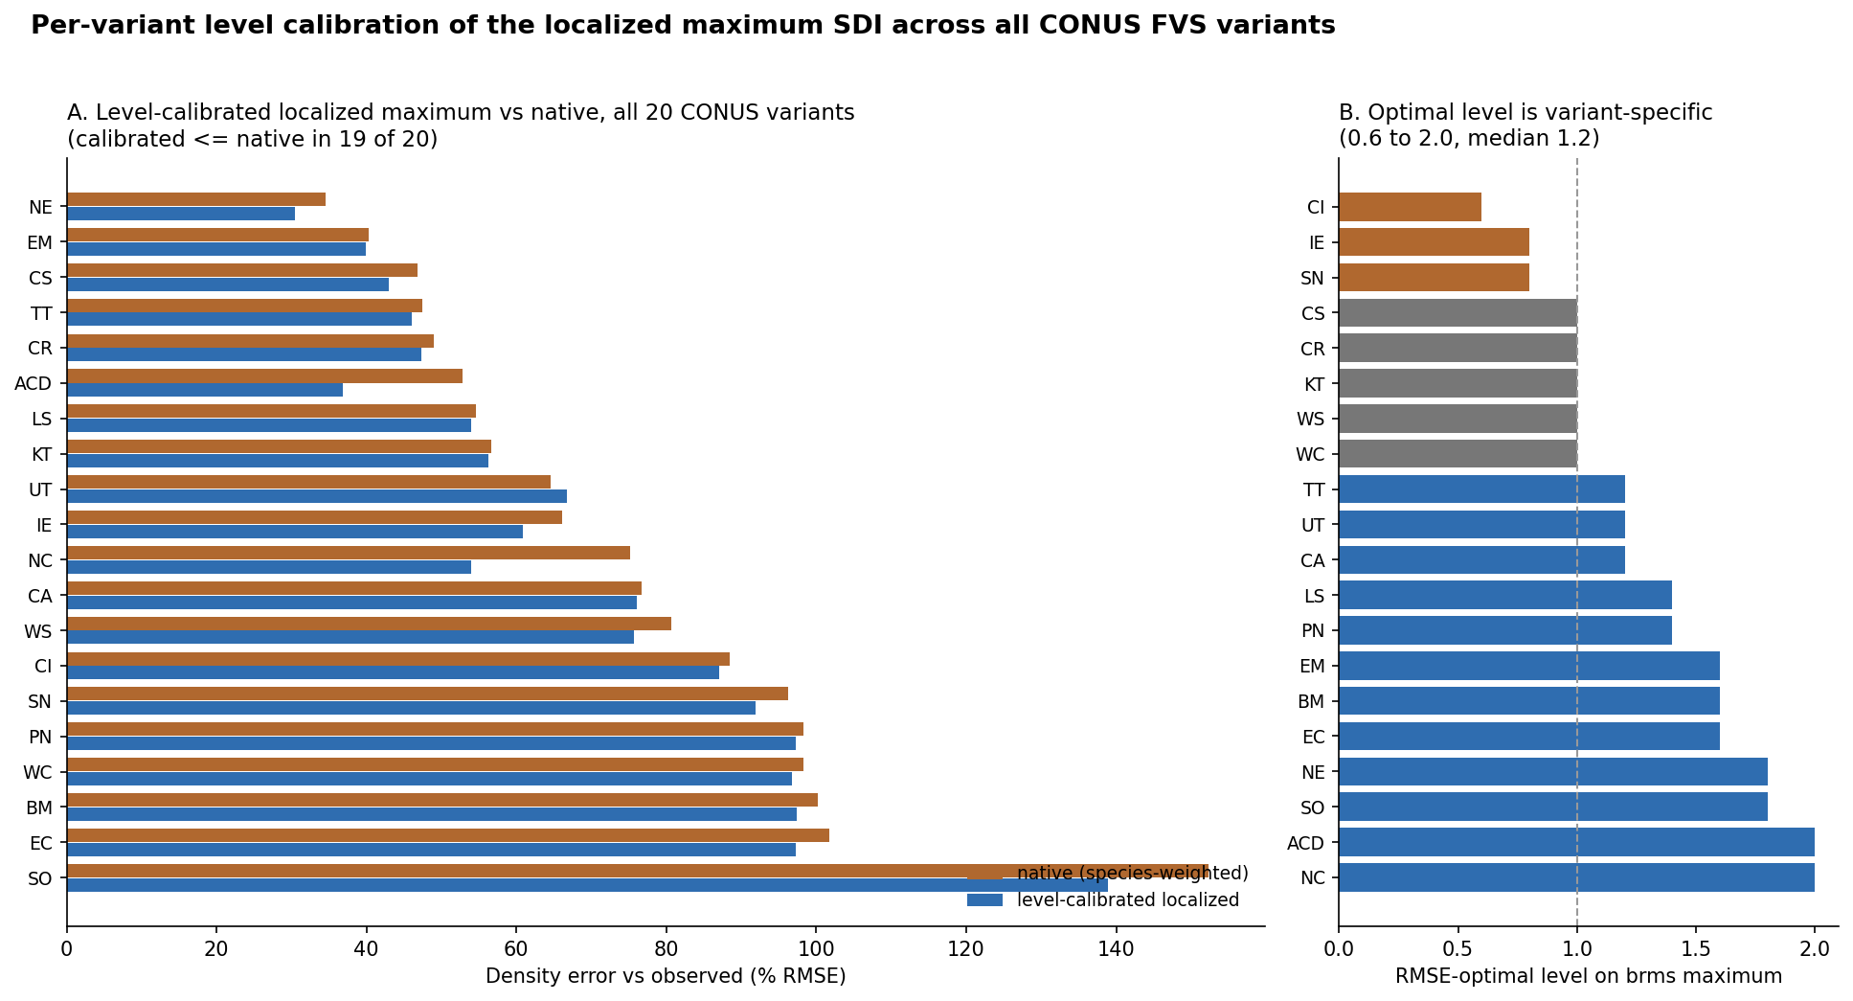
Figure 3. Per-variant level calibration across all 20 CONUS variants. Left: calibrated is at or below native in 19 of 20. Right: the optimal level is variant-specific, 0.6 to 2.0, median 1.2.

Step 2 recommendation
Set the density limit from a localized, FIA-derived maximum SDI, not from composition-weighted per-species constants, and calibrate its level jointly with the density-dependent mortality response. The more than three-fold spread of optimal levels shows a common maximum cannot be dropped into native variants at a uniform level. This is automatic in a unified fit (Step 3) and a one-parameter regional adjustment when retrofitting a native variant. The FIA-derived surface (Zenodo 10.5281/zenodo.19509367) and its plot table are available now.

Step 3. Refit the component equations as one CONUS variant
The long-term goal is a single trait-aware CONUS variant that covers all species and retires the 20 regional variants, addressing the maintenance burden, the thin support for rare species, and the difficulty of consistent national analyses. It is organized on two axes: tree-level versus stand-level, and species-dependent versus species-independent.
 | Species-dependent (per-species) | Species-independent (trait-driven)
Tree-level | Growth, height-diameter, crown, survival, ingrowth fit per species | Same components from a trait and climate form; covers rare and unsampled species
Stand-level | Composition-driven density and basal area | Density and basal area on the localized maximum SDI from Step 2
A per-species shrinkage blend joins the two columns, so well-sampled species keep their own fit and rare species fall back to the trait form. The tree-level components are built, the stand-level constraint layer is prototyped, and injecting the trait-driven equations into the engine is the next task.

Early evidence
On Douglas-fir diameter growth, our species-dependent fit is competitive with Greg Johnson's species-specific model (RMSE 0.091 versus 0.097 cm/yr), and the species-free leg reaches RMSE 0.118 predicting Douglas-fir from traits alone, having never seen one, within about 22 percent. That is the rare-species case the regional variants do not cover, and it is the core value of the trait approach.
Model | RMSE (cm/yr) | Species data used
Greg, species-specific | 0.097 | full Douglas-fir
Ours, species-dependent | 0.091 | Douglas-fir in training
Ours, species-free | 0.118 | zero Douglas-fir

Status and where FVS-team input would help
- Step 1, FIA calibration modifiers: working and benchmarked; deployable on the current engine.
- Step 2, maximum SDI: validated across all 20 variants; ready to adopt jointly with mortality.
- Step 3, CONUS variant: components built, stand-level prototyped; engine injection is the next task.
We would value the FVS team's guidance on three things:
- The recommended source for the maximum-SDI value and the SDI convention to match, so relative density is computed consistently between our surface and FVS internals.
- The cleanest mechanism to inject CONUS component equations into the engine for evaluation (keyword, alternate equation hooks, or a parallel build).
- The benchmark protocol and held-out evaluation you would want us to match, so results are directly comparable to FVS's own validation.
We are glad to share the data, the code, and the supporting analyses behind each step.

Selected references
Chivhenge, E., A. Weiskittel, C. Woodall, A. D'Amato, and A. Daigneault. A 30 m wall-to-wall raster of stand density index, maximum stand density index, and relative density for the conterminous United States from TreeMap 2022 and FIA. Zenodo. https://doi.org/10.5281/zenodo.19509367
Houtman, R., et al. TreeMap 2022: a tree-level model of the forests of the conterminous United States.
Reineke, L. H. 1933. Perfecting a stand-density index for even-aged forests. Journal of Agricultural Research 46:627-638.
Weiskittel, A. R., D. W. Hann, J. A. Kershaw, and J. K. Vanclay. 2011. Forest Growth and Yield Modeling. Wiley.

