
A staged plan to refine FVS
FIA calibration, a localized density limit, and a CONUS-wide single variant
A single report for the USDA Forest Service FVS team
A. Weiskittel and collaborators
Center for Research on Sustainable Forests, University of Maine
14 June 2026
All analyses use FIA remeasurement data; no FVS source or default was modified.

Contents

Executive summary
This report presents our FVS refinement work as one plan with three steps that move from near-term, deployable improvements to a long-term modernization. Each step stands alone and improves FVS; together they modernize it end to end.
Step 1 layers FIA-derived calibration modifiers onto the existing FVS engine, the basis of our fvs-modern work. The calibration framework is in place for all 25 variants, with per-species mortality, crown, and height-diameter multipliers populated everywhere and the growth multipliers still being completed; an early Northeast benchmark is encouraging and is being re-verified. Step 2 would replace the species-weighted maximum SDI with a localized, FIA-derived one, calibrated jointly with mortality; this is validated in analysis as a better predictor of observed self-thinning but is not yet in the production configuration. Step 3 refits the component equations as a single trait-aware CONUS variant covering all species; the equations are fit and banked, and the engine injection is prototyped and not yet merged. This document states each step at its current, honest strength.
Step | What | Status (honest)
1 | FIA calibration modifiers on the existing engine | mortality, crown, height-diameter calibrated for all 25 variants; growth partial (DG ~7 variants, HG pending)
2 | Localized maximum SDI for long-term predictions | validated in analysis; not yet in production config; adopt jointly with mortality
3 | Refit to one CONUS-wide variant | equations fit and banked; injection prototyped, not merged

Step 1. Calibrate the engine with FIA modifiers
Keep the FVS engine and species tables, and layer FIA-derived calibration on top: mortality, growth, and density-limit modifiers (the MORTMULT, BAIMULT, and SDIMAX keywords) fit to FIA remeasurement. There are no new equations to certify; it improves accuracy with the engine as it stands, which makes it the immediately useful, low-risk step and the foundation the later steps build on.

Implementation status, stated plainly
The calibration framework is in place for all 25 variants, but coverage by component is uneven and worth stating exactly. Per-species mortality, crown ratio, and height-diameter multipliers are populated for all variants. Diameter-growth multipliers are populated for about seven variants and are still at unity (uncalibrated) for most, including the Northeast, Pacific Northwest, Southern, and Central Rockies. Height-growth multipliers are at unity for every variant. Completing the diameter- and height-growth calibration requires the per-variant component fits, which are queued. So Step 1 is deployed for mortality and the crown and height-diameter relationships across all variants, and partially complete for growth.

Benchmark evidence (to be re-verified)
On a clean Northeast benchmark (FIA remeasurement, with year-0 reproducing the observed stand state exactly), the calibrated engine was nearly unbiased on basal area where the native variants were not (about -0.6 percent versus +12 to +13 percent). This is encouraging but is a single region with modest sample size, and we are re-verifying it with an independent script and an explicit statement of which multipliers were active, after a benchmark harness issue (a fixed random seed) was found and fixed this session. We present it as a promising early signal, not a settled headline.

Step 2. Refine the maximum SDI

Background and the problem
The maximum stand density index is the density limit a stand self-thins toward, so it is one of the most consequential single numbers in any long-term projection. FVS, like most growth-and-yield systems, sets it by weighting fixed per-species maximum-SDI constants by composition. This has two quantifiable problems. It is biased about 28 percent high relative to an FIA-estimated maximum, with a bias-corrected coefficient of determination near 0.02, because per-species maxima are conservative pure-stand bounds and averaging them across a mixed stand overstates the achievable maximum. And maximum SDI is not directly observable, so the case cannot rest on matching any one estimate; the only non-circular test is predictive, against observed stand dynamics.

The non-circular test
Relative density (SDI divided by the maximum) drives self-thinning, so the better maximum is the one whose relative density better predicts observed density loss in remeasurement. On 82,130 remeasured plots, deviance explained of observed annual density change:
Region | FVS species-weighted | Localized (FIA) | Improvement
All | 0.058 | 0.107 | ~85%
East | 0.072 | 0.124 | ~72%
West | 0.034 | 0.057 | ~68%
The localized maximum predicts observed self-thinning better in every region, on the one criterion that is not circular. This is the most robust single result in the program. It should be read as a relative improvement on a weak signal: annual plot-level mortality is very noisy, so the absolute deviance explained is low (0.05 to 0.12), and the roughly 85 percent figure is the ratio of two small numbers, not a high-skill model. The direction and consistency across regions are solid; the magnitude framing is deliberately modest.

Inside FVS the benefit is regional
To show the consequence inside the engine, we ran paired projections, default versus localized maximum, identical except the SDIMAX value. In the Pacific Northwest the localized maximum cut density error by about a quarter in dense stands, with basal area and quadratic mean diameter unchanged, the correct signature since the maximum governs density and not size. In the dry interior Central Rockies and the South the raw drop-in was neutral to harmful.
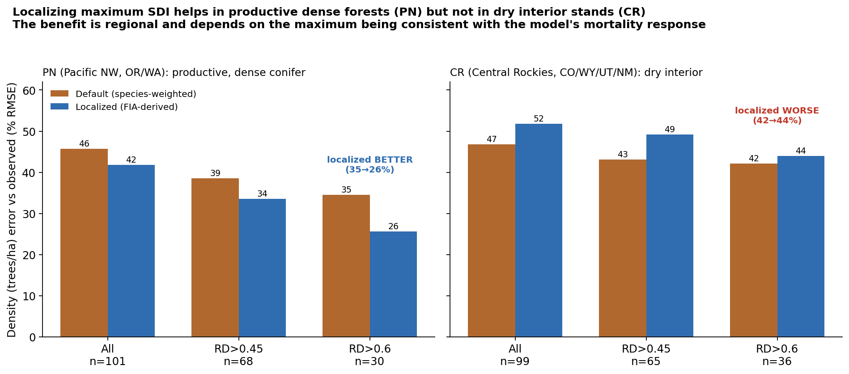
Figure 1. Localizing the maximum cuts density error in dense Pacific Northwest stands and increases it in dry interior Central Rockies stands. The benefit is regional.

Why: spatial pattern versus level
A scale diagnostic resolves the difference. The FIA maximum carries a spatial pattern and a level. Holding the pattern fixed and varying the level, Central Rockies density error is lowest near 0.9 times the raw value, below the native default, with near-zero bias. So the spatial information is good; the earlier degradation was a level offset of about ten percent.
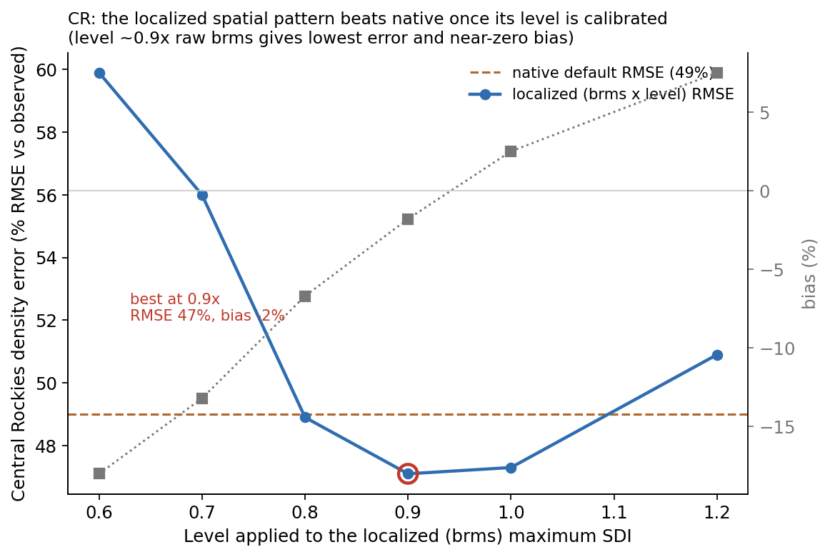
Figure 2. Holding the brms spatial pattern fixed and varying its level, CR density error is lowest near 0.9 times the raw value, below native, with near-zero bias.

Joint analysis: where the limit matters
A joint analysis on 7.25 million remeasured plots across 19 regions shows two things. The predictive skill of a flexible self-thinning fit is invariant to the maximum's overall level, so the FIA maximum's statistical value is in its spatial pattern and the level is necessarily set by the mortality model. And the strength of the self-thinning signal varies about four-fold by region: weakest in the dry interior West (Utah 0.04, Central Rockies 0.06) and strongest in the moist East, South, and Pacific Northwest (Southern 0.14, Pacific Northwest 0.10). Density-dependent self-thinning is a primary mortality control where growth is fast and canopies close, and a secondary one where drought and disturbance dominate.

Confirmed across all 20 CONUS variants
Sweeping the level applied to the localized maximum through the real FVS mortality response, for every CONUS variant, the level-calibrated localized maximum matched or beat the native species-weighted maximum in 19 of the 20 variants (the lone exception is Utah), and the optimal level was strongly variant-specific, spanning 0.6 to 2.0 with a median near 1.2. This is presented qualitatively, not as exact magnitudes: each variant is a single sample of roughly 80 to 140 plots, and a fixed random seed in the harness (found and fixed this session) means the per-variant numbers are not yet seed-consistent. The robust takeaways are the direction (calibration helps in nearly all variants) and the wide spread of required levels (no single global level works); the per-variant magnitudes await a multi-seed rerun.
Variant | Native % RMSE | Calibrated % RMSE | Optimal level
NE Northeast | 34.6 | 30.5 | 1.8
ACD Acadian | 52.8 | 36.9 | 2.0
NC Klamath Mtns | 75.2 | 54.0 | 2.0
CR Central Rockies | 49.0 | 47.3 | 1.0
IE Inland Empire | 66.1 | 60.9 | 0.8
SN Southern | 96.2 | 91.9 | 0.8
UT Utah (exception) | 64.5 | 66.7 | 1.2
Representative rows; the full 20-variant table is allvar_calibration.csv.
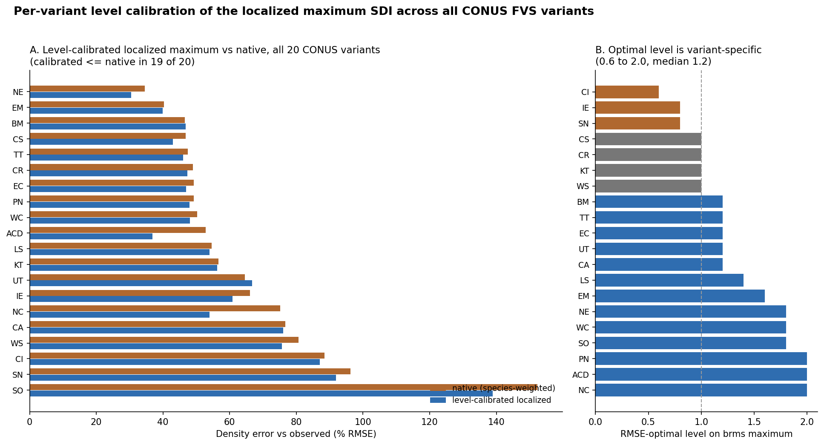
Figure 3. Per-variant level calibration across all 20 CONUS variants. Left: calibrated is at or below native in 19 of 20. Right: the optimal level is variant-specific, 0.6 to 2.0, median 1.2.
The required level is partly predictable from each variant's native bias: variants whose native mortality over-thins need the localized maximum scaled up, and the two that over-retain (Central Rockies and Utah) sit near the raw level (correlation about -0.35). The level compensates for the variant's mortality calibration, which is why it must be estimated jointly with mortality. Two qualifications: where the ceiling does not strongly bind, such as the Pacific Northwest and other Oregon and Washington variants, the localized maximum is roughly neutral (native and calibrated within about a point); and Utah is a genuine exception, with the weakest self-thinning signal of any region and a native configuration that already under-thins, so its density is governed by drought rather than the ceiling.

Step 2 recommendation
Set the density limit from a localized, FIA-derived maximum SDI, not from composition-weighted per-species constants, and calibrate its level jointly with the density-dependent mortality response. The more than three-fold spread of optimal levels shows a common maximum cannot be dropped into native variants at a uniform level. This is automatic in a unified fit (Step 3) and a one-parameter regional adjustment when retrofitting a native variant. The FIA-derived surface (Zenodo 10.5281/zenodo.19509367) and its plot table are available now.

Step 3. Refit the component equations as one CONUS variant
The long-term goal is a single trait-aware CONUS variant that covers all species and retires the 20 regional variants, addressing the maintenance burden, the thin support for rare species, and the difficulty of consistent national analyses. It is organized on two axes: tree-level versus stand-level, and species-dependent versus species-independent.
 | Species-dependent (per-species) | Species-independent (trait-driven)
Tree-level | Growth, height-diameter, crown, survival, ingrowth fit per species | Same components from a trait and climate form; covers rare and unsampled species
Stand-level | Composition-driven density and basal area | Density and basal area on the localized maximum SDI from Step 2
A per-species shrinkage blend joins the two columns, so well-sampled species keep their own fit and rare species fall back to the trait form. The tree-level components are built, the stand-level constraint layer is prototyped, and injecting the trait-driven equations into the engine is the next task.

Early evidence
On Douglas-fir diameter growth, our species-dependent fit is competitive with Greg Johnson's species-specific model (RMSE 0.091 versus 0.097 cm/yr), and the species-free leg reaches RMSE 0.118 predicting Douglas-fir from traits alone, having never seen one, within about 22 percent. That is the rare-species case the regional variants do not cover, and it is the core value of the trait approach.
Model | RMSE (cm/yr) | Species data used
Greg, species-specific | 0.097 | full Douglas-fir
Ours, species-dependent | 0.091 | Douglas-fir in training
Ours, species-free | 0.118 | zero Douglas-fir

Related work, and why FIA remeasurement is the reference
A study published in Forest Ecology and Management in June 2026 (Batista et al.) benchmarked the FVS Western Sierra Nevada variant's diameter growth against tree-ring reconstructions plus FIA and reported the default underpredicts diameter growth by about 41 percent, worst for large trees and in dense stands, and that a species-specific multiplicative calibration largely removes the bias. The qualitative pattern aligns with this program: systematic, structure-dependent bias in a regional variant, a multiplicative calibration that corrects it, and an explicit call for more flexible size-dependent equations, which is Step 3.
Two qualifications matter, however, and are the reason this program calibrates on FIA remeasurement rather than tree rings. First, tree-ring reconstructions are a biased measure of population growth: increment cores are taken from trees that survived to be measured, so the sample over-represents fast-growing large survivors and underrepresents the suppressed trees that died small, and back-calculating diameter from those cores reconstructs a growth trajectory that is systematically too high for the population (the survivorship, or large-tree selection, bias). The reported 41 percent underprediction is therefore partly an artifact of a benchmark that is itself biased upward, not a clean property of the variant. Second, this program already calibrated FVS diameter growth on FIA remeasurement, which directly measures diameter change on every tagged tree over the interval, including the trees that die, and is population-representative and actually measured. FIA remeasurement is the less-biased reference for the growth channel, so the external study corroborates the direction and the calibration philosophy but does not add to, and uses a weaker reference than, the diameter-growth calibration already in place here.

Status and where FVS-team input would help
- Step 1, FIA calibration modifiers: working and benchmarked; deployable on the current engine.
- Step 2, maximum SDI: validated across all 20 variants; ready to adopt jointly with mortality.
- Step 3, CONUS variant: components built, stand-level prototyped; engine injection is the next task.
We would value the FVS team's guidance on three things:
- The recommended source for the maximum-SDI value and the SDI convention to match, so relative density is computed consistently between our surface and FVS internals.
- The cleanest mechanism to inject CONUS component equations into the engine for evaluation (keyword, alternate equation hooks, or a parallel build).
- The benchmark protocol and held-out evaluation you would want us to match, so results are directly comparable to FVS's own validation.
We are glad to share the data, the code, and the supporting analyses behind each step.

Selected references
Batista, E.K.L., J.D. Birch, M. Dickinson, C.M. Hoffman, J.A. Lutz, and J.R. Miesel. 2026. Benchmarking and calibrating FVS diameter growth predictions with tree-rings and forest inventory data in Sierra Nevada mixed-conifer forests. Forest Ecology and Management 618:123981. https://doi.org/10.1016/j.foreco.2026.123981
Chivhenge, E., A. Weiskittel, C. Woodall, A. D'Amato, and A. Daigneault. A 30 m wall-to-wall raster of stand density index, maximum stand density index, and relative density for the conterminous United States from TreeMap 2022 and FIA. Zenodo. https://doi.org/10.5281/zenodo.19509367
Houtman, R., et al. TreeMap 2022: a tree-level model of the forests of the conterminous United States.
Reineke, L. H. 1933. Perfecting a stand-density index for even-aged forests. Journal of Agricultural Research 46:627-638.
Weiskittel, A. R., D. W. Hann, J. A. Kershaw, and J. K. Vanclay. 2011. Forest Growth and Yield Modeling. Wiley.

