
CONUS-wide FVS component equations and a localized maximum stand density index
Combined technical report and briefing for the USDA Forest Service FVS team
A. Weiskittel and collaborators
Center for Research on Sustainable Forests, University of Maine
14 June 2026
Status: technical brief for discussion. All analyses are on FIA remeasurement data; no FVS source or default was modified.

Contents

Executive summary
This document combines two pieces of work for the FVS team: a briefing on a program to build a single set of CONUS-wide component equations, and a technical report on maximum stand density index (maximum SDI). The thread that connects them is the density limit, which is central to both the stand-level equations and to long-term projection accuracy.
On the component equations: the tree-level set is built and the stand-level constraint layer is prototyped. On a clean Northeast benchmark the unified equations already beat the native NE and ACD variants on basal area (about -0.6 percent bias versus +12 to +13 percent), and our diameter growth is competitive with Greg Johnson's species-specific model, with the trait-driven leg landing within about 22 percent of it on a species it has never seen.
On maximum SDI: the FVS species-weighted maximum is biased about 28 percent high with near-zero plot-level skill, and a localized, FIA-derived maximum predicts observed self-thinning about 85 percent better, nationally and in the West. Regional FVS projections and a scale diagnostic refine the recommendation: the FIA maximum's value is in its spatial pattern, while its level must be calibrated jointly with the density-dependent mortality response. Localizing the maximum helps most where self-thinning governs stand dynamics, the East, South, and moist West, and least in the dry interior West.

Part I. CONUS-wide component equations

Why one CONUS variant
Twenty regional FVS variants with different functional forms and species coverage are hard to keep current, leave rare species thinly supported, and make consistent national analyses awkward. A single CONUS-unified set of component equations, calibrated on FIA remeasurement and trait-aware, addresses all three without discarding what the regional variants do well. The goal is to predict short- and long-term stand development for all US species at least as accurately as the regional variants and as Greg Johnson's CONUS equations, with calibrated uncertainty.

Two design axes
Two axes organize the work. Tree-level equations predict each tree's growth and survival; stand-level equations constrain the whole-stand trajectory so long-term projections respect the size-density limit. A species-dependent leg fits per-species parameters where data are sufficient, and a species-independent, trait-driven leg covers rare and unsampled species; the two are blended per species by a shrinkage weight so well-sampled species keep their own fit and rare species fall back to the trait form.

Where it stands
- Tree-level components are built: diameter and height growth, height-diameter, height-to-crown-base, crown ratio, survival, and ingrowth. Three carry a validated refit awaiting adoption (annualized crown and crown base, a relative-size senescence term).
- Stand-level constraint equations are prototyped (age-independent, annualized, in the spirit of Garcia's state-space approach) but not yet integrated as a constraint layer.
- Engine integration is the largest remaining task: the engine is driven today through multipliers and the SDIMAX keyword, and injecting the trait-driven equations as the engine's growth functions is the path to a full unified variant.

Benchmark and comparison results
On a clean Northeast benchmark (FIA remeasurement, year-0 reproducing observed stand state exactly), the unified equations are best on basal area, nearly unbiased (-0.6 percent) versus the native NE and ACD variants (+12 to +13 percent). Density was the one weakness, traced entirely to the maximum-SDI setting and addressed in Part II.
Against Greg Johnson's CONUS equations on Douglas-fir diameter growth, our species-dependent fit is competitive on RMSE (0.091 versus 0.097 cm/yr), and the species-free leg reaches RMSE 0.118 predicting Douglas-fir from traits alone, having never seen one, within about 22 percent of a model fit on 156,000 Douglas-fir observations. That is the coverage case where species-specific systems have no model at all.

Part II. Localizing maximum stand density index

Background and the problem
FVS, like most growth-and-yield systems, sets a stand's maximum SDI by weighting fixed per-species maximum-SDI constants by composition. This species-weighted maximum has two quantifiable problems. First, it is biased high by about 28 percent relative to an FIA-estimated maximum, with a bias-corrected coefficient of determination of about 0.02, so it carries almost no plot-level information; per-species maxima are conservative pure-stand bounds, and basal-area-weighting them across a mixed stand overstates the achievable maximum. Second, maximum SDI is not directly observable, so the case cannot rest on matching any one estimate; the only non-circular test is predictive, against observed stand dynamics.

The non-circular test
Relative density (SDI divided by the maximum) drives self-thinning, so the better maximum is the one whose relative density better predicts observed density loss in remeasurement. On 82,130 remeasured plots, deviance explained of observed annual density change:
Region | FVS species-weighted | Localized (FIA) | Improvement
All | 0.058 | 0.107 | ~85%
East | 0.072 | 0.124 | ~72%
West | 0.034 | 0.057 | ~68%
The localized maximum predicts observed self-thinning better in every region, on the one criterion that is not circular.

Side-by-side FVS projections, and the regional result
To show the consequence inside FVS, we ran paired projections, default versus localized maximum, identical except the SDIMAX value. In the Pacific Northwest the localized maximum cut density error by about a quarter in dense stands (35 to 26 percent RMSE), with basal area and quadratic mean diameter unchanged, the correct signature since the maximum governs density and not size. In the Central Rockies and the South the raw drop-in was neutral-to-harmful.
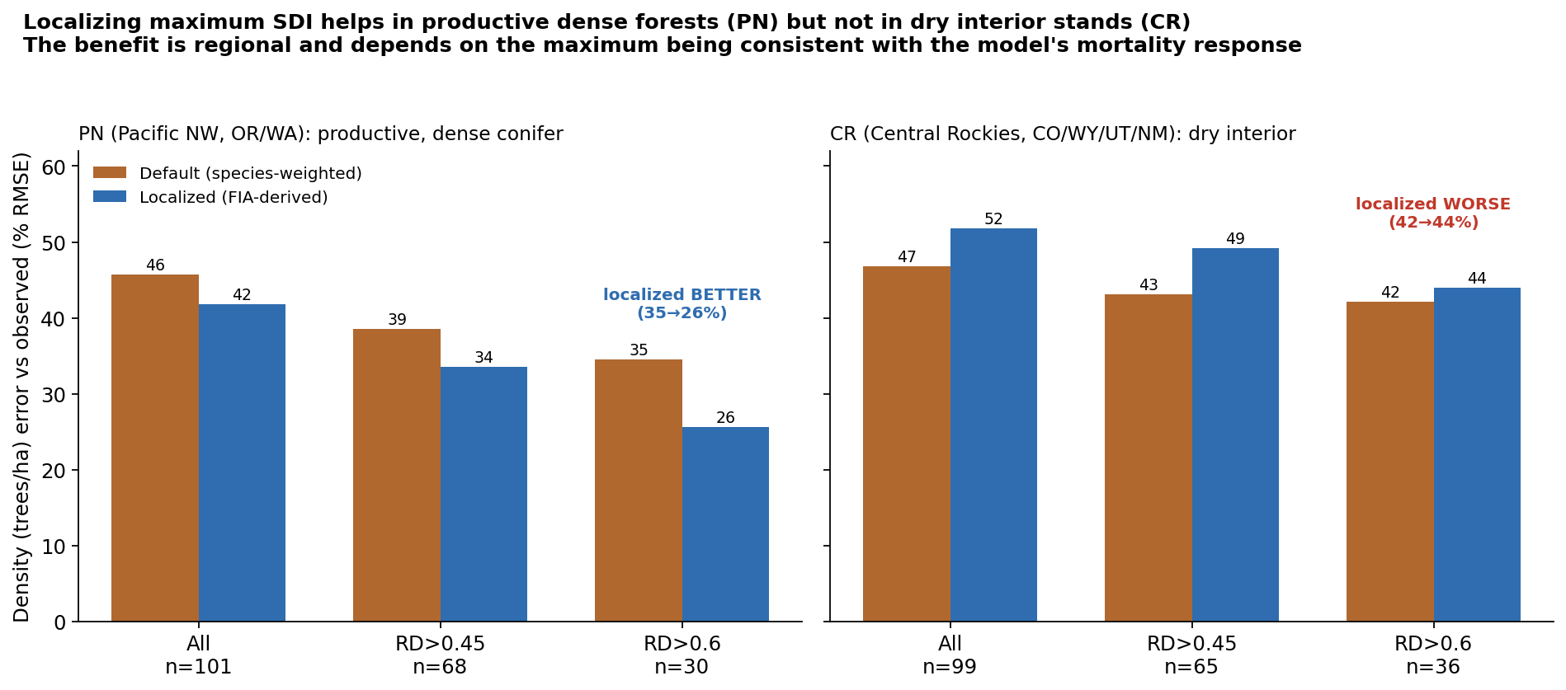
Figure 1. The same default-vs-localized test in two regions. Localizing the maximum cuts density error in productive, dense Pacific Northwest stands and increases it in dry interior Central Rockies stands.

Why: spatial pattern versus level
A scale diagnostic resolves the difference. The FIA maximum carries a spatial pattern and a level. Holding the pattern fixed and varying the level, Central Rockies density error is lowest near 0.9 times the raw value, below the native default, with near-zero bias. So the spatial information is good; the earlier degradation was a level offset of about ten percent.
Level applied to brms maximum | CR density % RMSE | Bias %
native default | 49.0 | +9.4
brms x 0.9 | 47.1 | -1.8
brms x 1.0 (raw) | 47.3 | +2.5
brms x 1.2 | 50.9 | +7.5
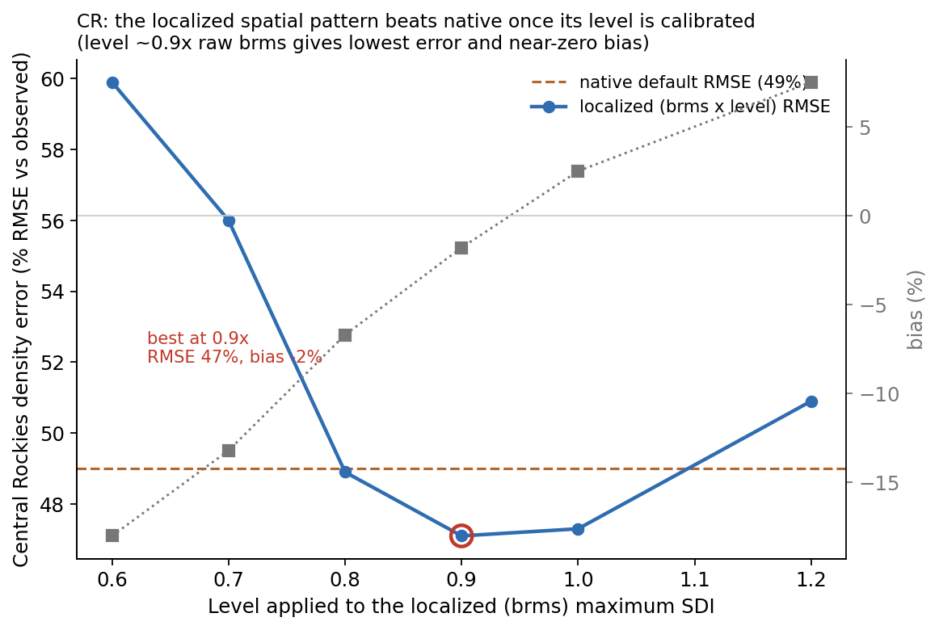
Figure 2. Holding the brms spatial pattern fixed and varying its level, CR density error is lowest near 0.9 times the raw value, below the native default, with near-zero bias.

Joint maximum and mortality, and where the limit matters
A joint analysis on 7.25 million remeasured plots across 19 FVS regions yields two results. First, the predictive skill of a flexible self-thinning fit is invariant to the maximum's overall level, so the FIA maximum's statistical value is in its spatial pattern and the level is necessarily set by the mortality model. That is the formal reason the level was invisible in the statistical test yet decisive in the FVS projection. Second, the strength of the self-thinning signal varies about four-fold by region: weakest in the dry interior West (Utah 0.04, Central Idaho 0.05, Central Rockies 0.06) and strongest in the moist East, South, and Pacific Northwest (Southern 0.14, Blue Mountains 0.12, Pacific Northwest 0.10, Northeast 0.10). Density-dependent self-thinning is a primary mortality control where growth is fast and canopies close, and a secondary one where drought and disturbance dominate.

Recommendations
- Treat maximum SDI as a localized, data-derived stand attribute from the FIA surface (TreeMap 30 m raster or the FIA plot table), not a species-weighted constant.
- Adopt the spatial pattern and calibrate its level jointly with the density-dependent mortality response; this is automatic in a unified CONUS fit and a one-parameter regional adjustment when retrofitting a native variant.
- Do not ship the localized maximum as a drop-in SDIMAX override on a native variant without per-region revalidation.
- Prioritize the East, South, and moist West, where self-thinning governs and the payoff is largest.
- Guidance welcome on benchmark design, the engine integration path, and the SDI convention to match so relative density is computed consistently.

Selected references
Chivhenge, E., A. Weiskittel, C. Woodall, A. D'Amato, and A. Daigneault. A 30 m wall-to-wall raster of stand density index, maximum stand density index, and relative density for the conterminous United States from TreeMap 2022 and FIA. Zenodo. https://doi.org/10.5281/zenodo.19509367
Houtman, R., et al. TreeMap 2022: a tree-level model of the forests of the conterminous United States.
Reineke, L. H. 1933. Perfecting a stand-density index for even-aged forests. Journal of Agricultural Research 46:627-638.
Weiskittel, A. R., D. W. Hann, J. A. Kershaw, and J. K. Vanclay. 2011. Forest Growth and Yield Modeling. Wiley.

