Design and specification for Shiva: A Programmable linking engine for ELF microcode patching

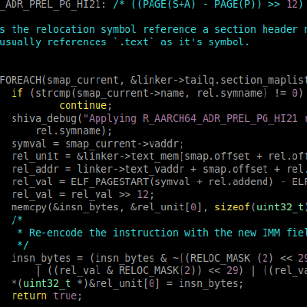

1.0 – Description
2.0 – Shiva linker chaining
2.1 Static ELF executables
3.0 – Shiva ELF ulexec loader
4.0 – Shiva runtime linking and loading of patches
4.1. Proces address space requirements
4.2. ET_REL modules for patching
4.2.A. DT_SHIVA_NEEDED entry in PT_DYNAMIC
4.2.B shiva-ld (The pre-linker)
4.4. Symbol interposition on code/data
4.5. Cross ELF relocation between chained linkers
4.6. Declaring external variables within patch source
4.7. Byte-code patching with Program Transformation directives
4.8. Function splicing with Transformations
5.0 – Shiva external re-linking on target executablePTD
- References

1.0 Description

Shiva is a programmable runtime-linker that is designed to run in a Linker Chain alongside the regular RTLD “/lib64/ld-linux.so”. It is a custom program interpreter that loads ELF patches in the form of ET_REL object files. Therefore and similarly to the dynamic linker, the patches are modular and contain the rich symbol and relocation meta-data that is necessary to transform the executable runtime environment.

The modular approach is dynamic, extensible, and elegantly follows conventions, rules, and linking policies of the existing ELF ABI toolchain for Linux.

Patches can be written purely in C when patching a symbol directly (i.e. symbol interposition). In more nuanced patching scenarios the patch may require the use of specialized C macros that instruct the linker on where to emit instruction bytes, splice in code, and extend the text or data segment. Transformations re-landscape the program at runtime with Shiva’s transformation engine; which is why we call it a “Programmable linking engine”.

Our goal is to be able to patch vulnerabilities within the NASA cFS (Control flight software). The software we are patching is a dynamically linked AArch64 ELF PIE binary. Currently our approach for microcode patching supports any AARCH64 PIE ELF binary, both dynamically linked and statically linked.

2.0 – Shiva Linker Chaining

Upon execution of a dynamically linked ELF executable, the kernel (See binfmt_elf.c) parses the ELF program header segments, and retrieves the “Interpreter Path” from the PT_INTERP segment.

Image 2.1: ELF executable with PT_INTERP: “ld-linux-aarch64.so”
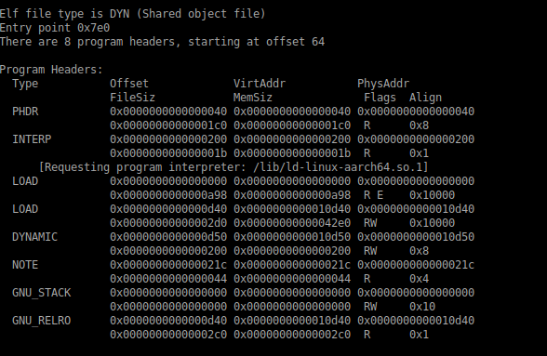

The Dynamic linker is loaded by the kernel, and executed before anything else. The dynamic linker is responsible for loading and linking shared object modules (i.e. libc.so). It is necessary for the linking and loading of dependencies at runtime. Our approach to microcode patching introduces a secondary Dynamic linker “/lib/shiva”. The standard convention is that there is only one PT_INTERP segment and it provides the path to the one and only Program Interpreter. So how do we get the kernel to load two separate dynamic linkers? The answer is Linker Chaining.

Linker Chaining is a technique that I first published in the paper titled “Preloading the linker for fun and profit” [1] The technique essentially explains how the Program Interpreter specified in the PT_INTERP segment can be loaded and executed by the kernel, and afterwards it is responsible for loading a secondary interpreter (Probably ld-linux.so). The next Interpreter in the chain, hence the term Linker Chaining.

Shiva replaces the standard program interpreter ld-linux.so in PT_INTERP and after Shiva has finished linking modular patches into the address space it is responsible for loading/mapping the original interpreter ld-linux.so into memory just like the kernel binfmt_elf.c would do it. The Shiva runtime linker eventually passes control over to the next chained interpreter, which happens to be ld-linux.so.
The ld-linux.so interpreter finishes it’s loading and linking of shared modules, and eventually passes control to the target executable.

Image 2.2: ELF executable with PT_INTERP: “/lib/shiva”
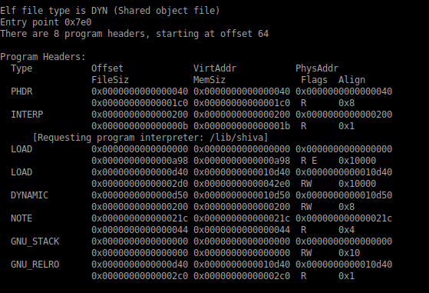

2.1 – Static ELF executables

ELF executables which have been statically linked have no need for a dynamic linker and therefore do not have a PT_INTERP segment. In this case the Shiva Prelinker “/bin/shiva-ld” will insert a PT_INTERP segment into the static ELF executable. This can be accomplished by converting the superfluous PT_NOTE segment into a PT_INTERP segment containing the path to “/lib/shiva”.

When the static executable is run the kernel will load “/lib/shiva” as the program interpreter and pass control to it. After the linking and loading of the needed micropatches Shiva will pass control to the entry point of the static executable (Instead of the entry point of “ld-linux.so”).

3.0 – The Shiva ELF ulexec loader

Shiva can be executed indirectly as an interpreter and directly as a regular executable.
When Shiva is executed indirectly (i.e. As another programs program interpreter) “/lib/shiva” is mapped into the process by the kernel as the interpreter program of the program that is being executed.

Linux kernel code for mapping the program interpreter:
https://elixir.bootlin.com/linux/latest/source/fs/binfmt_elf.c#L592

Shiva also may execute directly as a regular static ELF executable, and it has a complete userland implementation of execve See grugqs original work on userland exec [2] that lets Shiva essentially be responsible for loading the entire address space at runtime. Shiva can be executed directly on the command line with the binary and patch object specified as arguments. In this case Shiva will load and map the target ELF program into memory along with it’s Program interpreter “/lib/ld-linux.so”, and once it has finished linking the required patch object into memory, the execution flow is passed to “/lib/ld-linux.so” so that it can finish loading and relocating the dependency modules.

Shiva is a Weird Machine in that it can be executed directly or indirectly offering flexibility in it’s use-cases. See Shiva slide-deck [3]

Image 3.1: Process execution flow with Shiva linker chaining
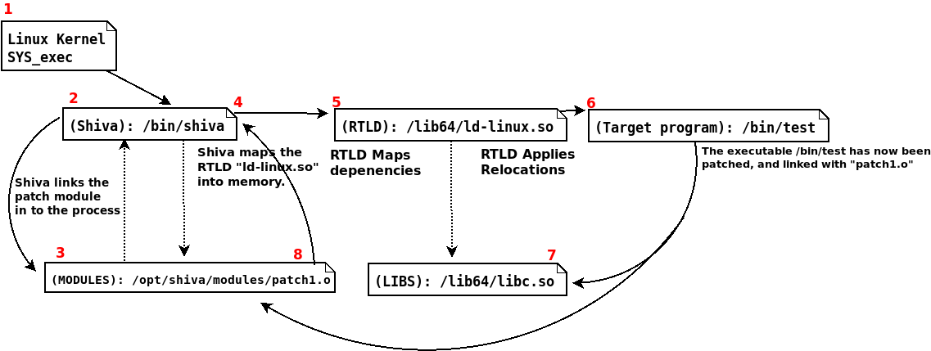

4.0 – Shiva runtime linking and loading of patches

The Shiva runtime linker aims to be programmable, flexible, and offer a relatively natural way to patch software within the context of the existing ELF ABI toolchain. The Shiva linker is a runtime linker, similar in nature to “/lib/ld-linux.so” in the sense that it performs ELF runtime linking, but akin too with the static ELF linker “/bin/ld” as Shiva uses ELF Relocatable objects for modules instead of ELF Shared libraries. Additionally, Shiva is programmable from a Shiva patch module and implements special directives for program transformation and cross relocation (See sections 4.7, 4.5).

Shiva uses ELF relocatable objects as a way to instrument symbolic patch code and data into the process image in the same sense that “/bin/ld” links an object into an ELF executable. The Shiva linker also aims to support custom ELF meta-data called Transformation Records that serve as instructions to Shiva’s program transformation engine and are defined within the patch code.

4.1 – Process address space requirements

The Shiva runtime environment is relatively complex in it’s fullness and many careful considerations have been taken while designing the runtime loading. A Shiva module (containing a patch) is an ELF relocatable object, a small file containing no loadable segments. Similar to how the Linux kernel must prepare an executable runtime environment for an LKM, we too must prepare an execution environment for the Shiva module. For this, Shiva creates a suitable text segment, data segment, .bss area, and copies the necessary code and data from the Shiva modules ELF sections over into the appropriate mapped segments, which are anonymous memory mappings.

Once the Shiva module containing all of the patch code has been loaded and linked into memory, the program that we are patching will be linked via XREF’s (Branches to code, and data references) to the Shiva modules patch code. In the event that the Linux kernel loads the Shiva module at an anonymous memory mapping that is more than 4GB in distance from the ELF executable we are linking it to, then the ELF relocations for the Shiva module won’t be able to encode large enough offsets. It’s important to mention that when Shiva is invoked directly (vs. as an indirect program interpreter) it is fully responsible for loading the module and the target executable into memory and therefore it can guarantee all modules will be within 4GB range of eachother. We must account for when Shiva is executed indirectly as a program interpreter though, which is it’s most common mode of operation for AMP, and we therefore defer to using a large code model when building the Shiva modules. This compiles code that uses PLT/GOT’s to handle code transfer in large code models.

The executable that is being patched generally has no ELF relocations beyond the normal .rela.plt and .rela.dyn sections which contain relocations utilized only by the “ld-linux.so” rtld. Therefore Shiva must perform live runtime analysis to acquire on-the-fly relocation information about where and how the target executable should be re-linked with the Shiva module at runtime. In the future we want our prelinking tool shiva-ld to emit pre-compiled relocation information about the target executable itself, that can be utilized by the Shiva linker at runtime.

If the process image requires a large code model, and our Shiva module’s are built with a large code model we have only solved half the problem; the ELF executable we are patching will almost always be compiled and linked with the code mechanics for a small code model. In this case there are two solutions:

1. Stick with a small code model, but with one big limitation. Execute Shiva directly (i.e. “/lib/shiva /path/to/executable). When executing Shiva directly it can garauntee that all modules including the executable are mapped with MAP_32BIT and will remain in a 4GB address space from eachother.

2. Use a large code model when building Shiva modules, i.e. ‘gcc -fno-pic -mcmodel=large -c patch.c`
This will generate the correct relocations for a large code model, so that the module can be properly linked at runtime. In order to address the re-linking of the ELF executable which is likely built with a small code model we must instrument a jmp stub that bridges the gap between the executable code and Shiva module, which may likely be mapped further apart than can be addressed with 32bits.

We generally defer to the 2nd option as it is flexible and can handle all possible code models and it doesn’t matter whether Shiva is running in Interpreter mode or not.

Another little issue that arose in x86_64 is that the Shiva interpreter when compiled as a no-pie static ELF executable with glibc, has initialization code that is not compatible with being executed indirectly, as it tries to incorrectly acquire the location of it’s own PT_TLS segment from the program header table of the executable being loaded and not the interpreter program. This is caused by the fact that it retrieves the location of the program header table from the auxiliary vectors AT_PHDR entry. To remedy this problem, Shiva is compiled and linked as a musl-libc static-pie executable using a custom musl patch, and avoids this problem completely.

Other interesting caveats and challenges are presented when building an intricate process transformation technology, but we will not include an exhaustive list beyond what is necessary to explain certain design decisions such as a large code model, and musl-libc.

4.2 – ELF ET_REL modules for patching

A complex technology such as microcode patching at runtime requires granularity, flexibility, and precision. Relocatable code is designed specifically for the purpose of linking code and data together via symbolic references, and it provides enough Relocation data to instruct a linker to re-landscape a process image in very nuanced ways. Additionally, relocatable code doesn’t contain program segments and takes up less space on disk than a shared object file, and it allows Shiva to build an entirely custom runtime image for the module, one that is tailored towards the predilections of our overall patching environment. Furthermore relocatable object’s allow us to build a single runtime image (i.e. a text and data segment) from multiple patch files. If each patch file was a shared library, it would require mapping the segments of each shared library creating multiple executable images, requiring a lot more space and losing the inherent strengths of a single text and data segment housing multiple modules.

Currently, for Shiva-AArch64 the following ELF relocation types are supported, and are elected by the ELF linker in order to create code that supports a large code model (i.e. gcc -mcmodel=large).

AARCH64 Relocations supported by Shiva

R_AARCH64_ABS64: (S + A)
R_AARCH64_CALL26: ((S + A - P) >> 2) & 0x3ffffff
R_AARCH64_ADD_ABS_LO12_NC: (S + A) & 0xfff
R_AARCH64_ADR_PREL_PG_HI21: ((PAGE(S+A) - PAGE(P)) >> 12) & 0x1fffff

These relocation types listed above are aarch64 ELF relocations for linking an object file into an executable image. In our case we link the object file into the executable memory image that is setup by Shiva for the loaded module. Sections such as the .text, .rodata, and .plt are placed within a mapped Text segment. The .data, .got.plt, and .bss sections are placed within a mapped Data segment.

A process image for a Shiva module can combine multiple patch objects into a single executable runtime image. The ELF patch object relocations are used specifically to fix up the patch code at runtime, but that does not solve the fact that the executable must be re-linked in memory still.

NOTE: The executable must still be properly reconstructed and linked with the patch module code and patch data as necessary. ELF binaries do not contain the type of relocations that we are looking for. This posits the challenge of needing to generate relocation information on the fly, which is slow on large programs. A future version will use pre-compiled relocation data for the binary being patched. Even legacy binaries that are already built can have pre-compiled relocation data generated and stuffed into an ELF section.

In addition to the standard ELF relocations, Shiva supports “transformations” a custom meta-data type that can be generated by shiva-ld (See section 4.7).

4.2.A DT_NEEDED_SHIVA entry in Dynamic segment

The dynamic segment is stored within the data segment, and contains various meta-data that is necessary for the dynamic linker “ld-linux.so” at runtime. The dynamic linker recognizes the DT_NEEDED dynamic tag as a pointer to a dependency that should be loaded, such as libc.so. When we apply a patch with the shiva-ld tool, a custom dynamic segment entry is added to the binary. DT_SHIVA_NEEDED has a pointer to the path of a patch module that is to be loaded. The Shiva linker parses this dynamic tag in order to retrieve the path to the module that it’s loading.

#define DT_SHIVA_NEEDED 0x6000000d

Image 4.2.1: Output from “readelf -d | grep NEEDED” might look like this

4.2.B Applying a patch with shiva-ld (The shiva pre-linker)

Up until this point we have discussed some of the linking and loading mechanics that are applied at runtime. We discussed using Shiva’s ulexec feature, which allows Shiva to run as a normal program that is fully responsible for loading and linking the ELF executable and ELF patch into memory. Shiva is also able to execute indirectly (As an ELF Program interpreter loaded by the kernel) when it is specified as the PT_INTERP interpreter path, but can be heavily optimized in this case by embedding pre-compiled Shiva-relocation data for program transformation and linking into the target executable’s custom dynamic segment.

Image 4.2.2: An unpatched program
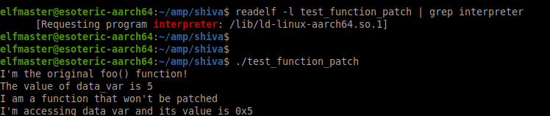

As we can see in the unpatched test_function_patch program, the standard dynamic linker is in PT_INTERP, which indicates that this binary has not been statically modified to invoke Shiva as it’s interpreter. Nonetheless, Shiva can still patch the program entirely at runtime with no modifications to the executable if Shiva is invoked directly.

Image 4.2.3: Runtime only Patching with Shiva ulexec loading
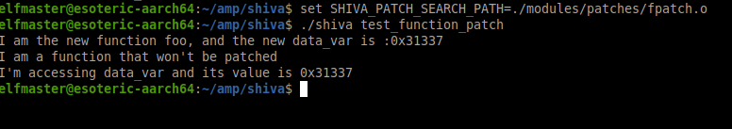

The example above (Image 4.2.3) shows how Shiva can be responsible for loading, patching, and executing the patched program at runtime. Shiva is being invoked directly, and therefore test_function_patch is only patched when running “./shiva test_function_patch”. If we were to run “./test_function_patch” alone, it would execute normally (Without the patch).

Most of the time when patching an executable, we want it to be more permanent. Having to run Shiva directly everytime you want to patch is not going to work. This is why Shiva runs predominately in Interpreter mode. Let’s patch the program test_function_patch with the shiva-ld tool (The Shiva pre-linker).

Image 4.2.4: Shiva-ld applies “Interpreter Path” and “Module Path” to binary
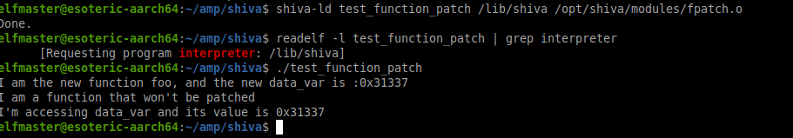
The shiva-ld program applies several modifications to the test_function_patch ELF executable.

1. Specifies “/lib/shiva” as the interpreter in the PT_INTERP segment
2. Creates a new dynamic segment area in the executable (See 4.2.A on custom PT_DYNAMIC)
2.A SHIVA_DT_SEARCH specifies the module search path “/opt/shiva/modules/”
2.B SHIVA_DT_NEEDED specifies the module basename “fpatch.o”
2.C SHIVA_DT_EXTERNAL_REL location of pre-compiled reloc data for the executable
2.D SHIVA_DT_TRANSFORMS location of pre-compiled Transform records (See section 4.7)

The shiva-ld tools is responsible for applying the correct ELF meta-data to the binary so that at runtime the kernel loads “/lib/shiva” as the interpreter, which in turn will load and link the patch. Since ELF executables don’t contain ELF relocation data (Other than for shared library imports) Shiva can and will analyze every instruction in the executable’s .text to find all instructions that must be linked to the patch module; this is slow at runtime, and can be heavily optimized by shiva-ld generating pre-compiled relocation data that lives in .shiva.xref.rel. (See section 5.0 Shiva runtime linking on target executable). Additionally custom Shiva relocation records that are specifically for Program Transformation. To avoid all of the runtime calculations necessary for building up to Program Transformation, shiva-ld will generate the necessary transformation meta-data, and store it in .shiva.ptd.rel.

The shiva-ld tool creates an extra loadable segment in the target executable, large enough for an updated PT_DYNAMIC segment, and all of the linking meta-data for Shiva.

So compiling and installing a patch to an ELF binary happens in 3 steps:

Pre-Runtime: Compile the patch, and pre-link it to the executable

1. gcc -fno-pic -mcmodel=large fpatch.c -o fpatch.o
2. shiva-ld ./test /lib/shiva /opt/shiva/modules/fpatch.o

Runtime: The Shiva linker applies the patch at runtime

3. ./test

4.3 Symbol interposition patching

It is our goal to make patching as natural as possible. Ideally we would like to be able to write our entire patch in C, or some C like expression. Our current Shiva implementation expects that the binaries it will be patching lack DWARF information, and therefore we can only use C code when it applies directly to patching code or data that is represented by a symbol of type STT_OBJECT or STT_FUNC; essentially global variables and functions. Replacing an entire function, or updating the value of a global variable is accomplished via Symbol Interposition.

From “Oracle linkers and libraries guide”

“Interposition can occur when multiple instances of a symbol, having the same name, exist in different dynamic objects that have been loaded into a process. Under the default search model, symbol references are bound to the first definition that is found in the series of dependencies that have been loaded. This first symbol is said to interpose on the other symbols of the same name.”

With Shiva, we adopt the dynamic linkers concept of symbol interpostion while breaking some of the traditional rules in order to give us more flexibility and power. Typically symbol interposition is primarily taken advantage of with the shared libraries that want to replace the code or data within a shared library of lesser precedence. Therefore it is limited to modifying functions or data within shared libraries only. Shiva allows for linking new functions and data into the executable program itself.

Let’s delve into an example of a simple program that we are going to patch.

AArch64 ELF program test_p1.c

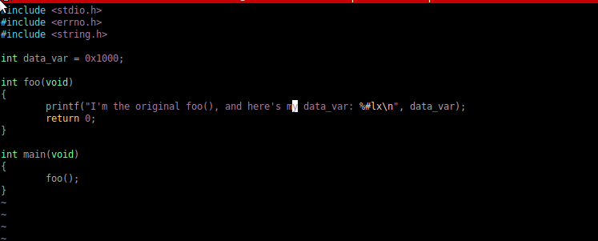

In this example we will show the source code just to make things extremely clear. The source code for test_p1 shows a main() function calling function foo(). In some cases it may be desirable to completely replace a function or global data (Such as .data, .rodata, or .bss variables). Essentially re-linking the process image to use the symbols/code/data created in a Shiva patch object.

Truncated symbol table of ELF binary “test_p1”

We can the relevant symbols in this binary that will ultimately be relinked with the patch symbols.
The STT_FUNC symbol foo is STB_GLOBAL. Therefore in our patch we will have to include the new function foo as an STB_GLOBAL. If we plan to patch the value of the data segment variable data_var we will have to include the new variable in our patch as an STT_OBJECT with GLOBAL bindings.

Source code for patch “p1.c”

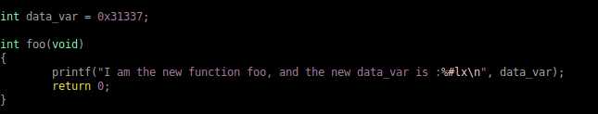

Our patch is written purely in C, and can be compiled as an ELF relocatable object. We must use a large code model (See section 4.1). Once the patch is applied, the executable will call the new version of foo, and reference the new version of data_var. The new foo, and data_var live within the text and data segment of the patch object’s executable runtime image.

NOTE: It is possible for an interposing replacement function, such as foo(), to call back to the original foo(). Shiva has a symbol resolver `shiva_resolve_symbol()` that can resolve symbols within the target executable. This can be very desirable when wanting to insert a patch that sanitizes data or performs a needed check before calling the original foo. See section 4.7.C

Symbol and relocation data for patch “p1.o”

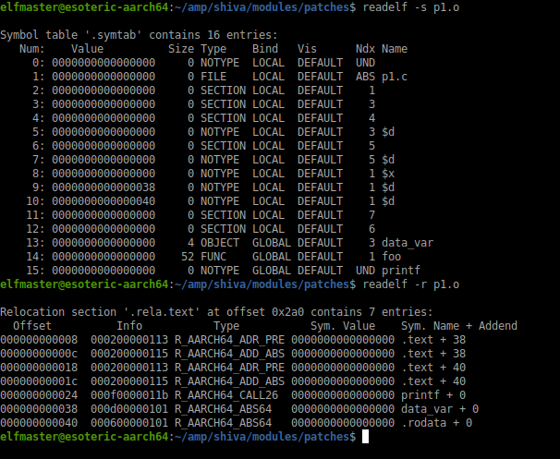

The symbol and relocation data for p1.o are all of the ELF meta-data necessary for the Shiva linker to load and link the module into a process address space. These relocations are only responsible for linking the code in the module into the address space; external linking to the executable is required to complete linking to the patch code (See section 5.0: Shiva runtime re-linking on executable).

After the p1.o patch has been fully linked into the running program and the external linking has been applied to the executable, every call to foo() and every reference to the data_var variable within the executable will be linked to the updated versions of the symbol from the p1.o patch, containing the new foo() and data_var.

Running the ./test_p1 program unpatched and then patched

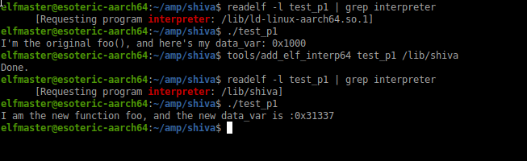

The output above is demonstrating how the program ./test_p1 has the path to the standard dynamic linker, in this case “/lib/ld-linux-aarch64.so.1”. When we execute the program it behaves as expected, before the patch. We use add_elf_interp64 to change the PT_INTERP segment path to “/lib/shiva”. The patch object: p1.o, is being loaded from a fixed path. Shiva is still a prototype and only loads one patch object from the fixed path “./modules/shakti_runtime.o”, in the near future a module search path and module basenames will be included in the custom dynamic segment to direct Shiva where to load the module from.

Shiva ignores the normal symbol visibility rules of symbol interposition in order to aggressively patch inlined functions or hidden symbols (i.e. STV_HIDDEN). The above example shows a more traditional example of overriding a function with STB_GLOBAL bindings and STV_DEFAULT visibility.

4.5 Cross ELF relocations between chained linkers

Cross ELF relocation occurs when a symbol reference from within a patch object is referencing a symbol or function that is meant to be relocated by the “ld-linux.so” rtld. In example… Shiva is loading and linking the patch object into memory, and the patch is calling function printf that lives in libc.so. The dynamic linker “ld-linux.so” hasn’t even begun execution yet, let alone resolution of it’s shared library symbols, so how does Shiva fixup the R_AARCH64_CALL26 relocation that binds the call instruction to libc.so:printf? This is a kunundrum where two runtime linkers that load a totally separate set of modules, must synchronize relocation data in some way. Shiva calls this Cross ELF relocation.

Let’s take a look at the ELF relocations and symbols for the p1.o patch object, one more time.
Symbol and relocation data for patch “p1.o”

The symbol table contains printf as a STT_NOTYPE symbol type, with an STT_GLOBAL symbol binding. This tells Shiva that the symbol does not exist within the patch module, but somewhere external. The R_AARCH64_CALL26 relocation instructs Shiva to insert the encoded 26bit offset to printf within the bl instruction at offset 24.

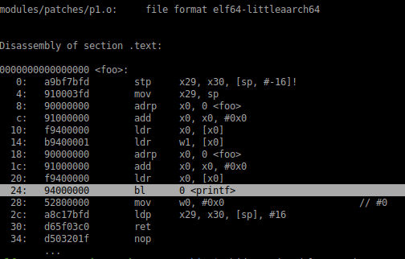

Shiva must locate the printf symbol in a module outside of the patch object, and relocate the patch object’s bl instruction accordingly.

Steps to linking an external function, with Cross Relocation

1. Check to see if printf lives within the target executable. If it exists in the target executable, and is STT_GLOBAL/STT_FUNC, then Shiva will link it to the bl instruction by solving the R_AARCH64_CALL26 relocation. Otherwise Shiva moves on to step 2.

2. Check if printf is in the target executable symbol table with STT_NOTYPE, which indicates that the symbol is external, and will likely be linked at runtime. If so, then Shiva checks to see if there exists a PLT entry for calls to printf. If a PLT doesn’t exist, then linking fails. Otherwise, Shiva resolves the R_AARCH64_CALL26 relocation so that it contains the offset to the printf@PLT entry within the target executable, in this way all calls to printf from the patch module will be transferred through the existing PLT entry. If lazy linking is used, the PLT/GOT entry won’t be resolved until the chained linker “ld-linux.so” is invoked and finishes its dynamic fixups. If printf doesn’t exist at all in the symbol table of the target executable, then move to step 3.

3. If we have arrived at this step, then Shiva could not find the printf symbol in the target executable’s symbol table, even as an undefined symbol it is not present. In this case we search all of the shared library dependencies, transitively, via the DT_NEEDED entries in the dynamic segment of the executable and it’s shared modules. If the symbol doesn’t exist then Shiva exits with a linker failure, as it cannot be resolved. If Shiva finds the symbol printf as STB_GLOBAL/STT_FUNC within a shared object dependency (Such as libc.so), then Shiva must generate new relocation tables containing a new R_AARCH64_JUMP_SLOT relocation, and a new PLT stub that support the linking of printf at runtime.

Steps to generating a new JUMP_SLOT relocation

1. Shiva creates an alternate .rela.plt section, that lives in memory allocated by malloc(3). Copies the original rela.plt into the new location, and adds an extra R_AARCH64_JUMPSLOT relocation at the end of the rela.plt table. The r_offset field should point to the address of the new .got.plt entry created in step 2.

2. Create a custom .got.plt entry, and a .plt stub specifically for the function that you are wanting to resolve at runtime. Each entry is a pointer-width in size, and should be allocated in the heap via malloc(1).

3. Create a new symbol table, containing the original symbol data and the symbol for the new function you are creating the entry for. This symbol table can be copied into memory allocted by malloc(3).

4. Update DT_JUMPREL (in the dynamic segment) to point to our new rela.plt table

5. Update DT_JMPRELSZ to contain the size of our newly created relocation table (original_size_of_table + sizeof(Elf64_Rela)).

3. Link all module call instructions with the offset that points to the newly added PLT stub.

This is a great example of how the first linker “/lib/shiva” can interact with and even instruct it’s chained linker “/lib/ld-linux.so” by generating ELF meta-data that “ld-linux.so” understands, specifically relocation data for linking purposes.

NOTE: In the event that we were linking to a variable instead of a function, Shiva would generate an R_AARCH64_GLOB_DAT relocation instead of an R_AARCH64_JUMP_SLOT.

4.6 Declaring external variables within patch source

The last section (4.5 ELF Cross relocation between linkers) gave an example of linking to external code and data implicitly, leading to cross-relocation. In many cases though too, it is desirable to simply declare an external variable, without patching it. Let’s take a look at an example program, and a corresponding patch to illustrate our needs.

Source code for test_p2.c, a program we are patching

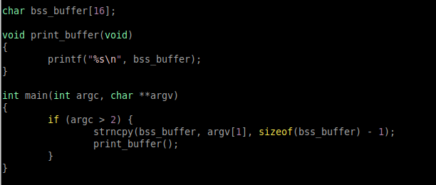

This program simply copies the argv[1] into the bss_buffer, and prints the string with printf. Though, let’s write a simple patch that only prints the buffer when it contains the string “hello world”.

Source code for p2.c patch

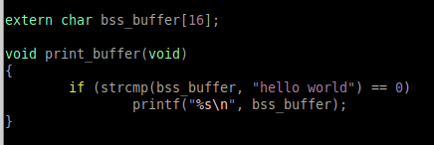

Notice that our patch code declares bss_buffer using the extern keyword. Because our patch wants to read from the bss_buffer from the executable vs. creating a new bss_buffer. This results in the symbol type being STT_NOTYPE vs. STT_OBJECT. If we fail to apply the extern keyword, Shiva would attempt to interpose the symbol bss_buffer and all of the program that references bss_buffer would be relinked to use the patches version of bss_buffer.

When Shiva applies the patch above, the program will only print argv[1] to stdout if it is the string “hello world”.

4.6 Program Transformations (Transforms)

Although symbol interposing is a strength in that it’s a natural grammar for re-writing and re-linking code and data that are represented by ELF symbols, it cannot readily be applied to the byte-code sequences in between all of the symbol definitions. For example, adding several bytes of code to an existing function requires that the function be extended in length. Let’s say we want to add 8 bytes in the middle of a function, this would cause any instructions that live after the insertion to have invalid xref offsets for any calls or references to code and data that live before the insertion. Therefore a complete transformation of the function being patched is required. This is where Transforms come into play. They give the patch writer the mechanics necessary to handle patching more nuanced parts of the program code. Shiva implements these directives as macros, that are interpreted by the Shiva Pre-linker, which interprets them and compiles them into custom Shiva Transformation records, similar to Relocation records.

Consider a simple function that has a minor security vulnerability due to strcpy usage. We must write a patch to fix this security vulnerability, and in doing so we will demonstrate how Transforms can be used to directly inform Shiva on where to emit code, and Shiva will handle all of the transformation under the hood.

Image 4.6.1: Vulnerable function source code strcpy_vuln.c

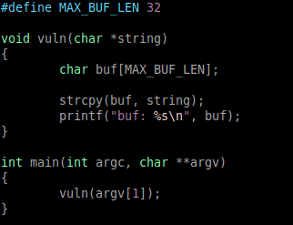

Our goal is to patch the function vuln directly, so that it uses strncpy instead of strcpy. Now since this vuln function is so simple, we could simply re-write it with a new version and patch it with symbol interposition, but in real life scenarios the function is often too complex to re-write, especially without source code. Let’s take a look at what the patched assembly for the function foo needs to look like

Image 4.6.2: Assembly diff for patched function vuln

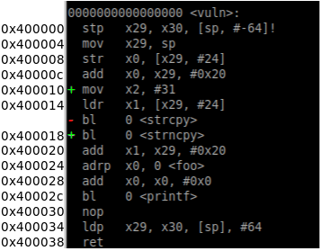

1. An instruction is added “mov x2, #31” at address 0x400010, which is where the “ldr x1, [x29, #24]” was at, and has now been shifted forward to 0x400014 to make room.

2. The call instruction at 0x400018 “bl strcpy” has been replaced with “bl strcpy”.

These types of code insertions may appear simple, but they require a relatively robust system for program transformation at runtime. Inserting new code into a function that extends the size of the function will cause erroneous code after the insertion due to the extension changing xref offsets. Additionally, the call to strcpy has been changed to strncpy which may be tricky to link if there is no PLT stub in the executable.

Image 4.6.3: Assembly code for original vuln functions

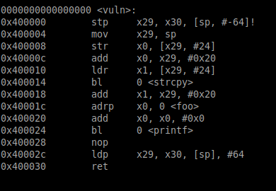

The above disassembly shows the function vuln before it has the patch applied. Our goal is two add one new instruction, and patch an existing bl instruction.

4.7 Patching manually with Transformation directives (The hard way)

1. To insert a new mov instruction in between the add at 0x40000c and the ldr at 0x400010, we can use the Shiva Transform macros for emitting new instructions, in this case a mov instruction.

To add the instruction “mov x2, #31”

We add the following line to our patch source code:

SHIVA_T_EMIT_NEW_MOV(0x400010, SHIVA_AARCH64_X2, 31);

Defined as

#define SHIVA_T_EMIT_NEW_MOV(address_of_insert, reg, imm)

The Shiva Pre-linker will interpret this command from the patch object, and compile it into Transformation record that is specific to the Shiva runtime, and specifically program transformation. To be more specific, this transform will be processed by the Shiva Pre-linker when applying the patch, and the custom transform data will be stored the ELF section .shiva.transform. Therefore at runtime the Shiva linker only needs to read pre-processed meta-data to transform the function, which is relatively fast. If Shiva is being invoked directly on an executable that hasn’t had the transformation/relocation meta-data installed (i.e. “shiva p ./patch.o test_prog” vs. “./test_prog”) then Shiva will have to calculate all of the transformation and relocation on the fly as it statically analyzes the code at runtime prior to linking.

A Transform directive that emits a new instruction will therefore extend the size of the function, and therefore require complete function relocation. The Shiva linker will make a copy of the old function moving it over to the Shiva modules memory space, insert any new instructions (Such as mov) and then handle any fixups in the code that live before or after the new instruction. Shiva will then fixup any calls or references to this function from within the target executable.
The SHIVA_T_EMIT_NEW_<INSN> macros will insert a new instruction in between two instructions, but sometimes we may want to simply overwrite an existing instruction. In this case we would use the SHIVA_T_OVERWRITE_<INSN> which will overwrite an existing instruction, and is a lot less labor intensive since it isn’t required to patch up relocations.

2. To modify the bl instruction from calling strcpy to calling strncpy we can add the following line to our patch source code:

SHIVA_T_EMIT_BL_RESOLVE(0x400014, “strncpy”);

Defined as

#define SHIVA_T_EMIT_BL_RESOLVE(address_of_insert, symbol_name)

If we knew what the address of strncpy was going to be (Which we won’t during patch creation) we could use

SHIVA_T_OVERWRITE_BL(0x400014, <offset>);

Often times when writing the patch though we may be linking to a symbol who’s value we won’t know until it’s been linked by the “ld-linux.so” RTLD, therefore it is very friendly to have a Resolver version of certain Transforms to handle the semantics of Cross Relocation symbol resolution.

There exist Transform directives to emit (insert or overwrite) any ARM instruction. They are a work in progress as the design of Shiva continues. More of them will exist down the road for various arbitrary operations.

4.8 A natural C approach, with Shiva’s function splicing

In many patching scenarios Shiva allows the patch to be designed in C, in the programming customs already known to developers.

Instead of using Shiva’s Transform directives to emit instruction encodings, we can simply splice in the call to strncpy so that it overwrites strcpy, using the function splicing transformation SHIVA_T_SPLICE_FUNCTION.

The patch identifies the name of the function vuln() that is to be transformed. The starting address of the splice insert, and the ending address. The patch also creates two .bss variables buf, and string. At runtime extra byte-code will be emitted that loads char buf[MAX_BUF_LEN] with the value at [sp + #32], and char *string will be assigned the pointer value from register x0. All of this data will be encoded into the ET_REL file (The patch object) in a way that Shiva can interpret and turn into a function splicing operation.

Image 4.8.1: Example of function splicing in strncpy patch. (strcpy_vuln_patch.c)

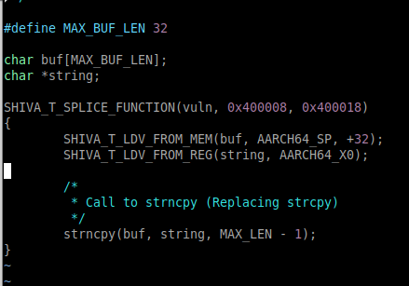

In section 4.2.B we discussed the Shiva Pre-linker which compiles these Transformations into a meta-data known as transform-records that can be stored within the executable that is being patched. Here is the preliminary definitions, with an example of applying one of these relocation fields at runtime.

Image 4.8.2: Shiva transform structs

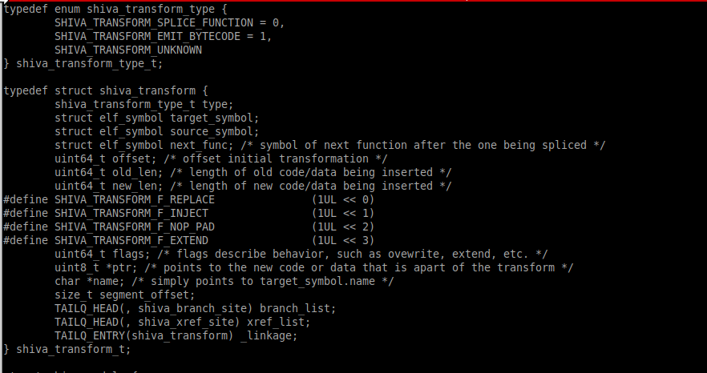

The patching transformation records are stored into the patch modules .shiva.transform section, and at runtime the Shiva Transformation Engine will parse and apply the transformation. In the future the shiva-ld tool will store both ELF Transformation and ELF Relocation meta-data within the target-executable with pre-compiled analysis data etc. to speed up the transformation and runtime relinking process at initial load-time of Shiva.

Image 4.8.3: Example code of how to apply a Transform relocation

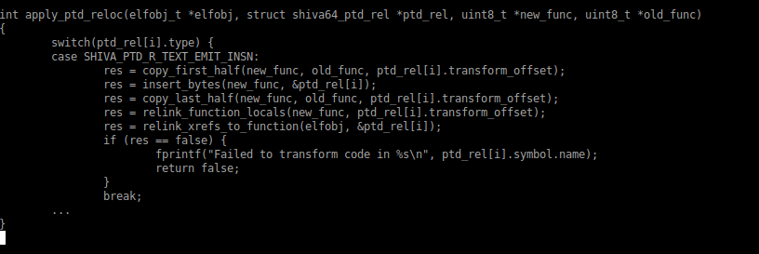

5.0 Shiva runtime linking on the target executable

ELF executable’s are not linked with enough relocatable data to link their code with the patch at runtime. A typical dynamically linked ELF executable usually contain 3 relocation types.

Relocations for “ld-linux.so”

R_AARCH64_RELATIVE
R_AARCH64_JUMP_SLOT
R_AARCH64_GLOB_DAT

These relocations tells the “ld-linux.so” where to patch various writable data segment entries, such as the .got, .got.plt, .init_array, and .fini_array. These relocations are perfect for what the “ld-linux.so” needs in order to link in shared object dependencies, but there are not descriptive enough to help Shiva fixup the executable image so that it is linked with the patch code and data.

Shiva must analyze the executable code in the .text section at runtime, in order to disassemble every instruction, and find the various xrefs (branches, memory references, etc.) that will require being patched with the correct linking offsets. This can happen during one of two possible phases.

1. After Shiva loads and relocates the module it performs runtime analysis on the target executable in order to find all instructions that must be re-linked.

2. Before runtime, when shiva-ld is used to apply the patch, it will statically analyze the executable’s .text section and generate ELF relocation data to describe the areas which must be patched within the ELF executable. For example, fo revery bl instruction there would be an R_AARCH64_CALL26 relocation.

The first option will certaintly trigger a performance impact that increases based on the size of the .text section of the executable we are patching. Every instruction is disassembled on the fly at runtime, and a then patched. This can be negligible on smaller programs or if the program load-time doesn’t matter. When applying a patch to an executable with the shiva-ld (Shiva prelinker) the relocation data is generated and stored within the executable, so that everytime it is executed the Shiva linker can read the relocation/transform data and apply the patches to the executable so that it links with the patch code.
Whether the analysis happens during pre-linking or runtime, it always follows the same process to acquire instruction data and generate relocation information.

Image 5.1: adrp/add instructions to load address of &data_var from .data section

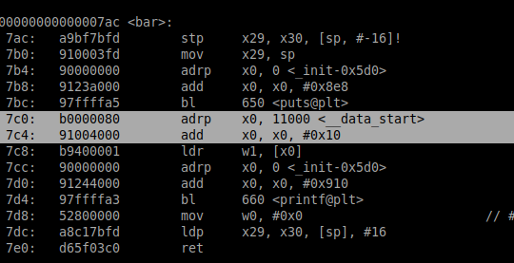

The adrp, and add instructions are generally used to reference a memory location, and therefore must be patched in order to re-link with the patch code and data. In the example above, the address value of &data_var (A .data section variable) must be re-linked by patching the adrp instruction with the correct offset to the patch objects data segment, which will be within 4GB of the adrp instruction. The add instruction is patched with the correct offset of the new data_var variable from the beginning of the data segment (where the modules respective .data section is).

The data segment for a patch is often loaded at 0x6000100, and so we would have to first re-encode adrp with the correct offset encoded into 26 bits. Then handle the offset in add so that it contains the correct offset to the the data_var variable.

Currently Shiva re-links the following instruction types:
As discussed in 4.2.B Shiva-Prelinker, this information will be generated into pre-compiled relocation data by shiva-ld when used, and stored within a new .shiva.ptd.rel.text or .shiva.ptd.rel.data.

Instruction: BL (Branch with link): To re-link calls from old function in executable to new function within patch module.

Generated Relocation Types: R_AARCH64_CALL26

NOTE: In the event of function pointers, we do not overwrite them, but do insert a trampoline in the old function so that it points to the new function. Therefore only function pointers will incur the overhead of an extra branch.

Instruction pair: ADRP/ADD (Page addr + offset) + Add-imm-offset: Patched to re-link with the new variable within the patch module.

Generated Relocation Types: AARCH64_ADR_PREL_PG_HI21,
AARCH64_ADD_ABS_LO12_NC

Instruction pair: ADRP/LDR (Page addr + offset) + Ldr-imm-offset: Patched to re-link with the new variable within the patch module.

Generated Relocation Types: AARCH64_ADR_PREL_PG_HI21,
AARCH64_ADD_ABS_LO12_NC

More Branch/Xref instruction types will be addressed in future development.

References:
1. Preloading the linker for fun and profit: https://tmpout.sh/2/6.html
2. Design and implementation of userland exec: https://grugq.github.io/docs/ul_exec.txt
3. Slide-Deck for Original x86_64 Shiva implementation:
https://github.com/advanced-microcode-patching/shiva/blob/main/presentation/shiva_runtime.pdf

