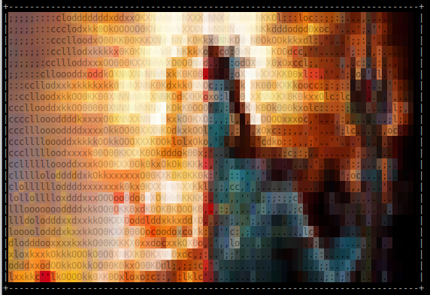
A friendly user guide to ELF micropatching with Shiva (alpha v1)

Shiva Manual
1 Introduction to Shiva 2
Shiva is LEJIT! 2
ELF program interpreters 2
Shiva is an ELF program interpreter 3
Systems and arch’s that Shiva supports 4
2 Installing Shiva-AArch64 4
Download Source code 4
Build source code 4
Build and install libelfmaster 4
Build and install Shiva 5
Build and install example patches 5
3 Writing patches with Shiva 6
The Shiva workflow 6
ELF Program compilation and linking example 6
Static linking of objects 6
Dynamically linked executable 7
Dynamically patched executable 8
ELF Symbol interposition 8
Patching an .rodata string (Simple first patch) 8
Building the patch 9
Testing our patch: ro_patch.o 10
Using shiva-ld to prelink the patch 10
Final outcome of patching test_rodata 12
Current limitations of patching const data 13
Symbol interposition on functions 14
Patch exercise 2: Replacing function foo() 14
Shiva Post Linker 16
Relocations and symbol data in foo_patch.o 18
Shiva external re-linking of the ELF executable 20
Patch example 2: Apply Function interposing patch, replace foo() 21
Shiva-ld tool. Prelink executable ./test_foo with foo_patch.o 22
Execute “test_foo” after shiva-ld has prelinked it 22
Symbol interposition on global data: .rodata, .bss, .data 23
Re-declaring the size of global variables 23
Fixing .bss overflow by increasing buffer size 23
Cross-Relocation with .bss relinking 25
The algorithm for cross relocations on .bss variables 27
Redeclaring global data types, signedness, and size 27
Redeclaring global integer signedness 27
Redeclaring the global storage type: 28
Redeclaring a global .data variable as a constant 28
Redeclaring a global constant into a .data variable 28
Initializing an uninitialied .bss variable (Conversion from .bss to .data) 29
Patching STB_LOCAL variables 29
Using the extern keyword in your patch code 29
Symbolic patching of stripped ELF’s 30

Introduction to Shiva

Shiva is LEJIT!

Shiva is a LEJIT micropatching system for Linux ELF software. LEJIT (Linking & Encoding Just In Time).

ELF program interpreters

Shiva is an ELF microcode-patching technology that works similarly to the well known (but little understood) ELF dynamic linker “/lib/ld-linux.so”. Every ELF program that is dynamically linked has a program header segment type called PT_INTERP that describes the path to the program interpreter. The program interpreter is a separate ELF program loaded by the kernel that is responsible for helping to build the process runtime image by loading and linking extra modules containing code and data. Traditionally these modules are called shared libraries, and the program interpreter is “/lib/ld-linux.so”. On aarch64 it is “/lib/ld-linux-aarch64.so.1”

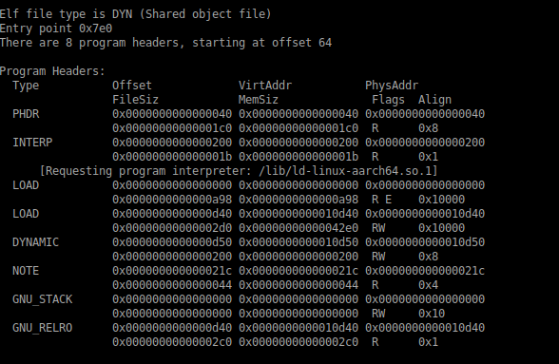
Image 1.0: Requesting program interpreter “ld-linux.so”

Just like any other interpreter, such as Python, or Java, the ELF program interpreter is responsible for performing various types of loading, patching and transformation.

Shiva is an ELF program interpreter

Shiva is a newly designed program interpreter who’s sole purpose is to load ELF microcode patches that are written in C and compiled into Shiva modules (ELF relocatable objects). Shiva modules are relocatable objects and by nature already contain the ELF meta-data (sections, symbols relocations) necessary to re-build much of the process image. Additionally Shiva has introduced some new concepts such as Transformations which are an extension to traditional ELF relocations, allowing for complex patching operations such as function splicing.

The core purpose of Shiva is to create a microcode patching system that seamlessly fits into the existing ELF ABI toolchain of compilers, linkers, and loaders. Shiva aims to load and link patches that are written 100% in C, in a way that is natural for developers who may not be reverse engineers but are experts in C. Shiva is in-itself a linker and a loader that works alongside and in conjunction with the existing Dynamic linker “ld-linux.so”. To understand more technical details see “shiva_final_desing.pdf” within the documentation directory.

Systems and arch’s that Shiva supports

Currently Shiva’s AMP tailored-microcode patching system runs on Linux AArch64, and supports AArch64 Linux ELF PIE binaries. Future support for ARM32, x86_64/x86_32 and other requested architectures. At the present moment Shiva doesn’t support ET_EXEC ELF binaries (non-pie) due to time constraints, but it’s on the road map.

Installing Shiva-AArch64

Download Source code

git clone git@github.com:advanced-microcode-patching/shiva
git clone github.com/elfmaster/libelfmaster

Build source code

Build and install libelfmaster

Shiva requires a custom libelfmaster branch that has not been merged into main yet. Specifically make sure to use the aarch64_support branch.

cd libelfmaster
git checkout aarch64_support
cd ./src
sudo ./make.sh

Build and install Shiva

Commands:

cd shiva
make
make shiva-ld
make patches
sudo make install

Build results:

Shiva is a static ELF executable and installed to “/lib/shiva”. The Shiva modules are typically stored in “/opt/shiva/modules”. The example patches all live within “/git/shiva/modules/aarch64_patches/”.

Build and install example patches
Please see the “shiva/modules/aarch64_patches/” directory. All of the example patches live here. Let us illustrate an example of building and testing one such patch on a program called ‘test_rodata’.

Commands:

cd shiva/modules/aarch64_patches/rodata_interposing
make
sudo make install

Test the patch by setting the patch path and running “/lib/shiva” manually.

$ SHIVA_MODULE_PATH=./ro_patch.o /lib/shiva ./test_rodata

Notice that the software prints the new string “The great arcanum”, per the patch. Yet when the program is executed without Shiva it executes with its old behavior.

$ ./test_rodata

Install the patch permanently

You may also install the patch permanently with the Shiva prelinking tool. This tool updates the PT_INTERP segment from “/lib/ld-linux.so” to “/lib/shiva”, and updates the dynamic segment with several new tags describing the path to the patch that should be loaded and linked at runtime: “/opt/shiva/modules/ro_patch.o”.

$ /bin/shiva-ld -e test_rodata -p ro_patch.o -i /lib/shiva -s /opt/shiva/modules -o test_rodata.patched

Shiva now installs the patch in memory everytime it’s executed

$ ./test_rodata.patched

The only discernible difference between test_rodata.patched and test_rodata are the PT_INTERP segment modification and the PT_DYNAMIC addition of three new entries describing the patch path. No actual code or data has changed within the ELF binary. Shiva performs all of the patching at runtime.

Writing patches with Shiva

The Shiva workflow

Before delving in to the use of Shiva, let us first explain the workflow of what the ELF compilation and linking process looks like before and after Shiva.

ELF Program compilation and linking example

Standard program compilation begins with a compiler like gcc; the source code files (I.e. main.o and foo.o) are compiled and then get linked (By “/bin/ld”) into a final output ELF executable my_program.

Static linking of objects
Image 3.0: static linking of two ELF relocatable objects with “/bin/ld”
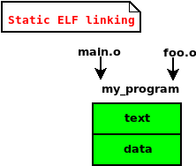

Additionally these ELF relocatable object files generally contain references to code and data within ELF shared libraries. Once the object files (foo.o and main.o) are linked into an ELF executable (my_program), additional dynamic linking meta-data is created and stored into what is known as the PT_DYNAMIC segment of the program header table. The PT_DYNAMIC segment contains additional meta-data that is to be passed along to the Program interpreter at runtime. The program interpreter (aka: dynamic linker) is specified as a file path in the PT_INTERP segment: “/lib/ld-linux.so”. When the program is executed the kernel loads and executes the interpreter program first: “/lib/ld-linux.so”. The interpreter loads and links the needed shared libraries (i.e. libc.so). The program is linked twice: once statically, and again dynamically.

Dynamically linked executable

Image 3.1: Dynamically link libc.so in at runtime
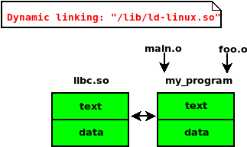

A Shiva patch can be written in C and compiled as an ELF relocatable object file. In the same sense that “ld-linux.so” loads and links shared libraries (ELF ET_DYN files), Shiva will load and link patch objects (ELF ET_REL files) to re-write the program in memory just before execution.

Dynamically patched executable

Image 3.2: Chained linking with Shiva
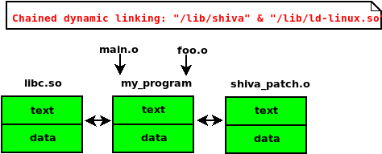

ELF Symbol interposition

The ELF format uses symbols to denote code and data. Program functions generally live in the .text section, and global variables live within the .data, .rodata, and .bss sections. Shiva makes use of the ELF relocation, section, and symbol data to allow patch developers to interpose existing symbols; in other words re-link functions and data that have symbols associated with them. As patch developers we will find this as a natural and beautifully convenient way to patch code and data.

Citation 3.0: From “Oracle linkers and libraries guide”

“Interposition can occur when multiple instances of a symbol, having the same name, exist in different dynamic objects that have been loaded into a process. Under the default search model, symbol references are bound to the first definition that is found in the series of dependencies that have been loaded. This first symbol is said to interpose on the other symbols of the same name.”

Patching an .rodata string (Simple first patch)

This patching exercise lives in “modules/aarch64_patches/rodata_interposing”.
In the following example we are going to look at a simple program that prints a constant string “Arcana Technologies”. Constant data is read-only and is usually stored in the .rodata section of a program. The .rodata section is generally put into text segment, or a read-only segment that is adjacent to the text segment. A shiva module has it’s own .rodata section within it’s mapped text segment at runtime. Our goal with the following patch is to replace a read-only string by simply re-defining it in C.

Image 3.3: Original source code of program rodata_test.c

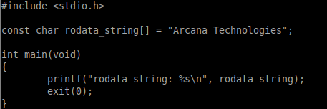

NOTE: The source code to rodata_test.c is only being shown for the sake of illustrating what the program does that we are patching. In many workflows the source code wouldn’t even exist, and Shiva doesn’t depend on or use the source in any way.

Image 3.4: Source code of patch object: ro_patch.c

This simple patch is re-defining a variable named rodata_string[]. At runtime Shiva will build a module process image which will contain the patch .rodata section with the updated version of rodata_string[]. Shiva will re-link the executable to use the new version of rodata_string[] that lives within the loaded modules .rodata section This is the concept of symbol interposition; one global symbol taking precedence over another with the same symbol name and type. Furthermore Shiva allows the user to interpose symbols of different types as well (Including STB_LOCAL symbols) as seen in later examples.
Compile this patch as an AArch64 Linux ELF relocatable object using a large code model. Each patch example, such as “modules/aarch64_patches/rodata_interposing”, contains a Makefile that illustrates how to build a patch object. Generally speaking, a Shiva patch should contain the include path to “modules/include” which contain the “shiva_module.h” header file, necessary to build ma

Image 2.2: “rodata_interposing” Makefile with comments

Building the patch

The patch source code “modules/aarch64_patches/rodata_interposing/ro_patch.c” is a single line patch, redefining the symbol “rodata_string[]”. To build this patch we can simply run the following gcc command to build the patch:

$ gcc -mcmodel=large -fno-pic -fno-stack-protector -c ro_patch.c -o ro_patch.o

The ELF ET_REL object: ro_patch.o describes a symbol with the same exact name as the symbol rodata_string in the target executable. Shiva will see this when linking and it will link in the version of the symbol from our patch. This perfectly demonstrates the concept of symbol interposition in Shiva.

Testing our patch: ro_patch.o

In this example we are patching the AArch64 ELF PIE executable: “modules/aarch64_patches/rodata_interposing/test_rodata” Let’s first run the program normally.

$ ./test_rodata
rodata_string: Arcana Technologies
$

The program simply prints the string “rodata_string: Arcana technologies”. To see if our patch worked we can invoke Shiva directly to load and link the executable with the patch at runtime. We must specify the path to our patch object with the SHIVA_MODULE_PATH environment variable.

$ SHIVA_MODULE_PATH=./ro_patch.o /lib/shiva ./test_rodata
rodata_string: The Great Arcanum
$

When executing ./test_rodata with “/lib/shiva” as the primary loader it installs the specified patch, and the new rodata_string[] value “The Great Arcanum” is printed to stdout. When we run ./test_rodata without “/lib/shiva” it does not install the patch and the original string “Arcana Technologies” is printed.

Using shiva-ld to prelink the patch

The reality is that a user doesn’t want to invoke “/lib/shiva” every single time they want to run a program that needs a patch. This is why “/lib/shiva” is designed to be an ELF interpreter like “ld-linux.so”. We can use the Shiva prelinker “/bin/shiva-ld” to install the appropriate meta-data into the program we are patching:

- Update PT_INTERP with the path to “/lib/shiva” (Replacing “/lib/ld-linux.so”).
- Add several custom entries to PT_DYNAMIC describing the patch basename: “ro_patch.o” and the module search path “/opt/shiva/modules”.

The following command will install the Shiva interpreter path and patch information into the ./test_rodata binary.

$ shiva-ld -e test_rodata -p ro_patch.o -i /lib/shiva -s /opt/shiva/modules

This next command copies the patch file into the correct search path: “/opt/shiva/modules”

$ sudo cp ro_patch.o /opt/shiva/modules

Before we run ./test_rodata, let’s take a quick look to see what modifications shiva-ld made to the executable:

Image 3.5: Requesting program interpreter is “/lib/shiva”
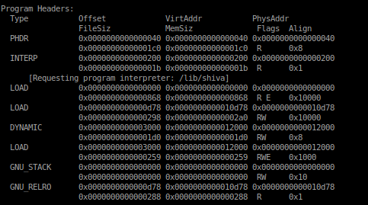

In image 3.5 we can see that “/lib/shiva” is set as the new Interpreter path. The astute reader will also notice that there is a third PT_LOAD segment marked RWE. The shiva-ld tool creates a new dynamic segment (As shown below in Image 2.3). In order to make room for this new and larger dynamic segment shiva-ld creates a new PT_LOAD segment and updates the PT_DYNAMIC segment program header so that it points into the new PT_LOAD segment at 0x3000. The updated PT_DYNAMIC segment is moved and stored in this new segment

Image 3.6: New dynamic segment contains 3 custom entries

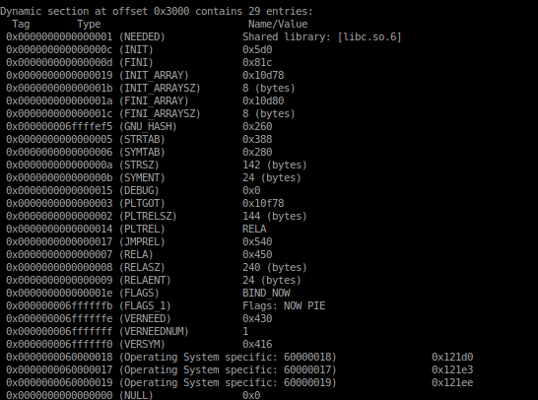
The above image 3.6 shows the dynamic segment of the ELF binary: test_rodata, after we ran the shiva-ld tool on it. Notice the three Operating System specific entries at the tail end. The readelf utility doesn’t know how to parse these custom entries. Here is what the actual entry types and values are:

(SHIVA_NEEDED) Patch object: [ro_patch.o]
(SHIVA_SEARCH) Search path: [/opt/shiva/modules]
(SHIVA_ORIG_INTERP) Original RTLD: [/lib/ld-linux-aarch64.so.1]

This data is needed by “/lib/shiva” at runtime so that it can locate and load the patch object, and the original dynamic linker (See Chained Linking in section x.x).

Final outcome of patching test_rodata

Now every time that the test_rodata executable is ran it will invoke the Shiva interpreter which will in turn load the patch object “/opt/shiva/modules/ro_patch.o”.

$ ./test_rodata
rodata_string: The Great Arcanum
$

We can observe that the program test_rodata is now printing the patched version of rodata_string [] when it is ran. This patch may appear permanent, but in effect the patch is actually being installed at runtime by “/lib/shiva” everytime the program runs.

Current limitations of patching const data

There are patching scenarios with const data that fail with symbol interposition due to code optimizations with read-only data. In the previous example we illustrated how to patch a read-only global variable defined in C as:
const char rodata_string[] = “Arcana Technologies”;

The target program gets re-linked to use the patch version of rodata_string. Using symbol interposition to overwrite .rodata variables works perfectly unless the read-only value is optimized out of memory and stored only in a register. Let’s look at the following example:

Image 3.7: C code illustrating a read-only global variable
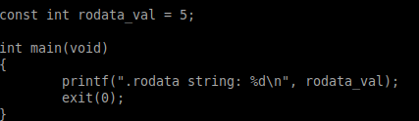

After compiling the code above with gcc, even after all optimizations are disabled, you will get code similar to the following AArch64 assembly.

Image 3.8: Code optimization of read-only variable in aarch64 assembly
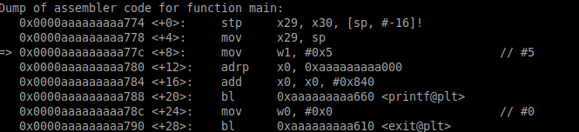

In the code above we can see that the value 5 is being copied as an immediate value into a register. This is an optimization that removes the need for an adrp/add/ldr instruction trio, thus eliminating two instructions and the need for memory access. This optimization is inauspicious for symbol interposition based patching since the actual .rodata variables memory is not being accessed and therefore there is no linking code to update. Instead there is only an instruction: “mov w1, #0x5”. Clearly this instruction can be re-encoded rather simply, but what would a patch look like for this? For the curious reader, move ahead to the section titled “ELF Transformations & Function splicing”.

Symbol interposition on functions

Shiva gives patch writers the ability to replace a function trivially using symbol interposition. We’ve all seen userland rootkits that re-write libc.so functions by introducing a preloaded library with a new version of the function. In the same spirit Shiva allows patch writers to replace any function in the target ELF executable with a symbol of type STT_FUNC and symbol bindings of STB_GLOBAL or STB_WEAK. The only exception is that the function main() cannot be replaced, although future support is on the way, as it depends on the glibc initialization code that transfers control to main from _start.
Let’s get started with a simple example of replacing a function called foo().

Patch exercise 2: Replacing function foo()

$ cd shiva_examples/function_interposing

Image 3.9: Original source code of the binary test_foo

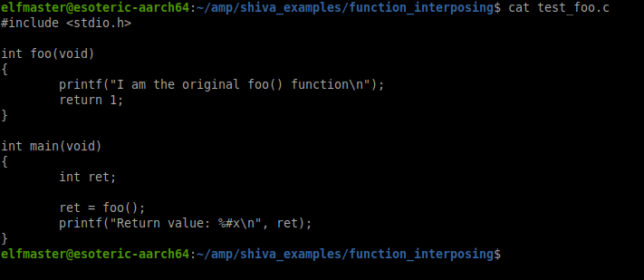

From the original source code shown in Image 3.9 we can clearly see that foo() is a global function called by main(). In order to replace foo() with our own version we can simply re-write the function by name in our patch source code.

Image 3.10: foo_patch.c source code
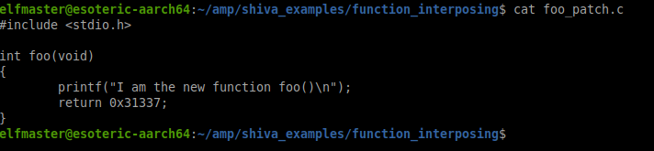

Shiva handles handles all of the linking at runtime for the patch, including shared library calls. Shiva works in conjunction with the ld-linux.so interpreter to accomplish these goals. All call instructions (i.e. branch with link) are given a PLT entry within the patch module at runtime. The patch has it’s own PLT/GOT and the GOT is filled in at runtime with the address to every function (Both in and out of the module) that are being called. Shiva handles all of the runtime relocations prior to passing control to ld-linux.so except for when the relocation references symbolic code or data that live within a shared library. A call to libc:printf() from within the patch code have it’s own respective GOT entry. The address of printf() won’t be known until ld-linux.so has mapped the shared libaries into memory and procesed their relocations. To handle this scenario Shiva incorporates a Post Linker which waits until ld-linux.so has processed all of the symbol relocations for each shared library, and then finalizes fixing up the patch modules GOT with the addresses to each respective shared library symbol.

Shiva Post Linker

The Shiva Post Linking Phase is a great example of what Shiva refers to as Cross-ELF-Relocations (Defined as a relocation who’s computation relies on the results of a secondary relocation solved by an entirely separate runtime linker – One linker must wait on the other to satisfy the Cross-Relocation) In particular though, the Shiva-Post-Linker is a linking mechanism that delays certain relocations from being processed until the standard RTLD “ld-linux.so” has finished mapping in each shared library and processing their respective relocations. In the event that Shiva has to fill in the PLT/GOT entry to resolve a function, such as printf() in the patch code above for foo(), it must rely on the dynamic linker to load and link libc.so:printf() first. After ld-linux.so is finished, it must somehow control must somehow be transferred back to Shiva, particularly to the function shiva_post_linker(). To make this happen we actuallyTo give some context, here is a screenshot of the shiva post linkers source code.

Image 3.11: shiva_post_linker.c comments
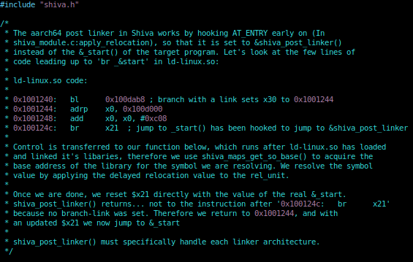
In the above image 3.11 the comments describe how Shiva actually replaces the auxiliary vector value for AT_ENTRY on the stack, which normally contains the address to _start() in the ELF executable that is running, and ld-linux.so passes final control to this address. Shiva takes advantage of this and hooks AT_ENTRY with the address of &shiva_post_linker(); The post linker introduces the concept of Delayed relocations. It is simply the concept that the linker notes a relocation entry for delayed fixups; meaning delayed until the ld-linux.so finishes loading and linking all of the shared libraries, at which point control is passed back to &shiva_post_linker() to apply the delayed relocation entries.

Image 3.12: shiva_post_linker() source code

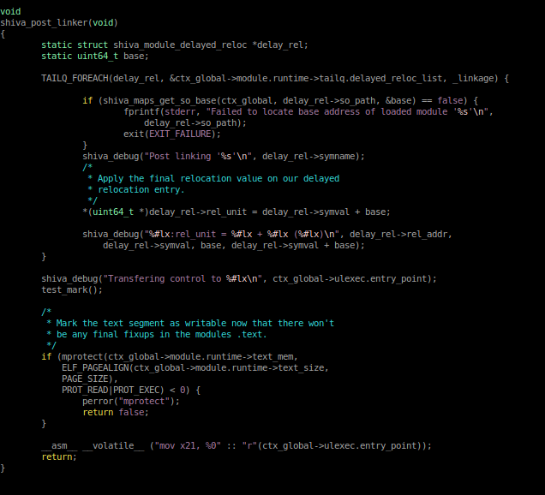

In Image 3.11 above, The shiva_post_linker() source code illustrates how it handles delayed relocations. Particularly (S + B) which is symbol value + base address. The final relocation value is stored in the patch modules GOT entry for the shared library function that is being called. The execution flow goes something like this:
[shiva runtime linker] → [ld-linux.so linker] → [shiva_post_linker] → [_start() in exe]
We reset the value in register x21 back to the original entry point of the executable in &_start().

Relocations and symbol data in foo_patch.o

Without further contemplation lets jump right into the patch directory: “shiva_examples/function_interposing”

Image 3.12: View the patch files in directory “function_interposing”
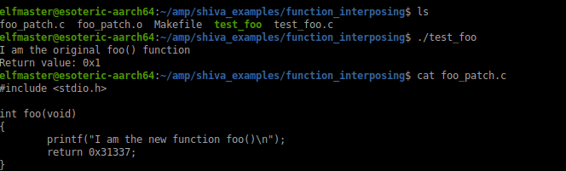
Notice the patch above ‘foo_patch.c’ is simply a re-write of the function foo(). At runtime Shiva will place this new version of foo() into the patch modules text segment. A quick look at it’s relocation entries:

Image 3.13: Relocation entries for program ./test_foo
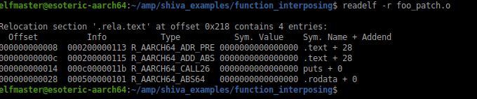
The relocations for our patch foo_patch.o will be processed and applied by Shiva at runtime. Here is an explanation of the relocations for our patch, while not yet discussing the re-linking of the target executable that has no viable relocation meta-data for Shiva.
- The first relocation is to to be applied at offset 0x8 within the .text section of our module. This relocation is symbolically referencing .text + 28, which is going to eventually contain the address to .rodata + 0, where the string “I am the new function foo()” lives. To be specific, this relocation is re-encoding an adrp instruction to return the page address of the .text encoding at 0x28
NOTE: Shiva refers to a relocation such as this, as a .text on .text relocation. Definition: The relocation is in .rela.text and symbolically links to a .text section offset. This becomes important to Shiva when it’s using more advanced features such as function splicing transforms. Therefore “.text on .text relocation” is a term that will be spoken about in this manual.
- The second relocation is adding the offset of the .text encoding so that the following ldr instruction can indirectly access the address from the .text encoding and store it into a register as a pointer to the string “I am the new function foo()”.
- The third relocation is a CALL26 to re-encode the bl instruction with the 26bit offset to the patches PLT entry for libc.so:puts().
- The last relocation is the one that fills in the .text encoding that should contain the address of .rodata + 0x28.
NOTE: The text encodings often act as an indirect reference to something like a GOT[] does, infact...The binutils linker “/bin/ld” generally moves these .text encodings into the .got[] when the final executable is built. However it is not a necessary linking procedure. Shiva modules do actually have a designated GOT in the modules data segment at runtime and is used exclusively for PLT/GOT linking of the CALL26 relocations. The .text encodings are kept in -place by Shiva without moving them into any kind of .got table.
Let’s take a look at the patch object file disassembly for function foo() and compare the instruction offsets to those specified in the relocations above.

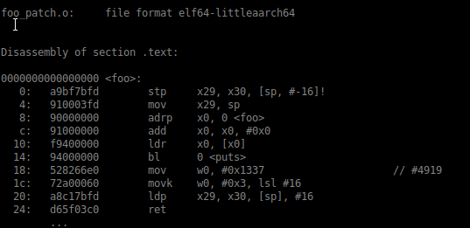
Image 3.14: Disassembly of foo_patch.o:foo() before relocation happens

The code shown above in Image 3.14 is the objdump output of our replacement foo() function. Resolving relocations to build our own modules runtime image is based on the relocatable nature of the object file and the symbolic scope that Shiva uses to re-link the process image. This code can be relocated fairly easy by Shiva’s standard linking capabilities. The next part to solving the patching at runtime is re-linking the code in the target executable (in memory) so that any calls to foo() are replaced with calls to the new location of foo() within the patches executable image. External re-linking can be a trifle difficult at times due to a lack of relocation records describing how to re-link .text code.

Shiva external re-linking of the ELF executable

Shiva’s initial linking job is to ensure that a runtime image can be setup for the patch module, in this case it is foo_patch.o. The ELF sections in this file are copied into heir respective memory segments that Shiva creates with mmap; a text segment (.text, .plt, .rodata, .shiva_transform, .shiva_CFG) and a data segment (.got, .data, .bss). Relocations are driven by section offsets, and thus Shiva creates an internal data structure pointing to where each section lives within the patches executable environment. (i.e. .text, .data, .bss section within the modules text segment). Shiva sets up an executable process image for the patch right next to the target executable in memory. Now that the patch code is ready for execution, the target program we are patching hasn’t yet been re-linked. Historically ELF executables have never stored the more granular ET_REL style relocations because they aren’t necessary as the program has already been linked into an executable. The only relocation data in an executable is for the initialization code or dynamic linker to resolve global symbols from shared objects. In this particular case Shiva needs to know the location of each call instruction to foo() and re-link the instruction to the replacement foo() from our foo_patch.o module. Ideally Shiva would have in this case an R_AARCH64_CALL26 relocation, but we haven’t really needed such relocation types as this one outside of linking object multiple files. Shiva re-links object files into executables at runtime, as it is a patching engine. Shiva scans the .text section at runtime to build all of the CFG data. See shiva_analyze.c:shiva_find_calls() which very early on parses every instruction in the target executables .text section generating calls/xrefs to code and data. This can be seen in the following function shiva_module.c:apply_external_patch_links() -- re-linking the target executable’s instructions to patch data and patch code. By the time you read this user-manual though, all of the CFG analysis will be generated in the Prelinker: “shiva-ld” a tool which stores all of the control flow graph data into a custom ELF section in the patch module (i.e. ELF section called .shiva.CFG). At runtime Shiva will simply read the CFG data in from this custom section who’s meta-data provides the correct relocations for where in the target executable we must re-link. This CFG and relocation data is generated by the Shiva prelinker: shiva-ld, which only has to run once vs. everytime Shiva runs. This will reduce Shiva’s load time dramatically.

Patch example 2: Apply Function interposing patch, replace foo()

We’ve spent the last little while discoursing on Shiva’s internals to give some insights into how ELF symbolic resolution, relocations, and cross relocations work together to support the JIT re-writing, re-encoding and transformation of the process image: Merging the patch and the executable into a single process image, eternally betrothed through linkage.

Image 3.15: Patch example 2, Replacing function foo()
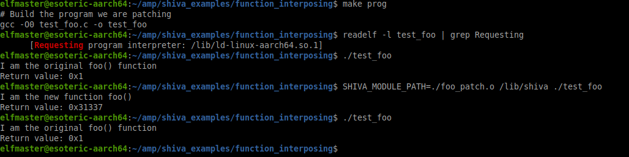
In the example above, Image 3.15, we illustrate that the target ELF binary: test_foo, is not using Shiva as the interpreter, but rather the standard “/lib/ld-linux.aarch64.so.1” . We want to test our patch out before prelinking the patch meta-data with Shiva-ld. Again we can invoke “/lib/shiva” directly and it assumes responsibility for loading the executable you are patching, rather than the kernel doing it

NOTE: See grugqs classic paper on engineering userland execve implementation for anti-forensics. So much mileage out of this great technique over the years.

Shiva-ld tool. Prelink executable ./test_foo with foo_patch.o
Image 3.16: Prelinking the patch: foo_patch.o to the executable: test_foo
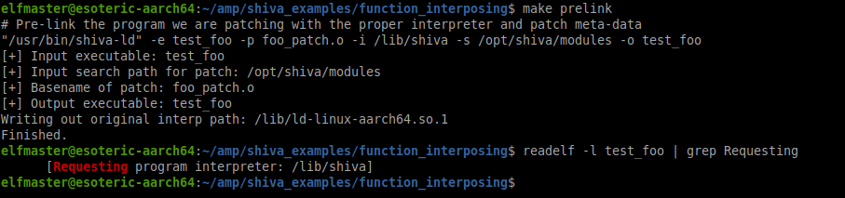

Execute “test_foo” after shiva-ld has prelinked it
Image 3.17: Executing test_foo with Shiva as ELF interpreter
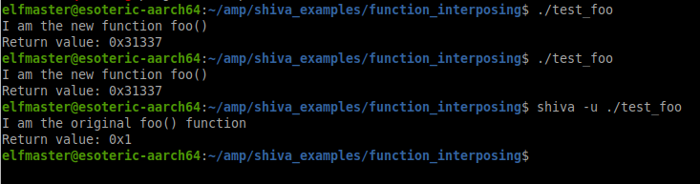
Notice from Image 3.17 that the ELF program test_foo executes and calls the replacement foo() function correctly from within the foo_patch.o module. The test_foo binary has been shiva-prelinked and contains the updated PT_INTERP segment with “/lib/shiva” replacing “/lib/ld-linux-aarch64.so.1”. Every time the program executes the kernel invokes Shiva as the interpreter, which in turn performs its LEJIT operations (Linking & Encoding, Just in time). The last command in Image 3.17 is note worthy too:

$ shiva -u ./test_foo
I am the original foo() function
Return value: 0x1
$

Notice that Shiva is invoked directly this time and we specify the ‘-u’ flag which essentially means “userland-exec only, don’t apply patches”. The program “test_foo” now executes without the patches installed at runtime. This illustrates the flexibility of a modular patching system well, as it’s workflow is more resilient than static patching.

Symbol interposition on global data: .rodata, .bss, .data

Thus far Shiva has demonstrated the ability to re-write global functions and global data by name. ELF Symbolic data of any type can be re-defined in a Shiva patch, whether it be a function or a global variable. Let us illustrate a patch that re-writes both global data and several functions all in the same patch, as there is no limitation to the number of global variables and functions that can be interposed.

Shiva doesn’t yet support re-writing thread local storage variables, but support for this is on the road map.

Re-declaring the size of global variables

When a variable is re-declared or re-defined in a Shiva patch, the target program is re-linked to reference the new global variable which exists somewhere within the Shiva patch module. Therefore it stands to reason that a variable can be redefined in size, and type. In this example we will demonstrate a patch that re-sizes a .bss global buffer in order to fix a ridiculous and hand-crafted vulnerability which results in local privilege escalation.

Fixing .bss overflow by increasing buffer size

Change directories to “shiva_examples/bss_vuln”. Let’s take a look at the original source code for this vulnerable program.

Image 3.18: bss_vuln.c source code

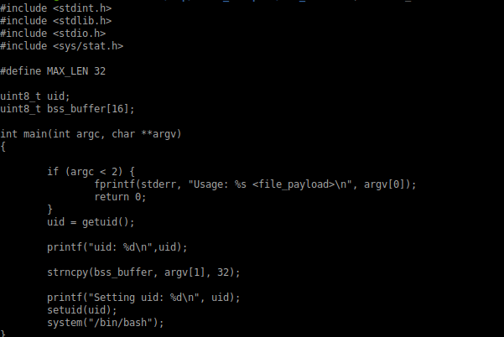

In image 3.18 we can see the original source code to the program “shiva_examples/bss_vuln/bss_vuln.c”. This program illustrates how the function strncpy pads the remaining length of a buffer with null bytes and how this behavior can lead to a .bss overflow that overwrites the bss variable uint8_t uid with the value 0, which is then passed to setuid() before a call to system(). In our somewhat unrealistic example, we aim to re-size the variable bss_buffer[16] to bss_buffer[32] to prevent the 0 padded .bss overflow.

Image 3.19: Running the vulnerable bss_vuln program
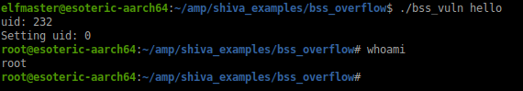

Running this program, and passing in a string length of less than 32 bytes will cause the bug to be triggered and for dramatic effect we can see the pop of a root shell in Image 3.19. And as already shown in the original source code, bss_buffer is an uninitialized static global variable that lives in the .bss. Let’s confirm that this global variable does indeed exist within the .bss of the target executable before we demonstrate our patch.

Image 3.20: Verifying bss_buffer variable exists in target executable

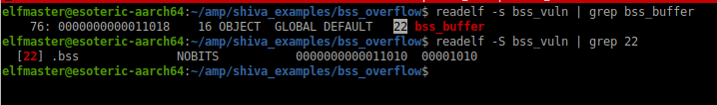
In Image 3.20 we confirm that a .bss variable ‘bss_buffer[16]’ does exist and it’s bindings are STB_GLOBAL. We can fix this vulnerability by simply re-defining bss_buffer as a 32 byte length buffer. Patching the program “bss_vuln” is straightforward, watch...

Image 3.21: Patching the bss_vuln vulnerability by re-defining bss_buffer
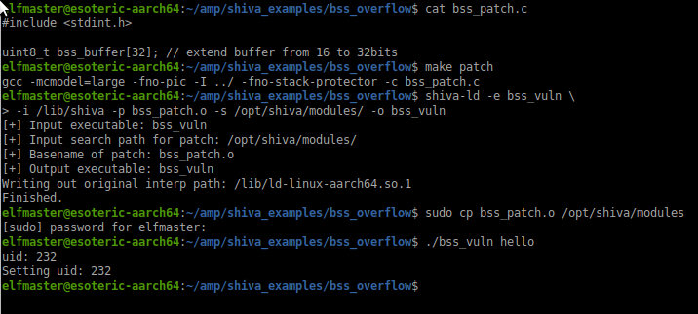

As shown above in Image 3.21 a simple patch re-declaring the size of bss_buffer[16] to bss_buffer[32] is compiled and pre-linked in just two commands. The program bss_vuln is now linked to the bss_buffer[32] and doesn’t overflow anymore at the call to strncpy().

Cross-Relocation with .bss relinking

For those interested in understanding the internals of .bss variable relocation in Shiva, please keep reading to understand a key Shiva feature known as Cross Relocations.
The .bss is uninitialized data and doesn’t take up any space in the ELF file. ELF PIE binaries use R_AARCH64_RELATIVE relocation’s to fixup the .got with the correct address to the .bss variable after it’s been allocated at runtime. In order for Shiva to re-link the binary to use the new .bss variable in the patch it must update the .got entry with the address to the new variable living within the patches runtime image. The RTLD “ld-linux.so” will process the R_AARCH64_RELATIVE relocation’s and overwrite the .got entry for the .bss variable. because the RTLD runs after Shiva and therefore updates the .got after Shiva. This introduces a little problem that is solved by a concept that we call Cross Relocation. It is an almost inevitable by-product of chaining two dynamic linkers together. Cross relocation refers to the idea that Shiva and ld-linux.so (Two linkers in the same process) must synchronize relocation data and work together to solve a relocation. In the case of linking .bss variables Shiva modifies the relocation record in memory. Specifically the r_addend value to reflect the location of the new .bss variable within the patch image. Let’s examine this up close.

Image 3.22: Lookup the address of the bss_buffer symbol

The bss_buffer variable is at address 0x11018 (As shown in Image 3.22 above). This address exists past the end of the data segment on disk and will be allocated by the kernel at ELF load time.

Image 3.23: Find the relative relocation for bss_buffer by address

The R_AARCH64_RELATIVE relocation in Image 3.23 is describing the computation (B + A), which means base_address + r_addend.

The r_offset (The address to be patched) is 0x10fc8. The r_addend value is 0x11018. The base must be added with the r_addend and stored at the location specified by r_offset. The RTLD will apply this like so:

*(uint64_t *)&0x10fc8[0] = 0x11018 + base_address

Shiva wants to redirect all references to bss_buffer from the old location 0x11018 to the new location within the patch object, who’s address won’t be known until runtime. At runtime Shiva calculates the offset from the executable base address to the patches bss_buffer variable. Shiva overwrites the r_addend field of the R_AARCH64_RELATIVE relocation from 0x11018 to the new offset of the patch bss_buffer variable.

The algorithm for cross relocations on .bss variables

1. locate the R_AARCH64_RELATIVE relocation who's r_addend is equal to the offset of the original .bss variable.

2. Calculate the offset of the new patch .bss variable from the base of the executable:
new_var_addr - executable_base – 4

3. Store the offset as the updated r_addend field in the relocation entry

Redeclaring global data types, signedness, and size

It is common to change the data-type, signedness or size of a variable in order to fix a bug. This is therefore a common requirement in the world of micropatching binaries. Shiva will create a new variable matching the correct data-type and size and relink the program to the new variables. This may or may not have expected results since Shiva doesn’t recompile the executable code that is reading or writing to that data. As it stands there are no limitations on changing the integer type and storage location of any global variable with the exception of TLS data. Any STT_OBJECT with STB_GLOBAL bindings can be re-linked to any other STT_OBJECT/STB_GLOBAL variable within a defined patch. Support for patching STB_LOCAL binded variables and functions will be supported in the future.

Redeclaring global integer signedness

When a patch re-declares a global variable’s signedness, it will create a new global variable within the patch, and all code within that same patch will be compiled into code that treats the variable by it’s new signedness. The code within the executable being patched will be re-linked to use the new global variable, but it’s code won’t be updated to reflect the change in the variables signedness and therefore the final outcome is somewhat ambiguous.
Old definition: int data_var = 5; (Defined within the ELF executable program)
New definition: unsigned int data_var = 5; (Defined within the ELF patch)

Outcome Results: Original program code will still see the new variable as signed. New program code introduced by the patch will see the variable as unsigned.

Outcome Description: Shiva will allocate sizeof(int) bytes in the .data section of the patch and relink the executable to use the new data_var variable. The signedness was changed from signed to unsigned, but only the code within the patch itself (Assuming there is any) will respect the new signedness since it’s code was compiled to see an unsigned int data_var = 5; whereas the code in the executable being patched was compiled when data_var was declared as a signed value, and therefore it’s computations and read/write accesses will still be treating it as signed.

Redeclaring the global storage type:

There may be times when the patch operator wants to re-declare an uninitialized global variable (i.e. .data) as const (i.e. .rodata). Or change an uninitialized .bss variable to a .data variable, etc. Shiva allows for the re-linking of any STT_OBJECT type symbols that are globally binded (STB_GLOBAL).

Redeclaring a global .data variable as a constant

Example 1:

Original source code: uint16_t pid = 0;
Patch source code: const uint16_t pid = 0;

Outcome results: The global initialized variable pid becomes read-only.

Technical details: Shiva creates an alternate .rodata section within the patch text segment, stores the pid variable there (As specified by the patches symbol and relocation table). Shiva then re-links the executable to use the new pid variable by re-encoding any instructions which reference the original pid variable.

Example 2:

Original source code: char comm[] = “/bin/ls”;
Patch source code: const char comm[] = “/bin/ls”;

Outcome results: The global initialized variable comm[] becomes read-only.

Technical details: Shiva creates an alternate .rodata section within the patch text segment, stores the comm[] buffer there (As specified by the patch objects symbol and relocation table). Shiva then re-links the executable to use the new comm[] variable by re-encoding any instructions which reference the original comm[] variable.

Redeclaring a global constant into a .data variable

An integer variable in .rodata cannot be relinked to a .data integer due to the current limitations of Shiva discussed in “Current limitations of patching .rodata-- page 13”.
The good news is that global .rodata strings can be relinked to a global .data string.

Supported conversion: Converting a global constant string (stored in the .rodata section) to a non-constant string (stored in the .data section).

Unsupported conversion: Converting a global constant integer (stored in the .rodata section) to a non-constant integer (stored in the .data section).

Original source code: const char string[] = “Hello world!”;
Patch source code: char string[] = “Hello world!”;

Outcome results: The string[] variable will become writeable.

Outcome description: Shiva will create it’s own .data section within the patch data segment at runtime. A character array called string[] = “Hello World!”; will be stored within the .data section, and all references to the old string[] variable within the executable will be re-linked by Shiva to reflect the location of the new writable string[] within the patch .data section.

Initializing a .bss variable (Conversion from .bss variable to .data variable)

In some instances the patch developer may need to initialize a .bss variable (uninitialized data).

Original source code: int count;
Patch source code: int count = 0;

Outcome results: The count variable is moved to the .data section and initialized to 0.

Outcome description: Shiva creates a .text, .data, .bss, sections and more within the patch objects process image. The new count variable will be stored within the .data section of the patch, and all references to the original countvariable will be re-linked to the new one.

Symbol interposing on STB_LOCAL symbols

At this present time Shiva does not support patching symbols that are locally bound (i.e. STB_LOCAL) functions and objects. Functions declared as static, or initialized/uninitialized static variables will be supported in the near future though! Awaiting the next big version of Shiva.

Symbol interposition on stripped ELF binaries

There are many occasions where legacy ELF binaries have been stripped. In particular we are referring to the binutils strip utility which removes the .symtab section from the ELF section header table. There are more durastic versions of stripping an ELF binary which include removing the entire section header table, and thus the map for locating the symbol, relocation, and other various meta-data within the ELF binary. Fortunately though Shiva uses libelfmaster under the hood which forensically reconstructs ELF section headers and symbol tables. Currently libelfmaster only reconstructs the symbol data for the functions that from .symtab, and .dynsym symbol tables. It is on libelfmasters roadmap to be able to forensically reconstruct STT_OBJECT symbols as well.

Using the extern keyword in your patch code

It is common to reference an external variable in your patch code. An external variable in Shiva is any variable that exists within the executable or it’s needed shared libraries. The extern keyword will create the symbol type as STT_NOTYPE in the patch object, thus instructing Shiva to search outside of the patch module and from the ELF executable. If Shiva cannot find the symbol within the executable then it searches the shared libraries.

Generate a symbol of type STT_OBJECT
int array_1[10]; // won’t use external variable, but rather create a new one

Generate a symbol of type STT_NOTYPE
extern int array_1[10]; // will use external variable called array_1[10]

Implicitly use external variables

A patch developer may choose not to explicitly declare an external variable, and instead simply reference the external variable implicitly by name. For example, assuming int array_1[10]; is a global variable from the executable that is being patched.

int i;

for (i = 0; i < 10; i++)
array_1[i] = i * 100;

