Exponential Superposition
by Sven Nilsen, 2020

In this paper I present an algorithm that can visualize exponential reference classes with superposition.

An exponential reference class^{[1]} might be visualized using the following pseudo-algorithm:

- Create a scalar field for storing gradient map
- Create an empty list of particles
- Choose an initial state for particles
- Emit `n+1` new particles, where `n` is the number of existing particles
- If the number of particles is above some limit, remove 50% of the particles randomly
- Update particles
- Add `1` to gradient map for each particle position
- Repeat step 4-7
- Visualize logarithmic contour of the gradient map using `sin(f · τ · ln(ε + gradient_map(x)))`
where `f` is the frequency of the wave representation, `τ` is `2π`,
`ε` is small positive number and where `x` is the position
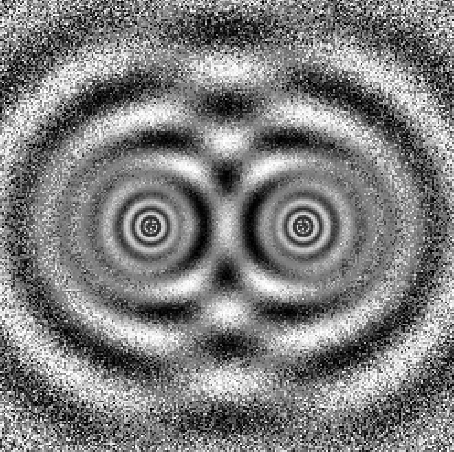
This algorithm will be modified to support superpositions^{[2]}.

A superposition for an exponential reference class might be thought of as a post-processing step, where one sums over a list of gradient maps, each associated with a superposition:

∑ i { sin(f · τ · ln(ε + gradient_map[i](x))) }

For a “classical” exponential reference class, one can use a single gradient map.
Mixed state {0: 0.9, 1: 0.1}

Assume that there are two initial states for particles. By using two gradient maps, one can visualize the wave interference between the logarithmic contour functions generated by the two initial states.

However, it is possible to transition smoothly from a “classical” state to a “pure superposition”:

- Create a gradient map index list for particles
- When emitting new particles, choose a gradient map index based on a probability distribution

For two superpositions, the gradient map indices are `{0, 1}`.
When choosing a gradient map index for new particles, one can write it `{0: P(0), 1: P(1)}`.
When `P(0) = P(1) = 0.5`, the mixed state behaves like a classical state.

In a “classical” state, there is no or little wave inference^{[3]}, because contributions gets lower with path distance from the initial position. If the particle is a little bit closer to one of the initial states, then the closest initial state will dominate the contributions. In the “pure superposition” state, the path distance does not affect the contributions, hence each initial state contributes the same, up to wave interference.

References:

[1] “Exponential Reference Class”
Sven Nilsen, 2019
https://github.com/advancedresearch/observer_selection_effects/blob/master/papers-wip/exponential-reference-class.pdf

[2] “Superposition principle”
Wikipedia
https://en.wikipedia.org/wiki/Superposition_principle

[3] “Wave interference”
Wikipedia
https://en.wikipedia.org/wiki/Wave_interference

