Noisy Path Reference Class
by Sven Nilsen, 2019

A Noisy Path Reference Class is a Path Reference Class with a term for noise.

Noisy Path Reference Class = Path Reference Class + Noise

For example, one can use Generalized Pascal’s Triangle for 2D. One property of Generalized Pascal’s Triangle is that odd-layers can be skipped by deriving a weight matrix for even-layers only.

For 2D this gives the following weight matrix for even-layers:
1
2
1
2
4
2
1
2
1
In addition to this sum, there is a term for noise, for example:

+ 0.00001 * random()

Usually, one normalizes after each step. This means that the noise becomes more significant over time.

The benefit of a Noisy Path Reference Class is that is preserves local maxima over time:

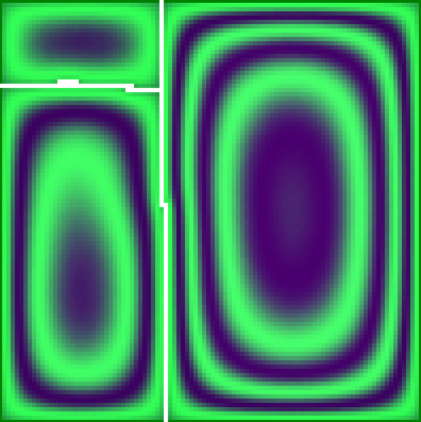
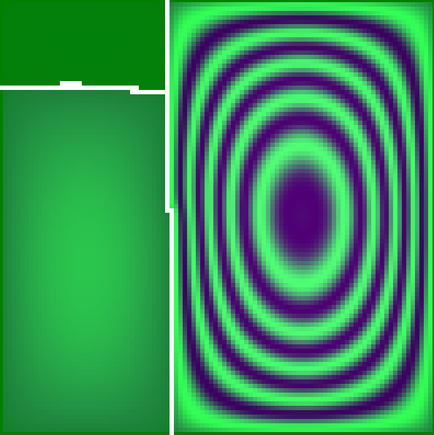

With noise (preserving local maxima) Without noise (loosing local maxima)

Here, the contour plot with noise shows the proximity to zero-constraints.

