Havox diagrams
by Sven Nilsen, 2018

A Havox diagram is an old invention of mine, an idea that is revisited for adoption in path semantics. The basic idea is to represent states or symbols as points in a space. When two symbols mean the same or are similar, they are connected by a solid line. When two symbols are different, they are connected with a dotted line. If all relations have been found, the dotted lines can be erased. A profound insight about these diagrams is that relations themselves can be connected with relations, by assuming their points as variables. This makes it possible to reason about kinds of equalities and inequalities without using other definitions than points and lines.

Despite the simple rules, Havox diagrams have non-trivial properties when you reason about them at higher level. For example, if three points are equal to each other, then their equalities can naturally be interpreted as the same kind, but it is not obvious why separated graphs should use the same kind of equality. How diagrams are interpreted depends on what rules one uses to tell whether a diagram is valid or not. The set of all possible diagrams satisfying the rules is equivalent to the rules themselves for that number of points, but since it is impossible to list all possible diagrams for any number of points, the set is better described as a sub-type, e.g. `x : [g] b` as in path semantics. Havox diagrams can be used to reason about path semantics because symbols can be replaced by points, but path semantics can also be used to reason about Havox diagrams!

Here are all kinds of Havox diagrams of 3 points that satisfies the rules below:

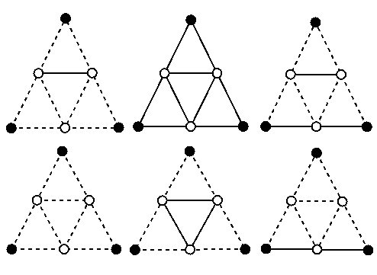

- Points that move freely around without changing their relations belong to the same diagram
- When two points are the same, they are identical (used for higher order reasoning)
- (A = B) ∧ (A = C) → (B = C)
- (A = B) ∧ (A ¬= C) → (B ¬= C)

These are the exact same rules that are used in the single axiom of path semantics. Identity of two objects means that every statement about one object is true for the other. If one thing said about an object is not the same as the same thing said about another, then the objects are not equal.
Identity has the property that when a point is equal to itself, the kind of equality it has with itself does not matter because the family of equalities is the same between identical points, and therefore the equality is equal to all other equalities connected to other points that are equal to the point.

The statement above is hard to wrap your way around, but can be simplified: There are no inequalities between equalities of points that are identical. If there is an inequality between two edges, then the graph can be separated into two parts by erasing all knowledge about inequality. For example, a `bool` is different from `true` in a different way than `true` is different from `false` (type membership vs variables). Therefore, `bool` and `false` are unequal.

One motivation for Havox diagrams, which can represent equal objects as separate points, is that equality can be changing over time. There is nothing that says since two objects are equal at one moment, they will be equal in the next moment. Why should they? It is true that some concepts are useful to behave consistently for all times, but there are also concepts that do not transport their consistency in a time symmetric way.

For example, in a lot of philosophical puzzles the problem is about equality relations over time. A teleportation of a person, when suddenly the machine breaks down and leaves the original intact, but now there are two clones. The question is: Who is the “real” person? Quantum information theory has its own variant of this that prevents cloning of quantum states, that might help solve the problem. Still, a person’s brain might be taken apart and reassembled in two pieces by adding extra atoms. Does the person live on two copies, or is the original person gone? Of course it is gone, but what do we mean by splitting a person into two parts that continue living?

Taking a step back, one can see that the problem is answering yes/no to a question that only has a truth value in the past. The person can only be considered as a whole when using space-time, where the past and the future is one.

A second kind of Havox diagrams shows how equality relations changes dynamically over time. Here, when there is distance between two points, they are unequal to each other. The name “Havox” is taken from the 5 letters of the power-set of a 3-bit code where `1` describes distance and `0` no distance.

| | /\ | | /\ \/ | \ / | time diagram
| | | | \/ \/ /\ / \ | |

1 0 1 0 1 0 1 0 binary code
1 1 1 1 0 0 0 0
1 1 0 0 1 1 0 0

== => <= <> >< >- -< –- symbols

In the real world, relations are very complex, so Havox diagrams are used to abstract over the details and only focus on the information needed for the proof. The advantage of this technique is that all complexity that is inside an object can be removed and some of it can be added back on top of the simplified information.

