Law of Excluded Middle
in Havox Diagrams
by Sven Nilsen, 2018

A Havox diagram consists of nodes and edges. An edge is solid if two objects represented by the nodes are identical. An edge is dotted if two objects are not identical. White dots represents the edge, such that edges can also be identical (ignoring the points they are connected to) or not identical. This gives Havox diagrams the ability to reason about symbolic meaning at higher order without depending on what the nodes represent.

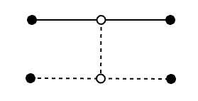

The law of excluded middle says that if a thing is not true, then it is false and if a thing is not false, then it is true. This axiom has been famously debated through the early 1900s and rejected in a branch of logic called “constructive mathematics”. The argument is that when using the law of the excluded middle, it is possible to prove the existence of a solution without giving the proof through a concrete example. By not assuming the law of the excluded middle, one can get higher quality proofs, but at the same time it is not limiting because the axiom can always be assumed when needed.

It can be a bit confusing to think of the law of excluded middle in Havox diagrams, because intuitively two things can be identical or not identical, but not both. So, it looks like at first sight that the law of excluded middle is built into those diagrams.

However, this is a misconception of how Havox diagrams works. You see, it is very easy to assume there is something called “true” and “false”! Havox diagrams only contain information about whether things are identical or not.

To explain how the law of excluded middle works, one must model “true” and “false” as two nodes:

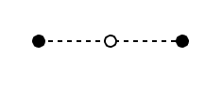
true
false

So, a Havox diagram in itself has no concept of true and false, it must be “programmed” in to do Boolean algebra. Yet, it turns out that you do not have to program in all the rules, because some of them are already implicit by the built-in rules of Havox diagrams!

Guess what needs to be added? The law of the excluded middle! Somehow it might seem Havox diagrams “knows” the deep philosophical discovery that mathematicians figured out, but actually it is because Havox diagrams only use the single axiom of path semantics. Path semantics is mathematics!
It is known that `true` and `false` are not identical. Havox diagrams have built-in rules for the following: If `a` is identical to `x` and `x` is not identical to `y`, then `a` and `y` are not identical. For `true` and `false` this looks like:

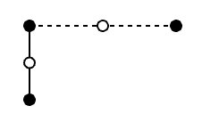
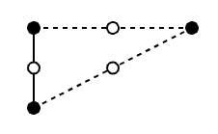
true
false
true
false

a
a

However, you can not go in the opposite direction: If it is known that `a` is not `false`, then it is not known that `a` is `true`!
false
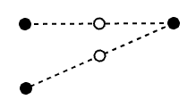
true
a

Intuitively, this is because `a` can mean anything except `false`. For example, `a` could be a bird, or the addition binary operator, or a matrix, or a complex number. It could be the universe itself!

In a such situation, what characterizes this distinction is that the way `a` and `false` is different, is not the same way `true` and `false` are different:

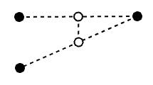
true
false

a

Imagine the process of judging whether two things are identical as a procedure, a function, that returns “identical” if two things are identical, “different” if they are different and “unknown” if it is currently impossible to know the answer from within that decision procedure. You can have two functions:

test_bool := \(a, b) =
if typeof(a) == “boolean” &&
typeof(b) == “boolean” { if a == b { “identical” } else { “different” } }
else { “unknown” }

test_type := \(a, b) =
if typeof(a) != typeof(b) { “different” } else { “unknown” }

One can take the meaning that the way identical things are identical or the way different things are different, as whether that judgement originated from the same decision procedure, or from the same family of decision procedures.
Since `test_bool` detects the difference between `true` and `false` and `test_type` detects the difference between `a` and `false`, it is not the same decision procedure that determines the difference, and therefore the “difference” in these two cases mean something different! This is modeled in the Havox diagram as a dotted line between the edges, without directly saying what actually happens.

In some branches of mathematics it might not be a decision procedure that determines the difference!
It turns out that Havox diagrams do not need to know what determines the difference. All you need is the available information in the diagram plus the axiom of path semantics.

According to path semantics, when two things are identical, everything that is known about those two objects is also identical in a higher order sense. If `a` and `true` was identical, this would imply that the way `a` and `false` was different was the same kind of difference that is between `true` and `false`. Otherwise, `a` and `true` would not be identical!

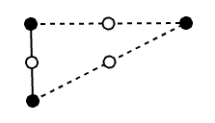
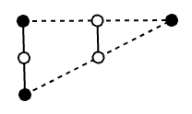
true
false
true
false

a
a

Therefore, when the differences are different, then `a` and `true` must be different because they can not be identical!

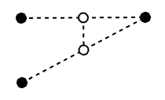
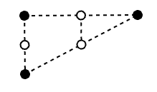
true
false
true
false

a
a

Still, what might seem surprising to most people, is that you can not prove `a` and `true` are identical even the differences are identical:
true
false
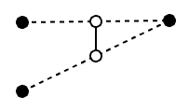

a

For example, instead of computing with booleans, I can compute with sets of booleans, so you can have “both” and “neither” in addition to “true” and “false”. If the logic of booleans is consistent, then there exists some logic of sets of booleans that is also consistent. I could also create a logic that combines both logics by making sets of booleans identical to either `true` or `false` when the size of the set is 1. The possibilities are endless!

This is why the law of the excluded middle must be added to compute with booleans in Havox diagrams. Mathematics in general only assume the single path semantical axiom, and everything else is a result of choices and the ability to check for consistency assuming infinite computing capacity.

