Associativity Avatar Graph
by Sven Nilsen, 2020

In this paper I present an Avatar Graph that models associativity.
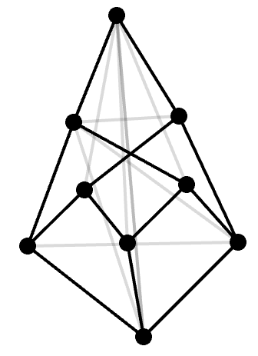
The Associativity Avatar Graph^{[1]} is the following, as illustrated:

Reading from the bottom to the top:

- The bottom node is the unit `()`
- Introduction of 3 elements `a, b, c`,
which can be thought of as `() → a, () → b, () → c`
- Two products `ab` and `bc`
- Two new products `a(bc)` and `(ab)c`
- A witness of the equality `a(bc) = (ab)c`

This avatar graph was discovered by the author during a discussion in the Bivector Discord Server^{[3]} when investigating axioms of the geometric product by comparing them with theorems in Avatar Algebra^{[4]}.

The Associative Avatar Graph has 9 vertices, which is uncommon for filled avatar graphs (usually 2^{n}).

This graph was not listed previously in the House of Graphs, a database of interesting graphs.
Graph properties calculated by the House of Graphs^{[2]}:

Acyclic: | No | Edge Connectivity: | 2 | Minimum Degree: | 2
Algebraic connectivity: | 1.268 | Eulerian: | No | Min. Dominating Set: | 3
Average degree: | 2.889 | Genus: | 1 | Number of Components: | 1
Bipartite: | No | Girth: | 4 | Number of Edges: | 13
Chromatic Index: | 4 | Hamiltonian: | Yes | Number of Triangles: | 0
Chromatic Number: | 3 | Independence Number: | 4 | Number of Vertices: | 9
Circumference: | 9 | Index: | 2.928 | Planar: | No
Claw-Free: | No | LLE*: | 5.414 | Radius: | 2
Clique Number: | 2 | Longest Induced Cycle: | 6 | Regular: | No
Connected: | Yes | Longest Induced Path: | 5 | SLE*: | 1.277
Density: | 0.361 | Matching Number: | 4 | Smallest Eigenvalue: | -2.414
Diameter: | 3 | Maximum Degree: | 3 | Vertex Connectivity: | 4

* LLE = Laplacian Largest Eigenvalue
* SLE = Second Largest Eigenvalue

References:

[1] “Avatar Graphs”
Sven Nilsen, 2020
https://github.com/advancedresearch/path_semantics/blob/master/papers-wip/avatar-graphs.pdf

[2] “Associativity, Filled Avatar Graph”
The House of Graphs
https://hog.grinvin.org/ViewGraphInfo.action?id=44059

[3] “Bivector”
Discord
https://discord.gg/vGY6pPk

[4] “Avatar Algebra”
Summary of Avatar Extensions
https://advancedresearch.github.io/avatar-extensions/summary.html#avatar-algebra

