Discrete Real Addition Isomorphisms
by Sven Nilsen, 2019

In this paper I explore binary operators on natural numbers that have an isomorphic structure preserved under addition on real numbers. I also prove that the strong Goldbach conjecture can not be solved with a non-dependent asymmetric path from the sum of prime indices.

A lattice^{[1]} is an important subgroup structure of ℝ^{N} which is isomorphic to the additive group ℤ^{N}.
Here I want to explore something lattice-like, but not necessary a group^{[2]}, and the additive property is embedded in the space of real numbers^{[3]} instead of the discrete side.

What happens if one considers the additive subgroup of ℝ^{[3]} which is isomorphic to a sub-set of ℕ^{[4]}?

Formally, there exists a path function product^{[5]} `g_{i→n}` such that:

∵ ∃ g_{i→n} { ∀ f { f[g_{i→n}] => add_{ℝ} } }

∴ f : ℕ ⨯ ℕ → ℕ `f` is a binary operator on natural numbers

One trivial example is addition on natural numbers:

∵ f <=> add_{ℕ} Adding natural numbers
∵ g <=> \(x : ℕ) = x as ℝ Casting a natural number `x` into a real number

∴ add_{ℕ}[\(x : ℕ) = x as ℝ] => add_{ℝ} `g` works as symmetric path^{[6]}

0 => 0.0, 1 => 1.0, 2 => 2.0 etc.

A non-trivial example is multiplication on non-zero natural numbers:

f <=> mul_{ℕ}{(¬= 0), (¬= 0)}
g <=> ln_{ℕ → ℝ}

This is because the following law corresponds to a symmetric path^{[6]}:

∵ ln(a · b) = ln(a) + ln(b) where `a ¬= 0 ∧ b ¬= 0`

∴ mul_{ℕ}{(¬= 0), (¬= 0)}[ln_{ℕ → ℝ}] => add_{ℝ} `g` works as symmetric path^{[6]}

Consider the following:

∵ f(a, b) = a² + b²

One can prove that there exists an asymmetric path^{[7]}:

∴ f[\(x : ℕ) = x as ℝ][sqrt_{ℝ} ⨯ sqrt_{ℝ} → id_{ℝ}](a’, b’) = a’ + b’
∴ f[\(x : ℕ) = x as ℝ][sqrt_{ℝ} ⨯ sqrt_{ℝ} → id_{ℝ}] => add_{ℝ}
∴ g_{i→n} <=> (\(x : ℕ) = sqrt(x as ℝ)) ⨯ (\(x : ℕ) = sqrt(x as ℝ)) → (\(x : ℕ) = x as ℝ)

Similarly, consider the following:

∵ f(a, b) = (a + b)²

∴ f[\(x : ℕ) = x as ℝ][id_{ℝ} ⨯ id_{ℝ} → sqrt_{ℝ}](a’, b’) = a’ + b’
∴ f[\(x : ℕ) = x as ℝ][id_{ℝ} ⨯ id_{ℝ} → sqrt_{ℝ}] => add_{ℝ}
∴ g_{i→n} <=> (\(x : ℕ) = x as ℝ) ⨯ (\(x : ℕ) = x as ℝ) → (\(x : ℕ) = sqrt(x as ℝ))

Notice that these four isomorphisms are quite useful in mathematics:

add_{ℕ}[\(x : ℕ) = x as ℝ] Connects natural numbers with real numbers^{[8]}
mul_{ℕ}{(¬= 0), (¬= 0)}[ln_{ℕ → ℝ}] Addition theorem^{[9]}
(\(a, b) = a² + b²)[…] Pythagorean theorem^{[10]}
(\(a, b) = (a + b)²)[…] Square area of side `a + b`

For example, the Pythagorean theorem^{[10]} says that:

∵ c² = a² + b²
∴ c = sqrt(a² + b²)

Notice the use of `sqrt`. The `sqrt` is used on the inputs in the asymmetric path:

(\(a, b) = a² + b²)[\(x : ℕ) = x as ℝ][sqrt_{ℝ} ⨯ sqrt_{ℝ} → id_{ℝ}]

This means that when you consider lengths of 2D discrete vectors as a group, the square of the lengths, which are natural numbers, form a sub-structure.

The semantics of these numbers is naturally interpreted by taking the square root to get the length. When you add two lengths together, you get a new length (this adds two real numbers, add_{ℝ}).

If you take the square of lengths and add them together, you get a member of the sub-structure.
Since `sqrt(1)² + sqrt(1)² = 2`, the real number `sqrt(2)` becomes a natural building block for talking about lengths. Just like `sqrt(1)`, it has an isomorphism to ℕ. By continuing this process, one can construct a way of relating these sub-structures of ℕ to each other by their paths to real addition.

One way of depicting this relationship is the “Spiral of Theodorus”^{[11]}:

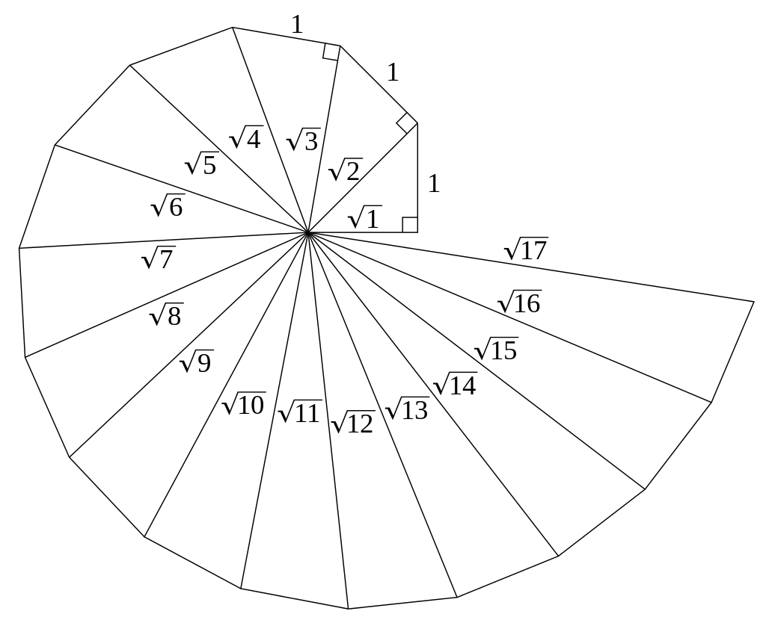
sqrt(1)² + sqrt(1)² = 1 + 1 = 2
sqrt(1)² + sqrt(2)² = 1 + 2 = 3
sqrt(1)² + sqrt(3)² = 1 + 3 = 4
sqrt(1)² + sqrt(4)² = 1 + 4 = 5
…

Each section in this spiral represents a path to a sub-structure of ℕ that all are isomorphic to each other.

Now, looking at the similar other example:

(\(a, b) = (a + b)²)[\(x : ℕ) = x as ℝ][id_{ℝ} ⨯ id_{ℝ} → sqrt_{ℝ}]

Here, the `sqrt` is used on the output instead of the input.

∵ (a + b)² = a² + 2ab + b²
∴ a + b = sqrt(a² + 2ab + b²)

The semantics of this example is addition of area into squares:

a²
ab
a

ab
b²
b

b
a

The positive difference between these two sub-structures of ℕ is another sub-structure of ℕ:
∵ f₀(a, b) = a² + b²
∵ f₁(a, b) = (a + b)² = a² + 2ab + b²
∵ f₂(a, b) = f₁(a, b) – f₀(a, b) = 2ab

∵ ln(a) + ln(b) = ln(2ab / 2) = ln(a · b)
∴ f₂[ln ⨯ ln → ln · (/ 2)] => add

The semantics of this sub-structure is the half-area of rectangles across the diagonal:

½ ab
b

½ ab

a

Notice that the diagonal splits the rectangle into two triangles where Pythagorean theorem holds.
It is a nice semantics that combines both the length interpretation and area interpretation into one.

Now, to take an example that is more relevant for number theory: The strong Goldbach conjecture^{[12]}.

There exists a natural way of mapping natural numbers to prime numbers:

primes := [2, 3, 5, 7, 11, 13, 17, 19, 23, …] Create list of prime numbers

f <=> add_{ℕ}[\(x : ℕ) = primes[x]] Map natural numbers to prime numbers

1 + 2 = 3 becomes f(3, 5) = 7
3 + 4 = 7 becomes f(7, 11) = 19

This operation makes seemingly no sense. However, by using an asymmetric path instead:

f <=> add_{ℕ}[(\(x : ℕ) = primes[x]) ⨯ (\(x : ℕ) = primes[x]) → id_{ℕ}]

This is a perfectly valid path, that looks up the prime numbers in the list and adds their indices.

It is possible to solve the Goldbach’s conjecture using this asymmetric path?
Find a dependent asymmetric path^{[13]} `f[[id] a ⨯ [id] b → g(a, b)]` such that for some constrained input^{[14]}, it outputs all even numbers greater than `2` and corresponds to addition on natural numbers:

f[[id] a ⨯ [id] b → g(a, b)]{
∃f[[id] a ⨯ [id] b → g(a, b)]{∀f[[id] a ⨯ [id] b → g(a, b)]} => (> 2) ∧ even
} => add_{ℕ}

The existence of this asymmetric path would prove the strong Goldbach conjecture.

This asymmetric path must be dependent, because a counter-proof exists for the even number `16`:

0 + 0 = 0 f(2, 2) = 0 2 + 2 = 4 0 => 4 g(0) = 4
0 + 1 = 1 f(2, 3) = 1 2 + 3 = 5 1 => 5
0 + 2 = 2 f(2, 5) = 2 2 + 5 = 7 2 => 7
0 + 3 = 3 f(2, 7) = 3 2 + 7 = 9 3 => 9
0 + 4 = 4 f(2, 11) = 4 2 + 11 = 13 4 => 13
0 + 5 = 5 f(2, 13) = 5 2 + 13 = 15 5 => 15
0 + 6 = 6 f(2, 17) = 6 2 + 17 = 19 6 => 19
1 + 1 = 2 f(3, 3) = 2 3 + 3 = 6 2 => 6 g(2) = 6
1 + 2 = 3 f(3, 5) = 3 3 + 5 = 8 3 => 8 g(3) = 8
1 + 3 = 4 f(3, 7) = 4 3 + 7 = 10 4 => 10 g(4) = 10
1 + 4 = 5 f(3, 11) = 5 3 + 11 = 14 5 => 14 since 1), can’t use `5` (2)
1 + 5 = 6 f(3, 13) = 6 3 + 13 = 16 6 => 16 since 3), no solution
2 + 2 = 4 f(5, 5) = 4 5 + 5 = 10 4 => 10
2 + 3 = 5 f(5, 7) = 5 5 + 7 = 12 5 => 12 g(5) = 12 must use `5` (1)
2 + 4 = 6 f(5, 11) = 6 5 + 11 = 16 6 => 16 since 3), no solution
2 + 5 = 7 f(5, 13) = 7 5 + 13 = 18 7 => 18
3 + 3 = 6 f(7, 7) = 6 7 + 7 = 14 6 => 14 g(6) = 14 since 2), must use `6` (3)
3 + 4 = 7 f(7, 11) = 7 7 + 11 = 18 7 => 18

This means that `g` is a higher order function^{[15]} that depends on the value of the primes:

[id] a ⨯ [id] b → g(a, b)

It is obvious that once you get to `add_{ℕ}`, you can go to `add_{ℝ}`:

add_{ℕ}[\(x : ℕ) = x as ℝ] => add_{ℝ}

The strong Goldbach conjecture is also a discrete isomorphism to partial addition of real numbers.

In order to return all even numbers greater than `2`, which are countable infinite, the size of the type of the constraint must also be countable infinite. If the set of sums of primes was not countable infinite, this would disprove the strong Goldbach conjecture. The set of primes is countable infinite, so since any prime greater than `2` added with `3` is an even number, the set of sums of primes is also countable infinite. Therefore, one can not use this technique to disprove the strong Goldbach conjecture.

The strong Goldbach conjecture turned out to be notoriously hard to prove and is one of oldest and the best-known unsolved problems in number theory and all of mathematics. Yet, it is just one of many discrete real addition isomorphisms with possibly similar interesting semantics.

References:

[1] “Lattice (group)”
Wikipedia
https://en.wikipedia.org/wiki/Lattice_(group)

[2] “Group theory”
Wikipedia
https://en.wikipedia.org/wiki/Group_theory

[3] “Real number”
Wikipedia
https://en.wikipedia.org/wiki/Real_number

[4] “Natural number”
Wikipedia
https://en.wikipedia.org/wiki/Natural_number

[5] “Path Function Product Notation”
Sven Nilsen, 2017-2019
https://github.com/advancedresearch/path_semantics/blob/master/papers-wip/path-function-product-notation.pdf

[6] “Normal Paths”
Sven Nilsen, 2019
https://github.com/advancedresearch/path_semantics/blob/master/papers-wip/normal-paths.pdf

[7] “Algebraic Notation for Asymmetric Paths”
Sven Nilsen, 2017
https://github.com/advancedresearch/path_semantics/blob/master/papers-wip/algebraic-notation-for-asymmetric-paths.pdf

[8] “Real line”
Wikipedia
https://en.wikipedia.org/wiki/Real_line

[9] “Addition theorem”
Wikipedia
https://en.wikipedia.org/wiki/Addition_theorem

[10] “Pythagorean theorem”
Wikipedia
https://en.wikipedia.org/wiki/Pythagorean_theorem

[11] “Spiral of Theodorus”
Wikipedia
https://en.wikipedia.org/wiki/Spiral_of_Theodorus

[12] “Goldbach’s conjecture”
Wikipedia
https://en.wikipedia.org/wiki/Goldbach%27s_conjecture

[13] “Dependent Asymmetric Paths”
Sven Nilsen, 2019
https://github.com/advancedresearch/path_semantics/blob/master/papers-wip/dependent-asymmetric-paths.pdf

[14] “Constrained Functions”
Sven Nilsen, 2017
https://github.com/advancedresearch/path_semantics/blob/master/papers-wip/constrained-functions.pdf

[15] “Higher-order function”
Wikipedia
https://en.wikipedia.org/wiki/Higher-order_function

