Hamming N-Sphere
by Sven Nilsen, 2020

In this paper I describe the Hamming N-Sphere, which are normalized spaces by Hamming distance.

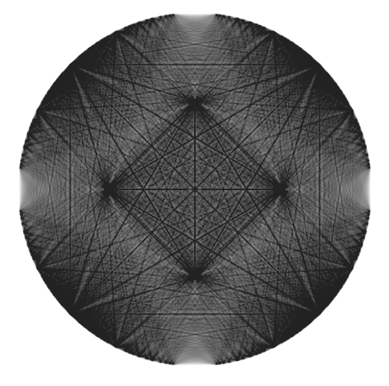

The connectivity of a 17x17 grid normalized to a Hamming circle

Hamming distance^{[1]} is used in many applications in computer science, but here I will describe the geometry of Hamming N-Sphere^{[2]}. A Hamming N-Sphere is obtained by normalizing points to unit vectors, multiplied with Hamming distance.

For example, a 2-sphere will look mostly like an ordinary sphere, except at 6 holes intersecting the faces of an axis aligned cube with half-size 2.

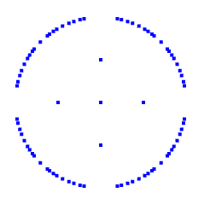
A Hamming N-Sphere has 5 points with trivial density.

- The center with density 1
- The axis points with continuum density / 2

Otherwise, the density is non-trivial.

References:

[1] “Hamming distance”
Wikipedia
https://en.wikipedia.org/wiki/Hamming_distance

[2] “n-sphere”
Wikipedia
https://en.wikipedia.org/wiki/N-sphere

