Seshatic-Platonic Cycles
by Sven Nilsen, 2021

In this paper I present a simple cyclic model of dynamic relation between Seshatism and Platonism.

In the paper “Seshatism”^{[1]}, I outlined an alternative way of thinking about existence to Platonism^{[2]}. Seshatism is the dual of Platonism, because the core axiom of Path Semantics works in reverse inference direction under inquality^{[3]}. The term is used similar to Platonism to describe a family of mathematical languages that are characterised by properties of dynamics and interactivity.

The model of Seshatic-Platonic Cycles is the following:

seshatic_platonic_cycles(x, y) = (sin(x) – sin(y) + 1) + sin(y) · 𝐢

shesatic_platonic_cycles : real × real → complex

re · seshatic_platonic_cycles Seshatic component
im · seshatic_platonic_cycles Platonic component

This model provides the analogue of potential energy^{[4]} in physical systems for complex values^{[5]}. Perhaps a more intuitive explanation is a “landscape”. A system might be described as a path through this space, by choosing values of `x` and `y` that are locally close in time. The path does not have to be linear or uniform over time, but the Seshatic and Platonic component are constrained to the values of the function. This makes it possible to talk about continous cycles of dynamic relations between Seshatism and Platonism in language.

The model is not intended to be an accurate device to explain phenomena of language, but to allow studying changes in language from an abstract perspective. By developing analysis methods on this model, more advanced tools and methods might be easier at later stage of research.

The inspiration of this model was the observation that the past 4 millenia years of history of western civilisation can be described approximately as a `-Seshat` period of 2 millenia, followed by a `+Plato` period of 2 milennia:

-2000 0 2000 year
-Seshat +Plato ideology

The `-Seshat` period represents the gradual discrediting of female avatars in religion while male avatars were gradually credited. The `+Plato` period represents the arise of abstract ideas and their influence on philosophy and technology. Something interesting happened by introducing ideas of physical laws described by mathematics, in which the world is not viewed through the actions of the individual, but as large systems of physical particles moving with semi-predictable behaviour. This extends the discrediting of individual originality (-Seshatism) into crediting of abstract ideas (+Platonism).

However, since Seshatism is the dual of Platonism, they are both essentially the same structure, but viewed from different perspectives. What happens if Seshatism becomes the next major movement of influence on philosophy and technology? Can Platonism coexist with Seshatism and would that lead to a dual-centric view of philosophy? This motivated the development of this model, such that a few principles of dynamics in their relation could be used to investigate possibilities.

Name | Sub-Formula | Range (real major)
Min Plato | \(x, -τ/4) = sin(x) + 2 - 𝐢 | [1-𝐢, 3-𝐢]
Zero Plato | \(x, 0) = sin(x) + 1 | [0, 2]
Max Plato | \(x, tau/4) = sin(x) + 𝐢 | [-1+𝐢, 1+𝐢]
Min Seshat | \(-tau/4, y) = -sin(y) + sin(y)·𝐢 | [-1+𝐢, 1-𝐢]
Zero Seshat | \(0, y) = 1 - sin(y) + sin(y)·𝐢 | [𝐢, 2-𝐢]
Max Seshat | \(tau/4, y) = 2 - sin(y) + sin(y)·𝐢 | [1+𝐢, 3-𝐢]

Here, the `τ` symbol represents the radians corresponding to 360 degrees.

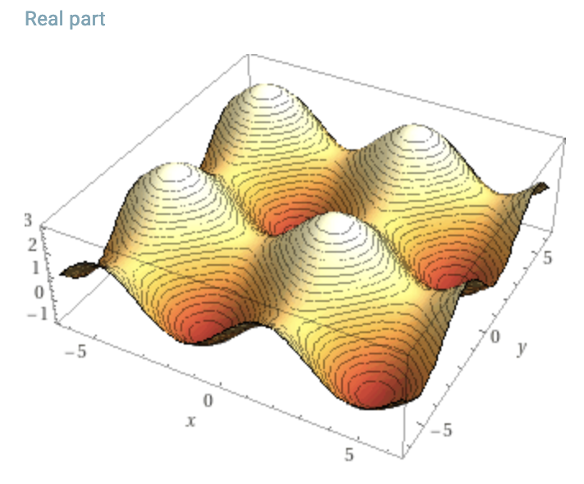
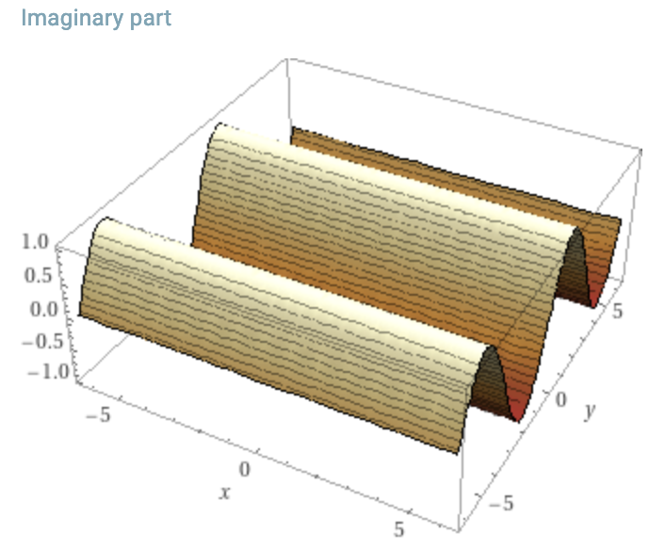

The model was designed by the following requirements:

- Platonism is pure (hence it can be controlled using the `y` variable)
- Platonism is imaginary (hence it is the imaginary component of the complex value)
- Platonism is symmetric and cyclic, it can vary over time (hence `sin(y)`)
- Seshatism is the dual of Platonism (hence is also depends on the `sin(y)` variable)
- Seshatism is the mirror/avatar which Platonism views itself (hence `-sin(y)`)
- Seshatism is asymmetric (hence `+1`)
- Seshatism is on its own a realisation of Platonism (hence `sin(x)`)

The ideology aspects of this model might be interpreted as Platonism producing a desire for perfectionism, in which the world is created in its image. This perfect image of Platonism tolerates no asymmetry. Seshatism arises to produce ambiguity in the mirror image, which causes in Platonic view both love and attraction for small deviations of symmetry, to anger and aggression for large deviations. Yet, since Seshatism is the dual of Platonism, this relation also represents a psychological projection and self-love or self-hate correspondingly. Self-love is associated with making the environment creative and prosperous, while self-hate is associated with the destruction of the environment for abstract values. The cycles of Platonism represents existential contradiction.

The asymmetry is both what provokes the Platonic view and what suppresses the Seshatic view, such that the more the Platonic ideal is weilded, seeking to control the world, the more angry and disappointed it becomes in failure to do so. While a gentle form of control, nudging the world in a better direction, leveraging time and patience, leads to beauty, harmony and gratefulness. This is related to the Tao of order and chaos, which is influential in Eastern traditions of philosophy and religion^{[6]}.

References:

[1] “Seshatism”
Sven Nilsen, 2021
https://github.com/advancedresearch/path_semantics/blob/master/papers-wip2/seshatism.pdf

[2] “Platonism in Metaphysics”
Stanford Encyclopedia of Philosophy
https://plato.stanford.edu/entries/platonism/

[3] “Path Semantics”
Sven Nilsen, 2016-2021
https://github.com/advancedresearch/path_semantics/blob/master/papers-wip/path-semantics.pdf

[4] “Potential energy”
Wikipedia
https://en.wikipedia.org/wiki/Potential_energy

[5] “Complex number”
Wikipedia
https://en.wikipedia.org/wiki/Complex_number

[6] “Tao”
Wikipedia
https://en.wikipedia.org/wiki/Tao

