Listing-Möbius Shifts
by Sven Nilsen, 2021

In this paper I introduce two simple shift functions on lists of objects with involutions, that have some interesting mathematical properties when applied to higher dimensional mathematical objects.

An involution^{[1]} is a function that is its own inverse:

inv · inv <=> id

inv : T → T

Assuming some involution, left and right Listing-Möbius shifts are two functions:

lmob : [T] → [T] Left Listing-Möbius shift
rmob : [T] → [T] Right Listing-Möbius shift

Left Listing-Möbius shift pops the first item in the list and pushes its inverse:

lmob([a, b, c, d]) = [b, c, d, inv(a)]

Right Listing-Möbius shift pops the last item in the list and pushes its inverse to the front:

rmob([a, b, c, d]) = [inv(d), a, b, c]

The name “Möbius shift” is in honour of the German mathematicians Johann Benedict Listing and August Ferdinand Möbius, who are attributed the independent discovery of the Möbius strip in 1858^{[2]}.

Listing-Möbius shifts can be used to study higher dimensional mathematical structures, because the embedded rules commute in a way that might be related to symmetries:

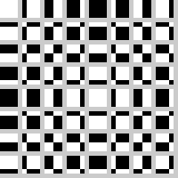
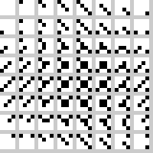
Row/columns go together
Opposite diagonals go together
However, e.g. row vs diagonal does not go together!
Open problem: Is this related to symmetries somehow?

References:

[1] “Involution (mathematics)”
Wikipedia
https://en.wikipedia.org/wiki/Involution_(mathematics)

[2] “Möbius strip”
Wikipedia
https://en.wikipedia.org/wiki/M%C3%B6bius_strip

