Avatars in The Holy Trinity
by Sven Nilsen, 2021

In this paper I explain how Avatar Extensions can be applied to christian theology of The Holy Trinity.

Avatar Extensions^{[1]} is a technique for abstract generalization in Path Semantics^{[2]},
an extremely expressive language for mathematical programming.

One way to teach Avatar Extensions is by using allegories^{[3]}. An allegory is a narrative in which a character, place or event is used to deliver a broader message, often through personification of abstract concepts. I often use christianity^{[4]} as an example to talk about avatars in theology^{[5]}.
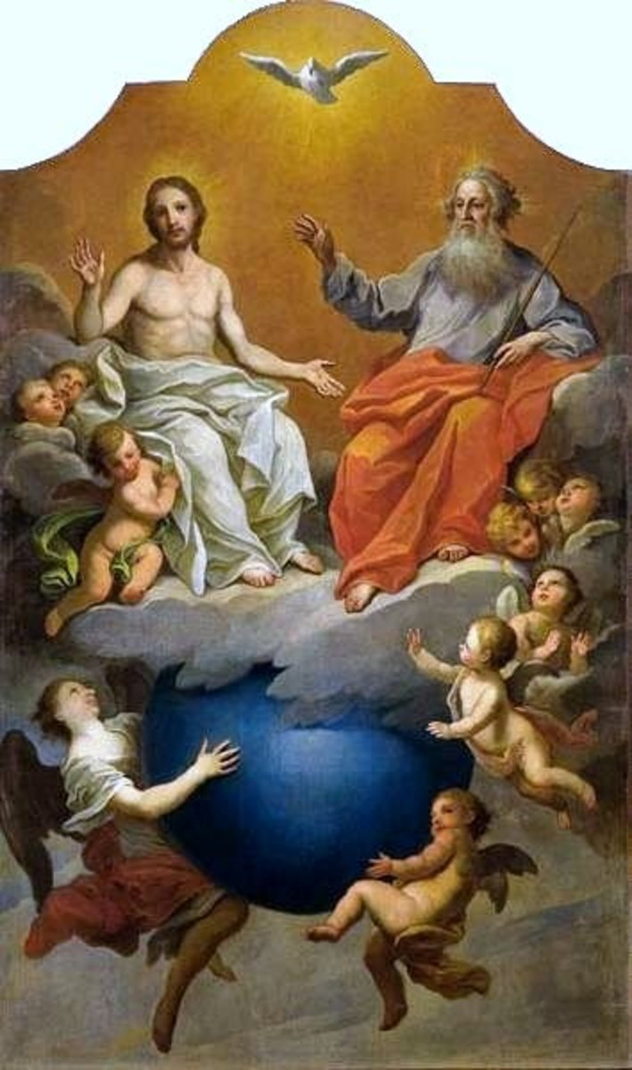
To the right, Holy Trinity,
depicted by Szymon Czechowicz.

The Holy Trinity is the following:

- Father
- Son
- Holy Spirit

Each of these 3 parts are aspects of God.
The 3 aspects unites the worldview, creating a form of belief related to environment, history and subjectivity.

To simplify things, I will focus on the relation between Son and Father. In this process, I will use a them as allegories of Avatar Extensions:

Father | Son
0 / false | 1 / true
In Heaven | On Earth
Source of all things | Relates things in-themselves
“Impossible” existence | “Possible” existence

Father has an “impossible” existence since in order for an object to exist, it must exist within the universe.

Son has a “possible” existence since he descends down to Earth, thus existing within the universe.

The universe is a boundary between the finite aspect and the infinite aspect of God.

The boundary of the universe represents the limits of language (see Wittgenstein^{[6]}).
Avatar Logic^{[7]} has two axioms which corresponds to the analogue of Father and Son:

p(a, b) b : p p(a) = b The analogue of Father
p(a, q'(b)) q'(b) : p p(a) = {q'(_)} ∈ q'(b) The analogue of Son
Both Father and Son coexist eternally (as axioms) before the world is created (data and rules).

The first axiom uniquely associates through a role, but might have too much constraints.
The second axiom provides a mechanism similar to the first, but more relaxing of constraints.

The constraints are the boundary of the universe due to limits of language.
Think of it as Father being outside of the limits of language, while Son is inside the limits of language.
This means that when the first axiom is over-constrained, one can use the second axiom instead.

The 1-avatar `q` “wraps” `b` into `q’(b)`.
This is like the Son taking on human form of God (it needs to be wrapped into something).
In the Heaven, the Father exist in pure form as God (it does not need to be wrapped).

Now, having the axioms, one can model The Holy Trinity from within the logic:

yahweh := the_father’(god)
jesus := the_son’(god)
dove := the_holy_spirit’(god)

Notice the symmetry of these 3 corners/1-avatars.
The Holy Trinity is a 3-avatar, because it integrates the information of 3 x 1-avatars.

References:

[1] “Avatar Extensions”
AdvancedResearch – Summary page on Avatar Extensions
https://advancedresearch.github.io/avatar-extensions/summary.html

[2] “Path Semantics”
AdvancedResearch
https://github.com/advancedresearch/path_semantics

[3] “Allegory”
Wikipedia
https://en.wikipedia.org/wiki/Allegory

[4] “Christianity”
Wikipedia
https://en.wikipedia.org/wiki/Christianity

[5] “Theology”
Wikipedia
https://en.wikipedia.org/wiki/Theology

[6] “Ludwig Wittgenstein”
Wikipedia
https://en.wikipedia.org/wiki/Ludwig_Wittgenstein

[7] “Avatar Logic”
AdvancedResearch – Summary page on Avatar Extensions
https://advancedresearch.github.io/avatar-extensions/summary.html#avatar-logic

