The Meditating Monk at
The Top of The Mountain
by Sven Nilsen, 2020

This is an idea about ethics I have kept floating around and thinking about from time to time. I think about it as a way to approach certain systems of ethics in the limit, such that instead of determining local actions to achieve some goal, one visualizes the final states.

An ever increasing function over time does not have a final state. All such systems of linear logic are incompatible with finite resources and will lead to a terminal state. However, visualizing a function that does not always increase, but converges to some neighborhood of stable states, is pretty hard and boring in general. It is much easier to explain this using storytelling.

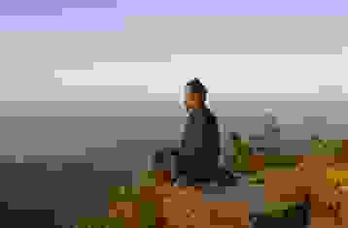

There is a meditating monk at the top of the mountain. Why he is there, meditating, nobody of us know.

From time to time, the monk stops meditating, steps down from the mountain and does something. When he is done, he goes back to the top of the mountain and continues meditation.

By observing this phenomena many times, we have determined that the monk goes back to meditation when the world is in “balance” with his goals. We say this because the monk is in balance, not about the world. If the world was not according to his goals, he would step down from the mountain and act accordingly. However, since this is not the case, the world must be in “balance” with his goals. His state as a person is used to label the state of the world. Yet, nobody of us know what it actually means.

When the monk goes hungry or have other needs, he stops meditating and takes care of himself. Then, he goes back to meditation. Therefore, we concluded the world is no different to him than his needs.

