Hypertorus Homotopy
by Sven Nilsen, 2022

In this paper I show that homotopy theory can be interpreted in a slightly different way than paths.
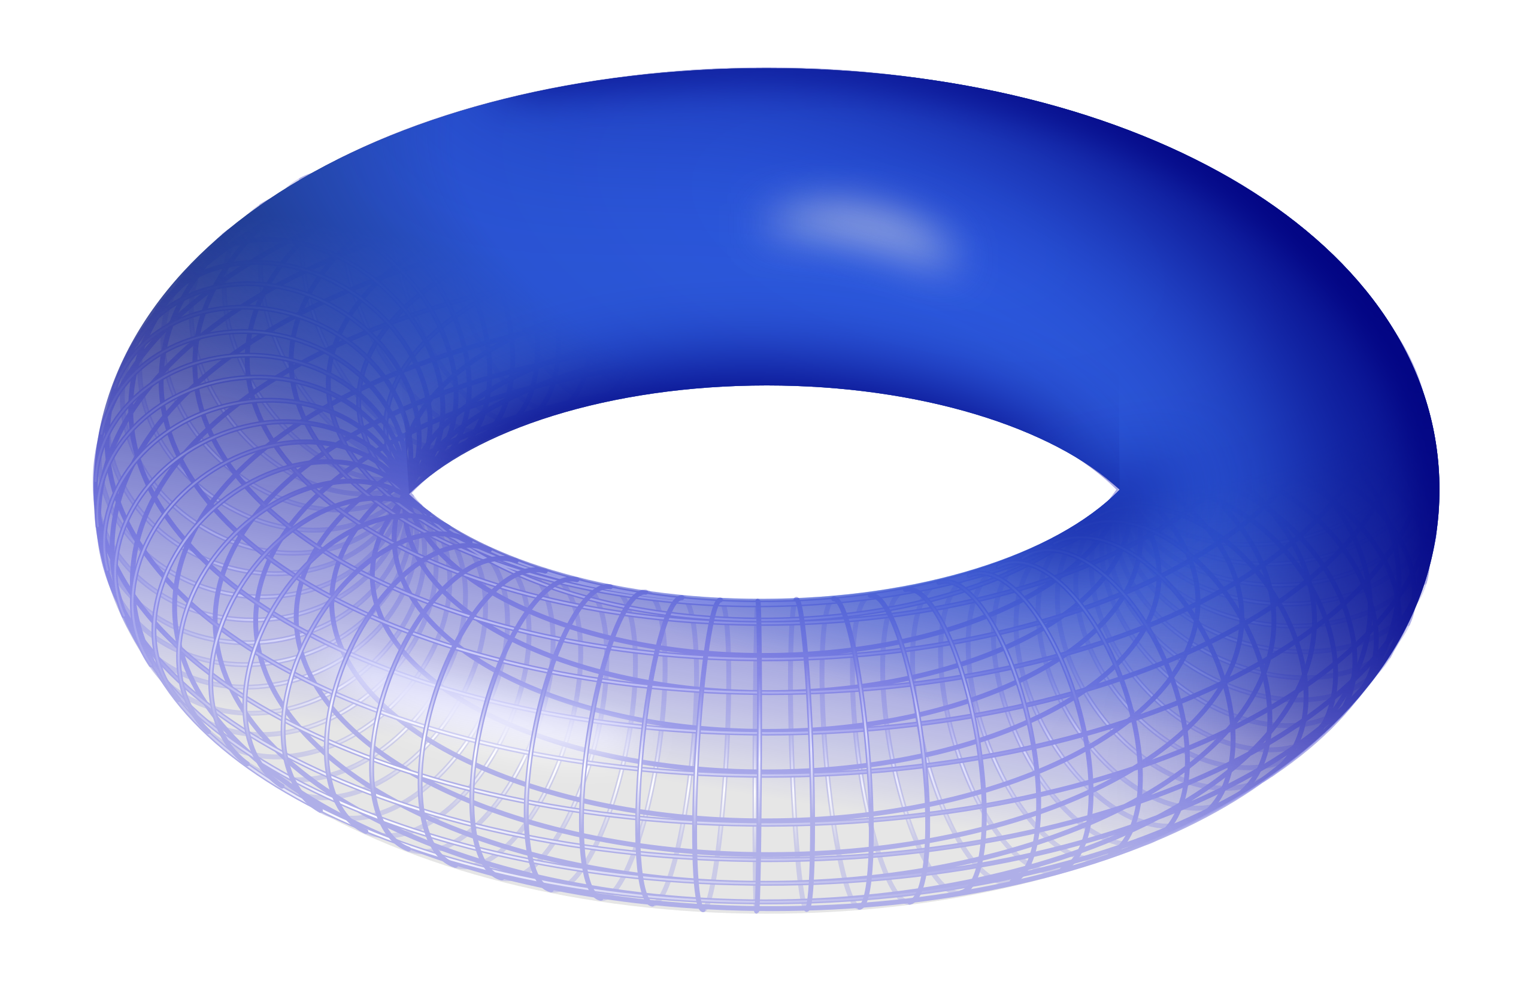
In homotopy theory^{[1]}, there is a way of thinking about homotopy and paths that is more subtle than commonly appreciated. To study this, one can learn from the discipline of philosophy where it is payed close attention to language of ideas. When people get the impression that homotopy simply means “paths between paths”, they are mislead into thinking that there is only one way of thinking and they leave out important details which are used to distinguish one interpretation of homotopy from another.
Hypertorus Homotopy uses n-dimensional toruses as basis for a model of homotopy theory
Image source

First and foremost, it is important to think of “paths between paths” as a proof of homotopy, but not homotopy itself. The argument for this perspective is that there exists a “normal form” of homotopy where some hypersurface is made as smooth as possible and distances are made as short/straight as possible. A deformed homotopy might be thought of as modifications of the normal form. This way of thinking about homotopy makes it natural to assume it exists prior to any path inside it, such that observing one path being continuously deformed into another is a proof of homotopy, but not necessarily a direct description of the homotopy itself. This interpretation is consistent with the standard definition of homotopy maps.

Assume that there are two points `a` and `b` in some space `S` and two paths `p` and `q` with a homotopy `h` between them. The standard definition of homotopy maps makes `h(0) == p` and `h(1) == q`. In Homotopy Type Theory^{[2]} the homotopy `h` is defined as the type:

h : Id{Id{S}(a, b)}(p, q)

Hypertorus Homotopy starts by constructing loops around `a` and `b`. One can think about these loops as `~a` and `~b` where `~` is the Path Semantical Qubit^{[3]} operation. What makes Hypertorus Homotopy different is that one is not directly talking about the paths between `a` and `b`. Instead, one considers a loop with base `a` to have a well defined meaning which is the proposition `~a`. Intuitively, as a loop shrinks to a point in `a`, there is no ambiguity.

The proof of homotopy in Hypertorus Homotopy is `~a == ~b`. Since a loop around a base has a proposition, one can equate two such propositions directly. There are no paths needed between `a` and `b` to prove the homotopy. The intuition is that the homotopy exists prior to any path in it.

Hypertorus Homotopy is a bit harder to understand, but it can be made more intuitive by comparing it to the “paths between paths” interpretation as proofs of homotopy. Assume that one path `p` can be continuously deformed into another `q` between points `a` to `b`. One can think about Hypertorus Homotopy as orthogonal, where there are many paths going from `a` to `b` with end-points following `p` and `q`. At the points `a` and `b`, the end-points meet and form loops. So, the propositional expression `~a == ~b` is interpreted as these loops being equal.

The downside of Hypertorus Homotopy is that one can only express a single homotopy between any two points. However, if the space of all homotopies is contractible, then the space satisfies this condition where expressing a single homotopy is sufficient. It turns out that this matches exactly the definition of homotopy levels^{[4]} in Homotopy Type Theory. Homotopy levels are defined recursively such that each homotopy level depends on the definition of lower homotopy levels. In homotopy level 0, the space is contractible, meaning there exists some homotopy of “normal form” by choice.

In Hypertorus Homotopy, the propositional expression `~~a == ~~b` is interpreted as the existence of some 2-homotopy between `a` and `b`. Instead of creating loops around `a` and `b`, one can create toruses. Just like with the loops, a torus with base `a` has well defined meaning when it shrinks to a. This well defined meaning is expressed using the proposition `~~a`. When two such toruses are made equal, one can think about it using the “paths between paths” interpretation as an unfolding of a torus onto a 2D surface, where the boundary follows the boundary of the 2-homotopy from `a` to `b`.

For example, in 3D space, a hole prevents the existence of some torus between two bases `a` and `b`. Think about the hole as a small sphere. By creating a torus such that the sphere is located inside the inner space of the torus, it is impossible to contract the torus to a single point. Now, shrink the hole to a point. It becomes possible to contract the torus to a single point, yet this torus can not be continuously deformed into a torus which does not contain the hole inside its inner space. When picking two bases `a` and `b`, one can express a hole in 3D as `~~a ¬= ~~b`, where either `a` or `b` is the base for the hole. Topologically, it does not matter which of `a` or `b` is the hole. Therefore, the proposition `~~a ¬= ~~b` uniquely represents the topology.

A 2-homotopy is like a solid, while a 1-homotopy is like a surface.
Therefore, it is natural to think about a 0-homotopy as a line.
A 0-homotopy from `a` to `b` can be expressed as `a == b`.

The propositional value of a point is a (-1)-homotopy with the “normal form” `true`.
This intuition comes from the following definition (used in Pocket-Prover^{[6]}):

hom_eq(n, a, b) := ∀ i n { qubit^i(a) == qubit^i(b) }

This definition describes equivalence of hypertorus homotopy for all levels up to `n`.
Notice when `n == 0` one gets `hom_eq(0, a, b) == true`.

Hypertorus Homotopy has a propositional model of n-dimensional toruses, therefore there are no paths in the sense of Homotopy Type Theory. However, it turns out that Path Semantical Quality^{[7]} has the exact same properties that are intuitive for a path (under gluing operations):

(a ~~ b) := (a == b) ⋀ ~a ⋀ ~b

When gluing the end points of a path to itself, one gets a loop.

(a ~~ a) == ~a

Loops are not constructed by default, so `a ~~ a` is not a tautology.
It follows that paths in Hypertorus Homotopy are partial equivalence relations^{[8]},
since they do not have the axiom of reflexivity^{[9]}.

One can use `hom_eq` as a weaker notion of a path, which satisfies reflexivity.

References:

[1] “Homotopy”
Wikipedia
https://en.wikipedia.org/wiki/Homotopy

[2] “Homotopy Type Theory”
Website for Homotopy Type Theory
https://homotopytypetheory.org/

[3] “Path Semantical Qubit”
Sven Nilsen, 2022
https://github.com/advancedresearch/path_semantics/blob/master/papers-wip2/path-semantical-qubit.pdf

[4] “homotopy level”
nLab
https://ncatlab.org/nlab/show/homotopy+level

[5] “Torus”
Wikipedia
https://en.wikipedia.org/wiki/Torus

[6] “Pocket-Prover”
AdvancedResearch
https://github.com/advancedresearch/pocket_prover

[7] “Path Semantical Quality”
Sven Nilsen, 2021
https://github.com/advancedresearch/path_semantics/blob/master/papers-wip2/path-semantical-quality.pdf

[8] “Partial equivalence relation”
Wikipedia
https://en.wikipedia.org/wiki/Partial_equivalence_relation

[9] “Reflexive relation”
Wikipedia
https://en.wikipedia.org/wiki/Reflexive_relation

