Hyperspherdisdodehedron
by Sven Nilsen, 2022

In this paper I introduce a way of constructing a general hyperspherical disdyakis dodecahedron.
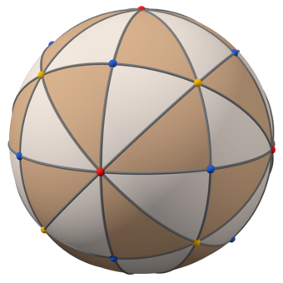
Illustration of a spherical disdyakis dodecahedron^{[1]}

A hypersphere^{[2]} is given by the following equation:

∑ i : ℕ { x_{i}² } = r²

x : [ℝ]
r : ℝ

By using a hypercube^{[3]} map onto a hypersphere, one obtains the following solutions for a general hyperspherical disdyakis dodecahedron, which is nick named “hyperspherdisdodehedron”:

r = sqrt(1 + i) · p_{i}

p : [ℝ]

Where `p_{i}` is a coefficient scaled with a vector `v_{ij}` such that one can calculate positions of points:

position_{ij} = v_{ij} · p_{i}

position : [[[ℝ]]]
v : [[[ℝ]]]

Where `v_{ij}` is some permutation of a vector `w_{i}`:

w_{i} = (±1, ±1, …, ±1, 0, 0, … 0)

The number of zeroes in the vector is `i`.
The total length corresponds to the dimensions of the hypersphere.
This vector is balanced ternary^{[4]} since it only contains `-1, 0, 1`.

References:

[1] “Disdyakis dodecahedron”
Wikipedia
https://en.wikipedia.org/wiki/Disdyakis_dodecahedron

[2] “n-sphere”
Wikipedia
https://en.wikipedia.org/wiki/N-sphere

[3] “Hypercube”
Wikipedia
https://en.wikipedia.org/wiki/Hypercube

[4] “Balanced ternary”
Wikipedia
https://en.wikipedia.org/wiki/Balanced_ternary

