[C:\Users\Tanya\Desktop\ProjectManager_logo_blue.png](https://www.projectmanager.com/pricing)

**Project Proposal**

**Template**

**[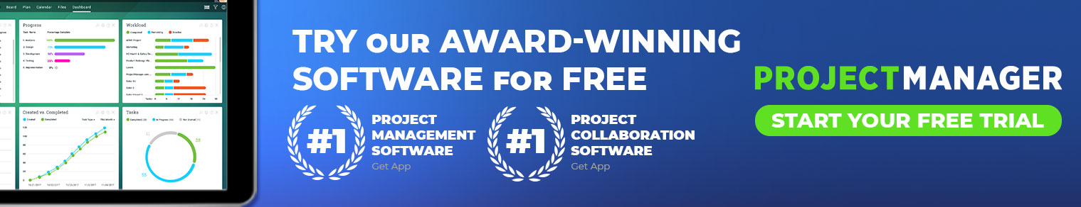](http://www.projectmanager.com/pricing?utm_source=project_manager_com&utm_medium=template&utm_campaign=word-proj-prop&utm_content=header)**

**Document Control**

Document Information

|  |  |
| --- | --- |
|  | **Information** |
| Document Id | **1856548654** |
| Document Owner | Software/Programming |
| Issue Date | *02/04/2020* |
| Last Saved Date | *02/04/2020* |
| File Name | *BookSpace* |

Document History

|  |  |  |
| --- | --- | --- |
| **Version** | **Issue Date** | **Changes** |
| *0.1* | *02/04/2020* | *Proceed step by step* |
| 0.2 | 02/04/2020 | Hope to create something beautiful |
| 0.3 | 02/04/2020 | Will be edited soon |
| 0.4 | 02/04/2020 | Will be edited soon |

Document Approvals

|  |  |  |  |
| --- | --- | --- | --- |
| **Role** | **Name©** | **Signature** | **Date** |
| Project Sponsor | Hellen Keller | Signature |  |
| Project Review Group | Michael Jordan | By email |  |
| Project Manager© | Grace Hopper | By email |  |
| Quality Manager  *(if applicable)* | Linus Torvalds | By email |  |
| Procurement Manager  *(if applicable)* | Brian Kernighan | By email |  |
| Communications Manager  *(if applicable)* | Tim Berners-Lee | Signature |  |
| Project Office Manager  *(if applicable)* | Bill Gates | Signature |  |

**Table of Contents**

[Template Guide 1](#_Toc293488333)

[1 Executive Summary 2](#_Toc293488334)

[2 Background 2](#_Toc293488335)

[2.1 History 2](#_Toc293488336)

[2.2 Requirements 2](#_Toc293488337)

[2.3 Solution 3](#_Toc293488338)

[3 Proposal 3](#_Toc293488339)

[3.1 Vision and Goals 3](#_Toc293488340)

[3.2 Deliverables 4](#_Toc293488341)

[3.3 Timeframe 4](#_Toc293488342)

[3.4 Resources 5](#_Toc293488343)

[3.5 Budget 6](#_Toc293488344)

[3.6 Ownership 6](#_Toc293488345)

[3.7 Reporting 7](#_Toc293488346)

[3.8 Risks & Issues 7](#_Toc293488347)

[3.9 Implications 8](#_Toc293488348)

[3.10 Success Criteria 8](#_Toc293488349)

[3.11 Authorization 8](#_Toc293488350)

[4 Appendix 9](#_Toc293488351)

[4.1 Supporting Documentation 9](#_Toc293488352)

# Template Guide

***What is a Project Proposal?***

*A Project Proposal is a document that is written to kick-off a new project. It needs to convince a sponsor that a project needs to be initiated to solve a particular problem or opportunity in the business.*

*It describes in depth, the basis upon which the project needs to be commenced, so that the sponsor fully understands why it’s critical to the business and what is involved.*

*It also needs to outline the implications of* ***not*** *approving the project, so that the sponsor is forced to make a clear decision – to approve the project, or not.*

***When do I use a Project Proposal?***

*Any time that you need to coordinate resources, tasks, equipment and raw materials within a specific timeframe to achieve a particular business goal, then you should consider doing this as part of a formal project.*

*The first step when initiating a project is to document a Project Proposal. It helps you formalize the project so that it has a specific vision that needs to be achieved in order to determine its success.*

*Ideally a Project Proposal will be written by the intended manager of the project. However sometimes it is written by a business manager if the Project Manager is yet to be selected. It is always presented to senior management within the business for approval.*

*Once approved, the next step is usually to write a* [*Business Case*](https://www.projectmanager.com/blog/how-to-write-a-business-case) *which justifies the project financially. Soon after that, a* [*Project Charter*](https://www.projectmanager.com/templates/project-charter-template) *will be written based on this Project Proposal, to scope out the project and ensure that everyone is clear about what needs to be done.*

***How to use this template***

*This document outlines the sections needed to complete a Project Proposal. You need to replace the content in each section with your own. Each section includes completion instructions so that you know what you need to write, to fill the document in from start to finish. You will want to remove these completion instructions as you go, to create your own customized Project Charter for your business.*

# Executive Summary

Before starting a project, it is necessary to make the ideas in mind open to the public, writing and declaring the formations that will be created soon. As we know, these issues proceed like this, first come to a conclusion by thinking, then present this result to the society and enlightenment together. I would like to accomplish this project on this platform who has come to my mind before and managed to create it. In fact, it can be called "Book Space" as the title related to my idea. A place where you can publish your own poetry or burrows on a platform that you have created on your own.

# Background

## History

Alan Turing is credited with being the first person to come up with a theory for **software** in 1935, which led to the two academic fields of computer science and **software** engineering.

The **first** programs were meticulously written in raw machine code, and everything was built up from there. The idea is called bootstrapping.

1957: Fortran: A computer **programming language** created by John Backus for complicated scientific, mathematical, and statistical work, Fortran stands for Formula Translation. It is the one of the **oldest** computer **programming languages** still used today.

## Requirements

Most professionals in project management understand that in order to successfully approach a project, the problem statement must be clearly defined. The problem is that many practitioners treat problems and opportunities interchangeably when developing Business Cases and Project Charters. Understanding the difference between problems and opportunities is critical to selecting the optimal approach any project. Below are some key differences that will help you determine if your next project is aiming to solve a problem or to take advantage of an opportunity.

## Solution

Understanding the key differences between problems and opportunities will help you develop more compelling and effective business cases and project charters. Not only will it increase the likelihood that your project gets approved but it will also set a clearer path for the business analysis tasks that will need to be executed and the techniques are most appropriate. Hopefully, this makes your project management and business analysis initiatives more successful!!

# Proposal

# My project that I want to create is a book treasure, as I did in the previous statement it’s a place where people can exhibit their high level talents and achievements.

It is important to read books, and important to make the time comfortable and it gives peace to our minds therefore the site I want to build should be festive with its users and visitors.

## Vision and Goals

Our aim is to renew people on the road to success, and to be aware that there is no gain in this world without effort and to be beneficial to both ourselves and our environment every second is our treasure

For this purpose, to create an site that will be visited by 50% of our people without giving a high average and to increase the reading.

## Deliverables

Every project produces deliverables which form part of the solution that solves the business problem or opportunity. These deliverables with are key to the success of the project and they also define the scope of what must be produced. Therefore it is critical that you list all of the key deliverables that are to be produced in as much depth as possible.

Use the following table to describe deliverables to be produced by the project. Note: a deliverable is something that is produced that is handed over to the customer at the end of the project, as part of the solution. It might be a new product, a new service or a new system for instance.

|  |  |  |
| --- | --- | --- |
| **Project Deliverables** | | |
| **Title** | **Description** | **Notes** |
| Prepare project structure | İdentify the milestones and timelines of the project |  |
| Login/Sign Up | Create the steps to login |  |
| Design wireframes | Design the layout of the website |  |

## Timeframe

The **project timeline** is the beating heart of every **project**. It captures the essence of what the **project** will accomplish and how it will be done.

**Timeline Elements**

* The list of tasks to be completed.
* The dates on which the tasks need to be complete.
* The expected duration of each task.
* Dependencies between tasks.

Here is an example of a generic project plan:

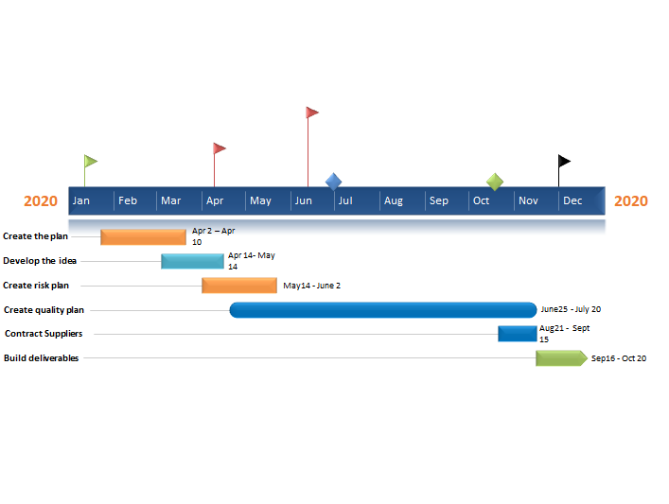

## Resources

|  |  |  |
| --- | --- | --- |
| **Project Resources** | | |
| **Type** | **Quantity** | **Notes** |
| Project Management plan | Default |  |
| Testing | Default |  |
| Requirements | Default |  |

## Budget

Research Coordinator x $60,000 per year including benefits paid at 25%

The Reseach Coodinator will be responsible for coordinating all aspects of the research project.

Research Analyst x $60,000 per year including benefits paid at 25%

The Research Analyst is responsible for data collection and analyzing the data colleted.

Office supplies $1,000

Open access journal publication $2,000

## Ownership

* ***Project Sponsor:*** Hellen Keller
* ***Customer:*** Louis Braille
* ***Project Manager:*** Brian Kernighan

|  |  |  |
| --- | --- | --- |
| **Project Ownership** | | |
| **Role** | **Name** | **Contact Details** |
| Project Sponsor | Hellen Keller | email |
| Project Customer | Louis Braille | email |
| Project Manager | Brian Kernighan | email |

## Reporting

## A plan will be created during the week.

Meeting logs will be made only 3 days a week

Each topic will be explained if there are questions to be discussed during the meeting. Telephone conferences can also be adapted.

## 

## Risks & Issues

|  |  |  |
| --- | --- | --- |
| **Project Risks** | | |
| **Risk** | **Details** | **Likelihood** |
| May not work as you wish | Complete the work | %80 |
| Purpose and need is not well defined | Define definite and well | %50 |
| Design and deliverable definition is incomplete | Finish the design | %89 |

|  |  |  |
| --- | --- | --- |
| **Project Issues** | | |
| **Issue** | **Details** | **Impact** |
| Improving benefit and relevance | Useful, design improved | %70 |
| Improving efficiency and effectiveness | Learning environments | %80 |
| Improving sustainability | Methods to sustain activities | %90 |

## Implications

Will be edited...

## Success Criteria

## What makes the project project can be delivered as a giving on time, but actually, it has many tactics. Because it is not something that happens immediately. Once the project's idea and plan have to attract people, a good plan should be created, useful and labored and creative.If I speak according to my experience, you should reflect this energy on yourself to endear the project. If you worked on it too much, you will definitely encounter a result that will make you happy. But it may not always be like this. You should prepare your project to satisfy your trust, And if possible, you can freshen up by taking the ideas of others.

## 

## Authorization

|  |  |  |
| --- | --- | --- |
| **Project Sponsor**  *Name:* Hellen Keller  *Position:* an American author, political activist,and,lecturer.  *Date: 02/ 04 / 2020* | **Customer**  *Name:* Louis Braille    *Position:* inventor of the **braille** code  *Date: 02 /04 /2020* |  |

# Appendix

## Supporting Documentation

<https://en.wikipedia.org/wiki/Project_manager>

<https://www.brightwork.com/blog/6-steps-to-start-any-project>

**[](http://www.projectmanager.com/pricing?utm_source=project_manager_com&utm_medium=template&utm_campaign=word-proj-prop&utm_content=footer)**