Practical No. 11 TestNg Annotations Date:

**Aim:**

To study TestNg Annotations.

# Theory:

Annotation is a feature introduced in Java 5 and is used to add metadata (data about data) to Java source code.

This will allow you to add information to an existing data object in your source code. It can be applied for classes, methods, variables, and parameters.

Annotations may affect the way different programs or tools use your source code. There are certain predefined set of annotations defined in Java.

For example, @Override, @Deprecated, @SupressWarnings, and so on, but Java allows users to define their own annotations too.

TestNg makes use of the same feature provided by Java to define its own annotations and build an execution framework by using it.

The following is a table containing information about all the annotations provided by TestNG and a brief description of them:

|  |  |
| --- | --- |
| **Annotation** | **Description** |
| @BeforeSuite or @AfterSuite | The annotated method will be executed before and after any tests declared inside a TestNG suite. |
| @BeforeTest or @AfterTest | The annotated methods will be executed before and after each test section declared inside a TestNG suite. |
| @BeforeGroups or @AfterGroups | These annotations are associated with the groups feature in TestNG.  BeforeGroups annotated method will run before any of the test method of the specified group is executed. |

|  |  |
| --- | --- |
|  | AfterGroups annotated method will run after any of the test method of the specified group gets executed.  For this method to be executed, the user has to mention the list of groups this method belongs to using groups attribute with the said annotation. You can specify more than multiple groups if required. |
| @BeforeClass or @AfterClass | BeforeClass annotated method is executed before any of the test method of a test class.  AfterClass annotated method is executed after the execution of every test methods of a test class are executed. |
| @BeforeMethod or @AfterMethod | These annotated methods are executed before/after the execution of each test method. |
| @DataProvider | Marks a method as a data providing method for a test method. The said method has to return an Object double array (Object[][  ]) as data. |
| @Factory | Marks a annotated method as a factory that returns an array of class objects (Object[ ]). These class objects will then be used as test classes by TestNG. This is used to run a set of test cases with different values. |
| @Listeners | Applied on a test class. Defines an array of test listeners classes extending org.testng.ITestNGListener. Helps in tracking the execution status and logging purpose. |
| @Parameters | This annotation is used to pass parameters to a test method. These parameter values are provided using the testng.xml configuration file at runtime. |
| @Test | Marks a class or a method as a test method. If used at class level, all the public methods of a class will be considered as a test |

|  |  |
| --- | --- |
|  | method |

# Test annotation

One of the basic annotations of TestNG is the Test annotation.

This annotation marks a method or a class as part of the TestNG test.

If applied at class level this annotation will mark all the public methods present inside the class as test methods for TestNG test.

It supports lot of attributes which you can use along with the annotation, which will enable you to use the different features provided by TestNG.

The following is a list of attributes supported by the Test annotation:

|  |  |
| --- | --- |
| **Supported attributes** | **Description** |
| alwaysRun | Takes a true or false value. If set to true this method will always run even if its depending method fails. |
| dataProvider | The name of the data provider, which will provide data for data- driven testing to this method. |
| dataProviderClass | The class where TestNG should look for the dataprovider method mentioned in the dataProvider attribute. By default its the current class or its base classes. |
| dependsOnGroups | Specifies the list of groups this method depends on. |
| dependsOnMethods | Specifies the list of methods this method depends on. |
| description | The description of this method |
| enabled | Sets whether the said method or the methods inside the said class should be enabled for execution or not. By default, its value is true. |
| expectedExceptions | This attribute is used for exception testing. This attribute specifies the list of exceptions this method is expected to throw. In case a |

|  |  |
| --- | --- |
|  | different exception is thrown. |
| groups | List of groups the said method or class belongs to. |
| timeOut | This attribute is used for a time out test and specifies the time (in millisecs) this method should take to execute. |

# Parameterization of test

One of the important features of TestNG is parameterization.

This feature allows user to pass parameter values to test methods as arguments. This is supported by using the Parameters and DataProvider annotations.

There are mainly two ways through which we can provide parameter values to test-methods: Through testng XML configuration file

Through DataProviders

## Parameterization through testng.xml

If you need to pass some simple values such as String types to the test methods at runtime, you can use this approach of sending parameter values through TestNG XML configuration files.

You have to use the Parameters annotation for passing parameter values to the test method.

## DataProvider

One of the important features provided by TestNG is the DataProvider feature.

It helps the user to write data-driven tests, that means same test method can be run multiple times with different datasets.

DataProvider is the second way of passing parameters to test methods. It helps in providing complex parameters to the test methods as it is not possible to do this from XML.

To use the DataProvider feature in your tests you have to declare a method annotated by DataProvider and then use the said method in the test method using the dataProvider attribute in the Test annotation.

## Groups

Grouping test methods is one of the most important features of TestNG. In TestNG users can group multiple test methods into a named group.

You can also execute a particular set of test methods belonging to a group or multiple groups. This feature allows the test methods to be segregated into different sections or modules.

For example, you can have a set of tests that belong to sanity test where as others may belong to regression tests.

You can also segregate the tests based on the functionalities/features that the test method verifies. This helps in executing only a particular set of tests as and when required

## Implementation

1. Create a test class with @BeforeClass/@AfterClass, @BeforeMethod/@AfterMethod annotations and execute it using a testng.xml

## Code:

package practical11;

import org.testng.annotations.AfterClass; import org.testng.annotations.AfterMethod; import org.testng.annotations.BeforeClass; import org.testng.annotations.BeforeMethod; import org.testng.annotations.Test;

public class Q1 {

@BeforeClass

public void beforeClassMethod(){

System.err.println("This is before class method");} @AfterClass

public void afterClassMethod() {

System.err.println("This is after Class Method");} @BeforeMethod

public void beforeMethod() { System.err.println("This is before Method");}

@AfterMethod

public void afterMethod() { System.err.println("This is After Method");}

@Test

public void firstMethod() { System.out.println("First method of Q1");

}}

## Output:-

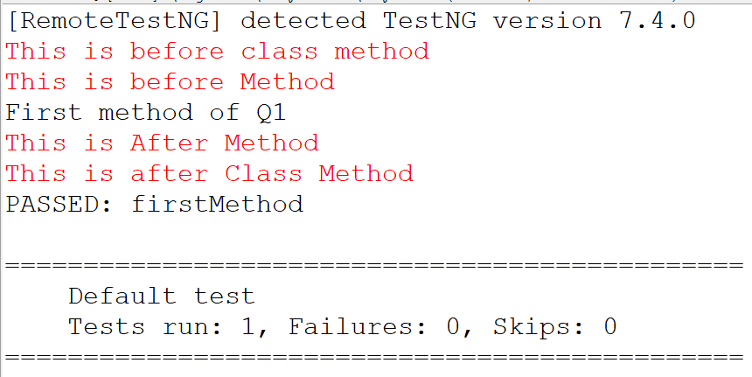

1. Create and execute a TestNG class using test annotation on class. The class contains two public methods and one private method.

## Code:

package practical11;

import org.testng.annotations.Test; @Test

public class Q2 {

public void publicMethod() { System.out.println("This is Public Method");

}

private void privateMethod() { System.out.println("This is private Method"); }

}

## XML:

<suite name="Practical_11_Q1">

<test name="Q1">

<classes>

<class name="practical11.Q2"/>

</classes>

</test>

</suite>

## Output:

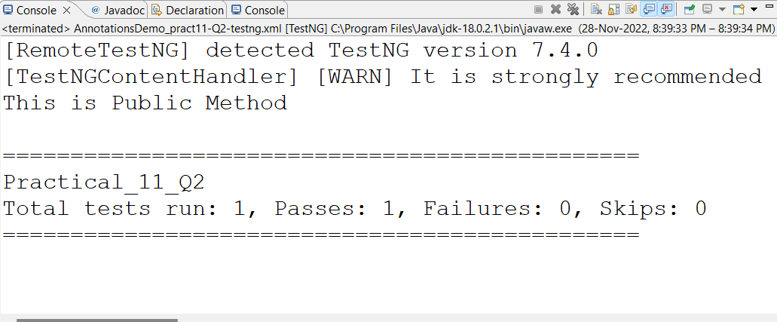

1. Create TestNG class containing three test methods using test annotation out of which any two methods are enabled and remaining method is disabled. Use appropriate attributes of test annotation.

## Code:

package beforeafter;

import org.testng.annotations.Test; public class test {

@Test

public void testMethodOne() { System.out.println("First Test Method");}

@Test(enabled=false)

public void testMethodTwo() { System.out.println("Second Test Method");}

@Test

private void testMethodThird() { System.out.println("Third Test Method");

}}

## XML:

<suite name="Test Suite" verbose="1">

<test name="First Test">

<classes>

<class name="beforeafter.test"/>

</classes>

</test>

</suite>

## Output:

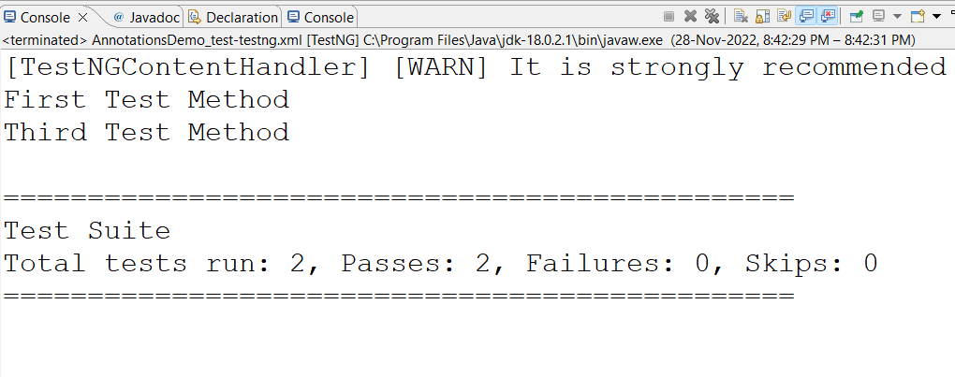

1. Create a test class with @BeforeSuite/@AfterSuite, @BeforeTest/@AfterTest annotations and execute it using a testng.xml.

## Code:

package practical11;

import org.testng.annotations.AfterSuite; import org.testng.annotations.AfterTest; import org.testng.annotations.BeforeGroups; import org.testng.annotations.BeforeSuite; import org.testng.annotations.BeforeTest; import org.testng.annotations.Test;

public class Q3 { @BeforeSuite

public void beforeSuite() {

System.err.println("This is before suite method");} @AfterSuite

public void afterSuite() {

System.err.println("This is before suite method"); } @BeforeTest

public void beforeTest() {

System.err.println("This is before Test method");} @AfterTest

public void afterTest() {

System.err.println("This is after Test method");

}

@Test

public void firstMethod() { System.out.println("In Method");

}}

## XML:

<suite name="Practical_11_Q3">

<test name="Q3">

<classes>

<class name="practical11.Q3"/>

</classes>

</test>

</suite>

## Output:

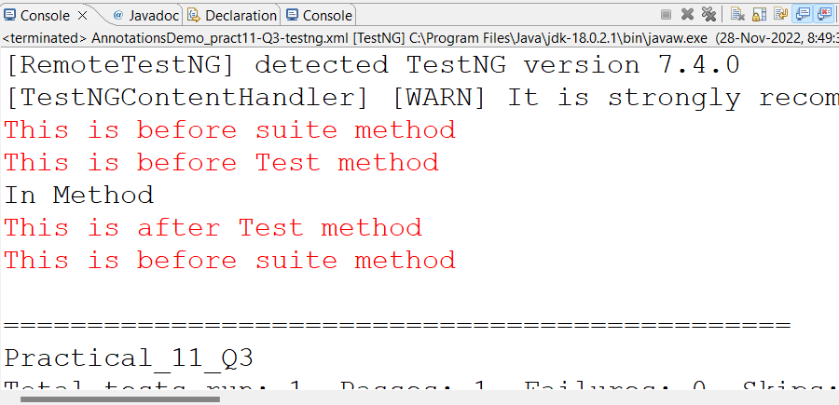

1. Create a test class that contains four test methods. Two of which should belong to one group and the remaining two to another group. Create testing.xml file to execute tests in a particular group.

## Code:

package beforeafter;

import org.testng.annotations.Test; public class GroupsTestDemo { @Test(groups ={"test-group"}) public void testMethodOne() {

System.out.println("Test method one belongs to test-group"); } @Test(groups= {"new-group"})

public void testMethodTwo() {

System.err.println("Test method two belongs to new group");} @Test(groups = {"test-group"})

public void testMethodThird() {

System.out.println("Test method third belongs to test-group");} @Test(groups= {"new-group"})

public void testMethodFourth() {

System.err.println("Test method Fourth belongs to new-group");

}}

## XML:

<suite name="groupt test suite">

<test name=" Group Testing">

<groups>

<run>

</run>

</groups>

<classes>

<include name="test-group"/>

<include name="new-group"/>

</test>

</suite>

## Output:

<class name="beforeafter.GroupsTestDemo"/>

</classes>

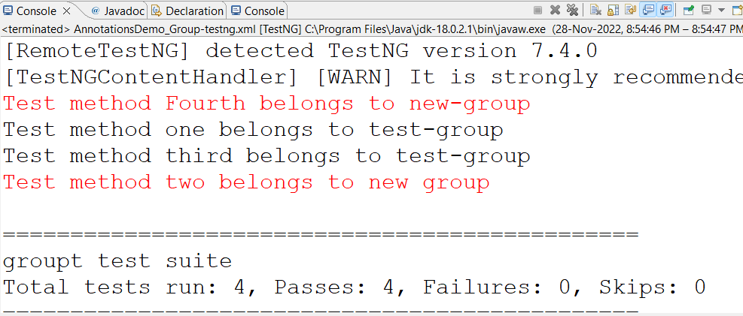

1. Write a test class containing test method that calculates the average marks that awarded by two reviewers prints whether writer is shortlisted if average is >4. The marks are passed as parameters whose values are passed from testing.xml at test level.

## Code:

package beforeafter;

import org.testng.annotations.Parameters; import org.testng.annotations.Test;

public class ParameterizationDemo { @Test

@Parameters({"Reviewer1","Reviewer2"})

public void check_if_shortLiisted(int marks1,int marks2) { float average=(marks1+marks2)/2;

System.out.println("Average achieve by reviewer "+average); if(average > 4)

System.out.println("Reviewer is ShortListed");

}}

## XML:

else

System.out.println("Reviewer is not ShortListed");

<suite name="parameterized" verbose="1">

<parameter name="Reviewer1" value="4"/>

<parameter name="Reviewer2" value="9"/>

<test name="Parameterized Test">

<parameter name="Reviewer1" value="4"/>

<parameter name="Reviewer2" value="1"/>

<classes>

<class name="beforeafter.ParameterizationDemo"/>

</classes>

</test>

</suite>

## Output:

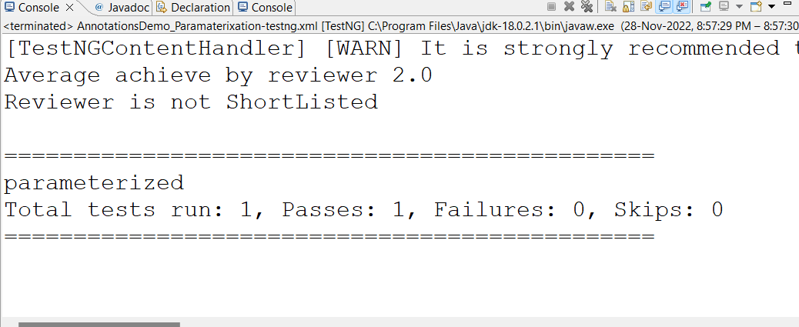

1. Write a test class containing test method that prints the value of parameters which are passed from data provider.

## Code:

package beforeafter;

import org.testng.annotations.DataProvider; import org.testng.annotations.Test;

public class DataProviderDemo { @DataProvider(name="dataProvider") public Object[][] dataProviderMethod() {

return new Object[][] {{"data one"},{"data two"}};

}

@Test(dataProvider="dataProvider") public void testMethod(String data) {

System.out.println("Data is :"+data);

}}

## XML:

<suite name="Test Suite">

<test name="Data provider Test">

<classes>

<class name="beforeafter.DataProviderDemo"/>

</classes>

</test>

</suite>

## Output:

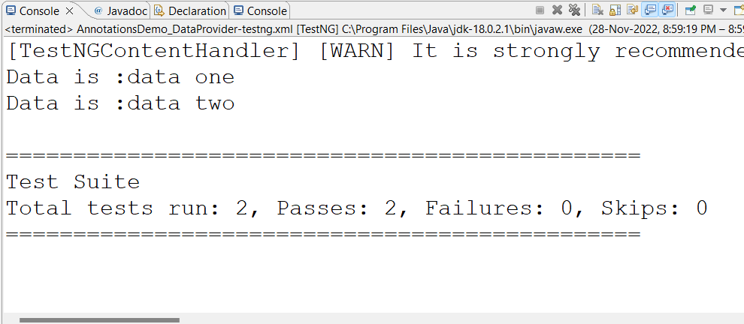

**Conclusion:** Understood how to use TestNG Annotations.

## After performing this Practical/lab, students are expected to answer following questions

* 1. What are TestNG Annotations?
  2. What is data provider?