# Practical No. 6. Handling different types of alerts in Selenium Date:

**Aim:**

To learn how to handle various types of alerts in Selenium.

# Theory:

An Alert in Selenium is a small message box which appears on screen to give the user some information or notification. It notifies the user with some specific information or error, asks for permission to perform certain tasks and it also provides warning messages as well. Here are few alerts in Selenium:

# Simple Alert

The simple alert class in Selenium displays some information or warning on the screen.

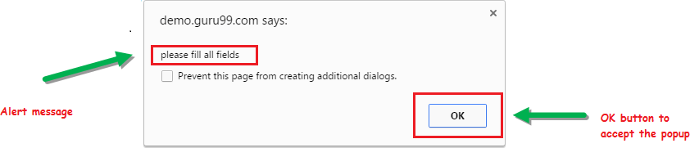

# Prompt Alert.

This Prompt Alert asks some input from the user and Selenium webdriver can enter the text using sendkeys(” input…. “).

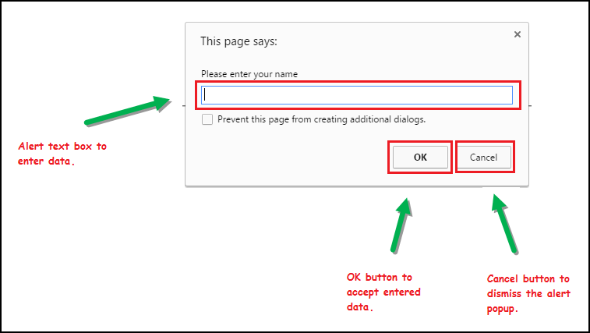

# Confirmation Alert.

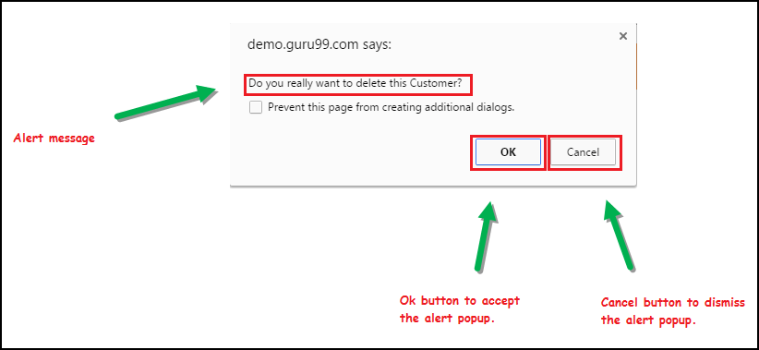This confirmation alert asks permission to do some type of operation.

Apart from switching between windows and frames, you may have to handle various modal dialogs in a web application. For this, WebDriver provides an API to handle alert dialogs. The API for that is as follows:

# Alert alert()

The preceding method will switch to the currently active modal dialog on the web page. This returns an Alert instance where appropriate actions can be taken on that dialog. If there is no dialog currently present, and you invoke this API, it throws back a **NoAlertPresentException.**

The Alert interface contains a number of APIs to execute different actions. The following list discusses them one after the other:

# void accept():

This is equivalent to the OK button action on the dialog. The corresponding OK button actions are invoked when the accept() action is taken on a dialog.

# void dismiss():

This is equivalent to clicking on the CANCEL action button.

# java.lang.String getText():

This will return the text that appears on the dialog. This can be used if you want to evaluate the text on the modal dialog.

# void sendKeys(java.lang.String keysToSend):

This will allow the developer to type in some text into the alert if the alert has some provision

for it.

# Implementation

* 1. Write a selenium script to handle alert on [http://only-testing-](http://only-testing-blog.blogspot.com/2013/09/test.html) [blog.blogspot.com/2013/09/test.html](http://only-testing-blog.blogspot.com/2013/09/test.html)

# Code:-

**package** practical6;

**import** org.openqa.selenium.Alert;

**import** org.openqa.selenium.By;

**import** org.openqa.selenium.WebDriver;

**import** org.openqa.selenium.WebElement;

**import** org.openqa.selenium.firefox.FirefoxDriver;

**public class** q1 {

**public static void** main(String args[]) **throws** InterruptedException { System.*setProperty*("webdriver.gecko.driver", "D:\\Finolex\\SEM 3\\Selenium-

Setup\\geckodriver.exe");

WebDriver driver=**new** FirefoxDriver(); //create driver instance driver.get(["http://only](http://only-testing-blog.blogspot.com/2013/09/test.html)-[testing-blog.blogspot.com/2013/09/test.html?](http://only-testing-blog.blogspot.com/2013/09/test.html)");

WebElement confirmBtn=driver.findElement(By.*cssSelector*("button[onclick='myFunction()']"));

confirmBtn.click();

//confirmation alert Thread.*sleep*(2000);

Alert confirmAlert=driver.switchTo().alert(); confirmAlert.dismiss();

Thread.*sleep*(3000);

WebElement simpleAlertBtn=driver.findElement(By.*cssSelector*("input[value='Show Me Alert']"));

simpleAlertBtn.click();

//simple alert Thread.*sleep*(1000);

Alert simpleAlert=driver.switchTo().alert(); simpleAlert.accept();

}

}

# Output:-

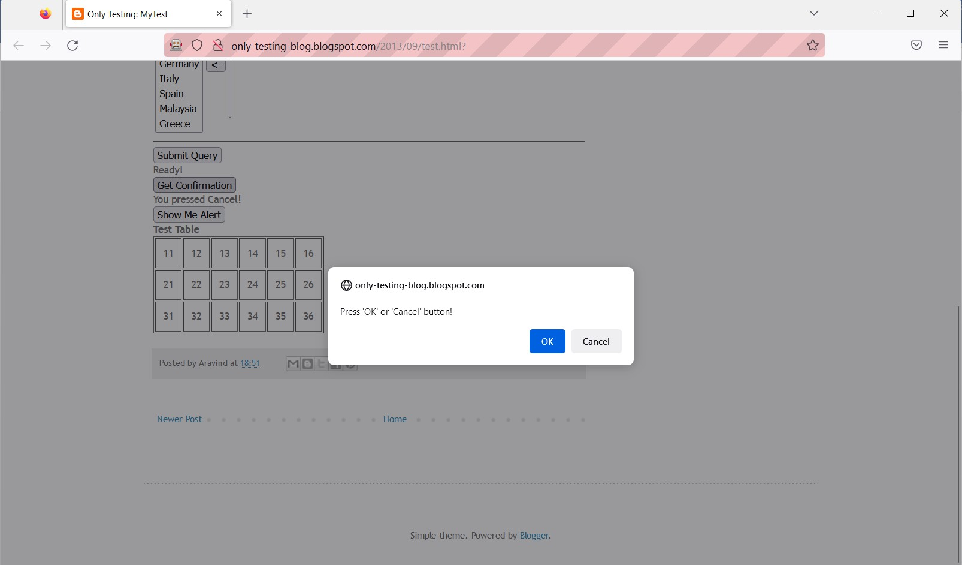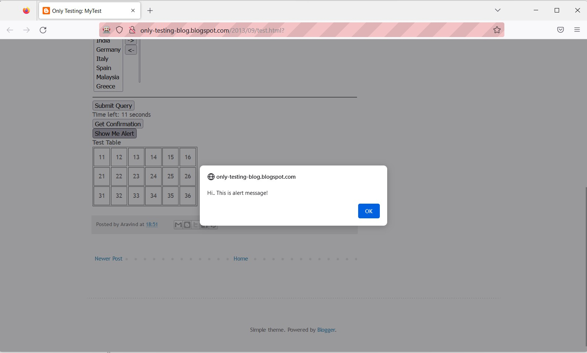

* 1. Write a selenium script to handle alerts on <https://demoqa.com/alerts>

# Code:-

**package** practical6;

**import** org.openqa.selenium.Alert;

**import** org.openqa.selenium.By;

**import** org.openqa.selenium.WebDriver;

**import** org.openqa.selenium.WebElement;

**import** org.openqa.selenium.firefox.FirefoxDriver;

**public class** q2 {

**public static void** main(String[] args) **throws** InterruptedException { System.*setProperty*("webdriver.gecko.driver", "D:\\Finolex\\SEM 3\\Selenium-

Setup\\geckodriver.exe");

WebDriver driver=**new** FirefoxDriver(); //create driver instance

}}

# Output:

driver.get("https://demoqa.com/alerts");

WebElement simpleAlertBtn=driver.findElement(By.*id*("alertButton")); simpleAlertBtn.click();

Thread.*sleep*(2000);

Alert simpleAlert=driver.switchTo().alert(); simpleAlert.accept();

Thread.*sleep*(2000);

WebElement propmtAlertBtn=driver.findElement(By.*id*("promtButton")); propmtAlertBtn.click();

Alert promptAlert=driver.switchTo().alert(); promptAlert.sendKeys("Akshay"); Thread.*sleep*(1000);

promptAlert.accept();

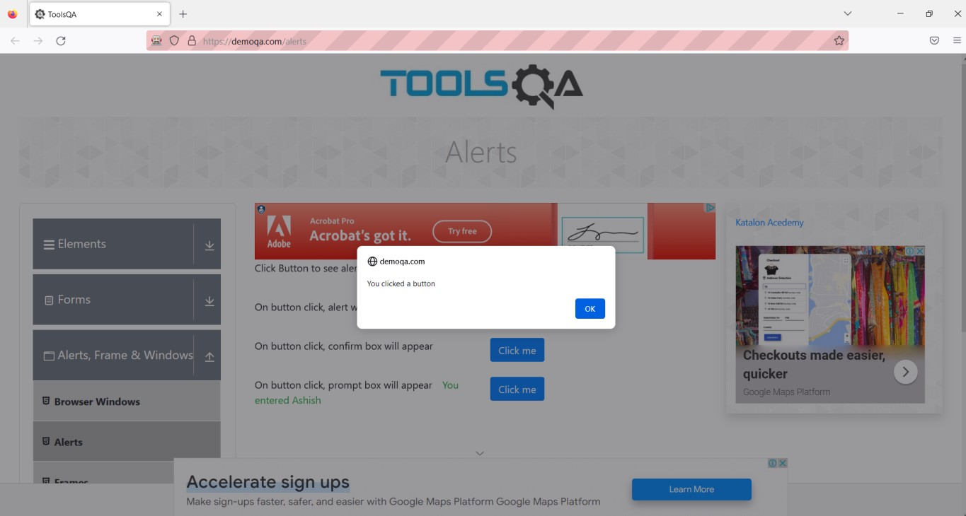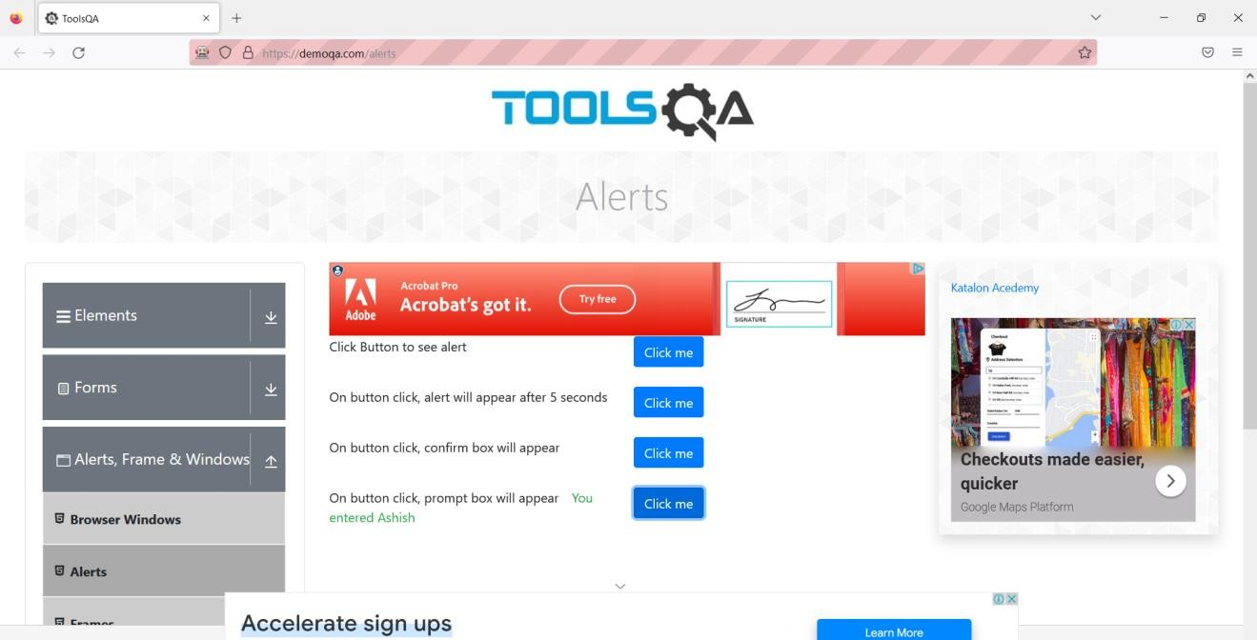

* 1. Write a selenium script to handle alert on <http://demo.guru99.com/test/simple_context_menu.html> **Code:-**

package selenium; import java.util.List;

import org.openqa.selenium.By;

import org.openqa.selenium.WebDriver; import org.openqa.selenium.WebElement;

import org.openqa.selenium.firefox.FirefoxDriver; public class LocateByTagName {

public static void main(String[] args) {

// TODO Auto-generated method stub System.setProperty("webdriver.gecko.driver", "D:\\Finolex\\SEM 3\\Selenium-

Setup\\geckodriver.exe");

WebDriver driver=new FirefoxDriver(); //create driver instance driver.get("https://demo.guru99.com/test/facebook.html");

List<WebElement> list=driver.findElements(By.tagName("input"));//locate multiple elements having input type

list.get(1).sendKe[ys("a](mailto:abcd@gmail.com)bc[d@gmail.com");](mailto:d@gmail.com) list.get(2).sendKe[ys("a](mailto:abcd@gmail.com)bc[d@gmail.com");](mailto:d@gmail.com)

}}

# Output:-

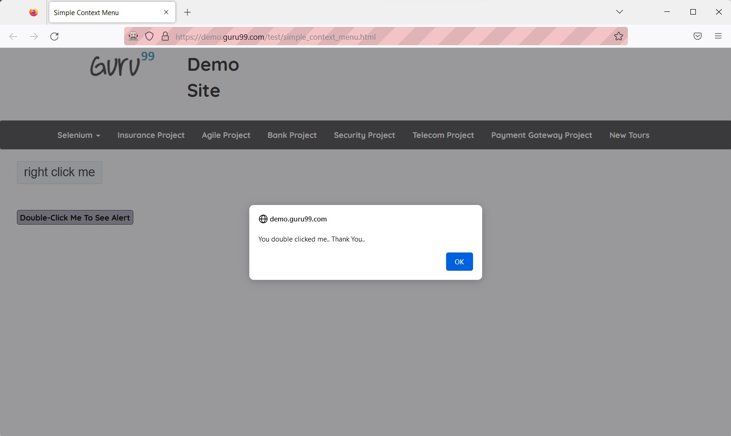

* 1. Open “train_reservation.html” page and handle the alerts on that page.

# Code:-

package selenium;

import org.openqa.selenium.Alert; import org.openqa.selenium.By;

import org.openqa.selenium.WebDriver; import org.openqa.selenium.WebElement;

import org.openqa.selenium.firefox.FirefoxDriver; public class ActionOnAlert {

public static void main(String[] args) throws InterruptedException { System.setProperty("webdriver.gecko.driver", "D:\\Finolex\\SEM 3\\Selenium-

Setup\\geckodriver.exe");

WebDriver driver=new FirefoxDriver(); //create driver instance driver.get("file:///D:/Finolex/SEM%203/Selenium-

Setup/Flight_Reservation/train_reservation.html");

WebElement trains=driver.findElement(By.linkText("Trains")); trains.click();

//*************Simple alert*************//

Alert simpleAlert=driver.switchTo().alert(); System.out.println(simpleAlert.getText()); Thread.sleep(2000);

simpleAlert.accept();

//************prompt alert***********// Thread.sleep(5000);

WebElement confirmButton=driver.findElement(By.cssSelector("input[type='button']"));

confirmButton.click();

Alert promtAlert=driver.switchTo().alert(); Thread.sleep(2000); promtAlert.sendKeys("3"); Thread.sleep(1000);

promtAlert.accept();

//************Confirmation Alert***********// Thread.sleep(3000);

WebElement bookTicket=driver.findElement(By.cssSelector("input[type='submit']"));

bookTicket.click();

Alert confirmAlert=driver.switchTo().alert(); Thread.sleep(1000);

System.out.println("Confirm msg : "+confirmAlert.getText()); confirmAlert.dismiss();

}}

# Output:-

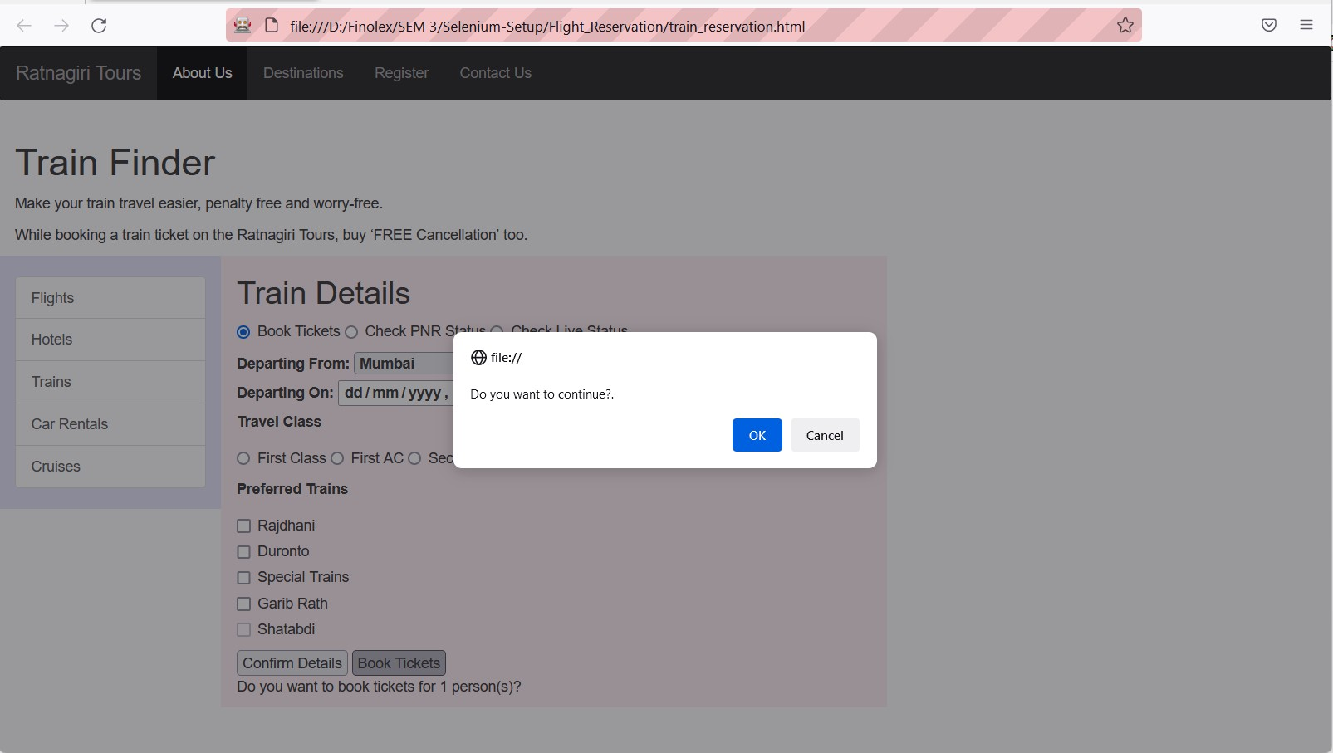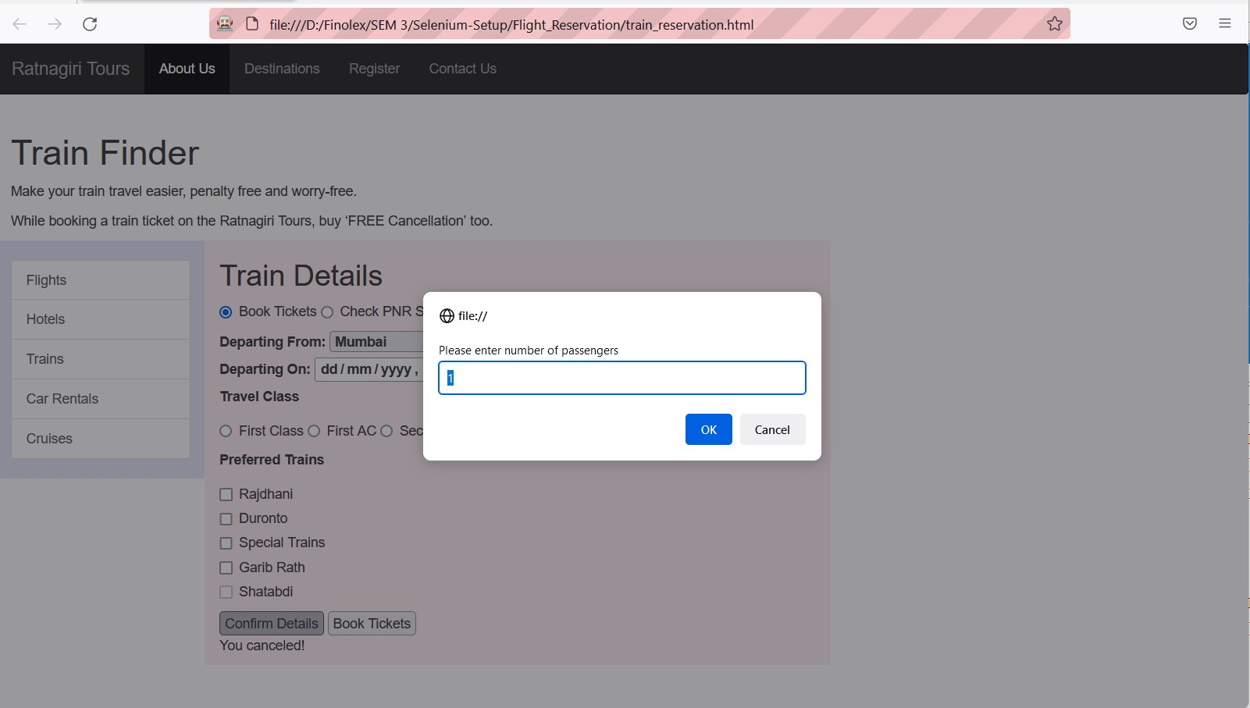

**Conclusion:** Learnt to handle all types of alerts in Selenium

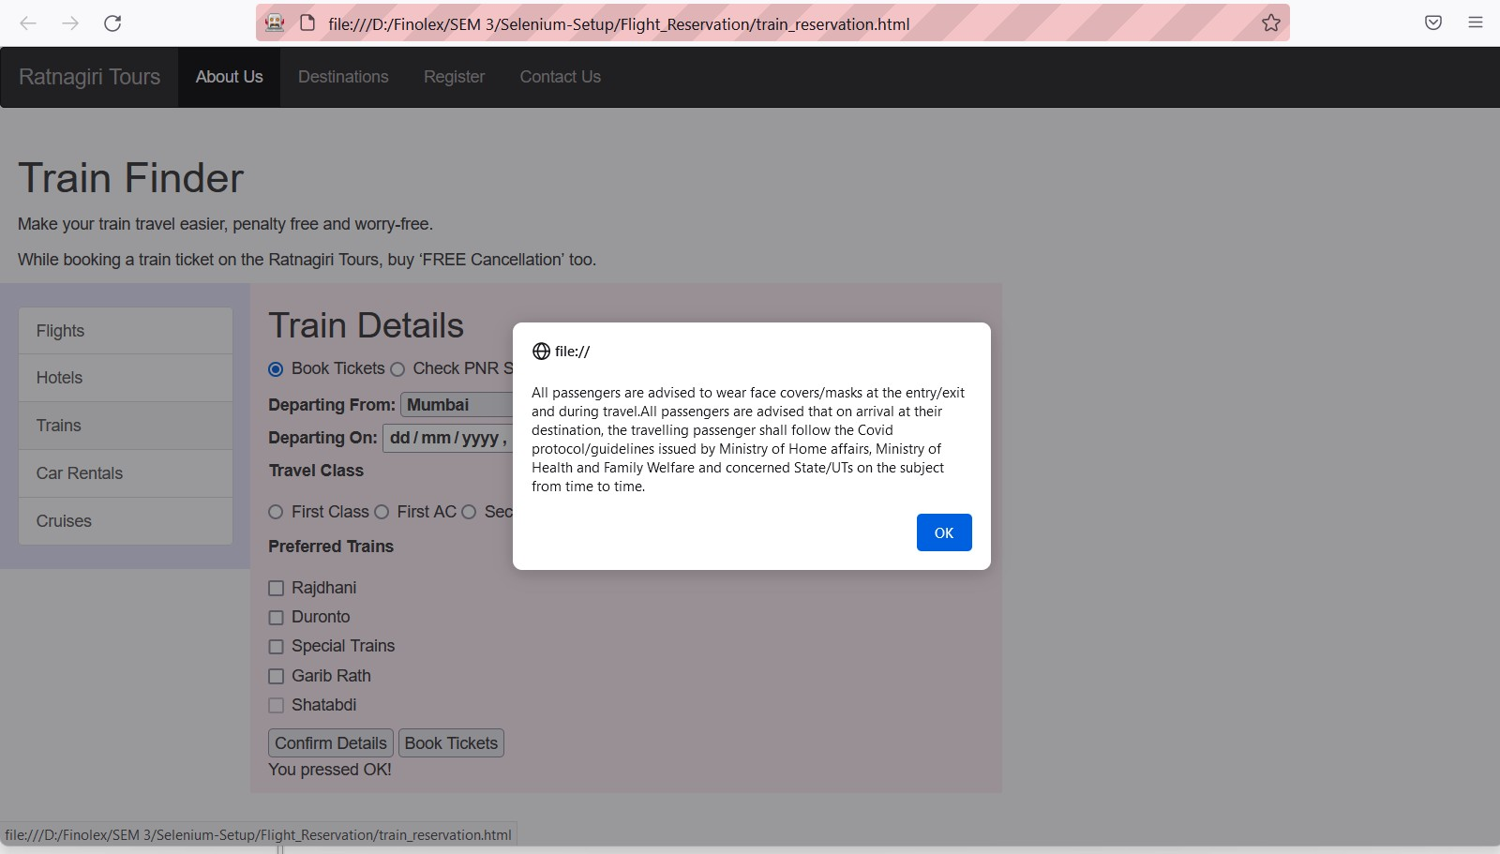

# After performing this Practical/lab, students are expected to answer following questions

* 1. What are different types of alert()?
  2. Which method is used to cancel or close alert window?