**Practical No. 7. Handling Drop Down, List Boxes, Command Button, Radio buttons & text boxes using Selenium.**

**Date:**

**Aim:**

To learn how to handle Handling Drop Down, List Boxes, Command Button, Radio buttons & text boxes using Selenium.

# Theory:

**Radio Button**

Radio Buttons too can be toggled on by using the click() method.

Locate the radio button by using findElement() method and unique By locating mechanism. Then you can toggle radio button on by using the **click()** method

# Check Box

Toggling a check box on/off is also done using the click() method.

Locate the checkbox by using findElement() method and unique By locating mechanism. Then you can toggle radio button on by using the **click()** method

# Dropdown List

The **Select Class in Selenium** is a method used **to implement the HTML SELECT tag**. The html select tag provides helper methods to select and deselect the elements.

The Select class is an ordinary class so New keyword is used to create its object and it specifies the web element location.

Following is a step by step process on how to select value from dropdown in Selenium:

Before handling dropdown in Selenium and controlling drop-down boxes, we must do following two things:

# Import the package org.openqa.selenium.support.ui.Select Instantiate the drop-down box as an object, Select in Selenium WebDriver

1. Import the “Select” package.
2. Declare the drop-down element as an instance of the Select class.
3. We can now start controlling an instance of the Select class by using any of the available Select methods to select dropdown in Selenium.

# selectByVisibleText() and deselectByVisibleText()

Selects/deselects the option that displays the text matching the parameter.

Parameter: The exactly displayed text of a particular option

# selectByValue() and deselectByValue()

Selects/deselects the option whose “value” attribute matches the specified parameter. Parameter: value of the “value” attribute **selectByIndex()**

# and deselectByIndex()

Selects/deselects the option at the given index. Parameter: the index of the option to be selected.

# isMultiple()

Returns TRUE if the drop-down element allows multiple selections at a time; FALSE if otherwise.

No parameters needed

# deselectAll()

Clears all selected entries. This is only valid when the drop-down element supports multiple selections.

No parameters needed

# TextBox and TextArea

Locate the text box and text area elements by using findElement() method and unique By locating mechanism.

To enter text into the Text Fields and Password Fields, **sendKeys()** is the method available on the WebElement in Selenium.

The **clear()** method is used to delete the text in an input box. This method does not need a parameter.

# Buttons

The Selenium click button can be accessed using the **click()** method.

Submit buttons are used to submit the entire form to the server. We can either use the click () method on the web element like a normal button or use the **submit()** method on any web element in the form or on the submit button itself.

# Implementation

1. Write a selenium script for following scenario on [http://only-](http://only-testing-blog.blogspot.com/2013/09/test.html) [testingblog.blogspot.com/2013/09/test.html](http://only-testing-blog.blogspot.com/2013/09/test.html)
   1. Check whether firstname and lastname textboxes are enabled or not. Enter data only if they are enabled.
   2. Delete the data entered in first name textbox and enter another name.
   3. Select “I have a bike” and “I have a car” checkboxes
   4. Select gender
   5. Is car drop down list multi-select. Display message accordingly. And select “Opel” Car

Model.

* 1. Is countries list multi select. Display message accordingly. And select “Opel” Car

Model.

Select two or three countries and display all selected options.

# Code:

import org.openqa.selenium.By; import org.openqa.selenium.WebDriver; import org.openqa.selenium.WebElement; import org.openqa.selenium.firefox.FirefoxDriver; import org.openqa.selenium.support.ui.Select; public class Q1 {

public static void main(String[] args) throws InterruptedException { System.setProperty("webdriver.gecko.driver","C:\\Setup\\geckodriver- v0.31.0win64\\geckodriver.exe");

WebDriver driver=new FirefoxDriver();

driver.get("<http://only-testing-blog.blogspot.com/2013/09/test.html>"); WebElement firstName=driver.findElement(By.name("fname"));

WebElement lastName=driver.findElement(By.name("lname")); if(firstName.isEnabled()){

firstName.sendKeys("abc");}

else{

System.out.println("First Name Text Box is not Enabled");} if(lastName.isEnabled()){ lastName.sendKeys("xyz");}

else{

System.out.println("Last Name Text Box is not Enabled");} Thread.sleep(1000); firstName.clear();

firstName.sendKeys("abc xyz");

WebElement bike=driver.findElement(By.xpath("//input[@value='Bike']")); bike.click();

WebElement car=driver.findElement(By.xpath("//input[@value='Car']")); car.click();

WebElement female=driver.findElement(By.xpath("//input[@value='female']")); female.click();

Select vehicle = new Select(driver.findElement(By.xpath("//*[@class=\"post-body entry-content\"]/div[1]/select[1]")));

vehicle.selectByVisibleText("Opel"); if(vehicle.isMultiple()){

System.out.println("In country dropdown Multiple Value Selection

Allowed"); vehicle.selectByVisibleText("Opel"); vehicle.selectByIndex(0);

}

else

{

System.out.println("In Car dropdown Multiple Value Selection Not Allowed"); vehicle.selectByVisibleText("Opel");

}

Select country=new Select(driver.findElement(By.name("FromLB"))); if(country.isMultiple()) {

System.out.println("In country dropdown Multiple Value Selection Allowed"); country.selectByIndex(1);

country.selectByValue("IND"); country.selectByVisibleText("Mexico");

}

else {

System.out.println("In country dropdown Multiple Value Selection Not Allowed");

}}}

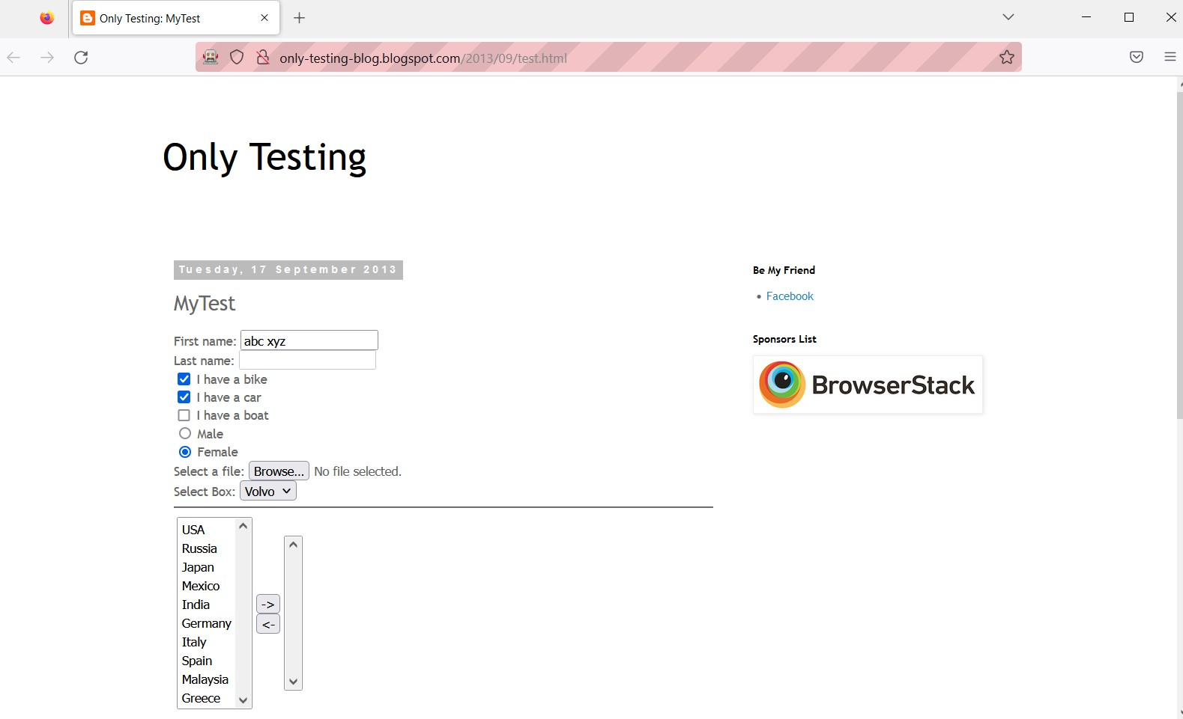

1. Write a selenium script to handle radio and checkboxes on following webpage [http://demo.guru99.com/test/radio.html.](http://demo.guru99.com/test/radio.html) Print the status of radio buttons i.e whether the radio button is selected or not. **Code:-** package selenium;

import org.openqa.selenium.By; import org.openqa.selenium.WebDriver; import org.openqa.selenium.WebElement; import org.openqa.selenium.firefox.FirefoxDriver; public class LocateRadioButtons {

public static void main(String[] args) throws InterruptedException {

// TODO Auto-generated method stub System.setProperty("webdriver.gecko.driver", "D:\\Finolex\\SEM 3\\Selenium-

Setup\\geckodriver.exe");

WebDriver driver=new FirefoxDriver(); //create driver instance driver.get("https://demo.guru99.com/test/radio.html"); WebElement option1=driver.findElement(By.id("vfb-7-1")); option1.click();

Thread.sleep(2000);

WebElement option2=driver.findElement(By.id("vfb-7-2")); option2.click();

Thread.sleep(2000);

WebElement option3=driver.findElement(By.id("vfb-7-3")); option3.click();

WebElement checkBox1=driver.findElement(By.id("vfb-6-1")); checkBox1.click();

Thread.sleep(2000);

WebElement checkBox2=driver.findElement(By.id("vfb-6-2")); checkBox2.click();

Thread.sleep(2000);

WebElement checkBox3=driver.findElement(By.id("vfb-6-3"));

checkBox3.click();

}}

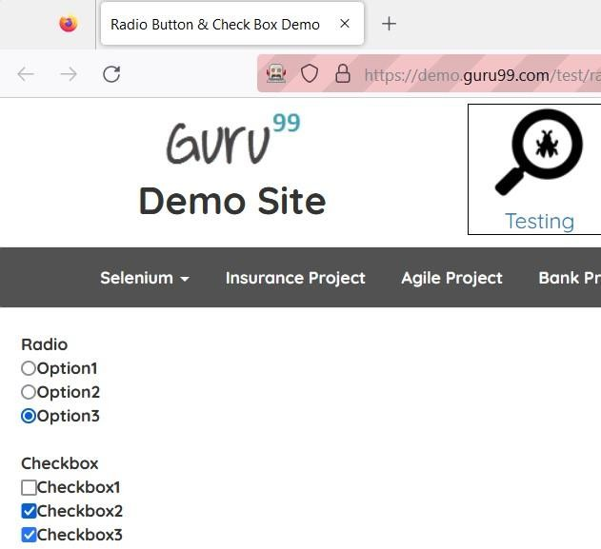

1. Write a selenium script to select options from dropdown list on <http://jsbin.com/osebed/2> using VisibleText, Value, Index and check whether you can select multiple options.

# Code:

package selenium; import java.util.List; import org.openqa.selenium.By; import org.openqa.selenium.WebDriver; import org.openqa.selenium.WebElement; import org.openqa.selenium.firefox.FirefoxDriver; import org.openqa.selenium.support.ui.Select; public class ActionOnDropdownList { public static void main(String[] args) {

// TODO Auto-generated method stu System.setProperty("webdriver.gecko.driver", "D:\\Finolex\\SEM 3\\Selenium-

Setup\\geckodriver.exe");

WebDriver driver=new FirefoxDriver(); //create driver instance driver.get("https://jsbin.com/osebed/2");

Select fruits=new Select(driver.findElement(By.id("fruits")));

//select a item by text fruits.selectByVisibleText("Banana"); //select a item by value fruits.selectByValue("apple");

//select a item by index fruits.selectByIndex(3);

System.out.println(fruits.getFirstSelectedOption().getText());

//deselect

/*fruits.deselectByIndex(0); fruits.deselectByVisibleText("Grape"); fruits.deselectByValue("apple");*/

List<WebElement> selected_items=fruits.getAllSelectedOptions(); for(int i=0;i<selected_items.size();i++) {

System.out.println(selected_items.get(i).getText());

}

System.out.println(fruits.isMultiple());

}}

# Output:

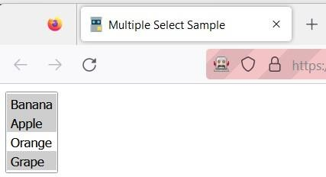

1. Write a selenium script to Browse to https://in.ebay.com/ website. Enter a product in the search box on the homepage (say Apple Watches). From categories dropdown, select category of your product (say Electronics). Click the Search button. Print the result of the product **Code:** package practical7; import java.util.List; import

org.openqa.selenium.By; import org.openqa.selenium.WebDriver; import org.openqa.selenium.WebElement; import org.openqa.selenium.chrome.ChromeDriver; import org.openqa.selenium.firefox.FirefoxDriver; import org.openqa.selenium.support.ui.Select; public class Q4 {

public static void main(String[] args) throws InterruptedException { System.setProperty("webdriver.chrome.driver", "D:\\Finolex\\SEM

3\\chromedriver_win32\\chromedriver.exe");

WebDriver driver=new ChromeDriver(); //create driver instance driver.get("https://[www.ebay.com/](http://www.ebay.com/)"); WebElement

inputBox,allCategories,cE,searchBtn; inputBox=driver.findElement(By.id("gh- ac")); inputBox.sendKeys("Apple Watches"); Thread.sleep(1000);

allCategories=driver.findElement(By.id("gh-cat-box")); allCategories.click(); Thread.sleep(1000);

cE = driver.findElement(By.xpath("//Select//option[@value='293']")); cE.click();

Thread.sleep(1000);

searchBtn=driver.findElement(By.id("gh-btn")); searchBtn.click();

//storing all items List<WebElement>

itemList=driver.findElements(By.xpath("//span[@role='heading']")); for(int i=1;i<=4;i++) {

# Output:

}}}

System.out.println(itemList.get(i).getText());

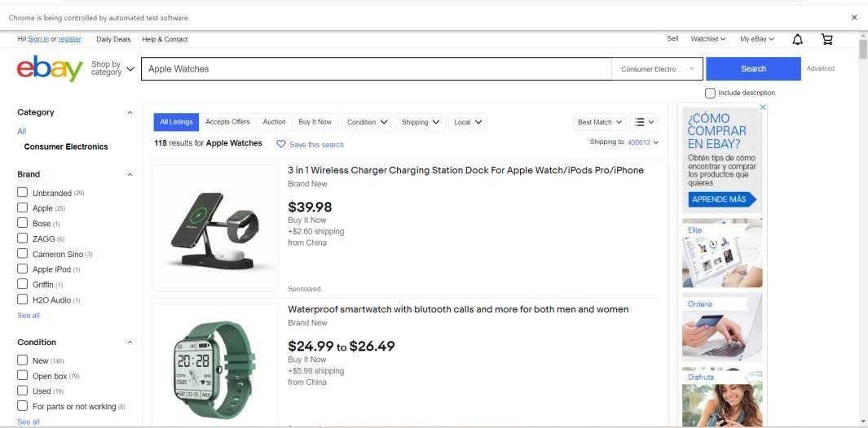

**Conclusion:** Learnt to handle Drop Down, List Boxes, Command Button, Radio buttons & text boxes using Selenium.

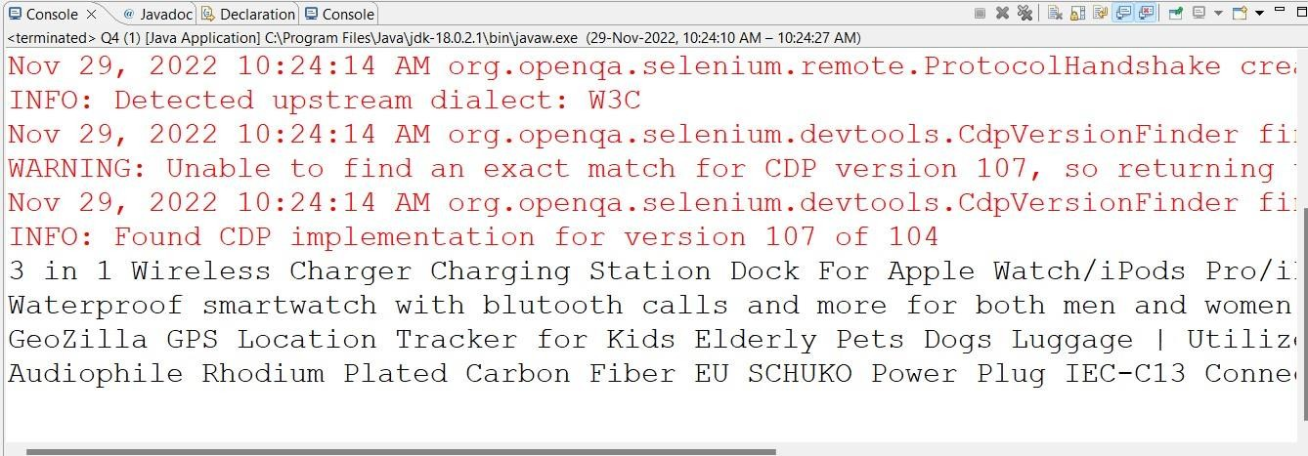

# After performing this Practical/lab, students are expected to answer following questions

* 1. Which Select methods are used to select options in dropdown in Selenium?
  2. Which method is used to cancel or close alert window?