# Practical No. 8 Exploring the Features of WebDriver Date:

**Aim:**

To explore the Features of WebDriver like taking screenshot and waits in selenium.

# Theory:

You, as a user of WebDriver, have the flexibility to create a session for a browser with your own set of desired capabilities that a browser should or shouldn't have. Using the capabilities feature in WebDriver, you are given a way to specify your choice of how your browser should behave.

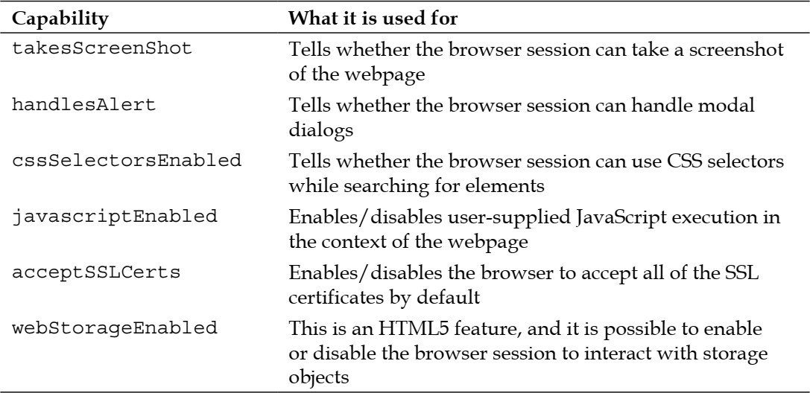Some of the examples of browser capabilities include enabling a browser session to support taking screenshots of the webpage, executing custom JavaScript on the webpage, enabling the browser session to interact with window alerts, and so on.

## Taking Screenshot

Taking a screenshot of a webpage is a very useful capability of WebDriver. This is very handy when your test case fails, and you want to see the state of the application when the test case failed. The TakesScreenShot interface in the WebDriver library is implemented by all of the different variants of WebDriver, such as Firefox Driver, Internet Explorer Driver, Chrome Driver, and so on.

The TakesScreenShot capability is enabled in all of the browsers by default. Because this is a read-only capability, a user doesn't have much say on toggling it. Before we see a code example that uses this capability, we should look at an important method of the TakesScreenShot interface— getScreenshotAs().

The API syntax for getScreenshotAs() is as follows:

## public <X> X getScreenshotAs(OutputType<X> target)

Here, **OutputType** is another interface of the WebDriver lib. We can ask WebDriver to give your screenshot in three different formats; they are: **BASE64, BYTES (raw data), and FILE**. If you choose the FILE format, it writes the data into a .png file, which will be deleted once the JVM is killed. So, you should always copy that file into a safe location so that it can be used for later reference.

The return type is a specific output that depends on the selected OutputType. For example, selecting **OutputType.BYTES will return a byte array**, and selecting **OutputType.FILE will return a file object.**

## Waits

WebDriver provides the test script developers a very handy feature to manage wait time. Wait

time is the time your driver will wait for the WebElement to load before it gives up and throws NoSuchElementException.

There are two ways by which you can make WebDriver wait for WebElement. They are **implicit wait time** and **Explicit wait time**.

## Implicit wait time

Implicit wait time is used when you want to configure the WebDriver's wait time as a whole for the application under test. Implicit timeouts are common to all the WebElements.

## Explicit wait time

Implicit timeout is generic to all the WebElements of a web page. But, if you have one specific WebElement in your application where you want to wait for a very long time, this approach may not work. Setting the implicit wait time to the value of this very long time period will delay your entire test suite execution. So you have to make an exception for only a particular case, like this WebElement. To handle such scenarios, WebDriver has explicit wait time for a WebElement.

## Implementation

1. Write a selenium script to take screenshot of <http://demo.guru99.com/test/newtours/index.php> **Code:**

package practical8; import java.io.File;

import java.io.IOException;

import org.openqa.selenium.OutputType;

import org.openqa.selenium.TakesScreenshot; import org.openqa.selenium.WebDriver;

import org.openqa.selenium.firefox.FirefoxDriver; import com.google.common.io.Files;

public class Q1 {

public static void main(String[] args) throws IOException { System.setProperty("webdriver.gecko.driver", "D:\\Finolex\\SEM 3\\Selenium-

Setup\\geckodriver.exe");

WebDriver driver=new FirefoxDriver(); //create driver instance driver.get("https://demo.guru99.com/test/newtours/index.php"); TakesScreenshot screenShot=((TakesScreenshot)driver);

//taking screenShot in FILE format

File srcFile=screenShot.getScreenshotAs(OutputType.FILE);

//locating where screenshot file is saved System.out.println(srcFile.getAbsolutePath());

File desFile=new File("D:\\Finolex\\SEM 3\\Selenium-Setup\\screenShot.png");

//copy srcFile to desFile Files.copy(srcFile, desFile);

}

}

## Output:

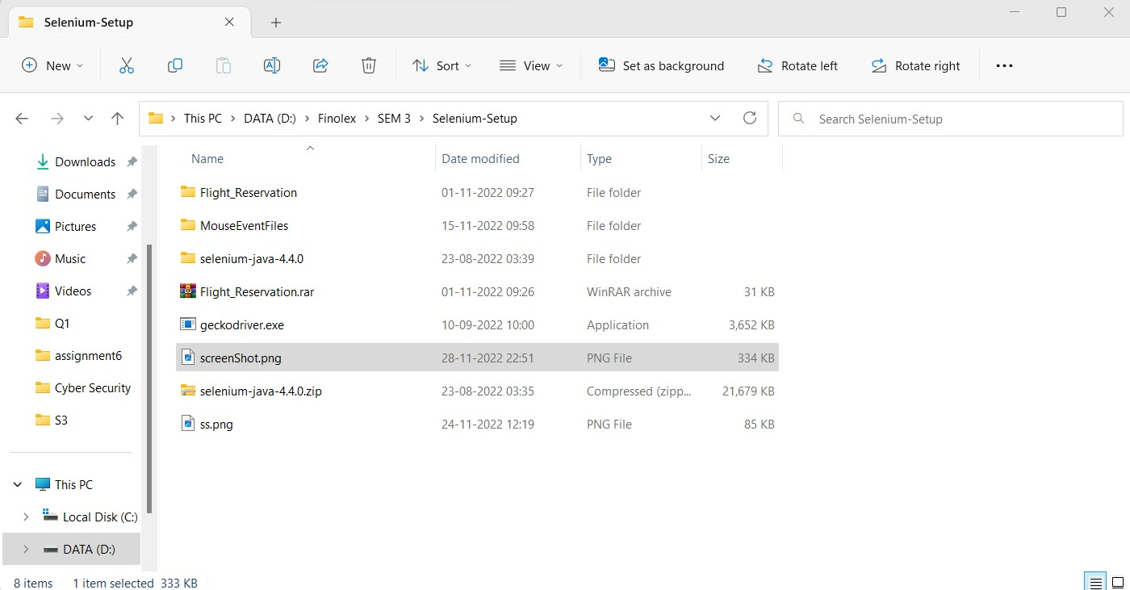

1. Write a selenium script to demonstrate explicit and implicit waits on <https://demoqa.com/alerts>

## Implicit:

**Code:**

package practical7;

import java.util.concurrent.TimeUnit; import org.openqa.selenium.WebDriver;

import org.openqa.selenium.firefox.FirefoxDriver; public class Q2 {

public static void main(String[] args) {

// TODO Auto-generated method stub System.setProperty("webdriver.gecko.driver", "D:\\Finolex\\SEM 3\\Selenium-

Setup\\geckodriver.exe");

WebDriver driver=new FirefoxDriver(); //create driver instance driver.get("https://demoqa.com/alerts"); driver.manage().timeouts().implicitlyWait(10,TimeUnit.SECONDS); System.out.println("The title pf webpage is:"+driver.getTitle());

}

}

## Output:

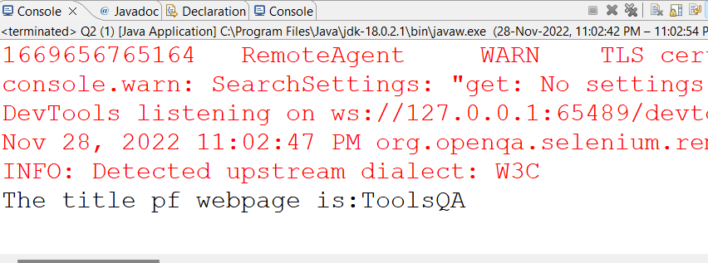

**Explicit: Code:**

package selenium;

import java.time.Duration;

import org.openqa.selenium.Alert; import org.openqa.selenium.By;

import org.openqa.selenium.WebDriver; import org.openqa.selenium.WebElement;

import org.openqa.selenium.chrome.ChromeDriver; import org.openqa.selenium.firefox.FirefoxDriver;

import org.openqa.selenium.support.ui.ExpectedCondition; import org.openqa.selenium.support.ui.ExpectedConditions; import org.openqa.selenium.support.ui.WebDriverWait; public class ExplicitWaitTime {

public static void main(String[] args) { System.setProperty("webdriver.chrome.driver", "D:\\Finolex\\SEM

3\\chromedriver_win32\\chromedriver.exe");

WebDriver driver=new ChromeDriver(); //create driver instance driver.get("https://demoqa.com/alerts");

WebElement alertBtn=driver.findElement(By.id("timerAlertButton")); alertBtn.click();

System.out.println("Alert button is clicked but alert window"

+ "yet to open");

WebDriverWait wait=new WebDriverWait(driver,Duration.ofSeconds(3));

//wait for alert to be present

Alert myAlert=wait.until(ExpectedConditions.alertIsPresent()); driver.switchTo().alert();

myAlert.accept(); System.out.println("Alert is accepted"); driver.close();

}}

## Output:

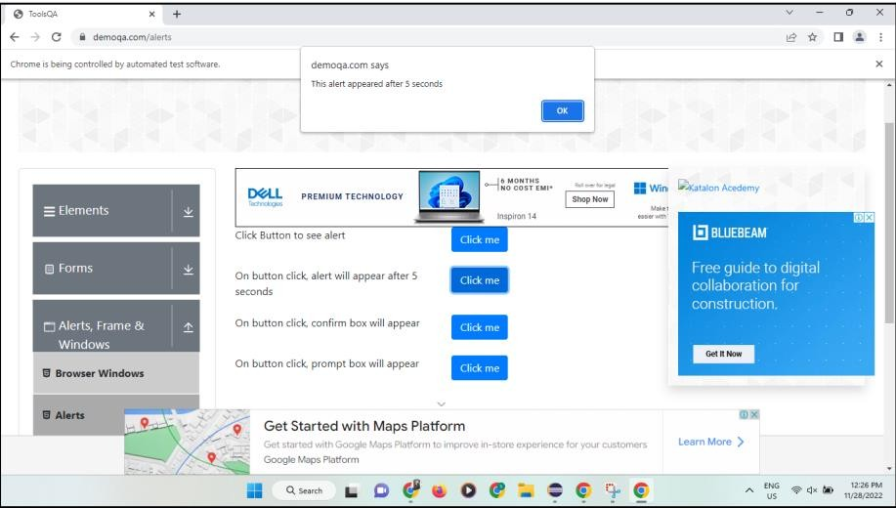

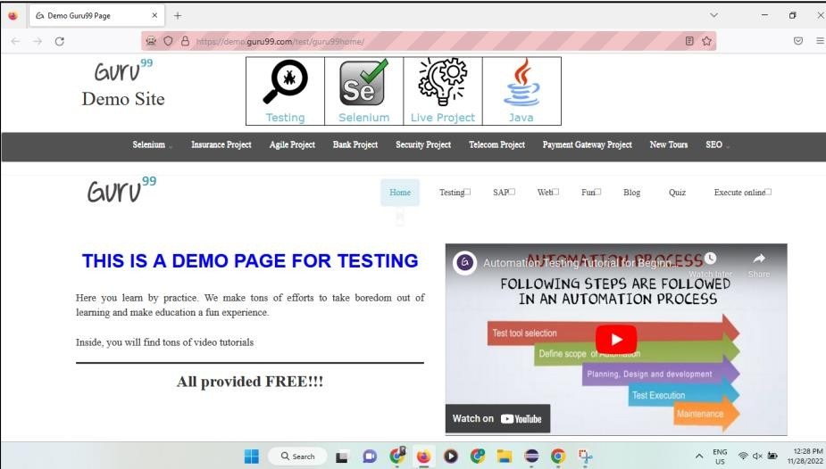

**Conclusion:** Learnt to take screenshot of webpage and manage waits in selenium.

## After performing this Practical/lab, students are expected to answer following questions

* 1. Why Do We Need Waits in Selenium?
  2. What are the Expected Conditions that can be used in Selenium Explicit Wait?
  3. Differentiate between Implicit Wait and Explicit Wait?