**Practical No. 9 Action Class in Selenium Webdriver Date:**

**Aim:**

To learn Action Class in Selenium, a built-in feature provided by the selenium for handling keyboard and mouse events.

**Theory:**

Action Class in Selenium is a built-in feature provided by the selenium for handling keyboard and mouse events. It includes various operations such as multiple events clicking by control key, drag and drop events and many more. These operations from the action class are performed using the advanced user interaction API in Selenium Webdriver. Handling special keyboard and mouse events are done using the Advanced User Interactions API. It contains the Actions and the Action classes that are needed when executing these events. The following are the most commonly used keyboard and mouse events provided by the Actions class.

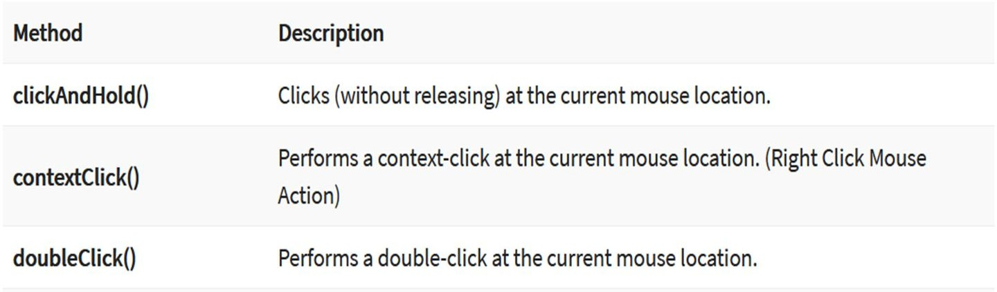

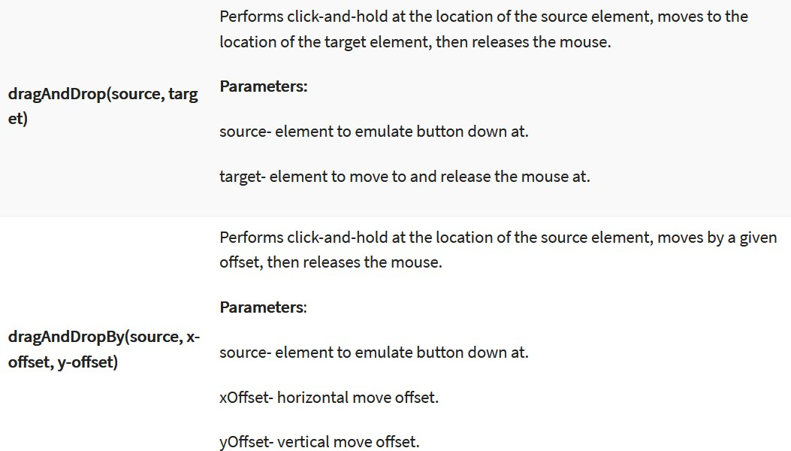

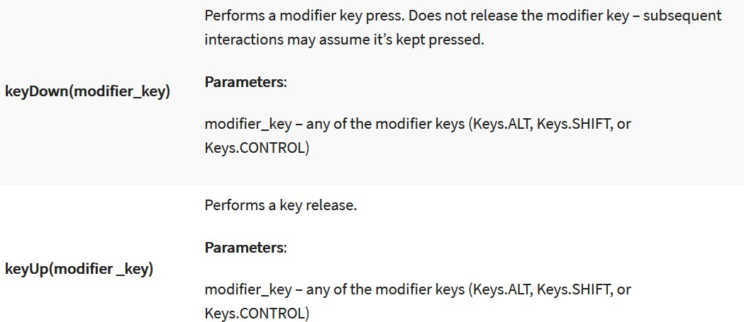

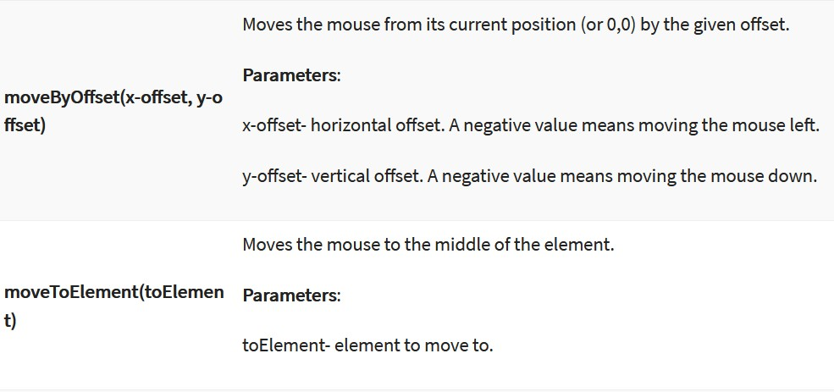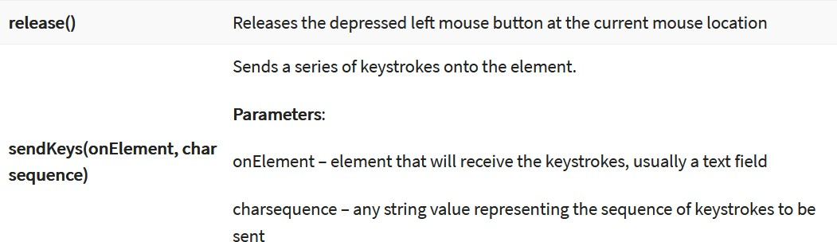

# Steps to use Actions Classes

Step 1: Import the Actions and Action classes. Step 2: Instantiate a new Actions object.

Step 3: Instantiate an Action using the Actions object in step 2.

Step 4: Use the perform() method when executing the Action object we designed in Step 3. Following Actions are available in Actions class

# The moveByOffset action

The moveByOffset() method is used to move the mouse from its current position to another point on the web page.

Developers can specify the X distance and Y distance the mouse has to be moved.

When the page is loaded, generally the initial position of a mouse would be (0, 0), unless there is an explicit focus declared by the page.

The API syntax for the moveByOffset() method is as follows:

# public Actions moveByOffset(int xOffSet, int yOffSet)

In the preceding code, xOffSet is the input parameter providing the WebDriver the amount of offset to be moved along the x axis. A positive value is used to move the cursor to the right, and a negative value is used to move the cursor to the left.

yOffSet is the input parameter providing the WebDriver the amount of offset to be moved along the y axis. A positive value is used to move the cursor down along the y axis and a negative value is used to move the cursor toward the top.

When the xOffSet and yOffSet values result in moving the cursor out of the document, a MoveTargetOutOfBoundsException is raised

# The click at current location action

The click() method is used to simulate the left-click of your mouse at its current point of location.

This method doesn't really realize where or on which element it is clicking. It just blindly clicks wherever it is at that point of time.

Hence, this method is used in combination with some other action rather than independently, to create a composite action.

The API syntax for the click() method is as follows:

# public Actions click()

The click() method doesn't really have any context about where it is performing its action; hence, it doesn't take any input parameter.

# The click on a WebElement action

When the WebElement has its own identifiers, such as a name or ID, we can use another overloaded version of the click() method to click directly on the WebElement.

The API syntax for clicking on a WebElement is as follows:

# public Actions click(WebElement onElement)

The input parameter for this method is an instance of the WebElement on which the click action should be performed.

This method, like all the other methods in the Actions class, will return an Actions instance.

# The clickAndHold at current location action

The clickAndHold() method is another method of the Actions class that left-clicks on an element and holds it without releasing the left button of the mouse.

This method will be useful when executing operations such as drag-and-drop.

This method is one of the variants of the clickAndHold() method that the Actions class provides.

# The clickAndHold a WebElement action

WebDriver provides the developers with another variant or overloaded method of the clickAndHold() method that takes the WebElement as input.

The API syntax is as follows:

# public Actions clickAndHold(WebElement onElement)

The input parameter for this method is the WebElement that has to be clicked and held. The return type, as in all the other methods of the Actions class, is the Actions instance.

# The release at current location action

The ultimate action that has to be taken on a held WebElement is to release it so that the element can be dropped or released from the mouse.

The release() method is the one that can release the left mouse button on a WebElement. The API syntax for the release() method is as follows:

# public Actions release()

The preceding method doesn't take any input parameter and returns the Actions class instance.

# The release on another WebElement action

This is an overloaded version of the release() method. Using this, you can actually release the currently

held WebElement in the middle of another WebElement.

In this way, we don't have to calculate the offset of the target WebElement from the held WebElement. The API syntax is as follows:

# public Actions release(WebElement onElement)

The input parameter for the preceding method is obviously the target WebElement where the held WebElement should be dropped.

The return type is the instance of the Actions class.

# The moveToElement action

The moveToElement() method is another method of WebDriver that helps us to move the mouse cursor to a WebElement on the web page.

The API syntax for the moveToElement() method is as follows:

# public Actions moveToElement(WebElement toElement)

The input parameter for the preceding method is the target WebElement where the mouse should be moved.

# The dragAndDropBy action

WebDriver has given us a convenient out of the box method to use. Let's see its API syntax. The API syntax for the dragAndDropBy() method is as follows:

# public Actions dragAndDropBy(WebElement source,int xOffset,int yOffset)

The WebElement input parameter is the target WebElement to be dragged, the xOffset parameter is the horizontal offset to be moved, and the yOffset parameter is the vertical offset to be moved.

# The dragAndDrop action

The dragAndDrop() method is similar to the dragAndDropBy() method.

The only difference being that instead of moving the WebElement by an offset, we move it on to a target element.

The API syntax for the dragAndDrop() method is as follows:

# public Actions dragAndDrop(WebElement source, WebElement target)

The input parameters for the preceding method are the WebElement source and the WebElement target, while the return type is the Actions class.

# The doubleClick at current location action

doubleClick() is another out of the box method that WebDriver provides to emulate the double-clicking of the mouse.

The API syntax is as follows:

# public Actions doubleClick()

This method doesn't take any input parameters, as it just clicks on the current cursor location and returns an Actions class instance.

# The doubleClick on WebElement action

Now that we have seen a method that double-clicks at the current location, we will discuss another method that WebDriver provides to emulate the double-clicking of a WebElement.

The API syntax for the doubleClick() method is as follows:

# public Actions doubleClick(WebElement onElement)

The input parameter for the preceding method is the target WebElement that has to be double-clicked and the return type is the Actions class

# The contextClick on WebElement action

The contextClick() method, also known as right-click, is quite common on many web pages these days. The context is nothing but a menu; a list of items is associated to a WebElement based on the current state of the web page.

This context menu can be accessed by a right-click of the mouse on the WebElement.

WebDriver provides the developer with an option of emulating that action using the contextClick() method.

The API syntax for the contextClick() method is as follows:

# public Actions contextClick(WebElement onElement)

The input parameter is obviously the WebElement that has to be right-clicked, and the return type is the Actions instance.

# The contextClick at current location action

The API syntax for the contextClick() method is as follows:

# public Actions contextClick()

As expected, the preceding method doesn't expect any input parameter, and returns the Actions

instance.

# Keyboard-based interactions KeyDown

**KeyUp SendKeys**

# The keyDown and keyUp actions

The keyDown() method is used to simulate the action of pressing and holding a key. The keys that we are referencing here are Shift, Ctrl, and Alt keys.

The keyUp() method is used to release the key that is already pressed using the keyDown() method.

The API syntax for the keyDown() method is as follows

# public Actions keyDown(Keys theKey) throws IllegalArgumentException

An IllegalArgumentException is thrown when the passed key is not one of the Shift, Ctrl, and Alt keys.

The API syntax for the keyUp() method is as follows public Actions keyUp(Keys theKey)

The keyUp action performed on a key, on which a keyDown action is not already being performed, will result in some unexpected results.

So, we must make sure we perform the keyUp action after a keyDown action is performed

# Implementation

1. Write a selenium script to move tile3 to the position of tile2 on Sortable.html

# Code:

package webDriver;

import org.openqa.selenium.By;

import org.openqa.selenium.WebDriver; import org.openqa.selenium.WebElement;

import org.openqa.selenium.firefox.FirefoxDriver; import org.openqa.selenium.interactions.Actions; public class MoveToElement {

public static void main(String[] args) { System.setProperty("webdriver.gecko.driver","C:\\Setup\\geckodriver-v0.31.0-

win64\\geckodriver.exe");

WebDriver driver=new FirefoxDriver();

ml");

driver.get("file:///D:/MCA/sem3/STQA/Sample%20Testing%20Files/Sortable.ht

WebElement tile3=driver.findElement(By.name("three")); WebElement tile2=driver.findElement(By.name("two")); Actions builder=new Actions(driver);

builder.moveToElement(tile2).clickAndHold().release(tile3); builder.perform();

}

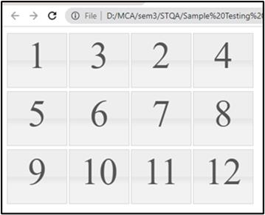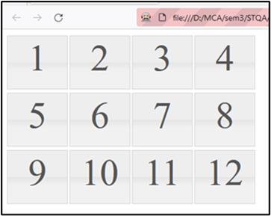}

1. Write a selenium script to select tile 1, tile 5, tile 11 on Selectable.html

# Code:

package webDriver;

import org.openqa.selenium.By;

import org.openqa.selenium.WebDriver; import org.openqa.selenium.WebElement;

import org.openqa.selenium.firefox.FirefoxDriver; import org.openqa.selenium.interactions.Actions; public class ClickOnElement {

public static void main(String[] args) throws InterruptedException { System.setProperty("webdriver.gecko.driver","C:\\Setup\\geckodriver-v0.31.0- win64\\geckodriver.exe");

WebDriver driver=new FirefoxDriver();

driver.get("file:///D:/MCA/sem3/STQA/Sample%20Testing%20Files/Selectable.html"); WebElement btnOne=driver.findElement(By.name("one"));

WebElement btnEleven=driver.findElement(By.name("eleven")); WebElement btnFive=driver.findElement(By.name("five")); Actions builder=new Actions(driver); builder.click(btnOne).click(btnFive).click(btnEleven); builder.perform();

}

}

# Output:

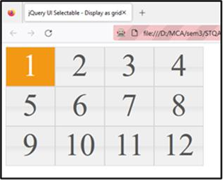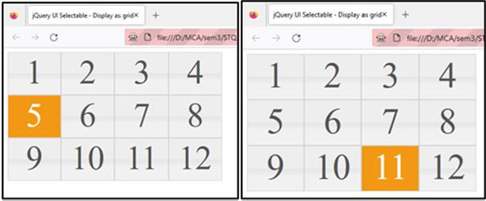

1. Write a selenium script to select tile 3 using moveByOffset() method and select tile 11 using click on web Element method click() on Selectable.html

# Code:

package webDriver;

import org.openqa.selenium.By;

import org.openqa.selenium.WebDriver; import org.openqa.selenium.WebElement;

import org.openqa.selenium.firefox.FirefoxDriver; import org.openqa.selenium.interactions.Actions; public class MoveByOffset {

public static void main(String[] args) {

System.setProperty("webdriver.gecko.driver","C:\\Setup\\geckodriver-v0.31.0- win64\\geckodriver.exe");

WebDriver driver=new FirefoxDriver();

driver.get("file:///D:/MCA/sem3/STQA/Sample%20Testing%20Files/Selectable.html"); WebElement tile11=driver.findElement(By.name("eleven"));

System.out.println("X Coordinate: "+tile11.getLocation().x+" Y Coordinate: "+tile11.getLocation().y);

Actions builder = new Actions(driver);//instantiate action class objrct builder.moveByOffset(tile11.getLocation().x+1,tile11.getLocation().y+1).click();

builder.perform();

}

}

# Output:-

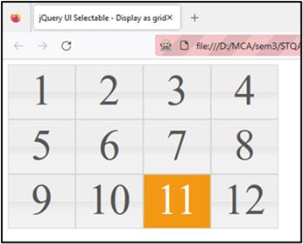

1. Write a selenium script to double click and right click the elements on

<http://demo.guru99.com/test/simple_context_menu.html>

# Code:

package Exercise;

import org.openqa.selenium.Alert; import org.openqa.selenium.By;

import org.openqa.selenium.WebDriver; import org.openqa.selenium.WebElement;

import org.openqa.selenium.chrome.ChromeDriver; import org.openqa.selenium.interactions.Actions;

public class Q4 {

public static void main(String[] args) throws InterruptedException {

System.setProperty("webdriver.chrome.driver", "D:\\Finolex\\SEM 3\\chromedriver_win32\\chromedriver.exe");

WebDriver driver=new ChromeDriver(); //create driver instance driver.get("https://demo.guru99.com/test/simple_context_menu.html"); WebElement context=driver.findElement(By.xpath("//span[@class='context-

menu-one btn btn-neutral']"));

WebElement li=driver.findElement(By.xpath("//li[@class='context-menu-item context-menu-icon context-menu-icon-edit']"));

Actions builder=new Actions(driver); builder.contextClick(context).click(li).perform(); Alert simpleAlert=driver.switchTo().alert(); Thread.sleep(1000);

simpleAlert.accept(); Thread.sleep(1000);

WebElement dblClick=driver.findElement(By.xpath("//button[@ondblclick='myFunction()']"));

builder.doubleClick(dblClick).perform(); Thread.sleep(1000); simpleAlert.accept();

}}

# Output:

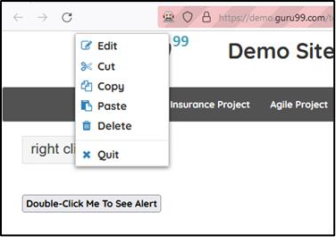

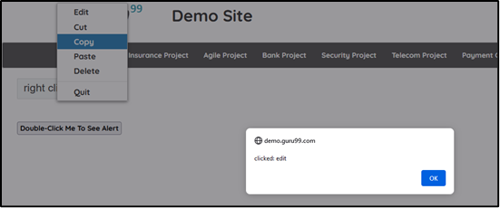

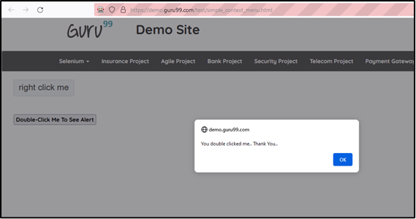

1. Write a selenium script to drag the BANK element and drop on the DEBIT SIDE block through dragAndDrop method on the following webpage [http://demo.guru99.com/test/drag_drop.html.](http://demo.guru99.com/test/drag_drop.html) Use xpath to locate required elements.

# Code:

package practical9;

import org.openqa.selenium.By;

import org.openqa.selenium.WebDriver; import org.openqa.selenium.WebElement;

import org.openqa.selenium.firefox.FirefoxDriver; import org.openqa.selenium.interactions.Actions; public class Q5 {

public static void main(String args[]) throws InterruptedException { System.setProperty("webdriver.gecko.driver", "D:\\Finolex\\SEM 3\\Selenium-

Setup\\geckodriver.exe");

WebDriver driver=new FirefoxDriver(); //create driver instance driver.get("https://demo.guru99.com/test/drag_drop.html");

WebElement bank=driver.findElement(By.xpath("//li[@data-id='5']//a")); Actions builder=new Actions(driver);

builder.clickAndHold(bank);

WebElement dropOn=driver.findElement(By.xpath("//div[@class='ui-widget- content']//descendant::ol[@id='bank']"));

builder.moveToElement(dropOn); builder.release().perform();

}}

# Output:

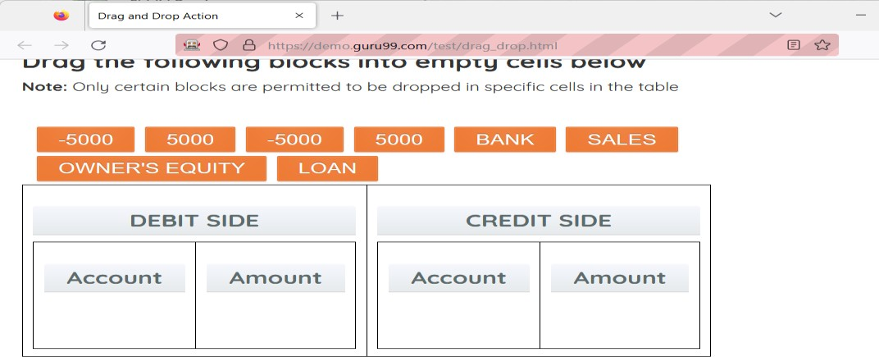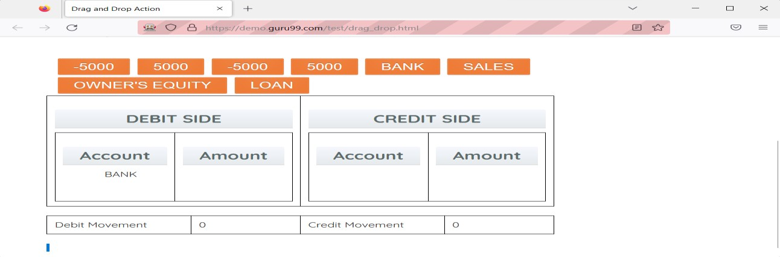

1. Write a selenium script to implement drag and drop action on <https://demoqa.com/droppable/>

# Code:

package practical9;

import org.openqa.selenium.By;

import org.openqa.selenium.WebDriver; import org.openqa.selenium.WebElement;

import org.openqa.selenium.firefox.FirefoxDriver;

import org.openqa.selenium.interactions.Actions; public class Q6 {

public static void main(String[] args) {

System.setProperty("webdriver.gecko.driver","C:\\Setup\\geckodriver-v0.31.0- win64\\geckodriver.exe");

WebDriver driver=new FirefoxDriver(); driver.get("https://demoqa.com/droppable/"); WebElement drag=driver.findElement(By.id("draggable")); WebElement drop=driver.findElement(By.id("droppable")); Actions builder=new Actions(driver); builder.dragAndDrop(drag, drop);

builder.perform();

}}

# Output:

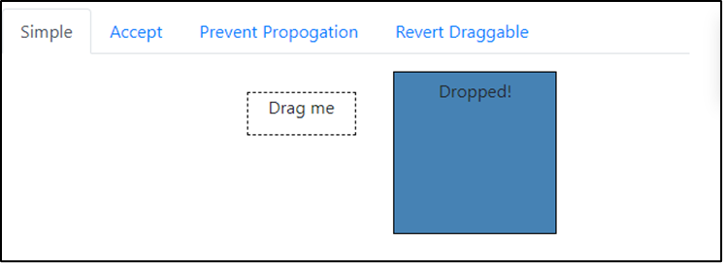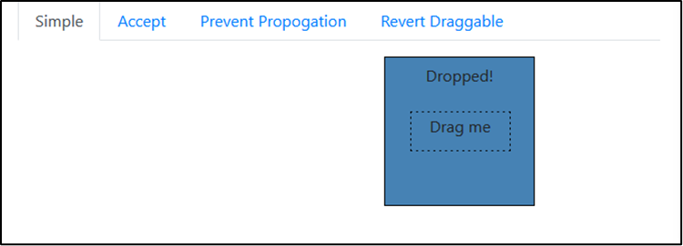

**Conclusion:** Learnt advance mouse and keyboard interactions using Selenium.

# After performing this Practical/lab, students are expected to answer following questions

* 1. What is Actions class in Selenium?
  2. How to build a set of actions in a composite action to execute it in one pass?