Exercise:

# Create an XML Web Service to implement calculator with web methods to add, sub, multiply, divide two decimal values. Consume this service through a web client application. Calculator_WS_XML.asmx.cs file:

using System;

using System.Collections.Generic; using System.Linq;

using System.Web;

using System.Web.Services;

namespace WebServices

{

/// <summary>

/// Summary description for Calculator_XML

/// </summary>

[WebService(Namespace = "<http://tempuri.org/>")] [WebServiceBinding(ConformsTo = WsiProfiles.BasicProfile1_1)] [System.ComponentModel.ToolboxItem(false)]

// To allow this Web Service to be called from script, using ASP.NET AJAX, uncomment the following line.

// [System.Web.Script.Services.ScriptService]

public class Calculator_WS_XML : System.Web.Services.WebService

{

[WebMethod]

public decimal Add(decimal a, decimal b)

{

return a + b;

}

[WebMethod]

public decimal Sub(decimal a, decimal b)

{

return a - b;

}

[WebMethod]

public decimal Mult(decimal a, decimal b)

{

return a * b;

}

[WebMethod]

public decimal Div(decimal a, decimal b)

{

return a / b;

}

}

}

# .aspx file:

<%@ Page Language="C#" AutoEventWireup="true" CodeBehind="Calculator_XML.aspx.cs" Inherits="Practical_5.Calculator_XML"



%>

<!DOCTYPE html>

<html xmlns="<http://www.w3.org/1999/xhtml>">

<head runat="server">

<title></title>

<style type="text/css">

.auto-style1 {

font-weight: bold;

}

</style>

</head>

<body style="text-align: center">

<form id="form1" runat="server">

<div>

<h1>Calculator using XML Web Service</h1>

<br />

Enter 1st Number :

<asp:TextBox ID="txtNum1" runat="server"></asp:TextBox>

<br />

<br />

Enter 2nd Number :

<asp:TextBox ID="txtNum2" runat="server"></asp:TextBox>

<br />

<br />

<asp:Label ID="lblAns" runat="server"></asp:Label>

<br />

<br />

<asp:Button ID="btnAdd" runat="server" CssClass="auto-style1" OnClick="btnAdd_Click" Text="Addition" />

&nbsp;&nbsp;&nbsp;

<asp:Button ID="btnSub" runat="server" CssClass="auto-style1" OnClick="btnSub_Click" Text="Substraction" />

&nbsp;&nbsp;&nbsp;

<asp:Button ID="btnMult" runat="server" CssClass="auto-style1" OnClick="btnMult_Click" Text="Multiplication" />

&nbsp;&nbsp;&nbsp;

<asp:Button ID="btnDiv" runat="server" CssClass="auto-style1" OnClick="btnDiv_Click" Text="Division" />

</div>

</form>

</body>

</html>

# .aspx.cs file:

using System;

using System.Collections.Generic; using System.Linq;

using System.Web; using System.Web.UI;

using System.Web.UI.WebControls;

namespace Practical_5

{

public partial class Calculator_XML : System.Web.UI.Page

{

Calc_WS_XML.Calculator_WS_XML calc = new Calc_WS_XML.Calculator_WS_XML();

protected void Page_Load(object sender, EventArgs e)

{

}

protected void btnAdd_Click(object sender, EventArgs e)

{

decimal ans = calc.Add(Convert.ToDecimal(txtNum1.Text), Convert.ToDecimal(txtNum2.Text));

lblAns.Text = "Addition is " + Convert.ToDecimal(ans).ToString();

}

protected void btnSub_Click(object sender, EventArgs e)

{

decimal ans = calc.Sub(Convert.ToDecimal(txtNum1.Text), Convert.ToDecimal(txtNum2.Text));

lblAns.Text = "Substraction is " + Convert.ToDecimal(ans).ToString();

}

protected void btnMult_Click(object sender, EventArgs e)

{

decimal ans = calc.Mult(Convert.ToDecimal(txtNum1.Text), Convert.ToDecimal(txtNum2.Text));

lblAns.Text = "Multiplication is " + Convert.ToDecimal(ans).ToString();

}

protected void btnDiv_Click(object sender, EventArgs e)

{

decimal ans = calc.Div(Convert.ToDecimal(txtNum1.Text), Convert.ToDecimal(txtNum2.Text));

lblAns.Text = "Division is " + Convert.ToDecimal(ans).ToString();

}

}

}

# Output:

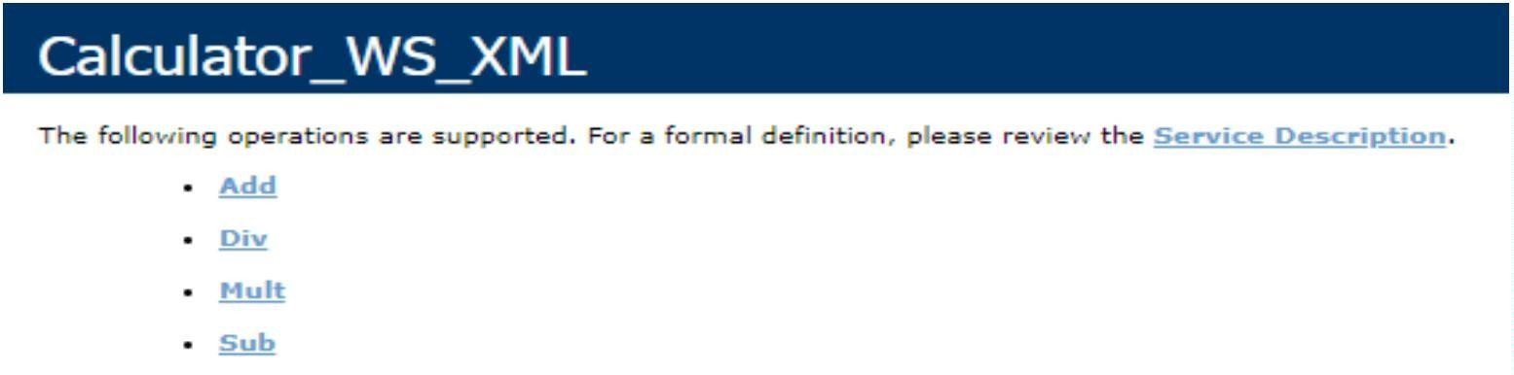

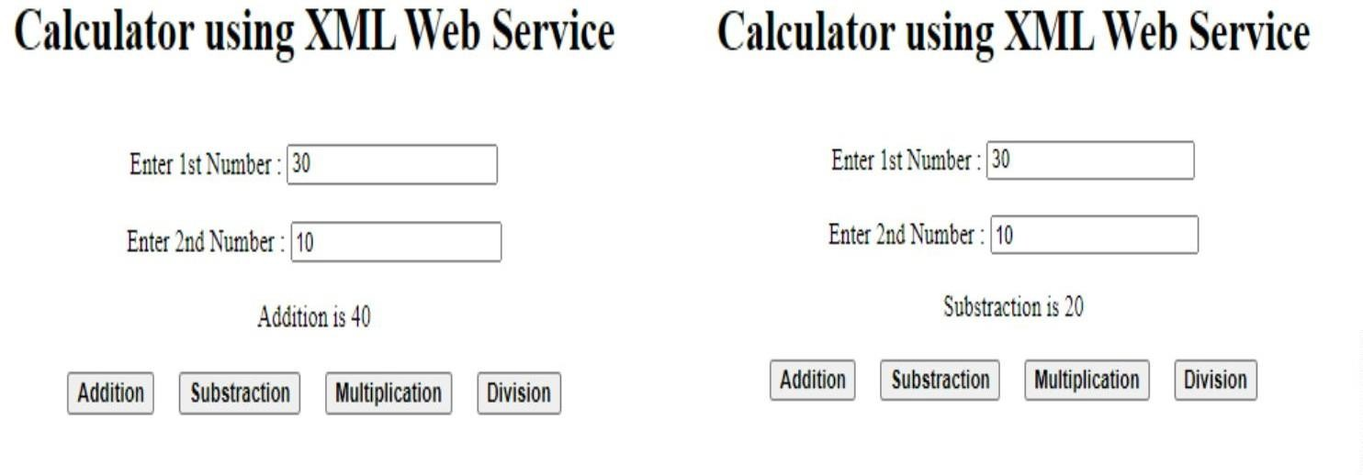

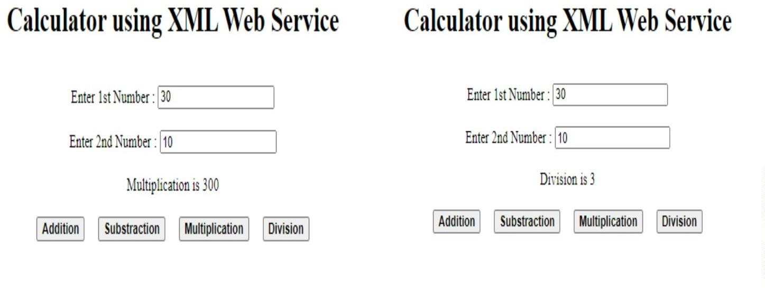

1. **Create an XML Web Service that retrieves employee details from emp_info Microsoft SQL Server Database table. Design a Web client that consumes this service.**

# EmployeeDetails_WS.asmx.cs

using System;

using System.Collections.Generic; using System.Configuration; using System.Data;

using System.Data.SqlClient; using System.Linq;

using System.Web;

using System.Web.Services;

namespace WebServices

{

/// <summary>

/// Summary description for EmployeeDetails_WS

/// </summary>

[WebService(Namespace = "<http://tempuri.org/>")] [WebServiceBinding(ConformsTo = WsiProfiles.BasicProfile1_1)] [System.ComponentModel.ToolboxItem(false)]

// To allow this Web Service to be called from script, using ASP.NET AJAX, uncomment the following line.

// [System.Web.Script.Services.ScriptService]

public class EmployeeDetails_WS : System.Web.Services.WebService

{

static string conStr = "Data Source=DESKTOP-59403VU\\SQLEXPRESS;Initial Catalog=EmpDB;Integrated Security=True";

SqlConnection con = new SqlConnection(conStr); SqlCommand cmd = null;

[WebMethod]

public DataSet GetData()

{

cmd = new SqlCommand("SELECT * FROM emp_info", con); if (con.State == ConnectionState.Closed)

{

con.Open();

}

cmd.ExecuteNonQuery();

SqlDataAdapter sda = new SqlDataAdapter(cmd); DataSet ds = new DataSet();

sda.Fill(ds);

con.Close();

return ds;

}

[WebMethod]

public int InsertData(int id, string name, string desg, decimal sal)

{

if (con.State == ConnectionState.Closed)

{

con.Open();

}

cmd = new SqlCommand("INSERT INTO emp_info(eid, ename, designation, salary) VALUES(@e_id,@e_name,@e_desg,@e_sal)", con);

cmd.Parameters.AddWithValue("@e_id", id); cmd.Parameters.AddWithValue("@e_name", name); cmd.Parameters.AddWithValue("@e_desg", desg); cmd.Parameters.AddWithValue("@e_sal", sal);

int r = cmd.ExecuteNonQuery(); con.Close();

return r;

}

}

}

# .aspx file:

<%@ Page Language="C#" AutoEventWireup="true" CodeBehind="RetrieveEmployeeDetails.aspx.cs" Inherits="Practical_5.RetrieveEmployeeDetails"



%>

<!DOCTYPE html>

<html xmlns="<http://www.w3.org/1999/xhtml>">

<head runat="server">

<title></title>

</head>

<body style="text-align: left">

<form id="form1" runat="server">

<div>

<h2>Retrieve Employee Details using XML Web Service</h2>

</div>

<div>

<asp:GridView ID="GridView1" runat="server"></asp:GridView>

</div>

</form>

</body>

</html>

# .aspx.cs file:

using System;

using System.Collections.Generic; using System.Data;

using System.Linq; using System.Web; using System.Web.UI;

using System.Web.UI.WebControls;

namespace Practical_5

{

public partial class RetrieveEmployeeDetails : System.Web.UI.Page

{

EmpDetails_WS.EmployeeDetails_WS emp = new EmpDetails_WS.EmployeeDetails_WS();

protected void Page_Load(object sender, EventArgs e)

{

DataSet ds = emp.GetData();

GridView1.DataSource = ds.Tables[0]; GridView1.DataBind();

}

}

}

# Output:

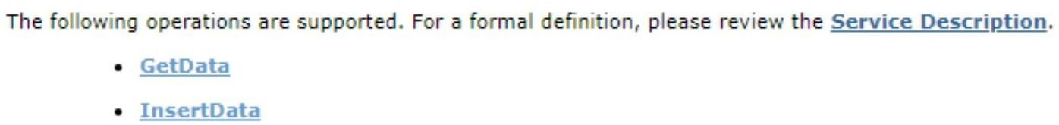

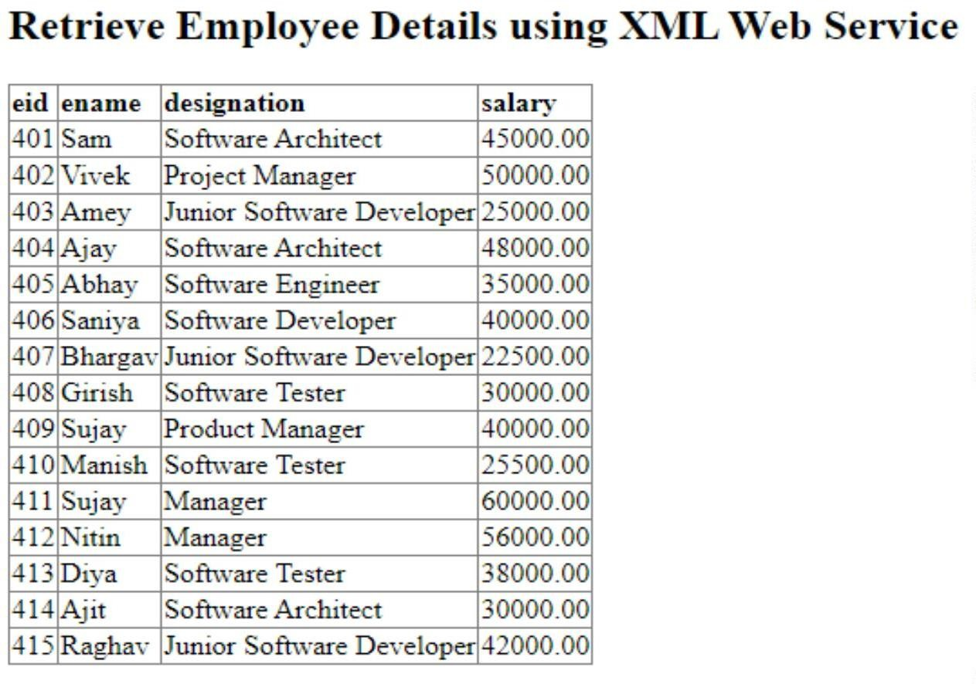

1. **Create an XML Web Service that insert employee details into emp_info Microsoft SQL Server Database table. Design a Web client that consumes this service.**

# EmployeeDetails_WS.asmx.cs

using System;

using System.Collections.Generic; using System.Configuration; using System.Data;

using System.Data.SqlClient; using System.Linq;

using System.Web;

using System.Web.Services;

namespace WebServices

{

/// <summary>

/// Summary description for EmployeeDetails_WS

/// </summary>

[WebService(Namespace = "<http://tempuri.org/>")] [WebServiceBinding(ConformsTo = WsiProfiles.BasicProfile1_1)] [System.ComponentModel.ToolboxItem(false)]

// To allow this Web Service to be called from script, using ASP.NET AJAX, uncomment the following line.

// [System.Web.Script.Services.ScriptService]

public class EmployeeDetails_WS : System.Web.Services.WebService

{

static string conStr = "Data Source=DESKTOP-59403VU\\SQLEXPRESS;Initial Catalog=EmpDB;Integrated Security=True";

SqlConnection con = new SqlConnection(conStr); SqlCommand cmd = null;

[WebMethod]

public DataSet GetData()

{

cmd = new SqlCommand("SELECT * FROM emp_info", con); if (con.State == ConnectionState.Closed)

{

con.Open();

}

cmd.ExecuteNonQuery();

SqlDataAdapter sda = new SqlDataAdapter(cmd); DataSet ds = new DataSet();

sda.Fill(ds);

con.Close();

return ds;

}

[WebMethod]

public int InsertData(int id, string name, string desg, decimal sal)

{

if (con.State == ConnectionState.Closed)

{

con.Open();

}

cmd = new SqlCommand("INSERT INTO emp_info(eid, ename, designation, salary) VALUES(@e_id,@e_name,@e_desg,@e_sal)", con);

cmd.Parameters.AddWithValue("@e_id", id); cmd.Parameters.AddWithValue("@e_name", name); cmd.Parameters.AddWithValue("@e_desg", desg); cmd.Parameters.AddWithValue("@e_sal", sal);

int r = cmd.ExecuteNonQuery(); con.Close();

return r;

}

}

}

# .aspx file:

<%@ Page Language="C#" AutoEventWireup="true" CodeBehind="InsertEmployeeDetails.aspx.cs" Inherits="Practical_5.InsertEmployeeDetails"



%>

<!DOCTYPE html>

<html xmlns="<http://www.w3.org/1999/xhtml>">

<head runat="server">

<title></title>

</head>

<body>

<form id="form1" runat="server">

<div>

<h2>Insert Employee Details using XML Web Service</h2>

</div>

<div>

<br />

&nbsp;&nbsp;&nbsp; Employee ID

:&nbsp;&nbsp;&nbsp;&nbsp;&nbsp;&nbsp;&nbsp;

<asp:TextBox ID="txtID" runat="server"></asp:TextBox> &nbsp;&nbsp;&nbsp;

<asp:RequiredFieldValidator ID="RequiredFieldValidator1" runat="server" ControlToValidate="txtID" Display="Dynamic" ErrorMessage="Please Enter Employee ID" ForeColor="Red"></asp:RequiredFieldValidator>

<br />

<br />

&nbsp;&nbsp;&nbsp; Employee Name :&nbsp;&nbsp;

<asp:TextBox ID="txtname" runat="server"></asp:TextBox> &nbsp;&nbsp;&nbsp;

<asp:RequiredFieldValidator ID="RequiredFieldValidator2" runat="server" ControlToValidate="txtname" Display="Dynamic" ErrorMessage="Please Enter Employee name" ForeColor="Red"></asp:RequiredFieldValidator>

<br />

<br />

&nbsp;&nbsp;&nbsp; Designation

:&nbsp;&nbsp;&nbsp;&nbsp;&nbsp;&nbsp;&nbsp;&nbsp;&nbsp;&nbsp;

<asp:TextBox ID="txtdesg" runat="server"></asp:TextBox> &nbsp;&nbsp;&nbsp;

<asp:RequiredFieldValidator ID="RequiredFieldValidator3" runat="server" ControlToValidate="txtdesg" Display="Dynamic" ErrorMessage="Please Enter Employee Designation" ForeColor="Red"></asp:RequiredFieldValidator>

<br />

<br /> &nbsp;&nbsp;&nbsp; Salary

:&nbsp;&nbsp;&nbsp;&nbsp;&nbsp;&nbsp;&nbsp;&nbsp;&nbsp;&nbsp;&nbsp;&nbsp;&nbsp;&nb sp;&nbsp;&nbsp;&nbsp;&nbsp;

<asp:TextBox ID="txtSal" runat="server"></asp:TextBox> &nbsp;&nbsp;&nbsp;

<asp:RequiredFieldValidator ID="RequiredFieldValidator4" runat="server" ControlToValidate="txtSal" Display="Dynamic" ErrorMessage="Please Enter Employee Salary" ForeColor="Red"></asp:RequiredFieldValidator>

<br />

<br />

&nbsp;&nbsp;&nbsp;&nbsp;&nbsp;&nbsp;&nbsp;&nbsp;&nbsp;&nbsp;&nbsp;&nbsp;&nbsp;&nbs p;&nbsp;&nbsp;&nbsp;&nbsp;&nbsp;&nbsp;&nbsp;&nbsp;&nbsp;

<asp:Button ID="insertBtn" runat="server" OnClick="insertBtn_Click" Text="Insert Data" />

<br />

<br />

<asp:GridView ID="GridView1" runat="server"></asp:GridView>

</div>

</form>

</body>

</html>

# .aspx.cs file:

using System;

using System.Collections.Generic; using System.Data;

using System.Linq; using System.Web; using System.Web.UI;

using System.Web.UI.WebControls;

namespace Practical_5

{

public partial class InsertEmployeeDetails : System.Web.UI.Page

{

EmpDetails_WS.EmployeeDetails_WS emp = new EmpDetails_WS.EmployeeDetails_WS();

protected void Page_Load(object sender, EventArgs e)

{

DataSet ds = emp.GetData();

GridView1.DataSource = ds.Tables[0]; GridView1.DataBind();

}

protected void insertBtn_Click(object sender, EventArgs e)

{

int r = emp.InsertData(Convert.ToInt32(txtID.Text), txtname.Text, txtdesg.Text, Convert.ToDecimal(txtSal.Text));

if (r > 0)

{

Response.Write("<script type=\"text/javascript\">alert('Record

Inserted Successfully!');</script>");

txtID.Text = txtname.Text = txtdesg.Text = txtSal.Text = " ";

}

else

{

Response.Write("<script type=\"text/javascript\">alert('Record Not Inserted!');</script>");

}

DataSet ds = emp.GetData();

GridView1.DataSource = ds.Tables[0]; GridView1.DataBind();

}

}

}

# Output:

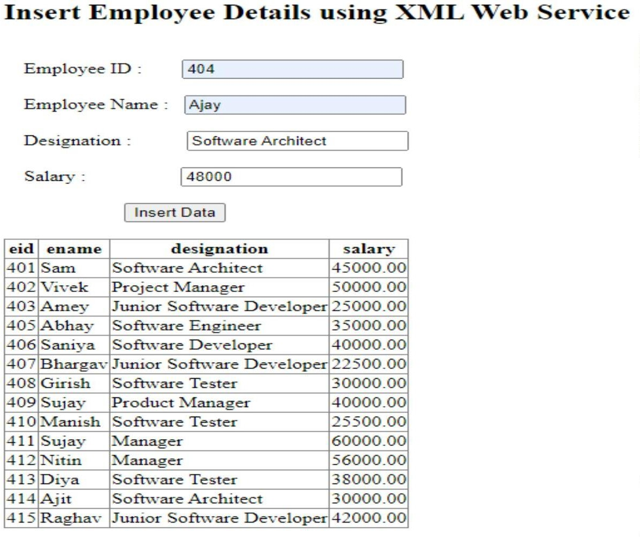

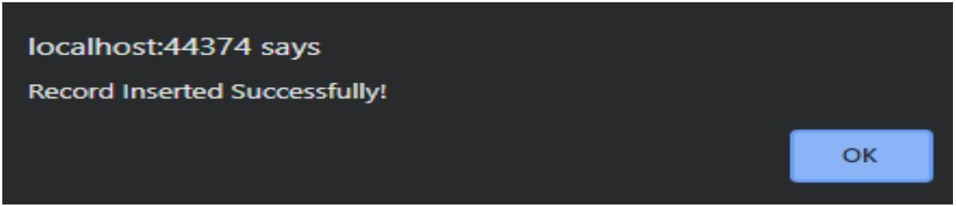

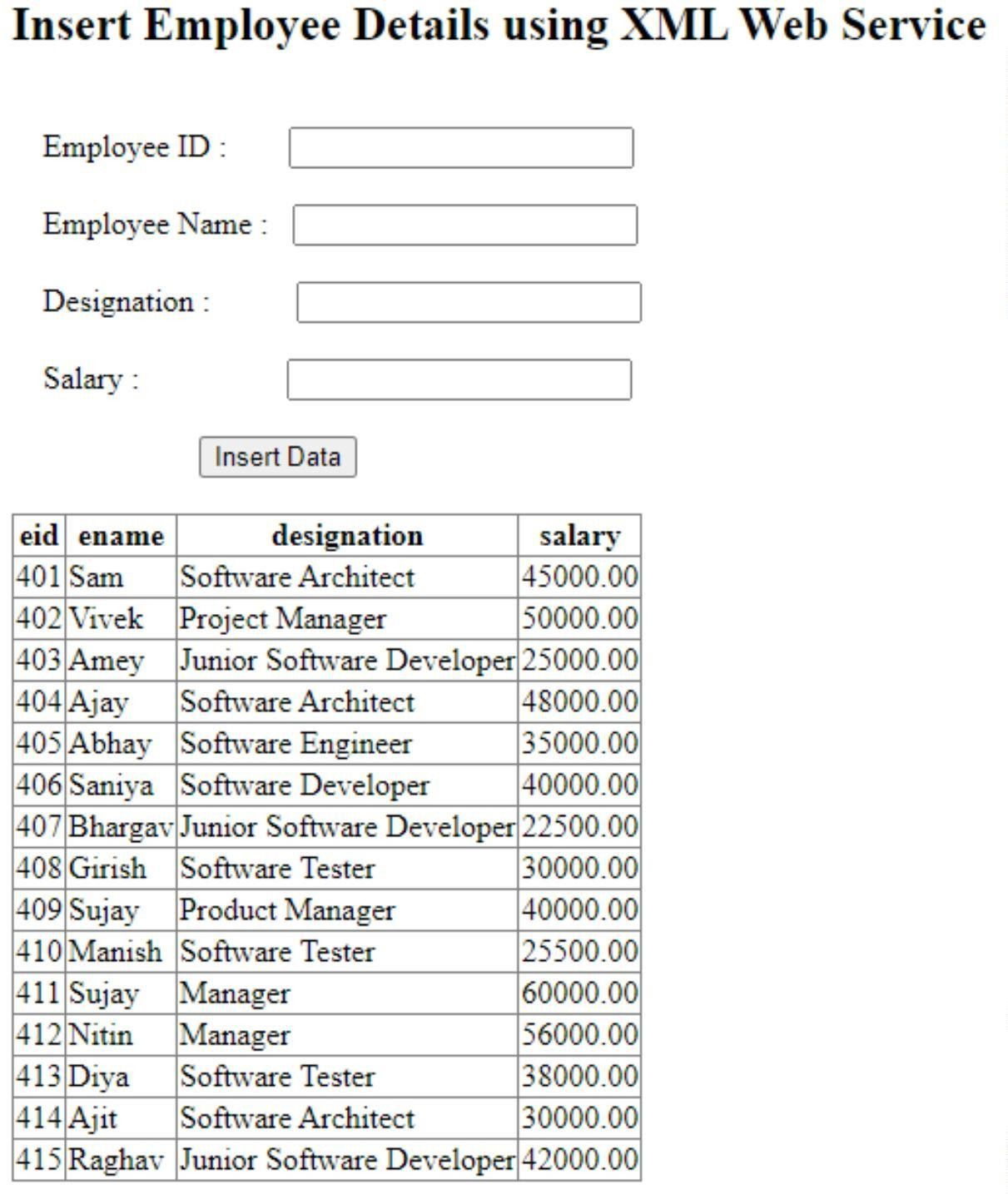

1. **Design a Web Service using WCF for simple Calculator and consume it with client application.**

# Calculator_WCF.cs (Class file):

using System;

using System.Collections.Generic; using System.Linq;

using System.Web;

using System.Runtime.Serialization;

namespace WebServices

{

public class Calculator_WCF

{

[DataMember] public double n1; [DataMember] public double n2;

}

}

# ICalculator_WS_WCF.cs (Interface file):

using System;

using System.Collections.Generic; using System.Linq;

using System.Runtime.Serialization; using System.ServiceModel;

using System.Text;

namespace WebServices

{

[ServiceContract]

public interface ICalculator_WS_WCF

{

[OperationContract]

double Add(double n1, double n2); [OperationContract]

double Subtract(double n1, double n2); [OperationContract]

double Multiply(double n1, double n2); [OperationContract]

double Divide(double n1, double n2);

}

}

# Calculator_WS_WCF.svc.cs (Service file):

using System;

using System.Collections.Generic; using System.Linq;

using System.Runtime.Serialization; using System.ServiceModel;

using System.Text;

namespace WebServices

{

public class Calculator_WS_WCF : ICalculator_WS_WCF

{

public double Add(double n1, double n2)

{

return n1 + n2;

}

public double Subtract(double n1, double n2)

{

return n1 - n2;

}

public double Multiply(double n1, double n2)

{

return n1 * n2;

}

public double Divide(double n1, double n2)

{

return n1 / n2;

}

}

}

# .aspx file:

<%@ Page Language="C#" AutoEventWireup="true" CodeBehind="Calculator_WCF.aspx.cs" Inherits="Practical_5.Calculator_WCF"



%>

<!DOCTYPE html>

<html xmlns="<http://www.w3.org/1999/xhtml>">

<head runat="server">

<title></title>

</head>

<body style="text-align: center">

<form id="form1" runat="server">

<div>

<h1>Calculator using WCF Service</h1>

<br />

Enter 1st Number :

<asp:TextBox ID="txtNum1" runat="server"></asp:TextBox>

<br />

<br />

Enter 2nd Number :

<asp:TextBox ID="txtNum2" runat="server"></asp:TextBox>

<br />

<br />

<asp:Label ID="lblAns" runat="server"></asp:Label>

<br />

<br />

<asp:Button ID="btnAdd" runat="server" CssClass="auto-style1" OnClick="btnAdd_Click" Text="Addition" />

&nbsp;&nbsp;&nbsp;

<asp:Button ID="btnSub" runat="server" CssClass="auto-style1" OnClick="btnSub_Click" Text="Substraction" />

&nbsp;&nbsp;&nbsp;

<asp:Button ID="btnMult" runat="server" CssClass="auto-style1" OnClick="btnMult_Click" Text="Multiplication" />

&nbsp;&nbsp;&nbsp;

<asp:Button ID="btnDiv" runat="server" CssClass="auto-style1" OnClick="btnDiv_Click" Text="Division" />

</div>

</form>

</body>

</html>

# .aspx.cs file:

using System;

using System.Collections.Generic; using System.Linq;

using System.Web; using System.Web.UI;

using System.Web.UI.WebControls;

namespace Practical_5

{

public partial class Calculator_WCF : System.Web.UI.Page

{

Calc_WCF.Calculator_WS_WCFClient calc = new Calc_WCF.Calculator_WS_WCFClient();

protected void Page_Load(object sender, EventArgs e)

{

}

protected void btnAdd_Click(object sender, EventArgs e)

{

double ans = calc.Add(Convert.ToDouble(txtNum1.Text), Convert.ToDouble(txtNum2.Text));

lblAns.Text = "Addition is " + ans;

}

protected void btnSub_Click(object sender, EventArgs e)

{

double ans = calc.Subtract(Convert.ToDouble(txtNum1.Text), Convert.ToDouble(txtNum2.Text));

lblAns.Text = "Substraction is " + ans;

}

protected void btnMult_Click(object sender, EventArgs e)

{

double ans = calc.Multiply(Convert.ToDouble(txtNum1.Text), Convert.ToDouble(txtNum2.Text));

lblAns.Text = "Multiplication is " + ans;

}

protected void btnDiv_Click(object sender, EventArgs e)

{

double ans = calc.Divide(Convert.ToDouble(txtNum1.Text), Convert.ToDouble(txtNum2.Text));

lblAns.Text = "Division is " + ans;

}

}

}

# Output:

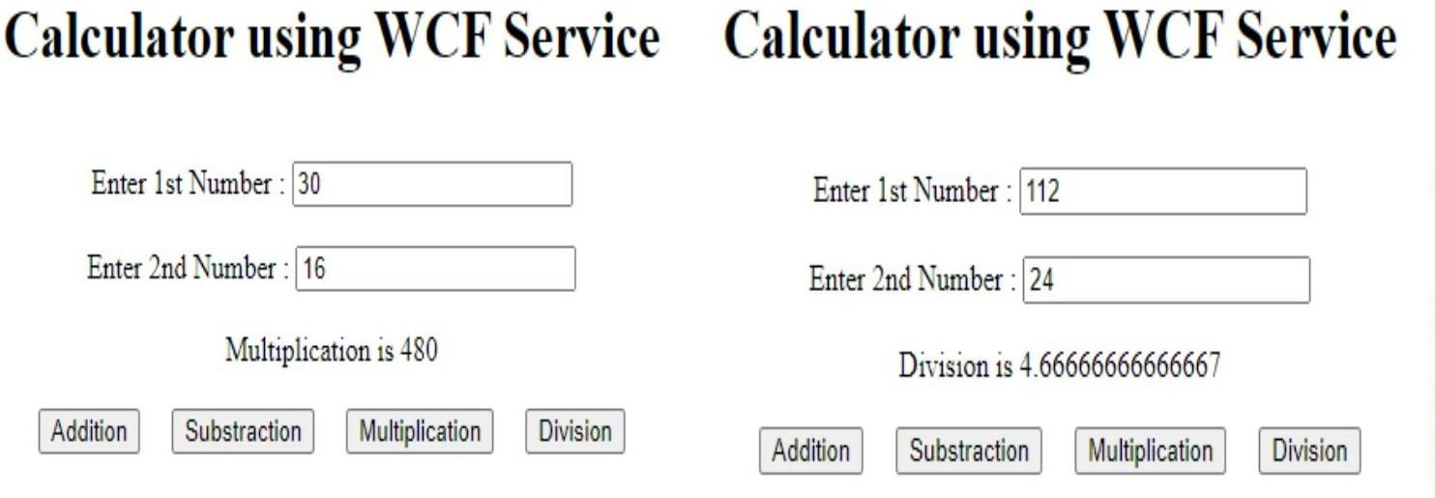

1. **Create an XML Web Service that update product details into product_info Microsoft SQL Server Database table. Design a Web client that consumes this service.**

# ProductDetails_WS.asmx.cs

using System;

using System.Collections.Generic; using System.Configuration; using System.Data;

using System.Data.SqlClient; using System.Linq;

using System.Web;

using System.Web.Services;

namespace WebServices

{

/// <summary>

/// Summary description for ProductDetails_WS

/// </summary>

[WebService(Namespace = "<http://tempuri.org/>")] [WebServiceBinding(ConformsTo = WsiProfiles.BasicProfile1_1)] [System.ComponentModel.ToolboxItem(false)]

// To allow this Web Service to be called from script, using ASP.NET AJAX, uncomment the following line.

// [System.Web.Script.Services.ScriptService]

public class ProductDetails_WS : System.Web.Services.WebService

{

static string conStr = "Data Source=DESKTOP-59403VU\\SQLEXPRESS;Initial Catalog=ProductDB;Integrated Security=True";

SqlConnection con = new SqlConnection(conStr); SqlCommand cmd = null;

[WebMethod]

public DataSet ShowData()

{

cmd = new SqlCommand("SELECT * FROM product_info", con); if (con.State == ConnectionState.Closed)

{

con.Open();

}

cmd.ExecuteNonQuery();

SqlDataAdapter sda = new SqlDataAdapter(cmd); DataSet ds = new DataSet();

sda.Fill(ds);

con.Close();

return ds;

}

[WebMethod]

public int UpdateData(int id, string name, int quantity, decimal price)

{

cmd = new SqlCommand("UPDATE product_info SET Product_Name=@p_name,

Quantity=@qunt, Price=@prc WHERE Product_ID=@p_id", con); if (con.State == ConnectionState.Closed)

{

con.Open();

}

cmd.Parameters.AddWithValue("@p_id", id); cmd.Parameters.AddWithValue("@p_name", name); cmd.Parameters.AddWithValue("@qunt", quantity); cmd.Parameters.AddWithValue("@prc", price);

int r = cmd.ExecuteNonQuery(); con.Close();

return r;

}

[WebMethod]

public int DeleteData(int id)

{

if (con.State == ConnectionState.Closed)

{

con.Open();

}

cmd = new SqlCommand("DELETE product_info WHERE Product_ID=@p_id",

con);

cmd.Parameters.AddWithValue("@p_id", id);

int r = cmd.ExecuteNonQuery(); con.Close();

return r;

}

}

}

# .aspx file:

<%@ Page Language="C#" AutoEventWireup="true" CodeBehind="UpdateProductDetails.aspx.cs" Inherits="Practical_5.UpdateProductDetails"



%>

<!DOCTYPE html>

<html xmlns="<http://www.w3.org/1999/xhtml>">

<head runat="server">

<title></title>

</head>

<body>

<form id="form1" runat="server">

<div>

<h2>Update Product Details using XML Web Service</h2>

</div>

<div>

<br />

&nbsp;&nbsp;&nbsp; Product ID

:&nbsp;&nbsp;&nbsp;&nbsp;&nbsp;&nbsp;&nbsp;

<asp:TextBox ID="txtID" runat="server"></asp:TextBox> &nbsp;&nbsp;&nbsp;

<asp:RequiredFieldValidator ID="RequiredFieldValidator1" runat="server" ControlToValidate="txtID" Display="Dynamic" ErrorMessage="Please Enter Product ID" ForeColor="Red"></asp:RequiredFieldValidator>

<br />

<br />

&nbsp;&nbsp;&nbsp; Product Name :&nbsp;&nbsp;

<asp:TextBox ID="txtname" runat="server"></asp:TextBox> &nbsp;&nbsp;&nbsp;

<asp:RequiredFieldValidator ID="RequiredFieldValidator2" runat="server" ControlToValidate="txtname" Display="Dynamic" ErrorMessage="Please Enter Product name" ForeColor="Red"></asp:RequiredFieldValidator>

<br />

<br />

&nbsp;&nbsp;&nbsp; Quantity

:&nbsp;&nbsp;&nbsp;&nbsp;&nbsp;&nbsp;&nbsp;&nbsp;&nbsp; &nbsp;

<asp:TextBox ID="txtqunt" runat="server"></asp:TextBox> &nbsp;&nbsp;&nbsp;

<asp:RequiredFieldValidator ID="RequiredFieldValidator3" runat="server" ControlToValidate="txtqunt" Display="Dynamic" ErrorMessage="Please Enter Quantity" ForeColor="Red"></asp:RequiredFieldValidator>

<br />

<br />

&nbsp;&nbsp;&nbsp; Price

:&nbsp;&nbsp;&nbsp;&nbsp;&nbsp;&nbsp;&nbsp;&nbsp;&nbsp;&nbsp;&nbsp;&nbsp;&nbsp;&nb sp;&nbsp;&nbsp;&nbsp;<asp:TextBox ID="txtprc" runat="server"></asp:TextBox>

&nbsp;&nbsp;&nbsp;

<asp:RequiredFieldValidator ID="RequiredFieldValidator4" runat="server" ControlToValidate="txtprc" Display="Dynamic" ErrorMessage="Please Enter Price" ForeColor="Red"></asp:RequiredFieldValidator>

<br />

<br />

&nbsp;&nbsp;&nbsp;&nbsp;&nbsp;&nbsp;&nbsp;&nbsp;&nbsp;&nbsp;&nbsp;&nbsp;&nbsp;&nbs p;&nbsp;&nbsp;&nbsp;&nbsp;&nbsp;&nbsp;&nbsp;&nbsp;&nbsp;

<asp:Button ID="updateBtn" runat="server" OnClick="updateBtn_Click" Text="Update Data" />

<br />

<br />

<asp:GridView ID="GridView1" runat="server"></asp:GridView>

</div>

</form>

</body>

</html>

# .aspx.cs file:

using System; using System.Data;

namespace Practical_5

{

public partial class UpdateProductDetails : System.Web.UI.Page

{

ProdDetails_WS.ProductDetails_WS product = new ProdDetails_WS.ProductDetails_WS();

protected void Page_Load(object sender, EventArgs e)

{

DataSet ds = product.ShowData();

GridView1.DataSource = ds.Tables[0]; GridView1.DataBind();

}

protected void updateBtn_Click(object sender, EventArgs e)

{

int r = product.UpdateData(Convert.ToInt32(txtID.Text), txtname.Text, Convert.ToInt32(txtqunt.Text), Convert.ToDecimal(txtprc.Text));

if (r > 0)

{

Response.Write("<script type=\"text/javascript\">alert('Record

Updated Successfully!');</script>");

txtID.Text = txtname.Text = txtqunt.Text = txtprc.Text = " ";

}

else

{

Response.Write("<script type=\"text/javascript\">alert('Record Not Updated!');</script>");

}

DataSet ds = product.ShowData();

GridView1.DataSource = ds.Tables[0]; GridView1.DataBind();

}

}

}

# Output:

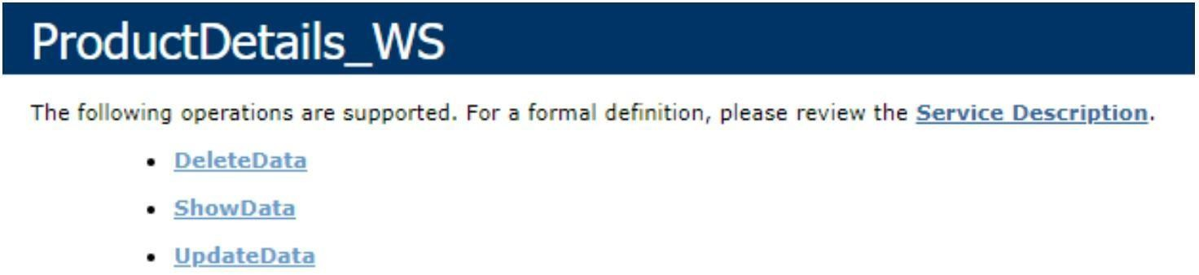

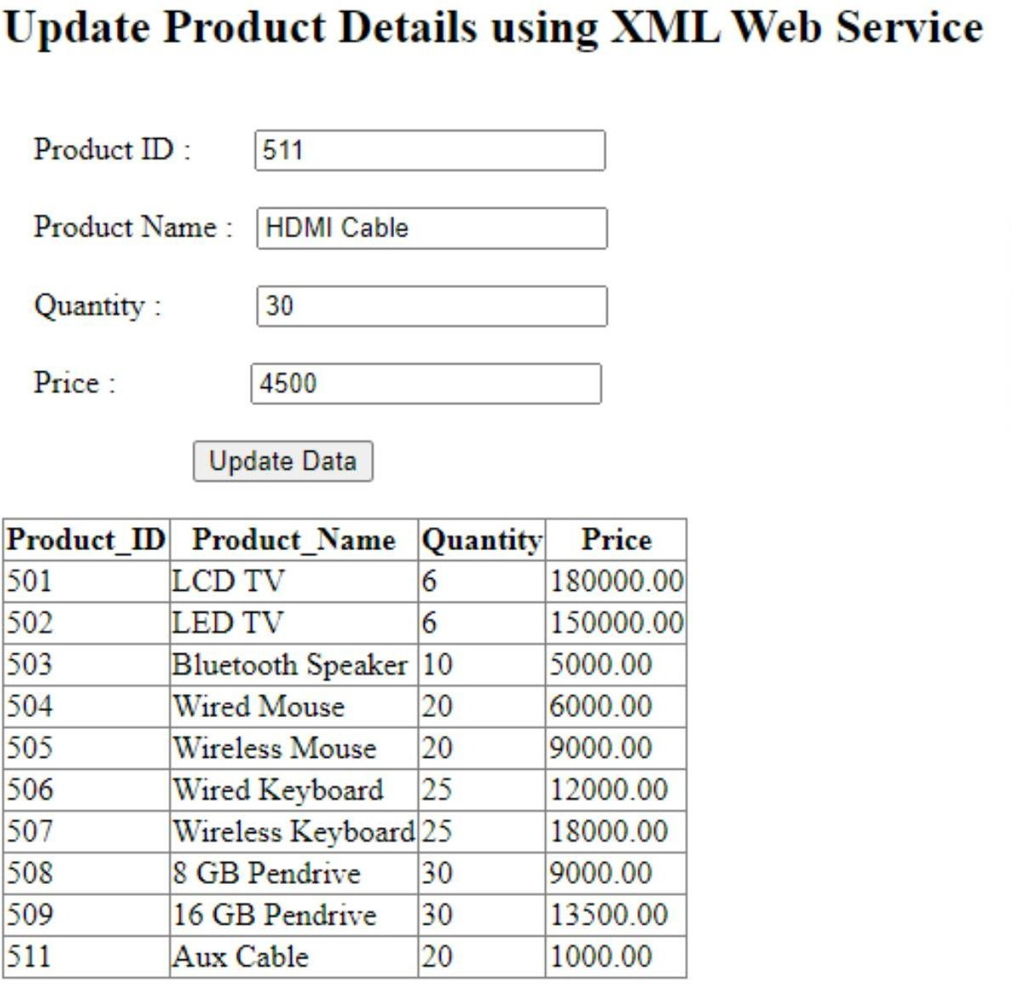

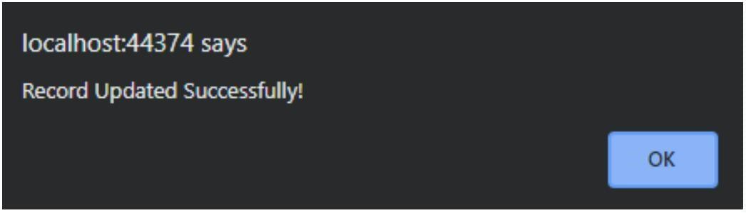

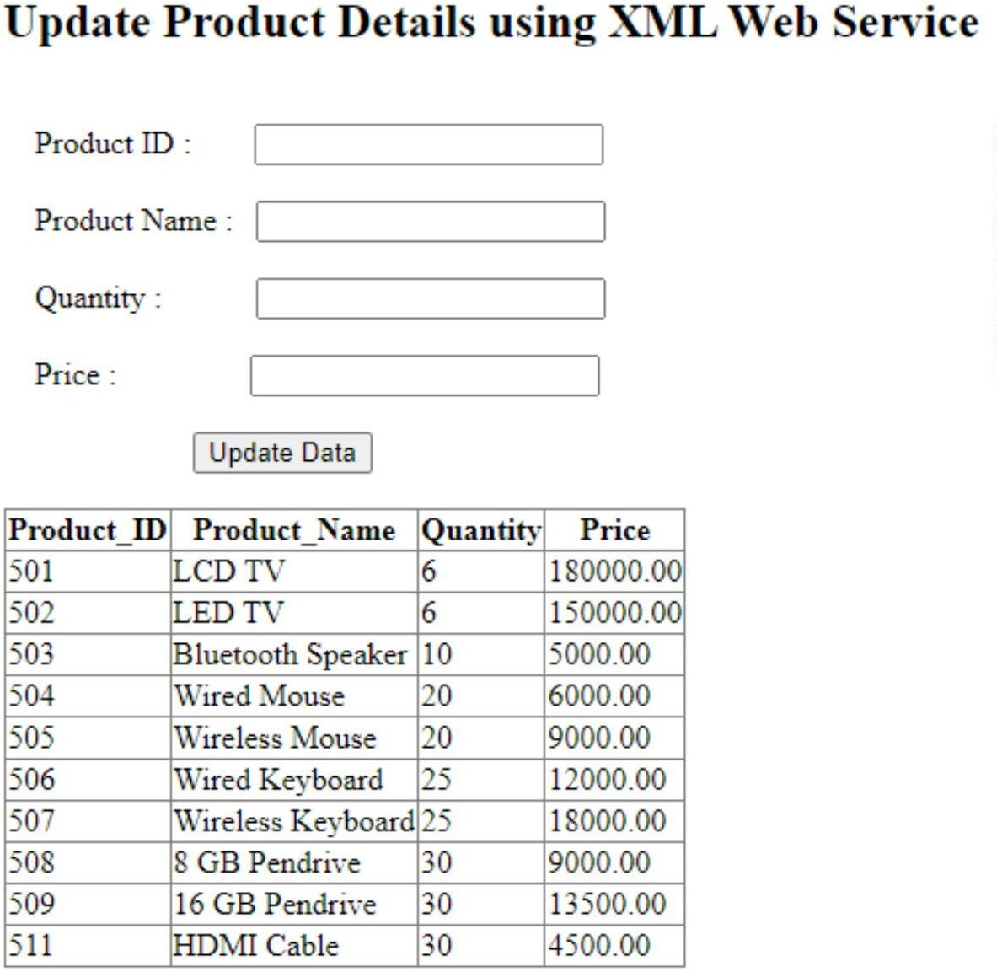

1. **Create an XML Web Service that delete product details from product_info Microsoft SQL Server Database table based on productID. Design a Web client that consumes this service.**

# ProductDetails_WS.asmx.cs

using System;

using System.Collections.Generic; using System.Configuration; using System.Data;

using System.Data.SqlClient; using System.Linq;

using System.Web;

using System.Web.Services;

namespace WebServices

{

/// <summary>

/// Summary description for ProductDetails_WS

/// </summary>

[WebService(Namespace = "<http://tempuri.org/>")] [WebServiceBinding(ConformsTo = WsiProfiles.BasicProfile1_1)] [System.ComponentModel.ToolboxItem(false)]

// To allow this Web Service to be called from script, using ASP.NET AJAX, uncomment the following line.

// [System.Web.Script.Services.ScriptService]

public class ProductDetails_WS : System.Web.Services.WebService

{

static string conStr = "Data Source=DESKTOP-59403VU\\SQLEXPRESS;Initial Catalog=ProductDB;Integrated Security=True";

SqlConnection con = new SqlConnection(conStr); SqlCommand cmd = null;

[WebMethod]

public DataSet ShowData()

{

cmd = new SqlCommand("SELECT * FROM product_info", con); if (con.State == ConnectionState.Closed)

{

con.Open();

}

cmd.ExecuteNonQuery();

SqlDataAdapter sda = new SqlDataAdapter(cmd); DataSet ds = new DataSet();

sda.Fill(ds);

con.Close();

return ds;

}

[WebMethod]

public int UpdateData(int id, string name, int quantity, decimal price)

{

cmd = new SqlCommand("UPDATE product_info SET Product_Name=@p_name,

Quantity=@qunt, Price=@prc WHERE Product_ID=@p_id", con); if (con.State == ConnectionState.Closed)

{

con.Open();

}

cmd.Parameters.AddWithValue("@p_id", id); cmd.Parameters.AddWithValue("@p_name", name); cmd.Parameters.AddWithValue("@qunt", quantity); cmd.Parameters.AddWithValue("@prc", price);

int r = cmd.ExecuteNonQuery(); con.Close();

return r;

}

[WebMethod]

public int DeleteData(int id)

{

if (con.State == ConnectionState.Closed)

{

con.Open();

}

con);

cmd = new SqlCommand("DELETE product_info WHERE Product_ID=@p_id",

cmd.Parameters.AddWithValue("@p_id", id);

int r = cmd.ExecuteNonQuery(); con.Close();

return r;

}

}

}

# .aspx file:

<%@ Page Language="C#" AutoEventWireup="true" CodeBehind="DeleteProductDetails.aspx.cs" Inherits="Practical_5.DeleteProductDetails"



%>

<!DOCTYPE html>

<html xmlns="<http://www.w3.org/1999/xhtml>">

<head runat="server">

<title></title>

</head>

<body>

<form id="form1" runat="server">

<div>

<h2>Delete Product Details using XML Web Service</h2>

</div>

<div>

<br />

&nbsp;&nbsp;&nbsp;Enter Product ID

:&nbsp;&nbsp;&nbsp;&nbsp;&nbsp;&nbsp;&nbsp;

<asp:TextBox ID="txtID" runat="server"></asp:TextBox>

&nbsp;&nbsp;&nbsp;

<asp:RequiredFieldValidator ID="RequiredFieldValidator1" runat="server" ControlToValidate="txtID" Display="Dynamic" ErrorMessage="Please Enter Product ID" ForeColor="Red"></asp:RequiredFieldValidator>

<br />

<br />

&nbsp;&nbsp;&nbsp;&nbsp;&nbsp;&nbsp;&nbsp;&nbsp;&nbsp;&nbsp;&nbsp;&nbsp;&nbsp;&nbs p;&nbsp;&nbsp;&nbsp;&nbsp;&nbsp;&nbsp;&nbsp;&nbsp;&nbsp;

<asp:Button ID="deleteBtn" runat="server" OnClick="deleteBtn_Click" Text="Delete Data" />

<br />

<br />

<asp:GridView ID="GridView1" runat="server"></asp:GridView>

</div>

</form>

</body>

</html>

# .aspx.cs file:

using System;

using System.Collections.Generic; using System.Linq;

using System.Web; using System.Web.UI;

using System.Web.UI.WebControls; using System.Data;

namespace Practical_5

{

public partial class DeleteProductDetails : System.Web.UI.Page

{

ProdDetails_WS.ProductDetails_WS product = new ProdDetails_WS.ProductDetails_WS();

protected void Page_Load(object sender, EventArgs e)

{

DataSet ds = product.ShowData();

GridView1.DataSource = ds.Tables[0]; GridView1.DataBind();

}

protected void deleteBtn_Click(object sender, EventArgs e)

{

int r = product.DeleteData(Convert.ToInt32(txtID.Text));

if (r > 0)

{

Response.Write("<script type=\"text/javascript\">alert('Record Deleted Successfully!');</script>");

txtID.Text = " ";

}

else

{

Response.Write("<script type=\"text/javascript\">alert('Record Not Deleted!');</script>");

}

DataSet ds = product.ShowData();

GridView1.DataSource = ds.Tables[0]; GridView1.DataBind();

}

}

}

# Output:



