**Exercise:**

# Design Web application to maintain the session data using In-proc session state.

**Design File:**

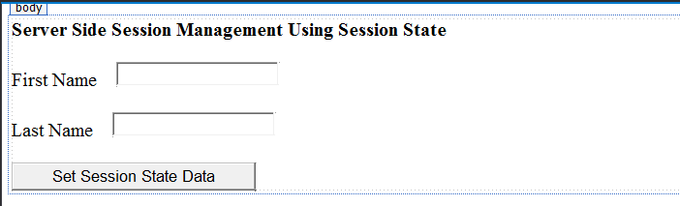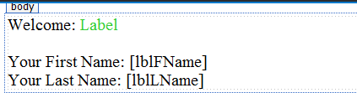

**Code Behind File: InProcSessionState.aspx.cs**

using System;

using System.Collections.Generic; using System.Linq;

using System.Web; using System.Web.UI;

using System.Web.UI.WebControls;

public partial class InProcSessionState : System.Web.UI.Page

{

protected void Page_Load(object sender, EventArgs e)

{

}

protected void btnset_Click(object sender, EventArgs e)

{

Session["FirstName"] = txtfname.Text; Session["LastName"] = txtlname.Text; Response.Redirect("InProcSessionState2.aspx");

}

}

**InProcSessionState2. aspx.cs**

using System;

using System.Collections.Generic; using System.Linq;

using System.Web; using System.Web.UI;

using System.Web.UI.WebControls;

public partial class InProcSessionState2 : System.Web.UI.Page

{

protected void Page_Load(object sender, EventArgs e)

{

if (!IsPostBack)

{

if (Session["FirstName"] != null && Session["LastName"] != null)

{

lblString.Text = Session["FirstName"].ToString(); lblFName.Text = Session["FirstName"].ToString(); lblLName.Text = Session["LastName"].ToString();

}

else

{

lblFName.Text = "Value for FirstName Key is not set!"; lblLName.Text = "Value for LastName Key is not set!";

}

}

}

}

**Output:**

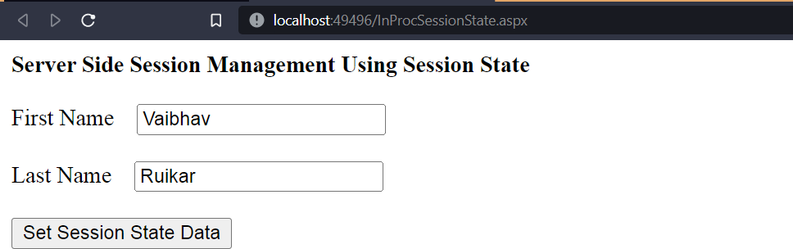

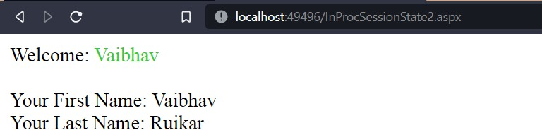

# Design Web application to maintain the session data using Out of process session state (Use StateServer and SQLServer modes).

**Design File:**

<%@ Page Language="C#" AutoEventWireup="true" CodeBehind="SessionState01.aspx.cs" Inherits="Practical_4.SessionState01" %>

<!DOCTYPE html>

<html xmlns="[http://www.w3.org/1999/xhtml">](http://www.w3.org/1999/xhtml)

<head runat="server"> <title></title> </head>

<body style="text-align: center">

<form id="form1" runat="server">

<div> <h2>In-Proc and Out-Proc(StateServer &amp; SQLServer) Session State Demo</h2> <br /> First Name:&nbsp;&nbsp;&nbsp;&nbsp;

<asp:TextBox ID="txtFName" runat="server"></asp:TextBox>

<br /> <br />

Last Name:&nbsp;&nbsp;&nbsp;&nbsp;

<asp:TextBox ID="txtLName" runat="server"></asp:TextBox>

<br /> <br />

Mobile No.:&nbsp;&nbsp;&nbsp;

<asp:TextBox ID="txtMobile" runat="server"></asp:TextBox>

<br /> <br /> City:

&nbsp;&nbsp;&nbsp;&nbsp;&nbsp;&nbsp;&nbsp;&nbsp;&nbsp;&nbsp;&nbsp;&nbsp;&nbsp;&nbsp

;&nbsp;

<asp:TextBox ID="txtCity" runat="server">

</asp:TextBox>

<br /> <br /> State:&nbsp;&nbsp;&nbsp;&nbsp;&nbsp;&nbsp;&nbsp;&nbsp;&nbsp;&nbsp;&nbsp;&nbsp;&nbsp;

<asp:TextBox ID="txtState" runat="server"></asp:TextBox>

<br /> <br /> &nbsp;&nbsp;&nbsp;&nbsp;&nbsp;&nbsp;&nbsp;

<asp:Button ID="Button1" runat="server" OnClick="Button1_Click" Text="Submit" Font- Bold="True" /> &nbsp;&nbsp;&nbsp;&nbsp;&nbsp;&nbsp;&nbsp;&nbsp;&nbsp;&nbsp;&nbsp;

<asp:Button ID="Clearbtn" runat="server" OnClick="Clearbtn_Click" style="font-weight: 700" Text="Clear" />

</div>

</form>

</body>

</html>

**Code Behind File:**

using System; using System.Collections.Generic; using System.Linq;

using System.Web; using System.Web.UI;

using System.Web.UI.WebControls;

public partial class SessionState01 : System.Web.UI.Page

{

protected void Page_Load(object sender, EventArgs e)

{

}

protected void Button1_Click(object sender, EventArgs e)

{

Session["FirstName"] = txtFName.Text; Session["LastName"] = txtLName.Text; Session["Mobile"] = txtMobile.Text; Session["City"] = txtCity.Text; Session["State"] = txtState.Text; Response.Redirect("SessionState02.aspx");

}

protected void Clearbtn_Click(object sender, EventArgs e)

{

txtFName.Text = txtLName.Text = txtMobile.Text = txtCity.Text = txtState.Text = ""; }

}

}

**Output:**

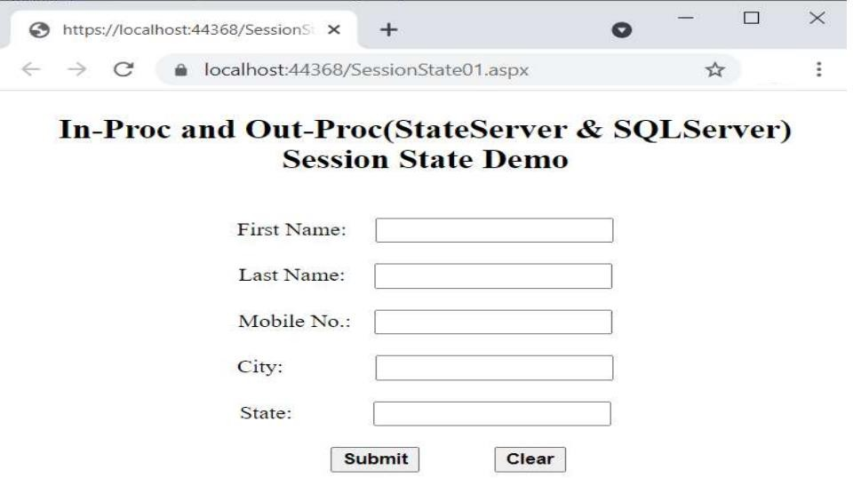

# Design an ASP.NET web application to display the number of times current page is visited using following session management techniques:

1. 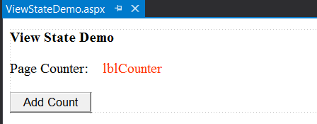**View State Design File:**

**Code Behind File:**

using System;

using System.Collections.Generic; using System.Linq;

using System.Web; using System.Web.UI;

using System.Web.UI.WebControls;

public partial class ViewStateDemo : System.Web.UI.Page

{

int counter;

protected void Page_Load(object sender, EventArgs e)

{

lblCounter.Text = "Counter : " + counter;

}

protected void btnaddcnt_Click(object sender, EventArgs e)

{

if (IsPostBack)

{

if (ViewState["Counter"] == null)

{

counter = 1;

}

else

{

counter = (int)ViewState["Counter"] + 1;

}

ViewState["Counter"] = counter;

lblCounter.Text = "Counter : " + ViewState["Counter"];

}

}

}

**Output:**

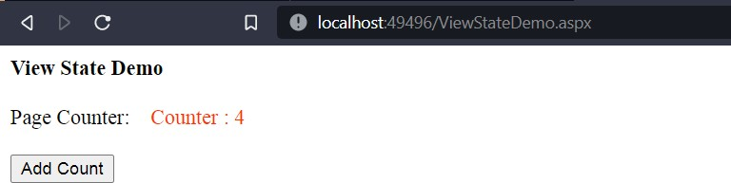

1. 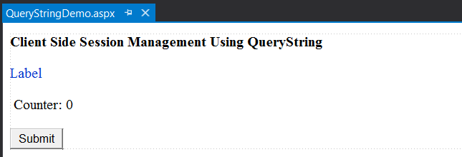**QueryString Design File:**

**Code Behind File:**

using System;

using System.Collections.Generic; using System.Linq;

using System.Web; using System.Web.UI;

using System.Web.UI.WebControls;

public partial class QueryStringDemo : System.Web.UI.Page

{

int cnt;

protected void Page_Load(object sender, EventArgs e)

{

cnt = Convert.ToInt32(Server.UrlDecode(Request.QueryString["count"]));

if (cnt != 0)

{

cnt = cnt + 1;

}

else

{ cnt = 1; }

lblCounter.Text = Convert.ToString(cnt);

lblmsg.Text = "Welcome " + Request.QueryString["name"];

}

protected void btnsubmit_Click(object sender, EventArgs e)

{

Response.Redirect("QueryStringDemo.aspx?count=" + Server.UrlEncode((lblCounter.Text)) + "&&name=Tushar");

}

}

**Output:**

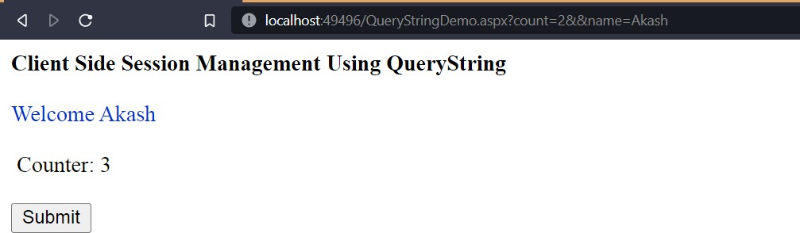

1. **Cookies**

**Design File:**

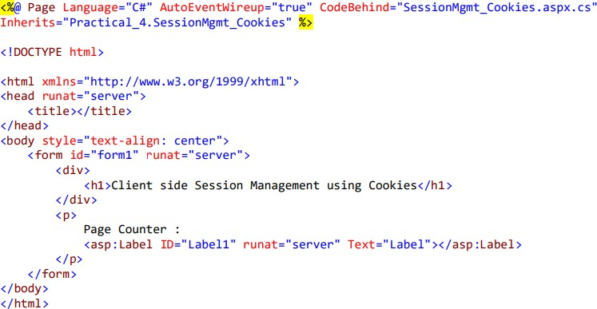

**Code Behind File:**

using System;

using System.Collections.Generic; using System.Linq;

using System.Web; using System.Web.UI;

using System.Web.UI.WebControls;

public partial class SessionMgmt_Cookies : System.Web.UI.Page

{

int counter = 0;

protected void Page_Load(object sender, EventArgs e)

{

if(Request.Cookies["counter"] == null) { counter = 1; } else

{

counter = int.Parse(Request.Cookies["counter"].Value) + 1;

}

//counter++;

Response.Cookies["counter"].Value = counter.ToString(); Response.Cookies["counter"].Expires = DateTime.Now.AddSeconds(5); if(Request.Cookies["counter"] != null)

{

Label1.Text = Request.Cookies["counter"].Value;

}

}

}

**Output:**

**Client side Session Management using Cookies**

Page Counter : 1

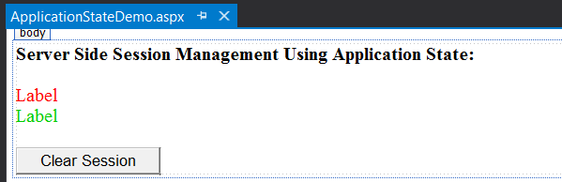**d. Application State Design File:**

**Code Behind File**:

using System;

using System.Collections.Generic; using System.Linq;

using System.Web; using System.Web.UI;

using System.Web.UI.WebControls;

public partial class ApplicationStateDemo : System.Web.UI.Page

{

protected void Page_Load(object sender, EventArgs e)

{

lblVisitorsCount.Text = "No of times site visited = " + Application["SiteVisiterCounter"].ToString();

lblOnlineVisitorsCount.Text = "No of users online on the site = " + Application["OnlineUserCounter"].ToString();

}

protected void btnclear_Click(object sender, EventArgs e)

{

Session.Abandon();

}

}

**Output:**

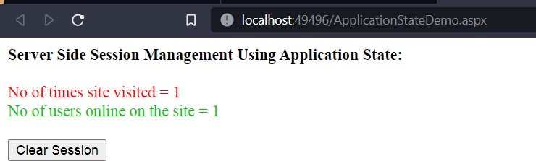

# Design an ASP.NET web form to display digital clock using AJAX.

**Design File:**

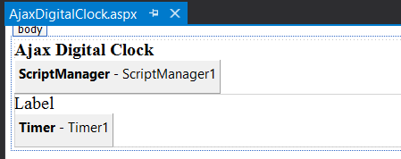

**Code Behind File:**

using System;

using System.Collections.Generic; using System.Linq;

using System.Web; using System.Web.UI;

using System.Web.UI.WebControls;

public partial class AjaxDigitalClock : System.Web.UI.Page

{

protected void Page_Load(object sender, EventArgs e)

{

}

protected void Timer1_Tick(object sender, EventArgs e)

{

Label1.Text = DateTime.Now.ToString("hh:mm:ss");

}

}

**Output:**

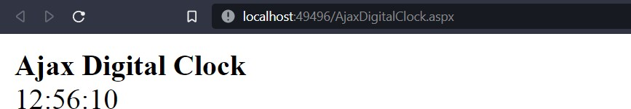

# Design an ASP.NET web form using AJAX controls to change the banner image of your college website every 10 seconds.

**Design File:**

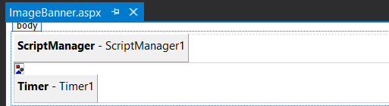

**Code Behind File:**

using System;

using System.Collections.Generic; using System.Linq;

using System.Web; using System.Web.UI;

using System.Web.UI.WebControls;

public partial class ImageBanner : System.Web.UI.Page

{

protected void Page_Load(object sender, EventArgs e)

{

}

protected void Timer1_Tick(object sender, EventArgs e)

{

Random RandomNumber = new Random(); int n = RandomNumber.Next(1, 4);

imgbanner.ImageUrl = String.Concat("images/banner_", n.ToString(), ".jpg");

}

}

**Output:**

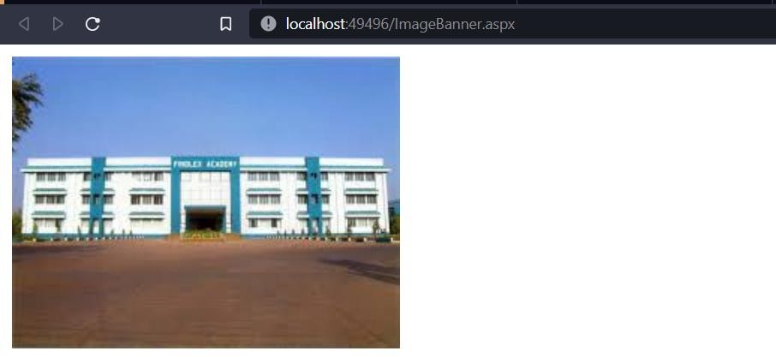

# Design an ASP.NET web form to demonstrate UpdatePanel and UpdateProgress AJAX controls.

**Design File:**

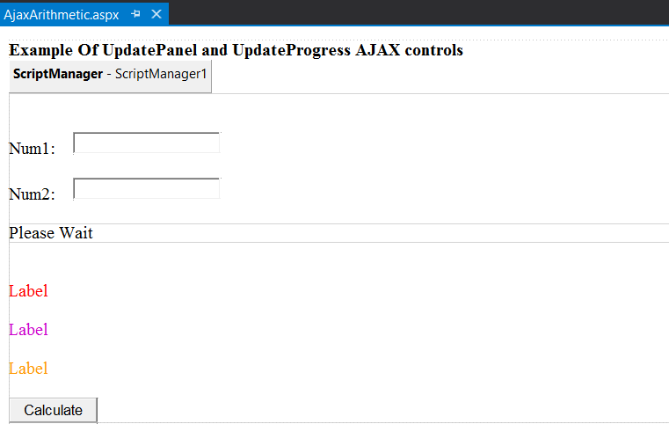

**Code Behind File**:

using System;

using System.Collections.Generic; using System.Linq;

using System.Web; using System.Web.UI;

using System.Web.UI.WebControls;

public partial class AjaxArithmetic : System.Web.UI.Page

{

protected void clearAllTextBox()

{

lbladd.Text = ""; lblsub.Text = ""; lbldiv.Text = "";

}

protected void Page_Load(object sender, EventArgs e)

{

}

protected void btncal_Click(object sender, EventArgs e)

{

clearAllTextBox(); try

{

int n1 = Convert.ToInt32(txtnum1.Text); int n2 = Convert.ToInt32(txtnum2.Text); System.Threading.Thread.Sleep(5000); int add = n1 + n2;

int sub = n1 - n2; int mul = n1 * n2;

lbladd.Text = string.Format(" Addition = {0}", add); lblsub.Text = string.Format(" Subtraction = {0}", sub); lbldiv.Text = string.Format("Multiplication = {0}", mul);

}

catch (Exception ex)

{

}

}

}

**Output:**

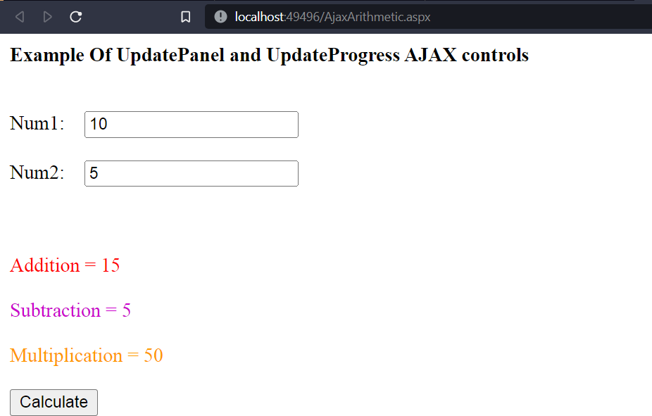

# Design an ASP.NET web form to show paginated output of customer_info table in GridView using AJAX.

**Design File:**

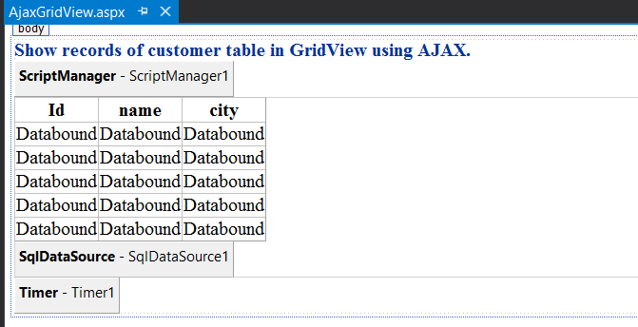

**Code Behind File:**

using System;

using System.Collections.Generic; using System.Linq;

using System.Web; using System.Web.UI;

using System.Web.UI.WebControls;

public partial class AjaxGridView : System.Web.UI.Page

{

protected void Page_Load(object sender, EventArgs e)

{

}

protected void Timer1_Tick(object sender, EventArgs e)

{

if (GridView1.PageIndex != GridView1.PageCount - 1)

{ GridView1.PageIndex = GridView1.PageIndex + 1; } else

{ GridView1.PageIndex = 0; }

}

}

**Output:**

