Exercise:

# Create an MVC application to demonstrate ViewBag Object.

## HomeController.cs

using System;

using System.Collections.Generic; using System.Linq;

using System.Web; using System.Web.Mvc;

namespace Practical6MVC.Controllers

{

public class HomeController : Controller

{

// GET: Home

public ViewResult Index()

{

int h = DateTime.Now.Hour;

ViewBag.greet = h < 12 ? "Good Morning" : "Good Afternoon"; return View();

}

}

}

## Index.cshtml

@{

Layout = null;

}

<!DOCTYPE html>

<html>

<head>

<meta name="viewport" content="width=device-width" />

<title>Index</title>

</head>

<body>

<div>

<h2> @ViewBag.greet</h2>

</div>

</body>

</html>

**Output:**

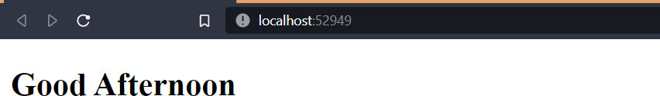

# Create an MVC application to accept Customer details and display the same using views. Use automatically implemented properties, strongly typed HTML Input helpers methods.

**HomeController.cs** using MVC3.Models; using System;

using System.Collections.Generic; using System.Linq;

using System.Web; using System.Web.Mvc;

namespace MVC3.Controllers

{

public class HomeController : Controller

{

// GET: Home

public ActionResult Index()

{

return View();

}

[HttpGet]

public ViewResult CustomerInput()

{

return View();

}

[HttpPost]

public ViewResult CustomerInput(Customer c1)

{

if (ModelState.IsValid)

{ return View("CustomerDisplay", c1); } else

{ //There is validation error return View();

}

}

public ViewResult ProductInfo()

{

return View();

}

}

}

## Customer.cs

using System;

using System.Collections.Generic;

using System.ComponentModel.DataAnnotations; using System.Linq;

using System.Web;

namespace MVC3.Models

{

public class Customer

{

[Required(ErrorMessage = "Please enter Customer ID!")] public int CustID { get; set; }

[Required(ErrorMessage = "Please enter Customer Name!")] public string CustName { get; set; }

[Required(ErrorMessage = "Please enter Customer Address!")] public string CustAdd { get; set; }

}

}

## CustomerDisplay.cshtml

@model MVC3.Models.Customer

@{

Layout = null;

}

<!DOCTYPE html>

<html>

<head>

<link href="~/Content/bootstrap.css" rel="stylesheet" />

<link href="~/Content/bootstrap-theme.css" rel="stylesheet" />

<meta name="viewport" content="width=device-width" />

<title>CustomerDisplay</title>

<style>

body {

background-color: #F1F1F1;

}

</style>

</head>

<body>

<div class="text-center">

<h1>Customer Information System</h1>

<p>Customer ID : @Model.CustID</p>

<p>Customer Name : @Model.CustName</p>

<p>Customer Address : @Model.CustAdd</p>

</div>

</body>

</html>

## CustomerInput.cshtml

@model MVC3.Models.Customer

@{

Layout = null;

}

<!DOCTYPE html>

<html>

<head>

<link href="~/Content/bootstrap.css" rel="stylesheet" />

<link href="~/Content/bootstrap-theme.css" rel="stylesheet" />

<meta name="viewport" content="width=device-width" />

<link rel="stylesheet" type="text/css" href="~/StyleSheet1.css" />

<title>CustomerInput</title>

</head>

<body>

<div class="panel panel-success">

<div class="panel-heading text-center">

<h4>

Customer Information System

</h4>

</div>

<div class="panel-body"> @using (Html.BeginForm())

{

@Html.ValidationSummary()

<div class="form-group">

<label>Customer ID :</label>@Html.TextBoxFor(x => x.CustID, new

{ @class = "form-control" })

</div>

<div class="form-group">

<label>Customer Name :</label>@Html.TextBoxFor(x =>

x.CustName, new { @class = "form-control" })

</div><div class="form-group">

<label>Customer Address:</label>@Html.TextBoxFor(x => x.CustAdd, new { @class = "form-control" })

</div>

<div class="text-center">

<input class="btn btn-success" type="submit" value="Submit Customer Data" />

</div>

}

</div>

</div>

</body>

</html>

## Index.cshtml

@{

Layout = null;

}

<!DOCTYPE html>

<html>

<head>

<meta name="viewport" content="width=device-width" />

<link href="~/Content/bootstrap.css" rel="stylesheet" />

<link href="~/Content/bootstrap-theme.css" rel="stylesheet" />

<title>Index</title>

<style>

.btn a {

color: white;

text-decoration: none;

}

body {

background-color: #F1F1F1;

}

</style>

</head>

<body>

<div class="text-center">

<p><h1>Customer Information System </h1><br /> </p>

<div class="btn btn-success">

@Html.ActionLink("Add Customer Details", "CustomerInput")

</div>

</div>

</body>

</html>

## ProductInfo.cshtml

@{

ViewBag.Title = "ProductInfo";

Layout = "~/Views/_BasicLayout.cshtml";

}

<h2>ProductInfo</h2>

## _BasicLayout.cshtml

<!DOCTYPE html>

<html>

<head>

<meta name="viewport" content="width=device-width" />

<title>@ViewBag.Title</title>

</head>

<body>

<div>

<h2>Product Information</h2>

<div style="padding: 20px; border: solid medium black; font-size: 20pt"> @RenderBody()

</div>

<h2>Visit <a href="[http://flipkart.com](http://flipkart.com/)">flipkart</a></h2>

</div>

</body>

</html>

**Output:**

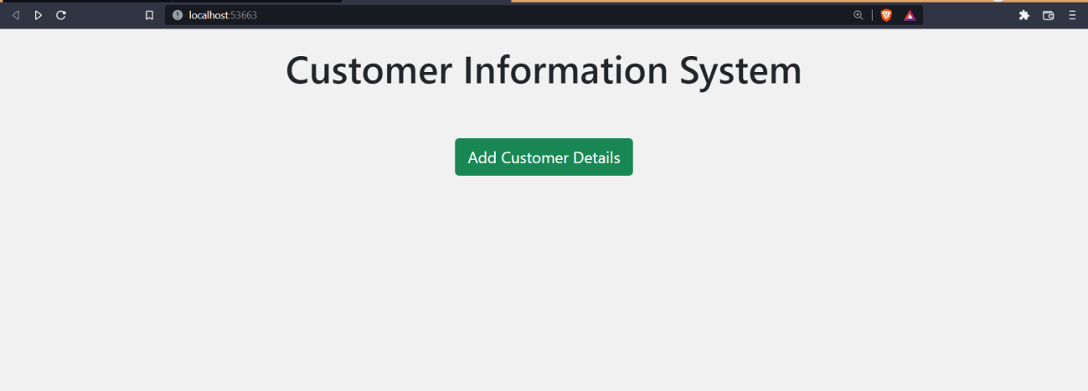

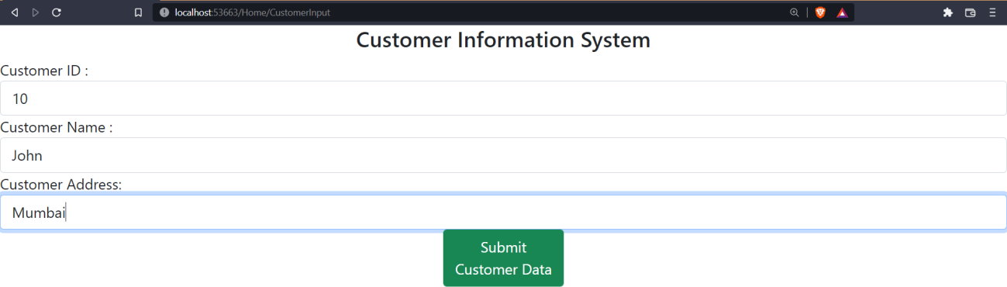

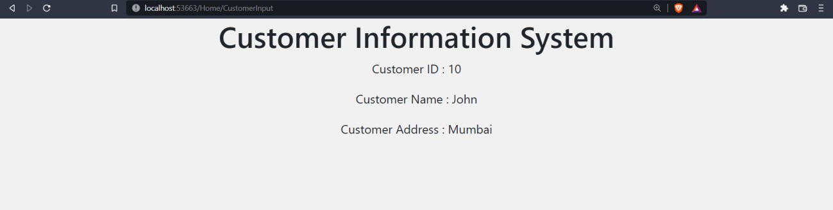

# Create an MVC application to demonstrate extension methods and use layout.

## Users.cs

using System;

using System.Collections.Generic; using System.Linq;

using System.Web; namespace Practical6.Models

{

public class Users

{

public List Customers { get; set; }

}

}

## Customer.cs

using System;

using System.Collections.Generic; using System.Linq; using System.Web; namespace Practical6.Models

{

public class Customer

{

public int CustID { get; set; }

public string CustName { get; set; } public string CustAddress { get; set; }

}

}

## MyExtensionMethodClass.cs

using System;

using System.Collections.Generic; using System.Linq;

using System.Web; namespace Practical6.Models

{

public static class MyExtensionMethodClass

{

public static decimal TotalCustomers(this Users user)

{

decimal total = 0;

foreach (Customer c in user.Customers)

{

total += 1;

}

return total;

}

}

}

**HomeController.cs** using Practical6.Models; using System;

using System.Collections.Generic; using System.Linq;

using System.Web; using System.Web.Mvc;

namespace Practical6.Controllers

{

public class HomeController : Controller

{

// GET: Home public ViewResult UseExtension()

{

Users user = new Users

{

Customers=new List

{

new Customer{ CustID= 45,CustName="Sameer",CustAddress="Arogya Mandir"}, new Customer{ CustID= 46,CustName="Suhail",CustAddress="MIDC"},

new Customer{ CustID= 47,CustName="Sakshi",CustAddress="Maruti Mandir"}, new Customer{ CustID= 48,CustName="Sneha",CustAddress="UDhyamnagar"} } }; decimal totalCustomers =user.TotalCustomers();

return View((object)("Total:"+totalCustomers)); }

}

}

## UseExtension.cshtml

@model String @

{

ViewBag.Title = "Result

Layout= "~/Views/_BasicLayout.cshtml";

}

<h2>Result</h2>

<div>@Model</div>

## _BasicLayout.cshtml

<!DOCTYPE html>

<html>

<head>

<meta name="viewport" content="width=device-width" />

<title>@ViewBag.Title</title>

</head>

<body >

<h1> Basic Layout Demo with Extension Method</h1>

<div style="padding:20px;border:solid medium black; font-size:10px;backgroundcolor:orange"> @RenderBody()

</div>

</body>

</html>

## Output:

