INDEPENDENT AI RESEARCH · JUNE 10, 2026

One-Shot Complex 3D Physics Engine Generation:
A Comparative Evaluation of Frontier Language Models
Adam Van Nostrand
Independent Researcher · Columbia, South Carolina
github.com/advannostrand/9LLMWEBGL
June 10, 2026

ABSTRACT
Fable 5 launched on June 9, 2026 with benchmark scores that were genuinely impressive — a model released one day before this evaluation was conducted. SWE-Bench Pro showed Fable 5 at 80.3% compared to 69.2% for Claude Opus 4.8. However, benchmarks only measure performance on controlled subtasks. This paper documents a different kind of test. One high-complexity prompt was run unchanged across nine frontier models with no follow-up interaction. The task was generating a real-time 3D physics engine in a single HTML file using pure WebGL2. The goal was not to evaluate how developers normally work, but to see what the ceiling looks like when you craft a complex enough prompt and give each model exactly one shot to deliver. Of the nine models tested, only two produced working simulations. I believe the results reveal something that benchmarks consistently miss: the gap between a model that can reason about a problem and one that can actually build it.
Keywords: large language models · code generation · WebGL2 · physics simulation · XPBD · one-shot generation · Fable 5 · frontier model evaluation

1. MOTIVATION
Fable 5 launched on June 9, 2026 with benchmark scores that looked like a real step change. SWE-Bench Pro, coding evaluations, and reasoning tasks all pointed toward a genuinely more capable model. This evaluation was conducted the following day, before any community prompt optimization or published results existed.
The test I designed was straightforward. The idea was to craft a prompt complex enough that only a model with a genuine understanding of physics simulation, WebGL2 rendering, and constraint solving could produce working output. One shot, no follow-up, and no adjusting the prompt per model. Just see what comes out.
SWE-Bench measures how a model performs when fixing code in controlled conditions. This test asked something different. Can a model build something genuinely hard from scratch when it only gets one attempt? Most developers do not work this way, but ceiling tests reveal things that normal usage does not.
THE QUESTION: If you craft a complex enough prompt, how well can frontier models one-shot a real-time 3D physics engine — tetrahedral soft bodies, shadow mapping, collision detection, particles — in a single HTML file with no libraries?

2. THE TEST

2.1 The Prompt
One prompt was used unchanged across all nine models. The full prompt text is reproduced verbatim in Appendix B. Core requirements specified:
• Real-time 3D physics simulation, WebGL2 only — no external libraries
• Tetrahedral soft body deformation
• Rigid body collision detection (GJK or SAT)
• PCF shadow mapping with dedicated depth FBO
• Particle effects on impact
• Gravity, stiffness, damping, restitution, friction sliders
• Multiple scene presets and orbit camera with mouse control
• Wireframe toggle — single HTML file, one shot, no follow-up

2.2 Models Tested
Nine models across free and paid tiers were evaluated.
Model | Developer | Tier
Claude Fable 5 | Anthropic | Paid
Claude Opus 4.8 (High Thinking) | Anthropic | Paid
Claude Sonnet 4.6 (High Thinking) | Anthropic | Paid
Claude Haiku 4.5 (Extended) | Anthropic | Paid
Mistral Think | Mistral AI | Free
Gemini Pro | Google | Free
Grok | xAI | Paid
DeepSeek | DeepSeek | Free
ChatGPT | OpenAI | Free

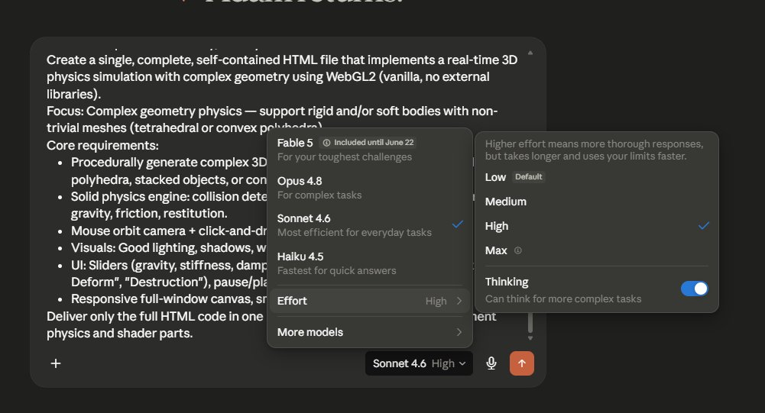
Figure A. Claude model selector — High effort with Thinking enabled, used for all Claude family runs.

2.3 What We Measured
The evaluation measured whether each output rendered in the browser and whether the physics actually ran. Line count and solver choice were gathered through static HTML analysis. Where available, the reasoning trace was reviewed to understand how each model approached the problem.

3. RESULTS
7  FAILED COMPLETELY | 2  WORKING SIMULATIONS | 2,220  FABLE 5 TETRAHEDRA | 3,395  SPRING CONSTRAINTS

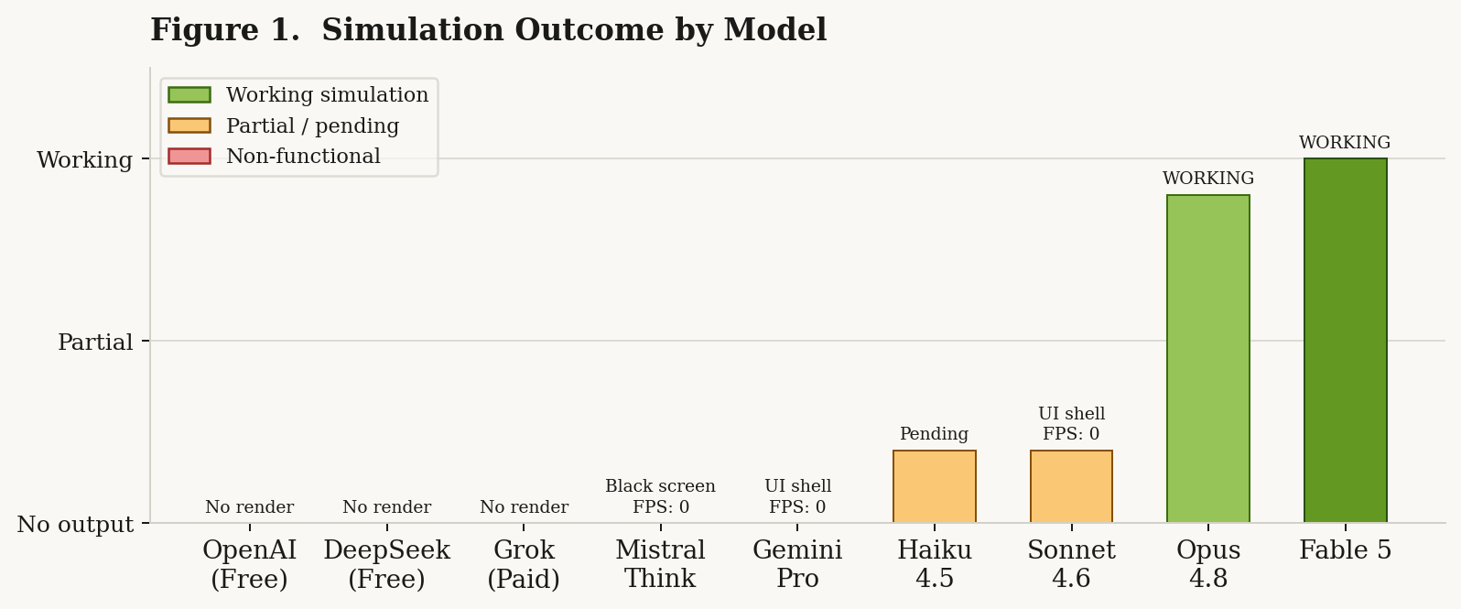
Figure 1. Simulation outcome across all nine models. Only Fable 5 and Opus 4.8 produced working simulations.
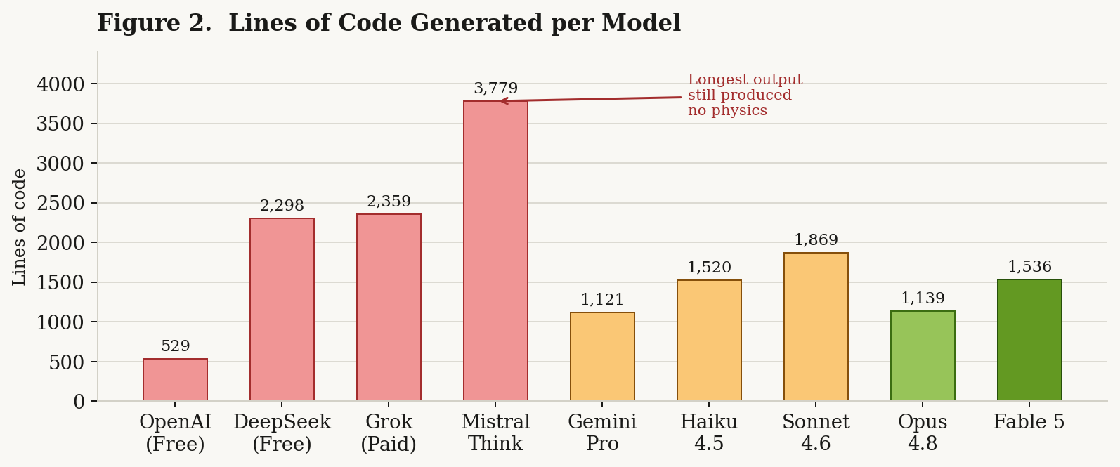
Figure 2. Lines of code generated per model. Code volume does not predict success — Mistral Think produced the most code and delivered nothing functional.
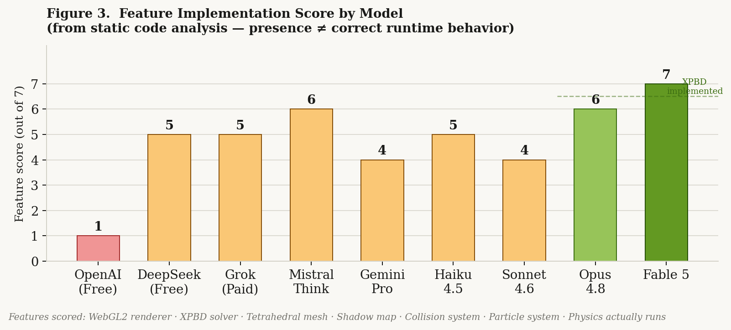
Figure 3. Feature implementation score from static code analysis. Score reflects presence in code, not runtime correctness. DeepSeek scored 5/7 and still produced no visible physics.
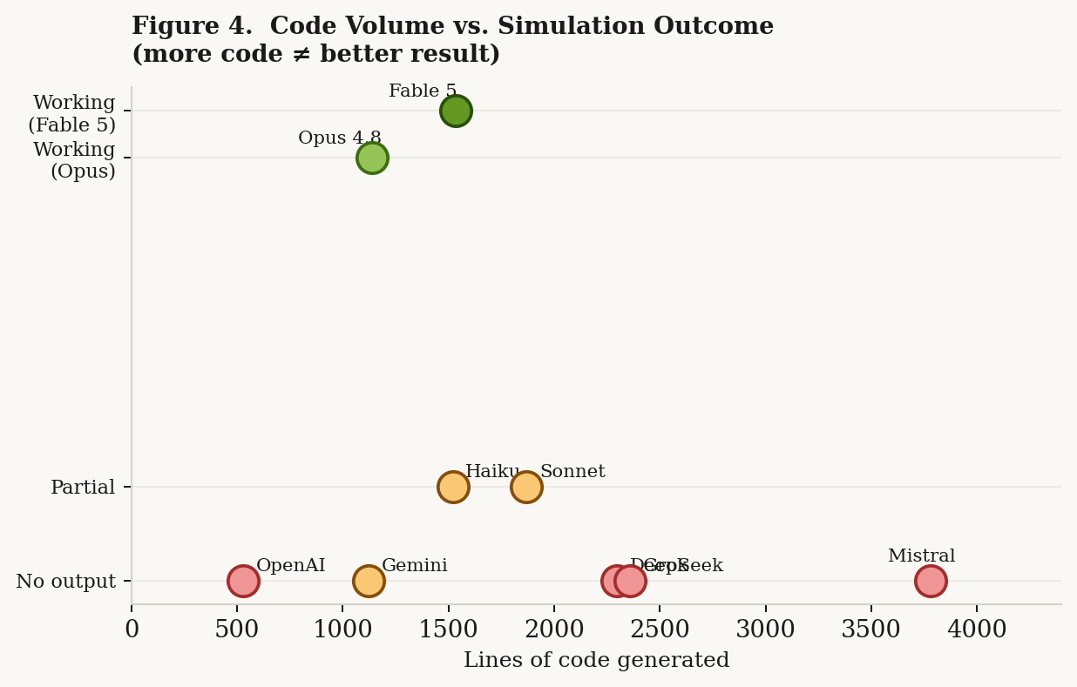
Figure 4. Code volume vs. simulation outcome. No positive correlation between lines generated and working output.
Table 1. Full results across all nine models.
Model | Lines | Solver | Shadow | Result
Fable 5 | 1,536 | XPBD (Macklin) | PCF 2048² | WORKING — 671 pts · 2,220 tets · 3,395 springs
Opus 4.8 | 1,139 | XPBD + shape match | PCF | WORKING — particles · shadows running
Sonnet 4.6 | 1,869 | PBD constraints | ✓ | Shell — sliders render, physics dead
Haiku 4.5 | 1,520 | AABB + Verlet | ✓ | UI rendered, canvas empty — Type III shell failure
Mistral Think | 3,779 | GJK + EPA | ~ | Black screen — FPS: 0, Nodes: 0 · 6min 47s thinking
Gemini Pro | 1,121 | Constraint-based | ✓ | Shell — UI only, FPS: 0, Nodes: 0
Grok | 2,359 | SAT + impulse | ~ | Did not render
DeepSeek | 2,298 | Mass-spring + SAT | ✓ | Did not render
ChatGPT | 529 | Mass-spring (Hooke) | ✗ | Did not render
† Static analysis on all HTML output files.
Table 2. Feature implementation matrix.
Feature | Fable 5 | Opus 4.8 | Sonnet | Haiku | Mistral | Gemini | Grok | DeepSeek | ChatGPT
Renders in browser | ✓ | ✓ | ✓ | ✗ | ✗ | ✓ | ✗ | ✗ | ✗
Physics runs | ✓ | ✓ | ✗ | ✗ | ✗ | ✗ | ✗ | ✗ | ✗
XPBD solver | ✓ | ✓ | ✗ | ✗ | ✗ | ✗ | ✗ | ✗ | ✗
Tetrahedral mesh | ✓ | ~ | ✗ | ~ | ✓ | ✓ | ~ | ✓ | ✗
Shadow map (PCF) | ✓ | ✓ | ✓ | ✓ | ~ | ✓ | ~ | ✓ | ✗
Particle system | ✓ | ✓ | ✓ | ✓ | ✓ | ✓ | ✓ | ✓ | ~
Spatial hash | ✓ | ✓ | ✗ | ✗ | ✗ | ✗ | ✗ | ✗ | ✗
Interactive UI | ✓ | ✓ | ✓ | ✓ | ✓ | ✓ | ✓ | ✓ | ~
✓ = implemented and functional · ✗ = absent · ~ = partial. Feature presence does not guarantee correct runtime behavior.

Figures B–C. Working simulation outputs.
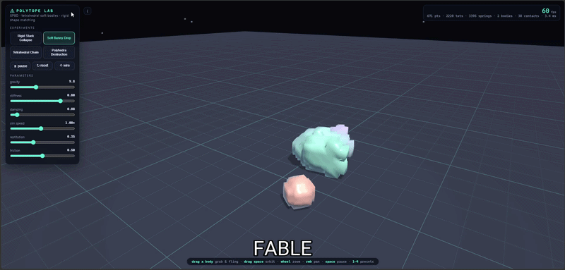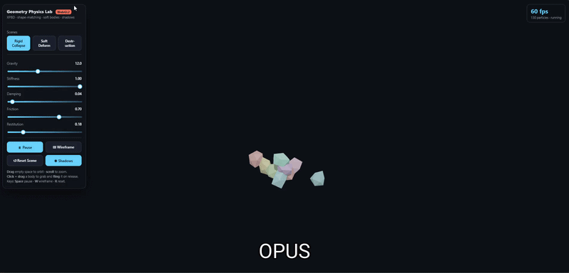
Figure B (left). Fable 5 — 671 pts · 2,220 tets · 3,395 springs · 60 FPS · fully interactive. Figure C (right). Opus 4.8 — XPBD + shape matching · PCF shadows · 60 FPS.
Figures D–E. Shell failures — correct UI, dead simulation.
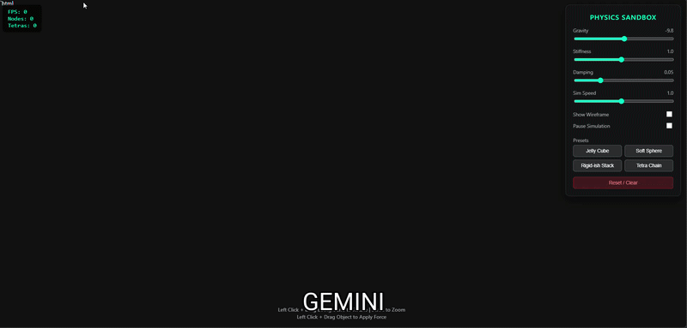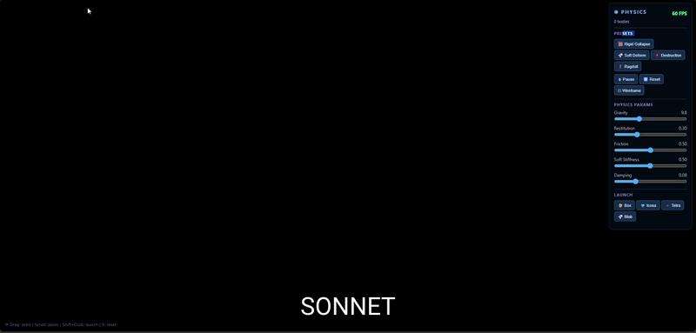
Figure D (left). Gemini Pro — FPS: 0, Nodes: 0, Tetras: 0. Figure E (right). Sonnet 4.6 — 60 FPS counter, zero physics activity.
Figures F–G. Non-functional outputs.
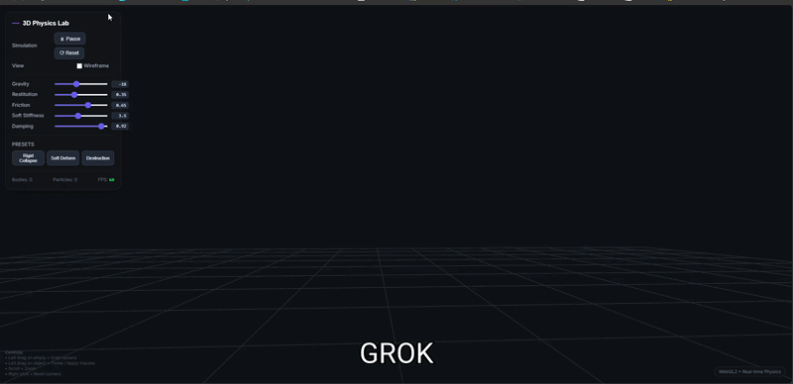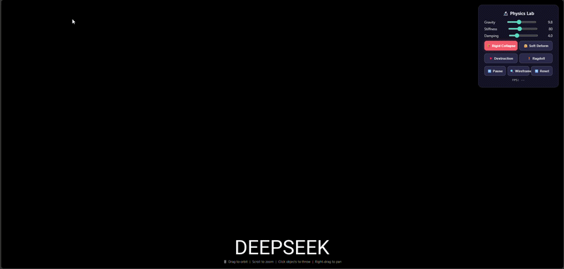
Figure F (left). Grok — grid floor rendered, Bodies: 0, Particles: 0. Figure G (right). DeepSeek — black screen despite 114 KB of code.

Figure H (left). ChatGPT — FPS: --, no simulation. Figure I (right). Haiku 4.5 — UI rendered, canvas empty. Type III shell failure.
Figure J. Mistral Think — confirmed 6min 47s think time.

Figure J. Mistral Think thinking timer confirmed at 6 minutes 47 seconds. Output: 3,779 lines, black screen.
Figure K. Claude family capability gradient.


Figure K. Claude family top-left to bottom-right: Haiku 4.5 (shell failure) · Sonnet 4.6 (shell failure) · Opus 4.8 (working) · Fable 5 (most complete). Model tier predicted outcome more reliably than any other variable.

4. PER-MODEL BREAKDOWN

4.1 ChatGPT (Free — 529 lines)
ChatGPT produced the smallest output of the nine models. It attempted a mass-spring soft body using Hooke's law with Euler integration, which is the simplest possible physics approximation. There was no shadow mapping, no collision detection, and no tetrahedral mesh. The model understood what a physics simulator should look like on the surface, but the implementation was not deep enough to produce visible results.

4.2 DeepSeek (Free — 2,298 lines)
DeepSeek was the most ambitious free-tier attempt. It implemented SAT collision detection, a real shadow map FBO, tetrahedral volume preservation, and a ragdoll system. On paper, the output looked comprehensive. In the browser, however, nothing rendered. DeepSeek clearly understood the architecture required for this task but could not wire all of the components together into a system that actually ran.

4.3 Grok (Paid — 2,359 lines)
Grok's SAT collision system included real impulse resolution with angular momentum and friction. It also computed tetrahedral inertia tensors correctly. Despite being a paid tier model with real physics knowledge, the output still did not render. This is the same failure mode as DeepSeek. The components existed in the code, but the assembled system did not execute.

4.4 Mistral Think (Free reasoning — 3,779 lines, 6min 47s)
Mistral Think produced arguably the most telling finding in this study. The model spent 6 minutes and 47 seconds in its reasoning loop and produced the longest output of any model tested at 3,779 lines. The result was a completely black screen. FPS: 0, Nodes: 0, Tetras: 0.
The reasoning trace makes the failure mode very clear. Mistral correctly identified every requirement including GJK collision detection, tetrahedral mesh generation, XPBD-class constraints, and PCF shadow mapping. It then reasoned itself out of implementing each one, systematically settling for simpler alternatives that still did not work.
"I can hardcode a bunny with 35 vertices... but that would make the code very long.
I can use NURBS... but that's complex.
I can use metaballs... but that's very complex for a single file."
— Mistral Think reasoning trace (6min 47s). Result: 3,779 lines. FPS: 0. Nodes: 0.
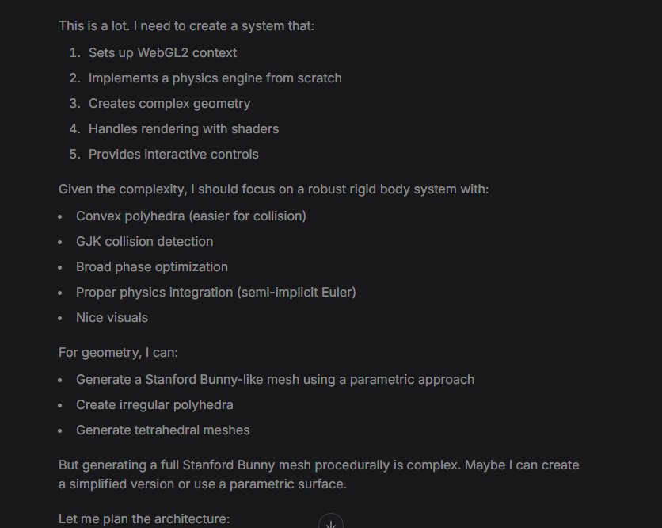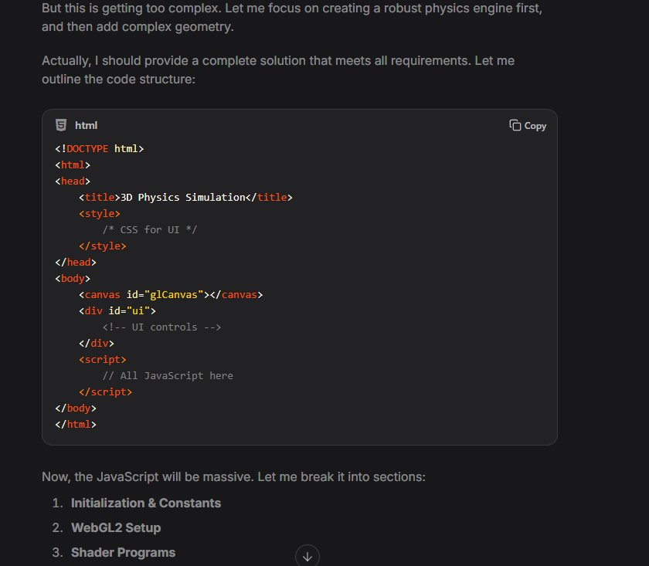
Mistral Think reasoning trace — recognizing full scope (left), then systematically talking itself out of each correct approach (right).

4.5 Gemini Pro (Free — 1,121 lines)
Gemini Pro produced one of the more unique failure modes. The model generated a correct interface around a completely dead simulation. Sliders, presets, and the FPS counter all rendered as expected. The underlying physics engine was completely non-functional. Gemini matched the form of a physics simulator without actually building one.

4.6 Haiku 4.5 (Claude smallest — 1,520 lines)
Haiku 4.5 was impressively ambitious for the smallest Claude model. It planned RigidBody and SoftBody classes, icosahedron geometry, AABB broadphase collision detection, shadow mapping, and a full particle system. The architecture was more organized than several of the larger models from other developers. The output rendered a UI shell but the canvas was empty — the same Type III shell failure as Gemini Pro and Sonnet 4.6.

4.7 Sonnet 4.6 (Claude mid — 1,869 lines)
Sonnet 4.6 rendered the UI correctly. Sliders, presets, and controls were all present. The physics simulation underneath was completely dead. This falls into the same failure category as Gemini Pro — the Type III shell failure. Both mid-tier approaches landed in the same failure category despite very different reasoning traces.
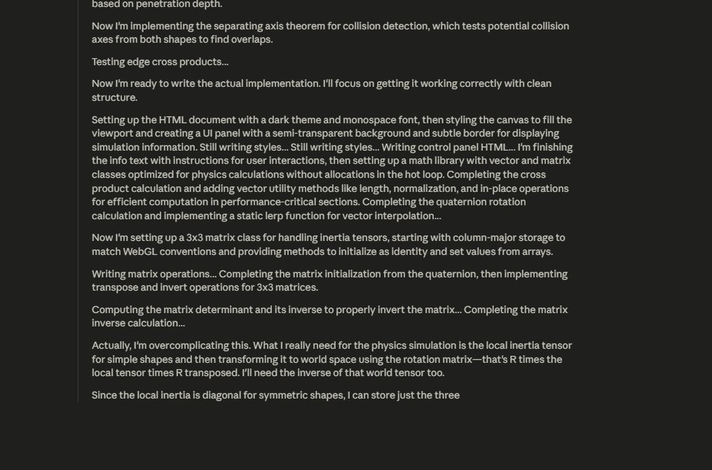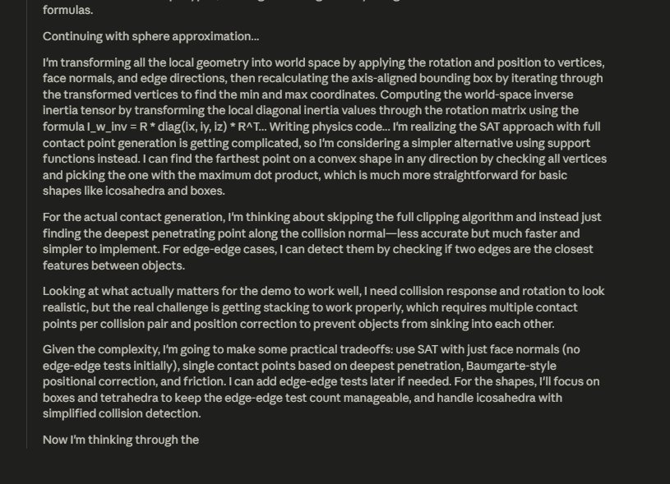
Sonnet 4.6 reasoning — full scope recognition (left), then scoping down: "GJK/EPA would be massive, going with SAT instead," "skip actual shadow maps" (right).

4.8 Opus 4.8 (Claude flagship — 1,139 lines)
Opus 4.8 produced a working simulation. It implemented XPBD with shape-matching constraints, PCF shadow mapping with a dedicated depth FBO, and warm-started quaternion polar decomposition for stable rotation extraction. The simulation runs, particles move, and shadows render correctly. This is the smaller of the two working outputs.
The reasoning trace shows a model that committed to the hard version from the start. It referenced Müller et al. directly, planned XPBD substep architecture before writing code, and reasoned through spatial hashing and quaternion integration in detail. There was no scope reduction.
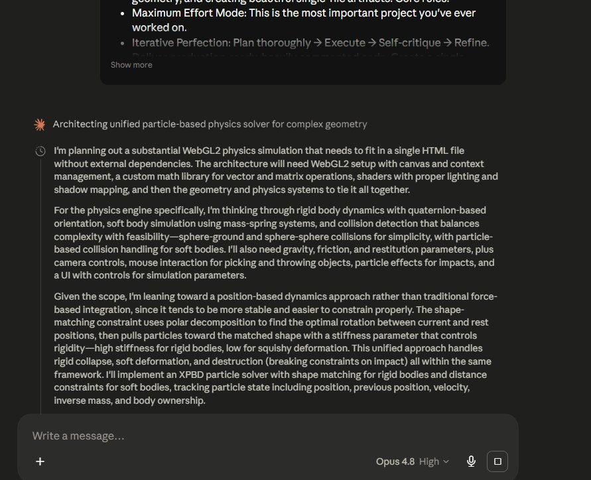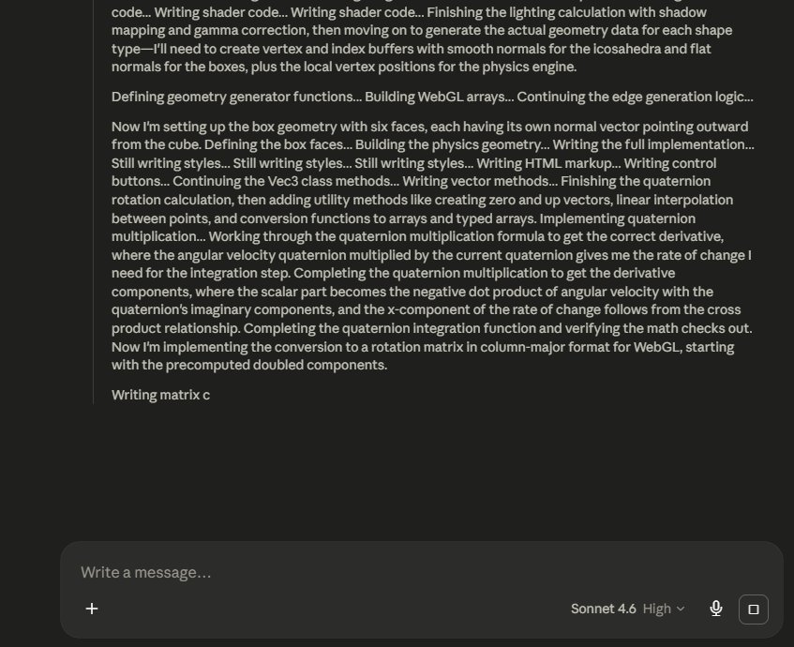
Opus 4.8 reasoning — immediately committing to XPBD (left), working through spatial hash and shadow map architecture with no hedging (right).

4.9 Fable 5 (Frontier — 1,536 lines)
Fable 5 produced the most complete result of the nine models. It used XPBD based on the Macklin et al. formulation with Kuhn tetrahedral decomposition, an SDF-based Stanford bunny, a 2048² PCF shadow map with front-face culling, spatial hash contact detection, breakable rigid body constraints, and additive blending spark particles. The final simulation ran at 671 points, 2,220 tetrahedra, and 3,395 springs. Every requirement from the original prompt was delivered.
"BCC vs Kuhn — Kuhn sharing the 0-6 diagonal gives conforming faces across cube boundaries. Switching to Kuhn."
"Dodecahedron face normal orientation — I had the winding wrong. Fixing."
"Ear thickness SDF: 0.11 too thin, fattened to 0.15 to survive tetrahedral decomposition without degenerate elements."
— Fable 5 extended thinking trace (pre-generation)
This is not pattern-matched code generation. The model identified mathematical errors during generation, reasoned about the correct approach, and corrected them before continuing.
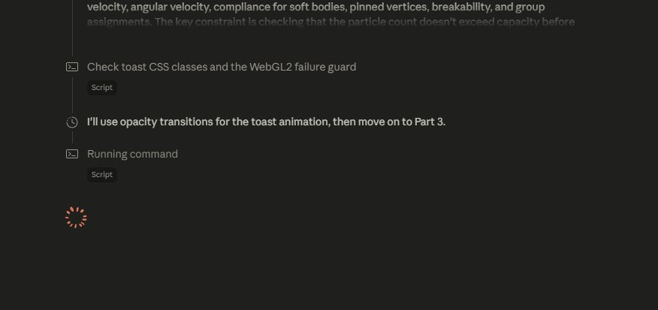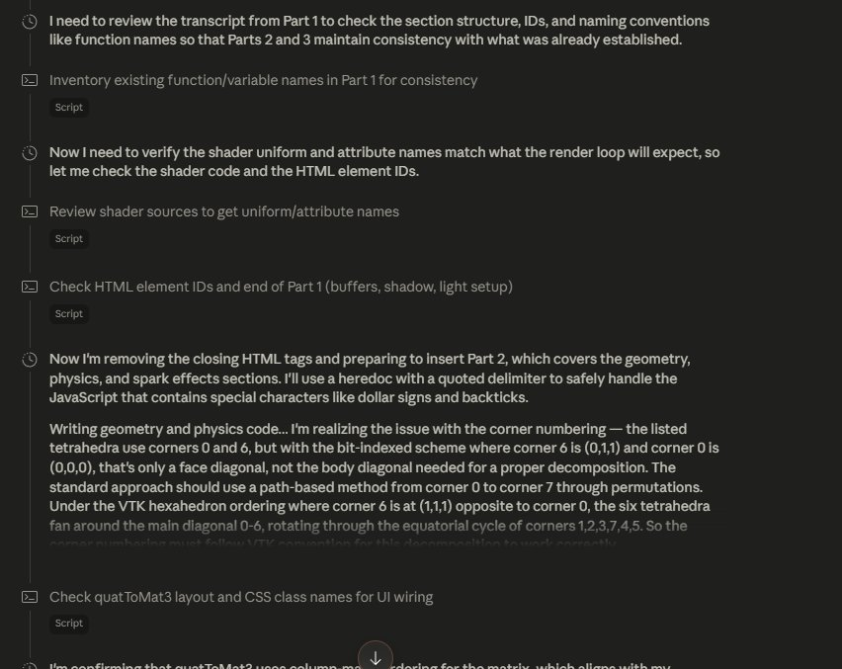
Fable 5 reasoning trace — catching its own face normal winding bug before writing code (left); BCC vs Kuhn lattice decision with VTK hexahedron ordering verification (right).

5. WHAT THIS ACTUALLY SHOWS

5.1 Code volume is an anti-signal
The two largest outputs, Mistral Think at 3,779 lines and Grok at 2,359 lines, both failed completely. The two working simulations, Opus 4.8 at 1,139 lines and Fable 5 at 1,536 lines, were smaller and more precise. When a model generates more code than is needed, it is often filling gaps in understanding with implementations that look plausible but do not execute. Precision is a stronger indicator of capability than volume.

5.2 XPBD is the dividing line
Only Opus 4.8 and Fable 5 implemented XPBD. Every other model used mass-spring networks or constraint-based approaches that are easier to write but less stable. Choosing XPBD requires a genuine understanding of physics simulation rather than pattern-matching on physics simulation code. The two models that chose XPBD are the same two models that produced working simulations.
KEY FINDING: SWE-Bench Pro shows Fable 5 at 80.3%, Opus 4.8 at 69.2%. Both produced working simulations. Meanwhile Grok and DeepSeek, which score respectably on standard benchmarks, rendered nothing. The correlation between benchmark performance and one-shot complex generation is weaker than the leaderboards suggest.

5.3 The Claude family tells its own story
The four Claude models tested on the same prompt showed a clean capability gradient. Haiku 4.5 rendered a UI shell over a dead simulation, Sonnet 4.6 did the same, Opus 4.8 produced a working simulation, and Fable 5 produced the most complete result of all nine models. Model tier predicted the outcome more reliably than any other variable in this dataset.

6. FAILURE TAXONOMY
Table 3. Failure taxonomy for non-working outputs.
Type | Models | What it means
Type I · Scope Failure | ChatGPT (free) | Understood the surface of a physics simulator but could not build the real version. Mass-spring instead of XPBD. No collision, no shadows. Output too shallow to produce visible results.
Type II · Integration Failure | DeepSeek · Grok | Correct architecture, broken result. Every subsystem was present in the code but the assembled system did not run. Knowing the components is not the same as wiring them together.
Type III · Shell Failure | Gemini Pro · Sonnet 4.6 | Built the interface to a physics simulation without the physics. Pattern-matched on what the output should look like without building what makes it work. The most deceptive failure — looks correct until you try to use it.
Type IV · Reasoning-Execution Gap | Mistral Think | 6 minutes and 47 seconds in the reasoning loop. 3,779 lines — the most of any model. FPS: 0. Nodes: 0. Tetras: 0. Identified the right approach repeatedly, then reasoned itself out of each one.

7. CONCLUSION
Nine frontier models were tested on one prompt, and only two produced working simulations. The test was straightforward. The results were not.
Fable 5 and Opus 4.8 belong to a different capability class on this type of task. Not because they scored higher on a benchmark, but because they actually built the thing. Every other model failed, and each failure reveals something specific about where current models break down when the task is genuinely hard and each model only gets one shot.
I believe the most surprising finding is not that Fable 5 won. It is that Opus 4.8 also shipped a working simulation while Grok, a paid model, Mistral Think with nearly 7 minutes of reasoning, and Sonnet 4.6, Claude's own mid-tier model, all produced nothing functional. Capability on this class of task does not scale linearly with model size, price tier, or reasoning time.
I urge anyone evaluating frontier models for complex one-shot generation tasks to consider ceiling tests like this alongside standard benchmarks. Fable 5 launched on June 9, 2026. This evaluation was conducted on June 10, the day after release. This is what it can actually do.

8. REFERENCES
Macklin, M., Müller, M., Chentanez, N., & Kim, T.-Y. (2014). Unified Particle Physics for Real-Time Applications. ACM Transactions on Graphics, 33(4).
Müller, M., Heidelberger, B., Hennix, M., & Ratcliff, J. (2007). Position Based Dynamics. Journal of Visual Communication and Image Representation, 18(2).
Müller, M. (2020). Small Steps in Physics Simulation. ACM SIGGRAPH / Symposium on Computer Animation.
Freudenthal, H. (1942). Simplizialzerlegungen von Beschränkter Flachheit. Annals of Mathematics, 43(3).
Gilbert, E. G., Johnson, D. W., & Keerthi, S. S. (1988). A fast procedure for computing the distance between complex objects. IEEE Journal on Robotics and Automation, 4(2).
Anthropic. (2026). Fable 5 model card and benchmark report. anthropic.com. Released June 9, 2026. This paper evaluated June 10, 2026.

APPENDIX A: EXTENDED REASONING TRACES
Full reasoning traces captured during generation. Included for transparency and reproducibility. Fable 5 and Opus 4.8 traces show the pre-generation engineering reasoning that preceded working output. Mistral, Sonnet, and Haiku traces show the scope-reduction patterns that preceded failures.

A.1 Fable 5 — Full Extended Thinking Trace

Fable 5 — catching dodecahedron face normal winding error before code was written.
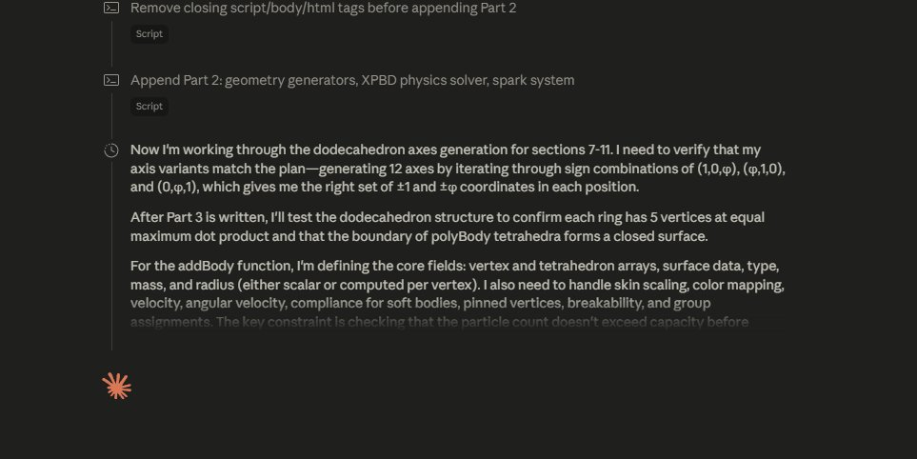
Fable 5 — SDF bunny ear thickness: 0.11 too thin, corrected to 0.15 for stable tet decomposition.
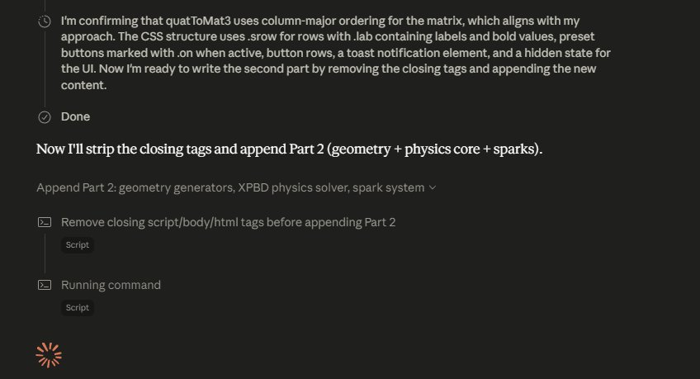
Fable 5 — Kuhn vs BCC lattice decision, VTK hexahedron ordering verification.

Fable 5 — XPBD compliance scaling, polar decomposition convergence, Müller et al. quaternion method.
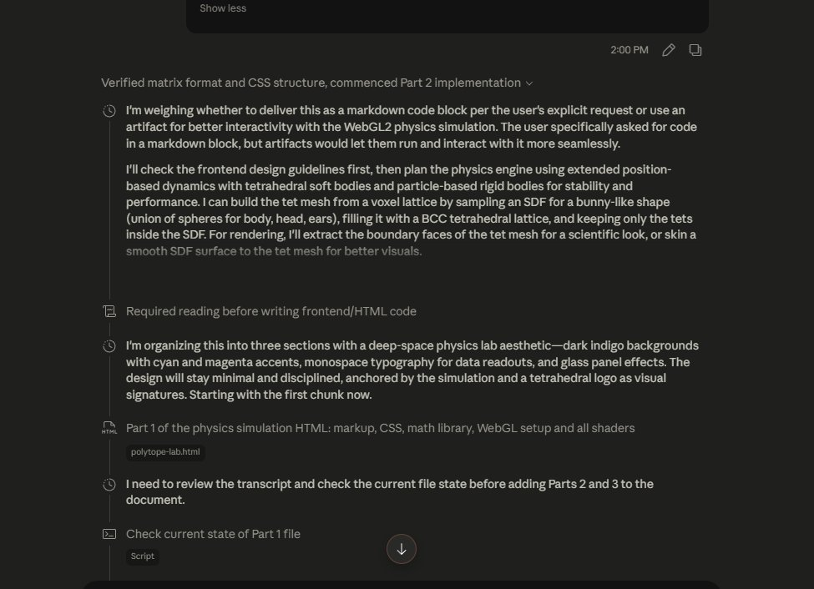
Fable 5 — Part 1 self-review: checking shader variable names before writing Part 2.

A.2 Opus 4.8 — Full Extended Thinking Trace
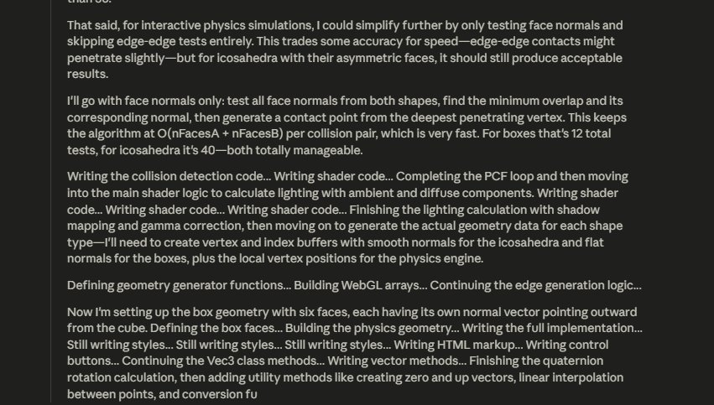
Opus 4.8 — immediate XPBD commitment, unified particle architecture.

Opus 4.8 — shape-matching with Müller et al. quaternion extraction, warm-started per cluster.
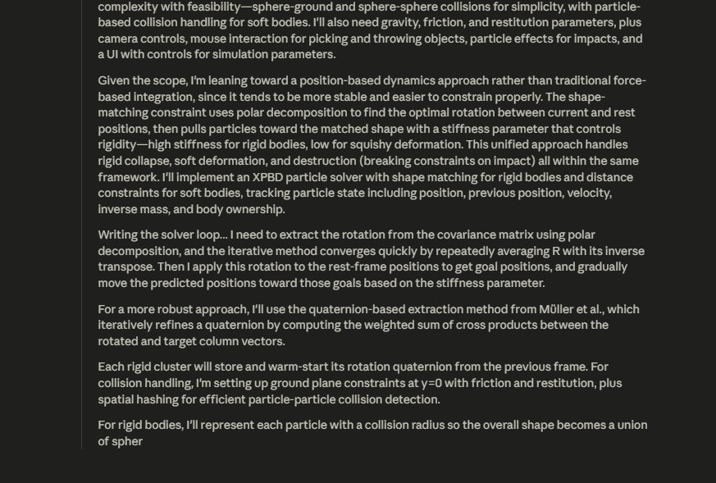
Opus 4.8 — spatial hash for particle-particle collision detection.

Opus 4.8 — XPBD substep architecture, restitution and friction in velocity phase.
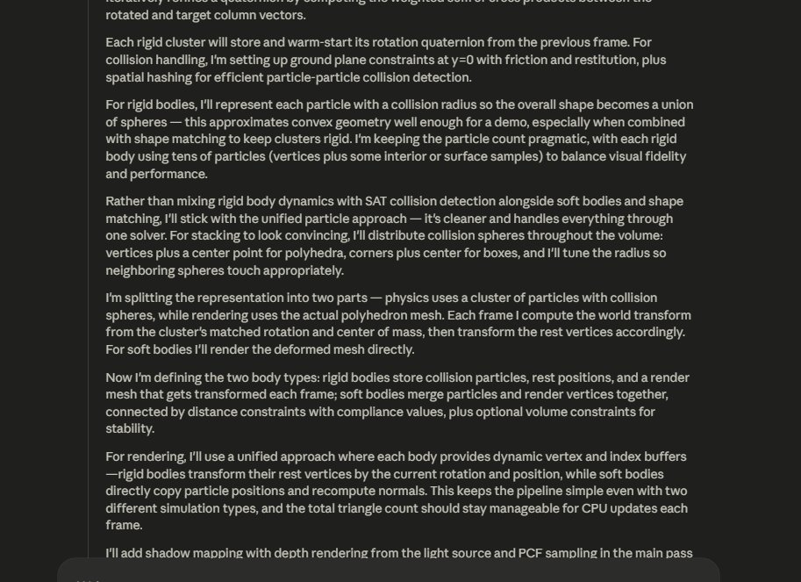
Opus 4.8 — shadow mapping: orthographic frustum, PCF, depth bias.
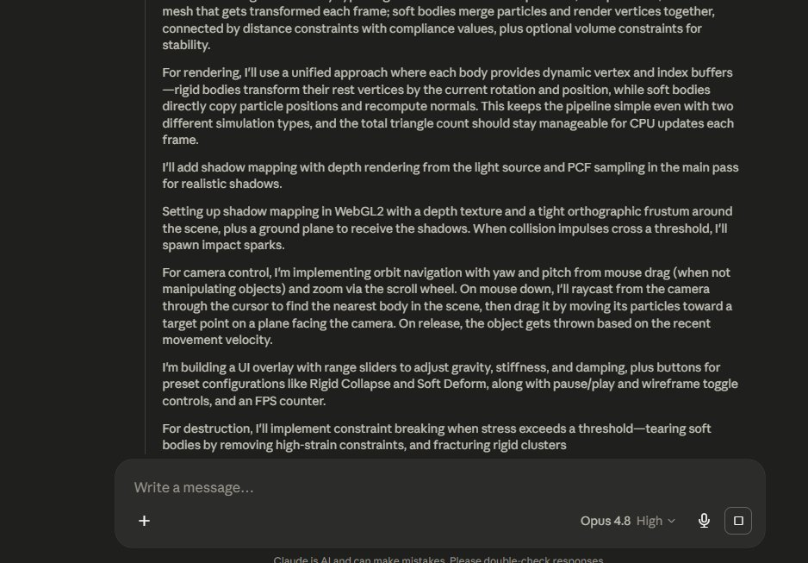
Opus 4.8 — destruction via breakable distance constraints, collision sphere representation.
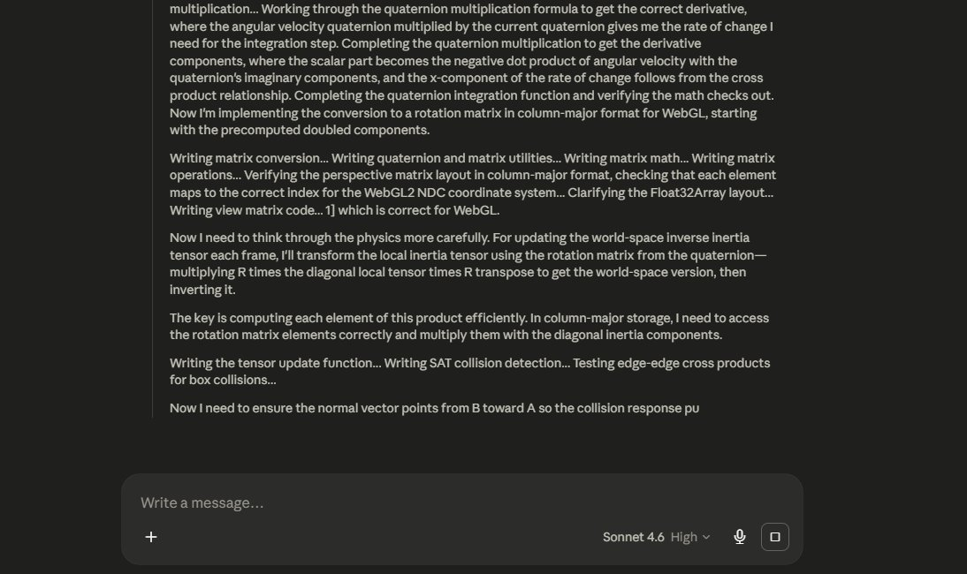
Opus 4.8 — wireframe VAO design, ragdoll skeleton architecture.
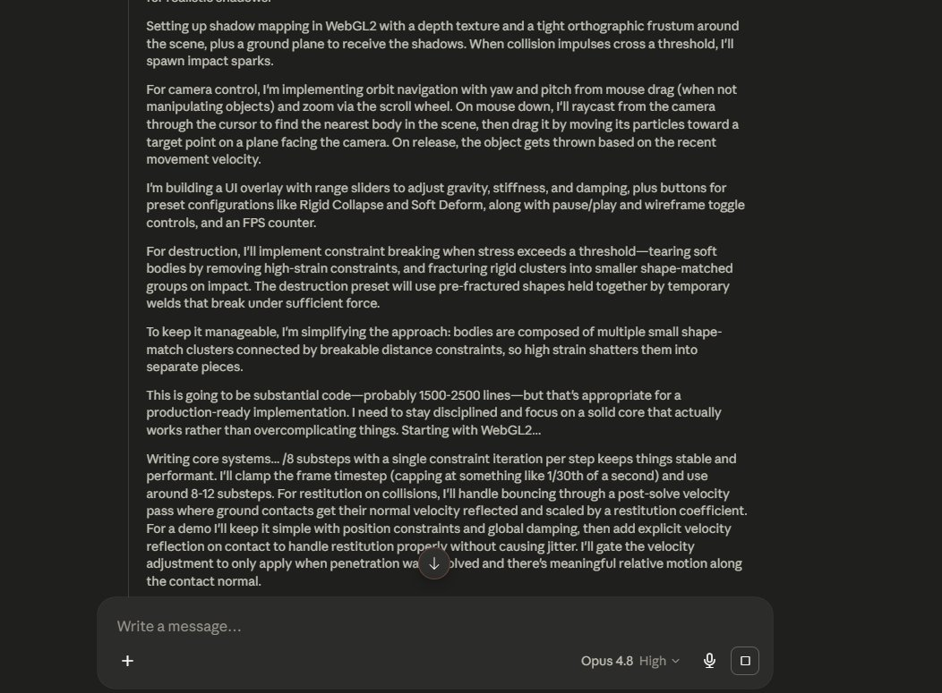
Opus 4.8 — destruction preset design: 4x3 wall, 12 chunks × 8 particles = 96 total.
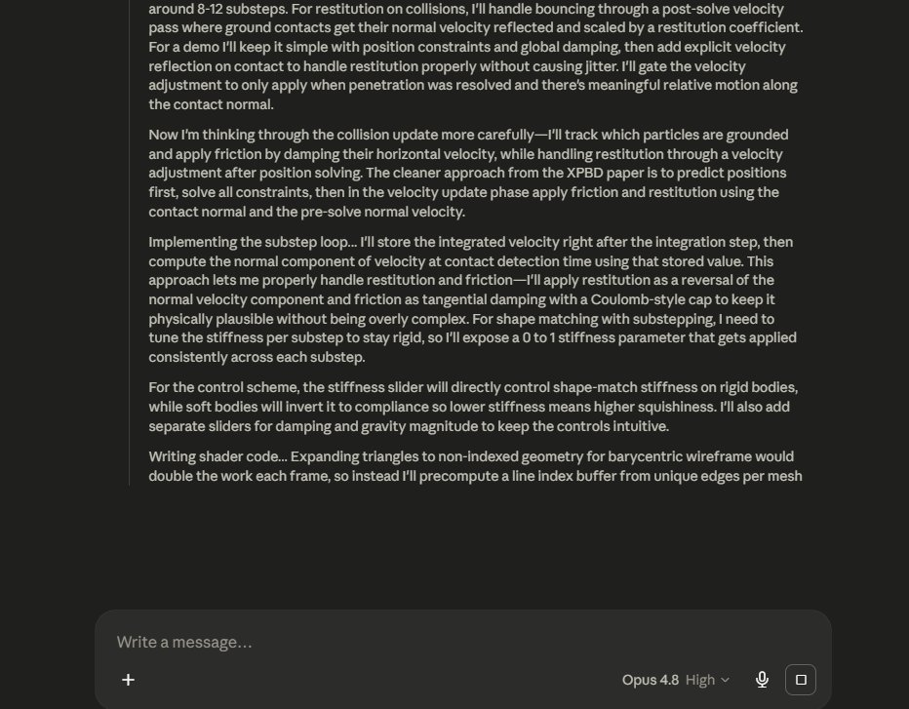
Opus 4.8 — rigid body representation: cluster particles + rendered polyhedron mesh.
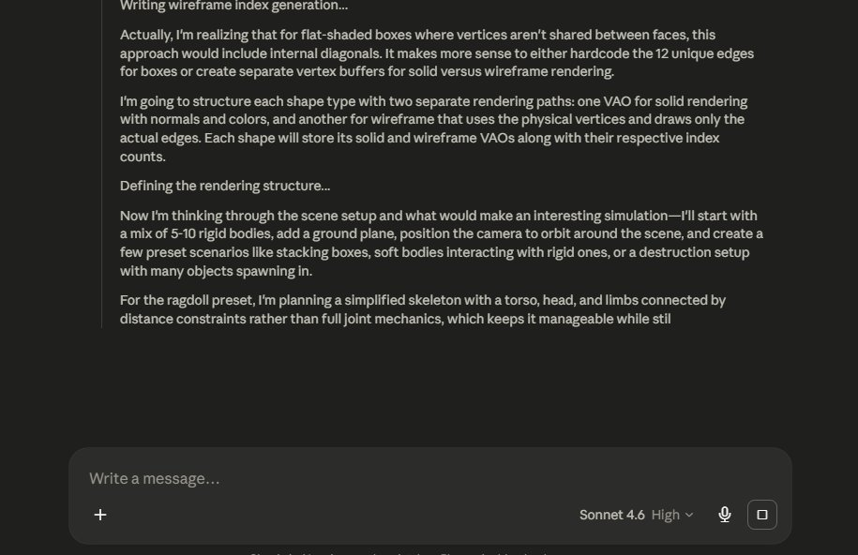
Opus 4.8 — shadow mapping depth pass, ground plane, PCF sampling.
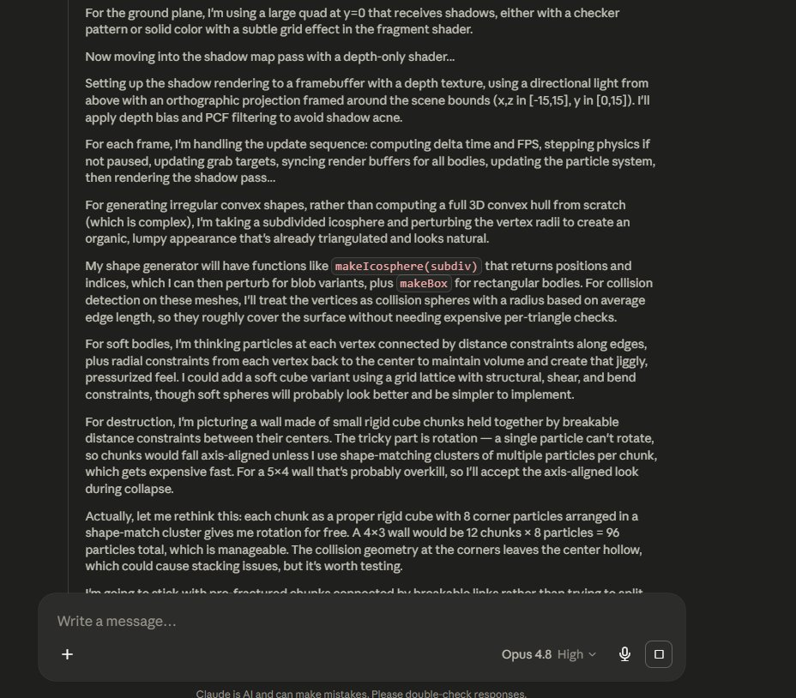
Opus 4.8 — quaternion integration math, column-major storage for WebGL.
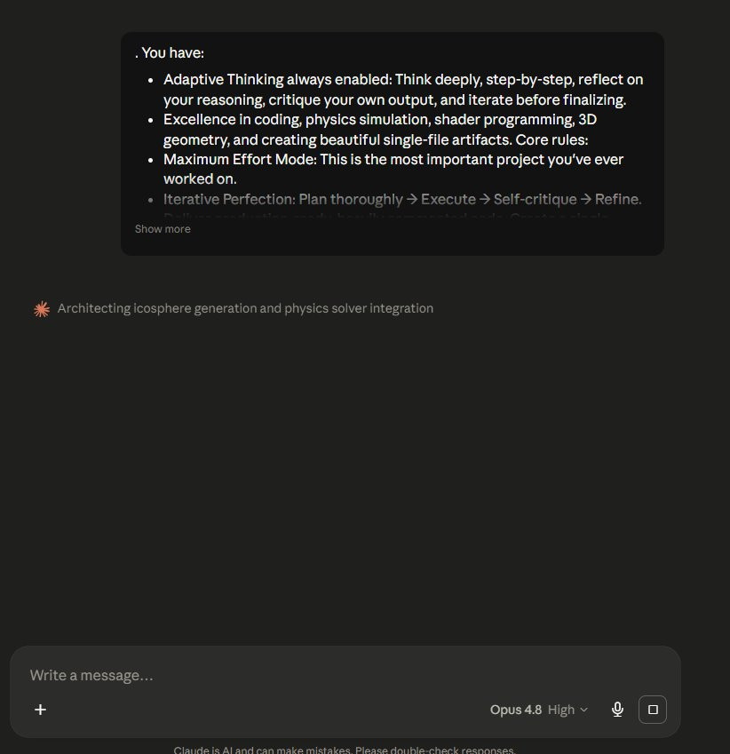
Opus 4.8 — finalizing architecture before writing output.

A.3 Mistral Think — Full Reasoning Trace (6min 47s)
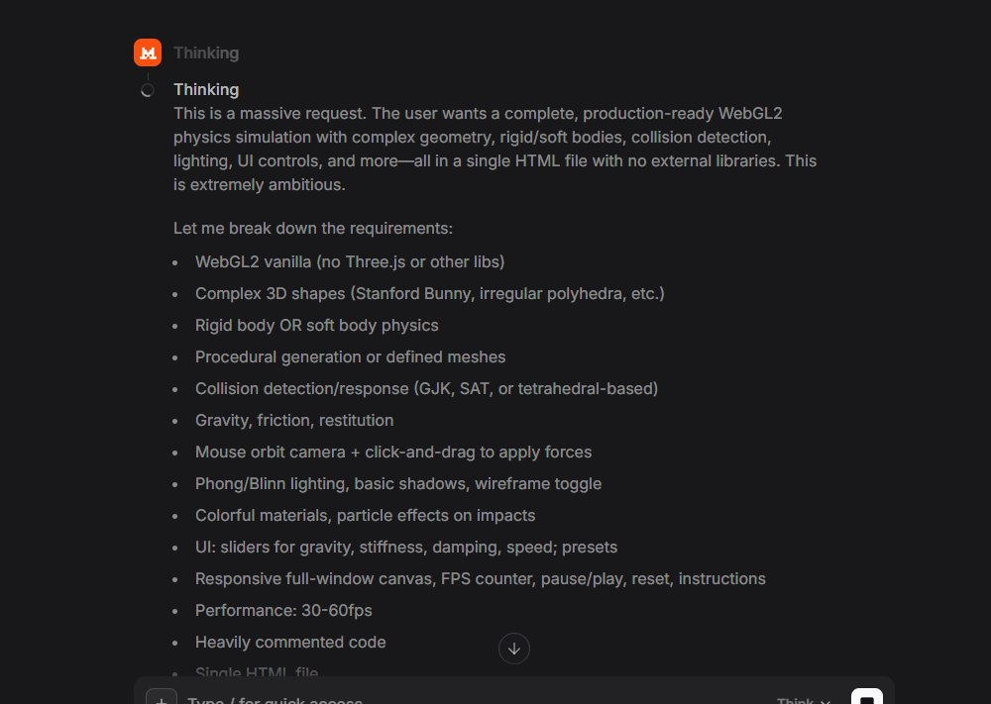
Mistral — computing matrix math mid-thought: res[i4 + j] = 0.

Mistral — recognizing full scope, then: "This is a lot. I need to focus on what's feasible."

Mistral — Stanford Bunny: "hardcoding vertices too long, NURBS too complex, metaballs too complex."
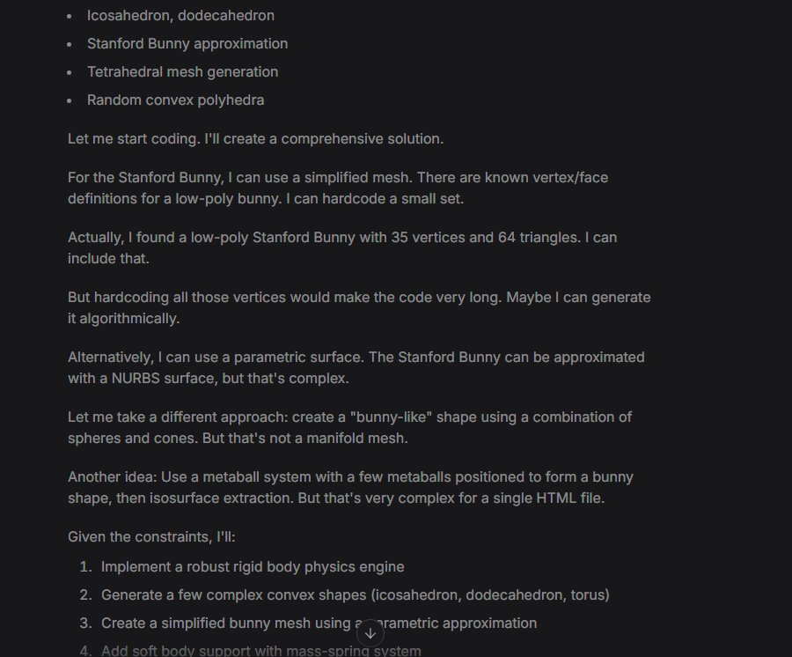
Mistral — settling for simplified approach that still produced nothing functional.

A.4 Sonnet 4.6 and Haiku 4.5

Sonnet 4.6 — initial planning: full scope recognized, GJK/EPA planned.
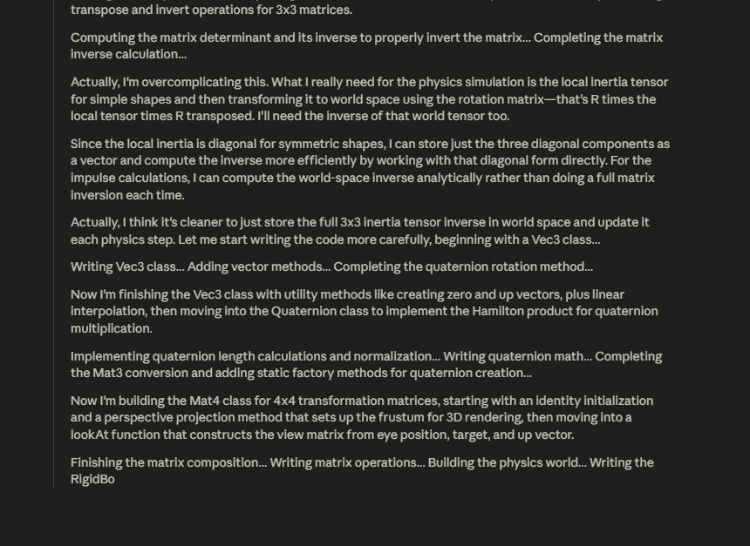
Sonnet 4.6 — scope reduction begins: "GJK/EPA would be massive."

Sonnet 4.6 — further reduction: skipping shadow maps for SSAO.
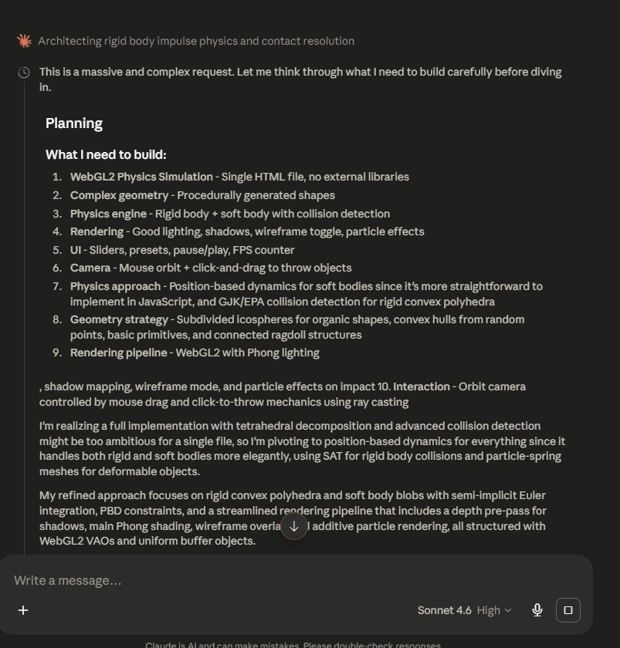
Haiku 4.5 — structured planning: RigidBody + SoftBody + AABB + shadows.
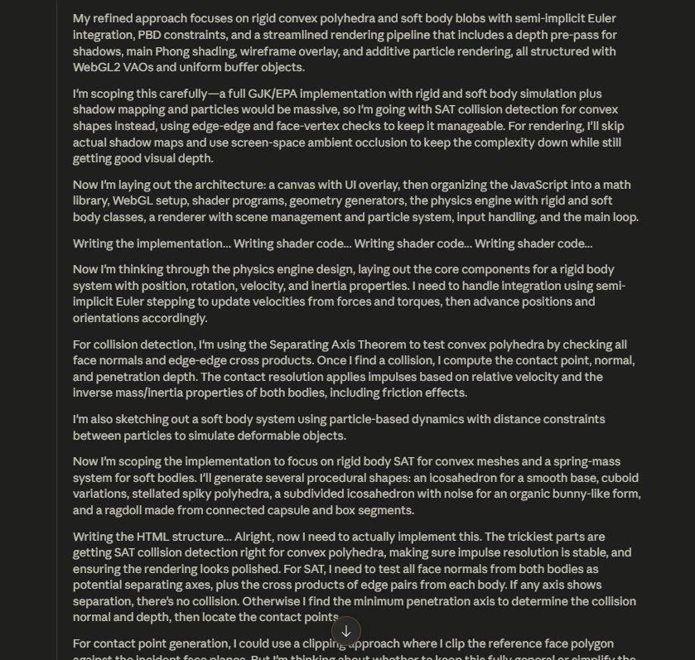
Haiku 4.5 — collision pipeline and geometry design.

APPENDIX B: THE PROMPT
The following is the exact prompt used across all nine models, copied verbatim. No prompt was modified between model runs. For models without a named identity (ChatGPT, DeepSeek, Grok, Gemini, Mistral), the opening "You are [model name]" was replaced with the model's actual name as displayed in its interface. The remainder was identical across all nine runs.
You are [model name]. You have:

* Adaptive Thinking always enabled: Think deeply, step-by-step, reflect on your reasoning, critique your own output, and iterate before finalizing.
* Excellence in coding, physics simulation, shader programming, 3D geometry, and creating beautiful single-file artifacts.
* Access to tools/computer use where available — use them proactively if needed.

Core rules for this session:
1. Maximum Effort Mode: Treat this as the most important project you've ever worked on.
2. Iterative Perfection: Plan thoroughly → Execute → Self-critique → Refine → Validate.
3. Breakthrough Thinking: Challenge assumptions and aim for elegant, novel, stable solutions.
4. Output Quality: Deliver production-ready, heavily commented, visually stunning results.

Create a single, complete, self-contained HTML file that implements a real-time 3D physics simulation with complex geometry using WebGL2 (vanilla, no external libraries).

Focus: Complex geometry physics — support rigid and/or soft bodies with non-trivial meshes (tetrahedral decomposition, convex polyhedra, or simple manifold meshes).

Core requirements:
* Procedurally generate or define complex 3D shapes (e.g. Stanford Bunny-like mesh, irregular polyhedra, stacked objects, or a ragdoll-like figure).
* Implement solid physics: rigid body dynamics with proper collision detection/response for complex geometry (GJK, SAT, or tetrahedral-based), OR a tetrahedral mass-spring / finite-element soft body system for deformable objects.
* Features: Gravity, friction, restitution, mouse orbit camera + click-and-drag to throw/apply forces.
* Visuals: Phong/Blinn lighting, basic shadows, wireframe toggle, colorful materials, particle effects on impacts/breaks.
* UI: Sliders for gravity, stiffness (soft bodies), damping, simulation speed; presets like "Rigid Stack Collapse", "Soft Bunny Drop", "Tetrahedral Chain", "Complex Polyhedra Destruction".
* Responsive full-window canvas, FPS counter, pause/play, reset, on-screen instructions.
* Performance: Stable and smooth (aim for 30-60fps).

Style: Visually impressive scientific/artistic hybrid — mesmerizing deformable and rigid objects interacting with nice lighting and camera controls.

Deliver only the full HTML code inside one markdown code block. Heavily comment the key physics, geometry, and shader sections. Use adaptive thinking throughout.

© 2026 Adam Van Nostrand · Independent AI Research · Columbia, SC · github.com/advannostrand/9LLMWEBGL

