DEVELOPER EXECUTION MANUAL - DO NOT OMIT SECTIONS

FRESH FOLD ALTOONA
Website Rebuild + Mobile Conversion + Booking + SEO/AIO + Service Areas + TNT Delivery
Master Directions for Ibrahim
Issued: Friday, September 4, 2026
HOMEPAGE DUE END OF DAY SEPTEMBER 4 • FULL IMPLEMENTATION DUE SUNDAY SEPTEMBER 6

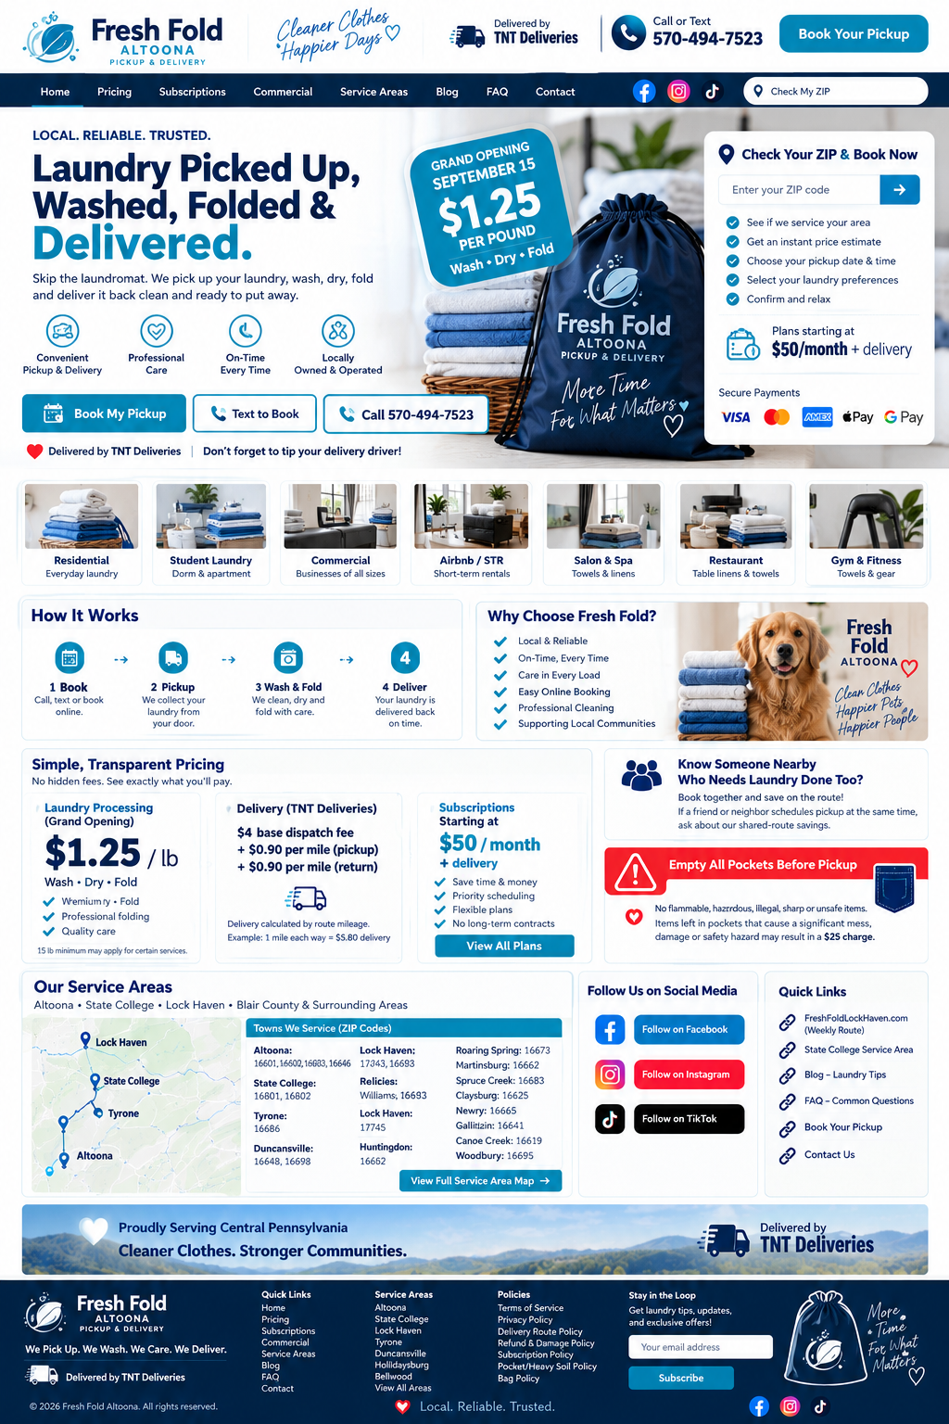
Target design direction: polished, mobile-first, complete, conversion-focused. Use the attached mockups as visual references, not as placeholder content.
WE PICK UP. WE WASH. WE CARE. WE DELIVER.
Delivered by TNT Deliveries • Don't forget to tip your delivery driver.

1. Executive Mandate
THIS IS NOT A BROCHURE WEBSITE. BUILD A WORKING CUSTOMER ACQUISITION + BOOKING PLATFORM.

FreshFoldAltoona.com must look finished, trustworthy, local, modern and app-ready. Every page must have a purpose: book a pickup, start a subscription, request a commercial quote, check service availability, learn pricing, or contact the company. Do not publish incomplete sections, placeholder reviews, fake numbers, old prices, generic lorem ipsum, sample addresses, broken buttons, or unfinished footer links.

Non-negotiable rules
✓ Mobile first, desktop second. Test the full customer journey on an approximately 390 px wide screen.
✓ Primary customer phone everywhere: 570-494-7523. Make every phone number tap-to-call.
✓ Brand the local consumer experience as Fresh Fold Altoona / Fresh Fold Delivery Altoona without keyword stuffing.
✓ Show 'Delivered by TNT Deliveries' wherever delivery logistics are explained, in booking, pricing, confirmation, order summary, footer and delivery notifications.
✓ Place 'Don't forget to tip your delivery driver' near the tip selector and order confirmation.
✓ Never expose a private residential or processing address. Use service-area-business language.
✓ Do not invent social-media URLs, reviews, route days, service availability, pricing, affiliations or discounts. Link only verified official profiles.
✓ Do not use Penn State logos, seals or language that implies official university affiliation.
✓ Every completed page needs a public URL, mobile test, desktop test and screenshot before it is marked DONE.

Deadline priority
Deadline | Required outcome
EOD Friday, Sept. 4 | Homepage rebuilt and live: header, hero, grand-opening offer, Book/Text/Call CTAs, ZIP checker, service cards, pricing preview, TNT delivery statement, social section, service-area preview, policies/footer.
Saturday, Sept. 5 | Pricing, subscriptions, booking flow, service areas, Altoona/State College/Bellefonte pages, commercial page, FAQ, contact, policy pages, redirects, SEO/meta setup.
Sunday, Sept. 6 | Full mobile QA, forms tested, redirects tested, ZIP routing loaded, schema/SEO completed, social links verified, no placeholders, screenshots + live URLs delivered.

2. Design System - Use the Mockups as the Quality Standard
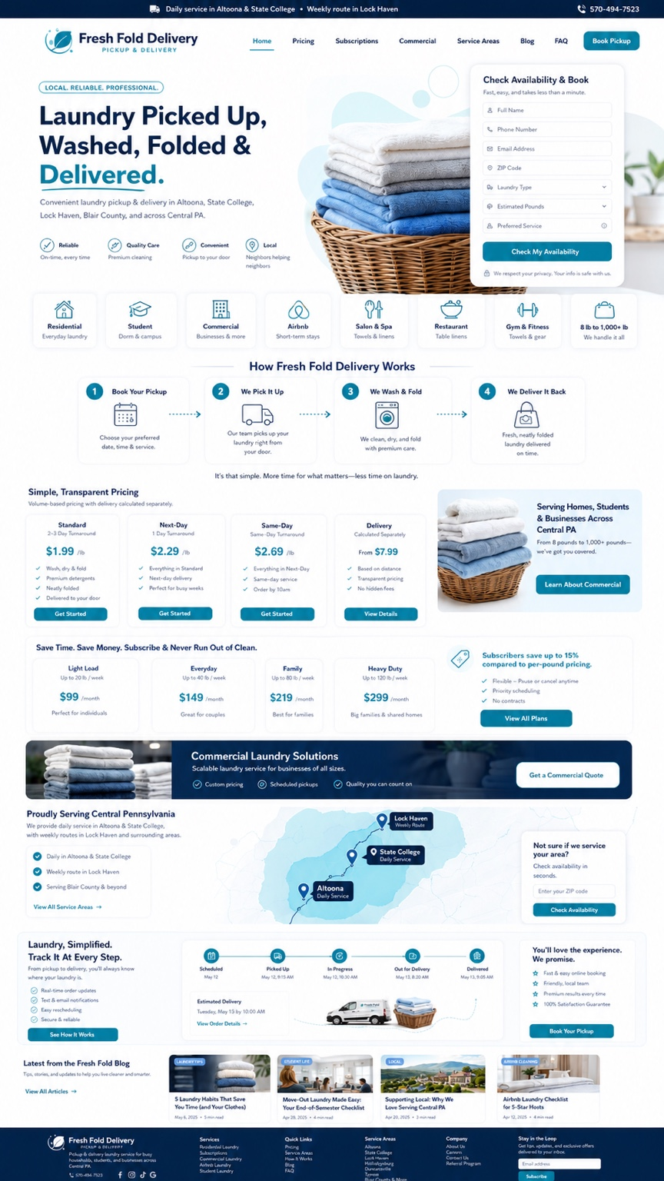
Reference: teal/navy Fresh Fold Delivery homepage direction.

Core visual palette
Use | Color | Hex / instruction
Primary text / header | Deep navy | #0F2742
Primary CTA / interactive | Teal / cyan | #16B8B3 or #009DC4
Light section backgrounds | Sky blue / aqua | #EAF6FF / #DFF8F7
Main background | White | #FFFFFF
Secondary text | Gray | #5B6775
Urgent / warning / limited promo | Red accent | #E21C2A - use selectively, not everywhere
Do not randomly mix two competing themes. The website should primarily use navy + teal + white. Use the red Fresh Fold Altoona accent for urgent CTAs, the grand-opening badge, pocket/hazard warnings, or limited local emphasis. The attached red mockups are layout references; the live site should still feel like one coherent brand.

UI components
✓ Rounded cards, subtle shadows, generous spacing, clean iconography.
✓ Large legible headings; no dense walls of text.
✓ Sticky mobile bar: Book Pickup | Text | Call.
✓ Desktop header must keep Book Pickup visible without scrolling.
✓ Use real laundry, branded bag, driver/vehicle, towels, linens, dorm/apartment and commercial imagery.
✓ Rename images before upload and write descriptive alt text.
✓ Use progress steps on booking and order tracking.
✓ Footer must be complete on every page: quick links, service areas, policies, contact, TNT delivery statement, social icons, copyright.

3. Homepage - Exact Build Order
HOMEPAGE MUST BE COMPLETED BY END OF DAY

Header + utility bar
• Top utility bar: 'Laundry Pickup & Delivery • Altoona • State College • Bellefonte • Central PA Routes' + phone 570-494-7523.
• Primary navigation: Home | Pricing | Subscriptions | Commercial | Service Areas | Blog | FAQ | Contact | Book Pickup.
• Right-side social icons: Facebook, Instagram, TikTok - link only to verified Fresh Fold Altoona profiles.
• Include 'Check My ZIP' in the header or immediately in the hero.

Above the fold
Element | Exact direction
Eyebrow | LOCAL. RELIABLE. TRUSTED.
H1 | Laundry Picked Up. Washed, Folded & Delivered.
Subhead | Skip the laundromat. Fresh Fold picks up your laundry, washes, dries and folds it, then delivers it back clean and ready to put away.
Grand opening badge | GRAND OPENING SEPTEMBER 15 - $1.25 PER POUND - Wash • Dry • Fold
Primary CTA | BOOK MY PICKUP
Secondary CTA | TEXT TO BOOK
Phone CTA | CALL 570-494-7523
Trust line | Delivered by TNT Deliveries | Don't forget to tip your delivery driver!
ZIP card | Check Your ZIP & Book Now - ZIP code, customer type, estimated pounds/bags, preferred pickup, turnaround.
Plan teaser | Plans starting at $50/month + delivery

Homepage section order - do not omit
1. Announcement/utility bar.
2. Hero with grand-opening price, ZIP checker and Book/Text/Call CTAs.
3. Trust/service cards: Residential, Student, Commercial, Airbnb/STR, Salon & Spa, Restaurant, Gym & Fitness.
4. How It Works: Book -> Pickup -> Wash/Dry/Fold -> Deliver.
5. Simple transparent pricing preview.
6. Subscriptions preview.
7. TNT Deliveries logistics explanation + driver tip reminder.
8. Commercial laundry callout.
9. Service-area map + ZIP checker.
10. Customer/order tracking preview.
11. Referral/shared-route savings section.
12. Pocket/hazard warning.
13. Social-media section.
14. Blog/latest tips preview.
15. Final CTA.
16. Complete footer.
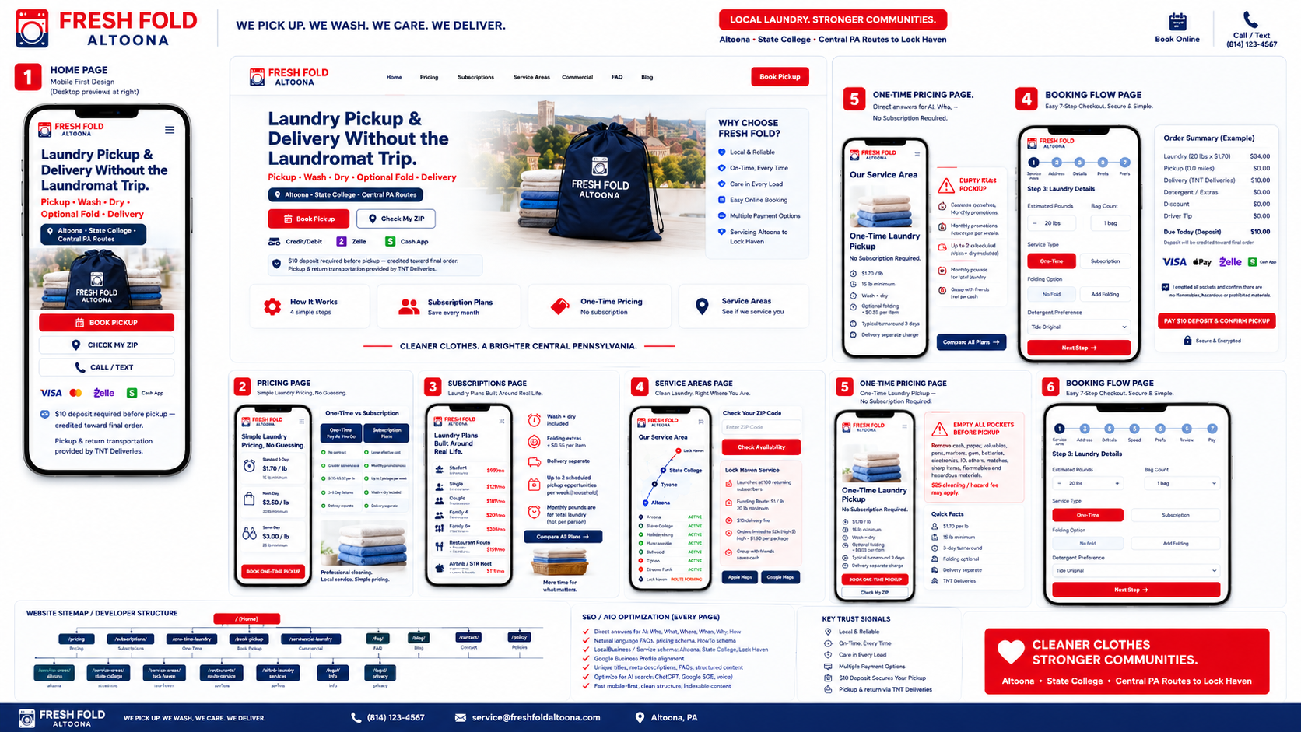
Reference board: homepage, pricing, service-area, booking and SEO layout.

4. Pricing + Delivery - Current Launch Source of Truth
DO NOT PUBLISH OLD PRICES FROM EARLIER MOCKUPS.

Component | Publish this
Grand-opening laundry processing | $1.25/lb - Wash • Dry • Fold
Subscription lead offer | Plans starting at $50/month + delivery
TNT delivery base | $4 base dispatch charge
Pickup route mileage | $0.90 per mile
Return route mileage | $0.90 per mile
Driver tip | Optional - prompt every customer: 'Don't forget to tip your delivery driver.'
Final total disclaimer | Final total may change based on actual weight, route mileage, selected add-ons and approved service requirements.
Example: if the pickup route is 1 mile and the return route is 1 mile, TNT delivery is $4.00 + $0.90 + $0.90 = $5.80. Keep laundry processing and delivery logistics as separate line items.

Pricing page layout
• Grand-opening wash/dry/fold card.
• One-time laundry pricing section.
• Subscription plans section.
• TNT delivery logistics calculator/explanation.
• Optional add-ons section only when prices are owner-approved.
• Tip explanation.
• Commercial quote link.
• FAQ: how final weight works, delivery mileage, deposits, cancellations, pocket policy, turnaround.

Payment methods
Display only methods that are actually active. Current business direction includes credit/debit cards, Zelle, Cash App and cash. Do not show Apple Pay, Google Pay, Amex, Discover or other methods unless the checkout actually accepts them.

5. Booking Flow - Mobile-First, Fast and Complete
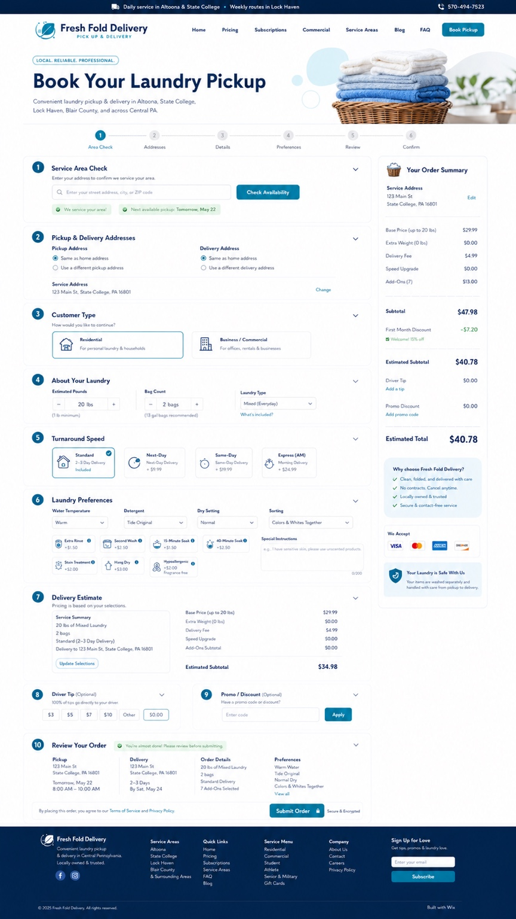
Reference: detailed booking-flow layout. Rebuild with current Fresh Fold Altoona pricing and TNT delivery logic.

Required booking steps
1. Service area / ZIP check.
2. Pickup address and delivery address.
3. Customer type: Residential / Student / Business / Airbnb / Salon / Restaurant / Gym / Commercial / Other.
4. Estimated pounds, bag count and laundry type.
5. Turnaround / requested pickup day and window.
6. Laundry preferences.
7. Delivery estimate - TNT base + pickup mileage + return mileage.
8. Optional driver tip.
9. Promo/referral code.
10. Review order.
11. Submit / deposit or payment / confirmation.

Laundry preferences
• Water temperature: cold / warm / hot / Fresh Fold standard.
• Dry setting: low / normal / other approved setting.
• Detergent: standard / fragrance-free / approved hypoallergenic / customer-provided if accepted.
• Sorting: wash together / colors & whites / towels/clothes / bedding/clothes / by bag / by person where supported.
• Options where operationally available: extra rinse, second wash, soak, hang dry, stain treatment, pet hair/heavy soil.
• Special instructions text field.

Required safety acknowledgement
EMPTY ALL POCKETS BEFORE PICKUP

Show before final confirmation: Remove cash, paper, valuables, pens, markers, gum, batteries, electronics, lighters, matches, sharp items, flammables and hazardous materials. No illegal, flammable, hazardous, sharp or unsafe items may be included. If the approved policy remains in effect, items left in pockets that create a significant mess, damage or safety hazard may result in a $25 cleaning / hazard handling charge.

Tip language
DELIVERED BY TNT DELIVERIES - DON'T FORGET TO TIP YOUR DELIVERY DRIVER.

6. Service Areas + ZIP Code Routing
The ZIP checker must be operational, not decorative. Do not allow a P.O. Box ZIP to function as a pickup address. For ZIPs outside current active routes, collect name, mobile, email, ZIP and estimated pounds into a waitlist instead of rejecting the lead.

Launch service-area ZIP table
Town / Area | ZIP Code(s) | Implementation note
Altoona | 16601, 16602 | 16603 is a P.O. Box ZIP - do not use as a physical pickup address.
State College | 16801, 16802, 16803 | 16804 and 16805 are P.O. Box ZIPs; 16802 also covers University Park/Penn State.
Bellefonte | 16823 | Add dedicated local service page / route availability.
Boalsburg | 16827 | State College route cluster.
Lemont | 16851 | State College route cluster.
Milesburg | 16853 | Centre County route - activate only when scheduled.
Pine Grove Mills | 16868 | State College route cluster.
Port Matilda | 16870 | Route-based.
Pennsylvania Furnace | 16865 | Route-based.
Warriors Mark | 16877 | Route-based / connection between State College and Tyrone corridor.
Tyrone | 16686 | Primary Tyrone ZIP.
Duncansville | 16635 | Primary Duncansville ZIP.
Hollidaysburg | 16648 | Primary Hollidaysburg ZIP.
Bellwood | 16617 | Primary Bellwood ZIP.
Roaring Spring | 16673 | Blair County route-based.
Martinsburg | 16662 | Blair County route-based.
Claysburg | 16625 | Blair County route-based.
Newry | 16665 | Blair County route-based.
Gallitzin | 16641 | Route-based.
Cresson | 16630 | Route-based.
Williamsburg | 16693 | Route-based.
Huntingdon | 16652 | Expansion / route-based - activate only when confirmed.
Lock Haven | 17745 | Weekly route / FreshFoldLockHaven.com acquisition domain.
Castanea | 17726 | Lock Haven route cluster.
McElhattan | 17748 | Lock Haven route cluster.
Mill Hall | 17751 | Lock Haven route cluster.
Developer rule: Every ZIP must have one of three statuses in CMS: ACTIVE, ROUTE-BASED, or WAITLIST. Do not label a ZIP as daily service unless the owner confirms the route. ZIP data above is for routing/search setup; operational frequency remains an owner-controlled field.

7. Local Pages, Domains and Redirects
Asset | Required implementation
FreshFoldAltoona.com | Primary Altoona acquisition domain / live destination. Canonical strategy must be consistent.
FreshFoldLockHaven.com | Keep active and 301 redirect to the approved Lock Haven service page or dedicated Lock Haven acquisition funnel. Test the redirect on mobile and desktop.
State College | Dedicated service-area page + student laundry content; include 16801/16802/16803 and parent/student FAQs.
Bellefonte | Dedicated service-area page or a clearly structured Centre County service section with 16823.
Tyrone / Duncansville / Hollidaysburg / Bellwood | Individual local pages only when content is unique and service is real; otherwise use strong service-area hub cards and dynamic CMS content.

Required local page pattern
✓ H1: Laundry Pickup & Delivery in [City], PA.
✓ First paragraph immediately states what Fresh Fold offers, who it serves and whether service is active/route-based.
✓ ZIP availability.
✓ How it works.
✓ Pricing link + TNT delivery explanation.
✓ Residential / student / commercial modules as relevant.
✓ Local FAQ.
✓ Book Pickup + Call/Text CTAs.
✓ Nearby service-area internal links.
✓ Unique photos/copy where available. Do not clone the exact same page dozens of times.

8. Social Media + Blog Section

Homepage social block
Platform | Required action
Facebook | Show Fresh Fold Altoona Facebook icon + 'Follow on Facebook'. Link to the verified official Fresh Fold Altoona Facebook URL.
Instagram | Show Fresh Fold Altoona Instagram icon + 'Follow on Instagram'. Link to verified official profile.
TikTok | Show Fresh Fold Altoona TikTok icon + 'Follow on TikTok'. Link to verified official profile.
If a verified Fresh Fold Altoona profile does not yet exist, do not invent a handle. Leave the icon hidden until the owner provides or approves the account. Once live, add the same three verified links to the footer and contact page.

Blog requirements
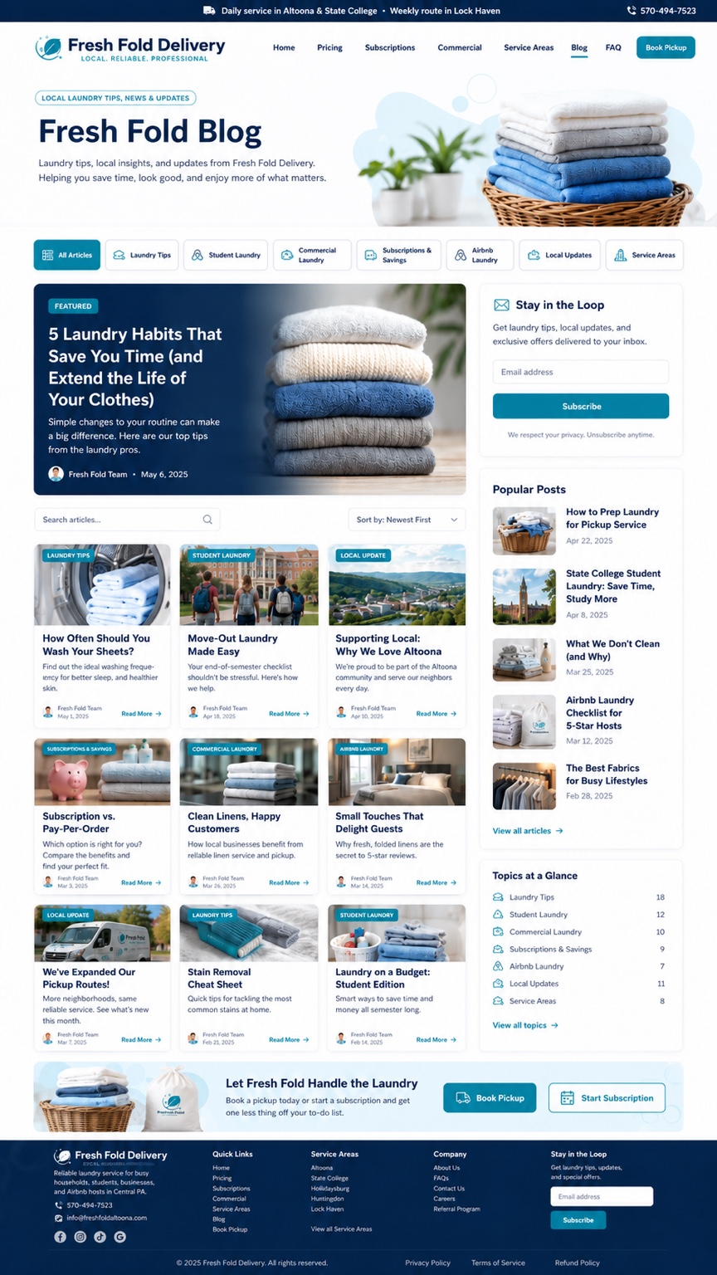
Reference: blog layout. Replace old dates and sample posts with current, real Fresh Fold content.
• Do not publish old 2025 mockup dates as if they are current.
• Initial categories: Laundry Tips, Student Laundry, Commercial Laundry, Subscriptions & Savings, Airbnb/STR Laundry, Local Updates, Service Areas.
• Each article needs one clear question/answer focus, local internal links, one CTA and descriptive image alt text.
• Homepage should preview 3-4 current posts only after core booking pages are complete.

9. Commercial Laundry
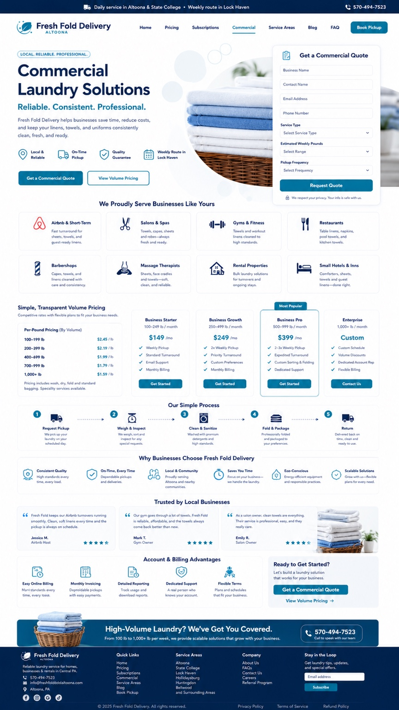
Reference: commercial page layout. Keep the strong quote form and industry cards; replace any unapproved pricing, testimonials or guarantees.

Commercial target categories
• Airbnb / short-term rentals
• Salons and spas
• Gyms and fitness
• Restaurants
• Barbershops
• Massage therapists
• Rental properties and property managers
• Small hotels / inns
• Cleaning companies
• Corporate / extended-stay housing
• Other recurring local businesses

Commercial quote form
✓ Business name
✓ Contact name
✓ Email
✓ Phone
✓ Business type / service type
✓ Estimated weekly pounds
✓ Pickup frequency
✓ Service address / ZIP
✓ Special requirements
✓ Preferred contact method
✓ Desired start date
Do not publish sample commercial volume rates, 'quality guarantee' claims, testimonials, revenue numbers or client counts unless they are approved and supportable.

10. SEO + AIO + Local Search Requirements

Every priority page
✓ One canonical HTTPS URL.
✓ One H1.
✓ Unique title tag and meta description.
✓ Clean descriptive slug.
✓ Immediate natural-language answer in the first paragraph.
✓ Logical H2/H3 hierarchy.
✓ Descriptive internal links.
✓ Compressed WebP/AVIF images where supported.
✓ Descriptive alt text.
✓ Breadcrumbs.
✓ Accurate Organization / LocalBusiness / Service / WebSite / WebPage / Breadcrumb schema.
✓ FAQ schema only where currently appropriate and accurate.
✓ No hidden keyword blocks, fake locations, fake reviews or mass-generated thin city pages.

Answer-engine questions to answer directly
• Who offers laundry pickup and delivery in Altoona, PA?
• Does Fresh Fold serve State College and Bellefonte?
• How does Fresh Fold pickup and delivery work?
• How much is the September 15 grand-opening laundry rate?
• How is TNT delivery priced?
• Does Fresh Fold offer monthly laundry plans?
• Can parents arrange laundry service for a State College student?
• Does Fresh Fold handle Airbnb/STR linens and commercial towels?
• What areas and ZIP codes does Fresh Fold serve?
• How do I book by phone or text?

Suggested metadata
Page | Slug | Title direction
Home | / | Laundry Pickup & Delivery in Altoona & Central PA | Fresh Fold Altoona
Pricing | /pricing | Laundry Pickup & Delivery Pricing | Fresh Fold Altoona
Book Pickup | /book-pickup | Book Laundry Pickup in Altoona & Central PA | Fresh Fold
Subscriptions | /subscriptions | Laundry Subscription Plans | Fresh Fold Altoona
Commercial | /commercial-laundry | Commercial Laundry Pickup & Delivery | Fresh Fold Altoona
Service Areas | /service-areas | Laundry Delivery Service Areas & ZIP Codes | Fresh Fold Altoona
Altoona | /service-areas/altoona-pa | Laundry Pickup & Delivery in Altoona, PA | Fresh Fold
State College | /service-areas/state-college-pa | Student Laundry Pickup & Delivery in State College, PA | Fresh Fold
Bellefonte | /service-areas/bellefonte-pa | Laundry Pickup & Delivery in Bellefonte, PA | Fresh Fold
Lock Haven | /service-areas/lock-haven-pa | Weekly Laundry Pickup & Delivery in Lock Haven, PA | Fresh Fold

11. Footer - No Missing Information
THE FOOTER MUST BE COMPLETE ON EVERY PAGE.

Column | Required content
Brand | Fresh Fold Altoona / Fresh Fold Delivery logo, short service descriptor, 570-494-7523, 'Delivered by TNT Deliveries'.
Quick Links | Home, Pricing, Subscriptions, Book Pickup, Commercial, Service Areas, Blog, FAQ, Contact.
Service Areas | Altoona, State College, Bellefonte, Tyrone, Duncansville, Hollidaysburg, Bellwood, Lock Haven, View All Areas.
Policies | Privacy Policy, Terms of Service, Delivery/Route Policy, Refund & Damage Policy, Subscription Policy, Pocket/Heavy Soil Policy, Bag Policy, Cancellation/Payment terms.
Social | Verified Fresh Fold Altoona Facebook, Instagram, TikTok.
Email capture | Stay in the Loop - email field + Subscribe only after email capture is actually connected.
Copyright | © 2026 Fresh Fold Altoona. All rights reserved.

Policy placement
✓ Pocket/hazard policy linked during booking acknowledgement.
✓ Delivery/route policy linked beside TNT delivery pricing.
✓ Subscription policy linked on all plan checkout pages.
✓ Terms and privacy linked at final checkout.
✓ Refund/damage policy linked in footer, FAQ and confirmation email.

12. Backend / Admin / App-Ready Structure
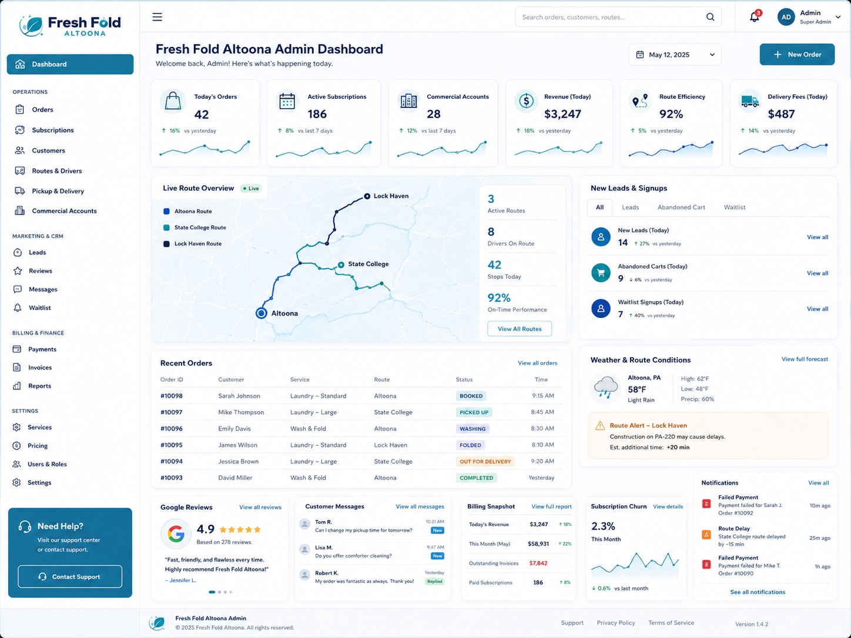
Reference: admin dashboard concept. Do not expose sample numbers or fake analytics on the public website.

Admin navigation
• Dashboard
• Orders
• Customers
• Subscriptions
• Routes & Drivers
• Pickup & Delivery
• Commercial Accounts
• Leads
• Reviews
• Messages
• Waitlist
• Payments
• Invoices
• Reports
• Services
• Pricing
• Users & Roles
• Settings

Order statuses
✓ Scheduled
✓ Driver Assigned
✓ Picked Up
✓ Weighed
✓ Washing
✓ Drying
✓ Folding
✓ Quality Check
✓ Out for Delivery
✓ Delivered
✓ Completed
Customer-facing order tracking must display only statuses the team can actually update. Driver pickup and delivery proof photos should be supported when implemented.

13. Approved CTA + Conversion Copy Library
Purpose | Copy
Primary | BOOK MY PICKUP
Phone | CALL 570-494-7523
SMS | TEXT TO BOOK
ZIP | CHECK MY ZIP
Subscription | START MY PLAN
Commercial | GET A COMMERCIAL QUOTE
Service-area waitlist | NOT ON OUR ROUTE YET? JOIN THE WAITLIST
Delivery | Delivered by TNT Deliveries
Tip | Don't forget to tip your delivery driver.
Referral | Know someone nearby who needs laundry done too? Book together and ask about shared-route savings.
Final hero | More time for what matters. Let Fresh Fold handle the laundry.

Text-to-book instruction card
When a customer taps TEXT TO BOOK, prefill or display: 'Fresh Fold pickup request - Name: ___ | Pickup address: ___ | ZIP: ___ | Estimated pounds/bags: ___ | Preferred pickup day/time: ___ | Turnaround: ___ | Laundry preferences: ___ | Special instructions: ___.'

14. Definition of DONE - Ibrahim's Final QA Checklist
✓ Homepage is live and visually finished.
✓ Mobile header and sticky Book/Text/Call bar work.
✓ 570-494-7523 is correct everywhere.
✓ Grand-opening September 15 offer shows $1.25/lb consistently.
✓ Plans say starting at $50/month + delivery unless final plan details are approved.
✓ TNT delivery shows $4 base + $0.90 pickup mile + $0.90 return mile.
✓ 'Delivered by TNT Deliveries' is present in pricing, booking, footer and confirmations.
✓ 'Don't forget to tip your delivery driver' is present near tip/checkout and confirmation.
✓ No private residential/processing address is shown.
✓ ZIP checker routes ACTIVE / ROUTE-BASED / WAITLIST correctly.
✓ State College and Bellefonte are included.
✓ Tyrone, Duncansville, Hollidaysburg, Bellwood and other approved towns are included.
✓ FreshFoldLockHaven.com redirect is live and tested.
✓ Facebook, Instagram and TikTok section exists and uses verified URLs only.
✓ Book, call, text, pricing, subscription and quote buttons all work.
✓ Booking form works end to end.
✓ Pocket/hazard warning appears before confirmation.
✓ Policy links work.
✓ Footer is complete on every page.
✓ No fake reviews or sample testimonials.
✓ No old 2025 mockup dates.
✓ No outdated pricing.
✓ No placeholder phone numbers such as (814) 123-4567.
✓ No sample customer/order/admin metrics visible publicly.
✓ One H1 per page.
✓ Meta titles and descriptions completed.
✓ Images renamed and alt text completed.
✓ Sitemap and robots checked.
✓ Google Search Console and Bing indexing connected when credentials are available.
✓ Desktop QA completed.
✓ iPhone-width QA completed.
✓ Android-width QA completed.
✓ Screenshots and live URLs delivered to owner.

Daily report format
DATE | PAGES COMPLETED | LIVE URLS | MOBILE QA | DESKTOP QA | FORMS TESTED | REDIRECTS TESTED | ZIP ROUTING COMPLETED | SEO/META COMPLETED | SOCIAL LINKS VERIFIED | BUGS FIXED | BLOCKERS NEEDING OWNER DECISION | NEXT 5 ACTIONS

15. Visual Reference Appendix
These screenshots are design references. They contain historical sample prices, placeholder dates, sample phone numbers, sample reviews and sample analytics. Use their layout quality, spacing, card hierarchy, booking structure and dashboard concepts - not their unverified content.
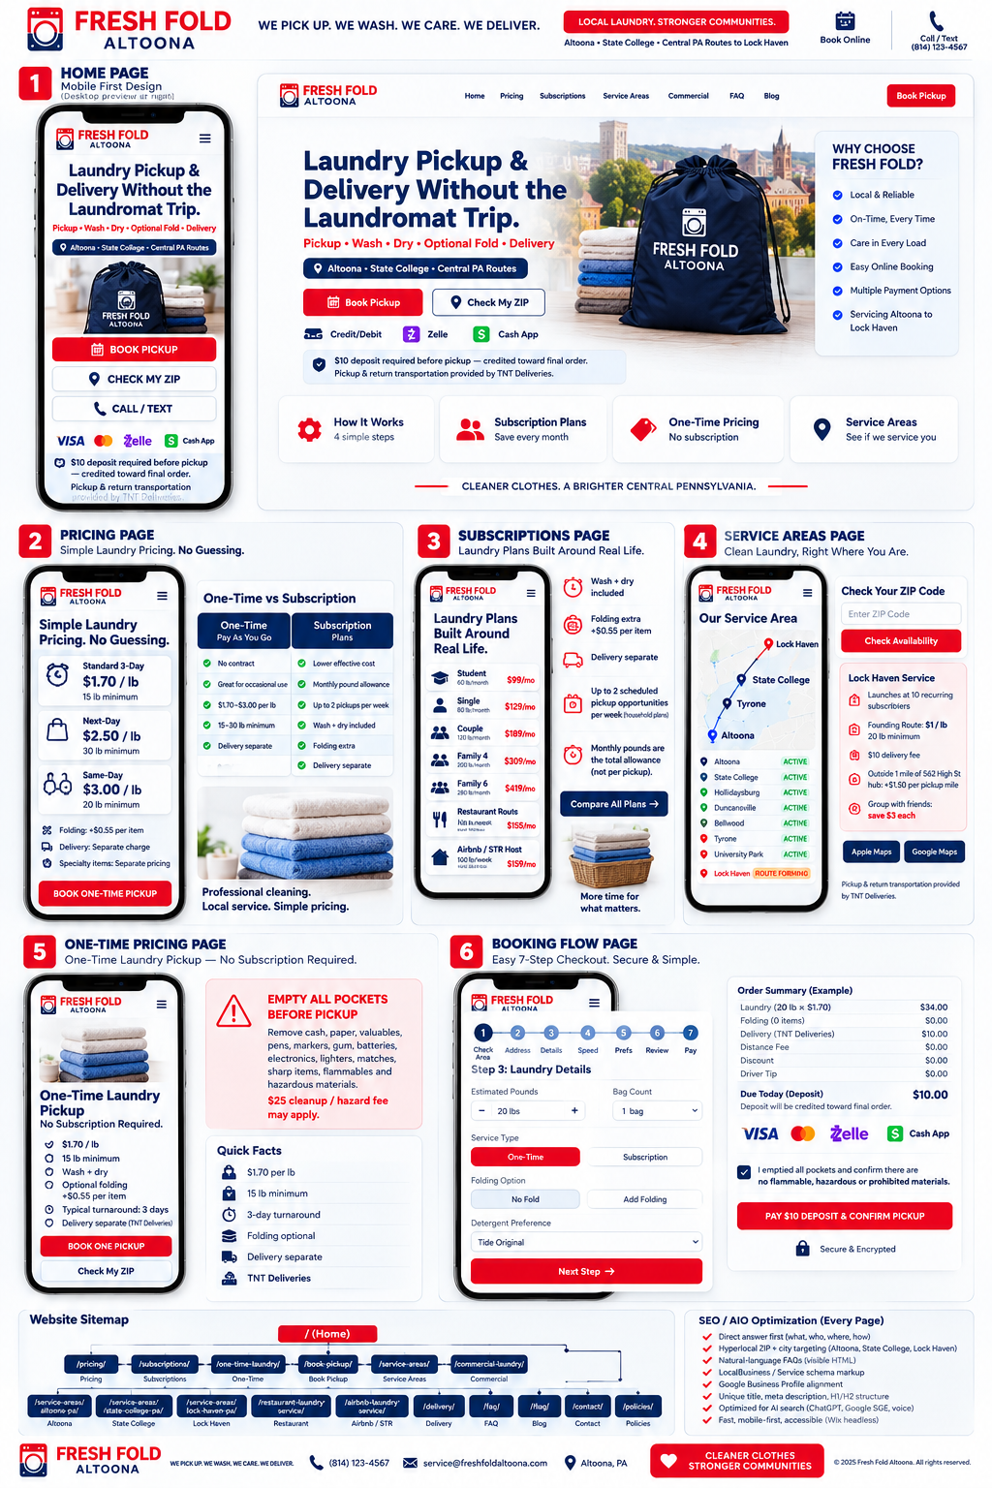
UX board reference.

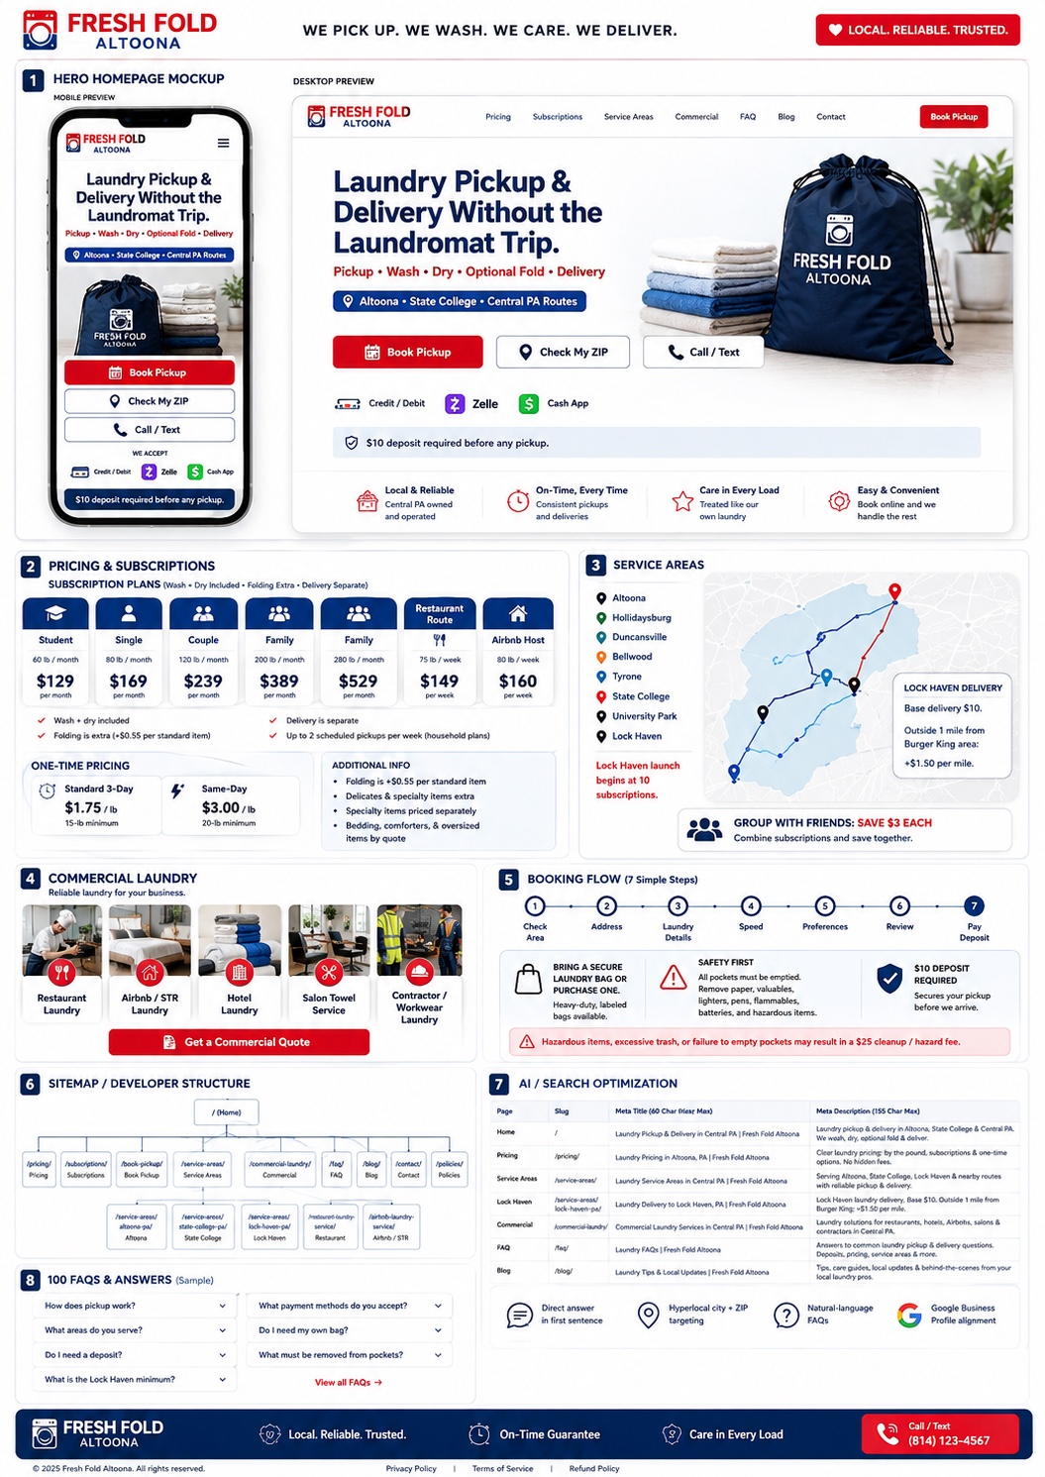
Red/local-brand board reference - use layout and component ideas, not sample pricing or placeholder phone numbers.


Teal/navy homepage reference.


Commercial page reference.


Booking page reference.


Admin dashboard reference.

16. Source & Verification Notes
This execution manual consolidates the Fresh Fold Master Brian/YBC website, SEO, directory and UX instructions; the Fresh Fold Pickup & Delivery Wix operations specification; the Fresh Fold Altoona developer brief; and the visual mockups supplied for this project.
ZIP-code routing notes were cross-checked against current USPS location/search data where available. State College also includes 16804 and 16805 as P.O. Box ZIPs; Altoona 16603 is a P.O. Box ZIP. Do not accept a P.O. Box as a physical laundry pickup location.

Owner decisions that must not be guessed
• Exact URLs/handles for Fresh Fold Altoona Facebook, Instagram and TikTok.
• Final included pounds/overage/frequency for the $50/month starting subscription.
• Which route-based ZIPs are active on which days.
• Whether the $25 pocket/hazard fee remains active and exact wording.
• Any deposit requirement and accepted payment-method availability in the live checkout.
• Any add-on pricing not explicitly approved in the current launch brief.

