# Model Documentation: 0001 - AlexNet

## Introduction

This model documentation corresponds to AlexNet, which is a machine learning and neural network-based model for computer vision tasks.

### Background

AlexNet is a groundbreaking convolutional neural network architecture that significantly advanced the field of computer vision. Developed by Alex Krizhevsky, Ilya Sutskever, and Geoffrey Hinton in 2012, it won the ImageNet Large Scale Visual Recognition Challenge (ILSVRC) with a top-5 error rate of 15.3%, far outperforming the competitors at the time.

### Importance

AlexNet popularized deep learning by demonstrating the power of convolutional neural networks (CNNs) trained on large-scale datasets using GPUs.

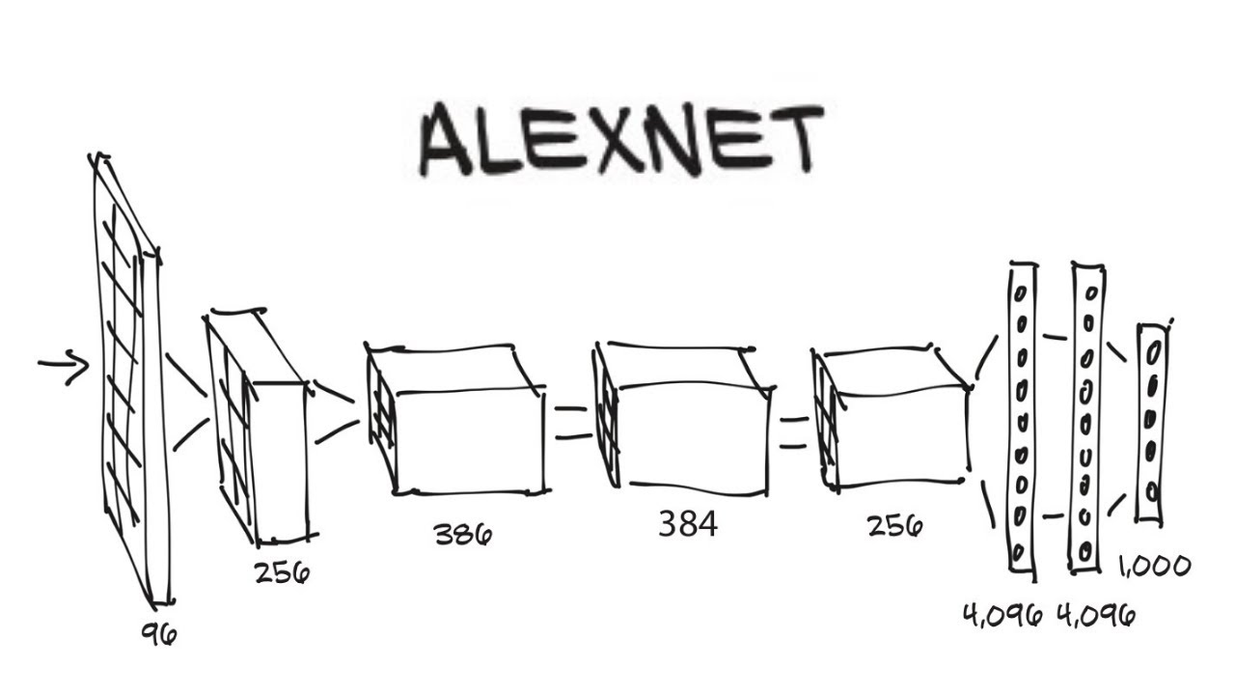

(Architecture diagram of AlexNet)

## Impact and Legacy

### Performance on ImageNet

AlexNet drastically reduced the error rate on the ImageNet dataset, marking a milestone in visual recognition.

### Influence on Future Models

AlexNet inspired the development of deeper and more complex CNN architectures such as VGG, ResNet, and Inception.

### Practical Applications

AlexNet’s success helped enable advances in autonomous driving, facial recognition, and medical imaging.

### Comparison to Resnet

|  |  |
| --- | --- |
| **AlexNet** | **ResNet** |
| Shallow, with stacked convolutional and pooling layers. | Deep, utilizing “skip connections” to enable learning from previous layers. |
| Limited due to shallow depth. | Excels at learning complex features due to depth and skip connections. |
| Lacks mechanisms to address vanishing gradients. | Skip connections alleviate the vanishing gradient problem. |
| Utilizes techniques like normalization and sigmoid activation. | Achieves higher accuracy through deeper architecture and robust mechanisms. |
| Primarily classification tasks. | Excels in image segmentation, classification, and other vision tasks. |