Understanding the Poleward Migration of Tropical Cyclones, its Climatic Drivers and Societal Impacts

Advay Bajaj | Brown University, Providence RI

Plain Language Summary: Tropical cyclones are powerful storms originating in intense low-pressure zones over (tropical) oceans that can cause widespread damage to ecosystems and infrastructure. Recent research suggests that these storms are gradually forming and moving further from the tropics, exhibiting “poleward migration,” a phrase used frequently throughout my study. Understanding this shift is of critical significance since it could change which regions are most at risk. In this study, I investigate the movement of tropical cyclone formation and tracks primarily post-1980, focusing on the Western North Pacific basin bordering East-Asia and the North Atlantic basin bordering Eastern North America. The main hypothesis is that tropical cyclones are migrating poleward. Sub-hypotheses include: exploring why this is phenomenon is taking place (the role of rising sea-surface temperatures and changes in vertical wind shear patterns), and examining how this migration affects ecosystems and coastlines inhabited by human populations near mid-latitudes. By combining satellite data, historical storm records, and environmental proxies like tree-ring data, this research aims to better understand and prepare for the evolving risks of poleward-migrating tropical cyclones.
Keywords: tropical cyclones, poleward migration, vertical wind shear, sea-surface temperature, environmental proxies.

- INTRODUCTION
I.A, Background: Tropical cyclones (TCs) are among the most powerful and destructive geophysical hazards on Earth. In the United States, some of the deadliest and costliest natural disasters have been tropical cyclones:

the 1900 Galveston Hurricane claimed nearly 8,000 lives, while Hurricane Andrew in 1992 caused over $35 billion in damages (Yanai, 1964). Globally, tropical cyclones rank alongside floods as some of the deadliest geophysical hazards; for example, a single cyclone in Bangladesh in 1970 resulted in nearly 500,000 fatalities (Griffin-Elliott, 2024). Despite their societal importance, many aspects of tropical cyclone behaviour remain poorly understood, particularly outside specialized research communities.
Tropical cyclones develop in warm ocean waters (typically over 26°C), as ascending humid air generates groups of thunderstorms. Gentle winds and minimal wind shear enable these storms to consolidate, creating towering cumulonimbus clouds and ultimately leading to the formation of a tranquil central eye encircled by a strong eyewall. The storm builds over the water, gaining power, and diminishes upon reaching land as it unleashes its fierce winds, heavy rains, and flooding. (Gray, 1998)
Tropical cyclones vary widely in both frequency and intensity across different regions. There are around 80 tropical cyclones in a typical year. The North Pacific sees the most activity, averaging around 30-35 storms per year, while the North Atlantic experiences about 15-20 storms annually. In contrast, the South Atlantic rarely sees cyclones, with only occasional storms forming (Sobel et al., 2021). Cyclone intensity also varies, from weaker tropical storms to extremely powerful systems with destructive winds, heavy rainfall, and storm surges.
Tropical cyclones are also sensitive to climate change. Observations and geological records from Walsh et al. (2015) show that TC frequency and intensity can vary over decades to centuries, influenced by factors such as sea surface temperatures, atmospheric conditions, and climate patterns over a large time scale. While trends differ by region, climate models generally project that the strongest storms may become more intense and produce heavier rainfall under future warming, highlighting the close link between TCs and climate.

I.B, Poleward Migration: Recent research has indicated that there has been evidence of the formation latitudes and peak intensities of TCs moving poleward over time in various oceans. This trend is more evident in the Western North Pacific and the Southern Hemisphere, in particular. Long-term observations have shown that the formation and intensification of storms are happening in slightly higher latitudes compared to the past. This trend of moving towards the poles seems to be connected with the overall shift in the climate system. (Walsh et al., 2015). The specific climatic causes behind this change in mechanism will be explored in Section III of the paper.

I.C, Paper Structure and Overview: The first part of the study seeks to gather data regarding tropical cyclones genesis and assess whether there appears to be any trend regarding the poleward shift of the formation and tracking routes of the tropical storm systems. In support of the result, the study seeks to utilize environmental proxy information such as tree rings, which would help prove the trend of the shift. The second component of the study seeks to investigate the factors causing the shift and how it could impact the coastlines. These factors would include sea surface temperatures, wind shear, and global circulation.
As TCs are prevalent throughout the world, the study will examine two of the most active TC areas, which are the North Atlantic and the Western North Pacific. By comparing the two, it would be possible to verify the major hypothesis that TCs are shifting poleward and various related concepts.

- DATASETS
In order to ascertain the tendencies of tropical cyclones and the environmental factors that are associated with the potential poleward migration, the study makes use of several sets of data. Each one of the sets of data that are utilized for the study, and the purpose thereof, are listed and explained in Table 1 below.
S. No. | Datasets | Time Span | Source | Purpose
1. | IBTrACS v4 Global Tropical Cyclone Best Track Data | 1980-Present  (subset used) | NOAA (National Oceanic and Atmospheric Administration) | Provides tropical cyclone tracks, genesis points, and intensity data for detecting poleward migration trends.
2. | ERA5 Reanalysis: Hourly Data on Pressure Levels | 1980-Present  (subset used) | ECMWF (European Centre for Medium Range Weather Forecasts) | Used to calculate vertical wind shear (VWS), an environmental driver linked to cyclone formation and movement.
3. | ERA5 Reanalysis: Hourly Data on Single Levels | 1980-Present (subset used) | ECMWF (European Centre for Medium Range Weather Forecasts) | Provides sea surface temperature (SST) fields to investigate thermal influences on cyclone migration.
4. | Admin 1:50m Coastline Dataset | N/A | Natural Earth (a public domain map dataset) | Used to map coastlines at 1:50 million scale (suitable for continental analysis, like the purpose of this paper), for visualizing cyclone tracks, study regions, and potential coastal exposure. The “Admin” label refers to Natural Earth’s category for boundary-related administrative map data.
5. | Tree-ring Canopy Disturbance Data | >50 yrs Before Present. | (Altman et al., 2018) | Used as a proxy for past tropical cyclone activity, since variations in canopy disturbance can capture storm-driven impacts across different latitudes.
Table 1. Summary of Datasets Used in This Study
This table lists the datasets used to examine tropical cyclone activity, environmental conditions, and long-term ecological signals. Together, these sources provide the information needed to assess trends in poleward migration and its potential drivers.

- ANALYSES

III.A, Main Hypothesis: “Tropical cyclone genesis and track locations have undergone a statistically significant poleward shift over recent decades.”
III.A.1, IBTrACS Data: Analysis of TC tracks from 1980 to 2025 reveals a consistent poleward shift in both genesis and maximum intensity locations:
Figure 1A shows the mean latitude of TC genesis over the study period for the North Atlantic and Western North Pacific basins. Linear regression indicates a statistically significant northward shift in genesis points of approximately 0.0779° per decade (p-value = 2.834e-06 < 0.05). This trend is evident in both basins.
Figure 1B presents the mean latitude at which TCs reach their maximum intensity. Similar to genesis trends, maximum-intensity latitudes have migrated poleward over the past four decades, with an average increase of 0.0783° per decade (p-value = 2.448e-05 < 0.05). These findings confirm that not only are storms forming farther from the equator, but their tracks also extend into higher latitudes, and thus unleash with maximum intensity at higher latitude regions; reinforcing the poleward migration pattern.
Figure 1C depicts the mean proximity of TC tracks to midlatitude coastlines, serving as a proxy for potential exposure of midlatitude regions. The results indicate that cyclones are increasingly occurring closer to midlatitude coastlines over time, with a statistically significant downward trend in distance, with mean proximity to midlatitudes increasing by 0.0331° per year (p-value = 1.673e-03 < 0.05). This suggests that the poleward shift in tracks is bringing storms into regions that historically experienced less frequent tropical cyclone activity.
Figure 1D provides an integrated overview by overlapping the trends in storm genesis and maximum intensity latitudes for the period 1980-2024. This combined view visually illustrates the parallel poleward shifts of both formation and peak-intensity locations, emphasizing that cyclones are not only forming farther north but also extending their tracks into higher latitudes. The alignment of the two trends highlights the significance of the poleward migration signal across multiple metrics.

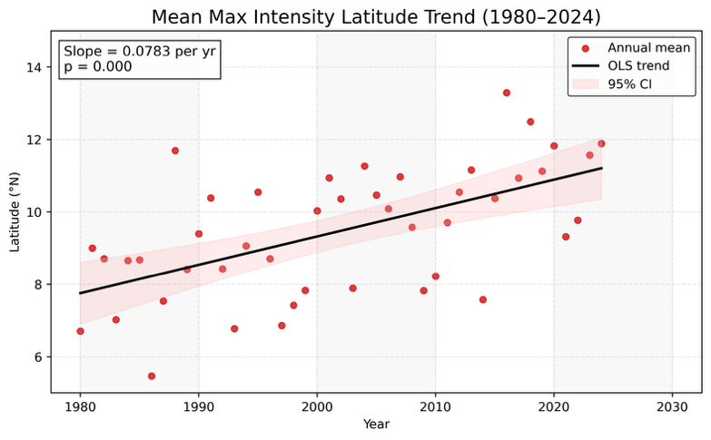
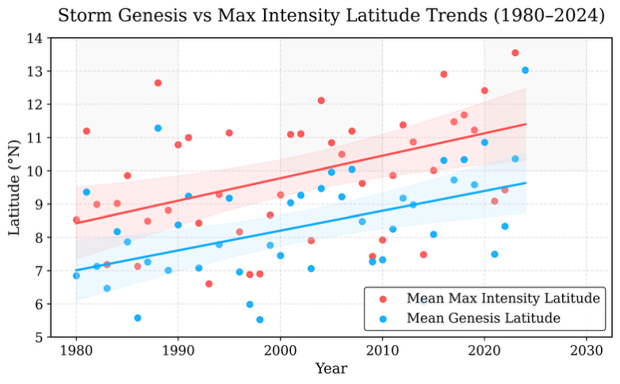
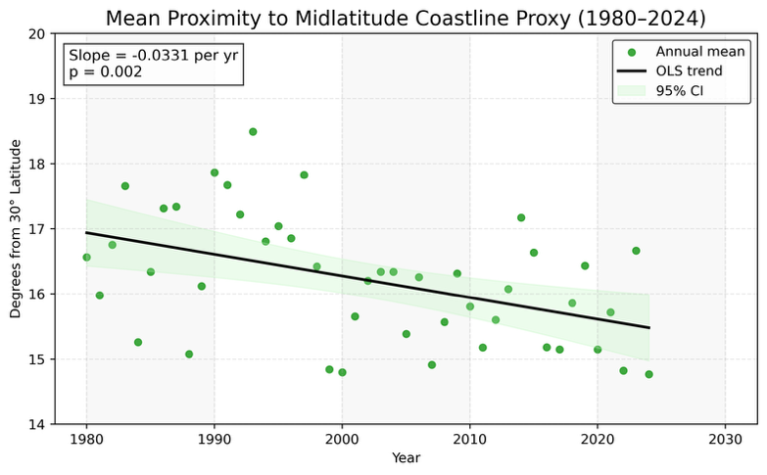
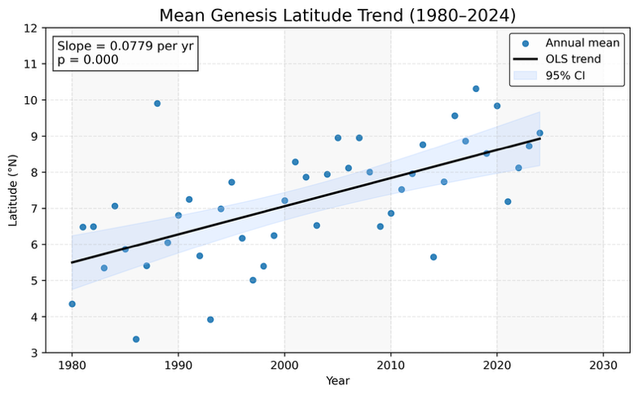
Figure 1. Poleward migration of tropical cyclones (1980–2024)
Panels A-D illustrate key metrics of tropical cyclone latitudinal shifts in the North Atlantic and Western North Pacific basins. (A) (top-left) Mean latitude of TC genesis shows a statistically significant northward trend. (B) (top-right) Mean latitude at which TCs reach maximum intensity demonstrates a parallel poleward shift. (C) (bottom-left) Mean proximity of TC tracks to midlatitude coastlines, serving as a proxy for TC exposure, indicating cyclones are increasingly occurring closer to higher-latitude coastlines. (D) (bottom-right) Combined overview of genesis and maximum-intensity latitude trends highlights the alignment of poleward migration in both formation and peak-intensity locations. All trends are significant (p << 0.05), confirming the consistent poleward movement of TCs across multiple measures.

Together, these three independent measures (genesis latitude, maximum-intensity latitude, and proximity to midlatitude coastlines) consistently demonstrate a poleward migration of tropical cyclones since 1980. Statistical analyses, including linear regression and p-tests, confirm that these shifts are significant, providing strong support for the main hypothesis.
III.A.2, Tree-Ring Data: To complement instrumental tropical cyclone records, tree-ring-based canopy disturbance (CD) data from Altman et al. (2018) has been used as an independent proxy for past storm activity. Canopy disturbances, such as broken or fallen

trees, can result from strong winds and heavy rainfall associated with tropical cyclones, making CD a useful indicator of past storm impacts. By analyzing these disturbances over time and latitude, we can infer historical cyclone activity and identify long-term patterns. The dataset tracks disturbance events along a latitudinal gradient (33°N-45°N, subset) from multiple forest sites in Northeastern Asia along the Northwestern Pacific coast and groups them into three age categories: <15 years, 15-50 years, and >50 years.
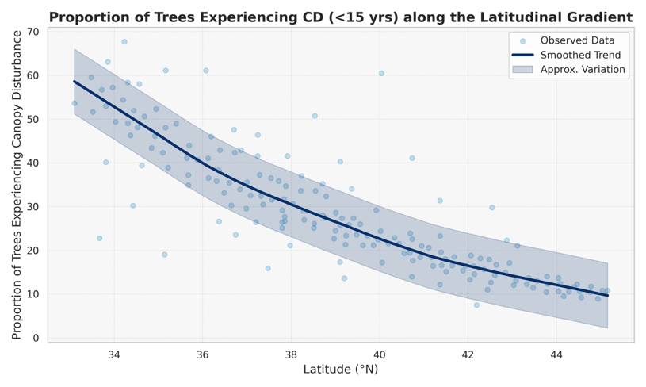
Figure 2A shows the proportion of trees experiencing recent disturbances (<15 years). Higher proportions at lower latitudes (closer to 33°N) indicate that the most recent disturbances are concentrated toward the southern end of the gradient, while higher latitudes experienced fewer recent events. On its own, this figure does not indicate a poleward shift, but it provides a baseline of recent disturbance distribution.
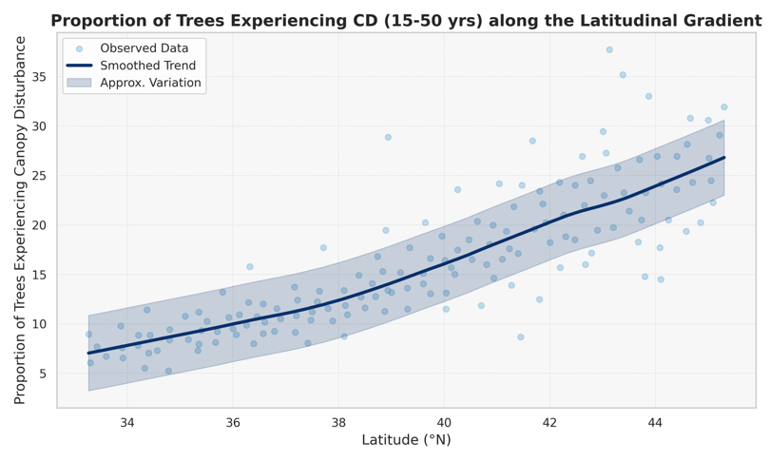
Figure 2B depicts moderate-aged disturbances (15-50 years). Here, the proportion of affected trees increases toward higher latitudes, suggesting that disturbances in this time window were more common further north compared to the most recent period.
Figure 2C shows older disturbances (>50 years), which also increase with latitude. This indicates that in the more distant past, northern sites experienced proportionally more cyclone-related canopy damage than they do in recent decades.
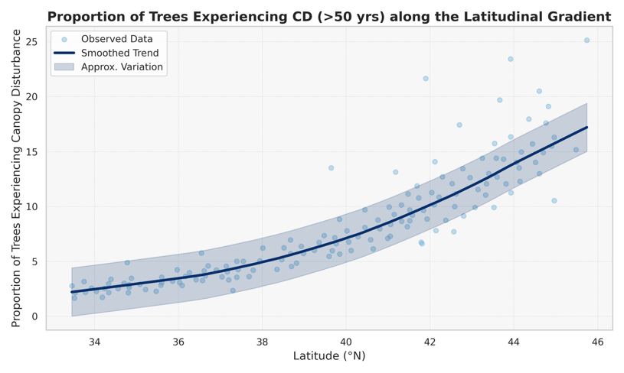
Comparing the age categories shows a latitudinal shift in disturbance patterns over time. Older disturbances are more frequent at higher latitudes, while younger disturbances are concentrated at lower latitudes, indicating that the areas of cyclone impact have gradually moved poleward. This pattern aligns with instrumental observations of tropical cyclone tracks and genesis, providing independent, long-term proxy evidence that supports the main hypothesis: tropical cyclones are migrating toward higher latitudes.
It is important to note that by including these data, my goal is to provide independent environmental evidence that my study regions are relevant for analyzing tropical cyclone behaviour. The CD data therefore contextualizes the instrumental track and intensity data, helping to validate the regions chosen for investigating long-term trends, including the poleward migration observed in modern records.
Figure 2. Tree-ring canopy disturbance (CD) as a proxy for historical cyclone impacts (33°–45°N).
Panels A-C (alphabetical, top to bottom) show the proportion of trees experiencing canopy disturbances in three age categories: <15 years (A), 15–50 years (B), and >50 years (C). Younger disturbances are more frequent at lower latitudes, while older disturbances are more frequent at higher latitudes. These patterns do not directly indicate poleward migration, but provide independent environmental evidence that both northern and southern sites have historically experienced cyclone-related impacts. The data contextualize the study regions and support the relevance of instrumental tropical cyclone observations.

III.B Sub-Hypotheses: The impacts and even the mechanisms and regional variations underlying the polewards shift of TCs still, remain complex. To better understand these patterns, several sub-hypotheses are proposed that break down the main question into more specific components.
III.B.1 Sub-Hypothesis 1: “Environmental drivers such as rising sea surface temperatures (SSTs) influence the poleward migration of tropical cyclones”
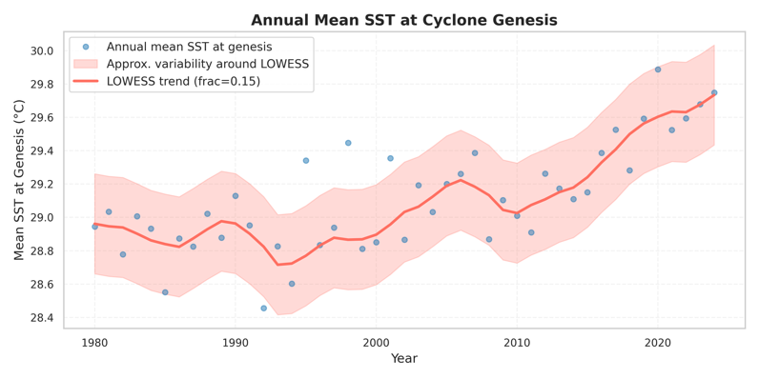
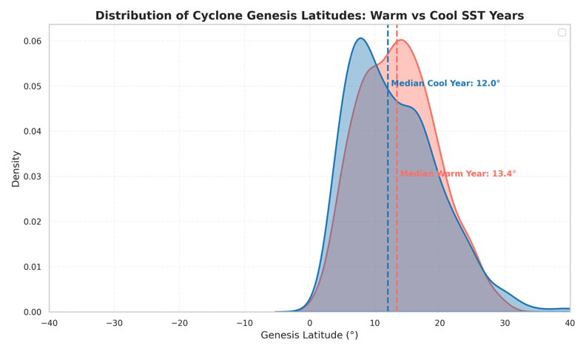
Rising sea surface temperatures (SSTs) can affect tropical cyclone formation by expanding the regions where ocean waters are warm enough to support cyclogenesis. Warmer SSTs provide more heat and moisture to fuel storms, allowing them to form at higher latitudes than usual.
Figure 3. SST and TC Genesis.
(A, Upper) Distribution of tropical cyclone genesis latitudes during warm and cool years. The graph shows the frequency of storms forming at different latitudes for each category.
(B, Lower) Time series of annual mean SST at cyclone genesis locations from 1980-2025. The graph plots the yearly average SST where storms originated.

In Figure 3A, comparing cyclone genesis during warm and cool SST years shows a clear pattern: in cooler years, storms form closer to the equator, while in warm years, genesis shifts toward higher latitudes. This suggests that elevated SSTs enable cyclones to form farther from the equator.
According to Figure 3B, the long-term SST record at genesis locations shows a steady warming trend. As ocean temperatures rise, regions farther from the equator increasingly meet the thermal threshold for cyclone development, thus broadening the potential zone for genesis.
Together, these analyses indicate that rising SSTs are a key environmental driver of poleward migration. Warm conditions allow cyclones to form at higher latitudes, supporting the sub-hypothesis that SST influences the observed shift in tropical cyclone formation.

III.B.2 Sub-Hypothesis 2: “Environmental drivers such as changes in vertical wind shear influence the poleward migration of tropical cyclones”
Vertical wind shear (VWS) refers to the change in wind speed or direction with height. Strong VWS can disrupt the vertical structure of developing cyclones, preventing them from organizing and intensifying, while moderate or weak shear allows storms to develop more easily. Understanding how VWS varies with latitude helps explain potential constraints on poleward cyclone formation.
Figure 4A shows a scatter plot of cyclone genesis latitude versus VWS at formation locations. Cyclones forming at higher latitudes tend to experience slightly higher shear, but formation still occurs, indicating that moderate shear does not entirely prevent poleward development.
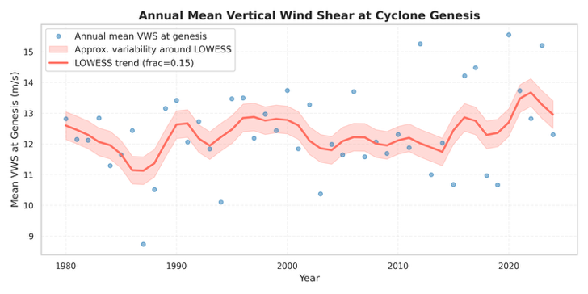
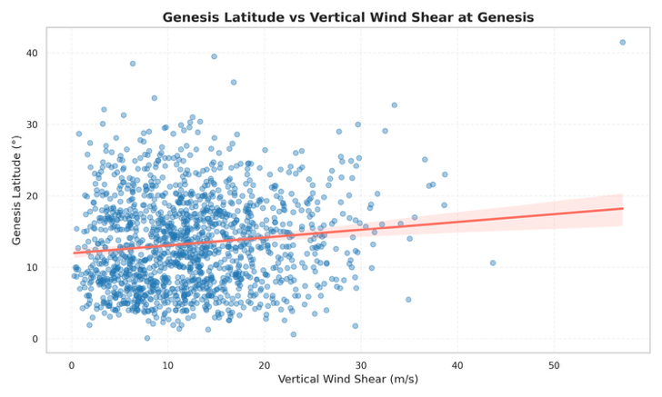
Figure 4B presents a time series of annual mean VWS at genesis locations. The graph shows small year-to-year fluctuations and a modest upward trend, indicating that cyclones are forming under slightly higher shear conditions over time.
Figure 4. Vertical Wind Shear and Cyclone Formation

(A, Upper) Scatter plot of tropical cyclone genesis latitude versus VWS at formation locations.
(B, Lower) Time series of annual mean VWS at cyclone genesis locations from 1980–2025, showing interannual variability

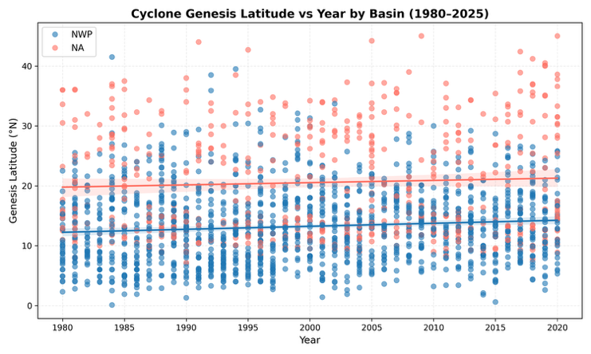
These analyses. suggest that VWS moderates where cyclones can form but is not the dominant factor driving poleward migration. Cyclones are able to develop under moderate shear, and other environmental drivers, such as rising SSTs, likely play a more significant role in enabling formation at higher latitudes.

III.B.3 Sub-Hypothesis 3: “Basin-specific differences exist in the poleward migration of tropical cyclones in the Northwestern Pacific and North Atlantic”
Tropical cyclone activity varies between ocean basins due to differences in environmental conditions. This sub-hypothesis explores whether poleward migration occurs similarly in the Northwestern Pacific (NWP) and North Atlantic (NA), or if each basin shows distinct patterns.
Figure 5 shows cyclone genesis patterns for both basins. The KDE curves indicate that NA cyclones tend to form slightly farther poleward than NWP cyclones and exhibit a secondary bulge at higher latitudes, suggesting basin-specific differences. The scatter plot of genesis latitude versus year shows modest northward trends in both basins, though variability makes these trends subtle.
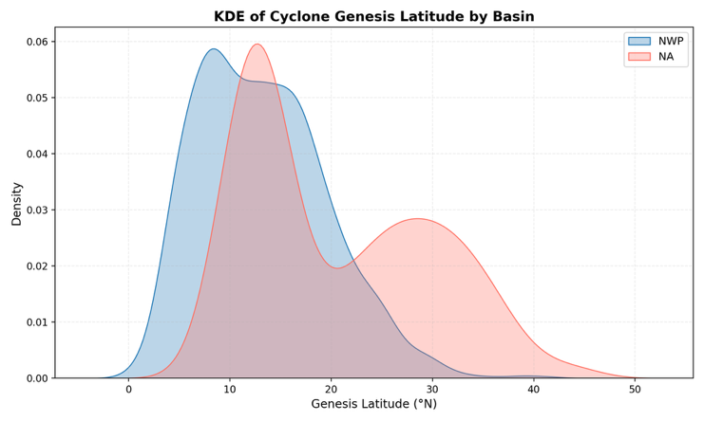
These analyses strongly indicate that poleward migration is more pronounced in the NA basin. The differences support the sub-hypothesis that migration may not occur uniformly across basins, highlighting the importance of considering basin-specific environmental controls when studying tropical cyclone behavior.
Figure 5. Basin-Specific Cyclone Genesis Comparison

(A, Upper) KDE of cyclone genesis latitudes for the Northwestern Pacific (blue) and North Atlantic (red). Peaks indicate the most common genesis latitudes for each basin.

(B, Lower) Scatter plot of genesis latitude versus year (1980-2025) for both basins, with trend lines showing the general northward trend over time.

III.B.4 Sub-Hypothesis 4: “Poleward migration of TCs increases exposure of human populations and coastline ecosystems”
As tropical cyclones migrate toward higher latitudes, regions that historically experienced fewer storms may face greater risk from wind, rainfall, storm surges, and associated coastal impacts. This sub-hypothesis proposes that the poleward shift of TCs is increasing the exposure of mid-latitude populations and coastal ecosystems.
To examine this, I prepared two heatmaps showing TC proximity to coastlines for 1980–2000 and 2000–2024. Figure 6A, the first heatmap (1980-2000), indicates that cyclone tracks were mostly concentrated farther from mid-latitude coastlines, while Figure 6B, the second heatmap (2000-2024), shows a noticeable shift, with more storms occurring closer to these coastal areas. This visual comparison suggests that TCs are now affecting coastlines that previously experienced fewer events, which may increase both human and ecological vulnerability.
Overall, these results support the sub-hypothesis that poleward migration is increasing the exposure of mid-latitude populations and coastal ecosystems to tropical cyclones.

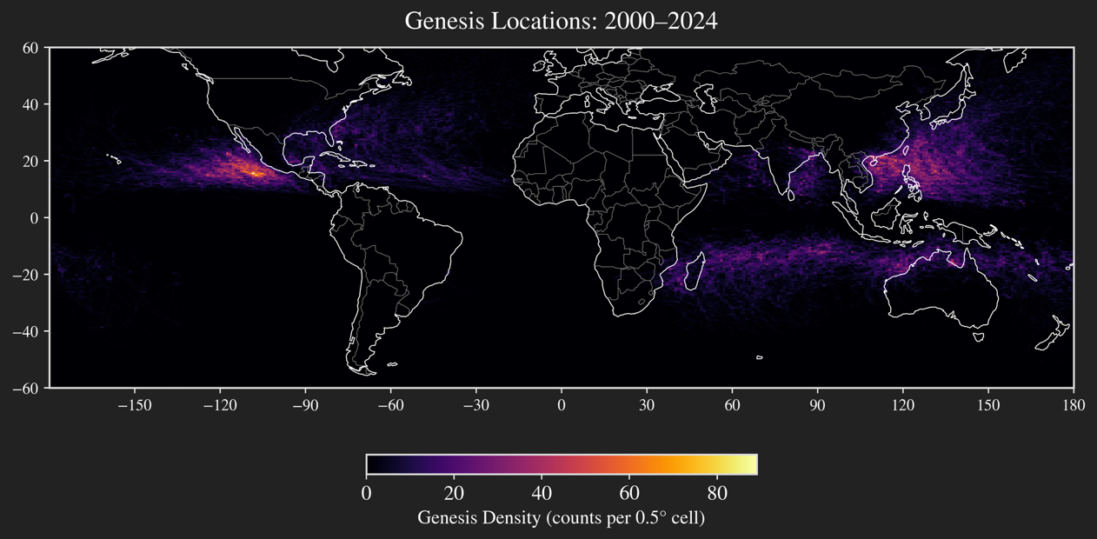
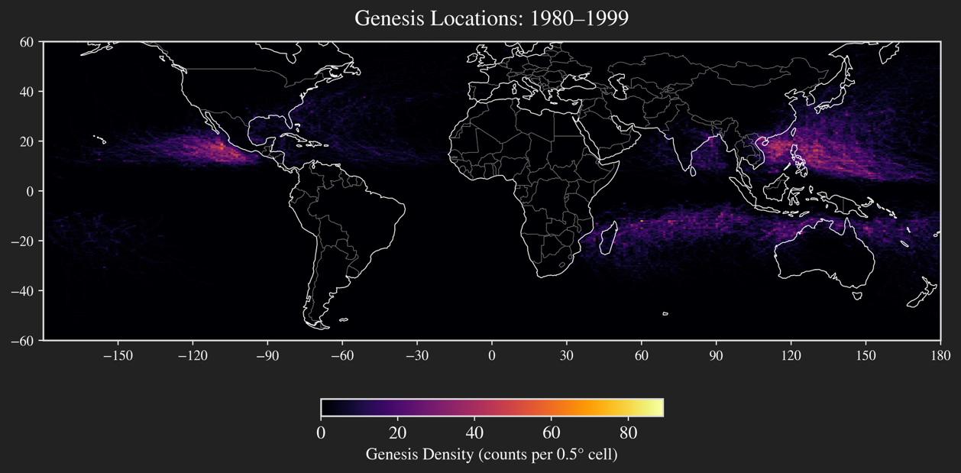

Figure 6. Cyclone proximity to mid-latitude coastlines.

(A, Upper) Heatmap of tropical cyclone tracks from 1980-1999, showing most storms occurring farther from mid-latitude coastlines.

(B, Lower) Heatmap of tropical cyclone tracks from 2000-2024, showing more storms occurring closer to mid-latitude coastlines.

- METHODS

Figure | Description | Data Used | Method / Analysis (rationale)
Figure 1 | Poleward migration of tropical cyclones (1980-2024) | IBTrACS TC tracks | Linear regression and calculation of mean latitudes and proximities were used to quantify shifts over time. P-value significance tests were applied to ensure observed trends were statistically robust.
Figure 2 | Tree-ring canopy disturbance (CD) as a proxy for historical cyclone impacts | Tree-ring CD data (Altman et al., 2018) | The proportion of trees experiencing canopy disturbances was analyzed along the latitudinal gradient using binomial mixed-effect models.  (Limitation) Data from Altman et al. (2018) was unavailable digitally. The dataset was, thus, reconstructed from published figures using x-step weighted interpolation, creating a complete latitudinal record (33°–45°N) to analyze historical cyclone-related impacts.
Figure 3 | SST and TC Genesis | ERA5 SST, IBTrACS TC tracks | Kernel density estimation (KDE) was used to compare genesis distributions in warm vs cool years, while time series analysis with LOWESS smoothing quantified long-term SST trends.
Figure 4 | Vertical Wind Shear and Cyclone Formation | ERA5 VWS, IBTrACS TC tracks | Scatter plots and regression analysis were applied to explore relationships between VWS and genesis latitude. Time series of annual mean VWS highlights temporal variability..
Figure 5 | Basin-specific cyclone genesis comparison | IBTrACS TC tracks | KDE and scatter plots with regression lines were used to compare latitudinal distributions and trends between basins.
Figure 6 | Cyclone proximity to mid-latitude coastlines | IBTrACS TC tracks, coastline shapefiles | Heatmaps and distance calculations were applied to visualize shifts in cyclone tracks relative to coastlines.

- IMPLICATIONS ON HUMAN POPULATIONS & COASTAL ECOSYSTEMS
The heatmap examination of the proximity of tropical cyclones to mid-latitude coastlines (see figure 6) indicates that the TCs are progressively impacting areas that were less prone to tropical cyclone occurrences in the past. This means that the mid-latitude coastlines, which were less susceptible to the effects of tropical cyclones, are now faced with high risks from the potential damage associated with strong winds, high rainfall, and flood-related disasters associated with tropical cyclones.
These tendencies imply that city administrations and coastal planning authorities must invest in good early warning systems and implement climate change adaptation and resilience into their planning processes. (Bakkensen & Blair, 2022). This would involve, for instance, upgrading building and flood control measures and safeguarding natural defenses such as dunes, mangroves, and wetlands that protect cities against the effects of the storm. (Wang et al., 2024).
In addition to physical damage, tropical cyclones often trigger population displacement. In the new, mid-latitude areas that are affected, there could be either short-term or permanent displacement of the population, leading to additional burdens on the provision of housing and services. This displacement could be understood as new patterns of vulnerability. (Mester et al., 2023).
In conclusion, the poleward shift of TCs has direct impacts on society and the environment. Awareness and proactive adaptations for the new threats and risks that are occurring as a result of the shifting cyclone climate are important for protecting human populations and maintaining the threatened ecological habitats.

- RESULTS & CONCLUSION
What my analysis shows is that there are clear indicators that the poleward migration of tropical cyclones into the North Atlantic and Northwestern Pacific basins is significantly prevalent. These indicators are: the mean genesis point, the point of maximum intensity, and the proximity of TC tracks to the coastlines of the mid-latitudes, as shown in Figure 1. These factors confirm that the TCs are migrating poleward, affirming the main hypothesis of the paper.
Environmental drivers appear to play a key role in this shift. An increase in sea surface temperatures enhances the areas where the generation of tropical cyclones becomes favorable, as shown by comparisons concerning the genesis latitude for warm and cool years (see Figure 3). Vertical wind shear influences cyclone formation at higher latitudes, but my analyses (Figure 4) suggest that cyclones can still form under moderate increases in shear, indicating that this acts more as a moderating factor than a limiting one.
There are regional variations as well. Basin-specific analyses (see Figure 5) show that the poleward migration is slightly stronger for the NA basin compared to the NWP basin. This indicates the significance of basin-specific factors when assessing the characteristics of cyclones.
Finally, the shift towards the higher latitudes has implications for human populations and coastal ecosystems. The heatmap analysis performed for proximity to the mid-latitude coastlines (see figure 6) indicates that TC activity is extending to locations that were less prone to TC impacts.
In summary, the above findings present an entire spectrum, which makes it clear that tropical cyclones are shifting towards the poles as a result of an increase in SST values, as well as other factors, and that such shifts are increasing the vulnerability of mid-latitude coastlines.

- BIBLIOGRAPHY

Google Drive Link containing programs, datasets, and code-generated figures: https://drive.google.com/drive/folders/1ljZGaE5yQwYxLkFwDuXF8kUv073LIUYc?usp=sharing

- Altman, J., Ukhvatkina, O. N., Omelko, A. M., Macek, M., Plener, T., Pejcha, V., Cerny, T., Petrik, P., Srutek, M., Song, J., Zhmerenetsky, A. A., Vozmishcheva, A. S., Krestov, P. V., Petrenko, T. Y., Treydte, K., & Dolezal, J. (2018). Poleward migration of the destructive effects of tropical cyclones during the 20th century. Proceedings of the National Academy of Sciences, 115(45), 11543–11548. https://doi.org/10.1073/pnas.1808979115
- Bakkensen, L., & Blair, L. (2022). The economics of tropical cyclone adaptation. In Edward Elgar Publishing eBooks. https://doi.org/10.4337/9781800880740.00008
- Gray, W. M. (1998). The formation of tropical cyclones. Meteorology and Atmospheric Physics, 67(1–4), 37–69. https://doi.org/10.1007/bf01277501
- Griffin-Elliott, T. (2024, June 7). 45th Anniversary of the Bhola Cyclone - NOAA's Atlantic Oceanographic and Meteorological Laboratory. NOAA’s Atlantic Oceanographic and Meteorological Laboratory. https://www.aoml.noaa.gov/hurricane_blog/45th-anniversary-of-the-bhola-cyclone/
- Mester, B., Vogt, T., Bryant, S., Otto, C., Frieler, K., & Schewe, J. (2023). Human displacements from Tropical Cyclone Idai attributable to climate change. Natural Hazards and Earth System Sciences, 23(11), 3467–3485. https://doi.org/10.5194/nhess-23-3467-2023
- Sobel, A. H., Wing, A. A., Camargo, S. J., Patricola, C. M., Vecchi, G. A., Lee, C., & Tippett, M. K. (2021). Tropical cyclone frequency. Earth S Future, 9(12). https://doi.org/10.1029/2021ef002275
- Walsh, K. J., McBride, J. L., Klotzbach, P. J., Balachandran, S., Camargo, S. J., Holland, G., Knutson, T. R., Kossin, J. P., Lee, T., Sobel, A., & Sugi, M. (2015). Tropical cyclones and climate change. Wiley Interdisciplinary Reviews Climate Change, 7(1), 65–89. https://doi.org/10.1002/wcc.371
- Wang, J., Chang, Y., & Tse, K. T. (2024). Synthesis of Tropical Cyclones: Understanding, modeling, and adapting to climate change impacts. In Sustainable development. https://doi.org/10.5772/intechopen.114390
- Yanai, M. (1964). Formation of tropical cyclones. Reviews of Geophysics, 2(2), 367–414. https://doi.org/10.1029/rg002i002p00367

