This project used nodejs and mysql.

The project structures are config, controllers, models, routes, etc.

You can change db.config.js and use data.sql.

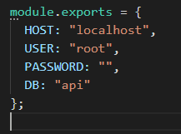

You can import data.sql file into api database.