# Lab: String and Text Processing

Problems for lab for the ["PHP Fundamentals" course @ SoftUni](https://softuni.bg/trainings/2344/php-fundamentals-may-2019).

You can check your solutions in [Judge](https://judge.softuni.bg/Contests/1223/).

## Substring

On the first line you will receive a string. On the second line you will receive a second string. Write a program that removes all of the occurrences of the first string in the second until there is no match. At the end print the remaining string.

### Examples

|  |  |  |
| --- | --- | --- |
| **Input** | **Output** | **Comment** |
| ice  kicegiciceeb | kgb | We remove ice once and we get "kgiciceeb"  We match "ice" one more time and we get "kgiceb"  There is one more match. The final result is "kgb" |

### Hints

* Read the input.
* Remove the matches.
  + Use the function **str_replace(searchText, '', string)**

## Reverse Strings

You will be given series of strings until you receive an **“end”** command. Write a program that reverses strings and print word and reversed word on separate line in format **"{word} = {reversed word}"**.

### Examples

|  |  |
| --- | --- |
| **Input** | **Output** |
| helLo  Softuni  bottle  end | helLo = oLleh  Softuni = inutfoS  bottle = elttob |
| Dog  caT  chAir  end | Dog = goD  caT = Tac  chAir = riAhc |

### Solution

Use while loop and read strings until you receive "**end**".

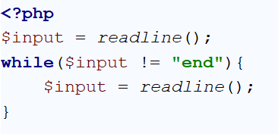

Reverse the string with **strrev()** function.



Print the reversed string in the specified format.



## Repeat strings

### Write a program that reads an array of strings. Each string is repeated n times, where n is the length of the string. Print the concatenated string.

### Examples

|  |  |
| --- | --- |
| **Input** | **Output** |
| hi abc add | hihiabcabcabcaddaddadd |
| work | workworkworkwork |
| ball | ballballballball |

### Solution

* Read a string array.



* Iterate through elements in the array.

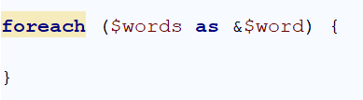

* Find the length of the current word.

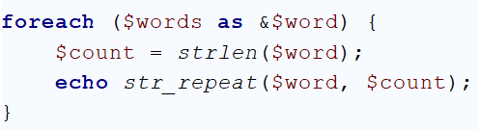

## Text Filter

Write a program that takes a **text** and a **string of banned words**. All words included in the ban list should be replaced with **asterisks** "**\***", equal to the word's length. The entries in the ban list will be separated by a **comma** and **space** "**,** ".

The ban list should be entered on the first input line and the text on the second input line.

### Examples

|  |  |
| --- | --- |
| **Input** | **Output** |
| Linux, Windows  It is not **Linux**, it is GNU/**Linux**. **Linux** is merely the kernel, while GNU adds the functionality. Therefore we owe it to them by calling the OS GNU/**Linux**! Sincerely, a **Windows** client | It is not *****, it is GNU/*****. ***** is merely the kernel, while GNU adds the functionality. Therefore we owe it to them by calling the OS GNU/*****! Sincerely, a ******* client |

### Hints

* Read the input.
* Replace all ban words in the text with asterisk (*).
  + Use the function **str_replace()**.
  + Use **str_repeat()** to create the replacement

## Count string occurrences

Write a program that receives a text and a string to search for. Use **spaces**, **commas**, **dots**, **question** **marks** and **exclamation** **marks** as word **delimiters**. Print all the occurrences of that word in the string

### Examples

|  |  |
| --- | --- |
| **Input** | **Output** |
| This is a word and it also is a sentence.  is | 2 |
| How are you?? Good, thanks.  are | 1 |

### Hint

Split the sentence into words and create a counter that stores how many times the searched word occurs

## Palindromes

Write a program that extracts from a given text all palindromes, e.g. **ABBA**, **lamal**, **exe** and prints them on the console on a single line, separated by comma and space. Use **spaces**, **commas**, **dots**, **question** **marks** and **exclamation** **marks** as word **delimiters**. Print only **unique** palindromes, **sorted** [**natural order**](http://php.net/manual/en/function.natcasesort.php).

### Examples

|  |  |
| --- | --- |
| **Input** | **Output** |
| Hi,exe? ABBA! Hog fully a string. Bob | a, ABBA, exe |

### Hints

To sorting result use natcasesort() function