THE
GAME DEVELOPMENT
FIELD GUIDE
A practical, engine-agnostic guide to designing, building, testing, and shipping games people want to play.
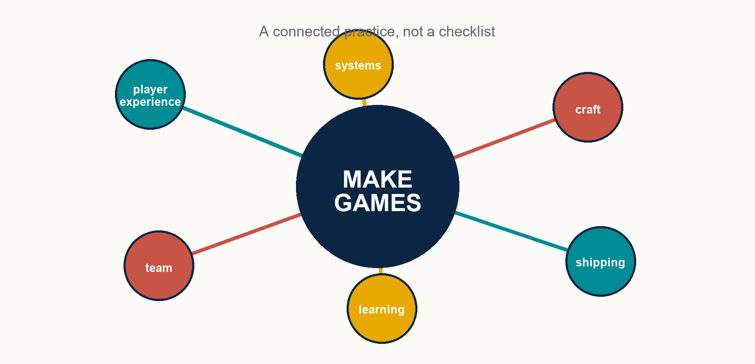
A game succeeds when its connected practices reinforce one another.
PUBLIC EDITION | 2026

HOW TO USE THIS GUIDE

A map for the work
  - Read it front to back, or enter where your next decision lives.
Games are not made by a single discipline. A control decision changes level design. A content pipeline changes production speed. A business model changes the player relationship. This guide is organized around the connections that matter most.
Part | What it helps you do
I. Create the experience | Set a player-centered north star; shape systems, challenge, feedback, space, story, and fairness.
II. Build it to change | Create architecture, art, animation, audio, content, performance, and quality practices that keep iteration inexpensive.
III. Learn on purpose | Use prototypes and player research to replace assumptions with evidence; protect vision, scope, and team health.
IV. Release with care | Treat launch, post-launch learning, and end-of-life decisions as part of the product.

A USEFUL RULE
Design intent is a hypothesis. The experience players actually have is the evidence. Keep the vision; stay willing to change the implementation.
The advice here is deliberately general. Genre, audience, platform, budget, and creative ambition change the right answer. Use principles to frame a decision, then test the decision in the game you are actually making.

PART I
Create the experience
Make the player experience the source of truth.

1. PLAYER-CENTERED DESIGN

Begin with what the player feels
The game is not the plan in the team's head. It is the experience produced through play.
A designer authors rules and content. A player receives consequences, sensations, emotions, and stories. That gap is why good teams write down the intended experience early and return to it whenever a feature, tutorial, level, or reward is evaluated.
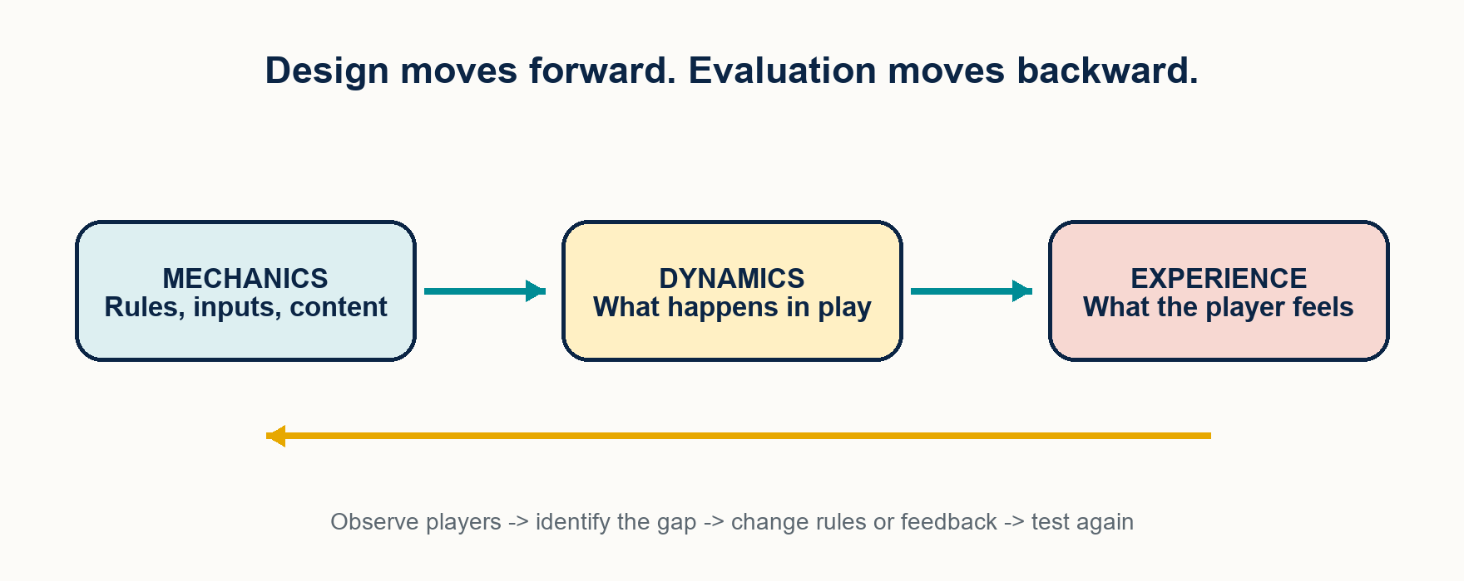
Figure 1. Build mechanics and feedback, then judge their value by the player experience they create.
- Name the experience in plain language: tense and resourceful, playful and expressive, deliberate and weighty, or another specific feeling.
- Design for a particular audience rather than an imaginary average player. Specificity gives tradeoffs a direction.
- Treat player confusion, hesitation, delight, and surprise as signals. They describe symptoms; the team still owns the cure.
DECISION TEST
When a feature is debated, ask: what will a player notice, learn, feel, or be able to do differently? If the answer is unclear, the feature is not ready to earn its complexity.
2. SYSTEMS AND AGENCY

Build a loop worth repeating
The most repeated seconds of play deserve the most attention.
A core loop is the recurring cycle of action, simulation, feedback, and the next decision. Progression, content, and story can enrich it, but they cannot rescue a loop that is inert on its own. Prototype the repeated interaction in its simplest form first.
- Make choices consequential and legible. Players need to see what happened because of what they did.
- Create real tradeoffs. A dominant option is not a decision; it is a shortcut around the design.
- Favor depth from interacting rules over a long list of exceptions. Simple surfaces can support long mastery when the rules combine productively.
- Surface enough cause and effect for players to form a mental model. Hidden systems create superstition, not satisfying depth.
SYSTEM DESIGN LENS
You do not directly design outcomes. You design rules, incentives, and feedback, then observe the behavior they produce. That is why every system needs a testable hypothesis.
3. LEARNING, CHALLENGE, AND PACE

Create room to learn and recover
Engagement grows when the next challenge meets a player who has just gained the means to face it.
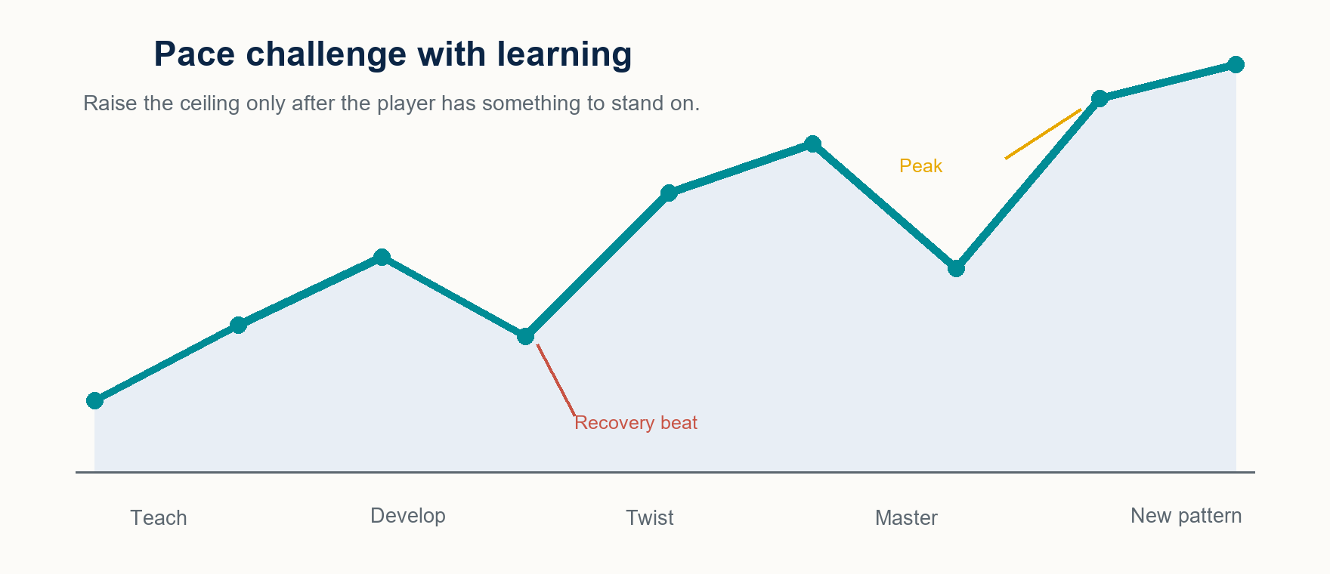
Figure 2. A useful learning rhythm introduces a pattern, develops it, twists it, lets the player demonstrate mastery, then creates room for the next pattern.
- Teach one idea in a safe setting. Let the player use it before the game asks them to depend on it.
- Raise challenge as skill rises. Too much pressure produces anxiety; too little turns mastery into boredom.
- Alternate intensity and release. Recovery is not empty time; it lets peaks land and gives players time to process.
- Decide how much growth comes from player skill versus character power. The mix defines the kind of mastery the game promises.
Good progression rewards the behavior the game wants to see. New tools, meaningful choices, and genuine mastery deepen the experience; repetitive rewards that substitute for fun eventually expose the absence of it.
4. FEEL, FEEDBACK, AND CONTROL

Make actions immediate, readable, and alive
Game feel is not decoration. It is the moment-to-moment conversation between intent, response, and sensation.
- Acknowledge input immediately. A player should see or hear a response as soon as the game can provide one.
- Interpret intent, not only literal input. Small forgiveness windows can make near-misses resolve the way a player reasonably expected.
- Layer feedback. Animation, sound, visual effects, camera, haptics, and UI can together confirm an action more clearly than any one channel alone.
- Choose the responsiveness-versus-commitment balance deliberately. Snappy cancellation and weighty follow-through can both be right when they serve the fantasy and the risk-reward model.
ACCESSIBILITY IS PART OF FEEL
Make motion intensity, screen shake, text scale, color cues, subtitles, difficulty assists, and control remapping adjustable. A more inclusive control loop is usually a better control loop for everyone.
5. SPACE, STORY, AND CLARITY

Let the world teach and communicate
Players should be able to read where they are, what matters, and why their next action makes sense.
Level design, narrative, interface, animation, and audio all answer the same questions: Where am I? What can I do? What just happened? What matters now? Use each channel to make the others clearer rather than making them compete.
- Guide attention with light, contrast, color, framing, sound, and leading lines. The environment can point without an arrow.
- Give spaces landmarks, paths, edges, districts, and nodes so players build a mental map instead of navigating by luck.
- Teach mechanics through space: safe introduction, clearer application, then richer combinations. The level can be the tutorial.
- Let narrative react to action and live in the world where possible. Players are participants, not an audience waiting for a delivery.
- Use interface hierarchy and familiar signifiers so the player does not have to hunt or guess. Reduce the friction between the player and the fun.
6. PROGRESSION, ECONOMY, AND BALANCE

Keep choices valuable as the game grows
Numbers are design language. Their job is to create decisions, pacing, and perceived fairness.
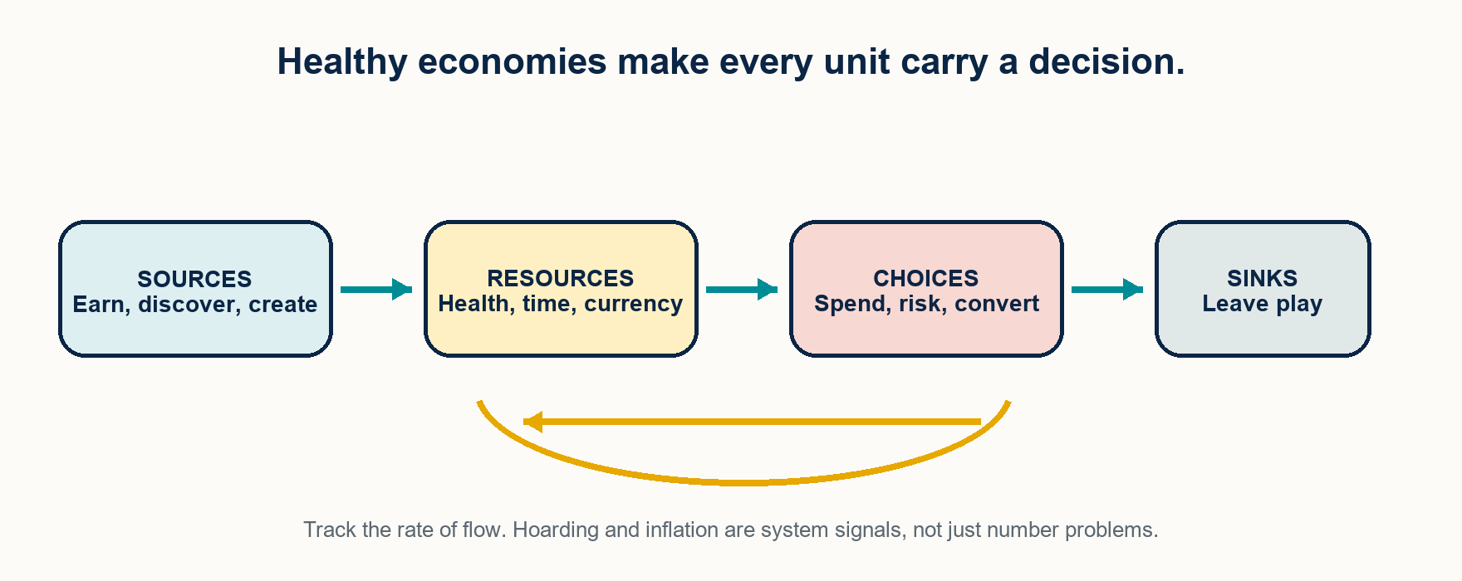
Figure 3. Resources gain meaning when sources, choices, and sinks are designed as a connected flow.
- Make resources scarce enough to create tradeoffs, but not so scarce that players feel trapped or unable to act.
- Give each currency or resource a distinct purpose. If two systems create the same decision, simplify or differentiate them.
- Track faucets and sinks over time. Runaway accumulation, inflation, and trivialized content are flow problems before they are tuning problems.
- Balance toward the intended experience. Mathematical parity is useful, but perceived fairness, counterplay, variety, and fun are the real goal.
- Use data to find suspicious outliers; use play to decide whether the result is good.
7. SOCIAL DESIGN AND PLAYER RESPECT

Design the relationship, not just the feature
Multiplayer and monetization are part of the player experience, not layers added after it.
- Design the social experience: cooperation, rivalry, communication, recovery from failure, and the norms players learn from the system.
- Shape behavior through incentives and feedback. Do not rely on moderation alone to repair a system that rewards toxicity or abandonment.
- Make competitive systems trustworthy: protect authoritative state, prioritize fair matchmaking, and respect connection quality.
- Choose a business model that fits the game and states the deal honestly. Sell value, expression, or convenience - not relief from problems deliberately created to sell relief.
- Be transparent about costs and chance. Keep payment out of competitive advantage; redesign any choice that feels manipulative when explained plainly.

PART II
Build it to change
Architecture and craft should make the next good iteration easier.

8. ARCHITECTURE FOR ITERATION

Build systems that can evolve
Good architecture protects change. It lets the team adjust the game without breaking the rest of it.
- Keep gameplay rules expressed in game terms, insulated from platform or rendering details wherever practical.
- Favor composition over deep inheritance. Small, reusable pieces are easier to combine, test, and replace.
- Use events or messages to decouple systems that only need to know that something happened. This makes new behavior cheaper to add.
- Move tuneable behavior and content into data that the people closest to the decision can edit without a full code change.
- Decide early what state is authoritative and how it persists. Save/load, networking, and repeatable tests depend on it.
ARCHITECTURE METRIC
Measure the time from a creator changing an idea to seeing its effect. Fast builds, live tuning, useful tools, and clear data all compound into more learning cycles.
9. ART, ANIMATION, AND AUDIO

Make the craft serve play
Visual and audio quality are not separate from usability. They direct attention, communicate state, and make actions believable.
- Choose a coherent art direction before chasing raw fidelity. A deliberate style reads clearly, ages well, and can fit a real production budget.
- Treat lighting as a primary design tool. It can shape mood, guide the eye, create depth, and clarify space.
- Build materials and shaders as flexible, data-driven systems rather than an unmaintainable pile of one-offs.
- Animate for communication. Wind-ups, recovery, hit reactions, and secondary motion tell the player as much as they impress them.
- Let player control win when animation fidelity and responsiveness conflict. Give control back before a beautiful animation has finished whenever the game needs it.
- Make sound feedback first. Mix dynamically so the audio cue that matters can be heard; use silence and contrast so impact still has a place to land.
10. PIPELINES, PERFORMANCE, AND QUALITY

Make good work repeatable
The quiet systems around the game determine how much of the team's time becomes player value.
- Invest in tools and content workflows. A small improvement in a repeated task pays back across every asset and every iteration.
- Use shared naming, organization, validation, and reproducible builds. A convention followed consistently is better than a perfect one ignored.
- Budget performance. Every frame is finite; art, simulation, and code all spend from the same player-facing resource.
- Profile before optimizing. Find the bottleneck, improve it, and measure again. Intuition is not a profiler.
- Automate deterministic regression checks. Use human testing for feel, difficulty, and emergence - the things tools cannot judge for you.
- Test on the hardware and conditions players actually use, including long sessions, real content loads, poor connections, and edge cases.
QUALITY IS A PROCESS
A defect caught at authoring or commit time is inexpensive. The same defect found late can cost scope, confidence, or the release itself.

PART III
Learn on purpose
Prototype assumptions, observe players, and protect the conditions for good decisions.

11. PROTOTYPE THE UNKNOWN

Find the answer before you build the answer
A prototype is a question made playable. Its value is the evidence it produces, not the code that survives.
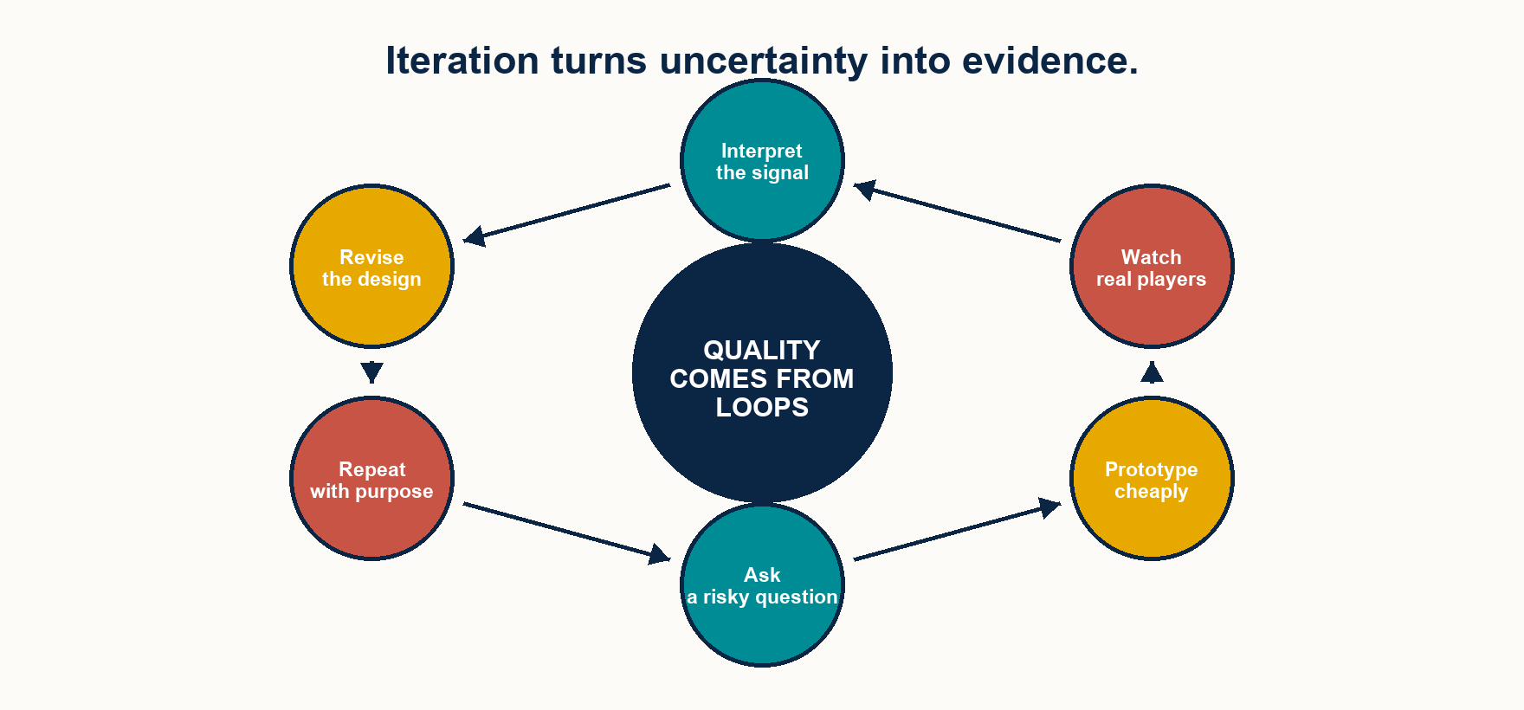
Figure 4. The highest-leverage development loop asks a risky question, builds the smallest useful test, observes the result, and repeats.
- Start with the riskiest assumption: the thing that would make the project fail if it is false.
- Prototype the core interaction before content, story, production art, and supporting systems. If the loop is not promising when rough, polish will not discover the missing premise.
- Greybox before you decorate. Placeholder visuals make it emotionally cheaper to change the space or mechanic.
- Keep prototypes narrow and disposable. One question, one useful answer, minimal attachment.
- Build a vertical slice later to prove that the desired quality can be made across disciplines, not merely imagined.
12. PLAYTEST FOR SIGNAL, NOT VALIDATION

Watch what players do
The team has privileged knowledge. Playtests reveal what a first-time player actually understands, feels, and attempts.
- Test early and often with rough builds. A cheap finding is a powerful finding because it arrives while the design can still move.
- Do not explain, coach, or defend during the test. The shipped game will not have the creator beside the player.
- Observe behavior before collecting opinion. Hesitation, backtracking, accidental success, repeated failure, and delight are evidence.
- Listen carefully to problems and cautiously to proposed solutions. Players are excellent at reporting friction and not obligated to diagnose it.
- Combine qualitative observation with telemetry. One reveals why; the other shows where and how often.
- Be deliberate about the sample. Friends, experts, and the team are rarely a representative substitute for the intended player.
RESEARCH POSTURE
A surprising result is not a player error or an attack on the vision. It is the moment the game taught you something you did not know.
13. VISION, SCOPE, AND TEAMS

Protect coherence without protecting assumptions
A healthy team needs both a clear direction and the safety to challenge the path toward it.
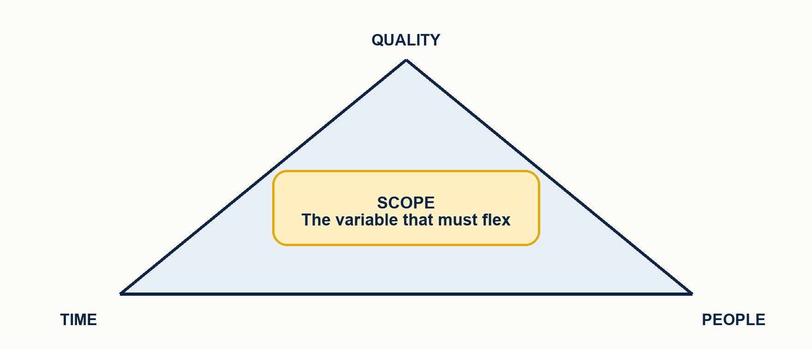
Figure 5. When commitments collide, scope is usually the variable that can flex without sacrificing people or the quality bar.
- State the creative vision in language everyone can remember. A short, specific promise helps the team resolve ambiguous choices.
- Turn the vision into a few design pillars. Every proposed feature should be able to answer how it serves them.
- Give vision a clear owner, while keeping feedback channels real. Coherence needs decision authority; quality needs dissent.
- Default to protecting scope. Every feature carries a tail of integration, balancing, testing, polish, and maintenance.
- Record decisions where the team can find the reasoning later. A decision that disappears from memory is not an alignment tool.
- Build psychological safety. Critique the work, run blameless postmortems, and make it safe to surface risk before it becomes a crisis.
SUSTAINABLE PACE
Sustained overwork is a planning signal, not a proof of commitment. Protecting people protects the game's quality, memory, and ability to finish.

PART IV
Release with care
The player's first impression and ongoing trust are part of the game.

14. SHIP THE EXPERIENCE

Launch is a design moment
A release is not the instant development becomes someone else's problem. It is the first large-scale test of the relationship the game makes with its players.
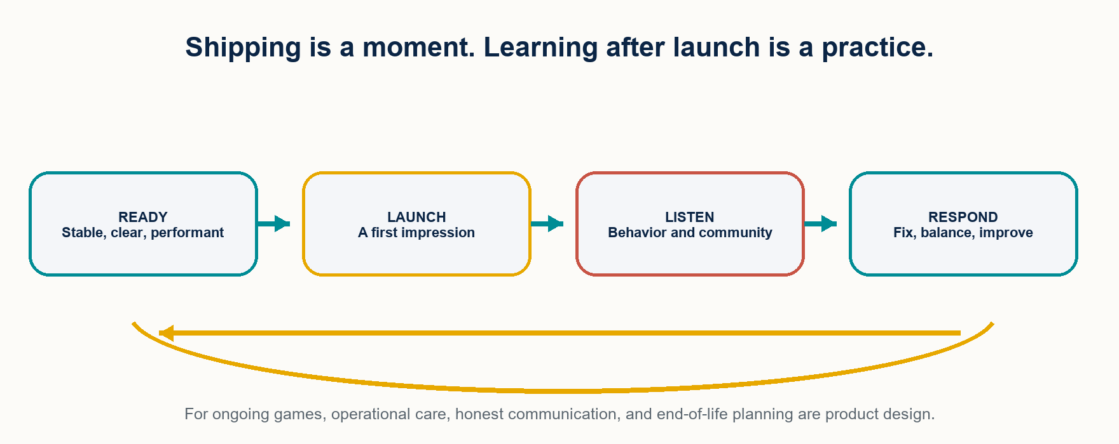
Figure 6. For ongoing games, launch begins a continuing loop of listening, responding, and earning trust.
- Define launch readiness deliberately: stability, performance, onboarding, clarity, and the first hour all shape the first impression.
- Finish by cutting and polishing, not by adding. Shipping is a distinct skill with its own discipline.
- For ongoing games, plan the operational work early: content cadence, balance, support, communication, and the tools needed to sustain them.
- Keep the learning loop alive after launch. Player behavior at scale and community feedback should inform fixes, balance, and improvements.
- Plan an ending with the same care as a beginning. Give early, honest communication and preserve access where feasible rather than treating players' time as disposable.
TRUST COMPOUNDS
Players can forgive a problem when they can see the team learning, communicating honestly, and treating their time and money with respect.
15. PRACTICAL REVIEW CARDS

Questions to carry into the next meeting
Use these prompts as a lightweight review before a milestone, playtest, or release decision.
Moment | Questions worth asking
Concept review | What experience are we promising? Who is it for? What is the smallest loop that can prove the promise?
Feature review | What player choice, skill, or feeling does this improve? What is the cost to learn, build, balance, explain, and maintain it?
Playtest review | What did players do without help? Where did their experience diverge from the target? What is the smallest change that tests a cure?
Production review | What is the riskiest assumption? What can be cut to protect quality and sustainable pace? Is the team seeing decisions and tradeoffs clearly?
Technical review | Does this shorten or lengthen change-to-feedback time? Has it been measured on real conditions? Can content creators use it safely?
Launch review | Is the first hour stable, clear, accessible, and performant? What will the team watch after release, and how will it respond?

APPENDIX

The complete discipline map
  - Twenty-four lenses for seeing the work as one connected practice.
Discipline | What it protects
Design | Player experience, agency, decisions, depth, and audience.
Feel | Responsiveness, physicality, feedback, impact, and control.
Systems | Core loops, emergence, feedback loops, and readable cause and effect.
Progression | Mastery, power curves, rewards, unlocks, and late-game goals.
Economy | Resources, scarcity, sources, sinks, and flow.
Balance | Viable choices, counterplay, tuning, and perceived fairness.
Level design | Guidance, pacing, encounter space, legibility, and exploration.
Narrative | Player agency, pacing, worldbuilding, and mechanics-story harmony.
UX and accessibility | Learning, controls, information hierarchy, readability, and inclusive play.
Multiplayer | Fairness, trust, social behavior, matchmaking, and the real player population.
Monetization | Value exchange, transparency, ethics, and player respect.
Architecture | Data, components, decoupling, state, and iteration speed.
Technical art | Art direction, real-time constraints, lighting, materials, and budgets.
Animation | Readability, responsiveness, timing, secondary motion, and intent.
Audio | Feedback, impact, adaptive music, spatial information, and dynamic range.
Content pipeline | Tools, creator autonomy, validation, naming, and reproducible builds.
Performance | Profiling, frame budgets, bottlenecks, memory, and target hardware.
Quality assurance | Risk-based testing, automation, reproduction, regression, and real conditions.
Prototyping | Risk reduction, greyboxing, disposable experiments, and vertical slices.
Playtesting | Observation, research bias, telemetry, feedback interpretation, and iteration.
Production | Scope, schedules, risk, milestones, sustainable pace, and finishing.
Vision | Creative direction, pillars, coherence, authority, and saying no.
Team | Psychological safety, critique, decisions, collaboration, and postmortems.
Shipping | Readiness, launch, live care, responsive patching, and respectful sunset.

SELECTED READING

Keep learning from the source
  - A starting shelf for deeper study.
This guide synthesizes durable practices. These works were checked against publisher, conference, or official resource records on July 16, 2026. Exact links are available in the public source registry.
- Schell, Jesse. The Art of Game Design: A Book of Lenses. Morgan Kaufmann, 2008.
- Hunicke, Robin; Marc LeBlanc; and Robert Zubek. MDA: A Formal Approach to Game Design and Game Research. AAAI Workshop, 2004.
- Salen, Katie and Eric Zimmerman. Rules of Play: Game Design Fundamentals. MIT Press, 2003.
- Koster, Raph. A Theory of Fun for Game Design. 2nd ed., O'Reilly Media, 2013.
- Swink, Steve. Game Feel: A Game Designer's Guide to Virtual Sensation. Morgan Kaufmann, 2008.
- Hodent, Celia. The Gamer's Brain. CRC Press, 2017.
- Norman, Don. The Design of Everyday Things. Revised ed., Basic Books, 2013.
- Nystrom, Robert. Game Programming Patterns. Genever Benning, 2014.
- Adams, Ernest and Joris Dormans. Game Mechanics: Advanced Game Design. New Riders, 2012.
- Schreiber, Ian and Brenda Romero. Game Balance. CRC Press, 2021.
- Collins, Karen. Game Sound: An Introduction to the History, Theory, and Practice of Video Game Music and Sound Design. MIT Press, 2008.
- Thomas, Frank and Ollie Johnston. Disney Animation: The Illusion of Life. Abbeville Press, 1981.
- Edmondson, Amy. The Fearless Organization. Wiley, 2018.
- Game Accessibility Guidelines. gameaccessibilityguidelines.com (official resource).
A FINAL PRINCIPLE
Reality outranks the document. Use a guide to improve your questions, then let the players and the work answer them.

