2018/1/15

S:

O:

A:

P:

Case: <https://stackoverflow.com/questions/48253711/how-do-i-enable-code-coverage-for-net-standard-library-2-0-project-in-vsts-c>

Hi ,

You could try touse Visual Studio Test Task instead of **dotnet Test task.** You choose **Code coverage enabled** checkbox in Visual studio Test Task. After building, you check the code coverage tab, as followed.

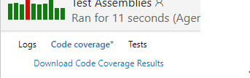

However,

S: How to add nodes in VSTS Scrum backlog to group sprints?

O: Iterations

A: Made some tests about OP’s questions.

P:

Case: <https://stackoverflow.com/questions/48222120/how-to-add-nodes-in-vsts-scrum-backlog-to-group-sprints>

Hi

You misunderstood them.

"Past", "Current", "Future" are not sprints nodes, just timeline of your sprints. “Past” represents that the end time of your sprints is before today, “Current” represents today is in the duration of your sprints, your sprints aren’t started for “Future”. They are associated with Set Dates of your sprints.

***>> I tried to add area "Release V1" and Release V2", but they doesn't appear in backlog ?***

Firstly, Add a sprint at <https://account.visualstudio.com/TeamName/_admin/_work>, as followed.

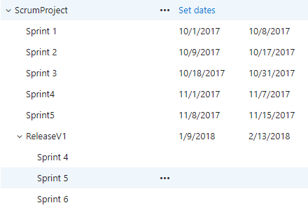

Secondly, Click **Select iterations** button at <https://account.visualstudio.com/TeamName/Development/_admin/_work?_a=iterations>, as followed.

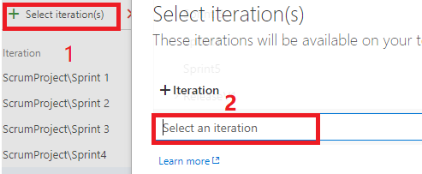

In the end, check your backlog tab and the sprints you created will display.

Note: it just shows the parent node or child node in the backlog tab. For example, Select Release v1 iteration, it will appear, but its child nodes will not appear, but it can show back items in all of child nodes. If select a child node of Release v1, Release v1 doesn’t appear.

Best Regards,

Aaron.

**2018/1/16**

S: Visual Studio GIT Revert

O: Rollback Sync operation.

A: Made a test, I can reset it. I gave some steps.

P:

Case: <https://stackoverflow.com/questions/48262348/visual-studio-git-revert>

Hi [Dead.Rabit](https://stackoverflow.com/users/424963/dead-rabit),

I reproduced your scene and try to reset the history of a branch in Visual Studio 2017, it worked. Please refer to the following steps:

1. Choose a branch you want to reset in Branches tab of Team explorer.

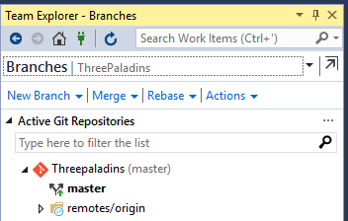

1. Right click the branch and choose View History option.

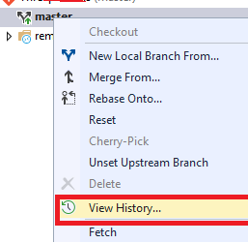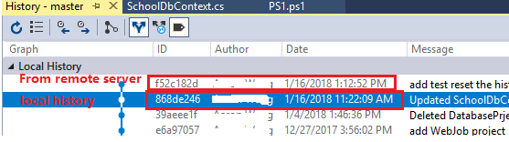

1. The f52c182d history is from remote server by Sync. If rollbacking the f52c182d history from remote server, choose 868de246 history in local histories> Reset option>Delete Changes(--hard),as followed.

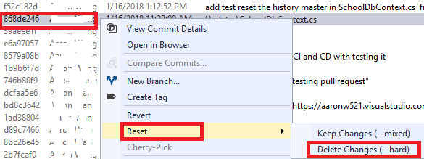

The local repository will rollbacks this Sync operation. But it will delete the uncommitted changes in master branch.

Best Regards,

Aaron.

**2018/1/17**

S: AutoMapper 6.2.2 restore fails on VSTS build server

O: Don’t restore AutoMapper Package.

A: I try to reproduce OP’s error. Unfortunately, I didn’t reproduce it. In the end, I just gave some suggestions.

P:

Case: <https://stackoverflow.com/questions/48289889/automapper-6-2-2-restore-fails-on-vsts-build-server>

Hi

Unfortunately, I didn’t reproduce your error. I made a test on netstandard2.0 and AutoMapper 6.2.2 package, I can build it successfully locally or it worked on VSTS. I tried dotnet core template and Asp.net core template, they worked, so I think netstandard version doesn’t affect NuGet restore AutoMapper package. You can set up System.debug variable to true to check more detail log about NuGet Restore task.

Besides, I also used Private Agent and Hosted Agent (Hosted VS2017) to test it, they worked. You can also try them.

Configure Private Agent: <https://docs.microsoft.com/en-us/vsts/build-release/actions/agents/v2-windows>

I think you could recreate a build definition to resolve it. Please provide a simple project which can reproduce your error in OneDrive.

Best regards,

Aaron

S: In Visual Studio Online, when I add a new State, can I also add the new state's specific “Changed Date” as a column in queries?

O: Work item and queryies.

A: OP want to add a field and a state of work item. I made some steps, let he refer to them.

P:

Case: <https://stackoverflow.com/questions/48288398/in-visual-studio-online-when-i-add-a-new-state-can-i-also-add-the-new-states>

Hi [Marcturis](https://stackoverflow.com/users/6788461/marcturis),

You can add a Spec Approved Date field and a Spec Approved state for a specific work item type on VSTS. Please refer to the following an example.

1. Add a Spec Approved state and a Spec Approved Date field in User Story by modifying the work items of a process which you inherited default processes ( for example: Agile process>**MyAgile**(<https://account.visualstudio.com/_admin/_process?_a=all>))

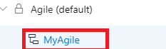

1. Choose a work item type (User Story) you want to modify, click it and.
2. Add a filed (**Spec Approved Date**) at **Layout** tab and a state (**Spec Approved**) at **States** tab, as followed.

**Spec Approved Date** Field:

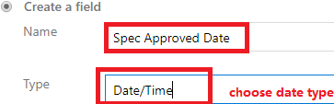

**Spec Approved state:**

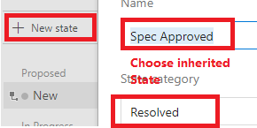

***>> Because I want to show a Query that includes the date of all of those states (to easily track when each ticket exited those states***.

If you query work item based on state=Spec Approved, it will query all of work item with Spec Approved state, if you would like to show Spec Approved Date field in the result of a query, please click **Column options** button in your query and add **Spec Approved Date** field and click OK.

Best Regards,

Aaron

S: VSTS URL load test results - understanding requests per second

O: URL-based load test.

A: I didn’t know what it is, learned it. At the end of learning it, I found a solution. Load test has two kinds pattern, such as constant and step patterns.

P:

Case: <https://stackoverflow.com/questions/48292675/vsts-url-load-test-results-understanding-requests-per-second>

Hi [zemien](https://stackoverflow.com/users/824036/zemien),

Throughput Chart is automatically generated when running test. You just set up it during creating or editing URL-based load by clicking **Setting** button.

Load test has two patterns, such as constant and step patterns. What pattern you use? Do you try the step pattern?

If you want to run test by step load pattern, please click **Edit test** button> Click **Setting** button, choose **load pattern** to **step**, run test like again, check the throughput chart, you will see the following result.

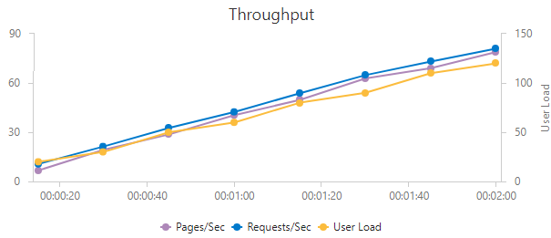

If the above pattern doesn’t satisfy your requirement, there is no way to implement it.

More detail information, please refer to URL-Based load tests(<https://docs.microsoft.com/en-us/vsts/load-test/get-started-simple-cloud-load-test#run-a-url-based-load-test>)

Best Regards,

Aaron

**2018/1/22**

S: microsoft-visual-studio-online-git-next-steps-manually-resolve-these-conflic

O: Pull request and conflicts

A: Gave some suggestions and operations

P:

Case: <https://stackoverflow.com/questions/48371911/microsoft-visual-studio-online-git-next-steps-manually-resolve-these-conflic>

Hi,

***>> So should I merge the branch instead of doing a pull request?***

Yes, pull request just merge branches with automatic conflicts, not conflicts resolved manually, therefore you should resolve them in local because there is no way to resolve conflicts with pull request in VSTS UI.

You can resolve conflicts in visual studio. You pull Dev and master branches into local repository and merge Dev into master. When conflicts happen, you can resolve them and all of Dev replace the content of master. Please refer to the following.

1. Choose **Branches** and merger Dev into master in Team explore.

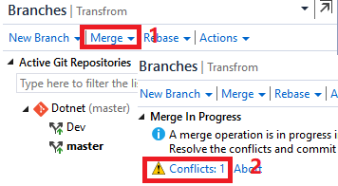

1. Click **Conflicts**, choose the content of Dev Branch, Click **Accept Merge** Button.

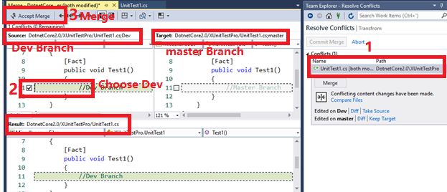

Resolve other conflicts in other files by the same way.

1. Push master into remote server.

Best Regards,

Aaron.

S: How to run Start-AzureVM in parallel from a VSTS Build in Azure Powershell?

O: The security context of Azure login and in parallel start Azure VM.

A: OP didn’t have the security context of Azure login, so I searched information about it. I found Set-AzureRmContext profile and Select-AzureRmProfile profile with .json file. Unfortunately, I didn’t make a test about Azure, so I didn’t know whether it works.

P:

Case: <https://stackoverflow.com/questions/48356475/how-to-run-start-azurevm-in-parallel-from-a-vsts-build-in-azure-powershell>

Hi

You need to set the security context of Azure remote with **Set-AzureRmContext**(<https://docs.microsoft.com/en-us/powershell/module/azurerm.profile/set-azurermcontext?view=azurermps-3.8.0>) profile or by **Select-AzureRmProfile**(<https://docs.microsoft.com/en-us/powershell/module/azurerm.profile/select-azurermprofile?view=azurermps-3.8.0>) with .json file if your Hosted agent can access shared file before your ***if*** statement block.

Besides, you can also refer to this(<https://github.com/robotechredmond/Azure-PowerShell-Snippets/blob/master/AzureRM%20-%20Start%20VMs%20in%20Parallel.ps1>).

Best Regards,

Aaron.

**2018/1/23**

S: How to build and deploy windows service application using VSTS? [on hold]

O: OP want to build and deploy windows service application using VSTS

A: Firstly, I create a window service application to make a test. Give some suggestions.

P:

Case: <https://stackoverflow.com/questions/48381846/how-to-build-and-deploy-windows-service-application-using-vsts>

Hi [pradeep](https://stackoverflow.com/users/5471259/pradeep),

Window Service Application is installed manually from the first link you provided. I suppose that you can save it into a shared folder that others can download it from.

Build Definition

You can refer to the second link which you provided and create build definition like the following.

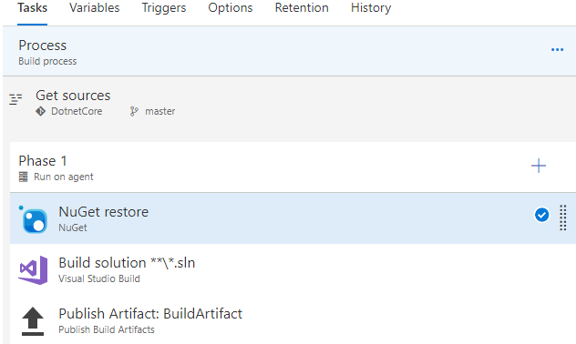

The artifact is used to save your build result.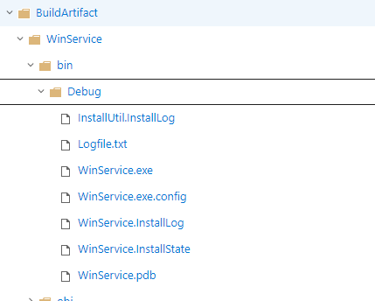

Release definition

You create Release definition and add a Window Machine copy file

and add PowerShell Task to deploy your file into FTP Server which others can download it. You can also add Window Machine Copy File task(deploy private agent(<https://docs.microsoft.com/en-us/vsts/build-release/actions/agents/v2-windows>) into the target machine) to copy your file into another machine with private agent, as followed.

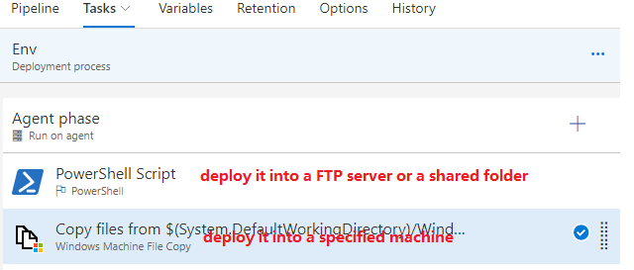

You can also copy files into a target machine or upload a TFP server during building in build definition.

Best Regards,

Aaron

**2018/1/24**

S: DACPAC Deployment in VSTS

O: OP wants to generate a .DACPAC file and execute it by Execute Azure SQL Task.

A: made a test by Visual Studio Build Task, which generates it.

P:

Case: <https://stackoverflow.com/questions/48396293/dacpac-deployment-in-vsts>

Hi Baskar,

Please refer to the following steps:

1. Modify your Database project in visual studio tool and push it in VSTS.
2. Create a build definition and add a Visual Studio Build Task, DACPAC file will be generated in **$(Build.SourcesDirectory)\SolutionName\ProjectName\bin\Release(or Debug)\DBProject.dacpac**.
3. In **Execute Azure SQL Task,** DAPAC file is configured with the above path.

Best Regards,

Aaron.

S: New BitBucket repositories not seen in dropdown.

O: OP wants to build Bitbucket repository with continuous integration.

A: Giving some suggestions, VSTS doesn’t create a BitBucket repository, it can build the remote bitbucket repository in Bitbucket Cloud by Get Sources Task.

P:

Case: <https://developercommunity.visualstudio.com/content/problem/187378/new-bitbucket-repositories-not-seen-in-dropdown.html>

Hi,

**问题理解错误**

You only create Git and TFVC repositories in VSTS, not create a Bitbucket project. It is possible to use Bitbucket Cloud Integration in VSTS, you can create a build definition, Get Sources task chooses Bitbucket type to connect the remote Bitbucket repository like the following.

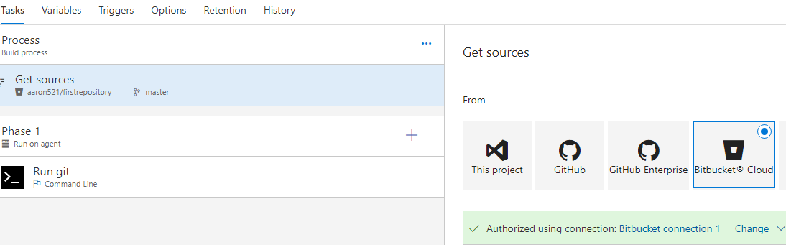

You can set up a trigger in **Triggers** tab when creating a pull request or modifying some changes in your Bitbucket cloud repository, it will queue a build automatically in VSTS.

正确理解：

I don’t know whether there is limitation about the count of service endpoints. You can recreate a new connection with Bitbucket Cloud in **Get Sources task**, then you go to <https://acount.visualstudio.com/TeamProject/_admin/_services> page to check whether it exists. Or you try to create a new connection, it can be created.

***>>I have a guess that VSTS is only pulling a certain number of repositories..?***

There is no limitation about the count of service endpoints, and then check whether it displays in dropdown. On the other hand, if it is limited, you can deploy a user voice about it here(<https://visualstudio.uservoice.com/forums/330519-team-services>).

Best Regards,

Aaron

**2018/1/25**

S: How to set system.web compilation debug mode off via VSTS

O: OP wants to remove debug element from web.config file by transformation.

A: made a test about XML transformation, gave some operation steps.

P:

Case: <https://stackoverflow.com/questions/48414644/how-to-set-system-web-compilation-debug-mode-off-via-vsts>

Hi,

Transformation usually is completed during deploying, you can use XML transformation(<https://docs.microsoft.com/en-us/vsts/build-release/tasks/transforms-variable-substitution#xml-transformation>) in release definition.

1. Add the following element in your web.Release.config file.

<system.web>

<compilation xdt:Transform="RemoveAttributes(debug)" />

</system.web>

1. Create a release definition after building your project, add a **Deploy Azure App Service Task** or **Deploy IIS Website Task,** check XML Transformation option in them.

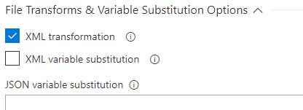

1. Create a Release and deploy it. Web.Release.config file will be automatically applied in web.config file.

If you want to transform in build definition, you can add a **XDT Transform Task**(<https://marketplace.visualstudio.com/items?itemName=qetza.xdttransform>)in build definition.

Best Regards,

Aaron

S: vsts project collection administrator remove

O: change the owner of an account after deleting all administrators from Project Collections Administrators group.

A: OP deleted all administrator uses including himself. But he wants to change the owner of an account. I made a test, it can’t be fixed. I suggest he makes a user voice.

P:

Case: <https://stackoverflow.com/questions/48417008/vsts-project-collection-administrator-remove>

Hi

There is no way to fix it, you can make a user voice here(<https://visualstudio.uservoice.com/forums/330519-team-services>).

Best Regards,

Aaron

S: Share Git repository directory across multiple build definitions

O: OP wants to save the result of building into different workspace.

A: VSTS doesn’t support it. I gave some explanation about private agent workspace, build workspace.

P:

Case: <https://stackoverflow.com/questions/48431874/share-git-repository-directory-across-multiple-build-definitions>

Hi [raterus](https://stackoverflow.com/users/2182665/raterus),

Private agent creates different workspaces for the different build definitions like the following.

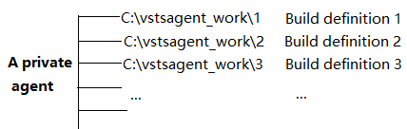

Or if you change the repository of Get Sources in a build definition 3, it will recreate a new workspace(C:\vstsagent_work\4) when a build starts.

Once the workspace is created, it can’t be changed before changing the repository or create a build definition, the next result of building will cover the result of the last build in the same build definition. You don’t set builds to different path in VSTS.

You can make a user voice here(<https://visualstudio.uservoice.com/forums/330519-team-services>).

Best Regards,

Aaron.

**2018/1/26**

S: How do I undo a bower change in Visual Studio Team Explorer using git?

O: visual studio 2017 git Undo changes not working.

A: I try to reproduce the problem. Unfortunately, it can’t be reproduced for me. I try other method committing the changes into a new branch and then delete it.

P:

Case: <https://stackoverflow.com/questions/48453363/how-do-i-undo-a-bower-change-in-visual-studio-team-explorer-using-git>

Hi Sam,

Your problem is hardly reproduced in my side. You can try to create a new branch and commit the changes into it, please refer to the following steps.

1. Right click master and choose New a Local Branch From, promote the following.
2. Commit the changes into Test branch, then delete Test branch.
3. Check out master branch, if other changes display, right click and choose undo changes.

Best Regards,

Aaron.

2018/1/29

S: https://stackoverflow.com/questions/48484457/vsts-extracting-msdeploy-zip-package-using-variables

O: OP want to reduce the result of the published path

A: I made a test with File System mode, it can save the published result in a specific path and then publish it into artifact. In the end, I gave some operations.

P:

Case: <https://stackoverflow.com/questions/48484457/vsts-extracting-msdeploy-zip-package-using-variables>

Hi,

There is a better way to publish your project without archiving your published result and catering for this path. You can publish your project with **File System** mode, it saves the published result in a specific location, and it can’t archive the published result.

Note: disable/remove **Publish symbol path** Task.

Please refer to the following steps:

1. Create a **FileSystemDebug.pubxml** file in **YouProject/Properties/PublishProfiles/FileSystemDebug.pubxml** like the following.

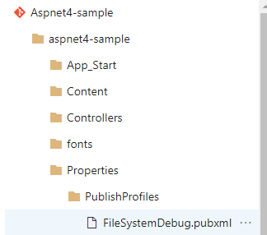

1. Add the following content into it.

<Project ToolsVersion="4.0" xmlns="http://schemas.microsoft.com/developer/msbuild/2003">

<PropertyGroup>

<WebPublishMethod>**FileSystem**</WebPublishMethod>

<LastUsedBuildConfiguration>**Release**</LastUsedBuildConfiguration>

<LastUsedPlatform>Any CPU</LastUsedPlatform>

<SiteUrlToLaunchAfterPublish />

<ExcludeApp_Data>False</ExcludeApp_Data>

<publishUrl>**C:\builds\MyProject**\</publishUrl>

<DeleteExistingFiles>True</DeleteExistingFiles>

</PropertyGroup>

</Project>

It will save the published result into **C:\builds\MyProject**\

1. Modify your MSBuild task arguments to **/p:DeployOnBuild=true /p:PublishProfile=FileSystemDebug.pubxml**
2. Set up Path to publish to **C:\builds\MyProject** in Publish artifact task.

Best Regards,

Aaron.

S: VSTS - NUGET creation build number as version

O: OP wants to use build number format as version when set up Automatic package versioning to User the build number option in NuGet Pack Task.

A: Made a test about op’s build number format, I got an error, I think the build.definitionname is error, it should be $(Build.DefinitionName), not $(BuildDefinitionName), so I made a test on $(Build.DefinitionName)_$(Year:yyyy).$(Month).$(DayOfMonth)$(Rev:.r) build number format in **Options** tab, it worked well.

P:

Case: <https://stackoverflow.com/questions/48465269/vsts-nuget-creation-build-number-as-version>

Hi

Do you get an error when setting up build number format to $(BuildDefinitionName)_$(Year:yyyy).$(Month).$(DayOfMonth)$(Rev:.r) in **Options** tab? I got an error like the above your build number format. This error is that **No value was found for the provided environment variable.**

When modifying $(BuildDefinitionName) in your build number format to $(Build.DefinitionName), it worked well in my side like the following.

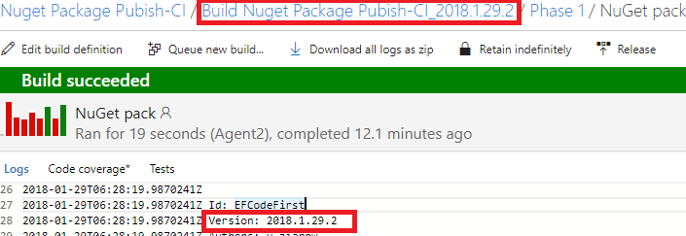

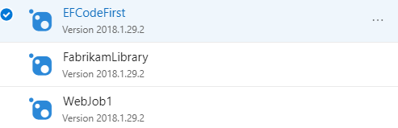

Best Regards,

Aaron

**2018/1/30**

S: VS-OnLine - Build/Release Error: Config is missing for service

O: Config is missing for service

A: Gave some advices, such as check whether the config file references service and a similar error link.

P:

Case: <https://stackoverflow.com/questions/39165542/service-fabric-deployment-error-servicemanifest-xml-is-missing-for-service/39223990>

Add a Comment:

What did you do in your solution after the first release? You can check whether the config file have lost service reference. There is an similar error(<https://stackoverflow.com/questions/39165542/service-fabric-deployment-error-servicemanifest-xml-is-missing-for-service/39223990>) for you, it was caused by that SF project must have lost the service reference when two projects were removed from the solution.

Best Regards,

Aaron

S:

O:

A:

P:

Case:

Hi

Do you push the local repository into remote server after committing? Is the branch that operates on VSTS that you have locally modified?

S:

O:

A:

P:

Case: <https://stackoverflow.com/questions/48496309/invalid-nuspec-file-target-framework-unsupported-version-v0-0-is-not-support>

Hi,

You can add a NuGet pack task to automatically generate a .nuspec file and pack your project like the following

https://aaronw521.visualstudio.com/_git/ThreePaladins

**2018/1/31**

S: VSTS Deploy to Azure WebApp For Linux

O: OP wants to deploy a Ruby application in Linux machine.

A: Firstly, I searched whether Ruby App can be compiled, unfortunately, it isn’t compiled. I thought a build in build definition only publish it into an artifact used in release definition by Publish Artifact Task. I searched deploying an application in Linux by Deployment group phase,

P:

Case: <https://stackoverflow.com/questions/48525048/vsts-deploy-to-azure-webapp-for-linux>

Hi

Yes, you can do it in VSTS. Please refer to the following steps.

1. Create a build definition with **Process** to **Hosted Linux Preview** in a Team Project of VSTS Account.
2. Set up **Get Sources Task** to **GitHub** type to connect your repository in GitHub, and add a Publish Artifact task to set up **Path to publish** to **$(Build.SourcesDirectory)**. If you want to do other things, you can add corresponding tasks.

Note: you can set a trigger(<https://docs.microsoft.com/en-us/vsts/build-release/concepts/definitions/build/triggers>) in Triggers tab of a build definition, it can automatically queue a build when modifying WebApp in GitHub repository.

1. Create a Release definition like this(<https://docs.microsoft.com/en-us/vsts/build-release/apps/cd/deploy-linuxvm-deploygroups>).

Note: you can set release triggers and environment triggers(<https://docs.microsoft.com/en-us/vsts/build-release/concepts/definitions/release/triggers#release-triggers>) in release definition, it is automatically deployed after a build completes successfully.

Best Regards,

Aaron.

2018/2/1

S:

O:

A:

P:

Case: <https://stackoverflow.com/questions/48536320/how-to-add-a-custom-tab-in-vsts-build-summary-hub>

Hi

Yes, please refer to the following steps:

1. Install Node.js tool
2. You can download **build-results-enhancer** folder in here(<https://github.com/Microsoft/vsts-extension-samples>).
3. Replace the content of vss-extension.json file by using the following text.

{

"manifestVersion": 1,

"id": "samples-build-results-enhancer",

"version": "0.3.5",

"name": "Build Results Enhancer",

"description": "A simple extension that demonstrates how to extend build summary page.",

**"publisher": "yourself",**

"public": false,

"icons": {

"default": "images/fabrikam-logo.png"

},

"tags": [

"Build"

],

"scopes": [

"vso.build_execute"

],

"categories": [

"Developer samples"

],

"targets": [

{

"id": "Microsoft.VisualStudio.Services"

}

],

"files": [

{

"path": "images",

"addressable": true

},

{

"path": "buildDumpSection.html",

"addressable": true

},

{

"path": "infoTab.html",

"addressable": true

},

{

"path": "statusSection.html",

"addressable": true

},

{

"path": "builtInTaskContribution.html",

"addressable": true

},

{

"path": "taskContribution.html",

"addressable": true

},

{

"path": "src/Tasks",

"addressable": true,

"packagePath": "Tasks"

},

{

"path": "node_modules/vss-web-extension-sdk/lib",

"addressable": true,

"packagePath": "lib"

}

],

"contributions": [

{

"id": "build-info-tab",

"type": "ms.vss-build-web.build-results-tab",

"description": "A tab contributing to build results view",

"targets": [

"ms.vss-build-web.build-results-view"

],

"properties": {

"name": "Custom Tab",

"uri": "infoTab.html"

}

},

{

"id": "build-status-section",

"type": "ms.vss-build-web.build-results-section",

"description": "A section contributing to our own new tab and also to existing build 'summary' tab",

"targets": [

".build-info-tab",

"ms.vss-build-web.build-results-summary-tab"

],

"properties": {

"name": "Custom Section",

"uri": "statusSection.html",

"order": 20,

"height": 310

}

}

]

}

Note: Change Publisher to yourself.

1. Create a path node_modules/vss-web-extension-sdk/lib in **build-results-enhancer** folder.
2. Open Node.js command prompt like this,

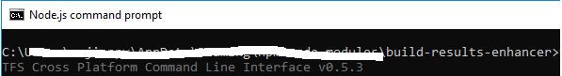

1. Execute tfx extension create –manifest-globs vss-extension.json
2. Upload .vsix file into your account, share it to your VSTS account, and install it.

Best Regards,

Aaron

**2018/2/2**

S: Sharing Directory between builds aka sharing node_modules

O: OP has three requirements

A: Download once, Use private agent; use the same downloaded dependencies in the different builds, create three same build definition to build different apps; a release includes the artifacts of three builds, add three artifacts from different build definition.

P:

Case: <https://stackoverflow.com/questions/48562501/sharing-directory-between-builds-aka-sharing-node-modules>

Hi

1. Hosted agent is cleaned after a build completed, so you need to use Private Agent during building and set Clean of **Get Sources task** to false in a build definition.
2. You can create three same build definitions for monorepo to build three different apps by **Filter Path**, such as App1BuildDefinition for App1, App2BuildDefinition for App2 and App3BuildDefinition for App3.
3. Because an artifact is a corresponding build of build definition, not from three different build of the same build definition. You need to add three artifacts from build definitions in a release definition like **the 2 step**, and set **Default version** to **Latest**. For example,

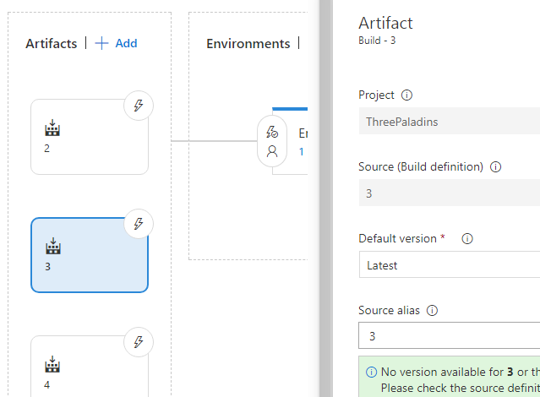

Best Regards,

Aaron

**2018/2/5**

S: How to include tags in NuGet package using CLI only

O: NuGet Tags

A: I made many tests on changing tags of a package. Firstly, I try Additional build properties of NuGet pack task, but it didn’t work. Then I locally try it with nuget pack – properties, it didn’t work. In the end, I check nuget pack -properties command, it just modifies $token$ in .nuspce file, so tags are automatically generated when creating a .nuspec file, not modified in .nupsec file, only modified manually.

P:

Case: <https://stackoverflow.com/questions/48611702/how-to-include-tags-in-nuget-package-using-cli-only>

Hi,

Yes, you can set metadata in .nupsec file. You only modify it manually in .nuspec file to modify tags. Besides, you can also modify metadata in aasemblies.cs file of your project, but it modifies tags.

You only modify $token$ in .nuspec file with -Properties arguments.

Properties(<https://docs.microsoft.com/en-us/nuget/tools/cli-ref-pack#options>):

Specifies a list of properties that override values in the project file; see [Common MSBuild Project Properties](https://docs.microsoft.com/en-us/visualstudio/msbuild/common-msbuild-project-properties) for property names. The Properties argument here is a list of token=value pairs, separated by semicolons, where each occurrence of $token$ in the .nuspec file will be replaced with the given value. Values can be strings in quotation marks. Note that for the "Configuration" property, the default is "Debug". To change to a Release configuration, use -Properties Configuration=Release.

Tags are not included in Properties argument.

Best Regards,

Aaron Wang

**2018/2/6**

S: How can I create a Pull Request when a release completes in VSTS?

O: Pull Request and release

A: Op wants to create a pull request after a release completed. I search some settings, but it doesn’t do it. Then I try to search some release tasks to do it, I didn’t find it. In the end, I thought there is a way that is creating a PowerShell script to call REST API to create a pull request, and found a script.

P:

Case: <https://stackoverflow.com/questions/48634358/how-can-i-create-a-pull-request-when-a-release-completes-in-vsts>

Hi Sawtaytoes,

There is directly no way automatically to create a pull request when a release completed in VSTS.

But you can use PowerShell script calling a REST API(<https://www.visualstudio.com/en-us/docs/integrate/api/git/pull-requests/pull-requests#create-a-pull-request>) to create a pull request. Please refer to the PowerShell script(<https://www.marcusfelling.com/blog/2017/create-vsts-pull-request-via-vsts-rest-api/>).

Best Regards,

Aaron

2018/2/6

S: How to Import test cases from Excel to TFS 2015, Please provide solution for this.

O: Test Case, Excel and TFS 2015

A: OP wants to import local test case form excel into TFS 2015. I made some steps to publish test cases from excel into TFS 2015.

P:

Case: <https://developercommunity.visualstudio.com/content/problem/193407/how-to-import-test-cases-from-excel-to-tfs-2015-pl.html>

Hi [Ghani, Dilshad](https://developercommunity.visualstudio.com/users/60740/8d83115c-957d-6d0c-b4a6-84d4155606c3.html),

You can directly add some Test Cases in Excel, please refer to the following steps.

1. Create a new excel file and click **New List** option in **Team** tab

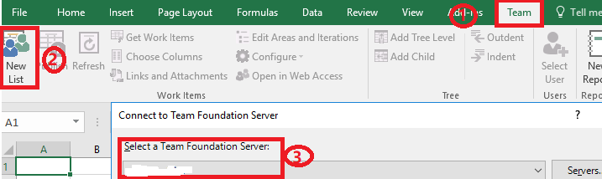

1. Connect your TFS like <http://account:8080/tfs>, and choose the corresponding Team Project Collections and Team project, click Connect.
2. Choose **Input List** option(or Query List to export some work items), click **OK** like the following.

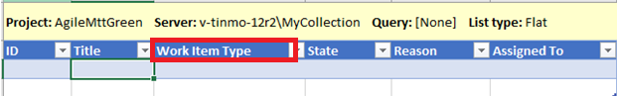

If you want to show other columns, please click **Choose Columns** option and add them.

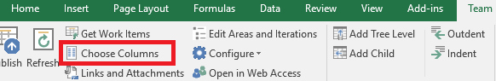

1. Copy test cases into it, choose **Test Case** under **Work Item Type** list.
2. Publish all of test cases.

Note: if you don’t find Team tab, please click **File** tab>click **Options**>click **Add-in**>choose **Manage: COM Add-in**, click **Go**>check **Team Foundation Add-in**>Click **Ok**.

You can create a query to search them in TFS.

Best Regards,

Aaron

Hi [Ghani, Dilshad](https://developercommunity.visualstudio.com/users/60740/8d83115c-957d-6d0c-b4a6-84d4155606c3.html),

You can directly publish test cases from Excel into TFS 2015 in excel **Team** tab, please refer to the following steps.

1. Please click **File** tab>click **Options**>click **Add-in**>choose **Manage: COM Add-in**, click **Go**>check **Team Foundation Add-in**>Click **Ok, Team tab will show.**
2. click **New List** option in **Team** tab



1. Click **Publish** button in **Team** tab and Publish all of test cases.

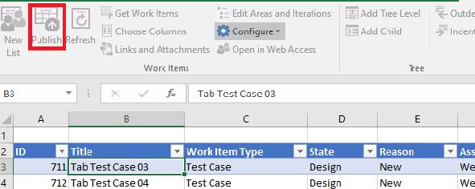

1. Create a query in TFS to search them.

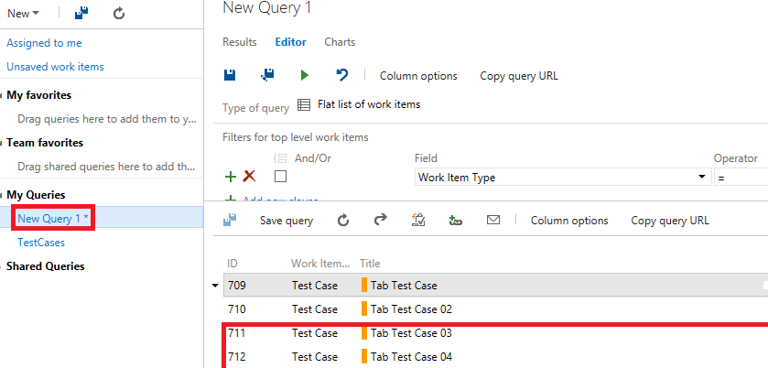

1. Create Query-based suite in TEST of TFS.

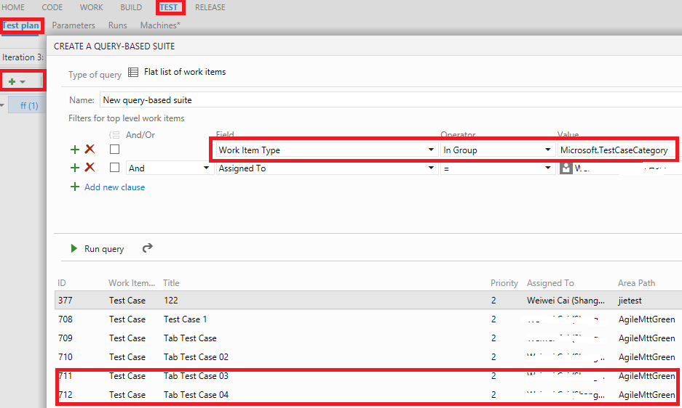

1. Run them.

Best Regards,

Aaron

**2018/2/7**

S: The members widget on dashboard not updating

O: The Team Members widget in dashboard is not updated.

A: I made a test that updates a team of a team project. And I tested the two teams, it doesn’t affect another team when deleting a user from a team. So I think the error is caused by it.

P:

Case: <https://developercommunity.visualstudio.com/content/problem/194487/the-members-widget-on-dashboard-not-updating.html>

Hi [kartik.tallapragada](https://developercommunity.visualstudio.com/users/26555/b512b4ea-345f-41cb-99bc-a36e4523bfb4.html),

Is there only a team in your team project? Dashboard in the home page is a dashboard of the default team. I made a test that the Team Members widget in dashboard of the default team has been updated after deleting a user from the security tab in the default team.

You can check how many team there are in <https://account.visualstudio.com/teamproject/_admin>. If you deleted a user from the security tab of other teams, it doesn’t affect the dashboard in the home page. Please check your teams in your team project.

Home Page 理解错误 There is a bug.

Best Regards,

Aaron.

S:

O:

A:

P:

Case:

Hi Eddie,

Thank you for submitting the feedback! For us to investigate this further, could you please share screenshots for your steps or the error information.

Best Regards,

Aaron

S: code: Entering a Custom destination and then changing the drop down does not remove custom destination

O: OP didn’t remove custom destination platform to use other destination platform.

A: I suggested he check the log of a build with setting system.debug to true. Or he recreates a new build definition.

P:

Case: <https://developercommunity.visualstudio.com/content/problem/193958/xcode-entering-a-custom-destination-and-then-chang.html>

Hi Eddie,

Thank you for submitting the feedback! For us to investigate this further, could you please share the XCode Build log? You could set System.debug to true, and check the log of a build. You can also recreate a build definition to build your project to check whether your problem still happen. We look forward to hearing from you!

Best Regards,

Aaron

**2018/2/8**

S: Changing Process Name breaks task work item custom states

O: Rename process template, the added states didn’t show in dropdown list.

A: I made a test on it, it worked well in my side.

P:

Case: <https://developercommunity.visualstudio.com/content/problem/195327/changing-process-name-breaks-task-work-item-custom.html>

Hi Eddie,

The following is my solution.

Thank you for submitting the feedback. We have determined that this issue is not a bug.

1. Create a SubCMMI process named SubCMMI like the following.

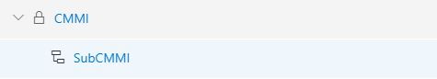

1. Add a state named Test for Task work, and add some new work items(refresh the page). Test state shows in dropdown list.
2. Change the myself process from SubCMMI to TestCMMI.
3. Go to Work tab and refresh the whole page, and open one of the previous task work added. Everything is ok like this

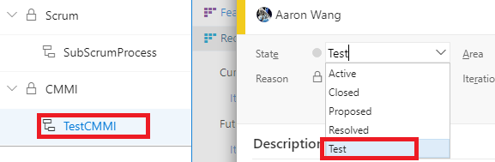

You could go to <https://account.visualstudio.com/CMMIProject/_admin> page to check whether the Process of your team project has been changed to a renamed process after renaming yourself Process.

Besides, are the states of a number of work items a state type you added? Please share your error information or screenshot to check it.

Please kindly let us know if the solution works or not so that we can reopen the ticket and continue to investigate it if needed. If it works for you, please click "Accept" button to mark the solution. Thanks for your cooperation.

Best Regards,

Aaron

S: Release Notifications to email address stopped working.

O: Release notifications don’t work.

A: I created a same release notification as OP, I can get an email when release state is fielded.

P:

Case: <https://developercommunity.visualstudio.com/content/problem/195054/release-notifications-to-email-address-stopped-wor.html>

Hi Eddie,

The following is my solution:

Thank you for submitting the feedback.  We have determined that this issue is not a bug.

Because the value of Deployment requested for doesn’t contain what you specified. You could check your release log to check the value of Deployment Requested for, and then set it in your release notification.

Please kindly let us know if the solution works or not so that we can reopen the ticket and continue to investigate it if needed. If it works for you, please click "Accept" button to mark the solution. Thanks for your cooperation.

Best Regards,

Aaron.

2018/2/9

Case: <https://developercommunity.visualstudio.com/content/problem/196025/vsts-editing-a-notifications-subscription-keeps-re.html>

Hi Eddie,

The following is my solution:

1. Create a Build notification like the following in .

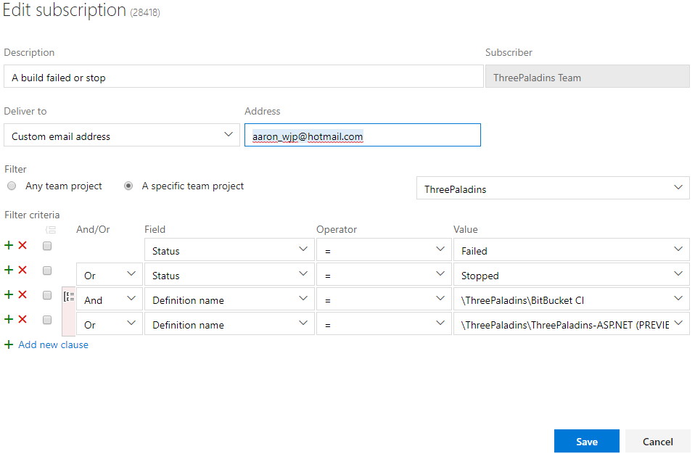

1. When opening it to edit, Custom email address is empty and needs to be configurated like OP.

I reproduced OP’s issue, I think it a bug.

But I made a build notification by clicking **Notification setting** in the upper right corner icon.

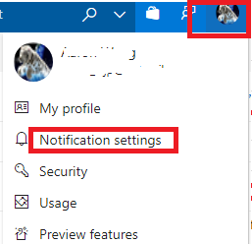

And setting the notification like this,

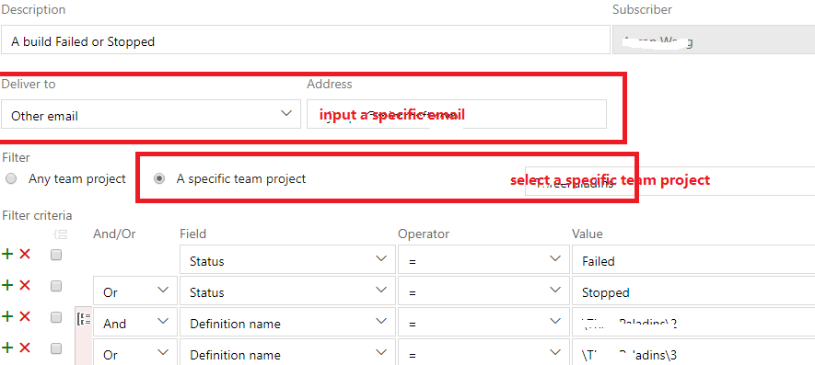

When reopening the build notification to edit, the email address isn’t cleaned.

Best Regards,

Aaron

Case: <https://developercommunity.visualstudio.com/content/problem/195986/xamarinios-task-failed-with-error-xbuild-failed-wi.html>

Hi Eddie,

The following is my sulotion.

Thank you for submitting the feedback.  We have determined that this issue is not a bug.

 I didn’t check BlackhawkPlatform.App in Get Sources log. Firstly, you must make sure that there is BlackhawkPlatform.App in your repository of Get Sources task.

Please click "Accept" button to mark the solution if it works or add a comment to let us know if it does not work so that we can reopen the ticket and investigate this further.

Best Regards,

Aaron

3 Case

Case: <https://developercommunity.visualstudio.com/content/problem/195906/new-issue-with-user-stories-that-has-rolled-throug.html>

Hi Eddie,

I create an Agile process template, but I don’t reproduce the issue that doesn’t add a Related Link.

The following is my solution.

Thank you for submitting the feedback. We cannot reproduce this issue at our side. Has the issue been resolved? Could you please indicate what changes you do in the custom process template? We look forward to hearing from you!

Best Regards,

Aaron

**2018/2/22**

S: New Release" dialog box only display limited number of builds

O: OP wants to choose older build in drop down.

A: I made a test, but all of builds display in drop down.

P:

Case: <https://developercommunity.visualstudio.com/content/problem/201587/new-release-dialog-box-only-display-limited-number.html>

Hi Eddie,

The following is my solution.

Thank you for your feedback! If the builds that are deleted or failed, they will not show in drop down. You could check whether the specified build version is deleted or success in history of your build definition. We look forward to hearing from you!

Best Regards,

Aaron.

S:

O:

A:

P:

Case: <https://developercommunity.visualstudio.com/content/problem/201586/manually-enter-build-version-in-new-release-is-con.html>

Hi Eddie,

The following is my solution.

Thank you for your feedback. We have determined that this actually a suggestion not an issue. This sounds like a good opportunity for an enhancement. Please feel free to log suggestions for us at <https://visualstudio.uservoice.com/forums/330519-team-services>. Thank you for helping us build a better VSTS.

Best Regards,

Aaron.